MakeMyMarrige
DATABASE SCHEMA DESIGN & DIAGRAMS
Version 1.0 | November 2026
MongoDB Atlas • Hybrid Modelling • 82 Collection Specifications • 5 ERD / Architecture Diagrams

1. Architecture baseline
- Shared MongoDB database and collections with logical tenant isolation through weddingId.
- One collection per independently managed domain entity; bounded parent-owned values may be embedded.
- Global account identity/session records are separate from tenant-owned wedding data.
- ObjectId internally; opaque high-entropy tokens externally, with token hashes stored.
- Integer paise and INR; display-only rounding up to the next whole rupee.
- Date-only values use validated YYYY-MM-DD; workspace timezone Asia/Kolkata; instants are UTC BSON Date.
- Three-layer validation: API DTO, domain rules, MongoDB JSON Schema.
- OCC + atomic conditional updates + idempotency + transactions for the relevant invariants.
- Selective TTL, cursor pagination for large collections, tenant-first query/index strategy.
- R2 stores photo objects; MongoDB stores metadata. Redis/BullMQ is queue/cache infrastructure, not source of truth.

2. Database context and entity relationship diagrams

System context and domain boundaries
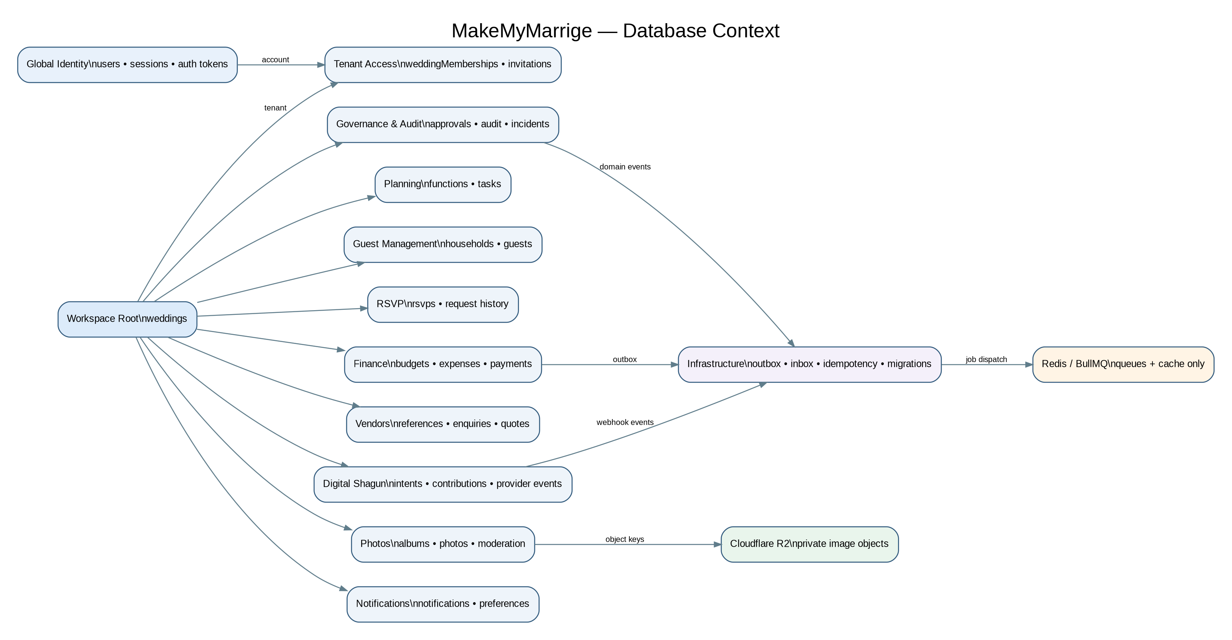

Global identity, workspace root, membership and invitation relationships
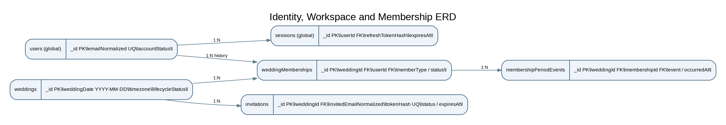

Households, guests, functions, task and RSVP relationships
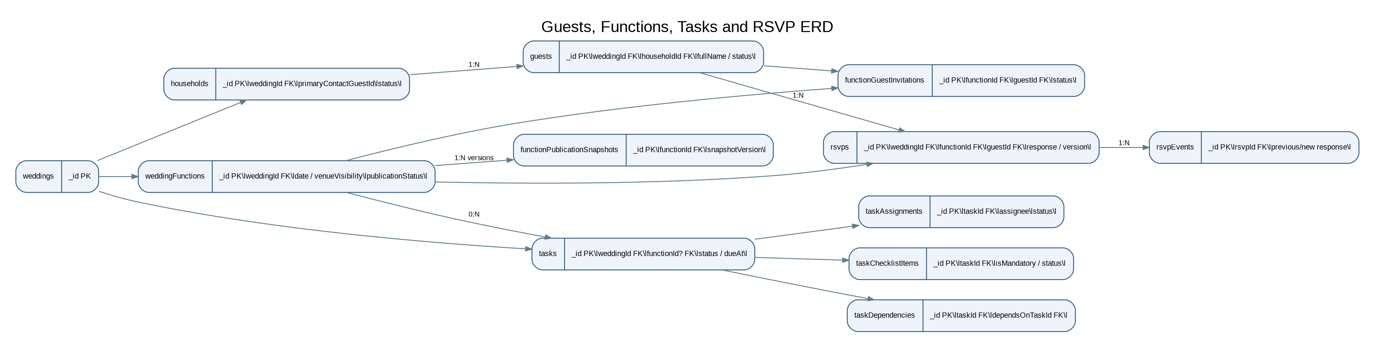

Budget, expense, vendor and Digital Shagun relationships
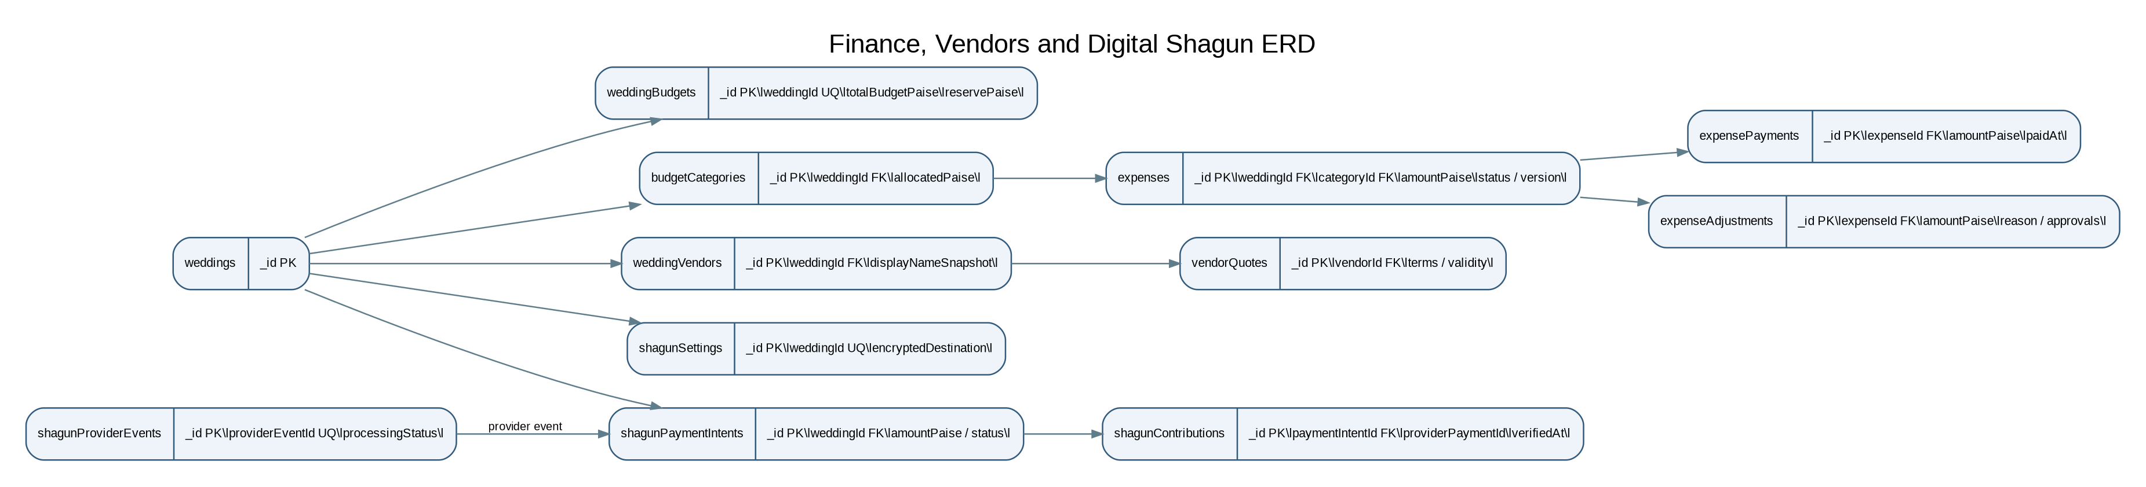

Photo moderation, notifications, audit and deletion relationships
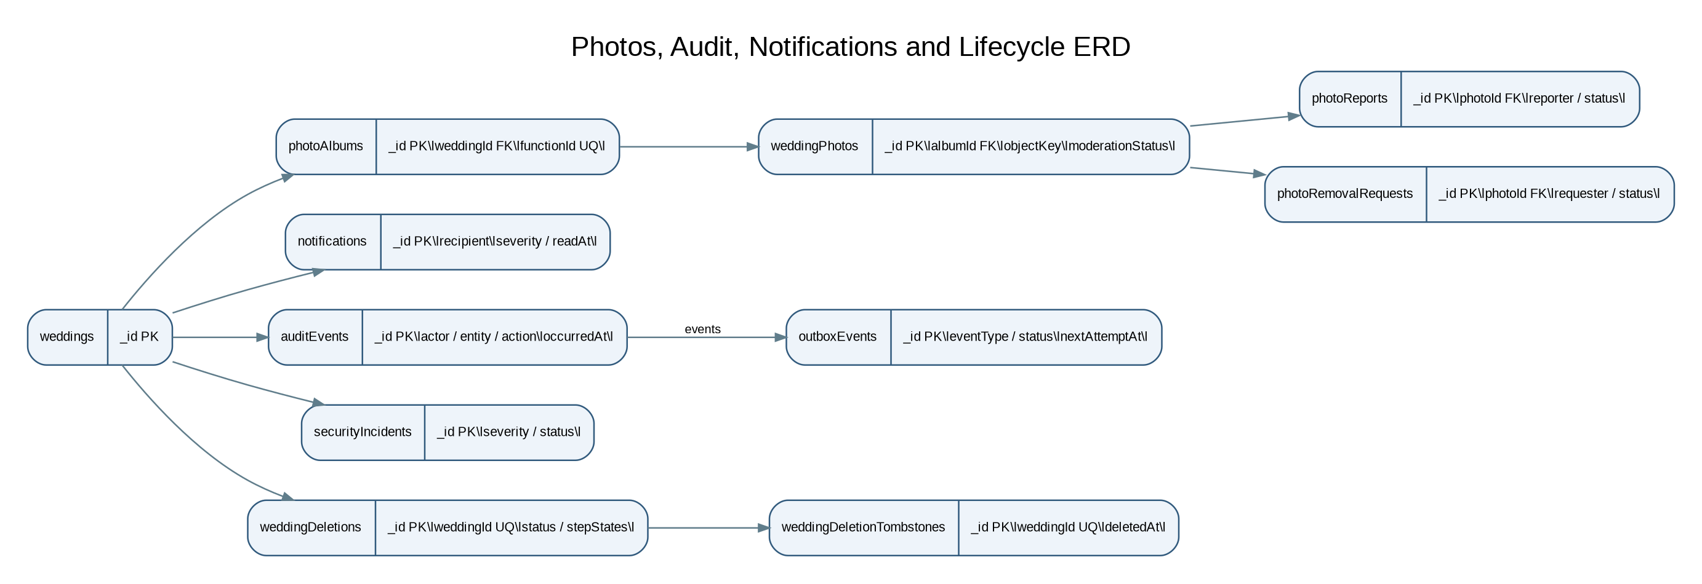

3. Collection inventory
Identity / global: users, sessions, emailVerificationTokens, passwordResetTokens
Workspace: weddings, weddingMemberships, membershipPeriodEvents, invitations
Governance: governanceRequests, weddingFinanceSettings, permissionChangeEvents
Planning: weddingFunctions, functionPublicationSnapshots, functionHouseholdInvitations, functionGuestInvitations, tasks, taskAssignments, taskChecklistItems, taskDependencies, taskComments, taskActivityEvents
Guests: households, guests, guestRelationshipTags, guestCorrectionRequests, guestMergeOperations, guestHouseholdHistory
RSVP: rsvps, rsvpEvents, additionalGuestRequests, additionalGuestRequestEvents
Finance: weddingBudgets, budgetCategories, budgetGovernanceRequests, budgetReserveAllocations, expenseEstimates, vendorQuotes, expenses, expenseApprovalEvents, expensePayments, expenseAdjustments, financeAuditEvents
Vendors: vendorReferences, weddingVendors, vendorCategories, vendorServices, vendorEnquiries, vendorEstimates, vendorAvailabilityChecks, vendorSelections, vendorBookingRecords, vendorActivityEvents
Shagun: shagunSettings, shagunConfigurationRequests, shagunPaymentIntents, shagunContributions, shagunProviderEvents, shagunReconciliationEvents, shagunAcknowledgements, shagunAuditEvents
Photos: photoAlbums, weddingPhotos, photoReports, photoRemovalRequests, photoAuditEvents
Notifications: notifications, notificationPreferences, dashboardSnapshots (optional)
Audit/lifecycle: auditEvents, securityIncidents, dataAccessRequests, dataCorrectionRequests, weddingLifecycleEvents, weddingDeletions, weddingDeletionTombstones, weddingExportRequests, cancellationNoticeRecords
Platform: supportRecoveryCases
Infrastructure: outboxEvents, inboxEvents, idempotencyRecords, migrationHistory

4. Detailed collection schema catalogue
All fields below are logical schema contracts. `?` means optional/nullable as applicable. Every tenant-owned collection includes `weddingId:ObjectId` unless it is the `weddings` root. Every collection also has an explicit retention and access policy in its owning domain.

users — Identity / global
Fields: emailNormalized:string unique; passwordHash:string?; emailVerifiedAt:Date?; displayName:string; accountStatus:ACTIVE|SUSPENDED|CLOSED; authProviderLinks:bounded array; createdAt; updatedAt; version:int.
Indexes / constraints: Unique emailNormalized. Never embed sessions.

sessions — Identity / global
Fields: userId:ObjectId; refreshTokenHash:string; sessionFamilyId:string; expiresAt:Date; revokedAt:Date?; lastUsedAt:Date?; deviceLabel:string?; minimal IP metadata; createdAt.
Indexes / constraints: Index userId+revokedAt+expiresAt. TTL only after expiry policy.

emailVerificationTokens — Identity / global
Fields: userId:ObjectId; tokenHash:string; expiresAt:Date; consumedAt:Date?; createdAt:Date.
Indexes / constraints: Unique tokenHash; TTL expiresAt; enforce expiry in API.

passwordResetTokens — Identity / global
Fields: userId:ObjectId; tokenHash:string; expiresAt:Date; consumedAt:Date?; createdAt:Date.
Indexes / constraints: Unique tokenHash; TTL expiresAt; single-use.

weddings — Workspace
Fields: name:string; weddingDate:YYYY-MM-DD; timezone:'Asia/Kolkata'; lifecycleStatus enum; deletionDueAt:Date?; createdAt; updatedAt; version:int.
Indexes / constraints: Workspace root; no embedded business collections.

weddingMemberships — Workspace
Fields: weddingId:ObjectId; userId:ObjectId; memberType:CO_OWNER|ORGANISER|TREASURER; status:ACTIVE|SUSPENDED|ENDED; permissions:bounded grants; joinedAt; endedAt?; version:int.
Indexes / constraints: Partial unique userId for ACTIVE/SUSPENDED; weddingId+status+memberType.

membershipPeriodEvents — Workspace
Fields: weddingId:ObjectId; membershipId:ObjectId; eventType:JOINED|SUSPENDED|REACTIVATED|ENDED; actorId; reason?; occurredAt.
Indexes / constraints: Append-only; weddingId+membershipId+occurredAt.

invitations — Workspace
Fields: weddingId:ObjectId; invitedEmailNormalized:string; invitationType; tokenHash; status:PENDING|ACCEPTED|REVOKED|EXPIRED; expiresAt; createdBy; acceptedBy?; acceptedAt?; createdAt.
Indexes / constraints: Unique tokenHash; weddingId+email+status; retain history.

governanceRequests — Governance
Fields: weddingId:ObjectId; requestType; targetEntityType; targetEntityId:ObjectId; proposedSnapshot:bounded object; proposalVersion:int; approvals:bounded distinct co-owner approvals; status; expiresAt; createdBy; createdAt; version:int.
Indexes / constraints: Index weddingId+status+createdAt; proposal changes invalidate approvals.

weddingFinanceSettings — Governance
Fields: weddingId:ObjectId unique; treasurerMembershipId:ObjectId?; approvalPolicyVersion:int; reserveApprovalThresholdPaise:int64?; updatedAt; version:int.
Indexes / constraints: One settings record per wedding; changes follow dual-owner governance.

permissionChangeEvents — Governance
Fields: weddingId:ObjectId; membershipId:ObjectId; changedBy; before/after permission snapshot; reason; occurredAt.
Indexes / constraints: Append-only audit of permission changes.

weddingFunctions — Planning
Fields: weddingId:ObjectId; name; date:YYYY-MM-DD; startTime/endTime:HH:mm?; venueVisibility:ANNOUNCED|TO_BE_ANNOUNCED|PRIVATE; draftDetails:bounded; publicationStatus:DRAFT|PUBLISHED|CANCELLED; version:int; timestamps.
Indexes / constraints: weddingId+date; status/date queries.

functionPublicationSnapshots — Planning
Fields: weddingId:ObjectId; functionId:ObjectId; snapshotVersion:int; publishedSnapshot:immutable bounded object; approvedBy:[two distinct co-owner IDs]; publishedAt:Date.
Indexes / constraints: Unique weddingId+functionId+snapshotVersion.

functionHouseholdInvitations — Planning
Fields: weddingId:ObjectId; functionId:ObjectId; householdId:ObjectId; status:INVITED|REVOKED; invitedAt; createdBy.
Indexes / constraints: Unique weddingId+functionId+householdId.

functionGuestInvitations — Planning
Fields: weddingId:ObjectId; functionId:ObjectId; guestId:ObjectId; householdInvitationId:ObjectId?; status:INVITED|REVOKED; invitedAt; createdBy.
Indexes / constraints: Unique weddingId+functionId+guestId.

tasks — Planning
Fields: weddingId:ObjectId; functionId:ObjectId?; title; description?; status:TODO|IN_PROGRESS|BLOCKED|COMPLETED|CANCELLED; priority; dueAt:Date?; createdBy; version:int; timestamps.
Indexes / constraints: weddingId+status+dueAt+_id; weddingId+functionId+status.

taskAssignments — Planning
Fields: weddingId:ObjectId; taskId:ObjectId; assigneeMembershipId:ObjectId; assignedBy; assignedAt; status:ACTIVE|REMOVED.
Indexes / constraints: Partial unique weddingId+taskId+assigneeMembershipId for ACTIVE.

taskChecklistItems — Planning
Fields: weddingId:ObjectId; taskId:ObjectId; title; isMandatory:boolean; status:OPEN|COMPLETED; completedBy:ObjectId?; completedAt:Date?; sortOrder:int; version:int.
Indexes / constraints: weddingId+taskId+sortOrder. Separate entity for independently validated completion.

taskDependencies — Planning
Fields: weddingId:ObjectId; taskId:ObjectId; dependsOnTaskId:ObjectId; createdBy; createdAt.
Indexes / constraints: Unique weddingId+taskId+dependsOnTaskId; reject self-edge and cycles in domain service.

taskComments — Planning
Fields: weddingId:ObjectId; taskId:ObjectId; authorId:ObjectId; body:string; createdAt; editedAt?; editReason?
Indexes / constraints: weddingId+taskId+createdAt; comments append-oriented.

taskActivityEvents — Planning
Fields: weddingId:ObjectId; taskId:ObjectId; actorId; action; beforeSummary?; afterSummary?; occurredAt.
Indexes / constraints: Append-only; weddingId+taskId+occurredAt.

households — Guests
Fields: weddingId:ObjectId; label:string; primaryContactGuestId:ObjectId?; status:ACTIVE|ARCHIVED; createdAt; updatedAt; version:int.
Indexes / constraints: weddingId+status; primary contact must be active guest in same household.

guests — Guests
Fields: weddingId:ObjectId; householdId:ObjectId?; fullName:string; phoneNormalized:string?; phoneLookupHmac:string?; emailNormalized:string?; status:ACTIVE|ARCHIVED; identityVerificationState; primaryRelationshipTagId?; secondaryRelationshipTagIds:bounded array; timestamps; version:int.
Indexes / constraints: weddingId+householdId+status; avoid global phone uniqueness because shared numbers allowed.

guestRelationshipTags — Guests
Fields: weddingId:ObjectId; name:string; tagType:PRIMARY|SECONDARY; isActive:boolean; createdAt; updatedAt.
Indexes / constraints: Unique normalised name per wedding/type if required.

guestCorrectionRequests — Guests
Fields: weddingId:ObjectId; guestId:ObjectId; requestedChanges:bounded object; requestedBy; status:PENDING|APPROVED|REJECTED|CANCELLED; reviewedBy?; reason?; timestamps.
Indexes / constraints: Requester cannot approve own request.

guestMergeOperations — Guests
Fields: weddingId:ObjectId; sourceGuestId:ObjectId; targetGuestId:ObjectId; requestedBy; approvals:[two co-owners]; status; createdAt; completedAt?; migrationSummary?
Indexes / constraints: Append-only operation record; preserve source guest history.

guestHouseholdHistory — Guests
Fields: weddingId:ObjectId; guestId:ObjectId; fromHouseholdId:ObjectId?; toHouseholdId:ObjectId?; changedBy; reason; changedAt.
Indexes / constraints: Append-only; weddingId+guestId+changedAt.

rsvps — RSVP
Fields: weddingId:ObjectId; functionId:ObjectId; guestId:ObjectId; response:NOT_YET_RESPONDED|ATTENDING|NOT_ATTENDING; respondedAt:Date?; source:GUEST|ORGANISED_ASSISTANCE; version:int; timestamps.
Indexes / constraints: Unique weddingId+functionId+guestId.

rsvpEvents — RSVP
Fields: weddingId:ObjectId; rsvpId:ObjectId; functionId:ObjectId; guestId:ObjectId; previousResponse?; newResponse; actorId; actorType; reason?; occurredAt.
Indexes / constraints: Append-only; weddingId+functionId+occurredAt.

additionalGuestRequests — RSVP
Fields: weddingId:ObjectId; functionId:ObjectId; requestingGuestId:ObjectId; requestedCount:int; approvedCount:int; status:PENDING_ARRANGEMENT|ARRANGEMENTS_CONFIRMED|CLOSED|CANCELLED; createdAt; updatedAt; version:int.
Indexes / constraints: weddingId+status+createdAt.

additionalGuestRequestEvents — RSVP
Fields: weddingId:ObjectId; requestId:ObjectId; action; actorId; detailsSnapshot; occurredAt.
Indexes / constraints: Append-only.

weddingBudgets — Finance
Fields: weddingId:ObjectId unique; totalBudgetPaise:int64; reservePaise:int64; currency:'INR'; version:int; updatedAt; updatedBy:ObjectId.
Indexes / constraints: Reserve is inside total budget; check reserve<=total.

budgetCategories — Finance
Fields: weddingId:ObjectId; name:string; allocatedPaise:int64; committedPaise?:int64; paidPaise?:int64; sortOrder:int; status:ACTIVE|ARCHIVED; version:int.
Indexes / constraints: Unique active normalised category name per wedding; aggregates rebuildable.

budgetGovernanceRequests — Finance
Fields: weddingId:ObjectId; requestType; sourceCategoryId?; targetCategoryId?; amountPaise:int64; proposalSnapshot; approvals; status; createdAt; version:int.
Indexes / constraints: Dual-owner approvals for allocation changes and threshold-governed reserve transfers.

budgetReserveAllocations — Finance
Fields: weddingId:ObjectId; fromCategoryId?; toCategoryId:ObjectId?; amountPaise:int64; requestId:ObjectId; createdBy; createdAt.
Indexes / constraints: Append-only transfer ledger.

expenseEstimates — Finance
Fields: weddingId:ObjectId; categoryId:ObjectId; vendorId:ObjectId?; lowPaise:int64; expectedPaise:int64; highPaise:int64; assumptions; createdBy; timestamps; version:int.
Indexes / constraints: Check low<=expected<=high.

vendorQuotes — Finance
Fields: weddingId:ObjectId; vendorId:ObjectId; quoteAmountPaise:int64?; quoteLines:bounded array?; inclusions; exclusions; taxDetails; terms; validUntil:Date?; receivedAt; status:CURRENT|SUPERSEDED|WITHDRAWN.
Indexes / constraints: Separate from estimate and booking; used by finance/vendor workflows.

expenses — Finance
Fields: weddingId:ObjectId; categoryId:ObjectId; vendorId:ObjectId?; title; beneficiaryMembershipId/userId; createdBy; amountPaise:int64; currency:'INR'; status enum; approvedBy?; approvedAt?; version:int; timestamps.
Indexes / constraints: weddingId+status+createdAt desc+_id desc; creator cannot self-approve.

expenseApprovalEvents — Finance
Fields: weddingId:ObjectId; expenseId:ObjectId; action; actorId; reason; approvalRoute; occurredAt.
Indexes / constraints: Append-only.

expensePayments — Finance
Fields: weddingId:ObjectId; expenseId:ObjectId; amountPaise:int64; currency:'INR'; paidAt:Date; recordedBy; method; reference?; evidenceObjectKey?; createdAt.
Indexes / constraints: weddingId+expenseId+paidAt desc; never silently edit/delete.

expenseAdjustments — Finance
Fields: weddingId:ObjectId; expenseId:ObjectId; adjustmentType; amountPaise:int64; reason; requestedBy; approvals; status; createdAt; appliedAt?
Indexes / constraints: Explicit correction/reversal; approval required by policy.

financeAuditEvents — Finance
Fields: weddingId:ObjectId; entityType; entityId:ObjectId; action; actorId; beforeSummary?; afterSummary?; reason?; occurredAt.
Indexes / constraints: Append-only; finance access restricted.

vendorReferences — Vendors
Fields: provider:GOOGLE_PLACES|MANUAL; providerPlaceId:string?; displayName; category; locationSummary; sourceMetadata; timestamps.
Indexes / constraints: Provider reference/catalogue data; not a wedding booking.

weddingVendors — Vendors
Fields: weddingId:ObjectId; vendorReferenceId:ObjectId?; displayNameSnapshot; categoryId:ObjectId; source:PROVIDER|MANUAL; status:ACTIVE|ARCHIVED; createdBy; timestamps; version:int.
Indexes / constraints: weddingId+categoryId+status.

vendorCategories — Vendors
Fields: weddingId:ObjectId; name; allowsMultipleSelections:boolean; createdAt; updatedAt.
Indexes / constraints: Unique normalised category name per wedding.

vendorServices — Vendors
Fields: weddingId:ObjectId; vendorId:ObjectId; serviceName; functionId:ObjectId?; status:ACTIVE|ARCHIVED; createdAt; updatedAt.
Indexes / constraints: weddingId+vendorId+status.

vendorEnquiries — Vendors
Fields: weddingId:ObjectId; vendorId:ObjectId; status:NOT_CONTACTED|CONTACTED|RESPONSE_RECEIVED|NEGOTIATING|SELECTED|REJECTED; managedBy; notes; timestamps; version:int.
Indexes / constraints: weddingId+vendorId+status.

vendorEstimates — Vendors
Fields: weddingId:ObjectId; vendorId:ObjectId; low/expected/high Paise; assumptions; createdAt; updatedAt.
Indexes / constraints: Validate ordered estimate range.

vendorAvailabilityChecks — Vendors
Fields: weddingId:ObjectId; vendorId:ObjectId; functionId/date; state:NOT_CHECKED|AVAILABLE_CONFIRMED|UNAVAILABLE_CONFIRMED|TENTATIVE|UNKNOWN; checkedBy; checkedAt; notes.
Indexes / constraints: Never infer availability from missing record.

vendorSelections — Vendors
Fields: weddingId:ObjectId; categoryId:ObjectId; vendorId:ObjectId; selectedBy; selectedAt; status:SELECTED|REMOVED; version:int.
Indexes / constraints: Partial unique active category selection unless category allows multiple.

vendorBookingRecords — Vendors
Fields: weddingId:ObjectId; vendorId:ObjectId; bookingState:NOT_BOOKED|BOOKING_PENDING|BOOKED|CONTRACTED|CANCELLED; contractReference?; bookingDate?; updatedBy; version:int.
Indexes / constraints: Selection/quote does not imply booked.

vendorActivityEvents — Vendors
Fields: weddingId:ObjectId; vendorId:ObjectId; action; actorId; detailsSnapshot; occurredAt.
Indexes / constraints: Append-only.

shagunSettings — Shagun
Fields: weddingId:ObjectId unique; providerId; destinationReferenceEncrypted; destinationDisplayMasked; status:INACTIVE|PENDING_APPROVAL|ACTIVE|SUSPENDED; version:int; updatedAt.
Indexes / constraints: Exactly one destination per wedding.

shagunConfigurationRequests — Shagun
Fields: weddingId:ObjectId; proposedDestinationEncrypted; proposedMaskedValue; approvals:[two co-owners]; status; createdBy; createdAt.
Indexes / constraints: Dual approval for activation and every destination change.

shagunPaymentIntents — Shagun
Fields: weddingId:ObjectId; guestId:ObjectId; providerId; providerIntentId; amountPaise:int64; currency:'INR'; status; idempotencyKey; timestamps; version:int.
Indexes / constraints: Unique providerId+providerIntentId; provider amount limits apply.

shagunContributions — Shagun
Fields: weddingId:ObjectId; guestId:ObjectId; paymentIntentId:ObjectId; providerPaymentId; amountPaise:int64; currency:'INR'; verifiedAt; status:VERIFIED|REVERSED|DISPUTED; createdAt.
Indexes / constraints: Only provider-verified events create verified contribution.

shagunProviderEvents — Shagun
Fields: providerId; providerEventId; weddingId:ObjectId; payloadHash; receivedAt; processingStatus; processedAt?; payloadRedacted?
Indexes / constraints: Unique providerId+providerEventId; do not store sensitive credentials.

shagunReconciliationEvents — Shagun
Fields: weddingId:ObjectId; contributionId/paymentIntentId; action; actorId; providerStatus; notes; occurredAt.
Indexes / constraints: Append-only; manual note/check does not mark success.

shagunAcknowledgements — Shagun
Fields: weddingId:ObjectId; contributionId:ObjectId; guestId:ObjectId; issuedAt; acknowledgementType.
Indexes / constraints: Unique contribution+acknowledgementType.

shagunAuditEvents — Shagun
Fields: weddingId:ObjectId; action; actorId; entityId:ObjectId; detailsSummary; occurredAt.
Indexes / constraints: Append-only.

photoAlbums — Photos
Fields: weddingId:ObjectId; functionId:ObjectId; title; createdAt; version:int.
Indexes / constraints: Unique weddingId+functionId; one auto-created album per function.

weddingPhotos — Photos
Fields: weddingId:ObjectId; albumId:ObjectId; functionId:ObjectId; uploaderType; uploaderId; objectKey; derivativeKeys; mimeType; byteSize:int; width:int; height:int; checksum; moderationStatus; exifStripped:boolean; timestamps; version:int.
Indexes / constraints: Private R2 keys only; never store public permanent URL.

photoReports — Photos
Fields: weddingId:ObjectId; photoId:ObjectId; reportedBy; reason; status:OPEN|REVIEWED|DISMISSED; createdAt; reviewedAt?
Indexes / constraints: weddingId+photoId+status.

photoRemovalRequests — Photos
Fields: weddingId:ObjectId; photoId:ObjectId; requestedBy; reason; status:PENDING|APPROVED|REJECTED; reviewedBy?; timestamps.
Indexes / constraints: Co-owners decide guest removal requests.

photoAuditEvents — Photos
Fields: weddingId:ObjectId; photoId:ObjectId; actorId; action; reason?; occurredAt.
Indexes / constraints: Append-only.

notifications — Notifications
Fields: weddingId:ObjectId; recipientMembershipId/userId; category; severity:CRITICAL|HIGH|MEDIUM|INFORMATIONAL; title; bodySummary; deepLink; readAt?; createdAt; dedupeKey.
Indexes / constraints: Index recipient+readAt+createdAt; re-authorise deep links.

notificationPreferences — Notifications
Fields: weddingId:ObjectId; recipientMembershipId:ObjectId; categoryPreferences; updatedAt; version:int.
Indexes / constraints: Unique weddingId+recipientMembershipId.

dashboardSnapshots (optional) — Notifications
Fields: weddingId:ObjectId; dashboardType; metrics; generatedAt; sourceWatermark; expiresAt?
Indexes / constraints: Rebuildable cache only; never authoritative finance source.

auditEvents — Audit/lifecycle
Fields: weddingId:ObjectId; actorId; actorType; action; entityType; entityId; requestId; reason?; beforeSummary?; afterSummary?; occurredAt.
Indexes / constraints: Append-only application policy; record sensitive reads/exports.

securityIncidents — Audit/lifecycle
Fields: weddingId:ObjectId; severity:SEV_1..SEV_4; status:DETECTED|TRIAGED|CONTAINMENT|INVESTIGATION|RESOLUTION|CLOSED; summary; openedBy; assignedTo?; timestamps; version:int.
Indexes / constraints: weddingId+status+severity.

dataAccessRequests — Audit/lifecycle
Fields: weddingId:ObjectId; requesterId; requestType; status; reviewedBy?; createdAt; resolvedAt?
Indexes / constraints: Restricted; audited.

dataCorrectionRequests — Audit/lifecycle
Fields: weddingId:ObjectId; requesterId; targetEntityType; targetEntityId; proposedChanges; status; reviewedBy?; timestamps.
Indexes / constraints: Restricted; reviewed workflow.

weddingLifecycleEvents — Audit/lifecycle
Fields: weddingId:ObjectId; eventType; actorId/system; eventSnapshot; occurredAt.
Indexes / constraints: Append-only.

weddingDeletions — Audit/lifecycle
Fields: weddingId:ObjectId unique; status:QUEUED|IN_PROGRESS|RETRY_PENDING|BLOCKED|COMPLETED|FAILED_REQUIRES_REVIEW; stepStates; requestedAt; dueAt; completedAt?; retryCount; version:int.
Indexes / constraints: Idempotent step tracking; no TTL.

weddingDeletionTombstones — Audit/lifecycle
Fields: weddingId:ObjectId unique; deletedAt; deletionJobId; restoreProtectionState.
Indexes / constraints: Retain outside ordinary tenant deletion sweep; replay after backup restore.

weddingExportRequests — Audit/lifecycle
Fields: weddingId:ObjectId; requestedBy; status:PENDING|GENERATING|READY|EXPIRED|FAILED; objectKey?; expiresAt?; createdAt.
Indexes / constraints: Export access restricted; short-lived download URLs.

cancellationNoticeRecords — Audit/lifecycle
Fields: weddingId:ObjectId; noticeStartedAt; noticeEndsAt; status:ACTIVE|COMPLETED; createdAt.
Indexes / constraints: One active cancellation notice per workspace.

supportRecoveryCases — Platform
Fields: weddingId:ObjectId?; requesterIdentity; caseType; evidenceReferences; status; assignedSupportActor; approvalTrail; timestamps.
Indexes / constraints: Platform-level restricted access; all access audited.

outboxEvents — Infrastructure
Fields: eventId unique; weddingId?; aggregateType; aggregateId; eventType; payloadVersion; payload; status:PENDING|PROCESSING|PUBLISHED|FAILED; occurredAt; publishedAt?; attemptCount; nextAttemptAt.
Indexes / constraints: Created in same transaction as business mutation.

inboxEvents — Infrastructure
Fields: consumerName; source; externalEventId; payloadHash; receivedAt; processedAt?; status.
Indexes / constraints: Unique consumerName+externalEventId.

idempotencyRecords — Infrastructure
Fields: scope; actorId; idempotencyKey; requestHash; status:IN_PROGRESS|COMPLETED|FAILED; responseStatus?; responseReference?; createdAt; expiresAt?
Indexes / constraints: Unique scope+actorId+idempotencyKey; financial retention not short TTL.

migrationHistory — Infrastructure
Fields: migrationId unique; checksum; status:STARTED|COMPLETED|FAILED; startedAt; completedAt?; executedBy; errorSummary?
Indexes / constraints: Run by controlled migration job, not every API instance.

5. Cross-collection constraints and indexes
- users: unique emailNormalized.
- weddingMemberships: partial unique userId for ACTIVE or SUSPENDED memberships; validate MongoDB partialFilterExpression support and index deployment behaviour.
- rsvps: unique (weddingId, functionId, guestId).
- invitations: unique tokenHash.
- functionPublicationSnapshots: unique (weddingId, functionId, snapshotVersion).
- photoAlbums: unique (weddingId, functionId).
- shagunSettings: unique weddingId.
- shagunProviderEvents: unique (providerId, providerEventId).
- outboxEvents: unique stable eventId.
- idempotencyRecords: unique (scope, actorId, idempotencyKey).
- Compound indexes should support actual filters/sorts and normally start with weddingId. Do not add a redundant single-field weddingId index when a compound index already serves the same access pattern.
- Use explain executionStats on high-value queries; index design must be query-driven.

6. TTL and retention policy
- TTL may be used for emailVerificationTokens, passwordResetTokens, persisted OTP challenges and safe temporary upload reservations.
- Do not TTL-delete invitations, audit events, payment records, RSVP history, expense history or workspace deletion records.
- MongoDB TTL cleanup is asynchronous. Every expiry-sensitive endpoint checks expiresAt against current time.
- Workspace deletion is a dedicated idempotent workflow. Backup retention and legal/provider retention exceptions must be documented.

7. Transaction boundaries
- Workspace creation + first co-owner membership + audit/outbox.
- Invitation acceptance + membership transition + invitation status + audit/outbox.
- Governance approvals and function publication snapshots.
- RSVP mutation + RSVP event + outbox when downstream side effects are required.
- Expense approval + approval event + outbox.
- Payment webhook deduplication + contribution state + outbox.
- Photo moderation + audit/outbox.
- Workspace deletion is a retryable multi-step workflow, not one long-running transaction.
- Never call payment, email, Google Places or R2 APIs inside a MongoDB transaction.

8. Implementation and production gates
- Implement Mongoose schemas and MongoDB JSON Schema validators alongside the owning NestJS module.
- Run migrations as a controlled deployment job, not from every API instance.
- Use expand-and-contract migrations for breaking schema changes.
- Test tenant isolation, unique/partial indexes, transaction rollback, OCC conflicts, duplicate webhooks, idempotency, deletion and restore tombstones.
- Verify Atlas tier/region, transaction and backup features, privacy/financial retention obligations, encryption key management, UPI provider contracts and R2 residency claims before production.
- Do not treat this logical schema specification as a substitute for executable schema validators and integration tests.

