CAMPAIGN AGENT: DESIGN DOCUMENT
This document describes an agent that converts a plain-language campaign brief into a campaign ready for approval across poster generation, in-store screens and email. The agent prepares drafts, a person approves them, and the platform publishes and sends. This is a design only.

Example brief: “Run a weekend sale for our coffee-shop chain. Make Arabic posters, show them on our in-store screens Thursday to Saturday from 10:00 to 16:00, and email our loyalty customers on Thursday at 9:00.”

Two rules are fixed. Both are enforced by the architecture rather than by instructions to the model.
- Nothing is published or sent without approval. The agent holds draft tools only. The tools publish_schedule and send_campaign are absent from its toolset. An approval service invokes them after a person approves, using a token bound to a hash of the content that person reviewed. Any later change voids the token.
- No access to another customer’s data. The model has no tenant parameter in any tool. A gateway injects the tenant identifier from the authenticated session, and each product backend verifies it again. Identifiers belonging to other tenants resolve as “not found”. Email recipients are reachable only through a segment owned by the tenant, and the agent receives counts, never addresses.
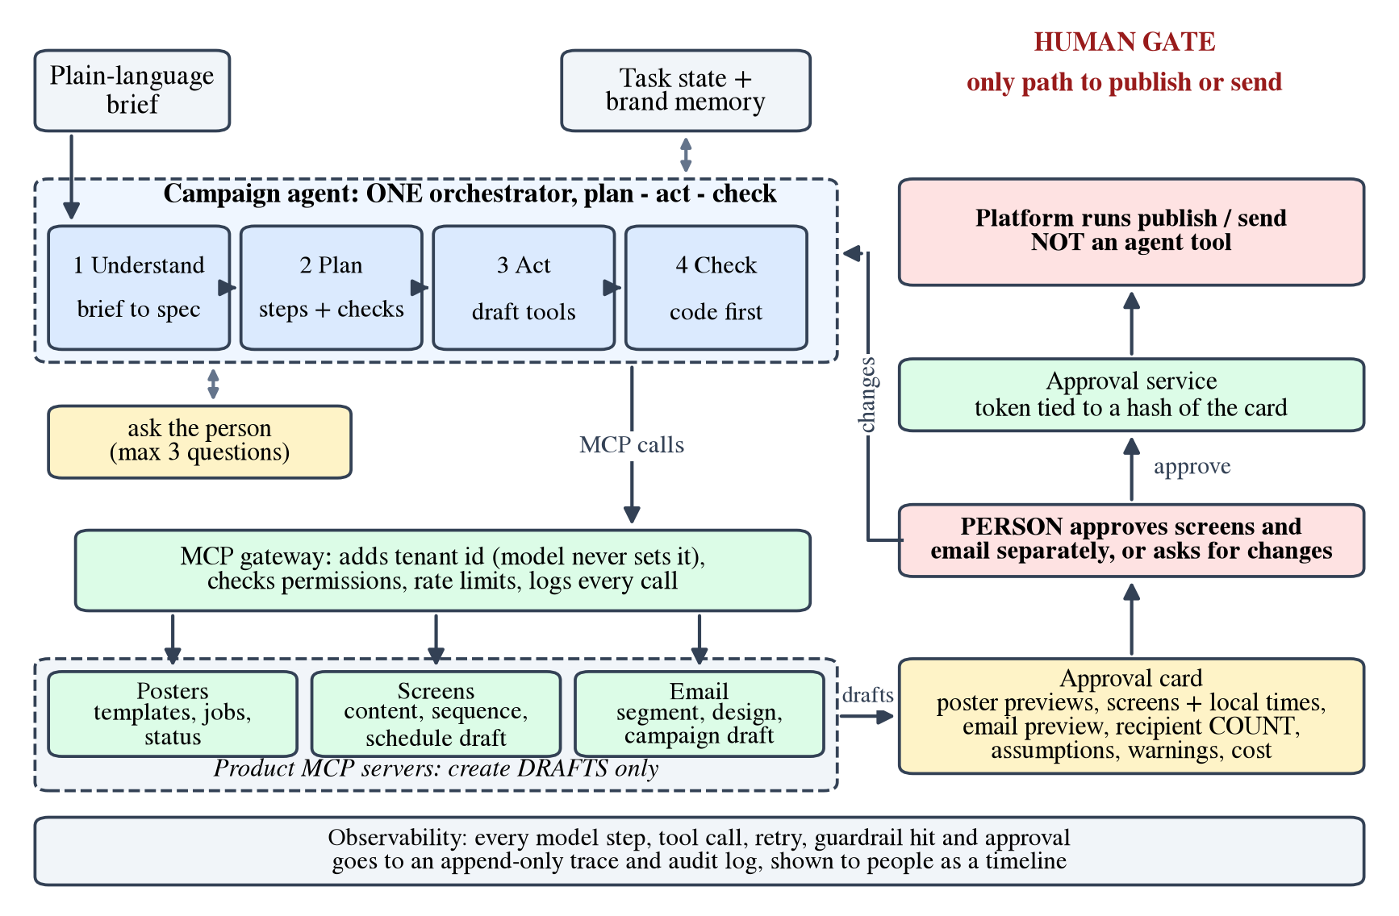
Figure 1. System architecture. The agent produces drafts only, and the human gate is the sole path to publication.

1. The Loop
A single orchestrator agent executes four stages in a loop.
- Understand. The brief is converted into a structured specification (objective, language, offer, assets, dates, screen groups, audience and send time), and missing or ambiguous items are listed.
- Plan. The agent writes ordered steps, each with an acceptance criterion, for example “three posters, status completed, Arabic headline matching the specification”.
- Act. Steps are executed with draft-only tools. Independent steps, such as poster generation and audience segmentation, run in parallel.
- Check. Deterministic validators run first: job completion, schedule days and hours in local time, a non-empty segment and a complete email. A model judges only what code cannot, such as brand fit. Failed checks return to Act within retry limits; when all pass, the agent assembles the approval card and stops.
A single agent is preferred because the steps are dependent (screens and email need the finished poster URLs), the context is small, and one trace is easier to audit than hand-offs between agents. Narrow helpers, such as an Arabic proofreader, are ordinary model calls. The execution harness, not the model, polls poster jobs and resumes the model when one completes, so waiting consumes no tokens.

2. Tools
Fourteen tools are defined. Only those relevant to the current phase are exposed to the model.
Tool | Key inputs
list_templates | category?, search?
create_poster_job | template_id?, product_image, background_image, prompt, image_count, resolution, idempotency_key
get_job_status, cancel_job | job_id
list_screen_groups | city?, location_type?
upload_screen_content | asset_url, name, duration_s
create_sequence | content_ids[], durations
create_schedule_draft | sequence_id, screen_group_ids[], days[], start, end, timezone
build_segment | rules (for example, “loyalty members”); returns an identifier and a count only
design_email | subject, preheader, body_blocks, image_urls, language, rtl
create_campaign_draft | email_id, segment_id, send_at, timezone
save_plan | steps[] and status updates
ask_user | questions[] (at most three, each with a default); pauses the task
request_approval | bundle_id; pauses the task
Exposure by phase: planning exposes four tools (save_plan, ask_user, list_templates and list_screen_groups); posters, six (the four poster tools, build_segment and save_plan); screens, five; email, four; and review, three. A smaller toolset improves tool selection and enforces least privilege. The publishing tools publish_schedule and send_campaign are intentionally excluded.

3. State and Memory
- Within a task. Each task has a record, keyed by task and tenant, in Postgres: the specification, the plan with step statuses, the artifacts (job, asset and draft identifiers and idempotency keys), approvals and an event log. The model receives a short summary and the latest tool results; images never enter the context. A failed task resumes from the record.
- Across tasks, per tenant only. A brand profile (names in Arabic and English, colours, logo, tone, dialect, default timezone and screens, and the loyalty segment identifier) and brief notes on what reviewers previously edited or rejected. Only approved outcomes are stored, customers may view and delete them, and only identifiers and counts are kept, never personal data. Nothing is shared between tenants.

4. Human Checkpoints
- Clarification. Where required, and before any cost is incurred, the agent asks at most three questions in a single message, each with a proposed default.
- Campaign review. A single review card is presented. Screens and email are approved separately, because an email cannot be recalled. The card shows: poster thumbnails; for screens, the group names and count, the sequence with durations, and the schedule in local time with dates (for example, Thursday 15 October to Saturday 17 October 2026, 10:00 to 16:00, Asia/Riyadh); for email, the subject, preheader, a right-to-left rendering, the segment name and recipient count (never addresses) and the send time (Thursday 15 October 2026, 09:00); the agent’s assumptions and warnings; the estimated cost; and a “send me a test” action executed by the platform.
- Actions. The reviewer can approve screens, approve email, request changes (free text, which re-enters the loop) or reject. An unusually large audience requires a second confirmation, and only users with publishing permission can approve.

5. Failure Handling
- Posters are ready but scheduling fails. Finished posters are stored as artifacts and never regenerated, because regeneration incurs cost. Transient errors are retried twice with the same idempotency key. If the failure persists (for example, screens offline or a slot conflict), the step is marked failed, independent work continues (such as the email draft), and the reviewer receives a partial result: what is complete, what failed and why, and the options (retry, alternative screens, next free slot). The agent never reports a campaign as scheduled unless a tool receipt confirms it.
- A tool times out. Every tool call has a deadline. Reads and idempotent creates are retried with backoff. If the outcome of a create call is unknown, the agent looks the object up by idempotency key before retrying. When the retry budget is exhausted, the step is marked blocked and the task is suspended, not terminated.
- The brief is ambiguous. The agent asks when a wrong assumption would be costly, difficult to reverse or unknowable: which audience applies when several segments could mean “loyalty customers”; which week and which screen groups are intended; offer details (prices and discounts are never invented); missing product or brand images; and contradictions such as a send time in the past. It decides the remaining items itself and records them as assumptions on the review card: timezone (Asia/Riyadh), number of variants (three at 1k), template, wording, sequence order and durations, dialect and subject line.

6. Cost and Speed
- Limits per task. 25 model steps, eight tool calls per step, approximately 150,000 tokens, tool results truncated to about 2,000 tokens, six poster jobs of at most four images each, two retries per step, and a 15-minute limit before suspension. When a limit is reached, the task is suspended with a report rather than looping.
- Model selection. A large model handles brief understanding, planning, creative-fit judgement and recovery from unexpected failures. A smaller, cheaper model handles argument formatting, copy variants, Arabic proofreading, approval-card summaries and JSON repair. No model is used for polling, retries, date arithmetic, validation or permission checks.
- Speed. Poster generation dominates elapsed time, so poster jobs and the segment build run in parallel, and the system prompt and tool schemas are cached. Because Arabic consumes more tokens than English, instructions are written in English and only user-facing copy is in Arabic.

7. Observability
Each task produces one trace in an append-only store; secrets are never logged and personal data is redacted. It records every model step (model, prompt version, tokens, latency, the plan step served and a one-line rationale given with each tool call), every tool call (redacted arguments, idempotency key, result summary, latency, retries), guardrail events (blocked tool, tenant mismatch, suspected injection) and approvals (who, when, token hash and a snapshot of the card reviewed). Users see a timeline with a reason beside each action, and any task can be replayed against mocked tools for evaluation. Alerts cover cross-tenant guard events, retry storms and tasks that exhaust their budget.

