Lab 10

Harshit Verma – 210905094

Sample)Configure the below topology to setup connectivity using RIPv2. R1, R2, and R3 will use dynamic routing protocol (RIPv2).

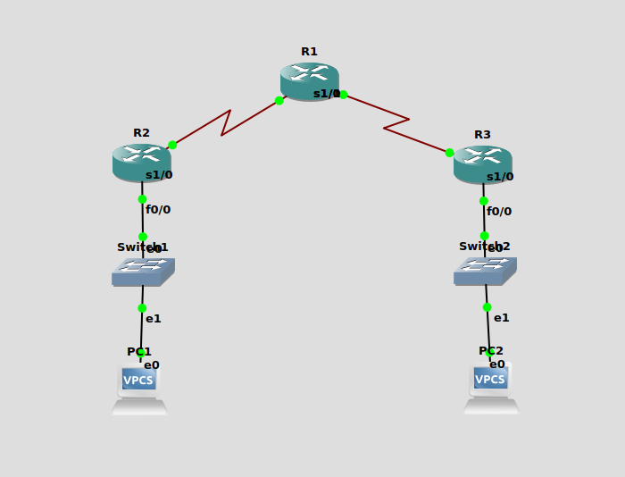

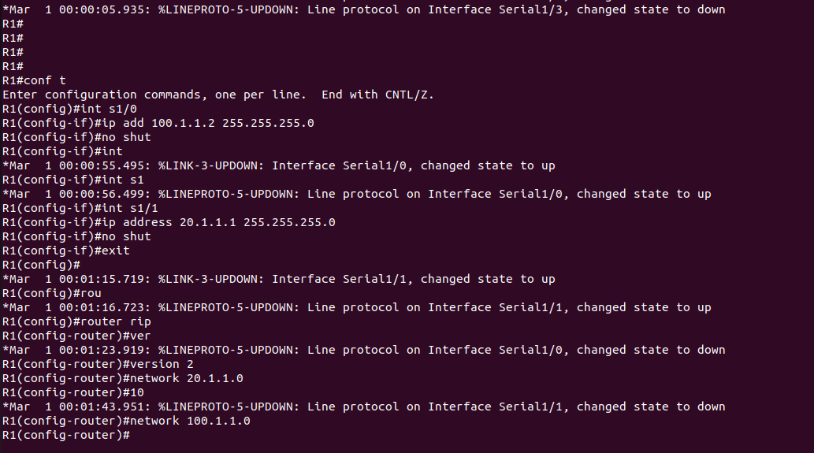
Configuration for R1->

Configuration of R2 ->

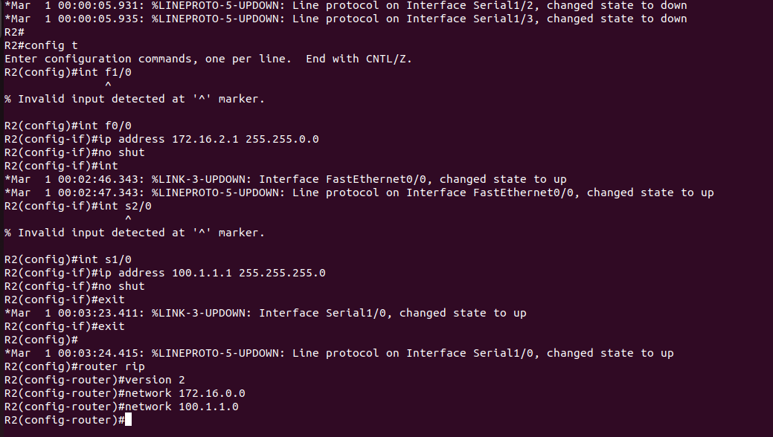

Configuration R3 ->
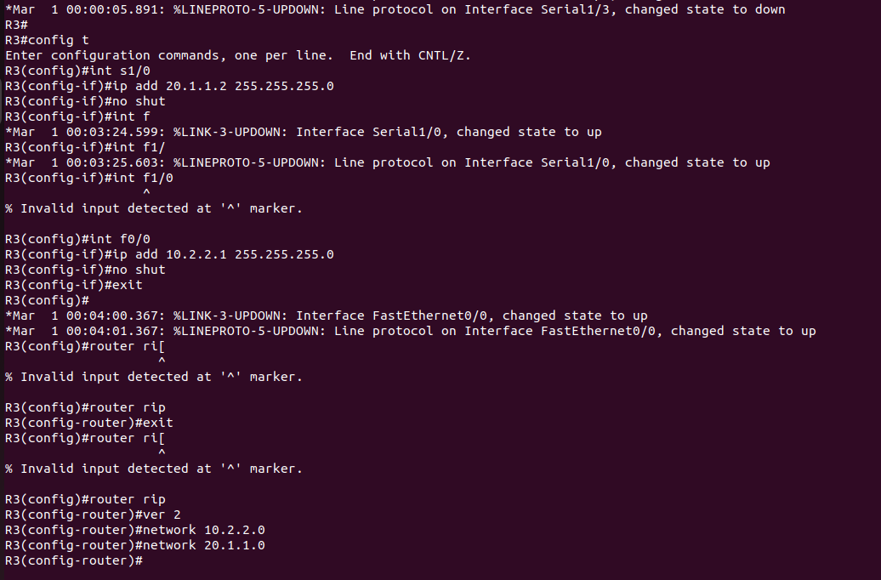

Q1.Configure the below topology to setup connectivity using RIPv2. R1, R2, and R3 will use dynamic routing protocol (OSPF).

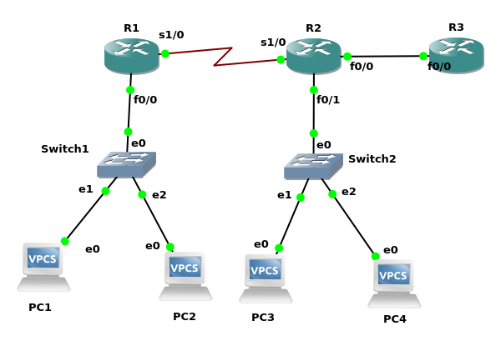

Configuration for R1->
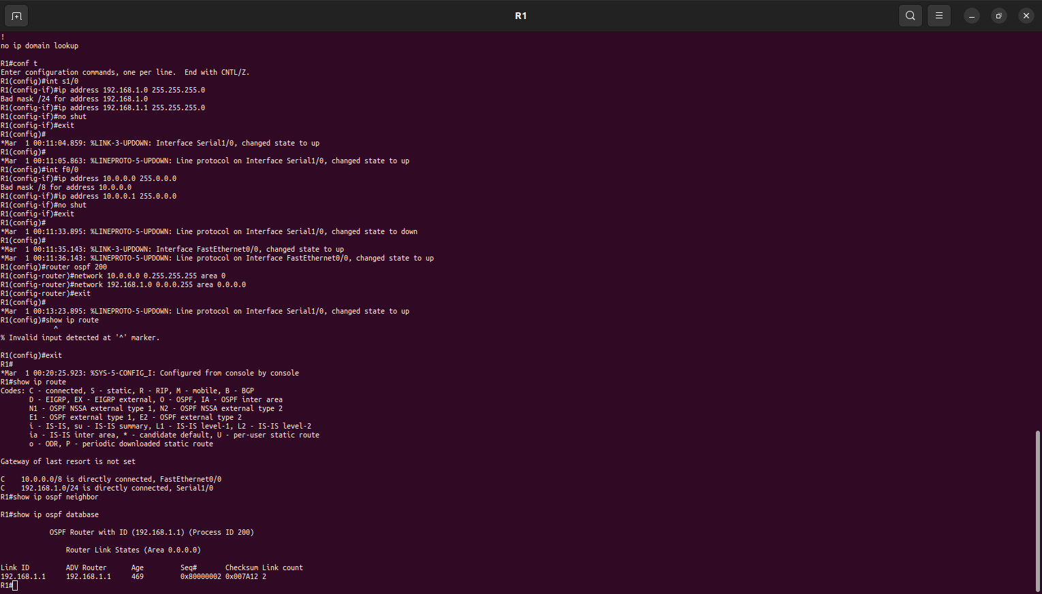
Configuration for R2->

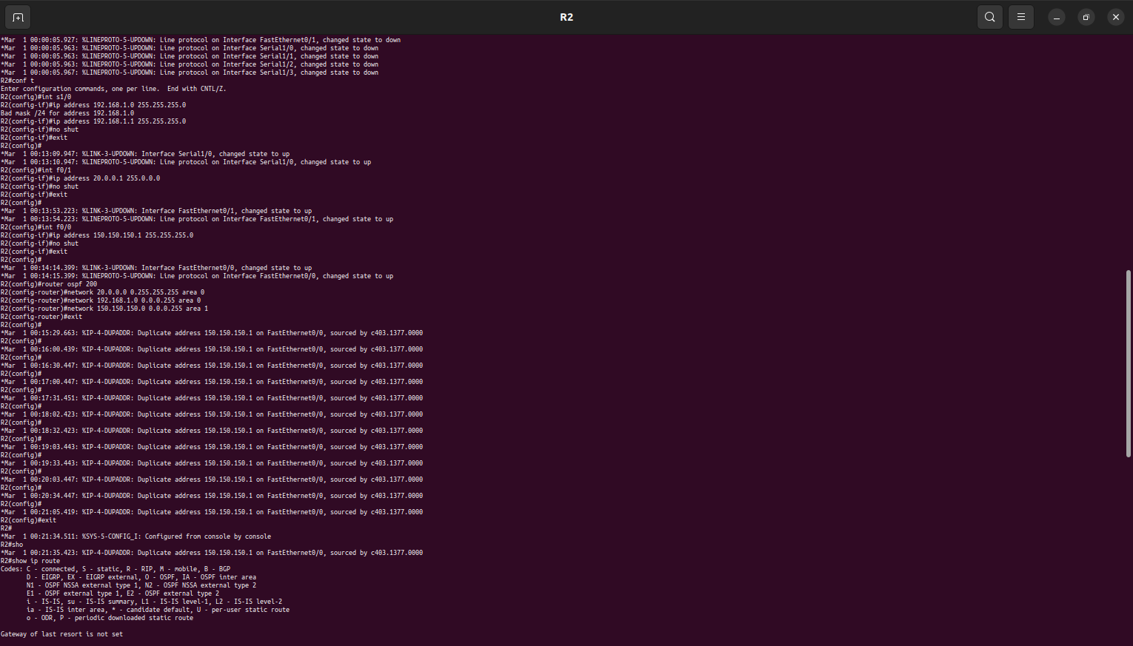
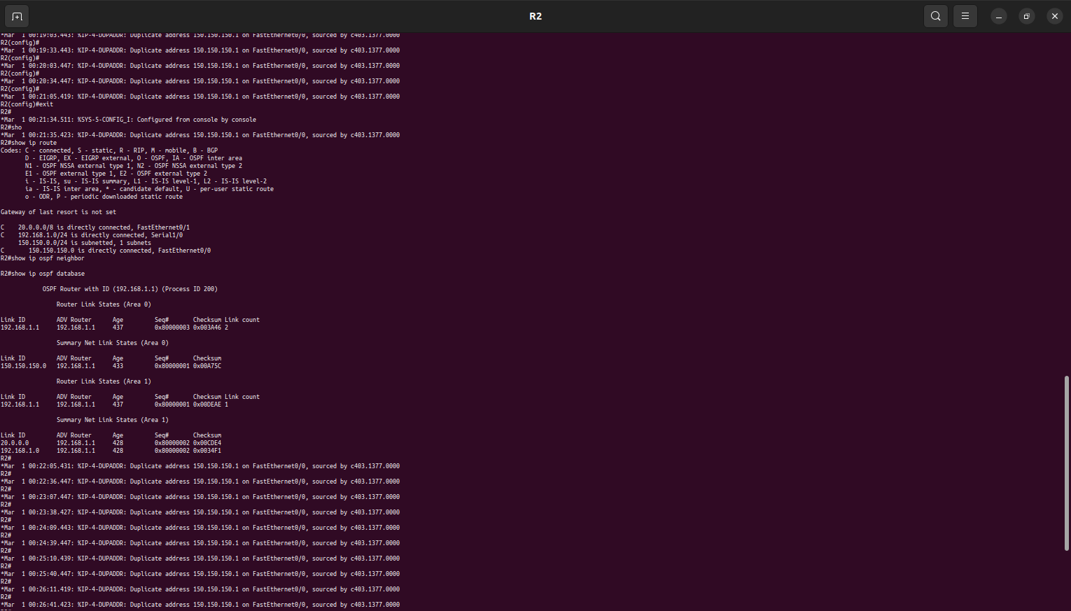

Configuration for R3->
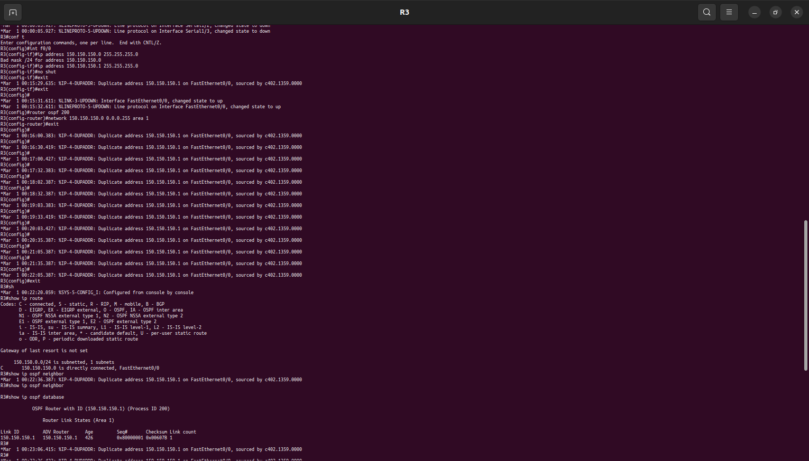

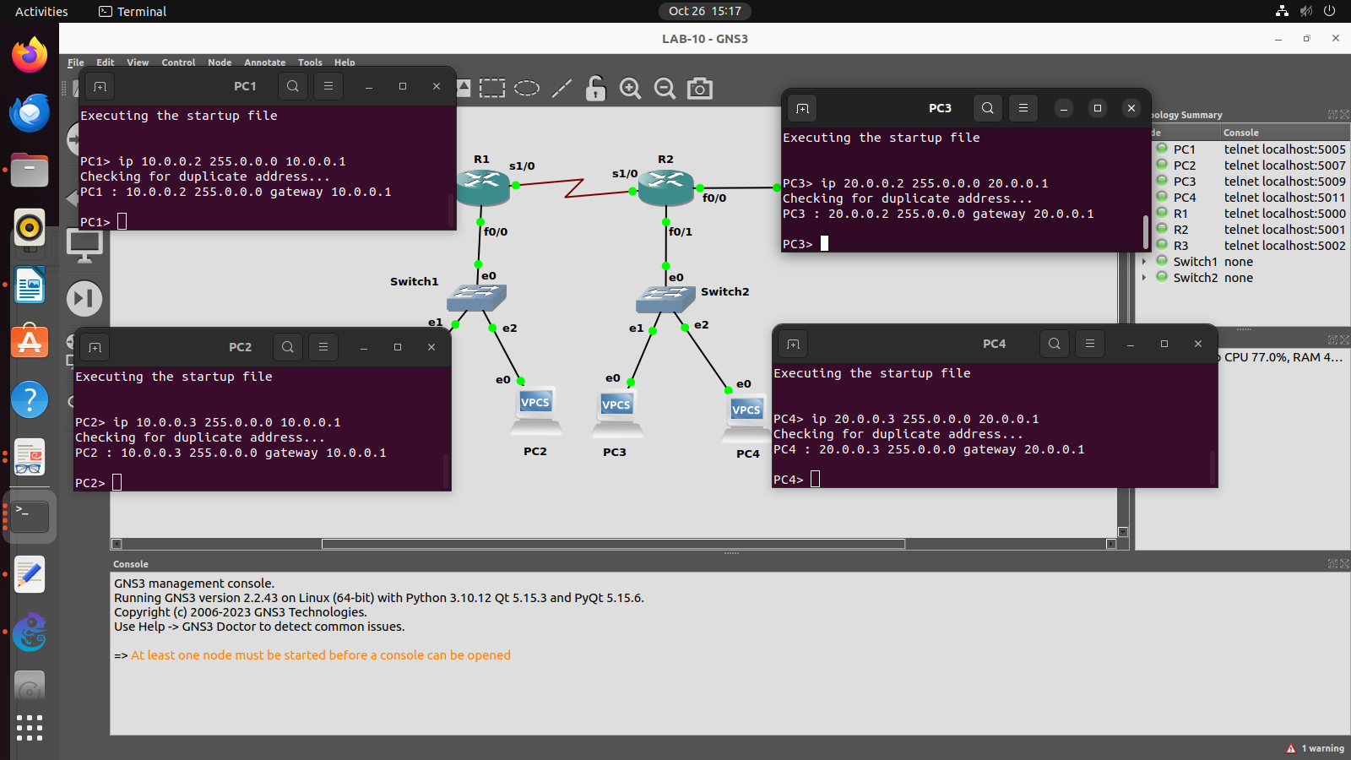
Q2.Configure the below network topology using RIP and OSPF as shown in Figure and check the connectivity by pinging from PC1 to PC2, PC3, PC4.
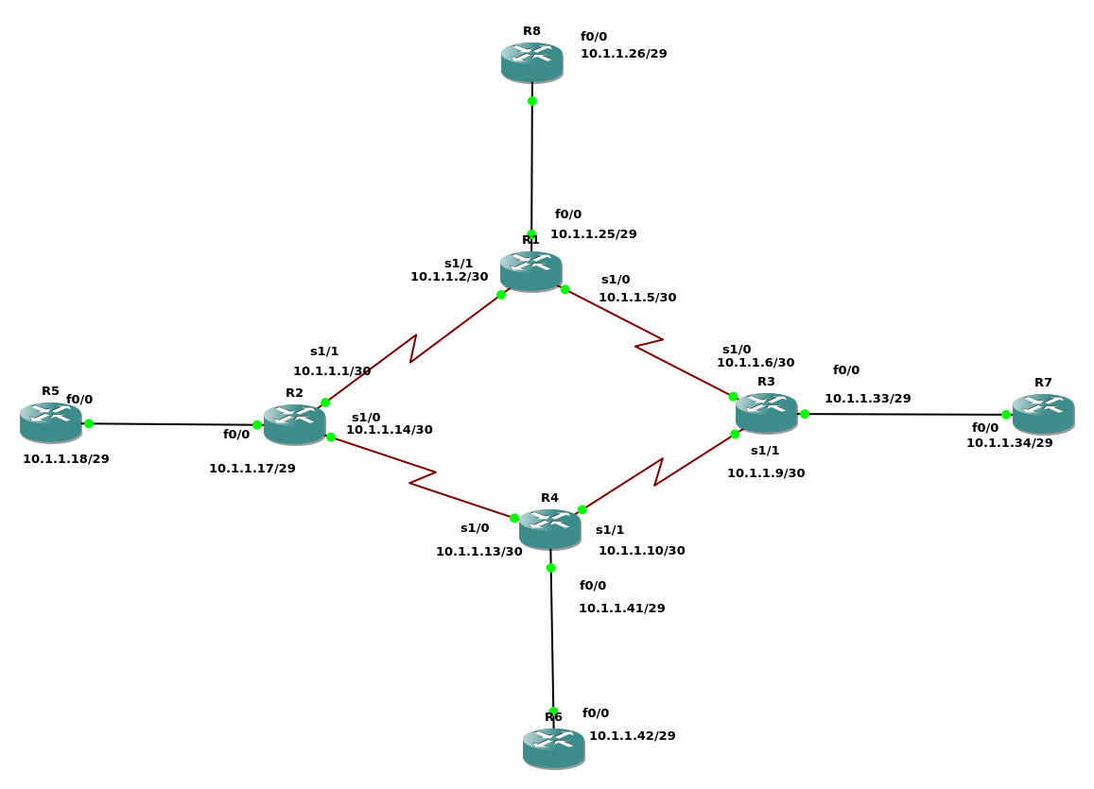
Configuring R1:

conf t

int s1/0
ip add 10.1.1.5 255.255.255.252
no shut
exit
int s1/1
ip add 10.1.1.2 255.255.255.252
no shut
exit
int f0/0
ip add 10.1.1.25 255.255.255.248
no shut
exit
router ospf 5000
network 10.1.1.0 0.0.0.3 area 0
network 10.1.1.4 0.0.0.3 area 0
exit
router rip
ver 2
network 10.1.1.24
exit

Configuring R2:

conf t
int s1/1
ip add 10.1.1.1 255.255.255.252
no shut
exit
int f0/0
ip add 10.1.1.17 255.255.255.248
no shut
exit
int s1/0
ip add 10.1.1.14 255.255.255.252
no shut
exit
router ospf 5000
network 10.1.1.0 0.0.0.3 area 0
network 10.1.1.12 0.0.0.3 area 0
exit
router rip
version 2
network 10.1.1.16
exit

Configuring R3:
conf t
int s1/0
ip add 10.1.1.6 255.255.255.252
no shut
exit
int s1/1
ip add 10.1.1.9 255.255.255.252
no shut
exit
int f0/0
ip add 10.1.1.33 255.255.255.248
no shut
exit
router ospf 5000
network 10.1.1.4 0.0.0.3 area 0
network 10.1.1.8 0.0.0.3 area 0
exit
router rip
ver 2
network 10.1.1.32
exit

Configuring R4:
conf t
int s1/0
ip add 10.1.1.13 255.255.255.252
no shut
exit
int f0/0
ip add 10.1.1.41 255.255.255.248
no shut
exit
int s1/1
ip add 10.1.1.10 255.255.255.252
no shut
exit
router ospf 5000
network 10.1.1.12 0.0.0.3 area 0
network 10.1.1.8 0.0.0.3 area 0
exit
router rip
ver 2
network 10.1.1.40
exit

Configuring R5:

conf t
int f0/0
ip add 10.1.1.18 255.255.255.248
no shut
exit
router rip
version 2
network 10.1.1.16
exit

Configuring R6:

conf t
int f0/0
ip add 10.1.1.42 255.255.255.248
no shut
exit
router rip
ver 2
network 10.1.1.40
exit

Configuring R7:

conf t
int f0/0
ip add 10.1.1.34 255.255.255.248
no shut
exit
router rip
ver 2
network 10.1.1.32
exit

Configuring R8:

conf t
int f0/0
ip add 10.1.1.26 255.255.255.248
no shut
exit
router rip
ver 2
network 10.1.1.24
exit

