CN Lab 5 – Harshit Verma 210905094

1. Network:
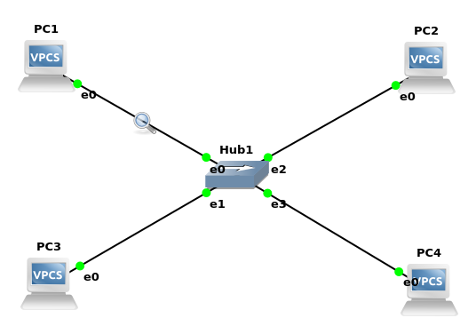
a. When we run show ARP without running any command, the terminal shows:
arp table is empty

However, after running a ping command, we get the following output:
00:50:79:66:68:01 10.0.1.12 expires in 114 seconds

b. Ping command is:
PC1> ping 10.0.1.12 -c 3

c. There are 2 ARP packets:

Request:
Sender MAC address: Private_66:68:00 (00:50:79:66:68:00)
Target MAC address: Broadcast (ff:ff:ff:ff:ff:ff)

Reply:
Sender MAC address: Private_66:68:01 (00:50:79:66:68:01)
Target MAC address: Private_66:68:00 (00:50:79:66:68:00)

Type field in packet headers: ARP (0x0806) and IPv4 (0x0800)

Q: Use the captured data to analyze the process in which ARP acquires the MAC address for IP
address 10.0.1.12.
A: A request is broadcasted from the sender, where the destination is currently ff:ff:ff:ff:ff:ff
A reply is recieved for this request, and on analyzing the packet, it is seen that the sender address is different from ff:ff:ff:ff:ff:ff. Hence, the IP address is found

2. Having two computers on the same network with the same IP address is not allowed.
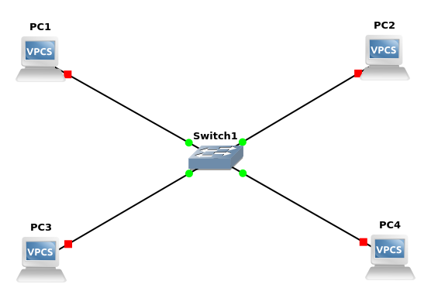
3. a.

b. Commands for capturing:
i) PC1> ping 10.0.1.120 -c 3

84 bytes from 10.0.1.120 icmp_seq=1 ttl=64 time=0.733 ms
84 bytes from 10.0.1.120 icmp_seq=2 ttl=64 time=0.878 ms
84 bytes from 10.0.1.120 icmp_seq=3 ttl=64 time=1.017 ms

It can be seen that the pings are successful

ii) PC1> ping 10.0.1.101 -c 3
84 bytes from 10.0.1.101 icmp_seq=1 ttl=64 time=0.978 ms
84 bytes from 10.0.1.101 icmp_seq=2 ttl=64 time=1.080 ms
84 bytes from 10.0.1.101 icmp_seq=3 ttl=64 time=1.092 ms

It can be seen that the pings are successful

iii) PC1> ping 10.0.1.121 -c 3

10.0.1.121 icmp_seq=1 timeout
10.0.1.121 icmp_seq=2 timeout
10.0.1.121 icmp_seq=3 timeout

It can be seen that the pings resulted in a timeout. We can see through wireshark that the ping request is sent successfully from PC1. A reply to the request is seen, but actually this reply should not occur. We can see ARP requests by PC4 to try to find the default gateway (instead of trying to find PC1). This is because 10.0.1.100/24 (PC1) is not considered to be on the same subnet by 10.0.1.121/28 (PC4). (For PC4, the valid IP range on its subnet is 10.0.1.112 to 10.0.1.127 (last 4 bits)). Hence, PC4 tries to look for the default gateway (10.0.1.122), but since it has not been configured, it cannot find it, and results in ping timeout.
iv) PC4> ping 10.0.1.100 -c 3

host (255.255.255.240) not reachable

It can be seen that there is an error: host (10.0.1.122) not reachable We can see ARP requests by PC4 to try to find the default gateway (instead of trying to find PC1). This is because 10.0.1.100/24 (PC1) is not considered to be on the same subnet by 10.0.1.121/28 (PC4). (For PC4, the valid IP range on its subnet is 10.0.1.112 to 10.0.1.127 (last 4 bits)). Hence, PC4 tries to look for the default gateway (10.0.1.122), but since it has not been configured, it cannot find it.

v) PC2> ping 10.0.1.121 -c 3

host (255.255.255.240) not reachable

It can be seen that there is an error: host (10.0.1.102) not reachable We can see ARP requests by PC2 to try to find the default gateway (instead of trying to find PC4). This is because 10.0.1.121/28 (PC4) is not considered to be on the same subnet by 10.0.1.101/28 (PC2). (For PC2, the valid IP range on its subnet is 10.0.1.96 to 10.0.1.111 (last 4 bits)). Hence, PC2 tries to look for the default gateway (10.0.1.102), but since it has not been configured, it cannot find it.

vi) PC2> ping 10.0.1.120 -c 3

host (255.255.255.240) not reachable

It can be seen that there is an error: host (10.0.1.102) not reachable We can see ARP requests by PC2 to try to find the default gateway (instead of trying to find PC3). This is because 10.0.1.120/24 (PC3) is not considered to be on the same subnet by 10.0.1.101/28 (PC2). (For PC2, the valid IP range on its subnet is 10.0.1.96 to 10.0.1.111 (last 4 bits)). Hence, PC2 tries to look for the default gateway (10.0.1.102), but since it has not been configured, it cannot find it.

