Summer Solstice: When the Sun Stands Still and the Soul Steps Forward
You must have studied about Solstices in your Geography classes. The Summer Solstice is one of the most significant turning points in Earth's annual journey around the Sun. Occurring around June 20–21 in the Northern Hemisphere, it marks the longest day and shortest night of the year. On this day, the Earth's North Pole is tilted closest to the Sun, allowing sunlight to reach its maximum duration. Yes, yes, yes… remember?
And our cultures reveal that ancient civilizations worldwide recognized this celestial event as sacred. From the stone alignments of Stonehenge to seasonal festivals celebrating abundance, fertility, and harvest, the Summer Solstice has long symbolized the peak expression of life force energy.
In the physical world, the Solstice represents fullness. Nature is vibrant, crops are growing, flowers are blooming, and daylight stretches generously across the horizon. It is a reminder that every seed planted in the darkness of winter eventually reaches a moment of visible growth.
Energetically, the Solstice acts like a spotlight from Cosmos. Whatever has been growing within us…our intentions, ambitions, habits, and desires, becomes easier to see. The heightened solar energy encourages vitality, confidence, creativity, and conscious action.
If you like to use Tarot and Oracle cards to check your inner alignment and connect with your purpose, your power, and your path, feel free to use the spread below.
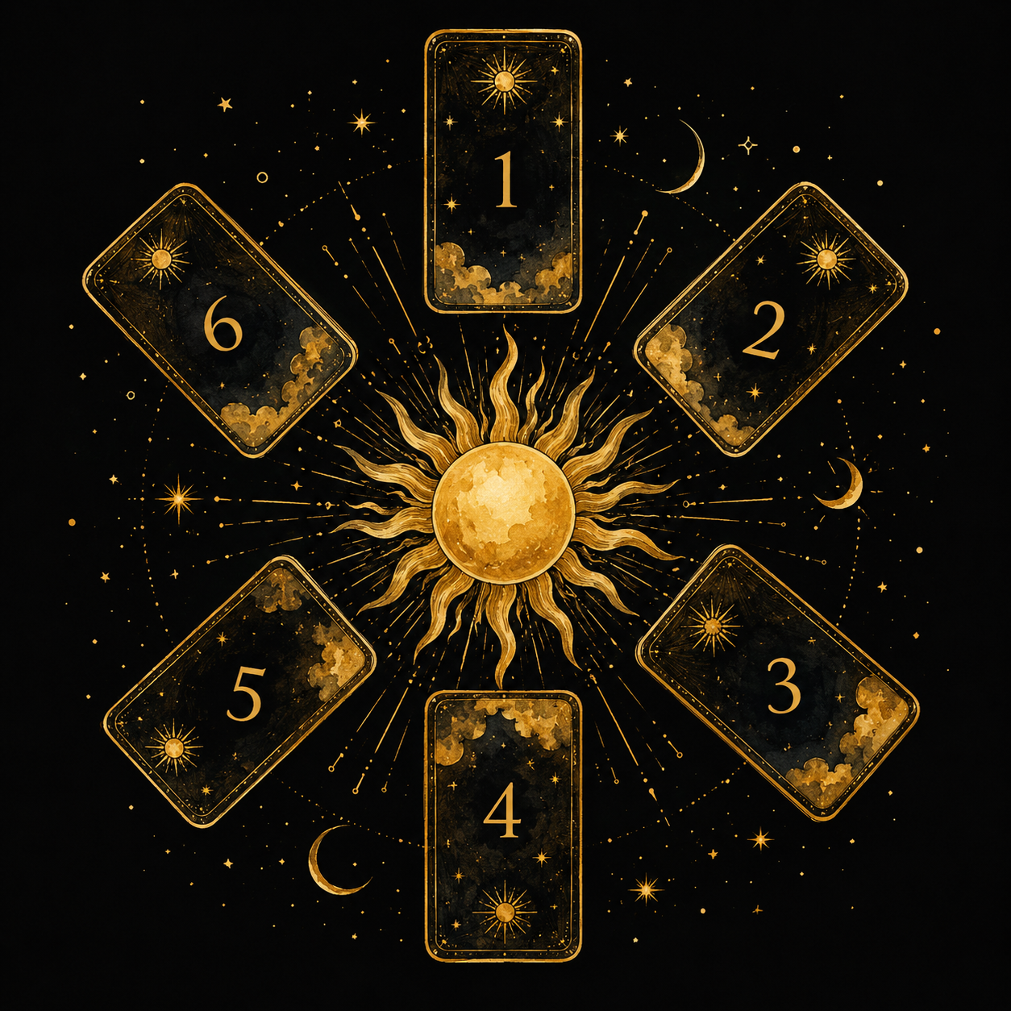
- What new chapter is beginning to unfold in my life?
- What needs my attention to reach the finish line?
- Where am I receiving growth and positive change?
- What can I be grateful for right now?
- What makes me feel most alive and fulfilled?
- How can I show up more authentically and make a positive impact on the world around me?
Do try the spread and let us know your insights. In case you wish to book a Summer Solstice Tarot Reading with Kriti, send a message on https://www.instagram.com/kosmictrinity

