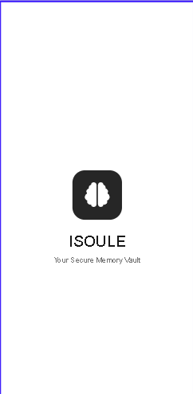
1. This is my first screen. It means this is my splash screen. With logo, title and description.
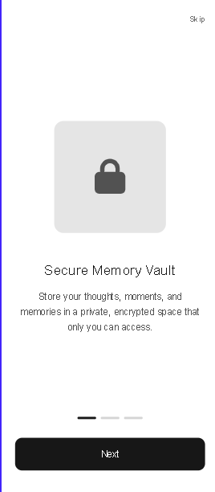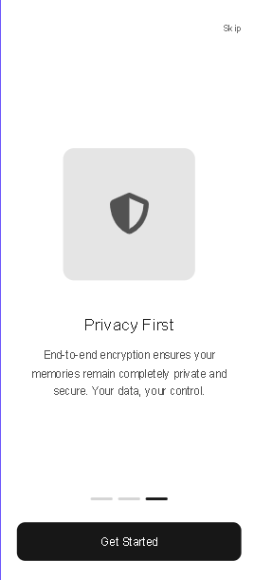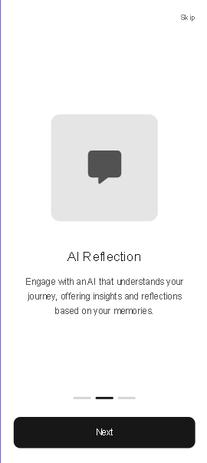

2. this three screen is my onboarding screen. Secure memory vault, privacy first, Al reflection screens.
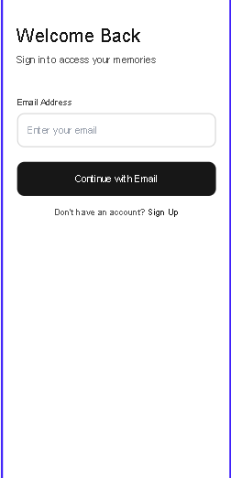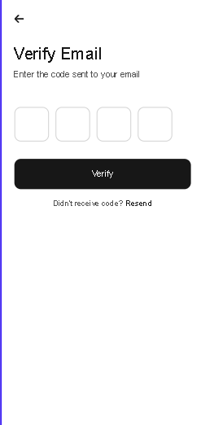
3. This is my auth screens. User able to signin with email with otp.
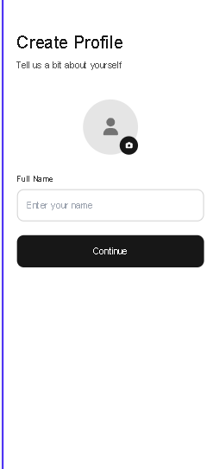
4. This is create a profile screen.
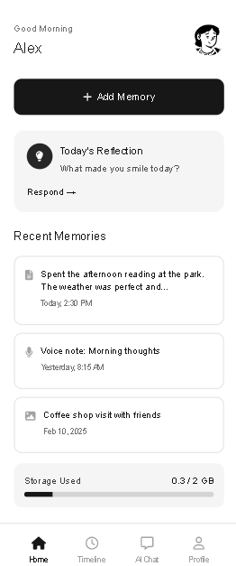
5. This is my dashboard . and this is home screen. In this screen user able to add the memory using add memory button in top of the center. And also AI ask the some questions for user like What made you smile today?. And and this is Today’s Reflection section.
and also in home screen show the user added recent memories. In recent memories I show the weekly or today and last two days memories. And also show the storage used percentage and status.
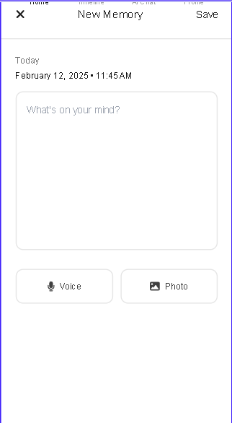
6. This is my add new memories page. In this page user add the text, voice, and photos. if you look any changes like not give functionality to add the image, voice for user. Only give text. So, tell me you thought also.
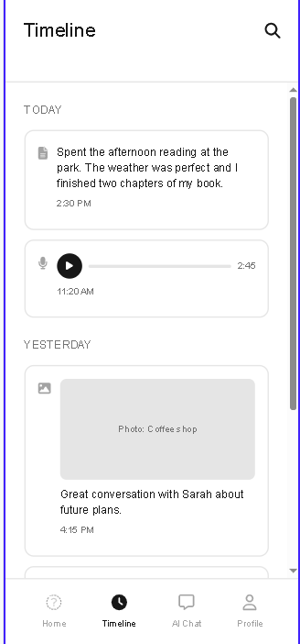

7. this is timeline screen. I think this screen is show me a memories in chat overview screen. 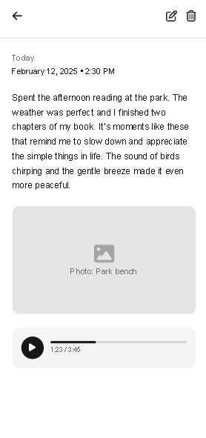
8. This is edit and delete memories screen. In this screen user edit and delete memories.
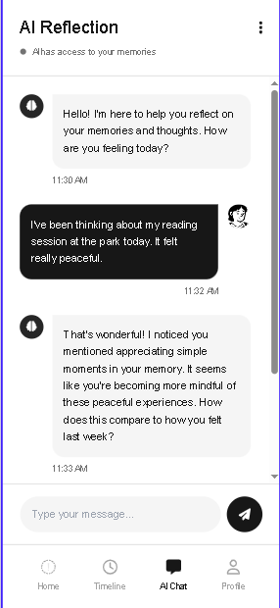
9. This is Ai reflection screen. This is ai chat screen in this screen user able to chat with ai agent.
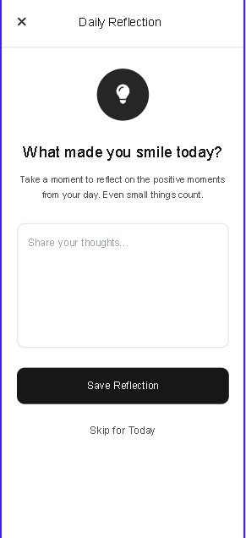
10. this is daily reflection screen. In press on today’s reflection in home screen. Open this screen in this screen user share our thoughts and able to save and skip.
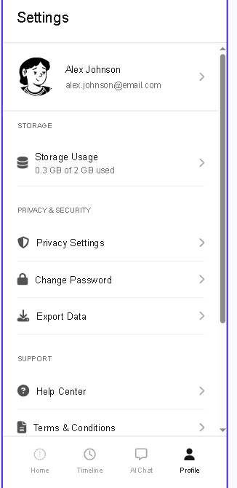
11. this is profile screen. In this screen show the user details, storage details and etc.
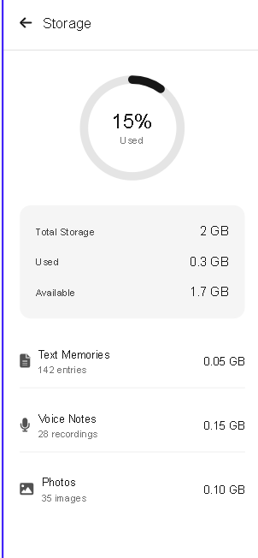
12. on press storage usage open this screen. In this screen show the in detail storage usage
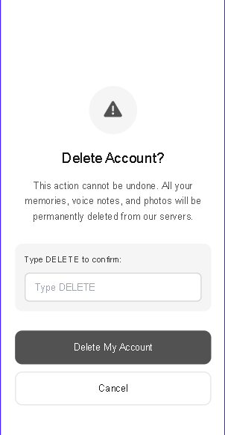

13. this is my delete account screen.

