RMarkdown Challenge

Melissa Polonenko

Monday, November 23, 2015

# Brief Description

In the state.x77 dataset there are:

* 50 rows, each row specifying a US state
* 8 variables, which include: Population, Income, Illiteracy, Life Exp, Murder, HS Grad, Frost, Area

The population across these 50 states averages 4246 +/- 4464 (SD).

# Plots

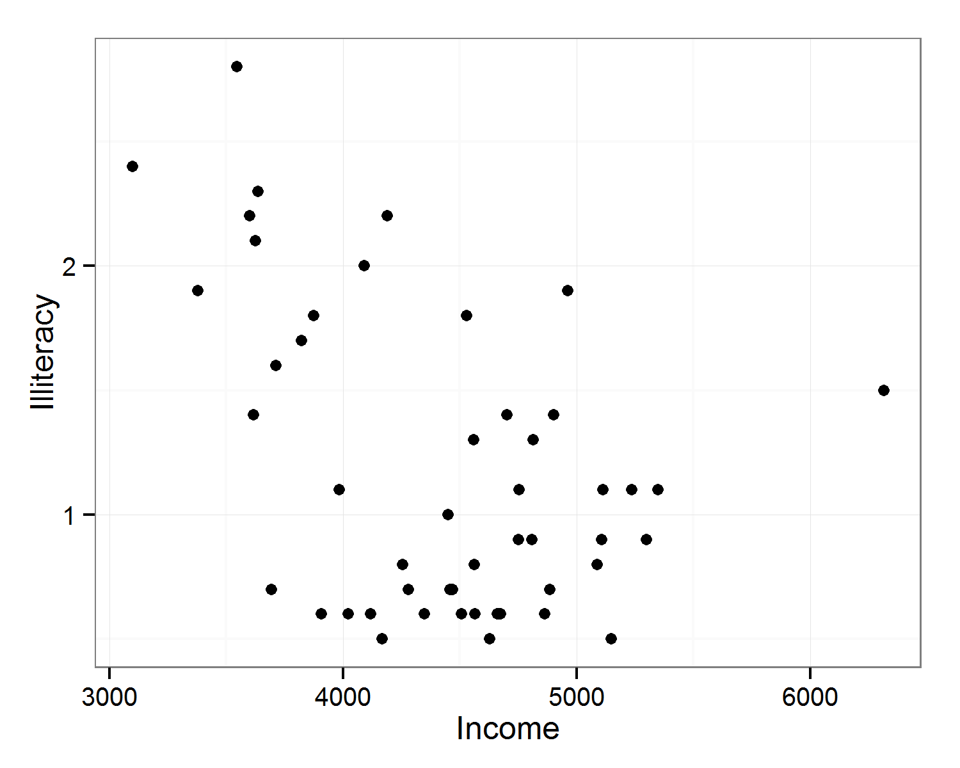

Figure 1: Illiteracy by Income for each of the US states

# Tables

|  |  |  |
| --- | --- | --- |
| Measure | Means | SD |
| Population | 4246 | 4464 |
| Income | 4436 | 614.5 |
| Illiteracy | 1.2 | 0.6 |
| Life Exp | 70.9 | 1.3 |
| Murder | 7.4 | 3.7 |
| HS Grad | 53.1 | 8.1 |
| Frost | 104.5 | 52 |
| Area | 70736 | 85327 |

Table 1: Summary of Statistics for the USA