Challenge

Viji

November 23, 2015

## num [1:50, 1:8] 3615 365 2212 2110 21198 ...  
## - attr(*, "dimnames")=List of 2  
## ..$ : chr [1:50] "Alabama" "Alaska" "Arizona" "Arkansas" ...  
## ..$ : chr [1:8] "Population" "Income" "Illiteracy" "Life Exp" ...

## [1] "rowname" "Population" "Income" "Illiteracy" "Life Exp"   
## [6] "Murder" "HS Grad" "Frost" "Area"

# Brief Description

The dataset consists of demographic information from 50 states for the following 8 variables: Population, Income, Illiteracy, Life Exp, Murder, HS Grad, Frost, Area. The mean population across all states is 4246.42 and the standard deviation is 4464.49

# Plots

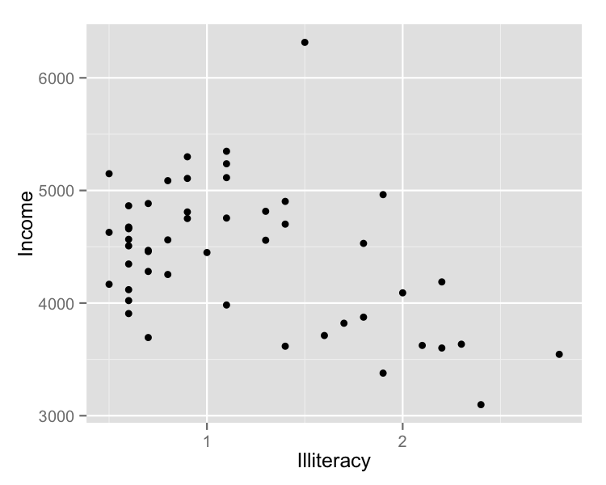

# Tables

##   
## ------------------------  
## Variable Means SD   
## ---------- ------- -----  
## Population 4246 4464   
##   
## Income 4436 614.5  
##   
## Illiteracy 1.17 0.61   
##   
## Life Exp 70.88 1.34   
##   
## Murder 7.38 3.69   
##   
## HS Grad 53.11 8.08   
##   
## Frost 104.5 51.98  
##   
## Area 70736 85327  
## ------------------------  
##   
## Table: Table 1: Demographic data of 50 states