Practice

Viji

November 23, 2015

#in the YAML, add the following  
#bibliography: give the location of the bib file  
#for a particular style  
#csl: give the location of the bib file citation style language. can be found in github

This is an R Markdown document. Markdown is a simple formatting syntax for authoring HTML, PDF, and MS Word documents. For more details on using R Markdown see <http://rmarkdown.rstudio.com>.

When you click the **Knit** button a document will be generated that includes both content as well as the output of any embedded R code chunks within the document. You can embed an R code chunk like this:

# Intro

## Citing a study

#how to enter here from papers. need to export the bib key  
#@some bibkey  
#[] will make the round bracketts around the citation.

#* makes the text in italics  
#** on either side will bold words  
#``` is a code block  
  
#` having things in line  
# > indicates that it is goin to be quote   
# @ with bib key will extract refs  
  
#YAML header is for R to know what to do. YAML has o be closed in ---  
  
#pander, kable creates tables  
#ggplot qplot creates figure  
  
#conrol+shift+K will knit html

|  |  |  |
| --- | --- | --- |
|  | speed | dist |
|  | Min. : 4.0 | Min. : 2.00 |
|  | 1st Qu.:12.0 | 1st Qu.: 26.00 |
|  | Median :15.0 | Median : 36.00 |
|  | Mean :15.4 | Mean : 42.98 |
|  | 3rd Qu.:19.0 | 3rd Qu.: 56.00 |
|  | Max. :25.0 | Max. :120.00 |

|  |  |  |  |  |
| --- | --- | --- | --- | --- |
|  | Estimate | Std. Error | t value | Pr(>|t|) |
| **dist** | 0.1656 | 0.01749 | 9.464 | 1.49e-12 |
| **(Intercept)** | 8.284 | 0.8744 | 9.474 | 1.441e-12 |

Table 1: This is the caption for table 1

REference to **Table 1**.

You can also embed plots, for example:

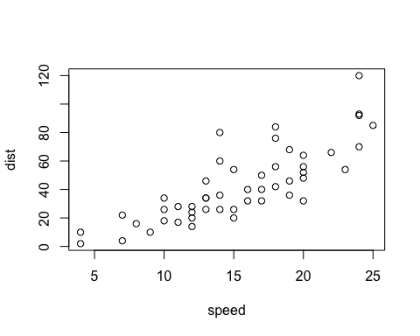

Figure 1: This is a caption for the figure

# Tables

##   
## Attaching package: 'dplyr'  
##   
## The following object is masked from 'package:stats':  
##   
## filter  
##   
## The following objects are masked from 'package:base':  
##   
## intersect, setdiff, setequal, union

|  |  |
| --- | --- |
| Measure | means |
| speed | 15.4 |
| dist | 42.98 |

# Figures

## Scatterplot

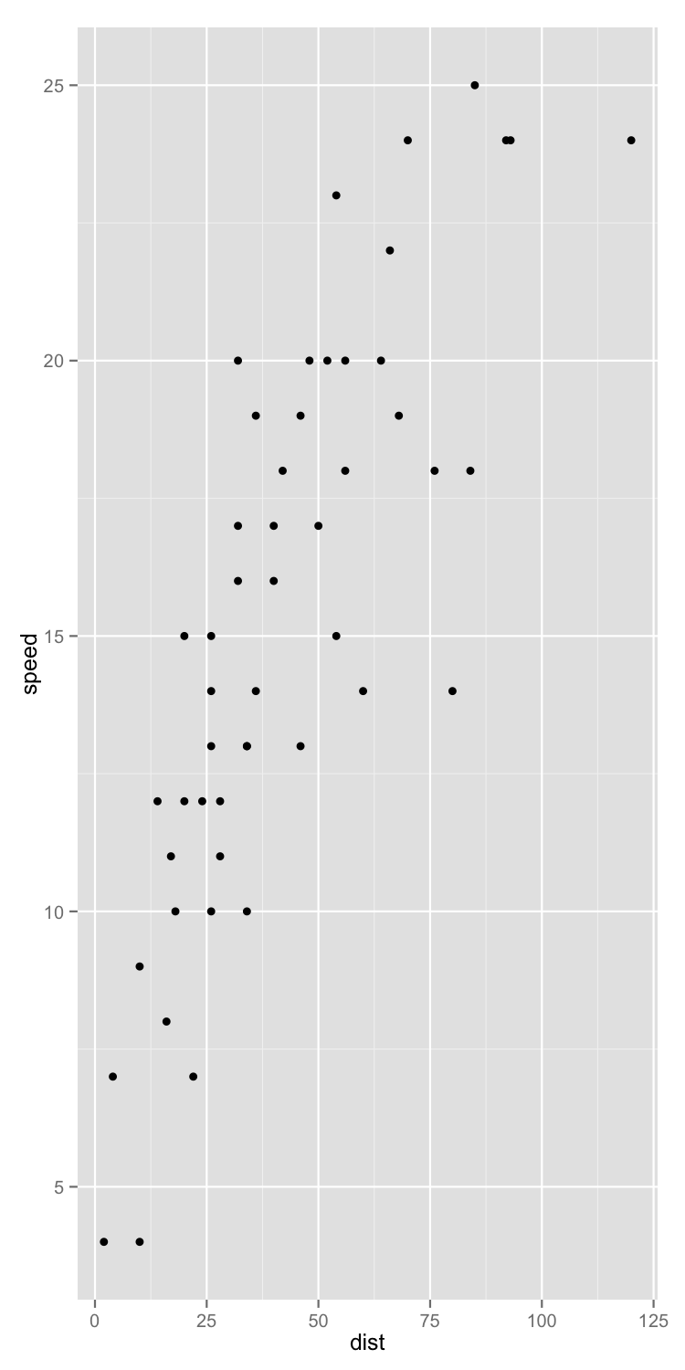

This is a list

* There is 2 rows in cars
* There are 2 variables in cars

you would add ` ` around the cars to differentiate it from regular text

This is a quote:

to be or not to be

# References