# Amir Ayoub

# aa2078

So, I changed the start position to 16 19 0

And, the destination position is still 92 16 0

And in problem.txt file you can change line 4 [0, 1, 2, 3, 4] for 5 algorithms

# Commands :

python3 solution.py and it will run for 50 operations using one algorithm

# Algorithm 0

This algorithm is implemented, and was run on 50 environments

On this algorithm the breath first search was implemented.

* It’s completed because it was able to reach the goal on the given 50 environments where the agent was not enclosed in a space where there is no possible way to reach the goal
* This algorithm is optimal because it was able to reach to the solution in a small amount of time, and it doesn’t check a node more than once, this algorithm also check the first node that was inserted which makes it not wasting the cost of going first up to the end of specific node

Below are the 50 environments that the agent was tested on, some selected graph output of the maze and the path or the agent are also shown below the 50-environment output

The failed environments are the environment where the agent is either enclosed in a space where the agent can’t find a way out

maze_ 000 : {'Length': 97, 'Cost': 118, 'Time': 1.7430393695831299}

maze_ 001 : {'Length': 139, 'Cost': 198, 'Time': 0.8040006160736084}

maze_ 002 : Failed

maze_ 003 : {'Length': 123, 'Cost': 168, 'Time': 1.452023983001709}

maze_ 004 : {'Length': 149, 'Cost': 214, 'Time': 0.3240022659301758}

maze_ 005 : {'Length': 97, 'Cost': 120, 'Time': 2.389998435974121}

maze_ 006 : Failed

maze_ 007 : Failed

maze_ 008 : Failed

maze_ 009 : {'Length': 145, 'Cost': 210, 'Time': 0.9020211696624756}

maze_ 010 : Failed

maze_ 011 : {'Length': 97, 'Cost': 120, 'Time': 2.401028871536255}

maze_ 012 : {'Length': 101, 'Cost': 128, 'Time': 2.1320338249206543}

maze_ 013 : {'Length': 107, 'Cost': 140, 'Time': 2.8040106296539307}

maze_ 014 : {'Length': 107, 'Cost': 140, 'Time': 3.005993366241455}

maze_ 015 : Failed

maze_ 016 : {'Length': 101, 'Cost': 126, 'Time': 2.6010019779205322}

maze_ 017 : {'Length': 97, 'Cost': 120, 'Time': 3.3759984970092773}

maze_ 018 : Failed

maze_ 019 : Failed

maze_ 020 : {'Length': 101, 'Cost': 128, 'Time': 3.024991035461426}

maze_ 021 : {'Length': 101, 'Cost': 128, 'Time': 3.143019676208496}

maze_ 022 : {'Length': 175, 'Cost': 266, 'Time': 2.421992540359497}

maze_ 023 : {'Length': 107, 'Cost': 140, 'Time': 2.7220001220703125}

maze_ 024 : {'Length': 95, 'Cost': 116, 'Time': 1.8779914379119873}

maze_ 025 : Failed

maze_ 026 : Failed

maze_ 027 : Failed

maze_ 028 : Failed

maze_ 029 : Failed

maze_ 030 : {'Length': 119, 'Cost': 164, 'Time': 0.9949958324432373}

maze_ 031 : {'Length': 95, 'Cost': 116, 'Time': 1.9969561100006104}

maze_ 032 : Failed

maze_ 033 : {'Length': 157, 'Cost': 232, 'Time': 1.823991298675537}

maze_ 034 : {'Length': 109, 'Cost': 144, 'Time': 2.2219953536987305}

maze_ 035 : Failed

maze_ 036 : {'Length': 117, 'Cost': 156, 'Time': 3.014993667602539}

maze_ 037 : {'Length': 97, 'Cost': 120, 'Time': 2.122999429702759}

maze_ 038 : Failed

maze_ 039 : Failed

maze_ 040 : {'Length': 221, 'Cost': 338, 'Time': 3.4569966793060303}

maze_ 041 : {'Length': 169, 'Cost': 250, 'Time': 2.7849960327148438}

maze_ 042 : Failed

maze_ 043 : Failed

maze_ 044 : {'Length': 103, 'Cost': 130, 'Time': 2.943065881729126}

maze_ 045 : {'Length': 95, 'Cost': 116, 'Time': 2.084998846054077}

maze_ 046 : {'Length': 95, 'Cost': 116, 'Time': 2.264021635055542}

maze_ 047 : Failed

maze_ 048 : Failed

maze_ 049 : Failed

maze_ 050 : Failed

maze_ 051 : {'Length': 97, 'Cost': 120, 'Time': 1.8375208377838135}

Sample output for maze 000

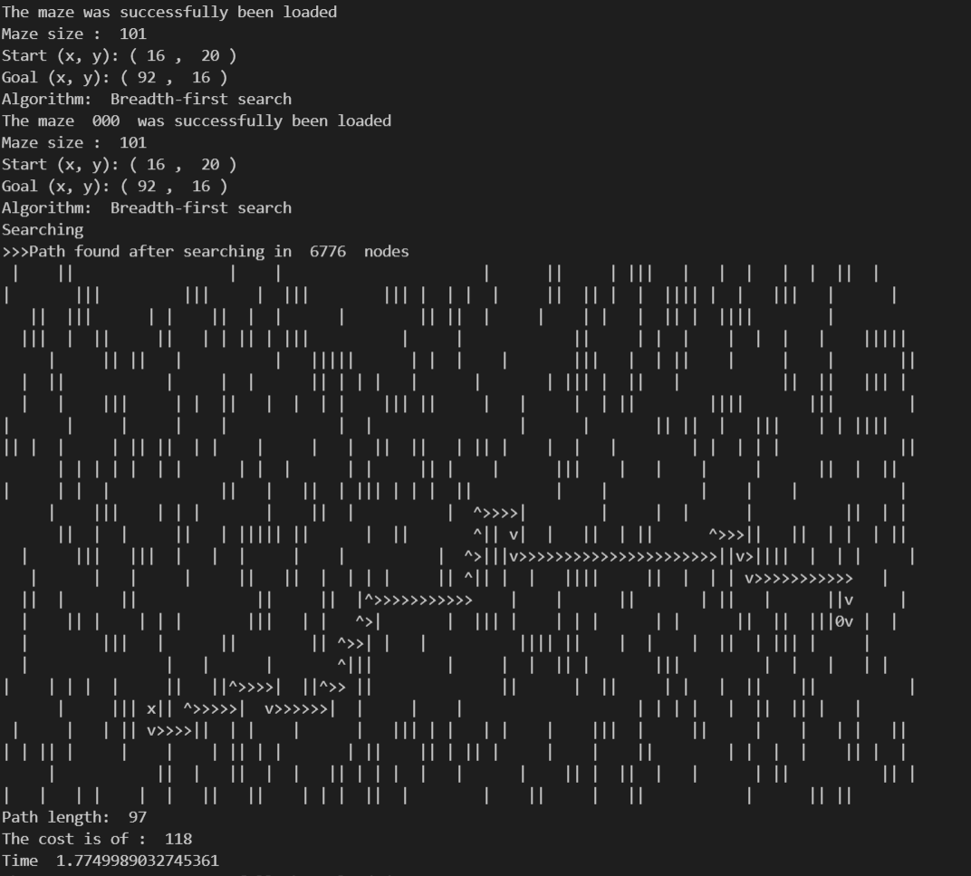

Sample output for maze 45

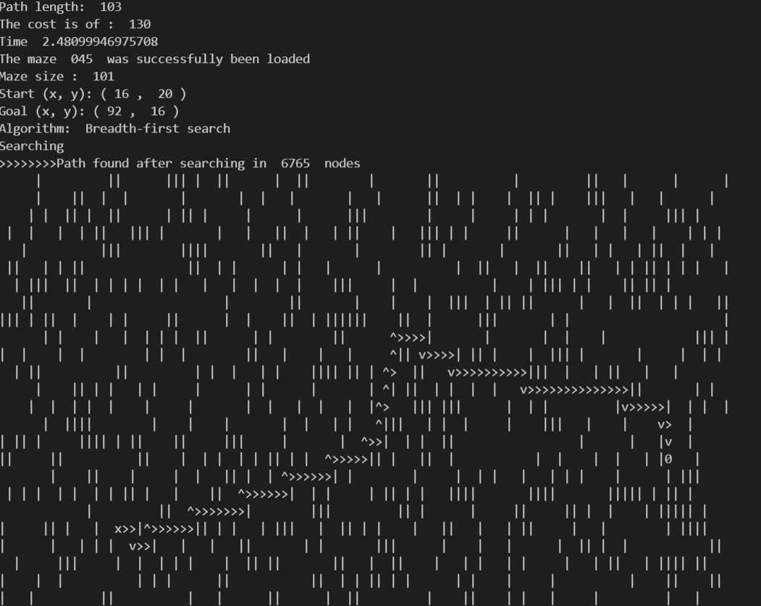

Sample output for maze 33

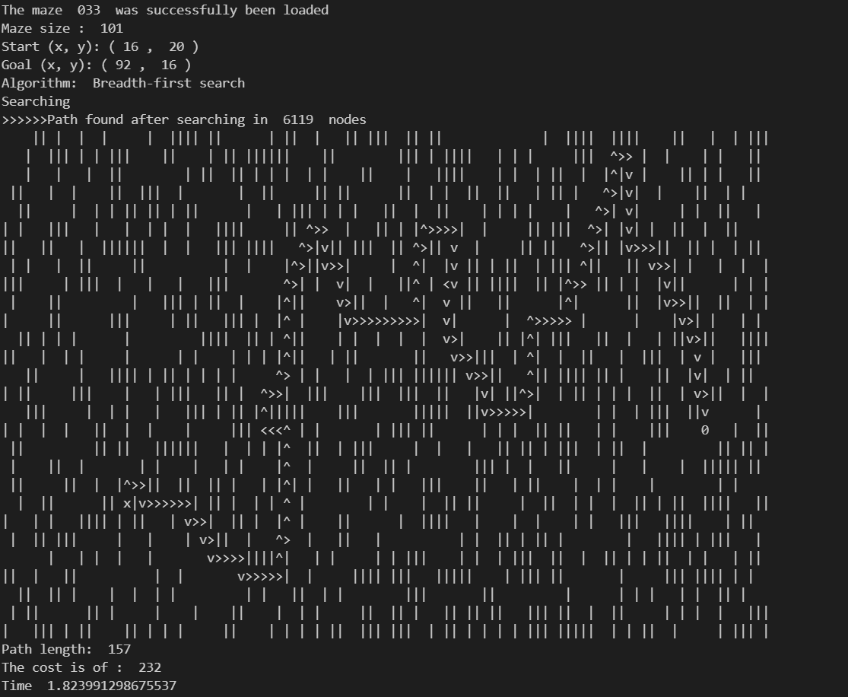

Plot for the time Usage

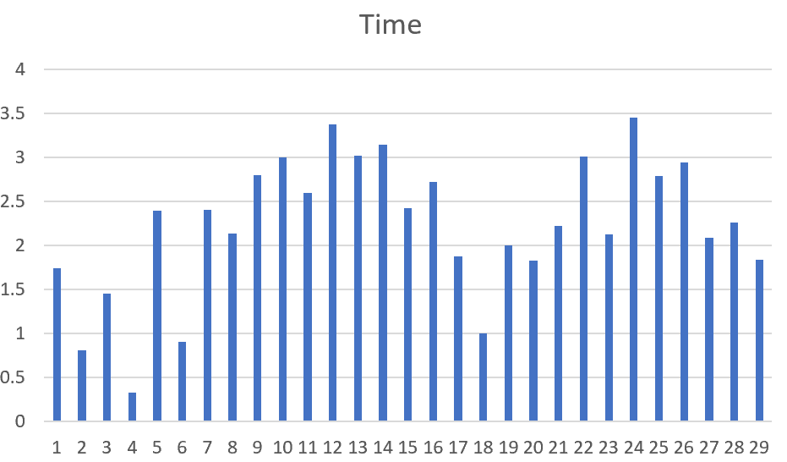

Plot for the cost

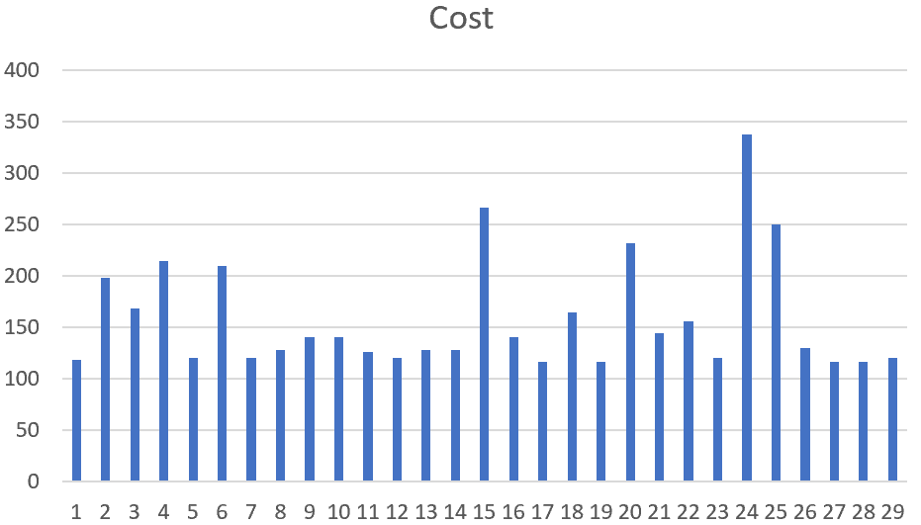

# Algorithm 1

This algorithm is implemented, and was run on 50 environments

On this algorithm the Iterative deepening depth-first search was selected.

* It’s completed because it was able to reach the goal on the given 50 environments where the agent was not enclosed in a space where there is no possible way to reach the goal
* This algorithm is not optimal because when talking about the cost the agent took to reach the goal, because before discovering another path it has first to exhaust the current path

Output for the 50 environments

maze_ 000 : {'Length': 2277, 'Cost': 3908, 'Time': 1.5010960102081299}

maze_ 001 : {'Length': 683, 'Cost': 1126, 'Time': 1.2440030574798584}

maze_ 002 : Failed

maze_ 003 : {'Length': 1169, 'Cost': 1952, 'Time': 0.48599672317504883}

maze_ 004 : {'Length': 281, 'Cost': 462, 'Time': 2.1699981689453125}

maze_ 005 : {'Length': 2783, 'Cost': 4838, 'Time': 2.9949967861175537}

maze_ 006 : Failed

maze_ 007 : Failed

maze_ 008 : Failed

maze_ 009 : {'Length': 863, 'Cost': 1462, 'Time': 0.6909952163696289}

maze_ 010 : Failed

maze_ 011 : {'Length': 2463, 'Cost': 4306, 'Time': 2.014983654022217}

maze_ 012 : {'Length': 1137, 'Cost': 1968, 'Time': 0.4065256118774414}

maze_ 013 : {'Length': 1747, 'Cost': 3010, 'Time': 0.8909933567047119}

maze_ 014 : {'Length': 2235, 'Cost': 3836, 'Time': 1.43202805519104}

maze_ 015 : Failed

maze_ 016 : {'Length': 2161, 'Cost': 3718, 'Time': 1.2230045795440674}

maze_ 017 : {'Length': 2467, 'Cost': 4308, 'Time': 1.53200101852417}

maze_ 018 : Failed

maze_ 019 : Failed

maze_ 020 : {'Length': 2869, 'Cost': 5008, 'Time': 2.4060003757476807}

maze_ 021 : {'Length': 2881, 'Cost': 4992, 'Time': 3.543001413345337}

maze_ 022 : {'Length': 1063, 'Cost': 1780, 'Time': 0.6589956283569336}

maze_ 023 : {'Length': 2619, 'Cost': 4526, 'Time': 2.0780084133148193}

maze_ 024 : {'Length': 3197, 'Cost': 5534, 'Time': 2.2759976387023926}

maze_ 025 : Failed

maze_ 026 : Failed

maze_ 027 : Failed

maze_ 028 : Failed

maze_ 029 : Failed

maze_ 030 : {'Length': 881, 'Cost': 1478, 'Time': 0.5090079307556152}

maze_ 031 : {'Length': 2123, 'Cost': 3660, 'Time': 1.3290235996246338}

maze_ 032 : Failed

maze_ 033 : {'Length': 881, 'Cost': 1478, 'Time': 0.3529956340789795}

maze_ 034 : {'Length': 2323, 'Cost': 4046, 'Time': 1.8769865036010742}

maze_ 035 : Failed

maze_ 036 : {'Length': 2243, 'Cost': 3868, 'Time': 2.3030266761779785}

maze_ 037 : {'Length': 2399, 'Cost': 4168, 'Time': 2.8069980144500732}

maze_ 038 : Failed

maze_ 039 : Failed

maze_ 040 : {'Length': 887, 'Cost': 1470, 'Time': 0.3059976100921631}

maze_ 041 : {'Length': 677, 'Cost': 1142, 'Time': 1.5105631351470947}

maze_ 042 : Failed

maze_ 043 : Failed

maze_ 044 : {'Length': 2757, 'Cost': 4786, 'Time': 2.2120020389556885}

maze_ 045 : {'Length': 2525, 'Cost': 4342, 'Time': 1.3264963626861572}

maze_ 046 : {'Length': 2895, 'Cost': 5066, 'Time': 1.8239972591400146}

maze_ 047 : Failed

maze_ 048 : Failed

maze_ 049 : Failed

maze_ 050 : Failed

maze_ 051 : {'Length': 2301, 'Cost': 3960, 'Time': 2.3389976024627686}

Sample output

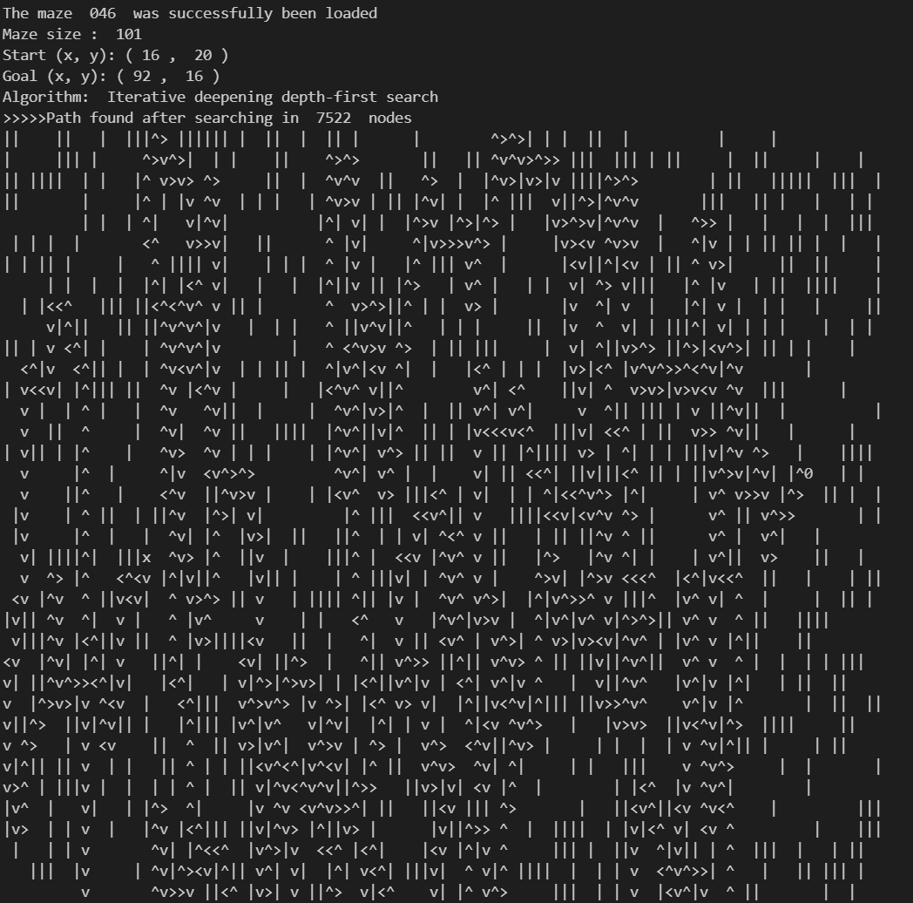

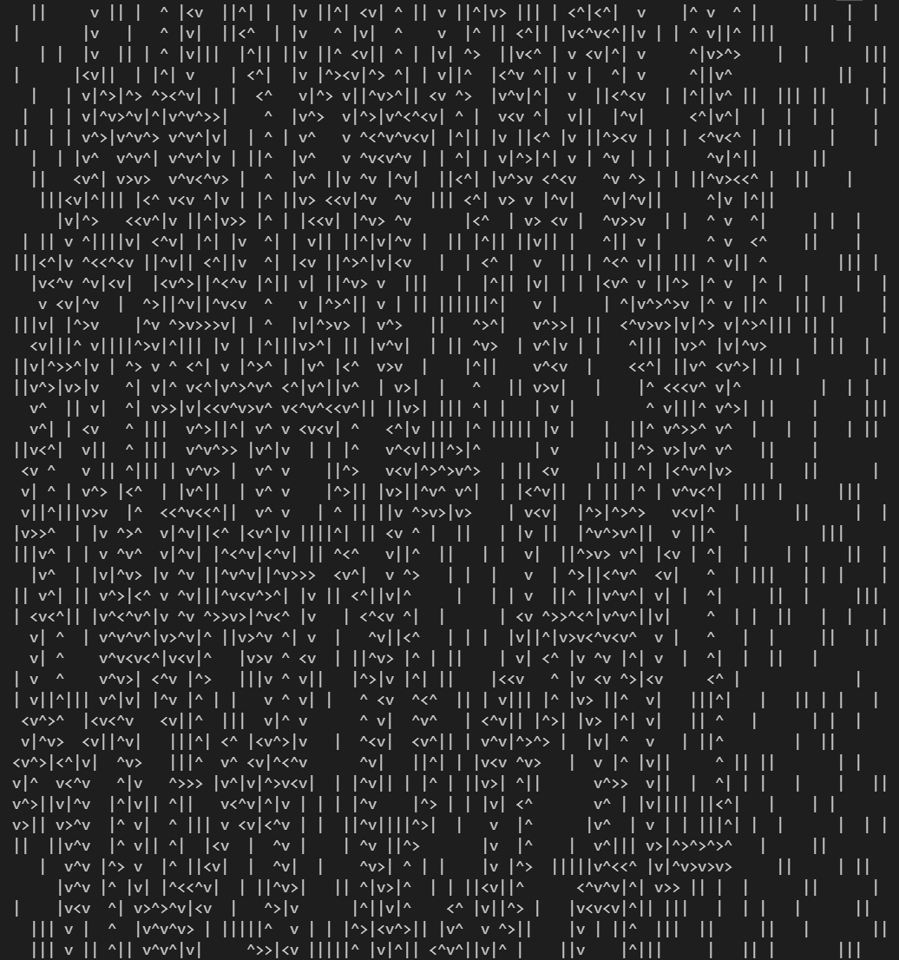

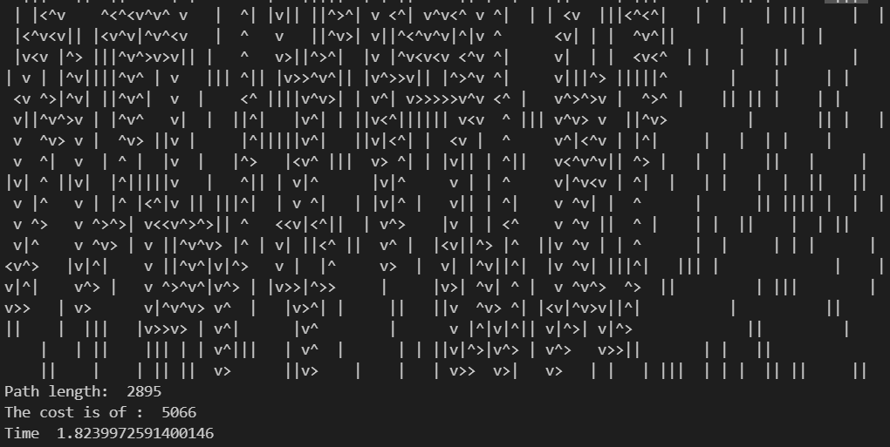

# Algorithm 2

This algorithm is implemented, and was run on 50 environments

On this algorithm the A* using h0 was selected.

This algorithm calculated h0 as the Euclidean distance

* this heuristic is consistent because it was able to perform the same way the breast first search performed.
* This algorithm is admissible because only the optimal distance is considered

Bellow is the output of the 50 environments

maze_ 000 : {'Length': 117, 'Cost': 158, 'Time': 0.01000666618347168}

maze_ 001 : {'Length': 203, 'Cost': 296, 'Time': 0.04199695587158203}

maze_ 002 : Failed

maze_ 003 : {'Length': 169, 'Cost': 242, 'Time': 0.045999765396118164}

maze_ 004 : {'Length': 159, 'Cost': 228, 'Time': 0.021998167037963867}

maze_ 005 : {'Length': 113, 'Cost': 152, 'Time': 0.006995439529418945}

maze_ 006 : Failed

maze_ 007 : Failed

maze_ 008 : Failed

maze_ 009 : {'Length': 219, 'Cost': 324, 'Time': 0.10401582717895508}

maze_ 010 : Failed

maze_ 011 : {'Length': 97, 'Cost': 120, 'Time': 0.005021572113037109}

maze_ 012 : {'Length': 109, 'Cost': 144, 'Time': 0.004990816116333008}

maze_ 013 : {'Length': 113, 'Cost': 152, 'Time': 0.006982326507568359}

maze_ 014 : {'Length': 119, 'Cost': 164, 'Time': 0.017000198364257812}

maze_ 015 : Failed

maze_ 016 : {'Length': 105, 'Cost': 134, 'Time': 0.010036706924438477}

maze_ 017 : {'Length': 107, 'Cost': 136, 'Time': 0.007054328918457031}

maze_ 018 : Failed

maze_ 019 : Failed

maze_ 020 : {'Length': 123, 'Cost': 172, 'Time': 0.007992267608642578}

maze_ 021 : {'Length': 105, 'Cost': 136, 'Time': 0.005999565124511719}

maze_ 022 : {'Length': 249, 'Cost': 382, 'Time': 0.08496928215026855}

maze_ 023 : {'Length': 117, 'Cost': 160, 'Time': 0.02699875831604004}

maze_ 024 : {'Length': 103, 'Cost': 132, 'Time': 0.006978034973144531}

maze_ 025 : Failed

maze_ 026 : Failed

maze_ 027 : Failed

maze_ 028 : Failed

maze_ 029 : Failed

maze_ 030 : {'Length': 149, 'Cost': 210, 'Time': 0.015005350112915039}

maze_ 031 : {'Length': 99, 'Cost': 124, 'Time': 0.01000070571899414}

maze_ 032 : Failed

maze_ 033 : {'Length': 167, 'Cost': 244, 'Time': 0.024008989334106445}

maze_ 034 : {'Length': 117, 'Cost': 160, 'Time': 0.005997180938720703}

maze_ 035 : Failed

maze_ 036 : {'Length': 145, 'Cost': 194, 'Time': 0.010033369064331055}

maze_ 037 : {'Length': 105, 'Cost': 136, 'Time': 0.0049974918365478516}

maze_ 038 : Failed

maze_ 039 : Failed

maze_ 040 : {'Length': 231, 'Cost': 348, 'Time': 0.07700037956237793}

maze_ 041 : {'Length': 175, 'Cost': 262, 'Time': 0.024000167846679688}

maze_ 042 : Failed

maze_ 043 : Failed

maze_ 044 : {'Length': 119, 'Cost': 162, 'Time': 0.007990121841430664}

maze_ 045 : {'Length': 115, 'Cost': 150, 'Time': 0.012000083923339844}

maze_ 046 : {'Length': 99, 'Cost': 124, 'Time': 0.0059964656829833984}

maze_ 047 : Failed

maze_ 048 : Failed

maze_ 049 : Failed

maze_ 050 : Failed

maze_ 051 : {'Length': 101, 'Cost': 128, 'Time': 0.005002021789550781}

sample output

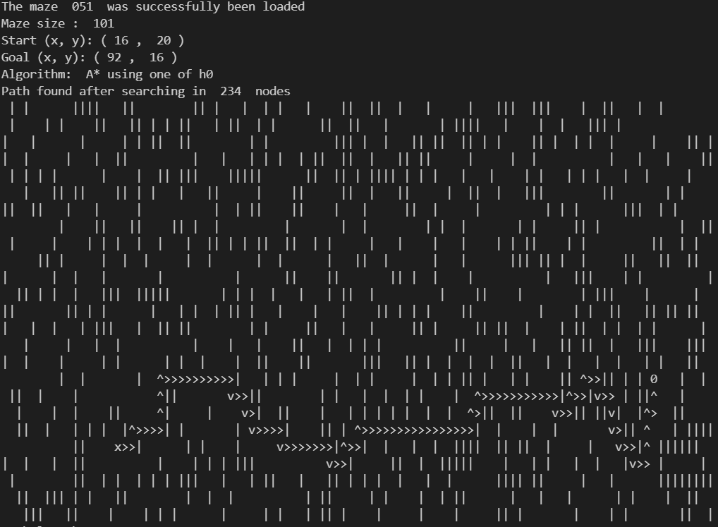

# Algorithm 3

This algorithm is implemented, and was run on 50 environments

On this algorithm the A* using h3 was selected.

This algorithm calculated h3 as given



* this heuristic is partly consistent because it was able to perform the same way as breast first search on some environment.
* This algorithm is admissible partly because on some case it will choose lower value which is not in the direction of the goal

Bellow is the output of the 50 environment

maze_ 000 : {'Length': 147, 'Cost': 212, 'Time': 0.23903965950012207}

maze_ 001 : {'Length': 223, 'Cost': 324, 'Time': 0.734299898147583}

maze_ 002 : Failed

maze_ 003 : {'Length': 137, 'Cost': 194, 'Time': 0.07103896141052246}

maze_ 004 : {'Length': 165, 'Cost': 238, 'Time': 0.08099746704101562}

maze_ 005 : {'Length': 145, 'Cost': 214, 'Time': 0.18500065803527832}

maze_ 006 : Failed

maze_ 007 : Failed

maze_ 008 : Failed

maze_ 009 : {'Length': 167, 'Cost': 244, 'Time': 0.31600022315979004}

maze_ 010 : Failed

maze_ 011 : {'Length': 153, 'Cost': 228, 'Time': 0.3549962043762207}

maze_ 012 : {'Length': 155, 'Cost': 234, 'Time': 0.15799808502197266}

maze_ 013 : {'Length': 181, 'Cost': 276, 'Time': 0.3019986152648926}

maze_ 014 : {'Length': 137, 'Cost': 194, 'Time': 0.4230022430419922}

maze_ 015 : Failed

maze_ 016 : {'Length': 145, 'Cost': 212, 'Time': 0.19699430465698242}

maze_ 017 : {'Length': 155, 'Cost': 232, 'Time': 0.24306368827819824}

maze_ 018 : Failed

maze_ 019 : Failed

maze_ 020 : {'Length': 135, 'Cost': 194, 'Time': 0.31999850273132324}

maze_ 021 : {'Length': 157, 'Cost': 232, 'Time': 0.20599627494812012}

maze_ 022 : {'Length': 219, 'Cost': 338, 'Time': 0.8925094604492188}

maze_ 023 : {'Length': 125, 'Cost': 176, 'Time': 0.31299710273742676}

maze_ 024 : {'Length': 131, 'Cost': 186, 'Time': 0.18399930000305176}

maze_ 025 : Failed

maze_ 026 : Failed

maze_ 027 : Failed

maze_ 028 : Failed

maze_ 029 : Failed

maze_ 030 : {'Length': 223, 'Cost': 328, 'Time': 0.4389984607696533}

maze_ 031 : {'Length': 135, 'Cost': 196, 'Time': 0.23899269104003906}

maze_ 032 : Failed

maze_ 033 : {'Length': 257, 'Cost': 382, 'Time': 0.7069985866546631}

maze_ 034 : {'Length': 163, 'Cost': 242, 'Time': 0.46599841117858887}

maze_ 035 : Failed

maze_ 036 : {'Length': 191, 'Cost': 280, 'Time': 1.112999439239502}

maze_ 037 : {'Length': 165, 'Cost': 242, 'Time': 0.22999787330627441}

maze_ 038 : Failed

maze_ 039 : Failed

maze_ 040 : {'Length': 269, 'Cost': 414, 'Time': 0.25499939918518066}

maze_ 041 : {'Length': 259, 'Cost': 400, 'Time': 0.4060025215148926}

maze_ 042 : Failed

maze_ 043 : Failed

maze_ 044 : {'Length': 185, 'Cost': 278, 'Time': 0.3399941921234131}

maze_ 045 : {'Length': 169, 'Cost': 244, 'Time': 0.5719971656799316}

maze_ 046 : {'Length': 157, 'Cost': 236, 'Time': 0.23504972457885742}

maze_ 047 : Failed

maze_ 048 : Failed

maze_ 049 : Failed

maze_ 050 : Failed

maze_ 051 : {'Length': 155, 'Cost': 228, 'Time': 0.17299365997314453}

sample output

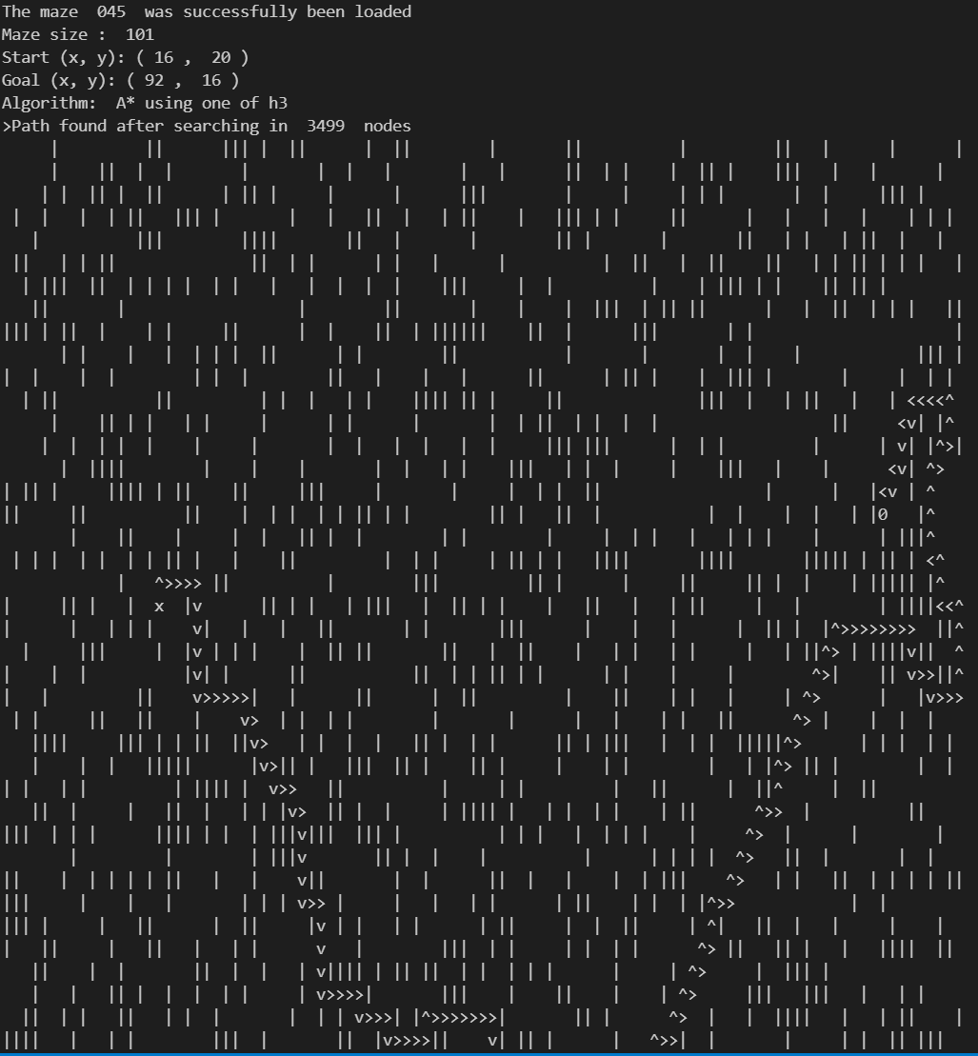

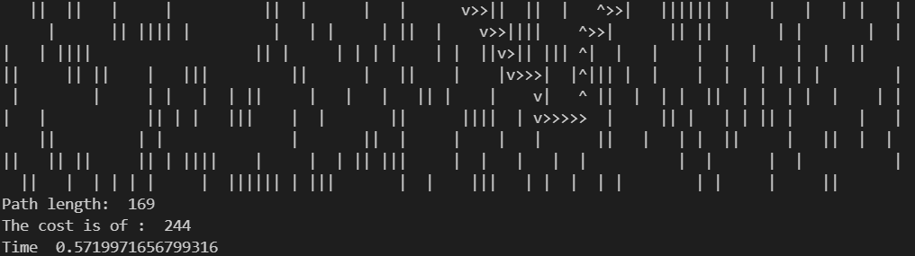

# Algorithm 4

This algorithm is implemented, and was run on 50 environments

On this algorithm the A* using h custom was selected.

This algorithm calculated h as given by the lowest value either going in y direction to the goal or x direction to the goal

* this heuristic is consistent because it was able to perform with lower cost as breast first search on some environment.
* This algorithm is admissible because the agent can only move up or down and left or right, so the Euclidean distance is very optimal here

Bellow is the output of the 50 environment

maze_ 000 : {'Length': 231, 'Cost': 338, 'Time': 0.4205002784729004}

maze_ 001 : {'Length': 269, 'Cost': 408, 'Time': 0.3859844207763672}

maze_ 002 : Failed

maze_ 003 : {'Length': 179, 'Cost': 264, 'Time': 0.5729999542236328}

maze_ 004 : {'Length': 225, 'Cost': 330, 'Time': 0.13999557495117188}

maze_ 005 : {'Length': 223, 'Cost': 324, 'Time': 0.470020055770874}

maze_ 006 : Failed

maze_ 007 : Failed

maze_ 008 : Failed

maze_ 009 : {'Length': 253, 'Cost': 374, 'Time': 0.5909981727600098}

maze_ 010 : Failed

maze_ 011 : {'Length': 209, 'Cost': 310, 'Time': 0.41199755668640137}

maze_ 012 : {'Length': 201, 'Cost': 290, 'Time': 0.13499736785888672}

maze_ 013 : {'Length': 209, 'Cost': 300, 'Time': 0.41199803352355957}

maze_ 014 : {'Length': 221, 'Cost': 330, 'Time': 0.4240000247955322}

maze_ 015 : Failed

maze_ 016 : {'Length': 207, 'Cost': 292, 'Time': 0.5260012149810791}

maze_ 017 : {'Length': 201, 'Cost': 294, 'Time': 0.550999641418457}

maze_ 018 : Failed

maze_ 019 : Failed

maze_ 020 : {'Length': 217, 'Cost': 322, 'Time': 0.4299964904785156}

maze_ 021 : {'Length': 203, 'Cost': 288, 'Time': 0.5922825336456299}

maze_ 022 : {'Length': 277, 'Cost': 430, 'Time': 1.3639848232269287}

maze_ 023 : {'Length': 201, 'Cost': 292, 'Time': 0.4379918575286865}

maze_ 024 : {'Length': 229, 'Cost': 346, 'Time': 0.13399767875671387}

maze_ 025 : Failed

maze_ 026 : Failed

maze_ 027 : Failed

maze_ 028 : Failed

maze_ 029 : Failed

maze_ 030 : {'Length': 163, 'Cost': 246, 'Time': 0.33699584007263184}

maze_ 031 : {'Length': 199, 'Cost': 280, 'Time': 0.39099621772766113}

maze_ 032 : Failed

maze_ 033 : {'Length': 161, 'Cost': 240, 'Time': 0.35399961471557617}

maze_ 034 : {'Length': 205, 'Cost': 290, 'Time': 0.3699963092803955}

maze_ 035 : Failed

maze_ 036 : {'Length': 211, 'Cost': 306, 'Time': 0.26399850845336914}

maze_ 037 : {'Length': 193, 'Cost': 278, 'Time': 0.3979976177215576}

maze_ 038 : Failed

maze_ 039 : Failed

maze_ 040 : {'Length': 387, 'Cost': 594, 'Time': 0.8199963569641113}

maze_ 041 : {'Length': 245, 'Cost': 388, 'Time': 0.7546703815460205}

maze_ 042 : Failed

maze_ 043 : Failed

maze_ 044 : {'Length': 163, 'Cost': 242, 'Time': 0.3869969844818115}

maze_ 045 : {'Length': 243, 'Cost': 358, 'Time': 0.3719971179962158}

maze_ 046 : {'Length': 169, 'Cost': 232, 'Time': 0.3829963207244873}

maze_ 047 : Failed

maze_ 048 : Failed

maze_ 049 : Failed

maze_ 050 : Failed

maze_ 051 : {'Length': 237, 'Cost': 356, 'Time': 0.40799975395202637}

# Time comparison

# Cost comparisons