 | Ultra*Log | 

The Castellan Project
Software Design Document

Software Version Number: 1.0
Document Revision Number: 1.1
Date: 8 Oct 2001

Prepared for:
Defense Advanced Research Projects Agency
Information Systems Office
3701 North Fairfax Drive
Arlington, VA 22203-1714
Prepared by:
Penn State/IAI
7519 Standish Place, Suite 200
Rockville, MD 20855
Contact Person:
Wilbur Peng
301-222-0455, wpeng@i-a-i.com

Document History
Revision Date | Revised By | Comments | Date Reviewed with Team | Approved *
* Document will be approved as part of CCB process.
Software Release History
Date | Comments

A Note on Terminology
This template uses the term “component” equivalent to the definition of “design entity” given in IEEE Std. 1016 (Software Design Description, SDD). In the context of Ultra*Log, components could be one of the following: Binders, Binding Sites, Node Services, Agent Services, PlugIns.
This template uses the terms “system” and “product” synonymously for the delivered output.
Also Note
Due to the variety of projects within Ultra*Log, this template does not necessarily require the output to be software, although that will be the case in most instances.

LEGEND (example; legend/copyright statement optional)
Use, duplication, or disclosure by the Government is as set forth in the Rights in technical data noncommercial items clause DFAR 252.227-7013 and Rights in noncommercial computer software and noncommercial computer software documentation clause DFAR 252.227-7014.
© Copyright 2001 <company name>
Contents
1 Executive Summary 1
1.1 Purpose 1
1.2 Scope 1
1.3 Design Overview 1
2 Functional Description 3
2.1 Introduction 3
2.2 System Capabilities 3
2.3 Design Approach 3
2.4 Performance Expectations 3
2.5 Required Resources 4
2.5.1 Client Side Resources 4
2.5.2 Network Resources 4
2.5.3 Server-Side Resources 4
3 System Structure 7
3.1 Introduction 7
3.2 Decomposition Description 7
3.3 Dependency Description 7
3.4 Interface Description 8
3.4.1 Castellan Logging Client 8
3.4.2 Castellan Server 8
3.4.3 Graph Analysis Modules 9
3.4.4 DatabaseEventLog Persistent Storage 9
3.5 TechSpecs (PlugIn Contracts) 9
4 Detailed Design Description 11
4.1 Castellan Client 11
4.2 Plan Event Protocol 11
4.3 Message Transport Layer 11
4.4 Castellan Server 11
4.4.1 Server User Interface 12
4.5 Pattern Analysis and Graph Visualization Plug-Ins 12
4.5.1 Log Plan Graph Builder 12
4.5.2 Aggregate Task Graphs 12
4.6 Asset Dependency Graph Generator 13
5 Capabilities Roadmap 17
5.1 Anticipated dependencies 17
Figures and Tables
Figure 1. Castellan Information Flow 8
Figure 2 Task Graph Reduction 13
Figure 3 Asset Dependency Graph 14

This page is blank intentionally.

Executive Summary

Purpose
This document describes the design and implementation of the Castellan distributed plan logging system. The purpose of Castellan is to provide a framework and implementation for logging, visualization and analyzing plan formation across multiple agents in real time. The system will be useful for developers interested in studying robustness, performance and scalability.
This document describes features and capabilities of Castellan Release 1.0. R1.0 includes event-based distributed logging, time correction, database integration as well as integrated visualization and analysis tools.

Scope
Castellan is a distributed plan logging and monitoring framework for monitoring distributed planning in Cougaar societies. Castellan provides:
- Client based, distributed plan event monitoring
- Timestamp correction between distributed agents
- Logging server for storing and analyzing event logs.
- Logging to memory, serialized data files, and MySQL databases, and
- Analytical modules for aggregate task dependencies, plan-time asset dependencies, and time series analysis
- Graph visualization through the Grappa and dot facilities.
Castellan can operate as part of the experimental and development framework as well as serving as a tool for developers.

Design Overview
The Castellan system is comprised of client plug-ins and a server. The clients are PlanMonitorPlugIns which are deployed to the target Cougaar agents/clusters. These subscribe to objects of interest (e.g. tasks, assets, and plan elements) and relay changes in state to the server.
The server is responsible for controlling clients, collection and persistent storage of event messages, and providing visualization, data mining and plan analysis tools.
Because Castellan is a monitoring tool, it requires access to the local network and sufficient bandwidth to send events to the server. The PlanMonitorPlugIns require "read-only" access to the local blackboard (Plan) and the ability to access experimental network resources (e.g. out of band message). The Castellan server can use access to local MySQL databases to store both message traces and time dependent views of the state constructed from the message traces.
This page is blank intentionally.

Functional Description

Introduction
Understanding and monitoring the behavior of distributed systems is often a challenging problem due to the fact that the system state is dynamically changing and spread across multiple nodes. In Cougaar, the plan evolves over time during planning and execution, but this process is difficult to observe. Moreover, the resultant plan can be difficult to visualize due to its size and complexity.
Castellan is intended to lead towards mechanisms for monitoring, understanding and regulating distributed planning and replanning in dynamic environment. Over the life of the U*L project, we envision that automated monitoring systems will be developed using lessons learned from studying distributed planning.
Castellan provides a framework for dynamic plan logging and analysis in an experimental environment. It is intended to capture changes in plan state from multiple agents and store them. These in turn will be used as inputs to analytical modules for pattern and situation extraction as well as studies of planning dynamics and instability.

System Capabilities
This release (R1.0) of Castellan is intended to serve as a part of the experimental infrastructure. By deploying monitoring plug-ins at agents of interest, the system will collect changes in plan state and send them to the server.
The Castellan server collects message traces and will provide a programming interface to which different analysis modules can be plugged in. The stored event log can be analyzed, studied, and used to compare between different planning results. Additionally, developers can use the system to visualize and understand the results of planning such as performance bottlenecks.

Design Approach
Castellan uses a client-server architecture to gather Each client is comprised of a PlanMonitorPlugIn deployed to each agent to be monitored and sends plan log event protocol data units (PDUs) to the PlanMonitorServer. Although the architecture eventually requires a centralized server for logging and analysis, it is not the case that entire societies need to be monitored, nor does every agent need to be monitored at the maximum level of detail.
Castellan will also include algorithms for the visualization of plan state over time. These allow generation of aggregated plan graphs and asset dependency graphs depicting planning activity over intervals in time. Finally, the use of a database event log will allow the creation of data mining, behavior and performance analysis and situation extraction tools.

Performance Expectations
The performance characteristics of the Castellan system can be considered in a number of ways. These include:
- The logging plug-ins and infrastructure support should have as little CPU overhead as possible to avoid impacting the system under observation.
- The event PDUs and message transport should provide for efficient, low-bandwidth transport between the server and agents. It is expected that there is some maximum number of agents that can be successfully monitored, depending on the degree of plan activity, the amount of bandwidth allocated to experimental infrastructure, and the amount of data collected. If a separate experimental infrastructure is used, the effects of logging can be diminished significantly.
- The off-line analytical modules should be scalable to large plan log sizes, both in terms of performance and the ability to extract patterns and useful visualization. Although this does not impact society performance, it will affect the usability and responsiveness of the system from the user’s standpoint.
The primary scalability concerns of Castellan are relate to scalability of the system to monitor large numbers of agents using relatively little bandwidth.

Required Resources

Client Side Resources
The client plug-in tracks changes in task state and hence keeps copies of the AllocationResult objects for each task being monitored.

Network Resources
Significant bandwidth is required for event transmission over the network, although quantitative studies have not yet been performed. Ideally, these events would be transmitted over a separate experimental network.

Server-Side Resources
The memory required by the Castellan server is proportional on the number of messages to be analyzed and stored in memory. MySQL is optionally supported for logging to persistent files.
This page is blank intentionally.

System Structure

Introduction
The central goal of the Castellan system is to act as an infrastructure for data mining, pattern discovery and situation extraction. To that end, the grand concept encompasses a detailed, distributed plan event logging system using plug-ins, a relational DBMS (MySQL) for logging events, and a pluggable framework for both runtime and off line pattern analysis and data mining.
The current release is able to capture events from different agents and demonstrates the ability to log events through serialization. Additionally, it demonstrates pattern extraction modules for constructing aggregate asset and task dependency graphs. It integrates with MySQL and provides a simple interface for pattern extraction and analysis modules.

Decomposition Description
The major logical components of the Castellan system include:
- Plan logging protocol. The protocol is comprised of different messages which capture changes in the local plan state.
- Event logging clients. This includes a Cougaar plug-in and associated support classes which captures changes in the plan and streams them to the server using the plan logging protocol.
- Castellan server application. This stores messages and interfaces with a database. It also provides a programming interface different kinds of analytical modules. The Castellan server also includes a graphical user interface for configuration and logging control.
- Analytical and visualization modules. These process message streams to build different representations of the observed plan. Currently, aggregate task graph and asset dependency graph generation algorithms have been implemented.

Dependency Description
Figure 1 shows the primary information flow betwee components in the Castellan system.
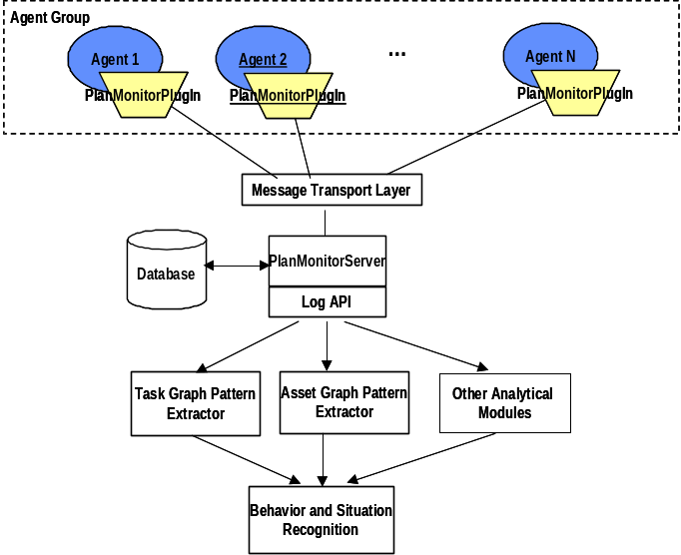
Figure 1. Castellan Information Flow

Interface Description

Castellan Logging Client
The Castellan logging client is consists of a plug-in and its support classes. It is configured by a PlanMonitorConfig.xml file found in the local directory which indicates the IP address of the target server. (If this configuration file cannot be found, the client attempts to connect to the localhost.)
Currently, only one Castellan server at a time is supported. The Castellan logging clients are started when their agent is loaded by Cougaar. The Castellan server must be initialized and connected before the Castellan client is loaded for the logging process to initialize correctly.

Castellan Server
The Castellan server function as a stand-alone application. It is invoked using through the org.castellan.server.ServerApp main method or through the RunHydra.bat file found in /test/bin. The ServerApp.main() method starts the user interface and initializing the system path settings.
A Castellan server session is comprised of a SocketServerMTImpl instance, a EventLog instance, and a ServerUIFrame which During startup, a default InMemoryEventLog is created which will be used to collect events. Each server session includes a org.hydra.server.SocketMTServerImpl which implements the message transport layer.
The UI is used to configure the server and to start and stop logging. Additionally, the Castellan UI is used to initiate graph analysis and visualization. Please refer to the Castellan User’s Manual for details.

Graph Analysis Modules
Curently, the graph analysis modules are closely integrated with the Castellan server. They are also invoked using the Castellan UI.

DatabaseEventLog Persistent Storage
The org.hydra.eventlog.DatabaseEventLog requires MySQL to be installed and running on the local system. Database management must be performed outside the Castellan UI using MySQL administration commands, as Castellan has not yet integrated the ability to delete databases.

TechSpecs (PlugIn Contracts)

This page is blank intentionally.

Detailed Design Description

Castellan Client
The org.hydra.plugin package defines classes for the Castellan monitoring client. For each agent/cluster to be monitored, an instance of PlanMonitorPlugIn is introduced. Upon start-up, the PlanMonitorPlugIn attempts to connect to the Castellan server. By default, it subscribes to all plan elements, tasks and assets objects. During execution, the PlanMonitorPlugIn is responsible for monitoring changes in plan state, i.e. and monitors new, changed, and removed objects. It also monitors allocation results for each task and transmits time-stamped events to the server.

Plan Event Protocol
The protocol data units (PDUs), defined in the org.hydra.pdu package, are used to transmit changes to the log plan as well as control messages between the server and client. They will allow efficient wire protocol for transmission.
Subclasses of EventPDU represent changes to the plan at particular types. Other PDU classes, such as the DeclarePDU, TimeReqPDU and TimeAckPDU, are used for control messages.
The EventPDU subclasses are mapped from the plan log definitions, e.g. the Task class is mapped onto a TaskPDU, etc. However, it is important to note that the EventPDU represents ADD, REMOVE and CHANGE actions to the plan at particular moments in execution and real time.

Message Transport Layer
Castellan relies on a reliable, two-way (duplex) transmission between the client and server. It defines a simple set of message transport layer which can be implemented in different ways. The org.hydra.plugin.ClientMessageTransport interface defines APIs used by the client PlanMonitorPlugIn to communicate with the server. Similarly, the org.hydra.plugin.ServerMessageTransport interface defines a corresponding interface for server processed.
Currently, the message transport is implemented using stream sockets using the ServerSocketMTImpl and ClientSocketMTImpl classes, respectively. Currently, object serialization is used to translate generated PDUs to the socket stream. However, more space efficient and faster methods may be used as well. (For example, a custom serialization routine combined with a ZIPOutputStream may be used.)

Castellan Server
Currently, the Castellan server uses a single thread per client architecture for receiving and storing messages. The org.hydra.server.ServerSocketMTImpl implementation of the org.hydra.server.ServerMessageTransport interface listens on port 9003 for new clients. It establishes connections with client PlanMonitorPlugIns and starts a new thread per socket architecture for receiving messages from the client.
The server corrects for relative time discrepancies between the server and the client before forwarding the EventPDUs to an instance of org.hydra.planlog.EventLog.
The org.hydra.planlog.EventLog interface defines a “sink” for EventPDUs processed by the server. Current implementations of the EventLog interface include in-memory versions and a database implementation which uses MySQL.

Server User Interface
The user interface for the Castellan server is defined in org.hydra.server.ui. The UI is used to control and configures messaging, logging, and analysis tools. Further details of the operation of the UI are described in the Castellan Users Guide.

Pattern Analysis and Graph Visualization Plug-Ins
The org.hydra.metrics package defines a set of analysis and visualization tools. The analysis tools will form the basis of the pattern recognition system. This section describes the set of modules which have been implemented.

Log Plan Graph Builder
The org.hydra.metrics.LogPlanBuilder class is used to build a representation of the whole of the observable log plan. It processes a time-ordered sequence of EventPDUs and creates a in-memory graph. This plan graph is subsequently used by other graph analysis modules. Because of the possibly large size of log plans, it is generally only usable for visualizing small subsets.

Aggregate Task Graphs
The org.hydra.metrics.AggregateTaskBuilder uses the LogPlanBuilder results to construct reduced or (aggregated) task graphs. The reduced task graphs represent reoccurring patterns generated in the full task graph during execution.
A task graph may be described as a graph which represents the all child subtasks which are generated during planning for a single high level task. During runtime, a task graph is explicitly created through the behavior of allocator, expander, and aggregator plug-ins. Each plug-in applies its local business rules and logic in allocating, expanding, or aggregating tasks, but it is expected that many graphs will consist of similar subparts. The resultant task graph generated and maintained by the plan may be very large, encompassing every task created during the planning process
A reduced task graph attempts to capture these patterns in a compact form. Because of the loose coupling between plug-ins and the complexity of task scheduling and allocation algorithms, all paths in the reduced task graph are not equally likely to occur during planning.
Reduced task graph patterns are defined in terms of the reduced task graph and the probabilities assigned to edges. These capture in compressed form the typical behaviors of the system. shows an example of task graph reduction. An original graph of tasks is compressed into a “AND OR” graph with probabilities based on measured results.

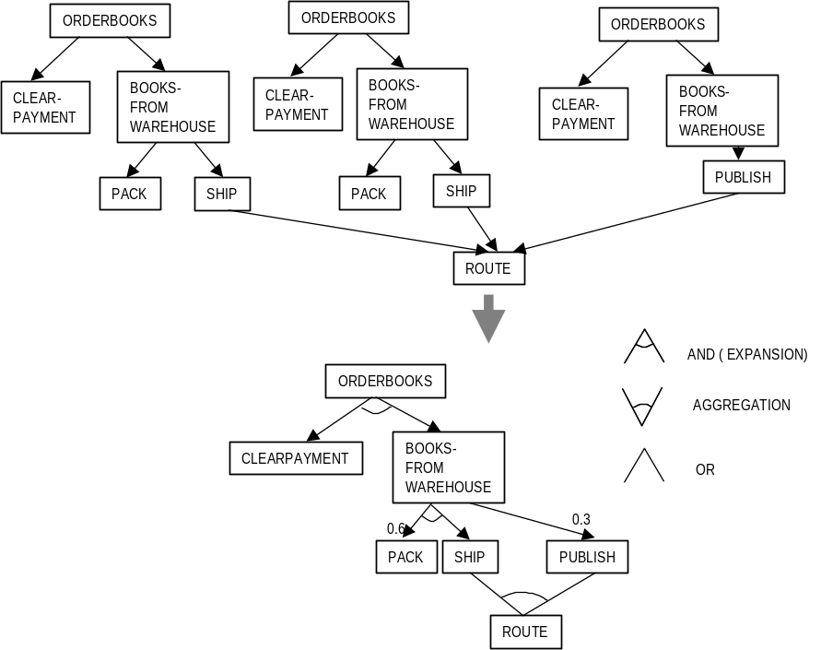
Figure 2 Task Graph Reduction

In a reduced task graph, each node represents a class of tasks which share some common feature. For example, all tasks with the verb “ORDERBOOKS” assigned to the same cluster could be grouped into a class S₁.

Asset Dependency Graph Generator
The org.hydra.metrics.AssetDependencyBuilder module finds planning time dependency graphs between both concrete (real) and organizational assets. (An organization asset is one which represents an agent. During formation of a plan, the assignment of tasks to assets is often dependent on the assignment of parent tasks to assets.
For example, a task K₁ defined as (SHIP Package1 FROM “New York” to “Washington”) is expanded into two subtasks K₂, (SHIP Package1 FROM “New York” to “JFK”) and T3, (SHIPBYAIR Package1 FROM “JFK” to “DCA”). If K₁ is allocated to Truck1 before K₂ is allocated to Aircraft2, then Aircraft2 has a plan time dependency on Truck1 for the completion of one of its currently assigned tasks.
A particular planning asset dependency only holds for a particular instance of the planning process. It is denoted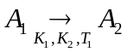, i.e. at an observed time T₁, the allocation of K₂ to asset A₂ is dependant on an allocation of K₁ to A₁. The planning asset dependency will manifest itself during the planning process.

Note that the planning asset dependency graph is conceptually different from a workflow asset dependency graph. A workflow dependency graph captures dependencies in plan time. A workflow dependency is denoted 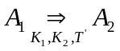, where T′ denotes a plan time instance, e.g there exists a task K₁ which A₁ must complete before A₂ can begin executing some task K₂.

Figure 3 shows an example of a task dependency graph. In this case, both organizational assets (“Warehouse”, “Shipper”) and physical assets (“Packer”) are shown.
Asset dependencies are of interest from the standpoint of studying planning behavior, because the number of asset dependencies in an existing plan increase the number of constraints which must be satisfied during the planning process. Such dependencies also affect the likelihood of replanning when assets are destroyed or made unavailable (e.g. the node which governs the asset is inaccessible, therefore we cannot assume that the plan is actually being carried out.)
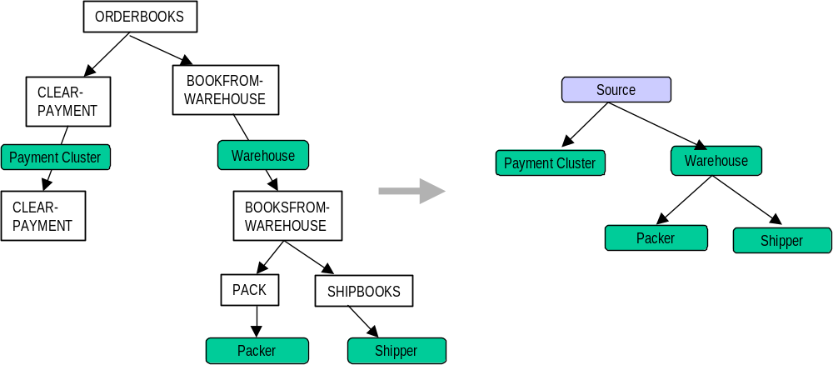

Figure 3 Asset Dependency Graph
Currently, the implementation of the asset dependency includes non-concrete assets (e.g. organizational clusters). However, the ability to create concrete (“real”) assets dependency graphs will also be added to future versions. This will allow analysis and discovery of scheduling dependencies between different assets, and will provide the ability to identify scheduling “bottlenecks.
This page is blank inentionally.

Capabilities Roadmap
The next version of Castellan is targeting the following capabilities:
- Improved data logging/mining API for extracting time series and performance parameters. This will allow observation of different parameters such as time to allocate distributions, time to result distributions, success/failure rates for planning classes of tasks, and other parameters.
- Analysis tools incorporating detailed log plan information (quantities, inventories, preferences, etc.)
- New analytical modules for aggregate asset dependency graphs and concrete scheduling dependencies.
- Improved user interface and server-configurable logging/monitoring settings.
- Situation recognition capabilities: the ability to track and differentiate between normal and abnormal planning activities and performance. This would depend on both performance metrics as well as the planning behavior graphs extracted during the planning process.

Anticipated dependencies
Cougaar infrastructural support for identifying the sources of task modifications/deltas would be useful. In particular, it might be useful to audit and track which plug-ins create and modify tasks, assets, and plan elements and at what system time. This would allow for a more detailed analysis of planning behavior.
This page is blank intentionally.

