Continuous Planning and Execution Society Design Document

Version 1.2

Introduction

This document describes a simple agent society implementing continuous planning and execution. The objective of the “CPEDemo” society is to identify key aspects within a continuous planning and execution scenario that will in turn help to identify and demonstrate key concepts in the argument for and concept of “design for survivability”.

The demo society and experiment will consist of:
- An agent society with hierarchical command and control (C2) as well as supplier-client relationships
- A model of continuous planning and execution within and across agents
- A set of domain MoPs
- TechSpecs for agents that define QoS measurement points.
- Experimental use cases that demonstrate the functioning of the system
- An implementation of the system either through analytic modeling or programmatic realization and including an adaptivity engine.

Although a simple operational scenario and world model is used as a motivating example in this document, this document can be viewed as a thought experiment in how agents and components might be designed with TechSpecs. Fundamental questions we hope to address include:
- What functionality to associate with what level of abstraction?
- What capabilities should the agent infrastructure provide and how general or specific will they be?
- What sort of expressiveness is needed in TechSpecs?
- How can domain/application QoS requirements be mapped back into infrastructure capabilities for measuring and sustaining QoS?
- How can control strategies utilize TechSpecs?
- How can survivability be modeled with TechSpecs? In particular, how do we model system functionality when “catastrophic” failures such as loss of links and loss of computational resources happen?

Continuous Planning and Execution Concept of Operations

This document describes the functionality and high-level design of agent society that performs continuous planning and execution in a combination of hierarchical C2 and supplier client roles. In a continuous planning and execution (CPE) model, each agent within the society is constantly:
- Evaluating its own perception of the world state through local sensors and remote inputs
- Performing planning, replanning, and plan reconciliation and refinement
- Executing plans, either through local actuators or through sending messages to other agents.
- Adapting to the environment, e.g. centralizing or decentralizing planning as computation resources permit.

World Model

For the CPE society, a simple world model is used. This is not meant to be realistic but rather to drive the society (and the planning models) rather than having a completely scripted approach. We assume:
- A rectangular map
- An unlimited supply of targets appearing at the top of the map and fall to the bottom. Targets move at a fixed rate down but can be “suppressed” (i.e. their movement rate slowed) by engaging by fire.
- Unit agents at the bottom of the board which can move in one-dimension along the x-axis.
- Targets appear in a scripted or random fashion, depending on the nature of the exercise.
- A probabilistic model of engaging targets which requires expending ammo.
- A deterministic model of fuel consumption based on distance moved.
- A logistics model for resupplying the units with fuel/ammo based on demand generation from maneuver plans.

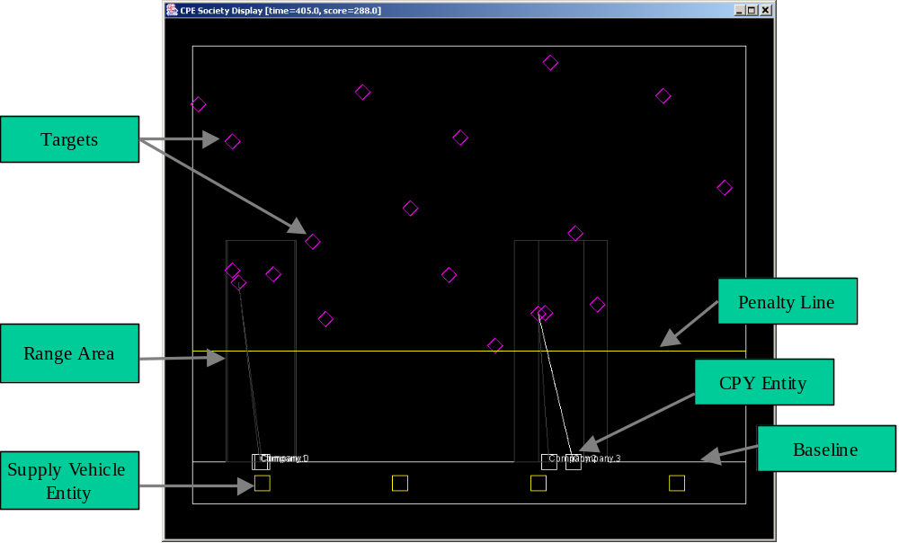

Figure 1 CPE Society In Action

Each unit has a fixed size radius which allows it to cover a particular 1D segment of the target area.

During planning, a sequence of actions for each agent will be constructed. During execution, the world model simulates the outcome of each agent, as well as adding additional visible targets to the world.

The model of logistics will be as follows. Each supplier agent controls a fixed pool of vehicles. Each vehicle can deliver a fixed number of units of supply (either fuel or ammo) per unit time to a given agent. Also, there is a fixed minimum delay between when a vehicle moves from the supplier to the unit agent.

The domain scoring function for a time interval from t to t₁=t+Δt will be characterized by giving a reward for each kill and a penalty for each target that falls below a “penalty” line for each unit of time as well as a higher penalty for falling below the baseline.

This domain is sufficiently simple that it is easy to understand. However, it will be sufficiently rich with the addition of delays, stresses, and incomplete knowledge, that a wide variety of behaviors can be produced.

Society Design

We use a model of a highly simplified military force structure to motivate the society design. We associate a set of agents with the following distinct domain entities:
- Combat entities.
- Support units. These represent supply units which carry out sustainment operations and resupply to combat entities.
- C2 entities. Although these are human commanders, the agents associated with them are not modeling the “command” aspect of the human but rather the set of tasks which the agent is to support, such as monitoring readiness.

The role relationships between the agents will consist of:
- Superior/subordinate relationships. These will denote military lines of command and control.
- Provider/customer relationships. These include logistics supplier and client type relationships.
- Peer to Peer relationships between agents are useful when decentralized control becomes necessary, e.g. due to loss of communications.

Configuration

For this society, we assume a configuration that includes:
- A small set of “company” (CPY) agents.
- Two levels of C2 hierarchy, designed as “battalion” (BN) agents and “brigade” (BDE) agents
- A pool of suppliers which can provide sustainment to all vehicles/units.

In addition, we assume the existence of a world model in which the society operates and feeds “external” events back into the system.

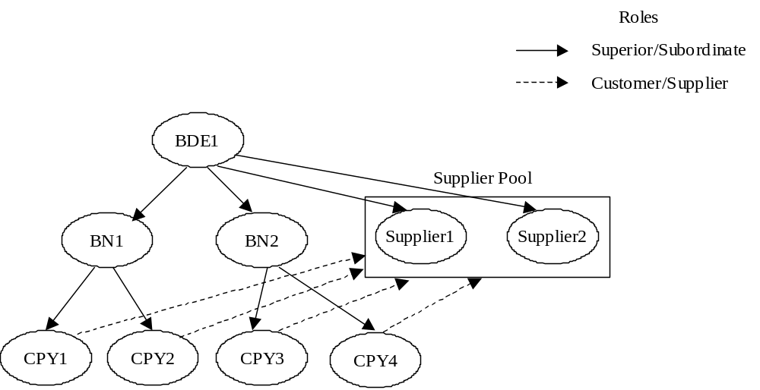
Figure 2 Society Configuration

CPY (Company) Agents

CPY agents represent entities that engage in combat actions in the world (e.g. move and engage by fire). Functionally, the combat units may include the following functionality:
- Simulate sensors and actuators on the vehicles. (This is largely farmed off to the WorldModelAgent.)
- Maintain inventory/stores of ammunition and fuel
- Consume ammunition and fuel
- Execute simple commands that result in fuel/ammo consumption
- Report status to superiors
- Forward maneuver plans to supplier(s) for demand generation.

Agent Internal State

This is not formally part of the TechSpec but included for completeness.

Name | Description
ManueverPlan | The current maneuver commands in action for this agent
SustainmentPlan | The current sustainment plan, generated in support of the maneuver plan. (This sustainment plan is generated by the agent’s suppliers, and the relevant portion is forwarded to the agent.)  [Note: This is not yet used as the CPY agents do not yet validate their sustainment plans. ]
Fuel | The quantity of gallons of fuel on hand
Ammo | The number of rounds of ammo on hand.

TechSpecs

Inputs
Name | Description | From | Action Taken | Measured QoS
NewManueverPlan | Dictates sequences of actions to undertake at any given moment. These can override and/or extend existing plans. | Role(Superior) | Update Sustainment  Plan | ManueverPlanFreshness (see below)
NewSustainmentPlan | Obtained from the SupplyProvider | Role(SupplyProvider) | EvaluateSustainmentPlan | SustainmentPlanFreshness
StoresChanged | Indicates observed change in fuel/ammo state. | WorldState | Change internal state | N/A
UpdateTimer | Periodic timer update to trigger world state update. | Timer service | UpdateStatus | TimerDelay

Outputs

Name | Description | To | Indicated QoS
StatusUpdate | Describes world state (location, fuel, ammo, etc.) as perceived by the agent at time T | Role (Superior) | StatusUpdateFidelity ={Low,High},  Timestamp
ReportTaskStatus | Update the status of a task when it is completed. | Role (Superior) | TaskStatusTimestamp
NewManueverPlan | A maneuver plan to be sustained. Issued whenever changes to the existing sustainment plan are committed. | Role (SupplyProvider) | ManueverPlanFreshness

Actions

Action Name | Triggered By | Outputs | Operating Mode Dependencies | Resources Consumed
UpdateManeuver  Plan | Input(NewManeuverPlan) | NewManueverPlan (to SupplyProvider) | N/A | CPU={C_{UL},C_{UU} ,C_{UAV}}  Network={N_{UL},N_{UL},U_{AV}}
ChangeInternalState | WorldModel | N/A | N/A | CPU=C_{IS}
UpdateUnitStatus | Timer(StatusUpdateRate) | UnitStatusUpdate | UpdateRate,  UpdateFidelity | CPU=C_{S}(UpdateFidelity),  Network={N_{SL},N_{SL},U_{Sav}}

[NB The NotifyTaskStatusChanged action is not yet implemented. Currently, no updates to the task status are sent to the BN agent; the BN agent simply assumes that the plan is carried out perfectly. This is OK since only a few stochastic/uncertainty elements have been added to plan execution yet.]

Operating Modes

Name | Values | Description
StatusUpdateRate | [R_{MIN} , R_{MAX}], Units= Milliseconds | How often status updates about the world are broadcast from the CPY agent to its superior
BroadcastTaskStatus | {“On”,”Off”} | Whether or not to broadcast task report events. Not yet implemented.
StatusUpdateFidelity | {“Low”, “High”} | How good the status information is.

StatusUpdateRate Operating Mode

The StatusUpdateRate knob governs how often status updates about the world are broadcast from the CPY agent to its superior. It has a continuous operational range defined as the closed interval [R_{MIN} , R_{MAX}], where R_{MIN} and R_{MAX} are measured in milliseconds.

StatusUpdateFidelity Operating Mode

This was originally combined with the StatusUpdateRate knob but has been broken out separately. For the purposes of this exercise, this will be modeled through rounding off fuel and ammo inventory numbers to the nearest decimal place. Here, the knob StatusFidelity is defined by the ordered set {LowFidelity,HighFidelity} Note that the StatusFidelity knob maps directly into the indicated fidelity QoS for StatusUpdate messages.

BroadcastTaskStatus Operating Mode

This is a simple on/off switch that controls whether or not the task status of the CPY agent will be reported back to its superior. TBD.

Local QoS Measurements

The following QoS measurement points will be generated:

ManeuverPlanFreshness

The ManueverPlanFreshness QoS measurement point is a function of the most recent StatusUpdate timestamp from this agent and the accumulated delays in sending, planning and receiving the NewManueverPlan message. For example, consider a case when the CPY1 sends a WorldStateUpdate at 15 second intervals and it takes a maximum of two seconds to propagate to the BN1 (superior) agent. In the worst case, the BN1 agent replans every 120 seconds using a 16 second old WorldStateUpdate from CPY1.

Further, suppose that the BN1 agent takes at most 10 seconds to plan 100 seconds into the future with a specific PlanningDepth and PlanningBreadth and transmits the result back to CPY1 agent as a NewManueverPlan taking an additional 1 second. Then the ManeuverPlanFreshness upon receiving the NewManueverPlan input is calculated as 16 + 10 + 1 = 27 seconds in the worst case, and 12 seconds in the best case.

SustainmentPlanFreshness

The SustainmentPlanFreshness QoS is calculated in a similar fashion except that it must be obtained through the SupplyProvider agents which the CPY is using to satisfy its maneuver plan requirements.

BN Agent Design and TechSpecs

The BN agent has the following functionality:
- Planning and replanning. The BN agent generates new maneuver plans for its subordinates.
- Maintaining “situational awareness”. The BN agent tries to build a consistent set of observations from all CPY under its direct command.
- Propagating orders. The BN propagates orders from superiors to subordinates.

Agent Design

Internal State

Name | Description
OperationalPlan | The current operational commands in action for this agent and its subordinates.
SustainmentPlan | The current sustainment plan for this agent and its subordinates.
WorldState | The current state of the world as perceived by this agent, e.g. the location and inventory status on the agent’s subordinates.

Functions

Assess/ Monitor Readiness of Subordinates

We model this by comparing the sustainment and the measured expenditures and triggering a replan if necessary.

Planning and Replanning

Based on the current perceived World State, devise a new action plan and sustainment plan for each agent. The algorithm used here will be a state space search algorithm. Each BN agent will plan the maneuvers of its subordinates based on a search algorithm. The quality of the plan will be dictated by the PlanningSearchDepth and PlanningSearchBreadth operating modes.

TechSpecs

Inputs
Name | Description | From | Action Taken | Actual QoS Measurements
NewManueverPlan | Dictates sequences of actions to undertake at any given moment. [Not yet implemented, since BN agents directly plan for CP agents and BDE agent functionality has not been fully specified.] | Role(Superior) | PropagateManueverPlan | MeasuredDelay
UnitStatusUpdate | Indicates observed change in world state from subordinates or imposed by superior. | Role(Subordinate) | UpdatePerceivedWorldState | StatusUpdateFreshness(measured),  StatusUpdateFidelity (indicated)
ReplanTimer | A timer which triggers periodic replans. | TimerService | ReplanAndPropagateOrders | Delay (e.g. was a delayed from the target timer firing time)

Outputs
Name | Action | Description | To | Indicated QoS
NewManueverPlan | PlanAndDistribute | Create a maneuver plan and distribute to subordinates. | Role(Subordinate) | ManueverPlanFreshness

The indicated QoS ManueverPlanFreshness is a function of the local WorldStateFreshness QoS measurement described below.

Actions

Action Taken | Triggered By | Operating Mode Dependencies | Resources Consumed
ReplanAndPropagateOrders | ReplanTimer | PlanningDepth,  PlanningBreadth | f(PlanningFidelity)  Network={N_{PL},N_{PU} ,U_{Pav}}
UpdatePerceivedWorldState | UnitStatusUpdate | None | CPU=C_{UP}

Knobs and Policies

Name | Values | Description
WorldStateFidelity | {“Low”,”High”} | Quality of the world state used by the planner.
PlanningRate | {Pr₁,…Pr_{N}}  Units=Seconds | How often to replan, given in seconds.
PlanningDepth | {Pd₁,…Pd_{N}}  Units=SearchDepth | Depth of the planning search conducted by the planner in seconds. This governs how far into the future the BN agent will plan for.
PlanningBreadth | {Pb₁,…Pb_{N}} | The number of nodes expanded at each level. >0.
PlanningDelay | {MinDelay,MaxDelay},  Units=seconds | Start time for planning from the current time. If the current time is t, the new plan will start at wall clock time + PlanningDelay (overlaid on top of the existing plan.)

and Operating Modes

Local QoS Measurements

WorldStateFreshness QoS

This is a measure of how accurate the BN agent’s picture of the world is and is based on the most recent status updates from the clients. We define the WorldStateFreshness measurement, Q_{WS,} as a vector of times from the most recent StatusUpdate from

each of the clients. Then, Q_{WS}(i) is equal to t-t_{WS}(A_{i}), where t is the current time and t_{WS}(A_{i}) is the timestamp of the most recent StatusUpdate message from subordinate agent A_{i}. This will naturally increase over time until each UnitStatusUpdate refresh arrives, at which point it will drop to the value measured at the input.

BDE Agent Description

The BDE (“Brigade”) agent is responsible for manuever planning for both BN agents and CP agents. In V1.1 of the society, the BDE agent is does not yet have any specific maneuver planning functionality. It monitors WorldStateUpdate messages from its subordinate BN agents.

Inputs

Name | Description | From | Measured QoS
StatusUpdate | Describes world state (location, fuel, ammo, etc.) as perceived by the agent at time T | Role (Subordinate) | StatusUpdateFidelity ={Low,High},  TotalStatusUpdateDelay

Actions

Action Taken | Triggered By | Operating Mode Dependencies | Resources Consumed
UpdatePerceivedWorldState | StatusUpdate | N/A | CPU=

Supplier Agent Design
The supply agents represent an abstracted set of supply and inventory and sustainment services. They exist to provide sustainment to platform agents. Minimally, they will include the following:
- Takes maneuver plans for all the CPY agents it is directly supplying
- Maintains a sustainment plan of a limited time horizon corresponding to the maneuver plan.
- Maintains a local POL/ammo inventory. [For now, this is assumed to be an infinite inventory.]
- An execution plug-in: e.g. withdraws from the inventory as time advances, sends events to the world.

For fuel inventory management, the following conditions hold
- All vehicles have capacity & consumption rate based on movement
- Projected consumption rates based on orders.
- Fuel is consumed when units move.

Similarly, we make the following assumptions about
- Assume single ammo type
- Ammo is consumed when engaged in combat.
- Projected consumption rates based on a sustainment plan generated from orders.
- Actual consumption externally imposed by world model, e.g. the presence of targets implies higher usage of ammo.

Agent Internal State
Name | Description
FuelInventory | The quantity of fuel on hand.
AmmoInventory | The quantity of ammunition on hand.
PerceivedWorldState | The current picture of the world w.r.t. this agent’s customers and its supply vehicles.
SustainmentPlans | The current sustainment plan for this agent’s supply vehicles.

TechSpecs

Inputs
Name | Description | From | Action Taken | Actual QoS Measurements
NewManueverPlan | New maneuver plan from client | Role(SupplyCustomer) | ScheduleDemandAndRespond | TotalDelay

Outputs
Name | Description | To | Indicated QoS
NewSustainmentPlan | A message describing the current sustainment plan | Role(SupplyCustomer) | TotalDelay

Actions

Action Taken | Triggered By | Operating Mode Dependencies | Resources Consumed
ScheduleDemandAndRespond | NewManueverPlan(Customer) | N/A | CPU={C_{SL},C_{SU},C_{Sav}},  Network={ N_{SL},N_{SU} ,N_{Sav}}
SendInventoryState* | QueryState(Superior) | N/A | Network={N_{WL},N_{WU} ,N_{Wav}}

*Inventory modeling not yet implemented. Currently, we assume that the inventory is infinite.

Knobs and Operating Modes

Local QoS Measurements

[TBD. This will include the ManueverPlanFreshness QoS.]

Test Environment Design and Configuration

The external world/environment model drives the simulation. The world simulation will include the following functions:

- Script driven (if necessary)
- Model extra-agent activities. Determines if plans are actually executed and with what level of fidelity to the original plan.
- Issues world events to agents.
- Score the performance of the system in domain MoP terms.

Currently, the external world state is implemented as an agent. The WorldState agent contains the contents of the world and the physical entities within it. It is “transparent” to the society and hence does not have any TechSpecs. Additionally, communications between society agents and the WorldState agent will be treated with high priority and hence be performed “instantaneously”.

Measures of Performance (MOPs)

Continuous planning and execution differs primarily in that there is no ability to stop the system and evaluate plan completeness. In this experimental context, MOPs might include:
- Planning responsiveness/ timeliness. This is similar to the current MOP. How long does it take a commander (at some level) to generate an overall plan? How long did it take to evaluate and put into place a different plan?
- Worlds state awareness and monitoring. How well do C2 agents understand/perceive the current world state and execution status with respect to their subordinates?
- Unit Awareness and Confidence. How confident is a unit that it will receive its resupply on time and in the correct quantity?
- Execution Performance. Using the described execution model and scoring system, the performance of the system over an extended period can be examined. The correlation between QoS measures chosen and the domain MOPs can be illustrated.

Experiment Design

The section details a general scenario which will be used as a experiment and a set of use cases which the experiment(s) may seek to demonstrate.

Scenario Description

The experiment is based on the CPE society executing over a fixed period of time. The following interactions (also specified in the TechSpecs) will occur:
- As execution progresses, new targets appear on the map and move towards the agents. CPY agents broadcast their state to their superior BN agents.
- BN agents formulate maneuver plans and send them to their subordinate CPY agents. The Unit agents carry them out and broadcast information about the world to the C2 agents.
- CPY agents forward the maneuver plans to the Supply agents.
- Supply agents take maneuver plans and formulate sustainment plans and forward the relevant parts of the plan back to the CPY agents.

QoS Modeling/Prediction Use Case 1

In this use case, the TechSpecs detailed above will be translated into a queueing system model. The queuing system model will include the same control knobs and operating modes specified in the TechSpecs (e.g. PlanningDepth, PlanningBreadth, etc). We will simultaneously observe the QoS aspects for a combination of the different operating modes and parameter values (e.g. planning time, CPU speeds, etc) and compare them to the observed behavior of the system in:
- Maintaining the freshness and fidelity of the “perceived” WorldState within the BN and BDE agents
- Maintaining the timeliness, freshness and quality of the maneuver plan for all CPY agents
- Maintaining the timeliness and freshness of the sustainment plan for all supply vehicles (and all CPY agents)

No “aggregate” QoS measures will yet be gathered. Instead, the objective of this use case is to predict based on the TechSpecs what the bounds for local QoS measurements would be based on different stresses (network delays) and knob settings.

System Model
Figure 3 shows an example of a queuing model for the current system. A set of QoS measurements points are shown (depicted as meters). These are measurements which can be made locally with respect to an agent. A set of control knobs are also shown for the BN1 agent.

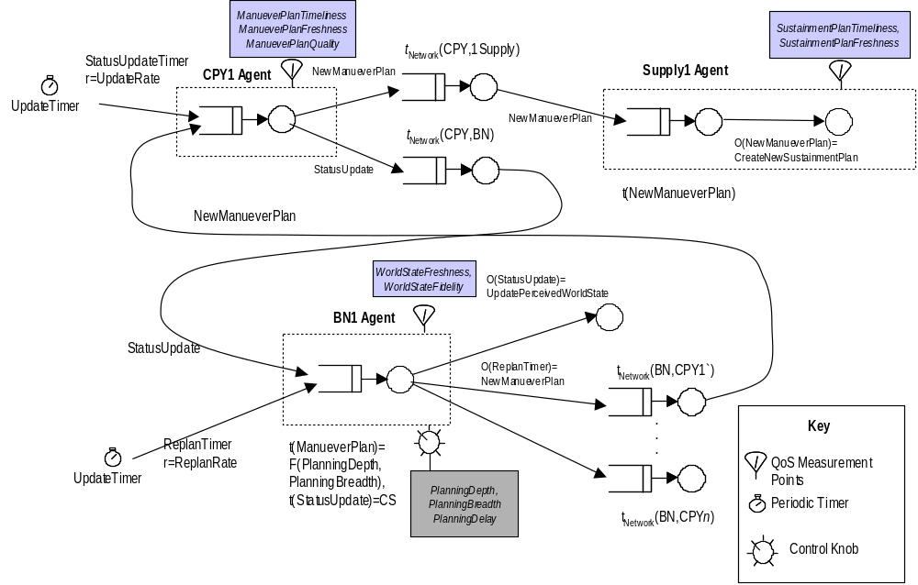
Figure 3 Queue Model of System Behavior

The QoS measurement points requiring tracking messages across multiple queues. For example, “SustainmentPlanFreshness” and “SustainmentPlanTimeliness” relate to overall delays from plan creation time to plan dissemination.

