Running Your Example

Michelle, we got your society running from AWB (up to the point where it complains about not having the UL overlays.)
A couple silly things prevented us from starting it yester:
- UNIX LF vs windoze CRLF
- Didn’t have some of the VM params needed to start with.
The second point suggests the we should mention something that we didn’t show in the society editor yester. Vide the following screen shot:

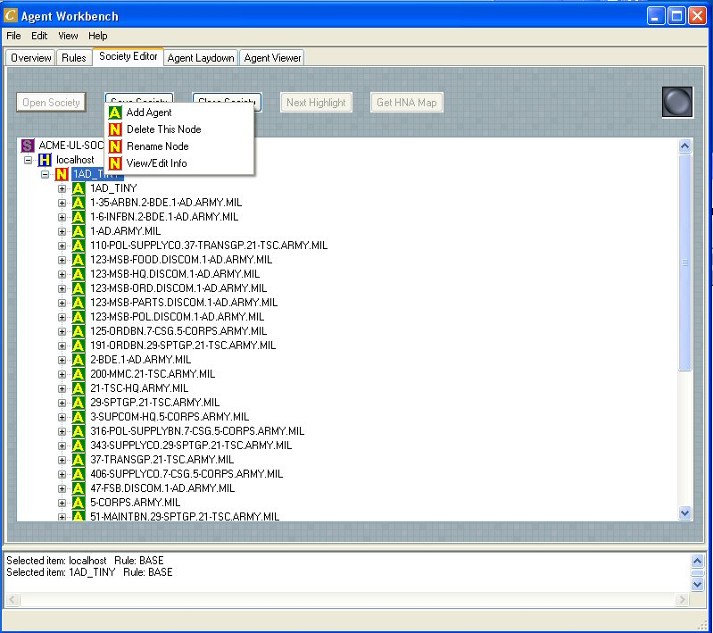
In society editor, if you right click on Node, then a context menu appears and offers “View/Edit Info”. Chose that.
This edit window appears:

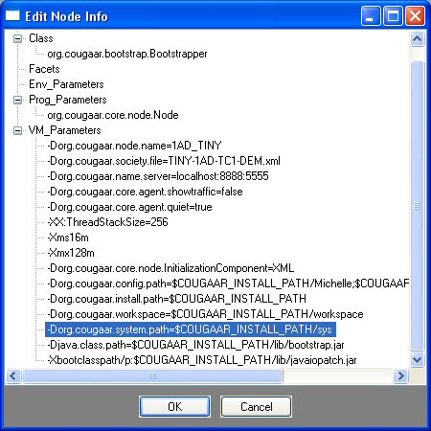
From here, you can add parameters; for example those necessary to actually run your app from AWB ☺

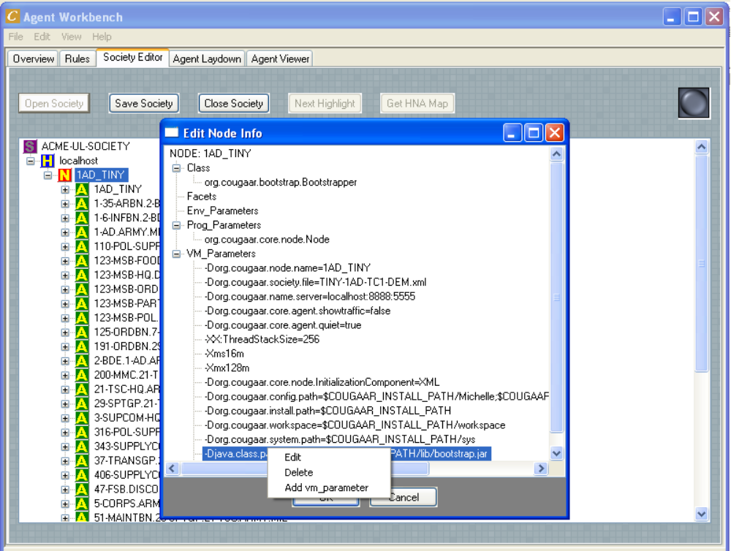

As a point of information, your XML file was missing the classpath info… you’re possibly supplying that thru some other mechanism? Here’s the stuff we edited into the xml file:
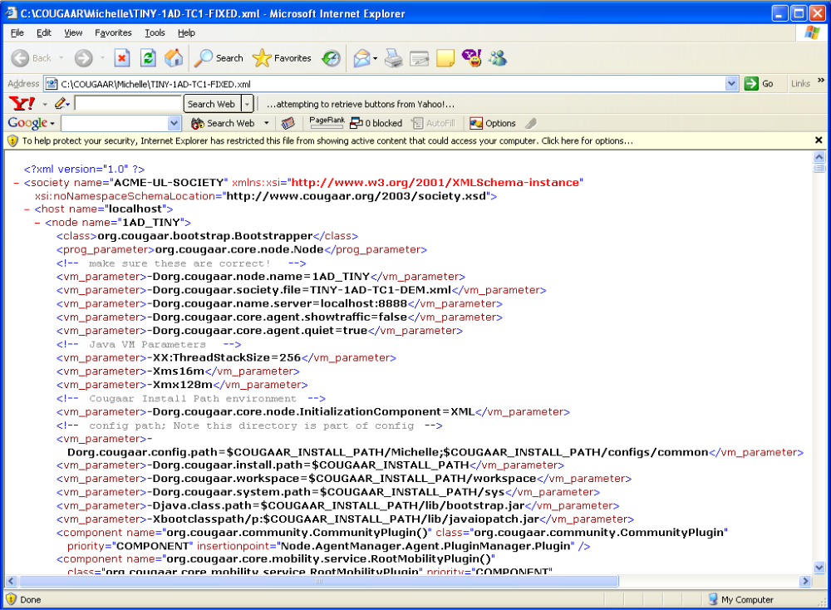

AWB Details
To use AWB, you need to get the following stuff:
- Python 2.3 (http://www.python.org/download/)
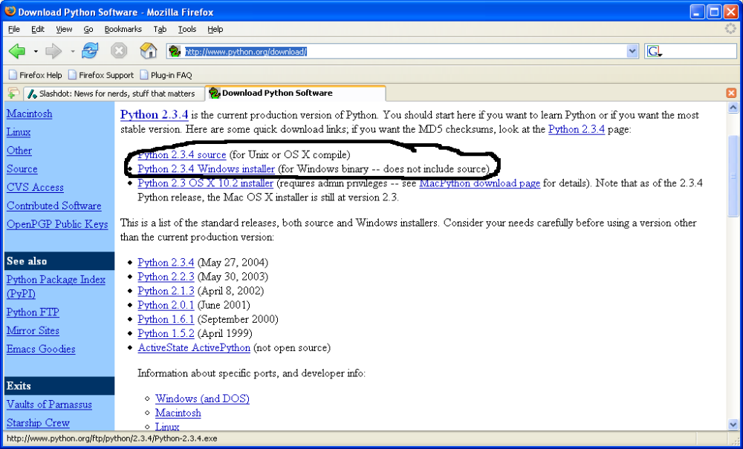
- WxPython (https://sourceforge.net/project/showfiles.php?group_id=10718&package_id=10559&release_id=188259)

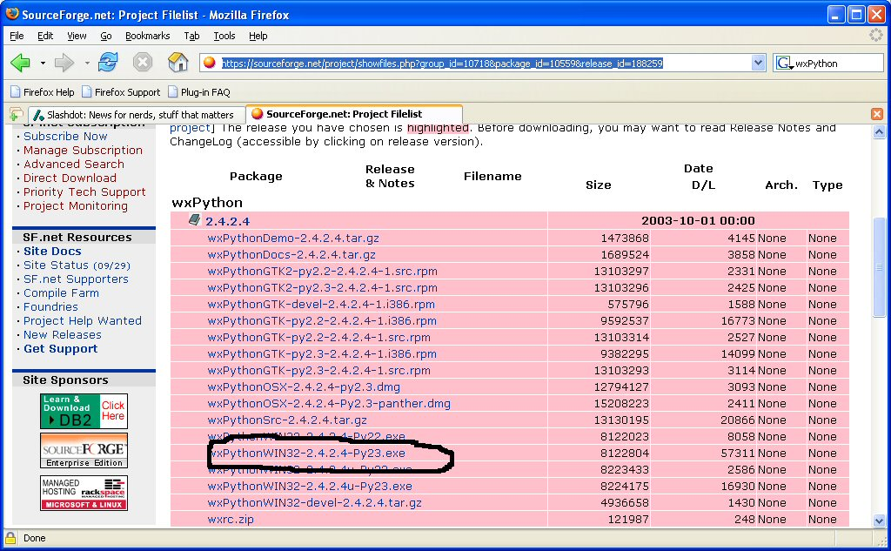
- XML Parser (http://4suite.org/?xslt=downloadproduct.xslt&show=http%3A%2F%2F4suite.org%2Fdata%2Fsoftware%2F4Suite)

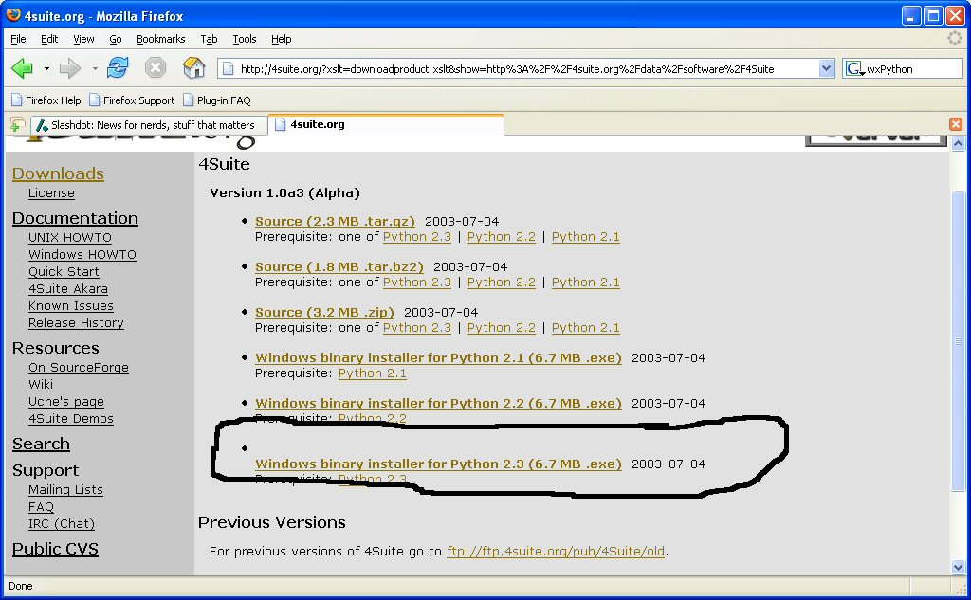
- ACMEPy (cougaar.org)
  - For this one you just have to grab it from the CVS repository on cougaarforge and drop it into <python-install-dir>\Lib\site-packages\

When you’re done, the python folder should look kind of like this:
