

Version 0.3

Cougaar Software, Inc.®
Cougaar Configuration Management
Design Document

Document Information

Trademark
Trademarked names may appear throughout this document. Rather than list the names and entities that own the trademarks or insert a trademark symbol with each mention of the trademarked name, the names are used only for editorial purposes and to the benefit of the trademark owner with no intention of infringing upon that trademark.

Contact Information
To request copies, suggest changes, or submit corrections, send a message to the email address below:
mabrams@cougaarsoftware.com
Cougaar Software Inc.
Attn: Matt Abrams
7925 Jones Branch Drive, Suite G300
McLean, VA 22102

File Information
Last Saved: 5/13/2004 08:07:00 PM

Revision History

Date | Version | Description
02/03/2004 | 0.1 | Initial
04/15/2004 | 0.2 | Updated to reflect community service usage
05/03/2004 | 0.3 | Added screenshots and updated to reflect design changes

References
The following lists describe the relevant project documentation.
Preceding Project documents:
Title | Brief Description
AMIIE Software Architecture Document, version 1.0, March 2003 | This document is one of Cougaar Software’s deliverables for Phase I of the Small Business Technology Transfer (STTR), DARPA ST021-002. The purpose of this document is to describe the architectural design for realizing the concept of Active Methods.
“Active Methods Phase II Proposal for STTR ST021-02”, June 18, 2003. | In 2002, DARPA awarded the Small Business Technology Transfer (STTR ST021-002) Phase 1 - “Active Methods for Warfighters” to Cougaar Software, Inc. This document, the final task of the Phase I effort, outlines a proposed development plan for Phase II of the STTR. This plan defines Cougaar Software’s technical approach for designing, implementing, and demonstrating a full functioning environment that enables the creation and delivery of co-active methods.
AMIIE Phase II Project Charter | Project Definition and Control
AMIIE Phase II Concept of Operations | Proof of Concept requirements
Reference documents:
Title
Cougaar Architecture Document, version for Cougaar 11.0, BBN Technologies, go to section Documentation.
Cougaar Developer’s Guide, version for Cougaar 11.0, BBN Technologies, go to section Documentation.
Cougaar Software, Inc., McLean, VA, ( http://www.cougaarsoftware.com ), go to section Learn About Cougaar Software, Inc.
Cougaar Framework, Open Source project ( http://cougaar.org ), go to section Download or History.
Service Discovery Developers Document - Cougaar Software’s document providing an overview and developer information for Service Discovery in the Cougaar environment.

Table of Contents
1 Document Information i
1.1 Trademark i
1.2 Contact Information i
1.3 File Information i
1.4 Revision History i
1.5 References i
2 Document 1
2.1 Purpose 1
2.2 Background 1
2.3 Project Objectives 1
3 Design 2
3.1 Overview 2
3.2 Current Process 2
3.3 Proposed Process 2
4 Key Components 3
4.1 Agent Containment Service 3
4.1.1 Overview 3
4.1.2 Usage 3
4.2 CSI Configuration Domain 3
4.2.1 Configuration Logic Provider 3
4.2.2 Configuration Directives 3
4.2.3 Configuration Domain Factory 3
4.2.4 Agent Initialization Logic Provider 4
4.3 Agent Configuration Plugin 4
4.3.1 Overview 4
4.3.2 Responsibilities 4
4.3.3 Processing Model 4
4.4 Configuration Manager Plugin 4
4.4.1 Overview 4
4.4.2 Responsibilities 5
4.4.3 Processing Model 5
4.5 Agent Initializer Plugin 5
4.6 Configuration Service 6
5 Configuration Viewer 6
5.1 Configuration Viewer 6

Document

Purpose
The purpose of this document is to describe the design of the Cougaar Configuration Management system for distributed agent societies. The system will discover and provide access to status information for Cougaar components and devices connected through Cougaar components. In addition to providing status information, the system will provide mechanisms to manipulate the environment. For example, the administrator will be able to add, remove and change components from an easy to use graphical environment.

Background
Configuration management for distributed agent societies is a difficult problem for several reasons. System designers need to perform a balancing act between the customizability of the society configuration and the level of complexity for creating the configuration. If designers create a system that is infinitely customizable but also infinitely complex to create, it is not likely that the architecture will gain wide acceptance. If the system sacrifices configuration customization capabilities for simplicity, it will also be a failure.

Project Objectives
Society configurations can be very large and very complex. This makes it very difficult for users to visualize a society. It is even more difficult for a user to grasp the current configuration of a dynamic society. To aid users in understanding the current configuration of the society, a graphical representation of the society is necessary.
The functionality to save a modified Cougaar configuration does not currently exist so users are forced to either start from the initial society configuration or manually modify the society configuration to reflect the changes that they are aware of. It is necessary to implement this functionality so that users can create a custom configuration, save it, and reuse it later.
The goal of the Cougaar Configuration Management project is to introduce infrastructure components that make it possible to create a very rich society configuration in a user-friendly environment. The project will provide real-time society visualization functionality in the form of an interactive graph so that users can drill down to the lowest levels of society configuration or provide a high-level view of the major society components. The graph will be interactive, allowing users to view the status of a component in the graph, send commands to that component, or remove that component from the society. In addition to the graph the GUI will include a hierarchical tree presenting the same information available in the graph. Users should be able to use the tree to navigate the graph to specific sections of the society. The project will also introduce infrastructure components to enable functionality for saving a modified configuration. These infrastructure components for society configuration, visualization, and management will provide users with robust, customizable and user friendly society configuration management utilities.

Design

Overview
The Cougaar Configuration Management system will provide infrastructure and utility components for capturing and visualizing a society configuration using both existing and new Cougaar infrastructure components. It is possible to provide this functionality by simply parsing the configuration file used to load the society; however, this method would not serve as the base architecture for providing future capabilities such as dynamically updating the society configuration and managing the society configuration during runtime. The system will provide society visualization functionality at various levels of the society. Configuration components will aggregate incoming configuration information and the forward that aggregated configuration information to managers at higher levels of the society. In addition managing the configuration of Cougaar components the system will be able to manage external devices (software or hardware) connected to the society.

Current Process
Currently Cougaar does not provide the capability to dynamically generate and visualize a society configuration to users. Tools such as CSMART provide some society visualization utilities but these tools use the initial configuration files for input so they are not able to present a dynamic view of the system or even verify that those components being displayed actually exist. For example, take a simple three-node society on three different hosts. If one of the hosts is not functional for one reason or another, a society visualization tool using the configuration file will still present that node and host even though it is no longer part of the society.

Proposed Process
This application will use the Cougaar infrastructure for dynamically discovering and communicating with nodes present in the society. When a component is registered in the configuration, those components will periodically send status information to their configuration managers. Configuration managers will monitor the health of registered components, if a component does not send its status information within a specified period of time the component will be marked as a non-communicating component and will eventually be removed from the society depending on the user defined parameters. This means that only those nodes and components that are actually up and running will forward configuration information to a global society configuration component. In addition to viewing the current configuration, the management system provides the functionality to manipulate the society. Cougaar communities will also be able to be viewed and controlled with the configuration manager. Users will be able to see the graphical and tree structure of the community and then add and remove components or change their status in the community with the tools available in the GUI.

Key Components

Agent Containment Service

Overview
The Agent Containment Service (org.cougaar.core.service.AgentContainmentService) is a vital component of the Cougaar Configuration Management system. This service provides methods for listing the child components of an agent, getting the state of those components, and getting a list of the binders for an agent. This service is an extension of the services offered by the Agent Containment Service that is part of the core package. Future versions of Cougaar, 11+, will have the functionality mentioned above. Until this time, developers will need to use a Cougaar Core overlay to use the initial versions of this functionality.

Usage
Agent Configuration plugins utilize the Agent Containment Service to discover the configuration of the agent they reside on. The plugin will use the service to traverse the list of components on the agent. When it finds a component, it will add it to the agent value object representing the configuration for this agent.

CSI Configuration Domain
The Configuration Domain contains the logic provider and factories used by the Cougaar Configuration Management system. The Configuration Domain provides the infrastructure components for creating configuration objects and forwarding configuration messages throughout the society.

Configuration Logic Provider
The configuration logic provider examines configuration directives and publishes the payload of incoming directives to the local blackboard.

Configuration Directives
Configuration directives extend from the Cougaar Directive class. The configuration directive has get() and set() methods for a payload object which can be any configuration object.

Configuration Domain Factory
The Configuration Domain Factory is responsible for providing component creation services to clients in the configuration domain. The factory provides methods for creating society objects, node objects, agent objects, and configuration directives.

Agent Initialization Logic Provider
The Agent Initialization Logic provider examines AgentInitializationDirectives and publishes them to the local blackboard if necessary.

Agent Configuration Plugin

Overview
The main responsibility of the Agent Configuration Plugin (ACP) is to maintain the current configuration for the agent and send any deltas to the Configuration Manager(s) (CM) for that agent. The ACP discovers the location of the CM by using the Cougaar community service mechanism to locate the configuration manager for that agent. In order for an agent to be viewed and controlled by the configuration manager, this plugin must be loaded on the agent. This plugin will keep track of the agent status and send the status information along with the configuration information to the CM.

Responsibilities
Agent configuration plugins are responsible for gathering the agent configuration and sending that configuration in the form of a directive to a node configuration agent. Agent configuration plugins must gather the configuration when the plugin is loaded. The plugin will periodically re-calculate the agent configuration and status information and send it to the CM. This information acts as the heart beat single from the agent to the CM.

Processing Model
Agent Configuration plugins use the Agent Containment Service to periodically gather the agent configuration the plugin. The plugin creates an Agent value object with the determined configuration. If the configuration has been modified, the plugin then creates a new configuration directive with the Agent value object as its payload. The plugin sends the directive to the agent with the CM.
Periodically the plugin will publish a task to request status information from child components. Since the plugin will be co-located (within the same JVM) with any component responding to the request, a callback mechanism can be used to retrieve the responses from the child components. The plugin will store this data in the plugin’s local cache and on the blackboard until a request for it is received. When the request for agent status information is received the plugin sends the status information for that agent as a response to the request.

Configuration Manager Plugin

Overview
The Configuration Manager Plugin (CM) is a plugin that manages the configuration on any agent in its configuration community. There should only be one configuration manager plugin per configuration community. This plugin receives and composes agent configurations from agents residing on various nodes and sends the composed set of node configurations to parent configuration manager(s). If the plugin has other configuration managers that report to it then the plugin will integrate the configuration and status information from the child managers into its local society representation.

Responsibilities
The Configuration Manager Plugin is responsible for subscribing to and processing all configuration directives from agents on the same node as this plugin. If the CM has parent managers it needs to send the collected information it has composed to those parents. If the CM has child managers, than it needs to handle incoming node configurations and compile them into the complete society representation. The CM is responsible for gathering agent status information and responding to node status request messages.

Processing Model
The Configuration Manager Plugin expects to receive messages with Agent configuration data. If the CM’s local society representation does not exist already, the CMP plugin creates it. The payload of the configuration directive should contain an Agent value object. The plugin adds the agent value object to the node-level society configuration. If the agent already exists in this configuration, the existing version and the incoming version are compared for equality and the existing version is replaced if they differ. If a node level configuration is modified the plugin creates a configuration directive with the nodes configuration and sends it to the society configuration agent. If the society configuration agent has not been discovered yet, the plugin will send the configuration when the society configuration plugin becomes available.
If the CM is has child managers reporting to it, it will handle incoming node configurations. . The plugin either adds or replaces the node-configuration to the society configuration. The plugin will search the society for the host that the node-configuration is for and then check to see if the node already exists on that host. If it does not already exist, it is added. If it does exist it is checked for equality and the old configuration is replaced if they differ. If any changes are made to the society configuration, the plugin publishes a change to the society configuration object so that other components are aware of the change.
The CM tracks all of the components that report to it and updates the status information for those components based on information it receives and monitors how long it has been since the last report. If the component exceeds the certain period of time before status updates the CM will change the components status to unknown and eventually mark the component as being dead. This information will be reflected in the GUIs presented in the GUIs.

Agent Initializer Plugin
The Agent Initializer Plugin should be added to each agent in the society. This plugin subscribes to AgentInitializationDirectives and uses the Configuration Service to load the components contained in the payload of the directive into the agent. This is the plugin that allows agents that do not have pre-existing configuration files to be loaded and created dynamically. Since agents can only load components on themselves, not other agents, it is necessary to call the configuration service from with the agent where the components are supposed to be loaded.

Configuration Service
The configuration service provides and API to add, remove, and modify Cougaar components. This service should be loaded on each agent and the functionality can be accessed through the Configuration GUI. The service leverages existing Cougaar Plugins for agent mobility. In addition to the configuration service each agent including the node agents needs the RootMobilityPlugin and the RedirectAndMovePlugin to support agent mobility.

Visualization

Configuration Viewer
The Configuration Viewer provides graphical and tree representations of the society. The viewer also provides control functionality to the user allowing them to add, remove and move society components with the graphical interface. Figure 1 is a screen shot of the Configuration Viewer with two nodes each with two agents (and a node agent). If the user single clicks a component in the tree view (see Figure 2), the graphical image will automatically drill down to display that component and the nearest N neighbors where N is a number selected by the user to determine how much of the society to display at any single moment. This mechanism allows the user to visualize a small section of a very large society. The user can also change the configuration by using the graphical display to select components and then use pop-up menus to perform society operations. For example a user can remove an agent by right-clicking on it and then selecting ‘Remove Agent’ (see Figure 3). After the user removes the agent the graph and table are automatically updated to reflect the changed society (see Figure 4). The table icon for the removed agent changes from green to red because the agent is no longer in the society. If the user did not take an active role in the removal of the agent but it stopped communicating for some reason (network or JVM failure for example) then the icon would first change to yellow to indicate a problem is occurring and then eventually change to red if the problem is not resolved within a parameterized period of time.
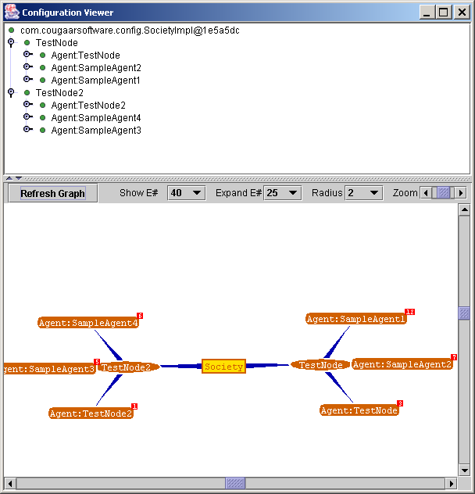
Figure 1 Configuration Viewer with two nodes and three agents per node
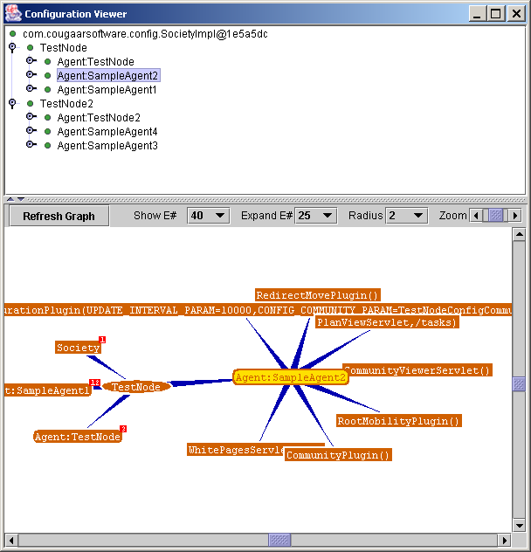
Figure 2 Society Drill down to user selected component
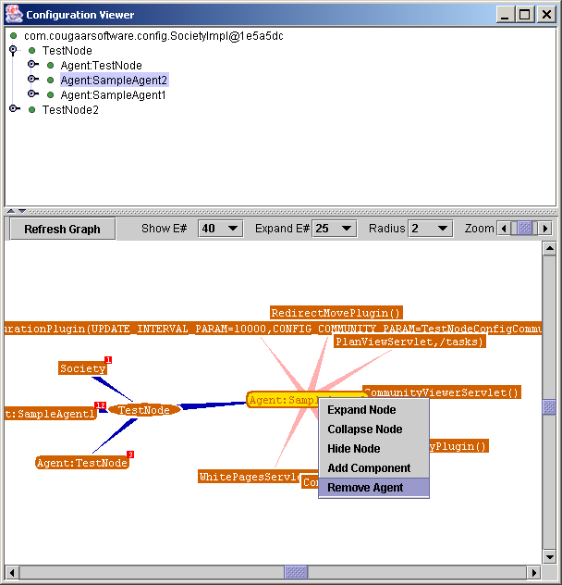
Figure 3 User uses pop-up menu to remove agent
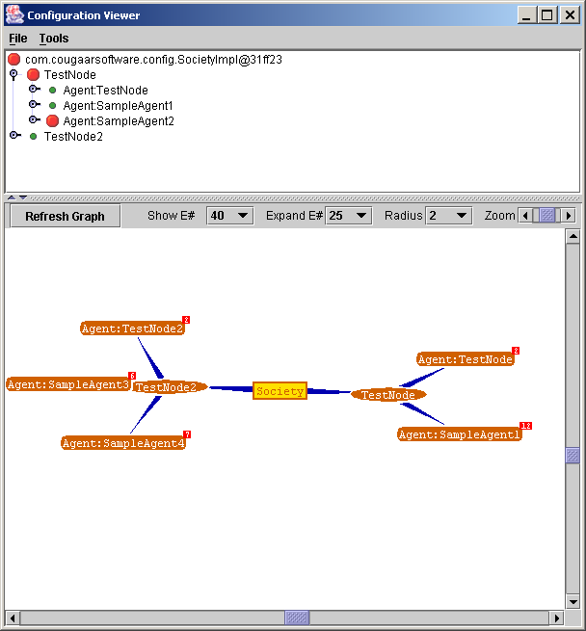
Figure 4 Society after SampleAgent2 is removed

