Overview
This document defines the requirements and implementation strategy for the incorporation of a community capability into the Cougaar infrastructure. The requirements driving this capability are primarily derived from the needs of the 4 UltraLog Defense Threads.

Key Concepts

Community structure
- A community is an aggregation of agents and/or other communities.
- An agent may be a member of multiple communities. However, an agent may only be a member of a single “restart community”.
- Community services are accessed via designated community “SpokesAgents”. Depending upon the types and number of services that are exported a community may be associated with multiple SpokesAgents. A particular SpokesAgent may also be associated with multiple community services (roles). Exported services includes both community management roles (such as MembershipManager or Distributor) and domain services (such as “FuelTransportProvider”). For 9.4, a single SpokesAgent will probably satisfy all these roles. Community management roles include:
- MembershipManager: The agent with this role receives requests to join or leave a community, and approves or denies the requests based on business rules and policies.
- Distributor: The agent with this role receives objects from external sources distributes them to affected member agents.
- The internal structure of a community is not visible to non-privileged components. Only authorized agents (such as community SpokesAgents and restart agents) and certain infrastructure components (such as the message transport) will be able to access community rosters.
- Each community must have a unique identifier. This identifier will be one of the community properties in the Yellow Pages.

SpokesAgents
- One or more “SpokesAgents” will be identified for each community. The SpokesAgents provide access to community provided services to external agents.
- A community may have more than 1 SpokesAgent for any provided service. Assuming that the SpokesAgents are hosted on different computers (or enclaves) the use of multiple SpokesAgents will enhance community robustness. The specific strategy for the selection of a specific SpokesAgent has not been determined yet.

Community Types
There are a variety of community types for various purposes. Listed below are some representative community types:
- Military hierarchy communities
- Service providing communities
- Restart communities
- Hardware based communities
- Customer Communities - This is the set of all customers of a service providing community. It might be useful to have this as an explicit community so that they can share policies.

Yellow Pages
Each community will register itself in the Yellow Pages as part of its startup processing. The Yellow Pages are used to relate a SpokesAgent and role (MembershipManager, Distributor, etc) to a named community. By using the Yellow Pages, agents will be able to discover communities and obtain references to the community SpokesAgent that is able to provide a particular service. Since the Yellow Pages contains sensitive information access will be restricted by a Community Service component.
The Yellow Pages will be a key element in the evolving UltraLog system design. As such many issues related to namespace and attribute tagging need to be resolved. For the Cougaar 9.2/9.4 releases we will be assuming the definition of a flat community structure. This will, of course, require that each community have a unique name.
The Yellow Pages will also be used to maintain all community state information such as community rosters.

Configuration Database
A startup community structure will be obtained from the configuration database during society startup. For Cougaar 9.2 this structure will not be modifiable at run time. Starting with 9.4 agents will be able to leave their default communities and join (and possible create) new communities. A mechanism must be established for generating/maintaining the Community/Member relationships in the configuration database (possibly using CSMART?). For 9.2 we will develop an SQL script for populating the configuration database with these relationships.

Requirements

General Requirements
- The internal structure of a community should not be visible to non-privileged agents. In this context, a privileged component is defined as a SpokesAgent for that community or an external agent that has been designated to fill the role of “restart agent” for the community.

Defense Thread Requirements

Robustness
- Must support notion of a ”Restart Community".
- ”Self" for a community is defined by its unique identifier and the SpokesAgent who (at least up to 9.4) maintains and distributes the membership list
- Agent restart: Ideally, for an agent to be restarted, a recent copy of its blackboard must be persisted. Details from the robustness defense team.
- Community restart: In order for all or part of a community to be restarted, a restart must be running or restarted. Note that until the SpokesAgent is restarted, the basic community functions will not be available. Thus, all community state must be maintained on the blackboard of the SpokesAgent, and that blackboard must be persisted.
- Must support WAN-distributed restart community members. Community membership overhead must be predictable and relatively low. [Can this be quantified?] Possible requirements for WAN communication where the restart agent and the restart community are on separate LANs:
- Notification of restart community membership and changes (low frequency)
- Notification of a dead agent (low frequency message from sensors?)
- Restart process. Potential for brief, high bandwidth communication over a WAN. Details from Robustness Defense Team.

Restart Communities and Restart Agents
A restart community is a set of agents thar are monitored by a restart agent. If the restart agent discovers one or more dead agents in its restart community, it restarts them. It could actually restart all the agents in a completely dead restart community. A restart agent is not a member of the community it monitors, although as any agent, it must be a member of exactly one restart community.
The restart agent obtains community rosters via the CommunityService interface. These rosters will be maintained in the Yellow Pages.

Adaptive Logistics
- Must support policy distribution within a community.

Load Balancing
Should be a subset of the robustness thread

Security
No requirements identified yet. Perhaps access control distributing rosters, and policy-based restrictions on joining or leaving a community.

Creating Agent Relationships
Up through 9.4, the current mechanisms for creating agent relationships will remain in place. No changes needed here until 9.4.

Design goals
This section defines implementation objectives that while not treated as mandatory requirements will nonetheless be strongly considered in the design of the community architecture and components.
- All client interaction with the community management infrastructure will be accomplished using blackboard publications and subscriptions.
- To the extent practical, the design of the community infrastructure will be compatible with existing domain and infrastructure components. In other words, a component that was developed prior to 9.0 should not require modification to function in a post 9.2 community-enabled society. Changes in community-level provider/customer interactions should be transparent to legacy plugins.

Use case summary (9.2 and 9.4)
This section provides a summary of the use cases that must be satisfied by the community components to be developed. Detailed use cases are included in section 11.
- Perform a cold start - Agents are started as they are now from a configuration database. The configuration database will have new information regarding community membership and roles.
- Establish agent relationships – Relationships are established from the configuration database as they are done now using ReportForDuty and ReportForService tasks. For now, this is not done with special logic for communities. However, there will be new roles and relationships for communities. Some new roles would be PointOfContact, MembershipManager, Distributor, (Member?). A new relationship would be Member/MembershipManager.
- Get a reference to a community spokesman – This is used by a community client to obtain a reference to a community SpokesAgent. If the SpokesAgent is acting as a broker for the specified community service, it would return the identity of internal community members providing that service. On the other hand, if the SpokesAgent is acting as a router, it would return a reference to itself.
- Get a community roster – This is primarily needed by restart agents and agents that perform policy distribution.
- Join a community - An agent that is not currently a member of a community requests membership. The membership request is made via the agents local CommunityService. The CommunityService will locate the communities SpokesAgent by querying the Yellow Pages for a CommunityMembership service provider for the named community. The community SpokesAgent is responsible for acting on the request. The manner in which this is accomplished is community-dependent. In some cases the SpokesAgent may disposition this unilaterally; in other communities there may be rules and policies governing permission for joining.
- Leave a community – An agent decides to leave a community of which it is currently a member. There may be rules and policies governing permission for leaving.
- Distribute objects to community – Communities will be responsible for the distribution of various objects to member agents. Each community will have a SpokesAgent that performs the Distribution role for the community. This SpokesAgent will likely have a DistributionPlugin that receives the objects and forwards them to member agents based on distribution rules. The objects are sent to various community member agents where a logic provider receives them and posts them on the member agents blackboard.
- Initialize a restart agent – When a restart agent is initialized, it is told the unique identifier of the monitored restart community. It obtains a community roster from the Yellow Pages using a local CommunityService. There may be a new restart customer/provider relationship between the SpokesAgent (restart customer) and the restart agent (restart provider).
- Restart agent restarts a community membert – This will be performed by the Robustness Defense Team. No special action is required from the Community implementation
- Get a community service - This use case represents the most typical use of a community. That is, an external (customer) agent obtains a reference to a community to access some service that the community provides. The provider community has registered one or more services in the Yellow Pages. The customer agent will obtain a reference to the appropriate community SpokesAgent via its local CommunityService interface. Once a reference to the communities SpokesAgent has been obtained the customer agent will allocate tasks to the community via the SpokesAgent.
- Perform community collaboration - Some community actions, such as the granting of membership to new agents, will likely require collaboration among community members. This use case defines a means for soliciting community wide decisions. A concept currently under consideration is based on a voting approach where each member is polled for a position.

Definition of terms used in use cases
This list defines terms that are used in the following use cases.
- Member agent: An agent that is a member of the community that is within the context of the use case described.
- Non-member agent: An agent that is not a member of the community that is within the context of the use case described.
- SpokesAgent: An agent that is acting in the role of SpokesAgent for the community that is in the context of the use case described.
- Customer agent: An agent that is not a member of a community but is interacting with the community as a user of a service provided by the community.
- Restart agent: An agent that is responsible for restarting failed agents or communities.
- Local community management components: Plugins, binders, or service components within an agent that implement community management capabilities.

Preliminary architecture
Figure 1 identifies 3 components to be developed in support of Cougaar 9.2/9.4 requirements.

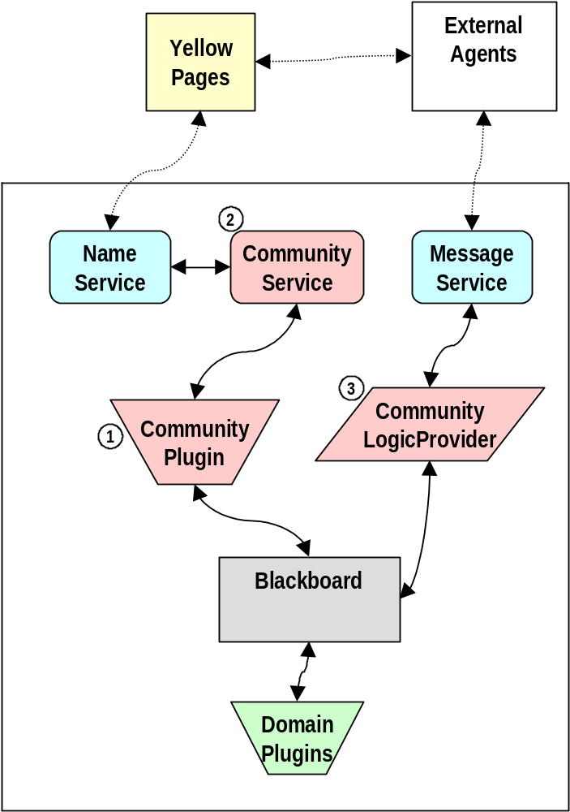
Figure 1: Community Infrastructure Components
- A Community Plugin will be developed to monitor the blackboard for community requests by client plugins. The Community Plugin will interact with the other community infrastructure components (the Community Service and Logic Provider) to perform the requested action. The Community Plugin is also responsible for creating and publishing response objects back to client plugins.
- The Community Service provides an interface to the Yellow Pages where community state information is maintained. The Community Service is not directly accessible by clients. Rather, clients must publish requests to the blackboard where the Community Plugin receives them and interacts with the Community Service.
- For community actions that require the involvement of multiple agents a special Logic Provider is used to send/receive community directive messages.

Techspecs
TBD

APIs
The API to the community management infrastructure is by a blackboard publish/subscribe protocol and a service interface that is accessed via a service broker. The following paragraphs describe these interfaces and associated object types. Appendix A includes the java specifications for each defined interface/class.

Community Service
This service provides access to community information maintained in the Yellow Pages. A reference to this service is obtained via the agents service broker. This service provides the following capabilities:
- Get a community roster
- Add an agent to a communities membership list
- Remove an agent from a communities membership list
- Get a list of communities of which a specified agent/community is a member
- Add a spokesagent to a community
- Remove a spokesagent from a community
- Add an agent to a communities “interested parties” list
- Add an agent from a communities “interested parties” list
- Get a spokesagent identifier from a community based on a community role
- Create a community
- Check for the existence of a community

Community Object Types
This section identifies the object types that are used to manage and interact with communities.

CommunityRequest
This object type is used by clients to request actions of the community infrastructure (e.g., get a community roster). The object contains a “verb” field (such as “GetRoster”) that is used to specify the specific action to be performed. The object also contains fields for specifying community names and agent names that are targets of the action.
A plugin initiating a community request will subscribe to the originating CommunityRequest to receive a response from the community infrastructure. The CommunityRequest provides a “getCommunityResponse” method for retrieving a CommunityResponse object.

CommunityResponse
This object type provides a response to a CommunityRequest. It includes a response code indicating the result of the request. Additionally, if an object is generated by the request (such as a community roster), the generated object is accessed from the CommunityResponse.

CommunityRoster
The CommunityRoster object type contains a list of community members (agents and other communities).

CommunityMembershipList
The CommunityMembershipList object type contains a list of communities of which an agent or community is a member.

CommunityOrganization asset
This object type is similar to a Organization asset object that is currently used to represent external agents. The CommunityOrganization asset will be used to represent a community on an agents blackboard. Using this object type agents will be able to allocate tasks to communities in the same manner as they currently allocate tasks to other agents. The community infrastructure will route allocated tasks to an appropriate spokesagent within the community.

CommunityDirective
This object type is used by the community infrastructure to send community messages between agents. This object is not used by client plugins. Rather, it used by the community infrastructure plugins and logic providers for inter-agent communication.

CommunityChangeNotification
This object type is used to notify an agent of a change in community state in the Yellow Pages. A CommunityChangeNotification is published to the blackboard of all agents that have registered as an interested party for a community.

SpokesagentDescriptor
This object type is used to associate a community spokesagent to one or more roles that it supports.

CommunitySpokesagentList
This object type is used by the community logic providers to identify a community spokesagent when a task is allocated to a CommunityOrganization asset. The community plugin will create and maintain a CommunitySpokesagentList for each supporting community. The CommunitySpokesagentList consists of SpokesagentDescriptor objects for the communities spokesagents.

Schedule

Implementation plan for 2002
Table 1 provides an overview of the community capabilities planned for 2002. The table identifies those capabilities that will be implemented for the major 2002 releases. The “Deferred Capabilities” column refers to community requirements that have been identified but are not needed this year. These capabilities will be developed once 9.4 has been delivered and will be integrated into a 2003 release. The capabilities identified for 9.4 have been subdivided into two categories. The first refers to those capabilities that are essential to the achievement of 9.4 objectives. The second category identifies capabilities that are desirable but not essential and will be worked on as a “best effort”. Those optional capabilities that are not completed in time for 9.4 will be considered “Deferred” and will be rolled into a 2003 release.

Table 1 : 2002 Implementation Plan Summary
Capability | 9.2 | 9.4 (essential) | 9.4 (optional) | Deferred capabilities
Community structure | Flat communities only. |  | Support for nested communities
Community membership | Initial community membership established via Community/Member roles and relationships in configuration database. | Capability for an agent to join or leave a community with limited membership authorization. | Authorization (grant/deny) of agent membership requests (join/leave) by MembershipManager
Community management services |  | MembershipManager service implemented in single SpokesAgent. |  | Support for multiple SpokesAgents with distributed roles.
MembershipManager |  | Initial implementation. Provides capability for an agent to join or leave a community with limited authorization | Agent request to join/leave a community is authorized using policy/rule based mechanism. | Agent request to join/leave a community is authorized using community specified mechanism.
CollaborationManager |  |  |  | Initial implementation
Discovery of external community spokesagents | SpokesAgent located via Yellow Pages. |  |  | Community roles distributed across multiple SpokesAgents.
Community spokesagent modes |  |  | SpokesAgent provides reference to domain service providers in “Broker” mode. | SpokesAgent provides reference to domain service providers in “Broker” mode.

Open design issues
- What kind of transaction/locking capabilities are provided by theYellow Pages? For instance, some operations such as testing for the existence of a community and community creation should be performed as an atomic operation.

Detailed Usage Scenarios
This section contains details for key use cases defined in section 5 planned for Cougaar 9.2/9.4.

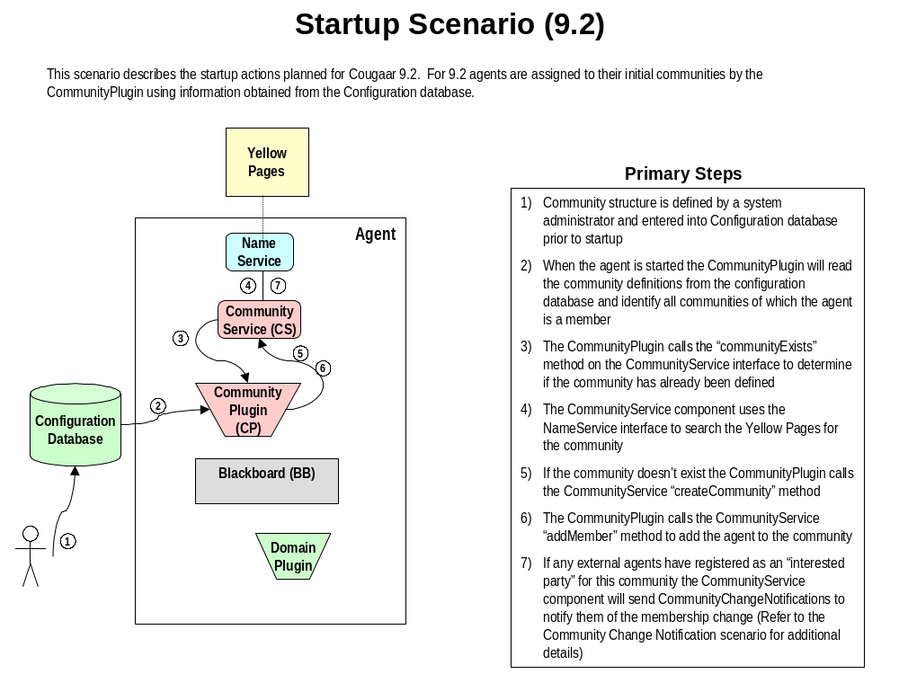

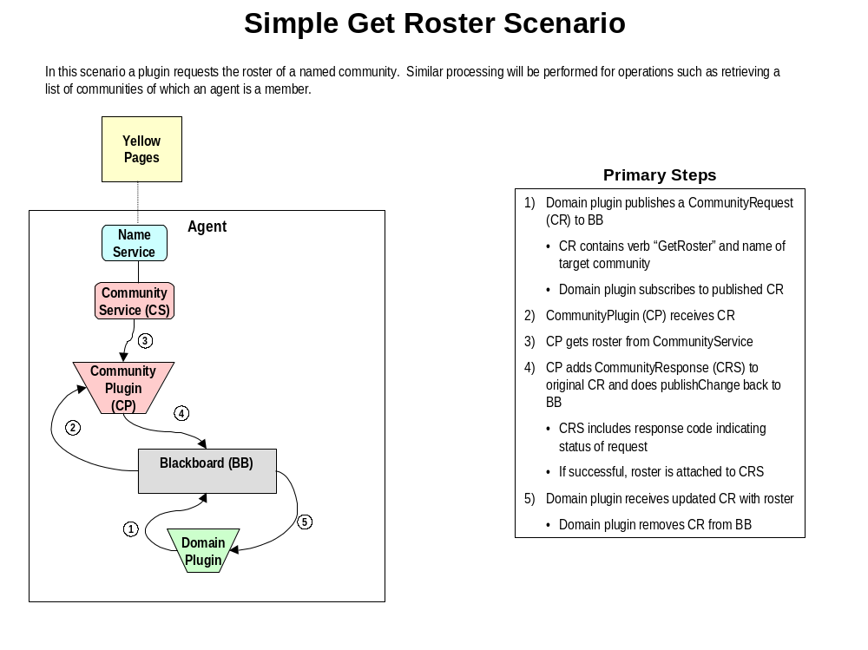

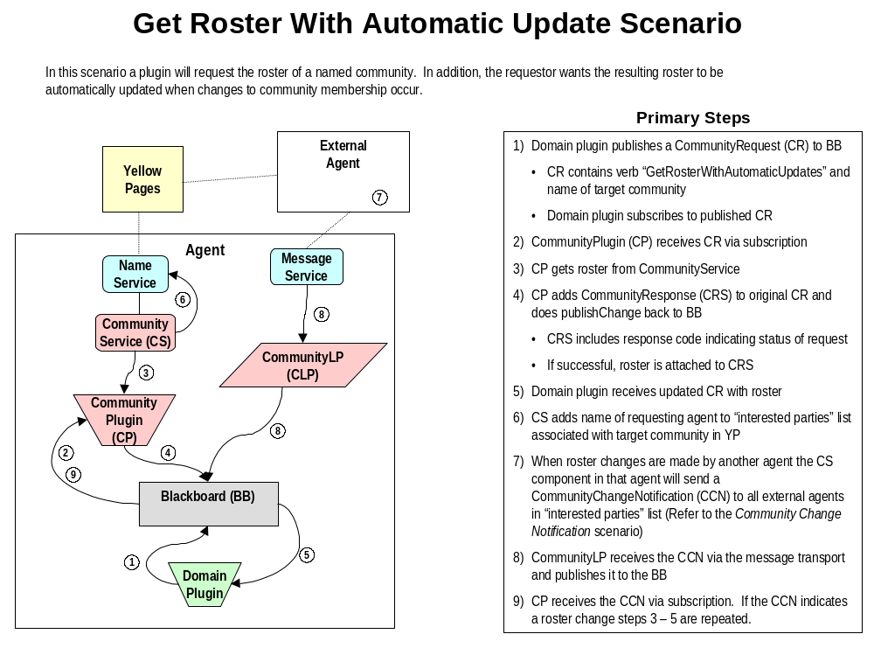

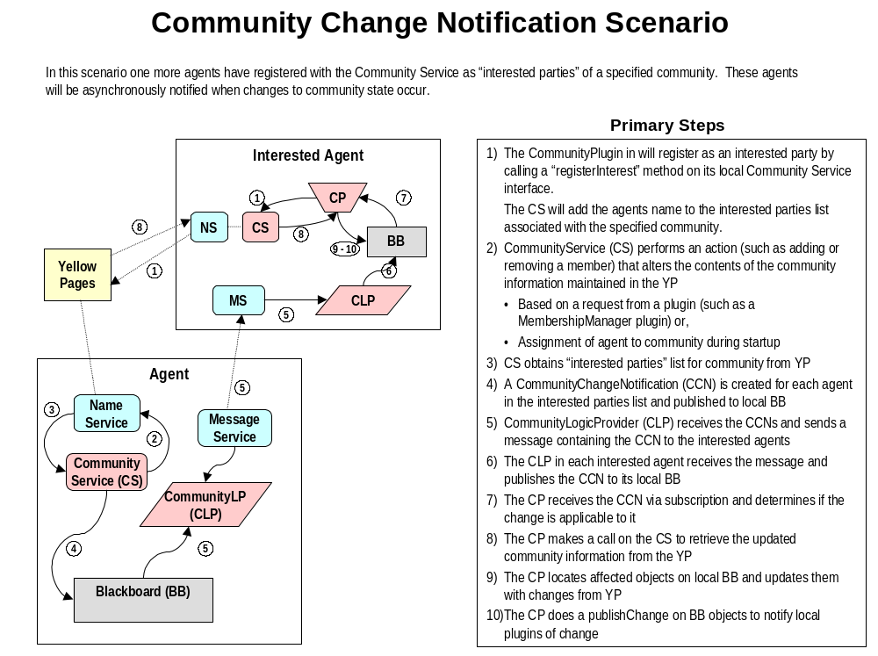

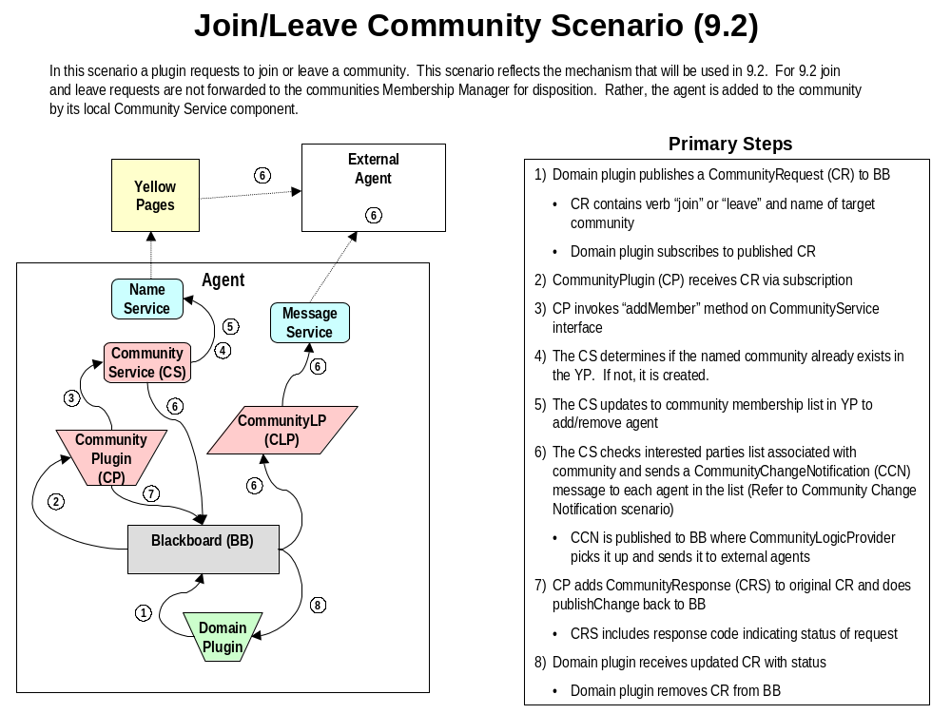

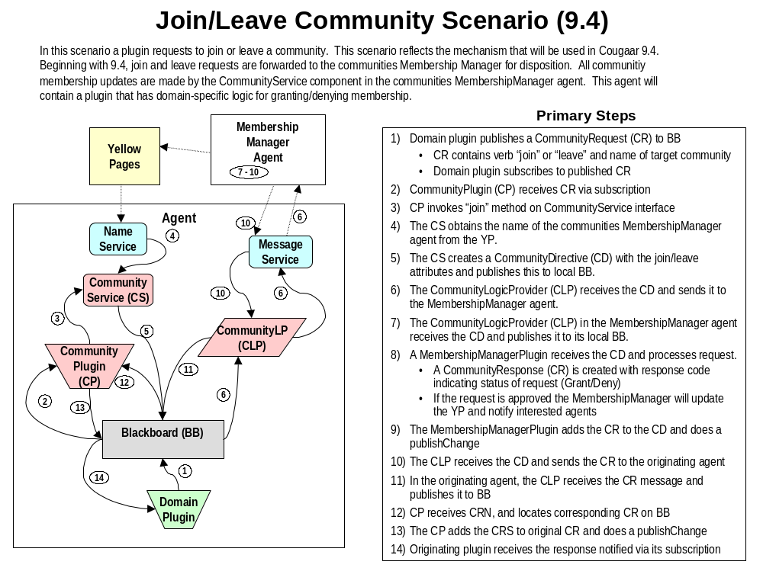

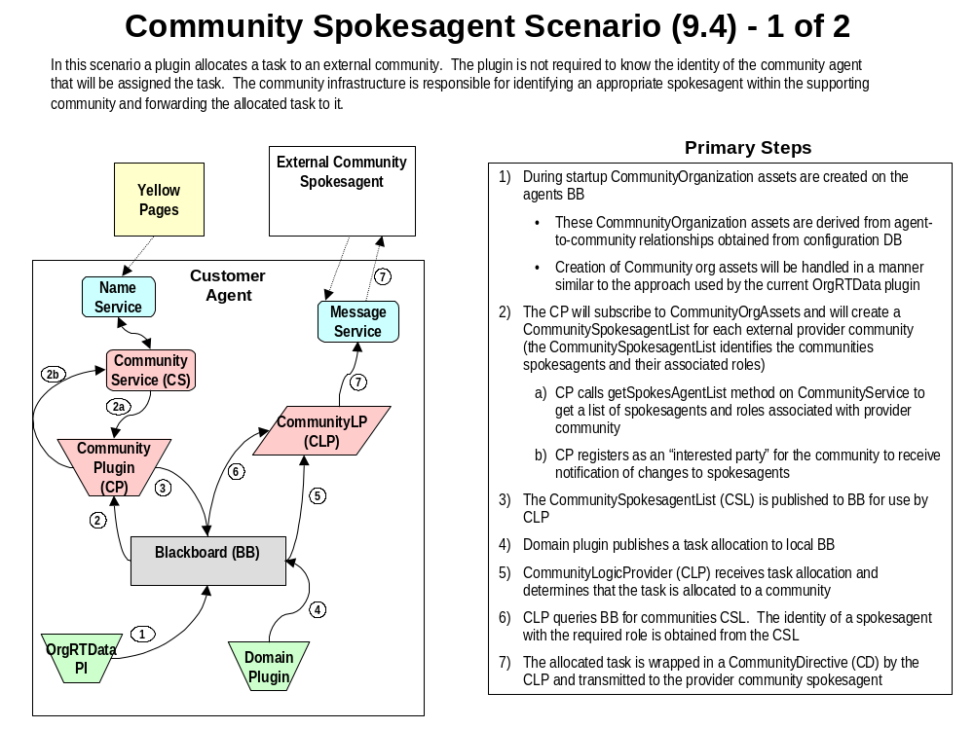

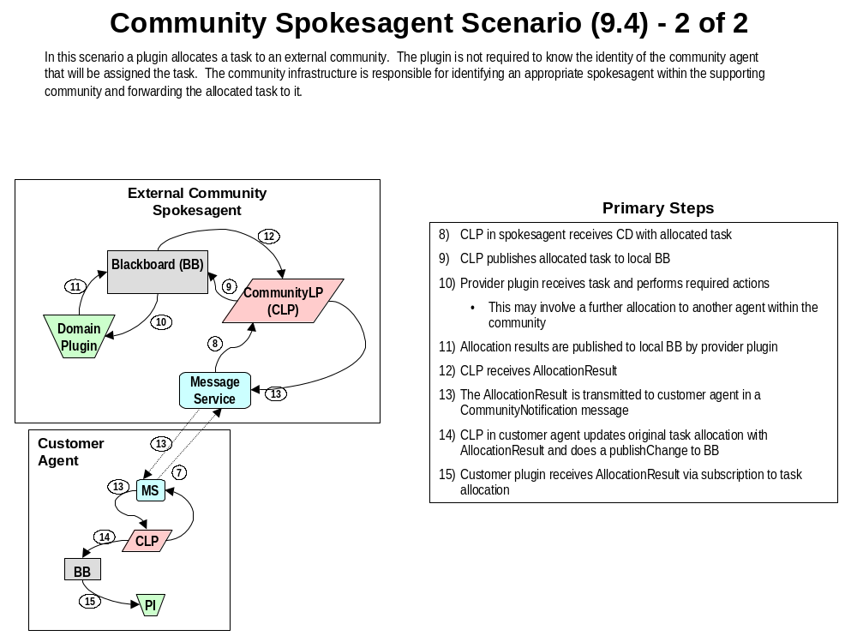
Appendix A: Java class/interface specifications

A.1 CommunityRequest.java

/*
* <copyright>
* This program is free software; you can redistribute it and/or modify
* it under the terms of the Cougaar Open Source License as published by
* DARPA on the Cougaar Open Source Website (www.cougaar.org).
*
* THE COUGAAR SOFTWARE AND ANY DERIVATIVE SUPPLIED BY LICENSOR IS
* PROVIDED 'AS IS' WITHOUT WARRANTIES OF ANY KIND, WHETHER EXPRESS OR
* IMPLIED, INCLUDING (BUT NOT LIMITED TO) ALL IMPLIED WARRANTIES OF
* MERCHANTABILITY AND FITNESS FOR A PARTICULAR PURPOSE, AND WITHOUT
* ANY WARRANTIES AS TO NON-INFRINGEMENT. IN NO EVENT SHALL COPYRIGHT
* HOLDER BE LIABLE FOR ANY DIRECT, SPECIAL, INDIRECT OR CONSEQUENTIAL
* DAMAGES WHATSOEVER RESULTING FROM LOSS OF USE OF DATA OR PROFITS,
* TORTIOUS CONDUCT, ARISING OUT OF OR IN CONNECTION WITH THE USE OR
* PERFORMANCE OF THE COUGAAR SOFTWARE.
* </copyright>
*/

package org.cougaar.community;

import org.cougaar.core.blackboard.Publishable;
import org.cougaar.core.util.UniqueObject;

/** CommunityRequest Interface
* The CommunityRequest provides a mechanism for components
* to interact with the community management infrastructure. A
* CommunityRequest is a request by an agent to the community
* management infrastructure to perform a specific task (such
* as joining a community).
**/

public interface CommunityRequest extends UniqueObject, Publishable {

/**
* The getVerb method returns the verb of the CommunityRequest.
* For example, in the CommunityRequest "join 1ad_community...", the
* Verb is the object represented by "join".
* @return Returns the verb string for this CommunityRequest.
**/

String getVerb();

/**
* The getAgentName method identifies the name of the agent
* that is the target of this CommunityRequest.
* @return Name of the agent that is target of this CommunityRequest
**/

String getAgentName();

/**
* The getTargetCommunityName method identifies the name of community
* that is the target of the CommunityRequest.
* For example, in the CommunityRequest "join 1ad_community...", the
* target community is the object represented by "1ad_community".
* @return Name of community that is target of this CommunityDirective
**/

String getTargetCommunityName();

/**
* The getSourceCommunityName method identifies the name of the community
* of which the target agent is currently a member.
* For example, in the CommunityRequest "reassign agent1 from communityA
* to communityB", the source community is the object represented by
* "communityA" and the target community is the object represented by
* "communityB".
* @return Name of community of which the target agent is currently a member
**/

String getSourceCommunityName();

/**
* Returns the response object associated with this CommunityRequest.
* @return CommunityResponse object associated with this request.
*/
CommunityResponse getCommunityResponse();

/**
* The setVerb method sets the verb of the CommunityRequest.
* For example, in the CommunityRequest "join 1ad_community...", the
* Verb is the object represented by "join".
* @param verb - The verb of the CommunityRequest.
* <PRE>
* Supported Verbs:
* GET_ROSTER - Gets membership list associated with community
* specified by TargetCommunity
* GET_ROSTER_WITH_UPDATE - Gets membership list associated with community
* specified by TargetCommunity. Changes in
* membership are automatically applied to the
* generated roster.
* GET_COMMUNITY_LIST - Gets list of communities of which the
* specified agent is a member
* JOIN - Request to join TargetCommunity
* LEAVE - Request to leave TargetCommunity
* REASSIGN - Reassigns the specified agent from the
* SourceCommunity to TargetCommunity
* </PRE>
**/

void setVerb(String verb);

/**
* The setAgentName method identifies the name of the agent
* that is the target of this CommunityRequest.
* @param Name of the agent that is target of this CommunityRequest
**/

void setAgentName(String agentName);

/**
* The setTargetCommunityName method identifies the name of community
* that is the target of the CommunityRequest.
* For example, in the CommunityRequest "join 1ad_community...", the
* target community is the object represented by "1ad_community".
* @return Name of community that is target of this CommunityDirective
**/

void setTargetCommunityName(String communityName);

/**
* The setSourceCommunityName method identifies the name of the community
* of which the target agent is currently a member.
* For example, in the CommunityRequest "reassign agent1 from communityA
* to communityB", the source community is the object represented by
* "communityA" and the target community is the object represented by
* "communityB".
* @return Name of community of which the target agent is currently a member
**/

void setSourceCommunityName(String communityName);

}
A.2 CommunityResponse.java

/*
* <copyright>
* This program is free software; you can redistribute it and/or modify
* it under the terms of the Cougaar Open Source License as published by
* DARPA on the Cougaar Open Source Website (www.cougaar.org).
*
* THE COUGAAR SOFTWARE AND ANY DERIVATIVE SUPPLIED BY LICENSOR IS
* PROVIDED 'AS IS' WITHOUT WARRANTIES OF ANY KIND, WHETHER EXPRESS OR
* IMPLIED, INCLUDING (BUT NOT LIMITED TO) ALL IMPLIED WARRANTIES OF
* MERCHANTABILITY AND FITNESS FOR A PARTICULAR PURPOSE, AND WITHOUT
* ANY WARRANTIES AS TO NON-INFRINGEMENT. IN NO EVENT SHALL COPYRIGHT
* HOLDER BE LIABLE FOR ANY DIRECT, SPECIAL, INDIRECT OR CONSEQUENTIAL
* DAMAGES WHATSOEVER RESULTING FROM LOSS OF USE OF DATA OR PROFITS,
* TORTIOUS CONDUCT, ARISING OUT OF OR IN CONNECTION WITH THE USE OR
* PERFORMANCE OF THE COUGAAR SOFTWARE.
* </copyright>
*/

package org.cougaar.community;

import org.cougaar.core.blackboard.Publishable;

/** CommunityResponse Interface
* A CommunityResponse is a direct reply to a CommunityRequest published
* by a client. The CommunityResponse will identify the result of the request
* in a response code. If the request generated an object (such as a
* community roster) this generated object is also accessed via the
* CommunityResponse.
**/

public interface CommunityResponse extends Publishable {

// Result codes
public static final int ERROR = 0;
public static final int SUCCESS = 1;
public static final int FAIL = 2;
public static final int GRANT = 3;
public static final int DENY = 4;

/**
* The getResultCode method returns the status of the CommunityRequest.
* @return Verb Returns the ResultCode of the CommunityRequest
**/
int getResultCode();

/**
* The getResultMessage method returns any detailed message that may
* be associated with the response. For instance, if the result code
* is ERROR, this method will return an error message to assist in debugging.
* @return Returns a message with details associated with the result code
**/
String getResultMessage();

/**
* The getResponseObject method returns any object that may have been
* generated by the CommunityService request.
* @return Returns request specific object
**/
Object getResponseObject();

}
A.3 CommunityRoster.java

/*
* <copyright>
* This program is free software; you can redistribute it and/or modify
* it under the terms of the Cougaar Open Source License as published by
* DARPA on the Cougaar Open Source Website (www.cougaar.org).
*
* THE COUGAAR SOFTWARE AND ANY DERIVATIVE SUPPLIED BY LICENSOR IS
* PROVIDED 'AS IS' WITHOUT WARRANTIES OF ANY KIND, WHETHER EXPRESS OR
* IMPLIED, INCLUDING (BUT NOT LIMITED TO) ALL IMPLIED WARRANTIES OF
* MERCHANTABILITY AND FITNESS FOR A PARTICULAR PURPOSE, AND WITHOUT
* ANY WARRANTIES AS TO NON-INFRINGEMENT. IN NO EVENT SHALL COPYRIGHT
* HOLDER BE LIABLE FOR ANY DIRECT, SPECIAL, INDIRECT OR CONSEQUENTIAL
* DAMAGES WHATSOEVER RESULTING FROM LOSS OF USE OF DATA OR PROFITS,
* TORTIOUS CONDUCT, ARISING OUT OF OR IN CONNECTION WITH THE USE OR
* PERFORMANCE OF THE COUGAAR SOFTWARE.
* </copyright>
*/

package org.cougaar.community;

/** CommunityRoster Interface
* A CommunityRoster identifies the agents that are currently the member
* of a specified community.
**/

public interface CommunityRoster {

/**
* The getCommunityName method returns the name of the community that
* this roster represents.
* @return Returns the community name
**/
String getCommunityName();

/**
* Returns an array of Agent names identifying the agent that are
* currently a community member.
* @return Array of Agent names
*/
String[] getMemberAgents();

/**
* Returns an array of CommunityMember objects representing the currenty
* community membership.
* @return Array of CommunityMember objects
*/
CommunityMember[] getMembers();

/**
* Returns an array of community names identifying the communities that are
* currently a member.
* @return Array of community names
*/
String[] getMemberCommunities();

}
A.4 CommunityService.java

/*
* <copyright>
* This program is free software; you can redistribute it and/or modify
* it under the terms of the Cougaar Open Source License as published by
* DARPA on the Cougaar Open Source Website (www.cougaar.org).
*
* THE COUGAAR SOFTWARE AND ANY DERIVATIVE SUPPLIED BY LICENSOR IS
* PROVIDED 'AS IS' WITHOUT WARRANTIES OF ANY KIND, WHETHER EXPRESS OR
* IMPLIED, INCLUDING (BUT NOT LIMITED TO) ALL IMPLIED WARRANTIES OF
* MERCHANTABILITY AND FITNESS FOR A PARTICULAR PURPOSE, AND WITHOUT
* ANY WARRANTIES AS TO NON-INFRINGEMENT. IN NO EVENT SHALL COPYRIGHT
* HOLDER BE LIABLE FOR ANY DIRECT, SPECIAL, INDIRECT OR CONSEQUENTIAL
* DAMAGES WHATSOEVER RESULTING FROM LOSS OF USE OF DATA OR PROFITS,
* TORTIOUS CONDUCT, ARISING OUT OF OR IN CONNECTION WITH THE USE OR
* PERFORMANCE OF THE COUGAAR SOFTWARE.
* </copyright>
*/
package org.cougaar.community;

import org.cougaar.core.component.Service;
import org.cougaar.core.util.PropertyNameValue;

import java.util.*;

/** A CommunityService is an API which may be supplied by a
* ServiceProvider registered in a ServiceBroker that provides
* access to community management capabilities.
*
* Some community management actions (such as joining and leaving a community)
* can potentially involve the interaction between multiple
* distributed agents/services. These will be performed as non-blocking
* operations that do not return their results directly. Instead, a callback
* mechanism is used whereby a UID is returned by the CommunityService method
* call and the actual results are provided asynchornously via a call on
* a CommunityServiceListener supplied by the client.
**/
public interface CommunityService extends Service {

/**
* Requests the roster for the named community.
* @param communityName Name of community
* @return Community roster (or null if agent is not authorized
* access)
*/
CommunityRoster getRoster(String communityName);

/**
* Requests an array of community names identifying the communities that
* contain the specified member.
* @pram name Member name
* @return An array of community names
*/
String[] getCommunityList(String member);

/**
* Adds an agent to a community.
* @param parent Name of parent community
* @param member Name of agent to add
* @param type Type of member (Agent or Community)
* @param roles Roles provided by member agent
*/
void addMember(String parent, String member, int type, String[] roles);

/**
* Removes a member (agent or community) from a community.
* @param parent Name of parent community
* @param member Name of member to remove
*/
void removeMember(String parent, String member);

/**
* Request to get a reference to an agent within a community that
* is filling a specific role (e.g., "MembershipManager").
* @param communityName Name of community
* @param role Role of community agent
* @return Spokesagent identifier
*/
String getSpokesagent(String communityName, String role);

/**
* Request to get a list of current community spokesagents and roles.
* @param communityName Name of community
* @return SpokesAgentList identifying community spokesagens and
* roles
*/
SpokesagentList getSpokesagentList(String communityName);

/**
* Checks for the existence of a community in Yellow Pages.
* @param communityName Name of community to look for
* @return True if community was found
*/
boolean communityExists(String communityName);

/**
* Creates a new community in Yellow Pages.
* @param communityName Name of community
* @param attributes Community attributes
*/
void createCommunity(String communityName, PropertyNameValue[] attributes);

/**
* Adds a new spokesagent to a community.
* @param communityName Name of community
* @param spokesagent Defines agent, roles and attributes for spokesagent
*/
void addSpokesagent(String communityName, SpokesagentDescriptor spokesagent);

/**
* Removes a spokesagent from a community.
* @param communityName Name of community
* @param agent Identifier for agent to remove
*/
void removeSpokesagent(String communityName, String agentName);

}

A.6 SpokesagentDescriptor.java

/*
* <copyright>
* This program is free software; you can redistribute it and/or modify
* it under the terms of the Cougaar Open Source License as published by
* DARPA on the Cougaar Open Source Website (www.cougaar.org).
*
* THE COUGAAR SOFTWARE AND ANY DERIVATIVE SUPPLIED BY LICENSOR IS
* PROVIDED 'AS IS' WITHOUT WARRANTIES OF ANY KIND, WHETHER EXPRESS OR
* IMPLIED, INCLUDING (BUT NOT LIMITED TO) ALL IMPLIED WARRANTIES OF
* MERCHANTABILITY AND FITNESS FOR A PARTICULAR PURPOSE, AND WITHOUT
* ANY WARRANTIES AS TO NON-INFRINGEMENT. IN NO EVENT SHALL COPYRIGHT
* HOLDER BE LIABLE FOR ANY DIRECT, SPECIAL, INDIRECT OR CONSEQUENTIAL
* DAMAGES WHATSOEVER RESULTING FROM LOSS OF USE OF DATA OR PROFITS,
* TORTIOUS CONDUCT, ARISING OUT OF OR IN CONNECTION WITH THE USE OR
* PERFORMANCE OF THE COUGAAR SOFTWARE.
* </copyright>
*/

package org.cougaar.community;

/**
* Defines a community spokesagent. Each spokesagent is associated with one
* or more community roles.
*/
public class SpokesagentDescriptor {

// Instance variables
private String identifier;
private String[] roles;

/**
* Constructor.
*/
protected SpokesagentDescriptor (String identifier,
String[] roles) {
this.identifier = identifier;
this.roles = roles;
}

/**
* Returns spokesagent identifier.
*/
public String getIdentifier() {
return identifier;
}

/**
* Returns roles satisfied by spokesagent.
*/
public String[] getRoles() {
return roles;
}

}
A.7 SpokesagentList.java

/*
* <copyright>
* This program is free software; you can redistribute it and/or modify
* it under the terms of the Cougaar Open Source License as published by
* DARPA on the Cougaar Open Source Website (www.cougaar.org).
*
* THE COUGAAR SOFTWARE AND ANY DERIVATIVE SUPPLIED BY LICENSOR IS
* PROVIDED 'AS IS' WITHOUT WARRANTIES OF ANY KIND, WHETHER EXPRESS OR
* IMPLIED, INCLUDING (BUT NOT LIMITED TO) ALL IMPLIED WARRANTIES OF
* MERCHANTABILITY AND FITNESS FOR A PARTICULAR PURPOSE, AND WITHOUT
* ANY WARRANTIES AS TO NON-INFRINGEMENT. IN NO EVENT SHALL COPYRIGHT
* HOLDER BE LIABLE FOR ANY DIRECT, SPECIAL, INDIRECT OR CONSEQUENTIAL
* DAMAGES WHATSOEVER RESULTING FROM LOSS OF USE OF DATA OR PROFITS,
* TORTIOUS CONDUCT, ARISING OUT OF OR IN CONNECTION WITH THE USE OR
* PERFORMANCE OF THE COUGAAR SOFTWARE.
* </copyright>
*/

package org.cougaar.community;

import java.util.Iterator;

/** SpokesagentList Interface
* A SpokesagentList contains a list of SpokesagentDescriptor objects for a
* specific community.
**/

public interface SpokesagentList {

/**
* The getCommunityName method returns the name of the community that
* this SpokesagentList represents.
* @return Returns the community name
**/
String getCommunityName();

/**
* Tests for the existence of a spokesagent providing the specified role.
* @return True if community currently has at least one spokesagent provding
* the specified role.
*/
boolean hasSpokesagent(String role);

/**
* Returns an array of community Spokesagent names that provide the specified
* role for the community.
* @return Array of Spokesagent names
*/
Iterator getSpokesagent(String role);

/**
* Returns an Iterator for all Spokesagent descriptors associated with this
* community.
* @return Iterator for SpokesagentDescriptors
*/
Iterator getAllSpokesagents();

}

