The ALP External Liaison Capability: Final Technical Report

Brandon L. Buteau
Litton PRC, A Northrop Grumman Company
email: buteau_brandon@prc.com

Abstract

In a recently completed milestone for DARPA’s Advanced Logistics Project (ALP), PRC designed, developed, and demonstrated a capability for integrating and managing the interfaces among a variety of heterogeneous, Java-based agents and agent frameworks:

- DARPA’s ALP technology, which supports large societies of agents working cooperatively to plan and monitor complex activities
- DARPA’s Control of Agent-based Systems (CoABS) Grid, which provides a Jini-based service directory and set of core services for distributed objects and agents
- CMU’s RETSINA framework including InfoAgents, which extract information from Web pages and supply it on demand.

Building upon these different foundations, we were able to implement a generic solution for supporting sophisticated interactions between ALP agents and non-ALP agents. We also experimented with the use of JavaSpaces technology as an information conduit in the design of an administration tool for regulating permissible interactions between ALP and non-ALP agents. The entire package enabled us to demonstrate an integration of weather forecasts from the CNN web pages (supplied by a RETSINA InfoAgent) within an ALP society built by Litton TASC to plan logistics support for an Air Expeditionary Force.

The paper begins with some background on agents, ALP technology, and the problem of heterogeneous agent interaction. It introduces the additional foundation technology elements that formed our starting point, including Jini, JavaSpaces, and the CoABS Grid. It discusses some technical details of the solution we developed and the results we achieved. Finally, it concludes with lessons learned about the strengths and weaknesses of these technologies, and explores avenues for future research.

Background

The Advanced Logistics Project (ALP) is a multi-year R&D program initiated in 1996 by DARPA’s Joint Logistics Technology Office (JLTO) and the Defense Logistics Agency (DLA). The overall goal of ALP is to build a technology infrastructure capable of rapidly planning, monitoring, assessing, and replanning large-scale end-to-end logistics operations grounded upon real-world/real-time information. The need for such a capability was highlighted in post mortem analyses of the actual logistics support provided during Desert Shield/Storm. These analyses determined that traditional manual planning methods based primarily upon predefined contingency or notional operations led to an enormous waste of materiel ($1.2 billion and a million tons) and time (100 days), and would be insufficient to cope with DoD’s future vision of highly focused logistics support. DARPA and DLA then established ALP to help achieve dynamic and optimized control of the logistics pipeline at all echelon levels and phases of operation, through the leverage of a large-scale distributed agent-based architecture.

Agents

Understanding the concept of an agent is necessary to fully grasp ALP technology. Unfortunately, there are many views of what qualifies as an agent, and the debate is not close to resolution. A dictionary definition informs us that an agent is “an entity that acts for or in place of another.” When restricted to the domain of automated entities, it is easy to confuse agents and other automation concepts, especially objects (as in the sense of object-oriented software). To stress the distinctions, agents have been described variously as objects that can act autonomously, objects that interact socially with each other, objects with their own threads of control, and objects with beliefs, desires, and intentions. An agent can therefore be thought of as a specialized kind of object. In fact, it is possible to extend conventional object-oriented software to have these additional capabilities, and this is a common way to create agent-based applications or general-purpose agent frameworks.

The ALP program office considers agents to be defined by a whole range of characteristics; the more of these are shared by an automated entity, the more appropriate it is to call that entity an agent. [1] Thus, agents should be:

- Autonomous – capable of operating independent of user interaction
- Adaptive/learning – capable of self-adjusting rules or behaviors
- Mobile – capable of migrating from one environment to another
- Persistent – capable of existing beyond any interactive session
- Goal-oriented – capable of deriving tasks from goals and situations
- Communicative/collaborative – capable of working with other agents and services in a coordinated fashion
- Flexible – resilient to change and failure during interactions with other agents/system or environment
- Active/proactive – capable of initiating actions based on observations, events or external situations.

In fact, with the exception of mobility, ALP agents can have all of these attributes by drawing on support of the underlying ALP technology infrastructure.

ALP Technology

An ALP agent’s specific behavior derives from a combination or cluster of object-oriented components called PlugIns (see Figure 1). Each PlugIn provides a portion of the functional capability required by an ALP agent; some may be strongly application-dependent components that are useful only to one individual agent, while others may be generic reusable components that are shared by many agents. Within a single agent, PlugIns work cooperatively by exchanging information through a locally-shared object memory, a blackboard-style structure called the plan.
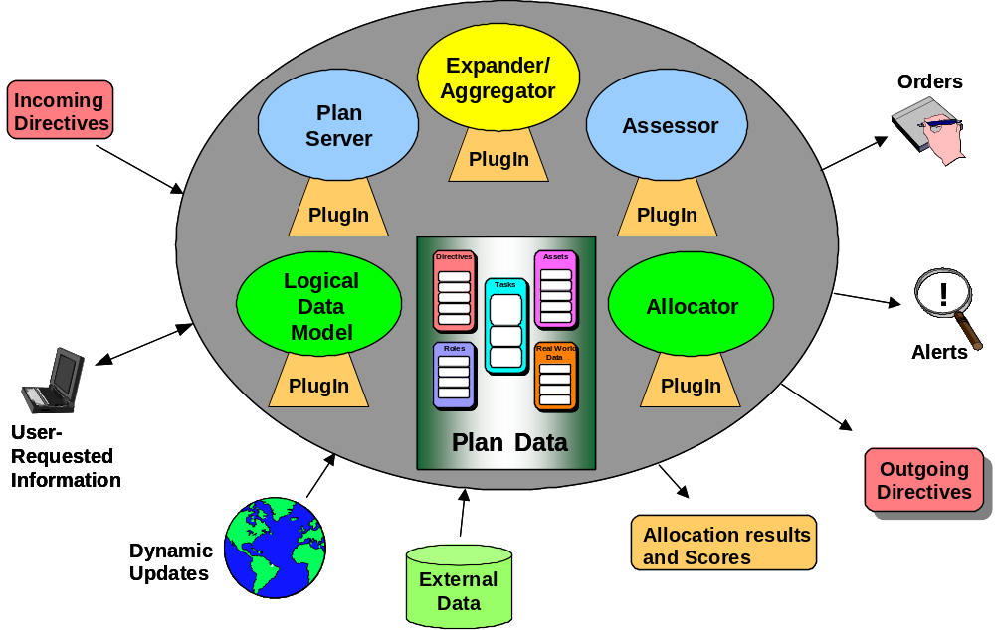

Figure 1. An ALP Agent is a Cluster of PlugIn Components. (Adapted from [2])
Because all current ALP applications focus on problems centered on plan development, it is possible to broadly categorize PlugIn functions:

- Expander/Aggregator PlugIns build new plan structure by taking a given planned task and splitting it into simpler subtasks, or by combining related overlapping tasks into a single inclusive task.
- Allocator PlugIns assign assets to tasks so that they can actually be performed; assets may be tangible objects or material (e.g., vehicles or fuel), or intangible collective entities (e.g., organizations).
- Assessor PlugIns monitor the execution status of planned tasks and react to real-world task failures by revising existing plans or building new ones.
- Logical Data Model PlugIns collect information from automated non-ALP sources and bring it into the plan.
- Plan Server PlugIns receive directives, policies, and queries from or on behalf of human users and provide graphical user interfaces (GUIs) that make agent plans and activities accessible to users.

Multiple ALP agents work together by establishing dynamic, task-based relationships with each other and forming complex, multi-tiered societies. For example, an agent representing one organization may construct a “report for duty” task for itself that causes it to become a subordinate asset of another agent. The ALP infrastructure uses these relationships to automatically identify and transfer relevant plan information between agents.

The Problem

ALP’s distributed agent-based architecture makes it a powerful tool for solving large-scale complex problems that are now handled manually by successively dividing them into smaller, heterogeneous, constrained tasks assigned to different parts of an organization. However, it is not the only agent-based technology in the world, and there exist many other independently-developed agent frameworks that are capable of supporting these types of functions. To be able to take advantage of these capabilities offered by external, non-ALP agents, it will be necessary for ALP agents to interact with them through some new communication protocols. Since neither the ALP infrastructure nor the current types of ALP PlugIns are designed to support these external, agent-oriented interactions, DARPA asked us to research and develop suitable extensions to the ALP technology, with three specific tasks:

- To develop a generic agent-oriented external interface capability between ALP and non-ALP agents
- To demonstrate an example of these new interfaces compatible with DARPA’s CoABS Grid technology (discussed later) that successfully links pre-existing ALP and non-ALP agents
- To develop a GUI for managing service visibility and access control, so that interactions between ALP and non-ALP agents can be regulated for performance or security reasons.

Furthermore, at DARPA’s request we focused our solution to take advantage of Sun’s more recent technologies for distributed object management, Jini and JavaSpaces.

Technology Foundation

The key non-ALP technologies underlying our approach are closely related, and these relationships must be understood before we describe our solution.

Jini

Jini is a distributed object networking technology developed by Sun to automate the creation and administration of highly dynamic object networks, where services can appear, locate each other, exercise their interfaces, and disappear without human intervention. Built upon Java’s Remote Method Invocation (RMI) technology, Jini simplifies the federation of distributed object networks through a core set of facilities:

- Discovery – allows potential Jini services and clients to find existing Jini object communities
- Lookup – allows Jini services to register proxy objects and attribute-based descriptions of their capabilities, and allows Jini clients to perform attribute-based searches for services and acquire the proxies needed to invoke them
- Leasing – allows proxies and descriptions to be registered in the Lookup facility for only a limited lease time, so that they will be automatically removed if a registered service disappears or fails to renew its leases
- Remote events – allow Jini services and clients to be automatically notified when changes occur in the Lookup facility, so that they can stay up-to-date on new services appearing or old services disappearing
- Transactions – allow multiple Jini services and clients to establish a two-phase commit type of interaction that maintains transaction-level safety over sequential operations

This combination of facilities enables Jini networks to be robust and scalable by preventing reliance upon the kinds of hidden assumptions that are the Achilles heel of typical distributed applications: the network is reliable, network topology doesn’t change, there is a single administrator, etc. Provided that these facilities are fully employed by their participants, Jini networks can spontaneously federate and heal themselves without direct human intervention or administration. However, the proper design and implementation of Jini objects can be a challenge, and even configuring and operating the core Jini facilities can be difficult for the novice.

JavaSpaces

JavaSpaces technology (the name is unfortunately plural) was developed as a Jini-based service to support distributed object applications built upon the concept of tuple spaces and the Linda programming model as originally envisioned by David Gelernter. [3] A tuple is simply a list of heterogeneous information implemented as a Jini Entry object with public, serializable fields. A JavaSpace is simply a persistent, network-accessible repository where tuples can be stored, searched for, and accessed; in this sense it functions something like a relational DBMS, even to the point of providing transaction-level safety for guaranteeing the integrity of sequential tuple operations. However, unlike a DBMS, a JavaSpace does not require that tuple schemas be defined in advance (or ever). Applications simply write arbitrary tuples into a JavaSpace whenever desired. A stored tuple will remain accessible (readable) from the JavaSpace until some application takes it permanently from the JavaSpace, or its lease in the JavaSpace expires, or the JavaSpace itself no longer exists.

By carefully designing patterns of tuples, a developer can easily construct distributed object structures and distributed algorithms that are both loosely coupled and robust. And because tuples are specializations of a Java class, they can carry behavior with them, which allows portions of a JavaSpaces application to be mobile. For example, given a CPU-intensive task that can be broken into independently executable chunks, only a few additional lines of JavaSpaces code are required to convert the task to an automatic load-balancing version that operates over a dynamically changing set of servers.

CoABS Grid

DARPA’s CoABS program was established with a vision of dynamically-formed applications that would be assembled (or would assemble themselves) out of existing agent, objects, and legacy systems. The emphasis has been on supporting interoperability between existing systems, with a special focus on those built upon agent-based frameworks. An experimental, round-the-clock network or Grid of available agents and services has been established, and Grid-aware components freely enter and leave the Grid at any time.

Grid services can be arrayed in a technical architecture analogous to other layered network architectures, with infrastructure or core facilities at the bottom and applications or application components at the top (see Figure 2). The Grid core services form what is essentially an augmented Jini lookup service, and include facilities for registering agents, logging Grid communications, visualizing agent networks, administering the Grid, etc.

Figure 2. CoABS Grid Technical Architecture Layers [4]

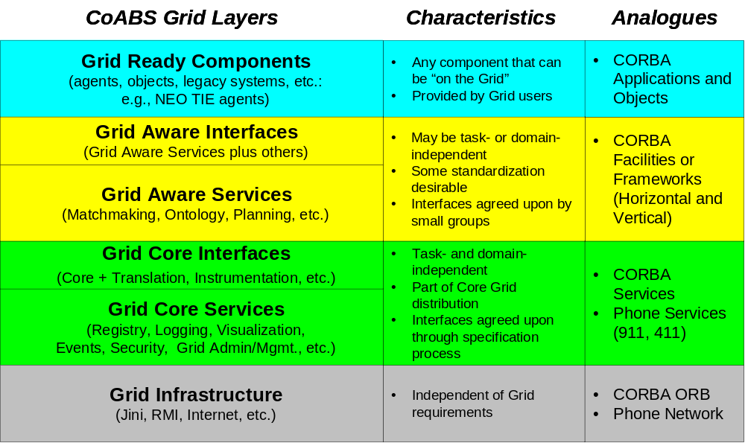
Components may interact with the Grid either as services or as agents. A service-based Grid component provides a proxy to install in the Grid Jini registry; this proxy carries whatever interfaces are provided by the component to invoke its services. However, this approach requires that services be performed synchronously, and that clients understand a priori how to operate the interfaces of any Grid service they may wish to invoke.

An agent-based Grid component also provides a proxy to install in the Grid registry, but this proxy only needs to support a single standardized message-passing interface. Messages are passed between Grid agents in an asynchronous, queued manner without persistence (so there is no guarantee of message delivery in the event of a process failure and restart). The contents of a message are expressed in an Agent Communication Language (ACL). There are many such languages, and although there have been attempts to standardize them, the Grid does not require that all agents use a single standard ACL. Therefore, Grid agents that wish to interact must either share a common ACL, be able to translate to/from each other’s ACL, or be able to find a third-party agent that can translate messages for them..

Technical Approach

Overview

By drawing upon and abstracting the capabilities of Jini and the CoABS Grid, we developed a general mechanism enabling an ALP society to interoperate with external agents in other societies through the establishment of persistent interactive relationships called liaisons. These agent-oriented liaisons meet the needs of ALP society agents by allowing them to dynamically locate and use the services of agents outside their own society. For example, a logistics transportation planner that has run short of taskable assets may choose to invoke the services of an external commercial shipping service through an interactive agent. Or it may contact a web crawler agent to subscribe to useful information that is updated dynamically. Alternatively, a liaison may meet the needs of external agents, by allowing them to coordinate their own service needs with an ALP society.

To make liaisons fully integrated with the rest of ALP agent capabilities, we elected to extend the ALP PlugIn model to include a new category: a liaison PlugIn (see Figure 3). With the assistance of additional supporting classes, these new PlugIns function as an interactive bridge between ALP agents and external agents available through the Grid. Specialized liaison PlugIns are responsible for applying a service map to transform what their agent cluster needs to accomplish into service requests satisfiable by external agents, and vice versa.

Furthermore, we took advantage of the availability of Jini within the Grid to supply a JavaSpaces service that acts as a global repository of permission data for existing and potential liaisons. We developed a separate administration GUI that allows an ALP society manager to control liaison permissions anywhere in a distributed ALP society by making changes to the entries in a single named JavaSpace associated with that society.

Our implementation of the fundamental technology underlying the liaison capability is built on a small set of classes and interfaces that are designed to make agent-oriented liaisons flexible and reusable in the ALP context. The solution includes components that address these needs by factoring out common features of liaisons at different levels.

Interactions
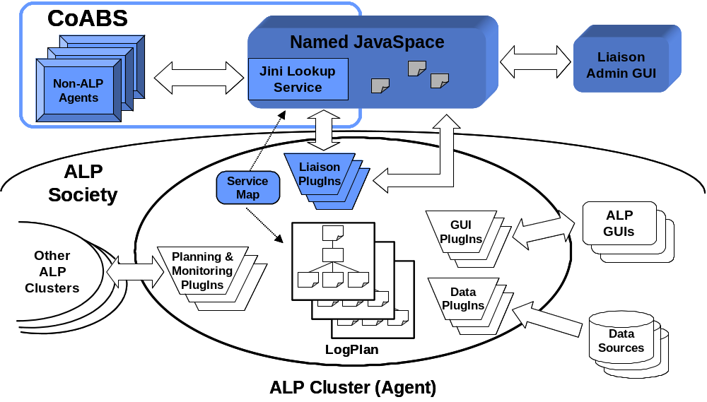

Figure 3. Adding ALP Liaison PlugIns to Support External Agent Interactions

In the most abstract sense, a liaison between agents requires the transfer of information between them, sometimes in one direction only, but usually in both directions. These transfers can be divided over time into distinct episodes or groupings called interactions. A simple interaction involving two agents might follow a query/response pattern, while a complex interaction involving multiple agents might implement an extended protocol involving RFP/proposal/negotiation/award phases executed over time. However, no matter what the pattern, an agent can only a perform a few distinct generic actions as part of an interaction:

- it can set up or initialize information required for the interaction,
- it can send information to or receive information from other agents (perhaps many times during the interaction), or
- it can terminate the interaction normally or abnormally and utilize any final results, if appropriate.

The liaison capability facilitates these actions and the transitions between them with the Interaction class, which provides an independently-threaded state-driven engine capable of performing both synchronous and asynchronous interactions of arbitrary complexity. The Interaction engine executes under the control of an Interactor (which knows how to behave during the interaction), a LiaisonDeputy (which maintains permission and intermediate/final results generated during the interaction), and a state (which may
be any arbitrary object).

Interactions are implemented as independent threads for two primary reasons:

- ALP agents may engage in multiple, concurrent, and time-sensitive interactions without worrying about delays in one interaction affecting another.
- ALP agents may either start an interaction and block until it completes or poll later to see when it is done, regardless of whether the underlying interaction itself is normally synchronous or asynchronous.

The combination of independent threads and a generic state-driven engine provides sufficient flexibility for an ALP agent to interact in principle with any combination of external agents, assuming that the behavior required for particular types of interactions is appropriately specified.

Interactors

While the Interaction class represents what is abstract and common among all agent-oriented information exchanges, instances of interactions must be highly differentiated somehow, in order to allow for the huge range of variability in the content, control, and communication methods required for specific exchanges. The liaison capability encapsulates this differentiability with the Interactor interface.

An Interactor is any object that implements specialized versions of the generic actions performed during an interaction, along with some decision logic that controls the order of those actions. In effect, interactors contain the pieces of a coupling for connecting the internal ALP environment with an external agent. Each interactor instance acts as a kind of specialized extension to the generic Interaction engine; the interaction instance provides a standardized control framework, while the interactor instance provides a customized, appropriate behavior pattern.

When constructed by a liaison PlugIn, each instance of an interaction is given a single interactor and an initialization object; the interaction will not actually do anything until its start method is invoked (see Figure 4). It then starts with the execution of its interactor's begin method, which returns a new state. The Interaction engine then continues to select successive actions by invoking the interactor's nextAction method (which returns the type of the next action to perform) and then performing the chosen action. Each action produces a new state which is available to control subsequent actions. This cycle continues until a normal or abnormal termination action has been selected and performed, or until a timeout exception has occurred.

Because each combined interaction/interactor encapsulates all of the behavior required to interact with external agents in a particular way, liaison PlugIns are relieved of any burden of controlling the flow of even complex interactions while they are happening. A PlugIn can simply create interactions and start them when needed. This freedom makes it easy for them to participate in multiple interactions simultaneously, and gives them the flexibility to react to changes in the ALP environment at the same time.

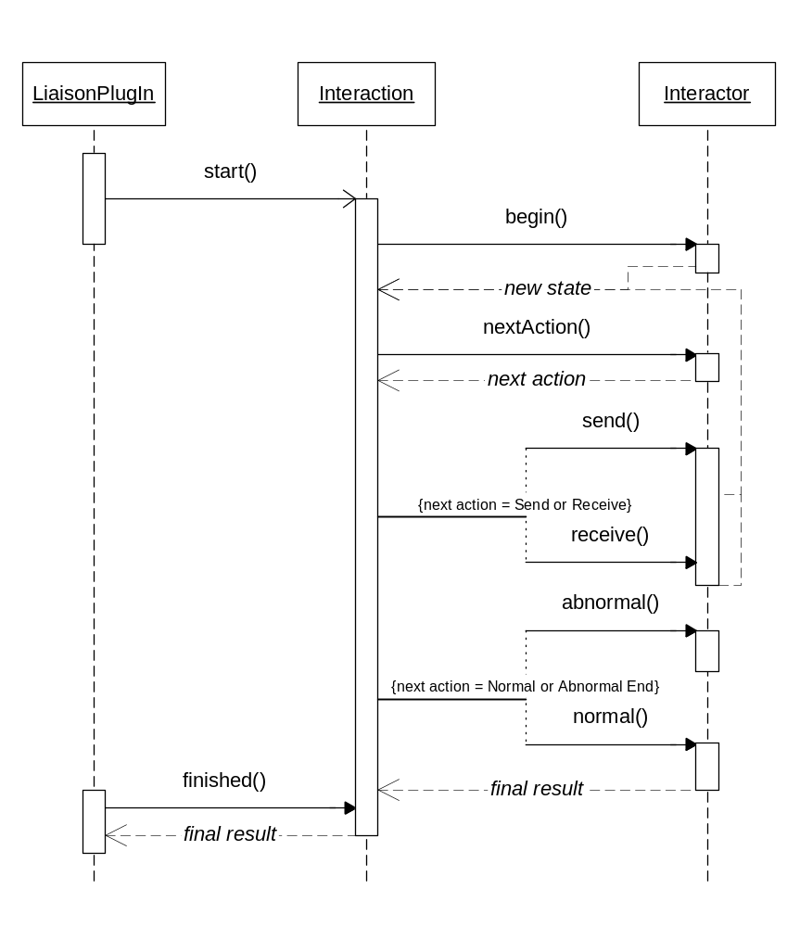

Figure 4. Interactions Proceed Through A State Transition Process
Driven by an Interactor
Liaison Administration

Once it is possible for an ALP society to dynamically identify and interact with external agents, the issue of liaison administration must be addressed. Administration in this context refers to the management of liaison permissions. It is clearly undesirable to allow any ALP agent to interact with any external agent that may happen to be accessible; there must be some mechanism that both allows society administrators to specify and change what kinds of interactions are acceptable, and allows PlugIns to rapidly check those permissions to control attempted interactions.

In order for liaison administration to be consistent in the distributed ALP context, there must be a global, society-wide perspective on what kinds of interactions are permitted. The ALP infrastructure does not currently provide any kind of global directory or yellow pages of agents in an ALP society, so there is no convenient existing place to record this kind of global permission information. Furthermore, new external agents can appear at any time, so interaction permissions cannot be simply specified a priori in some kind of fixed configuration tables. But however this permission status is recorded, it should be persistent and independent of failure/restart by individual ALP agents, external agents, or the administration facilities themselves.

The liaison capability provides an experimental implementation of this mechanism built upon a Jini JavaSpace service. A single named JavaSpace associated with an ALP society stores information about ALP and external agents, and records whether or not individual ALP agents can initiate or respond to interactions with specific external agents. These permissions are changed in a persistent and transaction-safe manner under human control through a GUI that displays both an ALP society and an external agent society side by side.

An ALP agent may be supporting several tasks concurrently, and so it may also need to engage in several liaisons with multiple external agents at the same time. To simplify the establishment and control of multiple liaisons, the liaison capability encapsulates a number of higher-level functions in an object called a liaison deputy. These deputies are responsible for representing an ALP cluster as an agent to some external agent society, and for providing interaction housekeeping support. A deputy is able to:

- establish initial contact with a particular type of external agent society (e.g., a CoABS Grid society)
- maintain information relevant to active interactions with that society
- check for possible timeouts associated with active interactions.

Finally, each deputy determines which interactions are permissible by consulting the administration JavaSpace through an object called a liaison manager. These checks are made prior to each potential interaction with a distinct external agent. Depending on configuration settings, a deputy may block or suspend attempts to engage in disallowed interactions (see Figure 5).

Demonstration

To demonstrate how liaisons can be an effective means of expanding the scope of ALP societies, we used the new liaison capability to construct a working example of a liaison between a pre-existing ALP society (the Litton TASC Air Expeditionary Force [AEF] society) and a pre-existing external agent society (CMU's Reusable Environment for Task Structured Intelligent Network Agents [RETSINA]), with interactions mediated via the CoABS Grid.
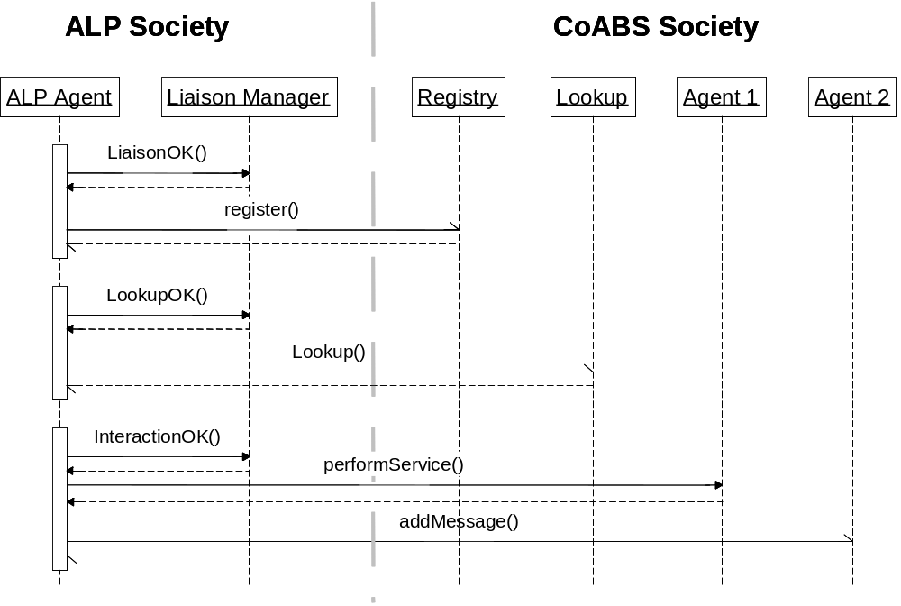

Figure 5. ALP Agents Verify Interaction Permissions with a Liaison Manager
Prior to External Communications
A RETSINA agent society has its own architecture, conventions, and agent types. One type of agent with significant potential value to an ALP society is an InfoAgent, which is capable of extracting information from external sources such as Web pages and supplying these extracts to requestors. In particular, one specialized InfoAgent is able to parse commercial Web site pages containing weather forecasts and deliver those forecasts to other agents that may need them. And although InfoAgents are not Grid-ready components, that can still interact with Grid components through the services of a separate RETSINA Interoperator agent, which provides liaison-like capabilities in the RETSINA context

Of course, simply acquiring weather forecast information from external agents would only demonstrate the feasibility of liaisons without showing their usefulness. We also expanded our demonstration shows the potential impact of weather forecast information on transportation planning, a central feature of ALP; weather information had previously been unavailable to ALP societies. We expanded the original plan task structure of the AEF society to include weather forecasting, and we added new PlugIns to an existing AEF agent (GlobalAir) that has some transportation planning responsibilities. Without modifying the original GlobalAir code, these new PlugIns:

- generate weather forecast requirements from existing transportation tasks
- extend the GlobalAir plan to include weather requirements correlated across multiple tasks
- interact with external RETSINA InfoAgent that extracts weather forecast information from a commercial Web site
- receive the externally-supplied forecast information and modify previously-established transportation plans.

In addition, we built a new ALP GUI that displays the before/after impact of the weather forecasts on AEF transportation plans (see Figure 6).

Results and Lessons Learned

We were therefore successful in completing our principal objectives: ALP societies now have a generic mechanism available for interacting in sophisticated ways with external agents, and we have demonstrated how this can be useful. Through our use of the CoABS Grid, we have made ALP technology a Grid-ready component, and we have brought weather information into the ALP environment for the first time. And finally, we have provided an initial method for managing permissions that can serve as an extensible basis for more sophisticated interaction administration functions in the future.
Figure 6. A Prototype GUI for Controlling Interaction Permissions between
ALP and External Agents

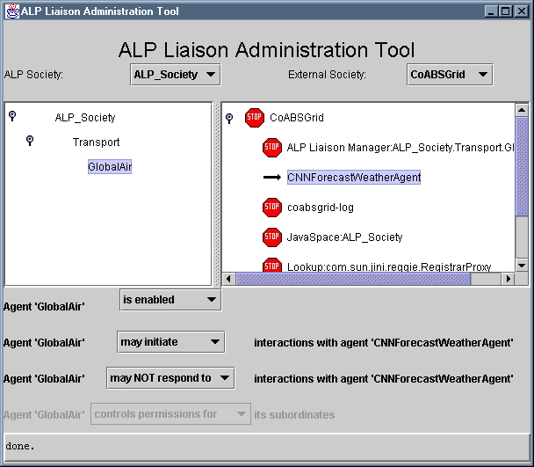

In the course of developing the liaison capability, we had the opportunity to work with several advanced technologies and learn about their strengths and weaknesses:

- ALP technology is a powerful agent framework applicable to any domain; it has been designed from the ground up to address issues of scalability and robustness that are likely to bound the complexity and size of multi-agent societies. Unlike many other agent frameworks, ALP is not simply a laboratory exercise that becomes impractical when applied to realistic problems; it holds the distinction of having the largest society of agents (> 100) working cooperatively to solve multiple problems over time based upon real-world data. Its depth and sophistication require one to climb a large learning curve in order to apply it effectively, however.

- Jini is a powerful distributed object technology which can potentially solve one major difficulty with highly dynamic object networks: administration. It will simply be infeasible to require human intervention every time an object joins or leaves a network, and Jini is well designed to eliminate this requirement. However, proper setup and implementation of Jini services is still challenging and critical to achieving this benefit, and can be error-prone for the novice.

- JavaSpaces technology supports a highly robust distributed object processing methodology. Given a working Jini environment, it is exceptionally easy to use; the application programming interface (API) for JavaSpaces is a model of simplicity. However, the technology is immature, and its initial implementation has both functional and performance quirks that reflect its youth. We expect that future JavaSpaces implementations based upon conventional DBMS technologies will be much more capable and stable.

- CoABS Grid was effective and easy to use for our application. Its APIs and management tools simplify use of Jini, and its standardized message-passing interface still provides a reasonable degree of flexibility to designers of different types of agent interaction protocols. The lack of a common ACL is both a strength and weakness of the Grid; agents that happened to share a common ACL can easily communicate through the Grid with little modification, but interaction involving heterogeneous ACLs requires a large investment in translation functions by one or more agents. The CoABS program hopes to implement some Grid-ready ACL translation services to help with this problem.

Beyond the difficulties of trying to integrate all of these specific novel technologies, we concluded that interoperation of heterogeneous agent-based systems faces at least two significant challenges no matter what particular technologies are applied. The first challenge is a lack of common ontologies, or ways to refer to the external world. Even if they share a common ACL, if two agents refer to the same external entity (e.g. a location) by different names, they are unlikely to be able to communicate effectively about it. This challenge will eventually be softened by ongoing efforts such as the semantic Web and DARPA’s Distributed Agent Markup Language program, which should provide some standardized ontologies that agents could use as a standardized semantic foundation.

The second challenge is ensuring that agents dynamically discovering and interacting with each other avoid pushing (or being pushed) beyond their design envelope. In our liaison demonstration, we uncovered a previously unknown race condition in the RETSINA InfoAgent when our ALP agent starting levying many more requests per second than the InfoAgent was capable of handling. This was not in itself a “flaw” in the InfoAgent, which had never been pushed to perform at that level. The problem is more fundamental: when agents are unaware of each others’ quality of service requirements or capabilities, and when they do not plan their interactions to account for quality of service, faults and errors are bound to occur. Effectively dealing with agent quality of service issues is another open area of research that is only beginning to yield useful results.

In spite of these challenges, however, agent technology is clearly starting to bear fruit in addressing some very complex real-world problems. ALP, Jini, JavaSpaces, CoABS, RETSINA, and many other technologies are all a part of this development, but it is too soon to say which ones will be most successful or influential in the end.

Future Directions

The initial agent liaison capability only begins to explore the space of technical issues related to interactions between ALP agents and external agents. There are many promising areas for potential future research:

- More sophisticated interactions with InfoAgents. The liaison demonstration uses a simple ad-hoc query style of interaction; every time an update on a weather forecast is needed, the ALP agent must create a new interaction. But InfoAgents support a monitor query, where a single request for information can yield an open-ended stream of future replies with updates. The liaison capability could take advantage of this method but does not do so currently.

- More sophisticated interaction with RETSINA. There are other kinds of agents available within the RETSINA framework that can provide useful liaison services. For example, the RETSINA Matchmaker agent could be contacted to find an agent capable of providing weather forecasts, rather than having the ALP agent know a priori the particular external agent it wishes to contact, as is done now. Also, liaison deputies and interactors could be developed to work directly within the RETSINA framework and bypass the CoABS Grid completely.

- Persistence of interactions. The current liaison capability treats interactions as ephemeral entities that would not survive the shutdown and restart of an ALP agent. For certain types of long-lived external interactions, it might be desirable to allow individual interactions to have the same persistence as the ALP agent’s plan data. This would require modifying liaison deputy code so that it saves interaction state information within the ALP plan itself.

- Translation interactions. The current liaison capability performs all translations required to support external liaisons internally. A more flexible alternative would be to locate an external agent that provides translation services and interact with it to perform any necessary translations.

- Nested interactions. In the broader context of general agent-to-agent communication, some agent interactions are complex, multi-phase processes that can be more conveniently specified as compositions of more primitive interactions. For example, there is a common need to lookup an agent with some characteristics, translate some messages to/from that agent, and engage in a functional dialogue. These individual interactions should be combined and controlled by a higher-level interaction. And some interactions will require liaison with multiple external agents concurrently.

- Interaction protocols. The agent research community has invested significant labor over many years to develop standardized patterns called interaction protocols that allow heterogeneous agents to communicate more easily. The liaison capability could be enhanced to take advantage of these patterns. For example, interactor classes could be subclassed for different interaction protocols, thereby simplifying the development of liaison code involving these standard patterns.

- Quality of service. The liaison capability could be enhanced to take advantage of ongoing research in ALP quality-of-object (QuO) services. For example, liaison deputies or interactions could self-regulate the rate at which they engage in external communications based upon network conditions. Additionally, deputies could by extended to compile interaction metrics of various kinds.

- Security improvements. The liaison administration facility is designed to manage liaison permissions rather than make them secure; it can be easily bypassed by knowledgeable developer. Stronger security for controlling external liaisons will depend upon further expected improvements in ALP and Jini security.

- Administration GUI improvements. The liaison administration GUI performs a static lookup of available ALP and external agents; this should be changed so that it automatically notices the appearance of new agents. Also, the GUI’s use of JavaSpace entries is inefficient and will not scale effectively for large ALP or external agent societies; it needs to be redesigned.

Even if none of these changes are made, the new external agent liaison capability for ALP agent societies represents a powerful and flexible tool for expanding the reach and interoperability of ALP technology.

Acknowledgments

This work was performed under GSA contract GS-35F-4340D, delivery order MDA972-98-F-0017, in support of DARPA JLTO and DLA. For more information about ALP, visit the Cognitive Agent Architecture (Cougaar) Web site at http://www.cougaar.org/. Cougaar is the open-source version of ALP technology. We are also grateful for the assistance of the Softagents group at CMU that is responsible for the RETSINA technology; their dedicated support was essential to our ability to demonstrate the liaison capability under tight time and resource constraints.

References

[1] Carrico, T. “Introduction to the Advanced Logistics Project.” Presented to the 7th ALP Workshop, December, 2000.

[2] ALPINE Joint Venture. “ALP PlugIn Developers’ Guide.” Version 6.2, May, 2000.

[3] Freeman, E., Hupfer, S., and Arnold, K. JavaSpaces Principles, Patterns, and Practice. Addison Wesley, Reading, MA. 1999.

[4] Kettler, B. “Grid Vision Update.” Presented to the CoABS Workshop, February, 2000.

