Sam

A Graphical Cougaar Society Maintenance Tool

Version 2.0

January 16, 2001

Mobile Intelligence Corporation
33150 Schoolcraft Road
Livonia, MI 48150
help@mobile-intelligence.com

This software to be used only in accordance with the Cougaar software License agreement (http://www.cougaar.org).

Document and Software Copyright 2000-2001 Mobile Intelligence Corporation.

Abstract

The Sam toolset has been developed to assist Cougaar users in creating, visualizing, maintaining, and assessing the correctness of Cougaar societies. Sam displays both the explicit structure of societies and the implicit structure formed from producer/consumer relationships between plugins and clusters. Using the publish and subscribe contracts, Sam calculates the producer/consumer dependencies and shows them as directed links. This makes many simple configuration errors obvious and speeds understanding of plugin coupling.

Using the dependency graph, Sam is also able to analyze the society and report cases where there is no publication matching a subscription, more than one subscription matching a publication, or no subscription matching a publication. These simple checks catch many of errors caused by missing or mutually exclusive plugins being instantiated in a cluster.

Sam is able to go a step further and also help with building the configurations. A suggest capability allows the user to ask for suggested sets of plugins to fill gaps in a configuration. Sam examines the available plugins and suggests which set of plugins would match the dangling publications and subscriptions in the cluster. Expanding the accuracy and utility of this design assistance is the focus of the current Sam effort and we expect to include extended capabilities in version 3.0 of the toolset.

1.Introduction to the Sam’s User Interface

Sam provides a single integrated workspace for configuration management.

The User Interface consists of a window that contains several panes and panels for performing these functions, including:

- Main Menu Bar: This provides access to many menus, such as File, Edit, View and Help.
- Main Tool Bar: Composed of buttons, which provide shortcuts to the commands.
- Project Pane: Displays the structure of the Society currently selected. Clicking on components in the display will move the Main Panel to show the new location in the society.
- Editor Pane: Contains another tool bar that gives the options to edit, save, print or clear the displayed contracts.
- Main Panel: Displays the selected society as a dependency graph. Each opened society is available by clicking on the tabs along the top of the panel.
- Error Pane: Displays the output of the analysis operation for the selected society.
- Status Bar: This is updated every time some process is performed on the society.

Fig 1: Sam’s User Interface
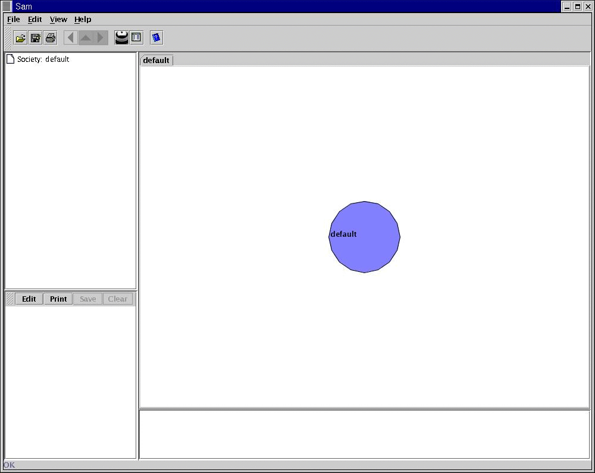

  - Main Menu Bar:
File Menu: The editor reads and writes societies in its own XML format (to support communities and other rich structures) and is also able to import and export clusters from their ini files. The Load Society option opens a dialog box from which the user can choose a particular society that is to be loaded from the xml file. The save society option opens a save dialog allowing the user to specify the directory and file name to use for the write. (Currently, the system contracts are saved in the same directory in a file named “contracts.xml”.) The “Import from ini” and the “Export to ini” options load a society from the ini files and save a society to the ini files. The print menu allows printing the graphical representation of the society either as a canvas printout or as a screen snapshot. The file menu also gives the option of closing one or all the societies at the same time.
- Edit Menu: The Edit menu is used to modify the editor’s properties and add, remove, copy, and paste components in the society. It also allows accepting one of the suggestions from the “suggest” command and discarding the others.
- View Menu: The view menu helps in the viewing of the layout that displays the present graphical representation.
- Help Menu: Loads the Java Documentation files and user manuals for the application.

1.2 Main Tool Bar: The main tool bar is composed of the following buttons.
- Open Button: Performs the same function as the “Load society” command of the file menu of the main menu bar. It opens a dialog box from which the XML file containing the society that needs to be loaded can be selected.
- Save Button: Performs the same function as the “Save society” command of the file menu of the main menu bar. It opens a dialog box through which the society can be saved to an XML file with a particular name.
- Print Button: This also aids in printing, but does not give the user an option of a canvas printout or a screen snap shot. It only prints in the canvas printout mode.
- Back, Forward, and Parent Buttons: These three buttons are used to move back and forward through the displayed page history as well as move up to display the parent of the current component.
- Analyze Button: This will let the user analyze if there are any kinds of problems associated with the society.
- Suggest Button: This suggests the different kinds of solutions that are appropriate if there are any problems found in the society. The solutions are displayed in the form new tabbed panes in the main panel with there own associated tabs, which bear their names. The required solution can be retained by clicking on the retain command in the edit menu of the main menu.
- Help Button: Loads the help files for the application. It also displays the version details for the application.

2.0 Working with the User Interface

2.1.1 Load society

Fig2: shows the options in the file menu of the main menu

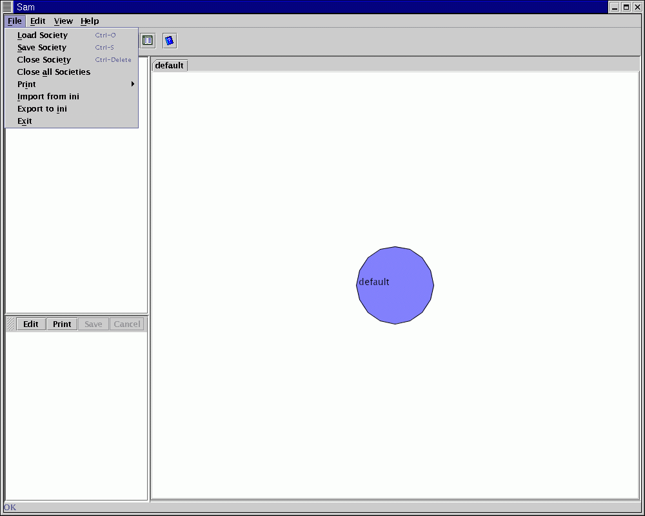

Once the Application is up and running, the Sam user interface can be used to load a society from the xml files. Once the “load society” command is clicked a file open dialog box pops up allowing the user to choose the file to load. After the society is loaded the Main Panel will show it as a dependency graph. Double clicking the left mouse button (or clicking the middle mouse button, if available) on the components will move about the society. Stepping into the society at this point will display the graphical representation of the clusters and the communities that are available within that society. Clicking the right mouse button on one of the arrows will open the contract popup menu and allow viewing the contracts and hiding dependency links to reduce complexity.

Fig 3: The file open dialog box for loading the “.xml” files

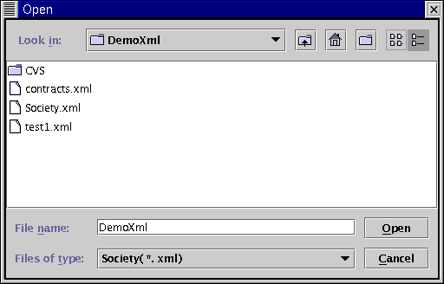

The different clusters and the communities displayed in this particular society are:

Fig 4: The Society.xml file with the clusters and the communities that are available

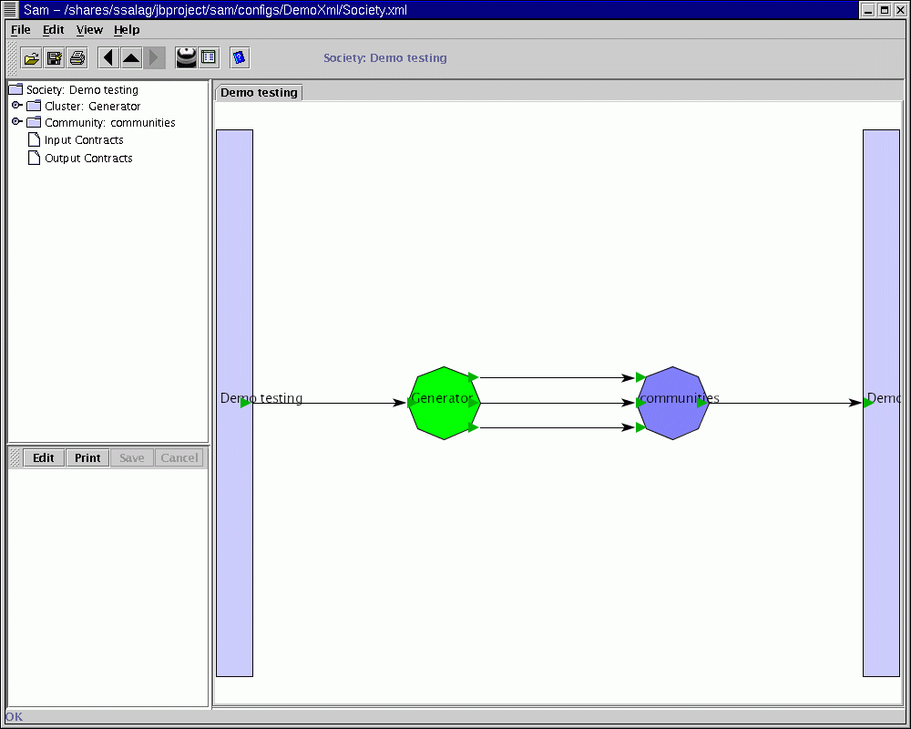

- Generator
- Communities
Stepping into the clusters will display the organized graphical representation of the plugins belonging to that particular cluster. Stepping into the communities will in turn display the clusters and the communities that are available in that community. In the example shown here the community consists of two clusters.

- Transport
- Consumer
Fig 5: The clusters present in the community of the society.xml

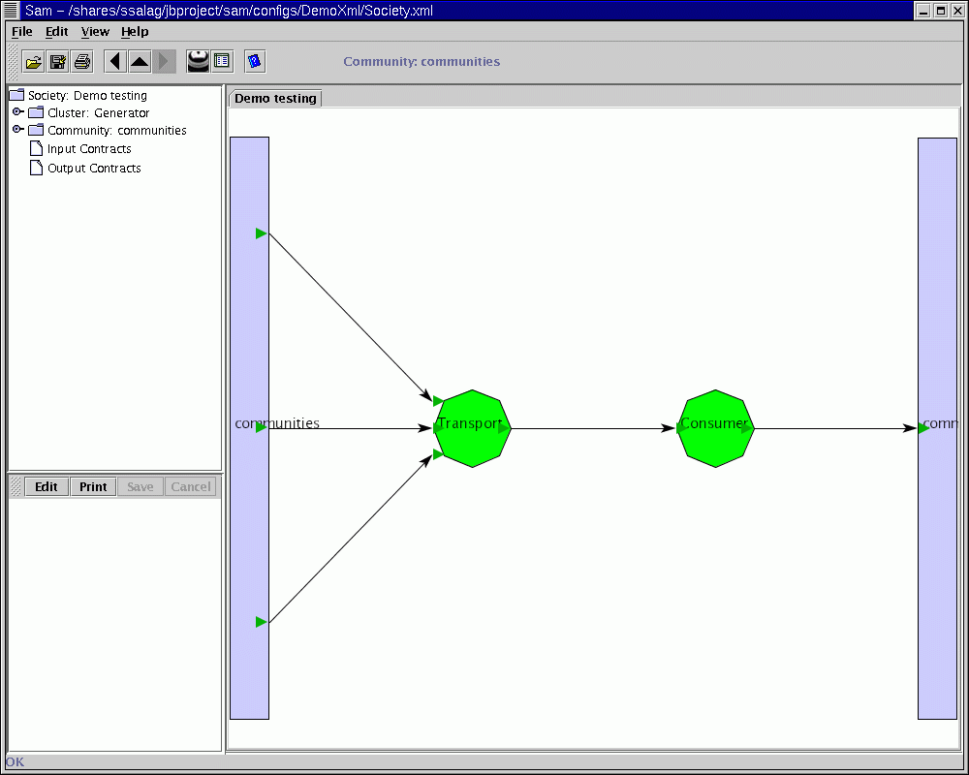

2.1.2 Saving the society
The save society command in the file menu of the main menu will save the society as an xml file, at the same time the contracts for that particular society are also saved as “contracts.xml” file. This will pop up a save dialog box, allowing the user to enter the file name.

Fig 6: The Save dialog box for the “. Xml” files

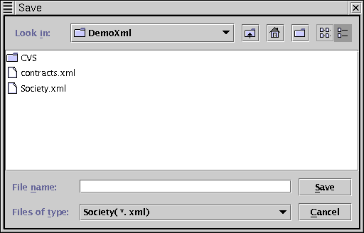

2.1.3 Close the Society
Unwanted societies can be closed using the “close society” command in the file menu.

2.1.4 Close all Societies
The “Close all societies” command on the file menu will close all the open societies and initialize the editor with the default society is automatically loaded so that the main panel is not left blank.

2.1.5 Import From ini
The Sam user interface can also load a society from the ini files. Once the “Import from ini” command is clicked a file open dialog box pops up providing the user to choose from the list of the “. Soc” files.
Fig 7: The file open dialog box for the “.soc” files

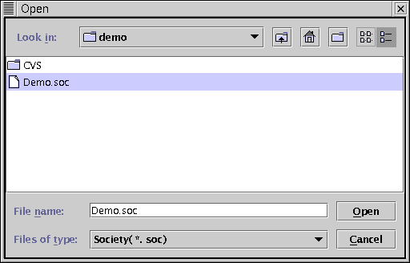
Once the choice is made the Main Panel will show the graphical representation of the society. Communities are not represented in the ini files. In the present society that is loaded the clusters that are present are:

- Generator
- Consumer
- Transport
Fig 8: The Cluster Generator.

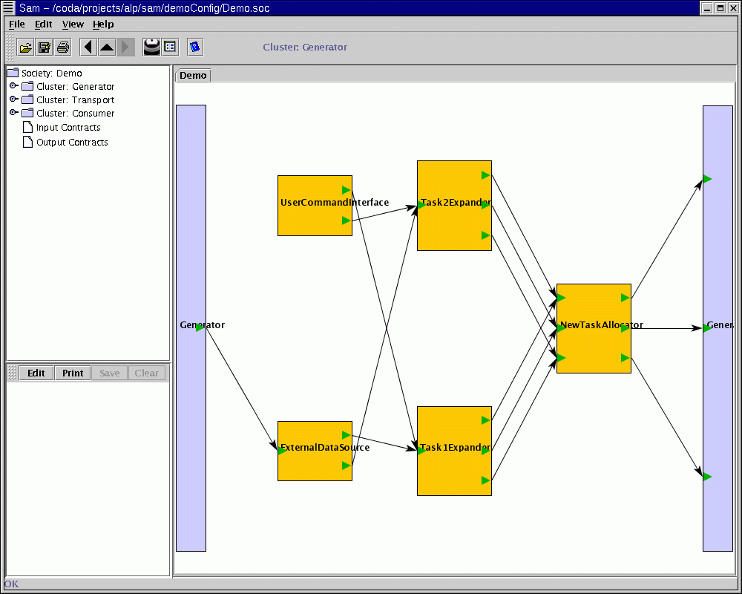

Fig 9: The Cluster Consumer
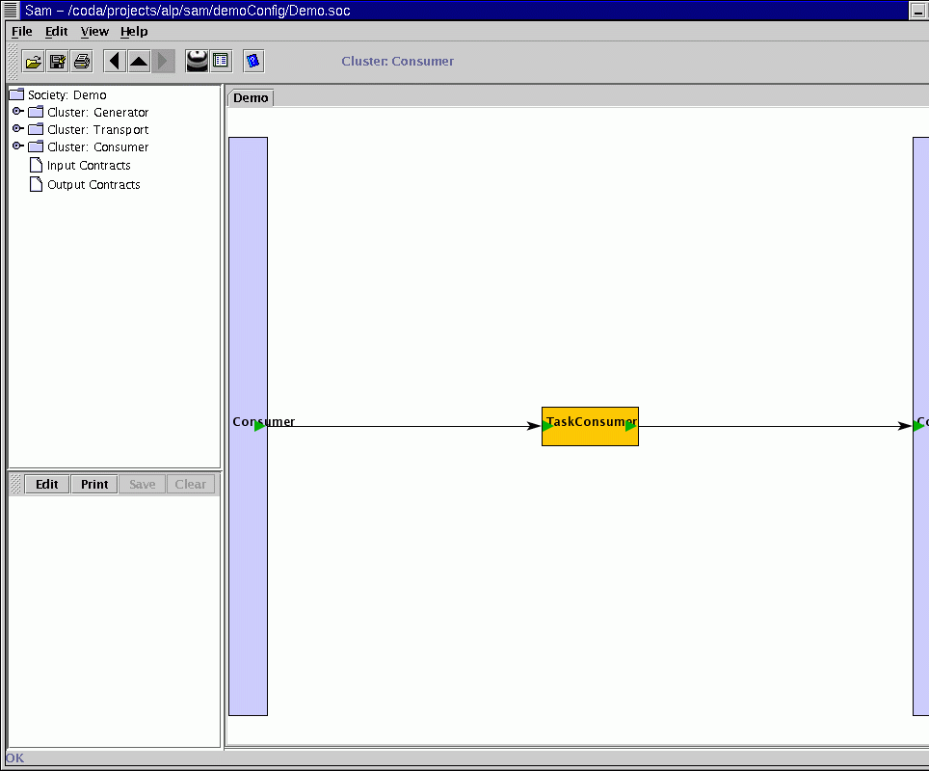
Fig 10 : The Cluster Transport

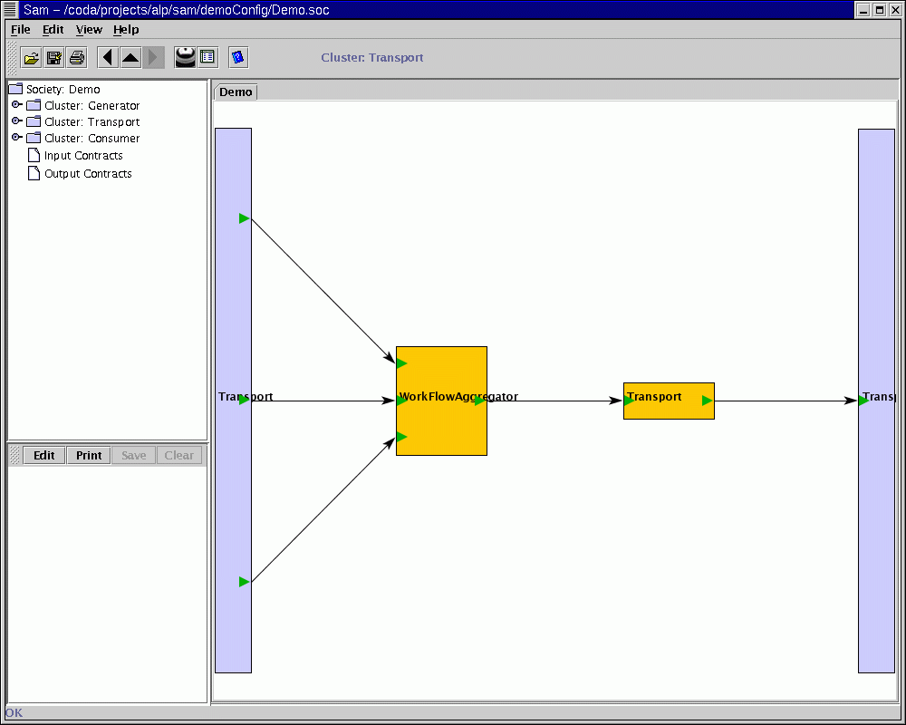

2.1.6 Export to ini
The Sam user interface can also generate .ini files for the society. Once the “Export to ini” command is clicked a file open dialog box pops up allowing the user to select the directory where the files should be written.

Fig 11: The file save dialog box for the “.soc” files

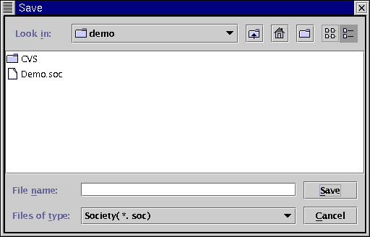
2.2 Editing the society
The edit menu can be used to edit the society.
Clusters, plugins, contracts and communities can be inserted, removed and copied. (Ref: fig 12)
Fig 12: The Edit menu Options
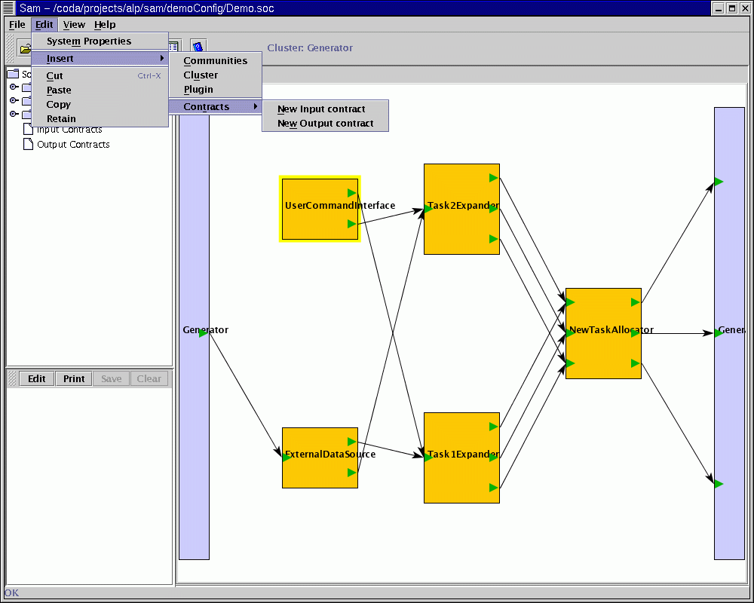

Once the Insert | Cluster is accessed a small list of all the clusters pops up from which the cluster that needs to be inserted can be chosen.
Fig 13:The Option Pane Dialog Box to insert a new cluster
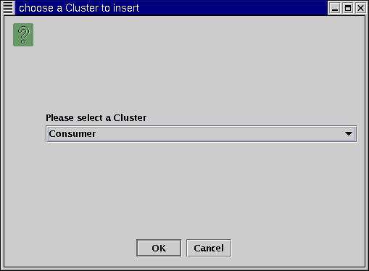
Fig 14: The Society after inserting a new Cluster Generator.
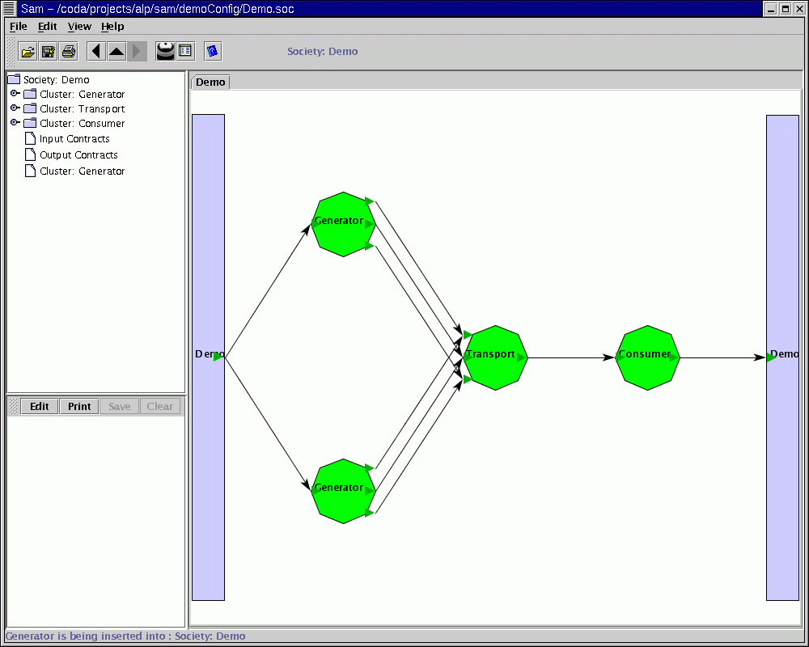

A cluster or a plugin can be inserted in their related fields only. An error dialog box would popup if a component is pasted or inserted into an unrelated field. For example if a plugin is being inserted in the cluster field or vice-versa.
Fig 15: Error Dialog Box

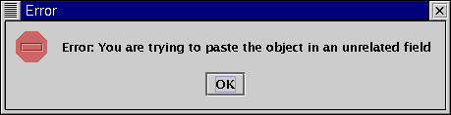

If the plugin is to be inserted into the field then the user must choose the Insert | Plugin command which will also display a list of the plugins from which the user can choose the one that needs to be inserted.

Fig 16: The Option Pane Dialog Box to insert a new plugin

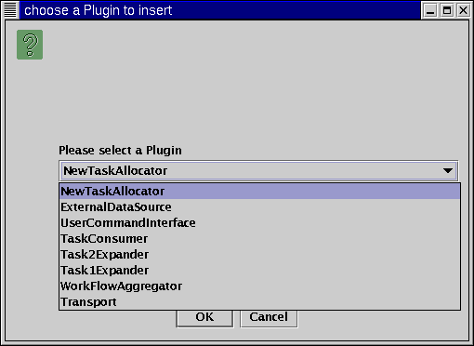

Once the desired plugin is selected it is then inserted into the field.

Fig 17: Cluster Diagram for the Generator after inserting a new plugin Task2Expander

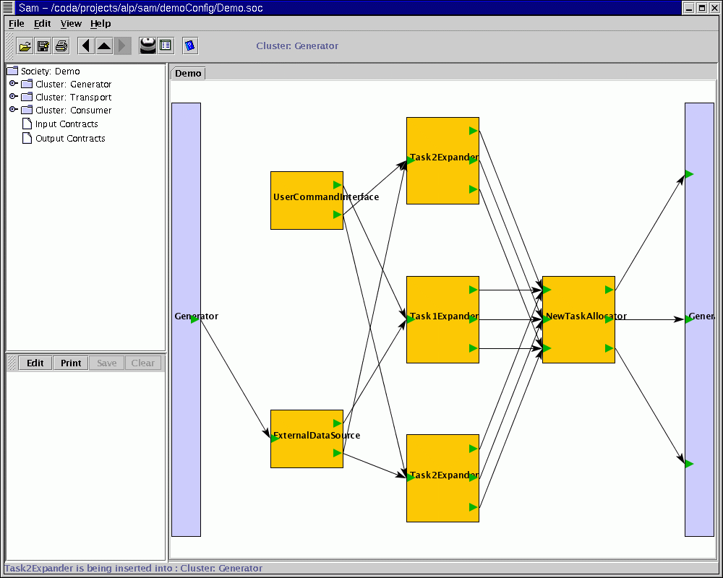

The edit menu has the other options like copy and paste that can also be used for the purpose of editing the society. An Element from the displayed component can be copied to the clip board and pasted back into the related field.

2.3 Loading more than one society
Once a single society is loaded another society can also be loaded, which will be opened in the main panel under a different tab.

2.4 Editing Contracts
To view and edit the contracts, the particular publish or the subscribe is chosen and right clicking the mouse will pop up a small menu with the options of
- View Contract
- Hide Dependencies or Show Dependencies
- Externalize Contracts

2.4.1View Contracts: Clicking on the View contracts will display the contracts of that particular publish or subscribe in the editor pane of the Main Window. Further clicking the edit button on the menu bar of the editor pane lets the user edit the contracts, save and also print them. Once the View contract menu item is clicked for one particular component, followed by the edit button of the editor pane, the system will not let the user view or edit contracts for the other components. The user needs to hit the clear button of the editor pane and clear the contents of the editor pane, which will also deselect the selected object.
Fig 18: Contracts for the particular object displayed in the editor pane of the UI

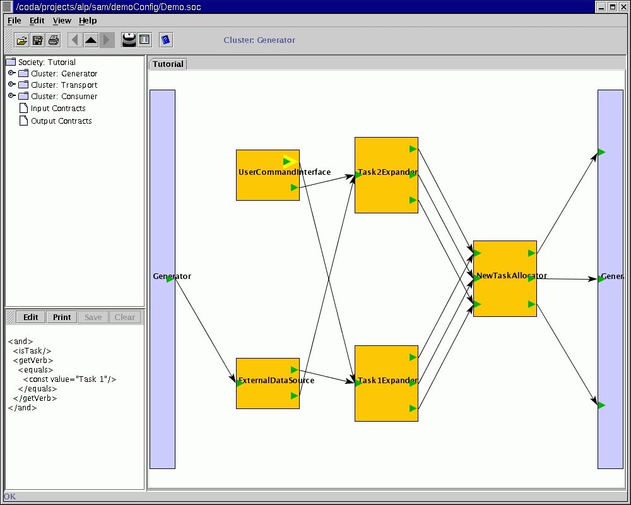
2.4.2 Hide Dependencies Clicking on the Hide Dependencies will hide all the related arrows for the particular publish or subscribe. If the right mouse is again clicked for the object whose related dependencies are hidden then the pop up menu will display Show Dependencies instead of the Hide Dependencies menu item. Clicking the Show Dependencies menu item will re-display all the hidden dependencies for that particular input or output contract.

Fig 19: The Grayed out (hidden) dependencies

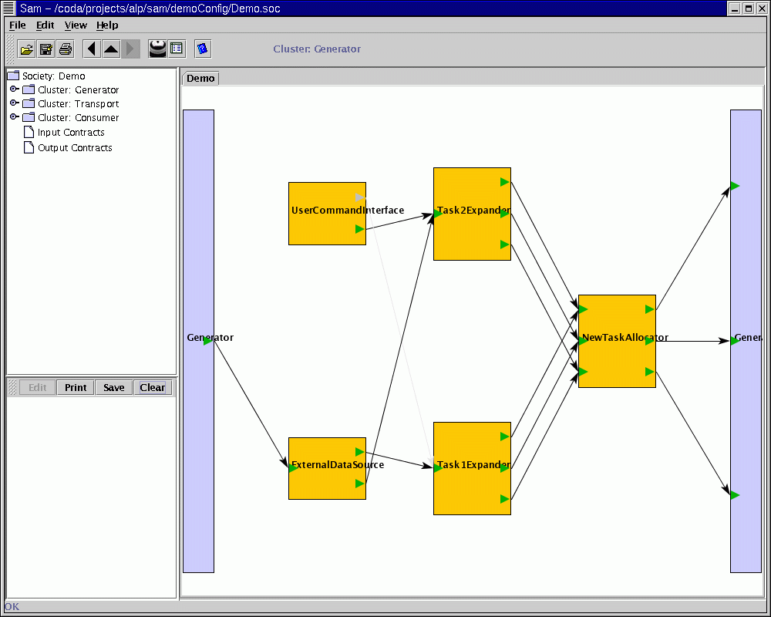

In the Fig 19 most of the arrows are clearly seen but few of them are grayed out indicating the hidden dependencies, for the chosen input or output contract.

2.4.3 Externalize Contracts

If a publication or subscription should flow in or out of the current cluster or community, we say it should be “externalized”. The “Externalize Contracts” menu item of the popup

menu.

Fig 20: Externalizing contracts

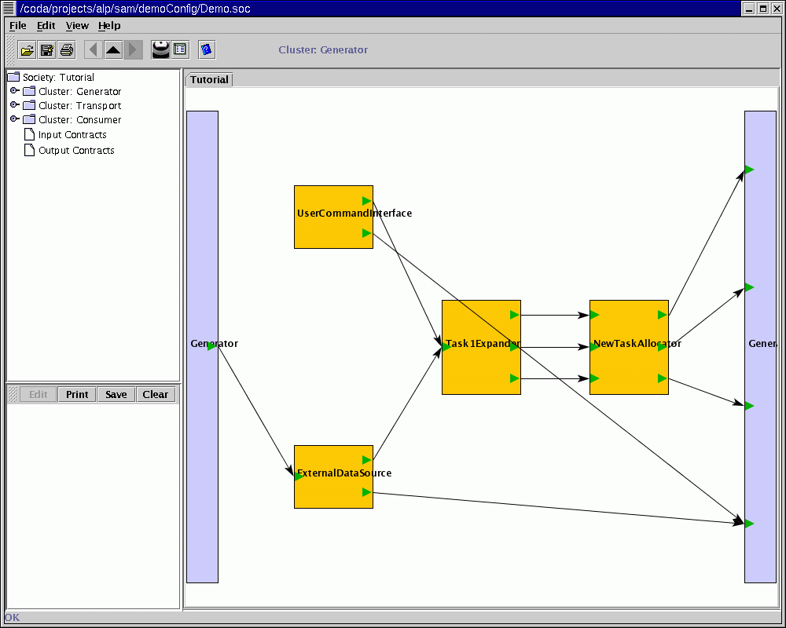

2.5 Analyze
The Analyze button is used to detect problems in the active society. The errors are displayed in the form of a JTree in the error pane.

Fig 21: Displaying the problems in the society from the analyze command.
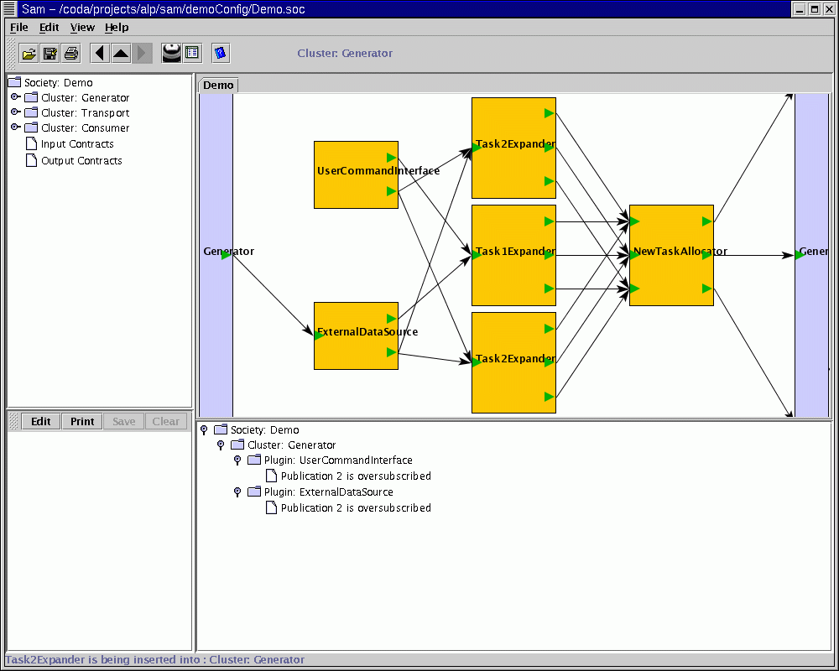

2.6 Suggest and retain
If there are missing plugins in the society, clicking the suggest button will offer suggestions for filling the gaps. At times more than one suggestion will be made. In that case, selecting the desired solution and clicking the retain command of the edit menu in the main menu will discard the remaining suggestions and replace the original problematic society wit the selected society. This also renames the retained solution to match the original society’s name.

Fig 22: Displaying the solutions for the different societies using suggest
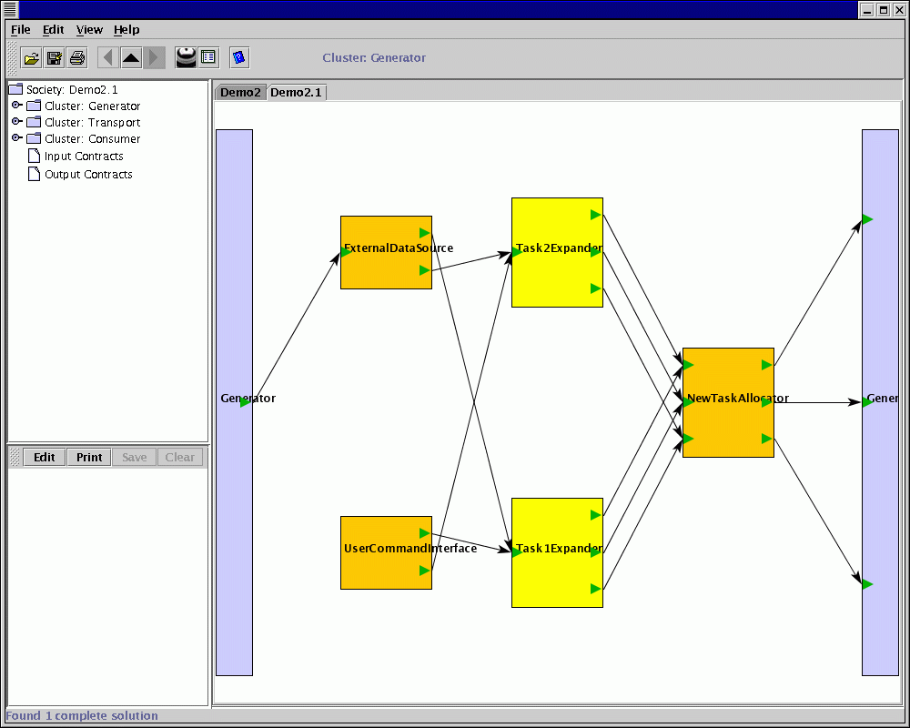

Fig 23: Retaining the solution with the name of the original society

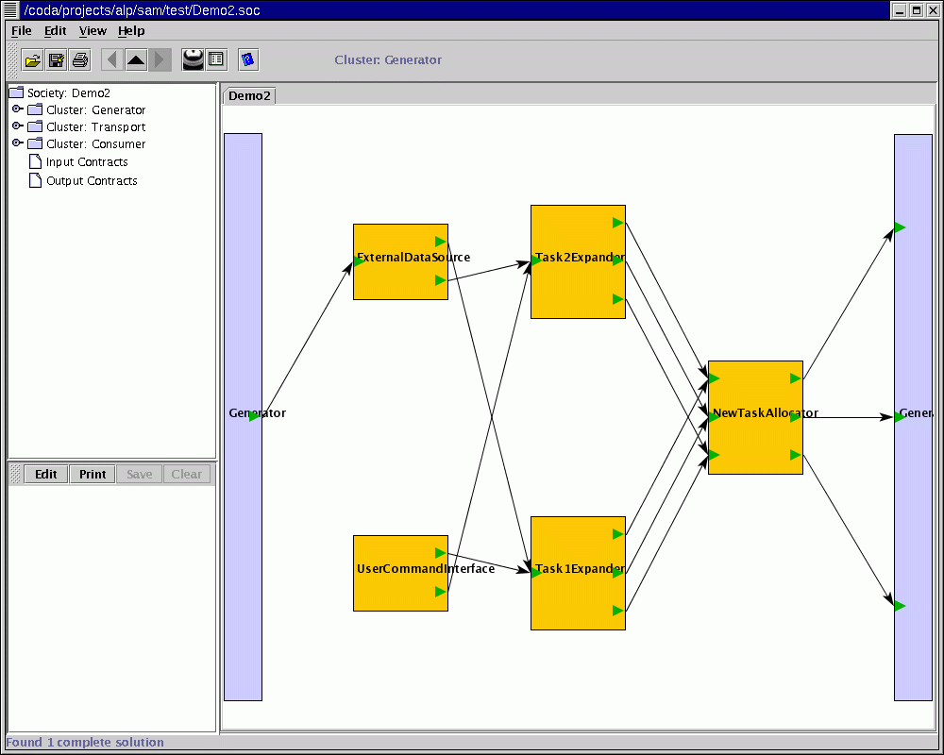

2.7 Using the associated JTree to navigate through the society

The navigator pane displays the structure of the society in the form of a JTree. This JTree can be used to move around the society by clicking on components.

Fig 24: Jtree can be used to access the different components of the society

