GLMTrans Documentation
Gordon Vidaver (gvidaver@bbn.com , 617 873 3558)
October 15th, 2004
GLMTrans is a small transportation society for Ultralog that is meant to replace the TOPS society from the ALPINE/ Cougaar project. It is a lower fidelity system with a much smaller footprint in terms of memory, runtime, and classfiles. Other requirements include very high reliability and repeatability, in addition to high performance. It should be simple and easy to understand, and reuse as many basic components as possible. These will include classes from and extending those in the Vishnu (written by DaveMontana, dmontana@bbn.com ) and Toolkit modules, in addition to the Sequential Backwards Planning Plugin, which is part of GLMTrans. Note that there is also an open source web site hosted at BBN that supports Vishnu .
GLMTrans does Continental US (CONUS) and Europe to theater planning of strategic transportation. This typically involves a ground leg in CONUS/Europe and one in theater, using trucks or railcars, and a sea or air leg in the middle. The tasks come from various demand sources, including requests for deployment of unit equipment and ammunition supply.
Consult the user's guide for how to start the society, and how to run the tools that analyze and visualize the results.

Contents
Packaging
Architecture
Configurations
Seven agent
Twenty agent
Separable Problems
Divisible Problems
Hierarchy
Performance Results
Expected Input
Agent Assets
Plugins
TRANSCOM
GlobalSea
GlobalAir
TheaterGround
PlanePacker
ShipPacker
CONUSGround
OSC
Transport Reservations
Parameters
Testing
Adaptivity
Why is there a performance gain with level 2?
How is adaptivity triggered?
Performance
Details
Problem Details
Configuration Details

Packaging
The GLMTrans society lives in the glmtrans module. Related modules are the datagrabber module, which contains the datagrabber and the TPFDD Viewer, and the vishnu module, which contains the reconfigurable scheduler and the related UltraLog-Vishnu bridge plugins. The datagrabber is a system that allows a datagrabber process to gatherer information about a target society (typically GLMTrans, or clusters in the demand society performing transportation) and aggregate it into one comprehensive, consistent picture. This information is stored in a database, which is then available for the TPFDD Viewer to present this information visually. (See the documentation in the datagrabber doc directory.) Click here for documentation for the vishnu module.
Note that the vishnu module is for client plugins and related classes. The vishnu module interacts with the classes in the vishnuServer jar, which is a separate component developed by BBN. The vishnu server jar contains the Vishnu Scheduler.

Architecture
The GLMTrans society comes in two configurations : a simple seven agent society and a higher performance twenty agent society. Each of the leaf agents is named for the transportation leg it plans : for example, TheaterGround plans theater transport.

Seven Agent configuration
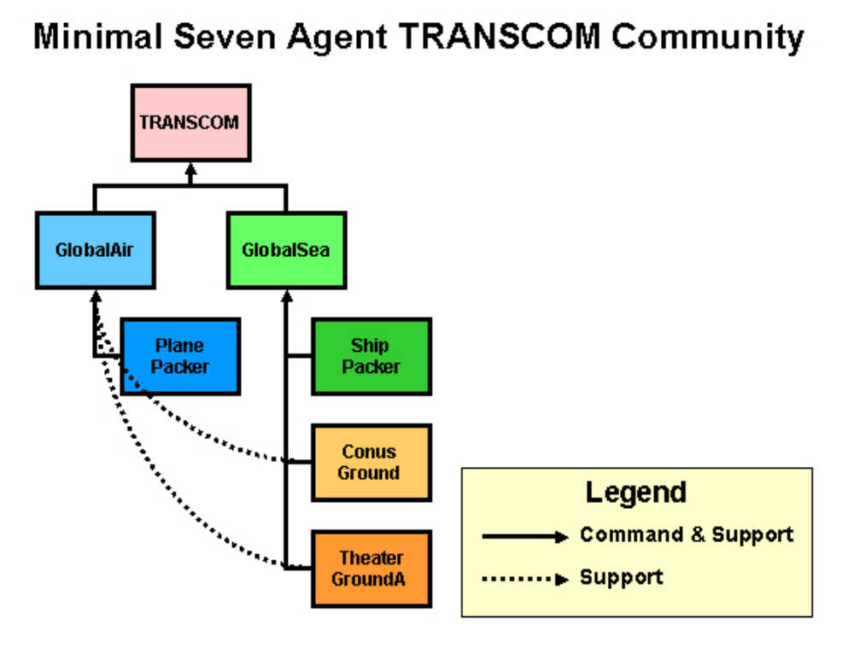
The entry point to the society is the TRANSCOM cluster. Below it are the GlobalSea and GlobalAir clusters that manage the planning of the transportation legs.
Below these clusters are four clusters that schedule tasks against physical assets : CONUSGround, ShipPacker, PlanePacker, and TheaterGround.
GlobalSea and GlobalAir receive tasks from TRANSCOM. GlobalSea sends tasks to CONUSGround, ShipPacker, and TheaterGround,
whereas GlobalAir sends the middle-step tasks to PlanePacker.
GlobalSea and GlobalAir orchestrate the sequential backwards planning process, which constructs the three step (CONUS-Air/Sea-Theater) transportation sequence from a basic template. As each leg is planned, the middle level agents use the information from the preceding leg to determine the time preference and destination of the dependent leg. For example, if the theater leg reports an allocation result specifying a departure from the point of debarkation (POD) at 10:00 am, this becomes the latest arrival date expressed in the end time preference for the sea leg. This guarantees the sequential, non-overlapping sequence of transportation
legs.
The only scalability achieved in the seven agent society is done with unique specialized agent types - one agent per agent type.

Twenty Agent configuration
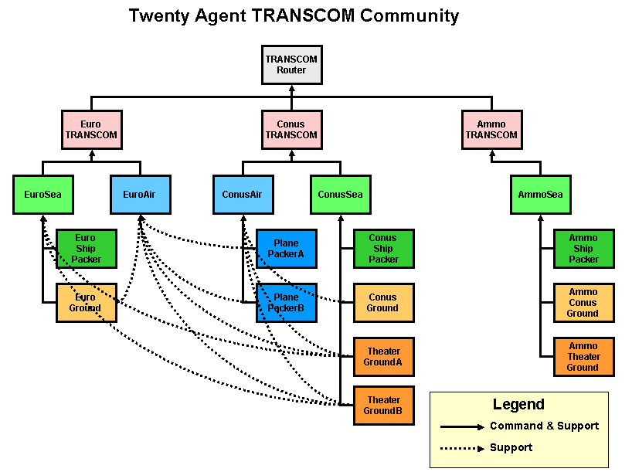
As the demand society grew to more than 1000 agents, we recognized the need to add new dimensions of scalability to the transportation community. Scalability was achieved with common agent types that share common functionality across 2 or 3 agents. There are multiple agents per agent type.

Separable problems
Where agents could be broken into separable problems, this was done. In the seven agent configuration, GlobalSea handled ammo sea requests, whereas in the twenty agent configuration, AmmoSea was added as an agent dedicated to ammo transportation. The ammo shipment problem is separable because ammo is transported on ammo-only shipping and to and from the port groud transport is done by dedicated ground resources. Similarly for transportation requests from europe vs CONUS.
Even for the generally separate problems of transporting from CONUS and europe, planes and theater trucking assets are shared, and this is represented in the support relationships. For example, TheaterGroundA supports both EuroAir and ConusAir to move items from theater airports.

Divisible problems
Some leaf transportation problems could be divided without adverse affects. The TheaterGround agent was divided into two parts, with the original agent's trucking assets divided into two sets, one given to each of TheaterGroundA and B. For example if the seven agent TheaterGround agent had 60 flatbeds, TheaterGroundA and B each had 30. In this way, two CPUs and two heaps could be applied to the theater transportation problem. Additional division could also be done if added performance is desired. An analogous approach divided the plane resources between PlanePacker A and B in the twenty agent configuration.
Note that although higher performance is achieved by this division, the potential downsides are:
- That two agents may not be able to find as good a solution as just one alone (perhaps two independent agents will schedule two planes to be half full whereas in the same situation one monolithic agent would be able to schedule one full plane).
- If the transportation requests are near to the maximum total capacity, some tasks may fail with two independent agents that would succeed with one agent. This depends on the size of individual requests. Consider again the case where two agents each have just two half full planes remaining. If an indivisible request arrives that would require one entire plane, neither agent can satisfy the request and the request will fail. A monolithic agent would have one completely empty plane remaining and be able to satisfy the request.
In our case, the possibility of using one more plane than necessary was not as important as higher performance and our problems never required the last few percent of our capacity.

Twenty Agent Hierarchy
TRANSCOMRouter
ConusTranscom
ConusSea
ConusShipPacker (Conus-Based Ships)
ConusGround
TheaterGroundA (50% of the trucks of seven-agent TheaterGround configuration)
TheaterGroundB (50% of the trucks)
ConusAir
PlanePackerA (50% of the C-5, C-17 of seven-agent PlanePacker configuration)
PlanePackerB (50% of the C-5, C-17)
EuroTranscom
EuroSea
EuroShipPacker (Euro-Based Ships)
EuroGround
EuroAir
AmmoTranscom
AmmoSea
AmmoShipPacker (Ammo Ships)
AmmoConusGround
AmmoTheaterGround

Notes
- ConusAir selects airports for air cargo & PAX from Conus
- EuroAir selects airports for air cargo & PAX from Europe
- PlanePackerA and PlanePackerB jointly support both ConusAir and EuroAir
  - They provide scalability at the expense of schedule optimality
  - More PlanePacker agents could be added
- TheaterGroundA and TheaterGroundB jointly support ConusSea, ConusAir, EuroSea and EuroAir
  - They provide scalability at the expense of schedule optimality
  - More TheaterGround agents could be added
- EuroGround supports EuroAir and EuroSea
- ConusGround supports ConusAir and ConusSea

Results
The twenty agent configuration enabled results that were well under the "TPFDD-in-an-hour" requirement.
Twenty agent performance data varied with demand configuration, but a typical result was 20 minutes to plan 22000 items and 34000 people.

Expected input
Input tasks are expected to have a few basic pieces of information attached to them:
- An item, aggregate, or asset group of cargo in the direct object
- A start time preference
- An end time preference. The end time preference may be structured to have earliest, best, and latest arrival times. This is preferred but not required.
- A From geolocation
- A To geolocation
- A For preposition indicating which unit the task originally comes from.
- Optionally, input tasks may be tagged with a prep "LOW_FIDELITY" which indicates that the task at Level-2 detail and should be handled differently from Level-6 tasks.
The input tasks are expected to be labeled with the Transport verb :
Task: Verb=Transport
General description : Transport tasks are requests on the transportation system to ship some cargo or transport some group of people from one location to another, starting no earlier than the departure preference and arriving no later than the arrival preference.
No. | Attribute | Attribute Details | Usage
1 | DirectObject | Asset | Represents the asset (item or items or people) being moved
2 | Preference | AspectType = START_TIME  ScoringFunction = nearOrAbove | The earliest allowed departure time.
3 | Preference | AspectType = END_TIME  ScoringFunction = VscoringFunction or nearOrBelow | The arrival preference. This can be of two forms : an earliest, best, and latest arrival window or a no-later-than latest arrival time.
4 | PrepositionalPhrase | Preposition = From  IndirectObject = <geoloc where the item is moving from> | The starting location of the item.
5 | PrepositionalPhrase | Preposition = To  IndirectObject = <geoloc where the item is requested to go to> | The requested destination of the cargo item.
6 | PrepositionalPhrase | Preposition = For  IndirectObject = <String, representing the owner> | The owner of the cargo item.
7 | PrepositionalPhrase | Preposition = LOW_FIDELITY  IndirectObject = LOW_FIDELITY | A tag that indicates the task is a Level 2 task. (Optional!)
Other tasks generated by GLMTrans include those with a Transit verb:
Task: Verb=Transit
General description : Transit tasks are tasks which are related to transport tasks but apply only to the resource being used and not to the task cargo itself. That is, these are implied tasks that represent, for instance, the fueling of a truck before, or the maintenance required after doing the main Transport task.
No. | Attribute | Attribute Details | Usage
1 | DirectObject | Asset | Represents the asset (item or items or people) being moved
2 | Preference | AspectType = START_TIME  ScoringFunction = nearOrAbove | The earliest allowed departure time.
3 | Preference | AspectType = END_TIME  ScoringFunction = VscoringFunction or nearOrBelow | The arrival preference. This defines an earliest, best, and latest arrival window.
4 | PrepositionalPhrase | Preposition = From  IndirectObject = <geoloc where the resource is moving from> | The starting/ending location of the resource.
5 | PrepositionalPhrase | Preposition = To  IndirectObject = <geoloc where the resource is moving to> | The starting/ending location of the resource.
6 | PrepositionalPhrase | Preposition = For  IndirectObject = <String, representing the owner> | The owner of the cargo item.

Agent assets
In the following, assets can be populated by either using the UTILLdmXMLPlugin or the LDMSqlPlugin and XMLPrototypeProviderPlugin. The option is provided in the ini files. The principle advantage of the UTILLdmXMLPlugin is that it doesn't require a database connection.

Transcom
Transcom has only the null asset as a physical asset. It has GlobalAir and GlobalSea as subordinates.

GlobalAir
CONUSGround, PlanePacker, and TheaterGround as subordinates.

GlobalSea
CONUSGround, ShipPacker, and TheaterGround as subordinates.

CONUSGround
34 ton trucks (M872) and 68 ft DODX railcars as assets.

PlanePacker
The plane packer uses C-17 s and 747 s.

ShipPacker
The ship packer uses two kinds of ships – Ammo-specific ships and LMSR ships.

TheaterGround
34 ton trucks (M872) and HET s (capable of carrying tanks and other heavy objects) as assets.

Plugins

Transcom
Transcom has two plugins : GLMTransOneToManyExpanderPlugin and TranscomVishnuPlugin. The first expander breaks up unit-sized incoming tasks into individual chunks. These may be aggregate s. The TranscomVishnuPlugin is an extension of the VishnuAllocatorPlugin (from the Vishnu module) that uses the Vishnu scheduler to determine whether tasks go by air or sea. If air, the task is allocated to GlobalAir, if sea, toGlobalSea.

GLMTransOneToManyExpanderPlugin
The GLMTransOneToManyExpanderPlugin has a number of responsibilities.
- It has to decide whether to handle a task at level-6, level-2, or "not-now" level of detail. The plugin compares the requested arrival date of the task against the level 6 time horizon operating mode and the level-2 time horizon. If it is before the level-6 horizon, the task is passed through untouched. If it is between the level-6 and level-2 times, the task will be converted to a level-2 level of detail and subsequent processing by lower-level GLMTrans agents will get a performance boost. If the arrival time is after the level-2 horizon, the task is temporarily ignored. The plugin remembers to wake up a day later (in cougaar time) and review all level-2 and not-processed tasks. If under this review, a level-2 task should be replanned at level-6, the planning for the original task is removed, and the task replanned. Similarly, if the task was previously ignored, the task may be planned at level-2 or 6, depending on the current horizon values. Typically, under stress, the time horizons will be moved closer to now (to the left) so as to reduce the amount of work the GLMTrans society will be forced to do. See figure below. For further discussion of Adaptivity in the GLMTrans community, see here .
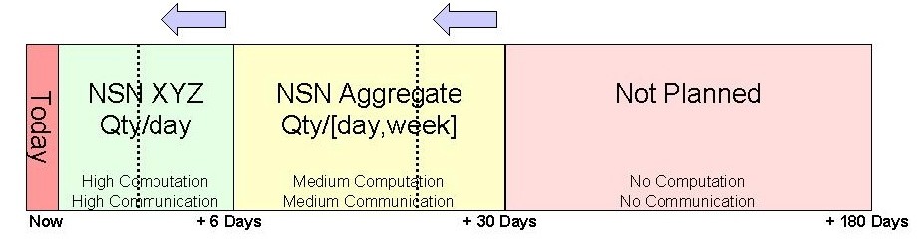
Figure 1 : Level-6 and Level-2 Time Horizons and their response to stresses
- It also has to examine the input task to see if it is already at a level-2 level of detail. If so, the task passes on through and is obviously not examined to see if it should be converted to level-2.
- It has to be sensitive to changes in operating mode, which might make it reconsider the level-of-detail choices it made for tasks.
- It figures out a ship route for the cargo to travel, and uses this to make a mode-selection decision. If there is not enough time for a ship to travel this distance, plus some time for CONUS and Theater ground transport, than the item goes by air. This is encoded in the business rules used by the next plugin.
- It also acts as the "front-door" plugin and so has well-formed tests applied to incoming tasks. Tests applied to incoming tasks are:
  - Departure and Arrival time preferences should make sense - the ready at, earliest, best, and latest arrival dates should proceed in order.
  - There must be from and to prepositions.
  - There must be valid lat/lon info on the from and to prepositions.

Programming details
The level-2 conversion takes asset groups and aggregates and creates one Level-2 aggregate per cargo type. For instance, there may be oversize, outsize, and bulk cargo in a transport task which specifies an asset group of cargo as a direct object. These types will be go as separate Level-2 tasks through the system, and appear so on the TPFDD.
An example of how level-2 assets appear on the TPFDD is :
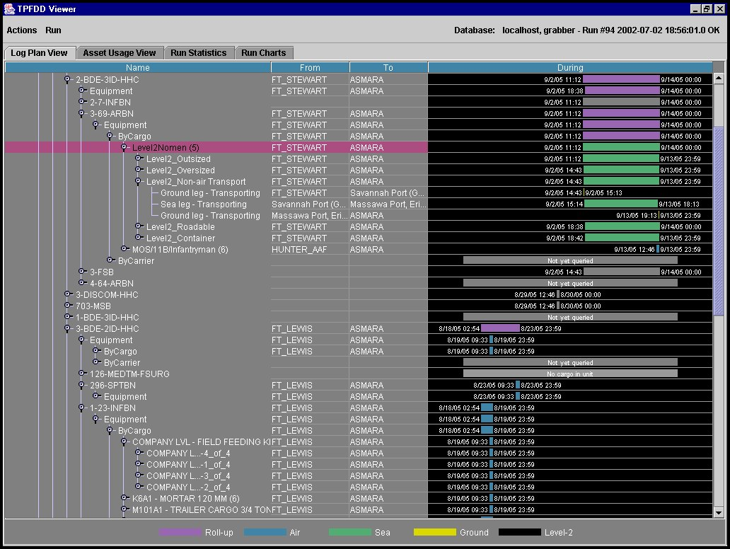
Figure 2 : TPFDD of Level-2 cargo
Sea routes are calculated from a sea network provided by Ken Anderson. There is a separate Route Finder component within the GLMTrans module that calculates the route.
An example route is (obtained by right-clicking on a cargo instance in the TPFDD and selecting Display Route) :
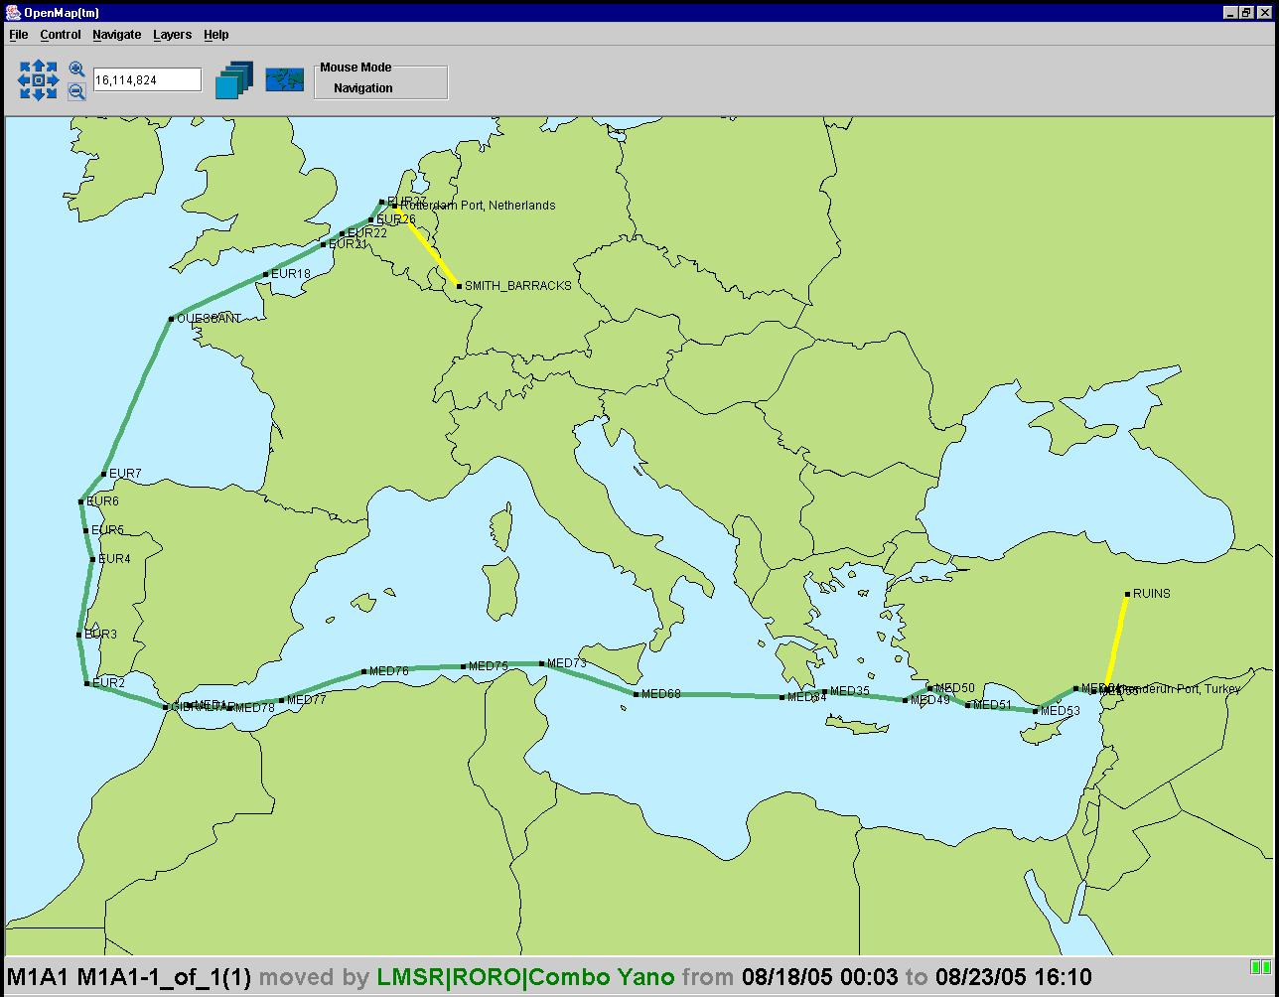
Figure 3 : Route calculated by route finder for a ship route from the Netherlands to Turkey, viewable from TPFDD Viewer

TranscomVishnuPlugin
This plugin is a Vishnu scheduler client, with it's scheduling constraints represented in an xml file for TRANSCOM.
These scheduling constraints/business rules are:
- Tasks which would require the a ship to take the route from source to destination faster than the fastest ship go by air
- Tasks which allow a ship to take the route from source to destination at a speed slower than the fastest ship go by sea
- People go by air
- Transport tasks whose "from" and "to" locations are the same are allocated to the null asset in TRANSCOM. This insures that prepositioned tasks that unload at the theater port and stay there appear on the TPFDD.
This plugin uses a custom XML processor that converts Cougaar objects into the XML format that the Vishnu scheduling system expects. The types of objects that are sent to Vishnu are defined in the Transcom.dff.xml file. For example, here's a snipet of the piece of the Transcom.dff.xml file that defines a task:
<OBJECTFORMAT name="Transport" is_task="true" is_resource="false" >
<FIELDFORMAT name="id" datatype="string" is_subobject="false" is_globalptr="false" is_list="false" is_key="true" />
....
</OBJECTFORMAT>
This says that objects named "Transport" are tasks (is_task="true"). It's first field is named "id" and it is of type "string." (For more information about the Vishnu object format, click here .)
The XML Processor that Transcom uses is called TranscomDataXMLize. It takes tasks and assets and creates XML that looks like this:
<OBJECT type="Transport">
<FIELD name="id" value="TRANSCOM/996629297256"/>
....
</OBJECT>
which is in the format that Vishnu expects for data. Each of the four clusters that allocates tasks to physical assets use custom data xmlizers that extend from TranscomDataXMLize.
Note that the of the modes that the Vishnu client can operate in : client-server, XML-internal, and direct internal, it currently runs in direct internal mode. This means that tasks and assets are directly converted from Cougaar objects into Vishnu objects, and Vishnu scheduling assignments represented as Java objects are directly translated into Cougaar Aggregations and Allocations.

GlobalAir
GlobalAir has one plugin : SequentialGlobalAirPlugin. The plugin extends the base class SequentialPlanningPlugin in the base directory. It manages the different possible templates that a parent task can be expanded into. These are:
- G, A, T (ground, air, theater) - if the task goes from a place that is not an airbase and is going to a place that is not an airport
- A, T (air, theater) - if the task goes from an airbase
- A - if the task goes between airbases
- T - if the task just goes from one location in theater to another
The Sequential planner guarantees that the legs will be planned in sequence as defined by their dependencies. For instance, once the theater leg is planned, its start time is used as the end time of the air leg.
The Sequential planned plugin attaches information to incoming tasks to be expanded in the form of a schedule as a preposition on the task. Each item in the schedule is a SequentialScheduleElement, which represents the information and smarts necessary to plan that segment of the sequence. The SequentialScheduleElement knows which other elements it depends on, so that when all dependencies have been planned, it can be planned. It has a method (planMe ()) which knows how to create the subtask for that segment of the sequence. The plugin notices when subtasks have been planned successfully and scan through the SequentialScheduleElements looking for elements that are ready to be planned. If they are planMe is called on that segment, and the cycle continues until all segments have been planned.
GlobalAir and GlobalSea define subclasses of the SequentialScheduleElement for each segment of the move : Theater, Air/Sea, and Ground.

GlobalSea
GlobalSea is almost identical to GlobalAir, except that it uses SequentialGlobalSeaPlugin, which extends SequentialGlobalAirPlugin to allocate its middle step to the ShipPacker.

CONUSGround, PlanePacker, ShipPacker, TheaterGround
These clusters all use variations on the same plugins : TransportExpanderPlugin, VishnuAggregatorPlugin, and the TransportAllocatorPlugin. The VishnuAggregatorPlugin derivatives use different specialized data xmlizers that add on fields needed for their specific scheduling problems. The expander breaks up incoming tasks, including aggregate s, into chunks the size of the cluster's carrier asset . The aggregator aggregates tasks together and assigns them to a carrier. The allocator actually makes the allocation of MPTask (multi-parent task) to carrier asset .

CONUSGround
CONUSGround has two specialized plugins, the GroundVishnuPlugin, a descendant of VishnuAggregatorPlugin and the GroundTransportAllocatorPlugin. The GroundVishnuPlugin uses the GenericDataXMLize data xmlizer to send data to Vishnu. The two plugins co-operate to specially process self-propelled assets. These are not processed by the GroundVishnuPlugin but are sent straight to the Allocator. There they are allocated to themselves.
Vishnu Specs:
Optimization Criterion - Make sure all tasks have assigned resources. Minimizes the difference between preferred and actual arrival times. Minimizes setup and wrapup times.
Delta Criterion - Penalizes assignments that use a new resource at each eval, having the overall effect of using as few trucks as possible to do the job. Also minimizes the difference between preferred and actual arrival times.
Task Duration - fixed 8 hours for rail; for trucks, calculate the duration using the distance between start and end locations and the speed of the truck
Setup Duration - fixed 1 hour
WrapupDuration - same as Task Duration. This is the time it taks the asset to make its return trip.
Resource Unavailable Times - Looks at the resource's role schedule and makes all entries in the role schedule unavailable
Task Unavailable Times - Task is available only between its start and end time

PlanePacker
The plane packer uses the GenericVishnuPlugin that extends the CustomVishnuAggregatorPlugin. It's main purpose is to redefine the createXMLizer method so that it can make and return the GenericDataXMLizer object. This object handles the custom translation specific to aircraft scheduling.
Vishnu Specs:
Optimization Criterion - Make sure all tasks have assigned resources. Minimizes the difference between preferred and actual arrival times. Minimizes setup and wrapup times.
Delta Criterion - Penalizes assignments that use a new resource at each eval, having the overall effect of using as few resources as possible to do the job. Also minimizes the difference between preferred and actual arrival times.
Capability Criterion - Assigns people to passenger planes (B747) and other assets to non-passenger planes
Task Duration - calculate the duration using the distance between start and end locations and the speed of the plane
Setup Duration - fixed 1 hour
WrapupDuration - fixed 1 hour
Resource Unavailable Times - Looks at the resource's role schedule and makes all entries in the role schedule unavailable
Task Unavailable Times - Task is available only between its start and end time
Capacity Contributions - passengers are counted toward the total passenger capacity of the plane, whereas other assets contribute according to their weight
Capacity Thresholds - see Capacity Contributions

ShipPacker
The ship packer uses the SeaVishnuPlugin that extends the CustomVishnuAggregatorPlugin . It's main purpose is to redefine the createXMLizer method so that it can make and return the SeaDataXMLizer object. This object handles the custom translation specific to ship scheduling.
Vishnu Specs :
Optimization Criterion - Make sure all tasks have assigned resources. Minimizes the difference between preferred and actual arrival times. Minimizes setup and wrapup times.
Delta Criterion - Penalizes assignments that use a new resource at each eval, having the overall effect of using as few resources as possible to do the job. Also minimizes the difference between preferred and actual arrival times.
Capability Criterion - Assigns ammo to ammo ships and non-ammo to other ships
Task Duration - calculate the duration using the distance between start and end locations and the speed of the ship
Setup Duration - fixed 1 hour
WrapupDuration - same as task duration; represent return journey of ship
Resource Unavailable Times - Looks at the resource's role schedule and makes all entries in the role schedule unavailable
Task Unavailable Times - Task is available only between its start and end time
Capacity Contributions - there are two kinds of capacity on a ship: slots for containers and area for non-containers. Containers each contribute to 1 slot of capacity, whereas non-containers contribute according to their areas
Capacity Thresholds - see Capacity Contributions

TheaterGround
TheaterGround is exactly like CONUSGround, except that it has HETs instead of rail cars for assets.
Vishnu Specs: See CONUSGround

OSC
Although the OSC agent is not part of the GLMTrans society, it has some plugins that come from the GLMTrans module.
The AmmoProjectionExpanderPlugin converts incoming Project Supply tasks into Transport Reservations.
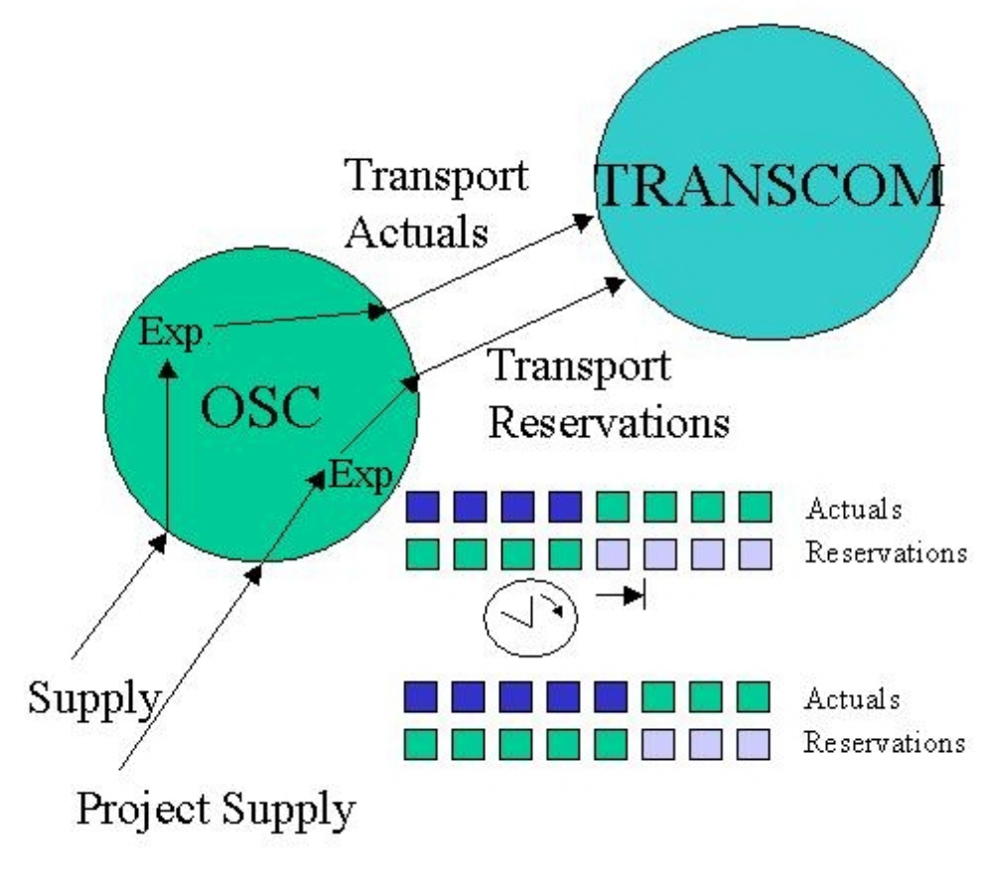
Figure 4 : Conversion of Project Supply tasks into Transport Reservations
The plugin takes the Project Supply tasks and creates Transport Reservations with milvans as direct objects. The reservations are monthly deliveries of the projected quantity of ammunition, divided into month-sized chunks. So for instance if a projection spans three months, three reservations will be generated. The manifest items inside the milvans are these quantities. The AmmoProjectionExpanderPlugin is essentially a poor-man's AmmoPacker. It doesn't attempt to do an optimal job of packing milvans.
Transport Reservations are handled by the GLMTrans community exactly as normal transport tasks. Their main difference is semantic - they represent reservations of assets for transport use. They will be replaced by actual, real transport requests as time progresses. Reservations mark specific assets as reserved for future use.
OSC (the AmmoProjectionExpanderPlugin) keeps tracks of overlaps of actuals with projections and replans them as necessary. As time moves forward, new actuals come in that overlap with existing projections. The AmmoProjectionExpanderPlugin notices this and rescinds and replans the Transport Reservation tasks as necessary. This replanning takes two forms:
  - the ready at date of the reservation task is moved forward to be after the actual task's arrival.
  - the tonnage quantity inside the milvan on the direct object of the Transport Reservation will be decremented to be consistent with the time span of the task. For example, if the original projection was for 10 tons of C380 every month, there will be transport reservations set to arrive at the end of each month with 10 tons. If an actual appears 15 days into the month of a transport reservation, the amount delivered in the milvan will be 5 tons.
Here's an example of a TPFDD with both reservations and actuals on the same page for one type of ammunition. Note that the reservations begin after the actuals end.
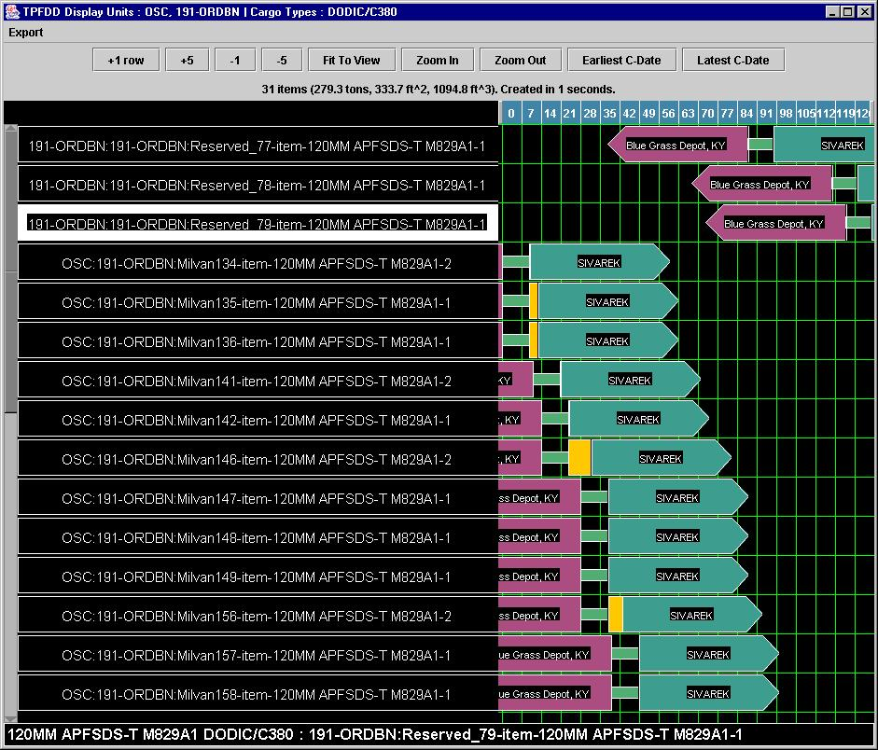
Figure 5 : Ammo Transport Reservations and Actuals for C380.
Note that the reservations begin after the actuals end.
(Generated by the TPFDD Viewer looking at a TINY-1AD run and selecting the TPFDD Filter dialog,
selecting both OSC and 191-ORDBN, clicking Get Manifest, and
then choosing the first ammo cargo type and clicking Display TPFDD. )

Parameters
There are really only three parameters that make any difference in the outcome of runs. These are GA ( click here for an introduction to Genetic Algorithms ) parameters :
* the number of evaluations (the number of new, randomly generated solutions) - currently set to 1
* the maximum amount of amount of time the GA is allowed to spend looking for a solution - currently 5 seconds
* the population size, set to 5
Having the number of evaluations set to 1 means that the GA does in fact not do any optimization after seeding the population with greedy solutions. Increasing it to larger than one would mean introducing random solutions, and beginning to optimize. Increasing any of the parameters would increase the quality of the solution of any particular problem (truck, ship, or plane packing) but would increase run time.

Testing
The main way to do testing of the GLMTrans society independent of other agents is to use the GLMStimulatorServlet. It can be told to read in any of a number of test input files in the testinput directory. These files specify different kinds of input tasks, which test different categories of behavior, covering topics like handling of air, sea, and non-moving transport requests. For more on the GLMStimulatorServlet and how to use it, consult the StimulatorServlet documentation page in the glm/doc directory of the cougaar distribution, which should be here .
Also, there is the AssetStimulator plugin which provides a gui which allows the developer to introduce new assets or assets in change an agent with click of a button. This is helpful when testing plugin responses to dynamic assets. (By default, it creates a new rail car as a new asset, and changes the type id of the first physical asset in the cluster to be X_changed, where X is the original name when changing an asset.)

Adaptivity
GLMTrans adapts to stresses by converting incoming level-6 tasks into level-2 tasks. It does this at the TRANSCOM agent only. See discussion in the TRANSCOM agent above . The TRANSCOM agent uses level-6 and level-2 time horizon operating modes. These modes define how many days into the future TRANSCOM will process tasks at level-6, level-2, or not at all. Tasks processed at level-2 or that are ignored are reexamined when either
- the operating mode values change
- time moves forward a day
When either of these changes occur, TRANSCOM looks through the blackboard for level-2 and not processed tasks and re-examines them to see if they should be processed at a higher level of detail. Note that level-6 tasks are not touched -- no information is ever thrown away.

Why is the there a performance win with Level-2?
The performance win for the GLMTrans society comes from the reduced number of tasks that flow through the society. During level-2 processing of incoming tasks, instead of each task representing the movement of an individual item, there are Level-2 tasks representing the movement of a whole unit's deployment cargo as an aggregate. Per unit, there will be a small number of level-2 tasks, since a unit's cargo is sorted into homogenous cargo category groups, e.g. Oversize, Outsize, Bulk, etc.
Having a small number of level-2 tasks per unit greatly reduces the number of tasks flowing through the society. There is also a performance win in that the Vishnu schedulers at each of the leaf agents are being asked to schedule far fewer tasks. The biggest wins are at the ShipPacker and PlanePacker, since those agents will be forced to divide incoming tasks into the largest chunks, compared to the trucking agents. (Incoming level-2 tasks are broken into subtasks whose chunk size is no larger than the size of the smallest carrier asset in the agent. This is done by the TransportExpanderPlugin .) So ships being much larger than trucks, the chunks will be relatively much larger, and so there will be far fewer subtasks to schedule.

How is adaptivity triggered?
There are plays for the TRANSCOM agent that are triggered when the FallingBehind Condition changes. The playbook for TRANSCOM is simple:
FallingBehind >= 2.0 : Level2TimeHorizon = 60 : Level6TimeHorizon = 21;
FallingBehind == 1.0 : Level2TimeHorizon = 225 : Level6TimeHorizon = 40;
FallingBehind <= 0.5 : Level2TimeHorizon = 225 : Level6TimeHorizon = 225;
The condition can come from the either the FallingBehindConditionServlet or any of several PSU condition servlets. The TimeHorizon OperatingModes are published by the TRANSCOM agent and watched there for changes. They are used in the level-of-detail decision making process applied to incoming tasks, see above .

Performance
Click here to learn more about the performance and scalability of GLMTrans in small configurations.
Twenty agent performance data varied with configuration, but a typical result was 20 minutes to plan 21000 items and 31500 people.

Details
Problem details -- there are a number of business rules that GLMTrans uses:
- Tasks which begin at an airport or seaport do not have CONUS ground legs. Similarly tasks which end at an airport or seaport have no theater leg.
- People do not have ground legs.
There are a number of business rules that GLMTrans does not follow:
- Unit integrity for ships.
- ISBs
- No RSO&I at ports/airbases.
- It doesn't try one mode and then if that fails try another. For instance, it doesn't try to schedule something to go by air, and then if that fails, schedule it to go by sea. This would add complexity to a system meant to be less complicated than its predecessor.

Configuration details
GLMTrans tries to reduce the number of configuration files necessary by making several plugins share parameter files. So in several places in the configuration files, plugins will use an envFile parameter to point to a shared parameter file. Note that we have to prefix some files with "GLM." because they are similar named files in configs/common, and we would have name collision on the config path.
Note that if a plugin doesn't have an envFile explicity declared for it, it will look for a parameter file beginning with the agent name. If it doesn't find one, it will note that it couldn't, but this is only a problem if the plugin needs parameters.
Similarly there are ldm.xml files that define the resources for the different agents. These are read by the UTILLdmXMLPlugin , which also looks for <agent name>.ldm.xml files. The use of this plugin is optional -- you can also use the more traditional XMLPrototypeProviderPlugin and LDMSQLPlugin plugins to populate agents with assets.

