Adaptive Defense Coordination
for Multi-Agent Systems
David Wells, Paul Pazandak, Marian Nodine, and Anthony Cassandra
Abstract— For manageability, large agent societies incorporate features that allow for self-healing in the face of individual failures. Individual features may support or conflict with each other; thus, it may not be optimal for them to act completely autonomously. An adaptive control defense coordinator chooses and mediates such actions to repair a damaged agent society or to protect it against future problems is described. The coordinator attempts to determine the real state of the agent system in the face of multiple diagnoses, then selects a course of action from a collection of potentially conflicting defense actions. In this selection process, it takes into account both any uncertainty about the exact nature of a perceived problem and any high-level policy defining the relative importance of application properties such as completeness, timeliness and security. The coordinator described in this paper is model driven, allowing it to be deployed in a variety of settings. This also allows operators to adapt its behavior to evolving situations by making changes to human-understandable profiles of anticipated stresses or by changing high-level policy describing system goals.
Index Terms—Multiagent systems, coherence and coordination, knowledge modeling, control methods.
——————————  ——————————
xxxx-xxxx/0x/$xx.00 © 200x IEEE
————————————————
- David Wells is with Object Services and Consulting, Inc., Baltimore, MD 21209. E-mail: wells@objs.com.
- Paul Pazandak is with Object Services and Consulting, Inc., Bloomington, MN 55420. E-mail: pazandak@objs.com.
- Marian Nodine is a Senior Research Scientist with the Telcordia Technologies, Inc., Austin, TX 78733. E-mail: nodine@research.telcordia.com.
- Anthony Cassandra is with the Department of Computer Science, St. Edward’s University, Austin, TX 78704. Email: arc@cassandra.org.
- Approved for Public Release. Distribution Limited.

Manuscript received 4/15/2004.

Introduction

This paper describes an adaptive control coordinator being developed to mediate potentially conflicting defense actions in large multi-agent Cougaar societies. Cougaar (Cognitive Agent Architecture) [1], is a Java-based architecture for the construction of large-scale distributed agent-based applications and is the product of a multi-year DARPA research project (UltraLog) [2] into large scale agent systems.
Cougaar has a variety of “defense” mechanisms that sense system state and attempt to repair (e.g. detect and restart a dead agent) or proactively defend (e.g. raise the encryption level under high security conditions) the society, thus allowing a Cougaar society to be survivable in the presence of a large number of physical and cyber threats. Because of their complexity, the different Cougaar defenses are developed independently, without considering the other defenses that may be present. Additionally, the set of defenses has expanded and evolved over time, and each evolution has had the potential to change the dynamics of the interactions among the defenses as well.
Unfortunately, a given problem or situation within the agent system or the infrastructure on which it runs may cause multiple symptoms, and these may in turn automatically trigger one or more correct or conflicting defenses. This problem is further compounded by the fact that the sensors that detect problems may be unreliable or inefficient, or have widely different latencies for reporting the problems that they sense. It only takes a small number of badly-timed, conflicting defensive actions before the agent system is being damaged rather than healed.
The independence of the defenses precludes any individual defense from correlating or organizing its potential actions with those of other defenses [3] in order to deal with these issues. This independence can also lead to misuse of resources when the lack of a global vision precludes making tradeoffs between of individually reasonable actions, not all of which can be performed due to resource limitations.
The Adaptive Defense Coordinator (DC) oversees and orchestrates the process of correlating, selecting, and organizing sets of defensive actions that may pertain in a given situation. The goals of the Coordinator are to:
- maintain an understanding of the state of the assets in the agent system,
- cope with uncertainty in the form of conflicting, missing, and incorrect diagnoses.
- make intelligent use of information about current status and expectations of future behavior when selecting actions,
- prevent undesirable combinations of actions,
- consider the importance placed on various survivability criteria (application completeness, timeliness, and security) when selecting actions,

Coordinator Interaction With the Defenses
Cougaar’s existing defensive capabilities can be characterized as a collection of sensors that monitor the state of a society’s assets and makes diagnoses about their status, and a collection of actuators that can take one or more actions to repair or protect those assets. The Coordinator uses a small API through which diagnoses are presented to the Coordinator and actuators are enabled by the Coordinator. Each sensor creates one Diagnosis object for each asset it monitors and each actuator creates one Action object for each asset upon which it can act. The sensor or actuator determines the level of abstraction at which it presents information and control to the Coordinator. For example, the diagnosis that an agent is dead and the offer to restart it are both made at the level of individual agents, whereas the offer to adjust an encryption level is made for a “community” of related agents on multiple hosts.
Sensors and actuators are frequently paired (a sensor detects problems that its paired actuator can address), but there are both free-standing sensors (e.g. load sensors) and free-standing actuators (e.g. encrypt with a particular key length). Actuators paired with sensors are usually designed to operate autonomously when they detect a problem. There are two reasons for this: (1) independent development means that most actuators are unaware of other actuators with which coordination is required, and (2) the need for fast response to either emergencies or frequently occurring situations often precludes requiring some actuators to seek outside permission before taking action. As previously noted, this requirement for autonomous operation of sensors and actuators (local autonomy) creates problems when multiple actuators decide the act in contradictory or redundant ways.
The requirement for local autonomy, coupled with the fact that defenses present diagnoses and accept control at different levels of abstraction require the Coordinator to be partitioned to have both a node and community level presence. The community-level Coordinator interacts with both community-level defenses (sensors and actuators) and with the node-level Coordinators. The node-level Coordinators in turn interact with node- and agent-level defenses. The Coordinator implementation at each level will be the same, the difference being that community level coordinators watch different sensors and control a different set of actions. This partitioning allows decisions to be made locally when they affect only a single host and at the same time allows coordination when the same action (e.g., encryption change) must be applied to a group of hosts or agents. It also allows for the local autonomy of sensors and actuators should the agent society become partitioned, either intentionally or due to communications problems. Fig. 1 shows the Coordinator partitioning and a condensed version of the sensing and control API.
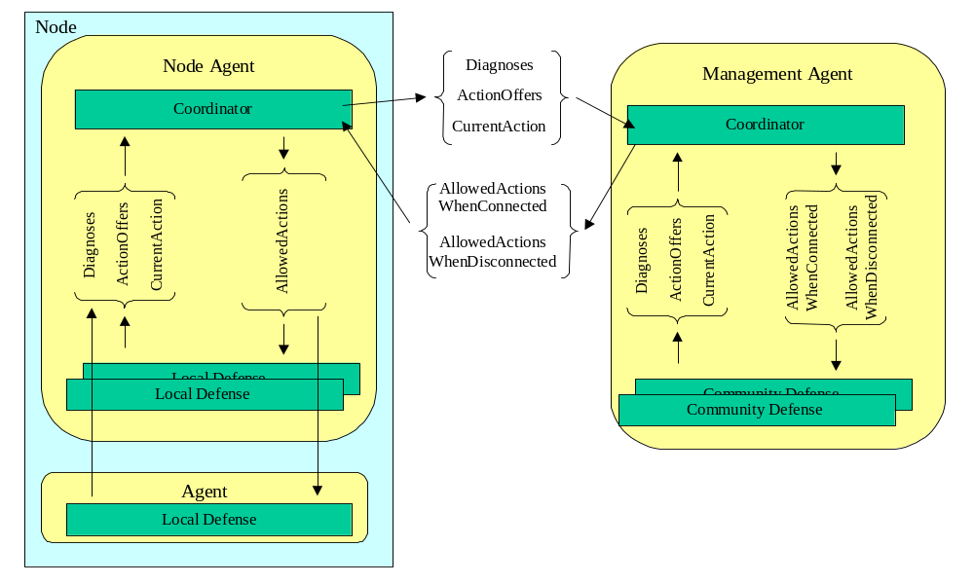
Fig. 1. The partitioning of the Adaptive Control Coordinator into node and community level components and showing the interaction between the components and with defenses.

Modeling the Society And Its Environment
The Adaptive Control Defense Coordinator maintains models of asset types whose instances may appear in a given Cougaar society, individual assets actually present in the society, sensors that report society state, actuators that can change society state, and threats to the society. These models are used by the Coordinator in the estimation of society state and the choice of actions to achieve and maintain a desirable state. Threat models are also used by the Cougaar test harness to inject stresses corresponding to the modeled threats.
Modeling information may be static (for the lifetime of the agent system) or dynamic (depending on configuration and environmental factors). Static information includes information about the types of assets in the agent system (e.g., agents, hosts), the types of sensors that sense status or problems within the agent system (e.g., agent liveness sensors, encryption level sensors), and the types of actuators that will be available to effect changes in the agent system (e.g., agent restart actuator). Generally, this information may be determined in a manner independent of a given individual instance of a Cougaar agent system. Therefore, this static information is encoded into XML technical specifications (TechSpecs) that can be reused in multiple applications. The defense coordinator reads in these TechSpecs during initialization.
Dynamic modeling information includes models of individual assets, and models of the threats that are likely to affect the agent system. The defense coordinator obtains dynamic modeling information from the Cougaar society itself (via the Community Service), from earlier, similar executions of the agent system, from external sources (e.g., intelligence warnings of changes in threat level or changes in high-level policy), and from a general understanding of the operational environment of the agent system (e.g., in a secure location vs. on a battlefield).

4.1 Asset Type Models
Each asset that is in the scope of the Coordinator has an asset type. Cougaar has several built-in asset types (agent, node, host, network, enclave). Asset types may be subtyped, and additional asset types not directly known to Cougaar may be defined. An example TechSpec fragment for the asset type “Agent” is shown in Fig. 2.
The state space for a given asset type is defined by the cross-product of a set of orthogonal and independent state dimensions, with each dimension having several possible state dimension states. In Fig. 2, the state dimensions are LIVENESS, COMMUNICATIONS and ENCRYPTION_LEVEL. The state dimension ENCRYPTION_LEVEL has three states: ENCRYPTED_256, ENCRYPTED_64 and NOT_ENCRYPTED. This means, for example, that a specific asset of Type “Agent” could be in state: [LIVENESS = LIVE, COMMUNICATIONS = DEGRADED, ENCRYPTION_LEVEL = NOT_ENCRYPTED].
The state of an asset determines what the asset is doing and how well it is doing it. This determines the asset’s contribution to application’s utility. The XML properties “relativeMauCompleteness” and “relativeMauSecurity” for each state define the contributions of that state towards application utility. Different asset types provide different utility to the society; some critical agent types are worth relatively much more than others. This is reflected in a separate specification that is used to scale the relative utilities described above. Utility will be discussed further in Section 4.

4.2 Asset Models
The Coordinator needs information about the assets actually in a society at any given moment. The asset models are constructed dynamically based on information obtained from the society (e.g. host size, agent location, and agent size) or calculated by the Coordinator itself (the state an asset is believed to be in).
We support a containment model for assets (e.g. networks contain hosts, which contain nodes, which in turn contain agents). Containment is important to the Coordinator for three separate reasons.
<AssetStateDimensions assetType=“Agent”>
<StateDimension name=“LIVENESS” >
<SimpleState name=”LIVE"
relativeMauCompleteness=”1.0”
relativeMauSecurity=”1.0” />
<SimpleState name=”DEAD"
relativeMauCompleteness=”0.0”
relativeMauSecurity=”1.0” />
</StateDimension>
<StateDimension name=“COMMUNICATION” >
<SimpleState name=“GOOD”
relativeMauCompleteness=”1.0”
relativeMauSecurity=”1.0” />
<SimpleState name=”DEGRADED”
relativeMauCompleteness=”0.5”
relativeMauSecurity=”0.9” />
<SimpleState name=”PLANNED_DISCONNECT”
relativeMauCompleteness=”0.3”
relativeMauSecurity=”1.0” />
<SimpleState name=”NOT_COMMUNICATING”
relativeMauCompleteness=”0.0”
relativeMauSecurity=”1.0” />
</StateDimension>
<StateDimension name=”ENCRPTION_LEVEL” >
<SimpleState name=”ENCRYPTED_256”
relativeMauCompleteness=”1.0”
relativeMauSecurity=”1.0” />
<SimpleState name=”ENCRYPTED_64”
relativeMauCompleteness=”1.0”
relativeMauSecurity=”0.7” />
<SimpleState name=”NOT_ENCRYPTED”
relativeMauCompleteness=”1.0”
relativeMauSecurity=”0.1” />
</StateDimension>
</AssetStateDimensions>

Fig. 2. Asset Type Tech Spec Example
- Threats that affect containers often affect the contained assets as well. For example, a node crash will cause all the contained agents to crash as well.
- If some assets in a container are experiencing a problem, it may increase the probability that other assets in the same container will experience similar problems. For example, if some agents in an enclave are known to be infected with a virus, the probability that other agents in that enclave will also become infected increases.
- Some Actuator actions taken at the container level may have an effect on the contained assets. For example, if an enclave is instructed to go to 64-bit encryption, this has an effect on all of the nodes in the enclave which must be synchronized on the new encryption level and then actually perform the 64-bit encryption.
The containment model for assets is defined very generically. This is because we believe that there are many different types of containment beyond the ones we have currently implemented.
Property lists can also be appended to assets to describe properties that are relevant to threats, sensors or actuators. For example, the location of a host may make it more or less vulnerable to certain location-sensitive threats.

4.3 Sensor Models
Sensor types are defined by two kinds of TechSpecs:
- SensorType TechSpecs define the intended properties of sensors.
- CrossDiagnosis TechSpecs describe the kinds of errors that sensor types can make when faced with situations outside their operating range whose effects may spill into their operating range.
A given sensor type monitors a specific state dimension of a specific asset type. The latency of each sensor type defines the time between the occurrence of an event monitored by the sensor and the time a diagnosis is actually made. This generally reflects an interval during which the sensor is either collecting or analyzing evidence about a problem, and is used by the Coordinator to determine how long it should wait for further diagnoses before taking action based on already received diagnoses.
The SensorType TechSpec models the diagnoses that the sensor type makes when faced with specific asset states. For each possible state in the monitored state dimension, the sensor will make a diagnosis. Because of either sensing or aggregation errors or other ambiguity, a type of sensor may make different diagnoses at different times when faced with the same (or similar) asset state. For example, when an agent is actually DEAD, a liveness sensor may declare that it is DEAD 90% of the time and LIVE 10% of the time (because the sensor has not yet gathered enough evidence to declare the agent dead).
Sensors can be confused by situations (asset states or events) in state dimensions that the sensor is not designed to deal with and does not know about. This is especially true in situations where the sensor is trying to process or communicate over an asset that it is also sensing. For example is that the AgentCommunication sensor will diagnose NOT_COMMUNICATING in the Communicating dimension when the agent is DEAD in the LIVENESS dimension. CrossDiagnosis TechSpecs define the kinds of errors that can be made by a sensor due to state dimensions not monitored by the sensor. An example appears in Fig. 3.
<CrossDiagnosis sensorType=”AgentCommunication”
isAffectedByStateDimension=”LIVENESS” >
<WhenActualStateIs name=”DEAD” >
<WillDiagnoseAs name=”DEGRADED”
withProbability=”0.01” />
<WillDiagnoseAs name=”NOT_COMMUNICATING”
withProbability=”0.99” />
</WhenActualStateIs>
</CrossDiagnosis>
Fig. 3. Cross Diagnosis Tech Spec Example

4.4 Actuator Models
An actuator is a Cougaar component that can take actions to affect the state of assets. Actuators are defined in ActuatorType TechSpecs. There are three basic kinds of actuators in a Cougaar society
- Actuators that attempt to repair an existing problem by moving an asset from an undesirable state to a more desirable state (e.g., restart a dead agent).
- Actuators that move between acceptable states in order to try to prevent the occurrence of future problems at a cost commensurate with risk (e.g., change encryption level for an enclave).
- Actuators that move between acceptable asset states to adjust society behavior by making tradeoffs based on resource availability and high-level policy to improve utility (e.g., change a logistics planning level).
Each actuator type acts to change the state of some asset type in one state dimension. In addition, just as with sensors, there may be collateral effects in other dimensions as well. For example, a restart will generally move an agent from DEAD to LIVE and also (collaterally) from NOT_COMMUNICATING to COMMUNICATING. An actuator type has one or more mutually exclusive actions it can perform. An action, if successful, moves the affected asset from one state to another within the affected state dimension. Thus, the actuators impose a set of state machine transitions on the asset states defined within the asset type TechSpec. Additional transitions are defined in the Threat Model (next section).
There is a one-time cost to attempt a given action. This cost is accrued whether or not the action succeeds (this is a slight simplification). Costs are specified in terms of the base resources (CPU, bandwidth, memory) that are consumed performing the action. The design of the controller does not assume that it is possible to collect precise estimates of resource utilization. Rather, it uses a set of discrete descriptors for intensity of effort; initially these are [VERY_LOW, LOW, MEDIUM, HIGH, VERY_HIGH], with a rough order of magnitude difference between values. The interpretation to numeric values will be provided externally to the TechSpec. This formulation allows costs to be determined dynamically based on information coming from the Cougaar society, which is important because many of the defensive actions available are sensitive to dynamic factors such as the number of messages needed to do the action, and the amount of information that must be transmitted.
Actions may also have continuing costs. For example, changing the encryption level of an enclave has both one-time and continuing costs. The one-time cost is the communication and handshaking to get all parts of an enclave to be aware of the change to the new encryption level (this is necessary because if they are all at different levels they can’t communicate effectively). The continuing cost is the cost to encrypt and decrypt messages on the individual nodes in the enclave.

4.5 Threat Models
The defense coordinator uses a simple, yet rich model of threats in its processes of estimating the state of assets and in performing cost-benefit analysis to determine which defensive actions to take. Threats are the potential for the occurrence of a spontaneous event. Threat is a generic term encompassing the potential for both failures and attacks. A threat manifests itself as an event that directly affects assets of a given type. Threats and events are modeled separately as shown in Fig. 4.
The likelihood of an event occurring for each instance of the potentially affected asset is specified as a function of time. To avoid the false implication that event likelihood can be expressed with great precision, we define a fixed set of terms [VERY_LOW, LOW, MEDIUM, HIGH, VERY_HIGH] in which event likelihood can be expressed. During operation, these are externally mapped to probability per unit time, the difference between terms being an order of magnitude as with the terms in the cost model.
If the event occurs for a given asset, it has a direct effect on the asset, described as a transition between asset states, thus completing the state machine model of asset behavior. In the example, if a NodeDeath Event occurs for a given Node, the Node will end up in the “DEAD” state in the “LIVENESS” dimension. The effects of an event may be transitive based on the containment model. For example, if a NodeDeath event occurs, it will cause AgentDeath events for all the agents in that node. This is defined in a separate TechSpec related to the containment model (not shown).
Note that the threat model also supports other features not discussed here. These include probabilistic transitive effects that raise or lower the probability of an event based on earlier events, and the ability to specify filters on agent properties to support partitioning of the assets and to allow threat likelihood to be time- or property- sensitive.

Measuring Utility
The goal of the defense coordinator is to maximize the utility of the assets within the agent system, based on the needs of the application and its users. The defense coordinator defines utility based on three categories: completeness of the application’s task, timeliness of needed information, and security of the application’s operation. These correlate with the categories of Measures of Performance (MOPs) within the UltraLog system.
The UltraLog program uses a multi attribute utility (MAU) algebra to measure how well an agent society is meeting multiple objectives, including survivability. MAU provides a mathematically sound procedure for assessing one’s preferences over multiple attributes. MAU models reflect explicitly the relative importance of attributes, and the degree to which system designs impact attributes [5], [6]. Overall system performance is broken down iteratively into component dimensions, each given a swing weight, such that they add to 100. At the leaves are the individual repeatable measures of performance (MOP). Each MOP is paired with an MAU curve, indicating the utility score given for a particular measurement on that MOP. Some MOPs will reflect the core application, while others will measure the supporting survivability aspects such as confidentiality, integrity, robustness, and availability. Some MOPs exist at a user level, reflecting the aggregate behavior of the whole society, while others represent measures of some sub-system, component or tier. Some MOPs vary in real-time and represent the ongoing execution performance of the system, while others represent quality of intermediate products and can only be measured at particular processing phases. The design of the MOPs, swing weights, and MAU curves must be worked out with functional experts.
As mentioned before, the AssetType TechSpecs contain information on the effects of a given agent state on the contribution of the asset to the agent system’s overall utility. Returning to Fig. 2, note that each state in the state dimension has, for relativeMauCompleteness and relativeMauSecurity, some value on the scale of 0.0 to 1.0, indicating its contribution to the completeness and security aspects of utility. In the example, being encrypted with a 64-bit key has no effect on completeness utility (a relative utility of 1.0 means that the asset is doing as well as is possible in a given dimension), but is only 70% as good in the security dimension as 256-bit encryption. The relative utility of an asset state is computed as the state-dimension-wise product of the relative utilities of the individual state dimension states.
The effectiveness of the defense coordinator in responding to a particular mix of threats can be measured in terms of improvement in the MAU score compared to the same society without the defense coordinator. The MAU-dictated preferences are also used by the defense coordinator in its decision process.

Coordinator Logic & Architecture
The Coordinator performs the following tasks in the selection and control of actions:

<Threat name=”NodeCrash” affectsAssetType=”Node"
causesEvent=”NodeDeath”
defaultEventLikelihoodProb=”LOW” />
</Threat>

<Event name=”NodeDeath" affectsAssetType=”Node"
affectsStateDimension=”LIVENESS">
<DirectEffect>
<Transition WhenActualStateIs=”*”
EndStateWillBe=”DEAD” />
</DirectEffect>
</Event>
Fig. 4. Threat and Event Model Examples.
- collect diagnoses about potential problems,
- determine what state it thinks an asset is in, based on a possibly conflicting, possibly incomplete set of diagnoses,
- determine the value of taking the available defense actions given its beliefs about state,
- select and enable one or more non-conflicting defense actions to maximize the overall benefit to the society,
- monitor the outcomes of selected actions and choose a new course of action if necessary
In addition, the Coordinator performs a number of ancillary actions to make possible its primary functions.
The defense coordinator is a Cougaar agent, and as such is composed of a collection of individually loadable plugins that perform specific logic and interact via a blackboard. The partitioning of the coordinator into plugins as shown in Fig. 5. This partitioning allows variants for each of the main functional units, thus allowing for incremental improvement as well as replacement of individual pieces of the decision process to tailor the Coordinator to different environments or to experiment with alternate policies. This section describes the individual plugins. Where interesting alternative implementations exist, they are noted.
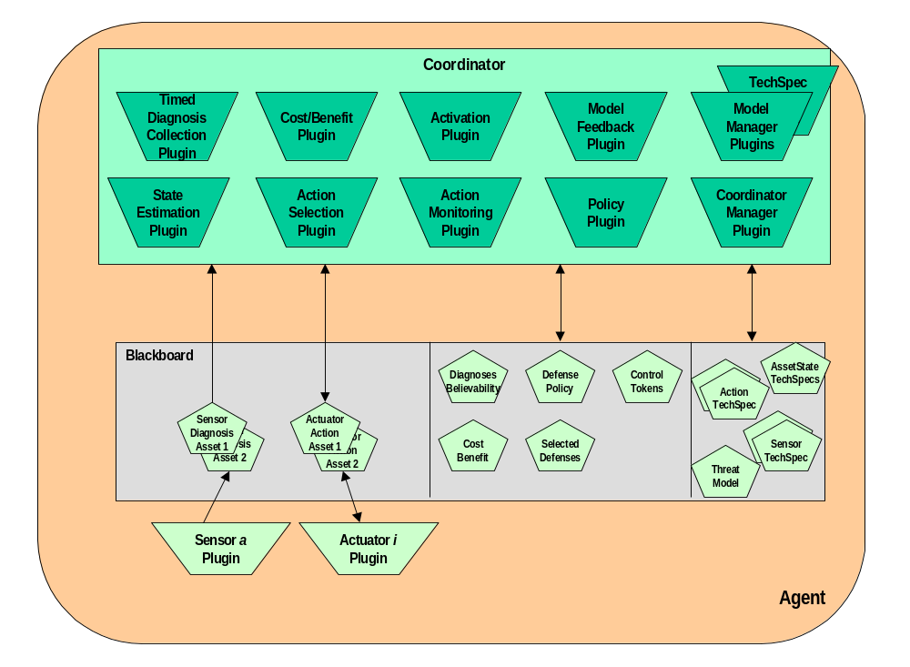
Fig. 5. Coordinator Internal Plugin Architecture.
Key to the understanding of the operation of the defense coordinator is the idea of asset state. Section 3 describes the models that underpin the agent state. For each asset, its AssetType TechSpec describes the orthogonal state dimensions that characterize the state of the assets of that type. Each of these state dimensions has a set of states, also defined in the AssetType TechSpec. Each of the state dimensions also is overlaid with state transitions by the Threat Model and the Actuator TechSpecs (below) to form a set of independent state machines. These state machines define the collection of potential behaviors of the society due to voluntary transitions as a result of defense actions and involuntary transitions due to environmental stresses.
At a given time, a specific asset is in some known asset state, which can be modeled as the cross-product of its current states in each state dimension. Potential changes in this asset state are defined by the transitions from the current state dimension states in the state machine for each state dimension. An agent state has a utility, computed from the completeness, timeliness and security of the state dimension states in the asset state. The defense coordinator tries to make decisions in a way that will maximize utility.
Unfortunately, the ability of the defense coordinator to observe the actual asset state is impeded by a number of factors, as described earlier. Therefore the defense coordinator maintains a probabilistic estimate of the asset state, termed the belief state of the asset. As with the asset state, the belief state of an asset is the cross-product of the belief states related to each state dimension. However, with respect to the state dimension, the belief state is a probabilistic distribution over the states of the belief that the asset actually is in that state. For example, the belief state may maintain that a given asset has a .7 probability of being in state “LIVE” in the LIVENESS state dimension, and a .3 probability of being “DEAD”. Potential changes in the belief state are defined by the transitions from the current state dimension states for each state dimension, moderated by the probability that the asset actually is in that state dimension state. The actual updating of the probabilities is done using a Partially-Observable Markov Decision Process (POMDP). Finally, the utility of a belief state is computed using the probabilities of being in each state dimension state.
The process of estimating belief state for an asset is triggered by the arrival of some diagnosis from some sensor of that asset. Eventually, the StateEstimation Plugin receives the diagnosis, and generates a new belief state. The CostBenefit Plugin evaluates the belief state with respect to its utility. If its utility is bad, the CostBenefit Plugin assesses the utility benefit of various actions. The ActionSelection Plugin selects an action based on the cost/benefit assessment, then one or more non-conflicting actions are initiated and their progress monitored. If the actions are successful, the StateEstimation Plugin is notified so it can update its belief state. If the actions fail, the ActionSelection Plugin will try a different action or actions.
The following subsections provide more detail on the defense coordinator plugins.

5.1 Model & TechSpecManager Plugins
The decision process followed by the coordinator, as described in the rest of this section, is model-driven for the following reasons:
- to facilitate the addition of new sensor and actuator types,
- to allow expectations of changes in the intensity of the threats to the society to cause the Coordinator to choose defensive actions appropriate to the new threats,
- to allow the Coordinator to be deployed into new operational environments, and
- to allow the tuning of behavior at a human-understandable level of abstraction (tune models of system and environment constructs rather than playbooks or code).
The Coordinator uses the previously-described models of asset types whose instances may appear in a given Cougaar society, individual assets actually present in the society, sensors that report society state, actuators that can change society state, and threats to the society. These models are used by the Coordinator in the estimation of society state and the choice of actions to achieve and maintain a desirable state as explained in subsequent sections. The Coordinator plugins maintain and provide access to the models used by the Coordinator. As described earlier, the model information is derived from statically-defined TechSpecs, dynamic information maintained by the Cougaar society, and external sources such as security alerts.

5.2 TimedDiagnosis Plugin
Sensors signal their diagnoses by setting Diagnosis objects. This is asynchronous, and different diagnoses may have very different latencies, so different diagnoses of the same situation will arrive at different times. To reason about a situation, we need to collect up sufficient diagnoses related to a given asset to make a good estimate of what has (or is) happening. If selection occurs as soon as a diagnosis arrives without waiting for other diagnoses of the same event to occur, then the diagnosis that was signaled fastest would always be believed even if it were not the most appropriate one. In addition, the system might thrash as other diagnoses fire as they would appear as separate event occurrences.
The TimedDiagnosis Plugin waits until a sufficient set of Diagnoses have been acquired, batches up copies of them, and publishes the collection to the blackboard for the StateEstimation Plugin. The current implementation uses the sensor latency specifications to determine the maximum time to wait after obtaining the first diagnosis. However, this is wasteful if latencies vary a lot (as they do in Cougaar). This is particular important when the sensors with the lowest latency are much more accurate than sensors with longer latency. An example of this situation concerns an agent that is killed by some actuator (for a security violation or to free up resources). The diagnosis that the agent is dead can be made very quickly and accurately by the entity that killed the agent. In this case, it is very inefficient to wait for a less accurate, longer latency sensor that attempts to deduce that an agent is dead by observing a prolonged lack of responsiveness from the agent.
To address this, we are experimenting with a new approach in which the diagnoses are not grouped, but rather forwarded as they are received. The StateEstimation Plugin (described in the next section) would monitor the effects of each diagnosis on its belief state for the affected asset. If the StateEstimation Plugin reaches a specified certainty threshold concerning some diagnosis, then it will ask the Coordinator to respond immediately; otherwise, it will ask the Coordinator to respond once the longest-latency sensor has reported.

5.3 StateEstimation Plugin
Because there are many independent diagnoses coming from the sensors, and because any of them may be late, missing, or inaccurate, sensor information alone is an insufficient basis upon which to select defensive actions. To compensate for this, the Coordinator estimates its belief concerning the state of each asset. Belief that an asset is in a particular state is a function of the asset’s prior known state, any diagnoses (pro and con) about the asset’s state, a statistical model of the accuracy of those diagnoses, information about the success or failure of any defenses that have acted, and a profile of the threats to which the asset may be subject.
Intuitively, if it is unlikely for an asset to be in a particular state, it should require more evidence of a higher quality before believing that the asset actually is in the unlikely state than is required to believe that the asset is in a likely state. Additionally, it is useful, for two reasons, to estimate how certain we are about the estimated state. Depending on how undesirable a state is, we may want to take immediate corrective action if we have a reasonable suspicion that the asset is in that state. For example, the compromise of a certificate server is a much more serious problem than the server’s death. Thus, the Coordinator (through calculations discussed later) should be quicker to deal with a potentially compromised certificate service than with a potentially dead certificate service. A second reason for wanting an estimate of the certainty of a belief is that if there are two possible causes of a problem, both roughly equally likely, it is generally better to try the simplest, cheapest solution first, because this maximizes overall benefit as explained below. The StateEstimation Plugin makes this determination.
While there are several ways in which an estimate of an asset’s actual state can be made (including playbooks, information theory, and Bayesian inference), the only approach we know of that uses all of the potential sources of information in a flexible (model driven) manner is a Partially Observable Markov Decision Process (POMDP) [4]. POMDPs are a form of Markov Decision Process that assumes that the information required to make the decision is incomplete (partially-observable). Because of this, it maintains current state not as a discrete value, but as a probabilistic distribution across all possible states. New observations will modify the probabilities rather than causing explicit state transitions.
Within the StateEstimation Plugin, the belief state is defined over the state dimensions from the TechSpec for the asset type. The belief state computation works forward in time, based on the received TimedDefenseDiagnosis and the Tech Specs, to estimate the state in which we believe the asset is in. We represent the belief state for the asset as of a given time t as B(t). For each received (batched) TimedDefenseDiagnosis, a belief update is done for every affected asset, every state to update the belief state in time. Fig. 6 illustrates the timeline over which the computation is done. The previous belief state computation estimated B(t_{a}). The TimedDefenseDiagnosis was received at time t_{z}. The current time is t_{c}.
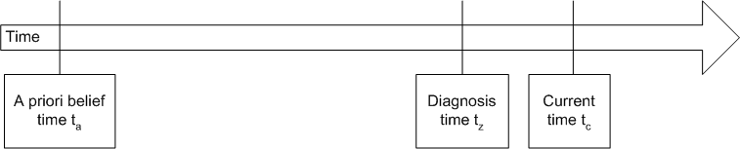
Fig. 6. Handling of Time in StateEstimation Plugin.
The belief update computation starts by estimating B(t_{z}) without taking into account the diagnoses. This calculation reflects the probability that, at the time the diagnosis was received, any of the threats reflected in the threat model have actually manifested in problems in the agent system. For a given asset A and state s_{i} in some state dimension of the asset, the probability that A is in state s_{i} at time t_{z} is estimated from:
- The probability that asset A was in state s_{i} at time t_{a}, and stayed in state s_{i} until time t_{z}, and
- The probability that there was a threat t manifested in the asset that transitioned it from another state s_{j} at time t_{a} to state s_{i} at time t_{z}
These probabilities depend on the time interval between t_{a} and t_{z}. The computation for the threat probabilities is computed from the threat and event likelihoods from the ThreatModel in the TechSpecs. In this computation, the threat likelihood determines the probability that the threat manifests in the given interval; this must be adjusted based on the number of such intervals between time t_{a} and time t_{z}. Once the believability calculation has caught up to time t_{z}, then we can update it by estimating the effects on the belief state of the diagnosis z that we received for time t_{z}. This diagnosis is an observation on the state of asset A. For a given asset A and a given state s_{i} in a given dimension D, the probability that a threat manifested itself to cause asset A to transition into state s_{i} at time t_{z} can be computed from:
- The probability that we believe that asset A is in state s_{i} as a result of some threat (from the previous step), and
- The probability that, for each state s_{i}, the diagnoses in the timed defense diagnosis confirm that asset A is really in state s_{i}.
The second probability is computed from the Sensor TechSpec, which defines the accuracy of the sensor with respect to the diagnosis. That is, it defines, for each diagnosis z and state s_{i} the probability Pr(s_{i}|z) that the sensor sends diagnosis z given that the asset is actually in state s_{i} of asset state descriptor D. The belief state estimation for time t_{z} then continues for each state s_{i} for each state dimension in the asset. It begins with the probability that asset A is in state s_{i}, and then factors in the probabilities from the diagnosis accuracy function concerning each component diagnosis and the state s_{i}.
The third step is to work forward from time t_{z} to time t_{c}. Because no threats are involved, this computation proceeds analogously to the one that estimated the changed belief state from time t_{a} to time t_{z}. The resulting belief state, B(t_{c}) will become the a priori belief state for the next belief state update.
Because state explosion is an issue in POMDP, we reduce state space by severely discretizing the set of representable state values and by pre-computing wherever possible. Note also that this example only shows belief state update with respect to new diagnoses; however, other types of information such as the success of an actuator also will change the belief state of an asset.

5.4 CostBenefit Plugin
The Coordinator performs a cost-benefit calculation to determine whether an action (or group of actions) can be expected to be a benefit to the society at large. Actions that are expected to provide a benefit are eligible for becoming part of a course of action chosen by the ActionSelection Plugin.
We model benefits as a property of an asset’s state (i.e. when an asset is in a particular state, it is assumed to be behaving in a particular way that benefits the society. Thus, the benefit of a successful action is the difference between the benefits of the states the asset would be in with and without the action. But, since we are rarely certain about the actual state of any asset, we must compute an expected benefit of the action, taking into account that the action may not succeed because it was taken in inappropriate circumstances. Regardless of whether an action succeeds, it has a cost in terms of resources consumed and in terms of other actions precluded.
Both the costs and benefits of an action can be felt over a time interval. The benefit of restarting a dead agent is accrued until the agent again dies, while the cost of encrypting is on-going as long as messages are being encrypted. Thus, the cost-benefit tradeoff of an action must be computed over some time interval. A planning horizon and a discount function are used for this. A short planning horizon is used if it is believed that the asset is likely to not stay in a particular state very long (either through a voluntary switch to a new state or because of some attack or failure). The discount function (usually a negative exponential) allows short-term behavior to be weighted more highly than long-term behavior. These are both parameterized by the Policy Plugin based on high-level policy statements.
When computing the cost-benefit of an action, we currently use “expected cost-benefit”, which maximizes the expected benefit to the society. Alternates are to compute the maximum possible value of actions (probably only useful in emergencies) and to compute the probability that the action will yield at least some minimum value (this is a very conservative policy and would be used to ensure that a minimum acceptable amount of benefit was accrued, even at the risk of getting a lower expected benefit).

5.5 ActionSelection Plugin
This plugin selects one or more compatible actions using action compatibility info from TechSpecs (conservatively, actions not identified as compatible are assumed to be incompatible), the previously computed cost-benefit estimates, and an action selection policy. The only policy currently supported is to select the action(s) with the greatest expected benefit, but other policies are possible. One such is to randomly select (possibly using weights) from among the highly scored actions to prevent the society from falling into predictable patterns that could be exploited by an attacker.

5.6 Activation Plugin
This plugin is used to enable/disable actions based on selection decisions made by the ActionSelection Plugin and connectivity status, subject to low-level timing issues peculiar to individual actions. A primary purpose of this plugin is to isolate the logic of selecting actions from implementation details of the individual actions (these tend to be timing issues related to specific actions). It also makes the Coordinator more portable to non-Cougaar environments by isolating the interaction with the rest of the society from the selection logic.

5.7 ActionMonitoring Plugin
This plugin monitors the diagnoses about an asset’s state to determine if the activated action(s) was successful. If the diagnoses do not indicate that an action has had the expected result in a TechSpec-indicated amount of time, it signals that the action has failed and that the state estimation and selection process must choose an alternative action, thus closing the control loop. This plugin is essential, because, while the coordinator attempts to choose the statistically “best” actions to take in a given situation, it will sometimes make the wrong choice. In addition, even a correctly chosen action will sometimes fail on its own.

5.8 Policy Plugin
The Policy Plugin uses high-level statements of the relative value placed on various application properties (at present completeness, timeliness, and security) to parameterize the inputs to the cost-benefit calculations and to select an objective function for the CostBenefitPlugin as described earlier. It should be noted that a perfect mapping is neither likely nor necessary; all that is required is that benefits are assigned in such a way as to cause “good” decisions to be made about which defense actions to select

Status, Plans and Issues
The coordinator’s basic functionality was demonstrated in late 2003 controlling a handful of defenses in a small Cougaar society. The specific defenses coordinated were to detect and restart dead agents, to attempt more aggressive communications with non-responsive agents, and to allow hosts to intentionally disconnect from the network without being treated as being either dead or out of communications by the other defenses. In practice, these defenses had been identified as conflicting within the normal UltraLog agent system. Also, during the preparation for this demonstration, the coordinator was also tested in a larger, 64-agent society. Thus far, in both the testing and the demonstration, the defense coordinator has behaved as expected. However, both were done in scripted situations.
Currently, the coordinator is being reimplemented to add the remainder of the capabilities described above and to scale it to a 1,200 agent society being tested in 2004 in the UltraLog program. As part of that process, it will be accepting diagnoses from and coordinating restart, messaging, security and application-level actions. These constitute a representative set of sensors and actuators with different properties and capabilities, and will serve to test more broadly the approach to coordination that we have described. The 2004 implementation also takes into account actuator success when computing the belief state. In addition to testing scalability, the goals for this year include capturing and specifying realistic modeling information.
Other plans in 2004 include applying the UltraLog MAU assessment, and its corresponding survivability argument, to executions of the UltraLog application that incorporate the defense coordinator. A comparison of runs with and without the defense coordinator should provide information on the defense coordinator’s contribution to overall survivability.
Finally, the 2004 defense coordinator also will take into account external preferences when making defense coordination decisions. For instance, if the application is run in a setting where there is a high need for security, the defense coordinator may favor security-enhancing decisions. Conversely, if the goal is to complete a task quickly, decisions favoring timeliness will take precedence, even if other factors, such as security, are ignored. Experimental runs using different weights for completeness, timeliness and security should provide insight into the defense coordinator’s effectiveness in maintaining these preferences during an execution, especially in resource-limited situations.
The Adaptive Control Defense Coordinator is expected to be part of the 2004 Cougaar Open Source release.

Conclusions

This paper describes a Defense Coordinator developed for the UltraLog project, operating within the Cougaar agent system. In order to enhance its survivability in chaotic environments, UltraLog implements a number of autonomous defenses that sense problems and initiate various actions to fix them. While the defenses operate well in isolation, when several defenses operate concurrently and autonomously, there is a real potential for destructive interaction.
Rather than explicitly deconflicting all of the defenses individually, UltraLog has begun using the Adaptive Defense Coordinator, descrbed in this paper. The purpose of the defense coordinator is to allow a collection of independent defenses to coexist in the same agent system, but to overlay them with functionality that analyzes the problems that they sense and coordinates the response. Also, rather than being based on a Cougaar-specific architecture, the Coordinator addresses the more general problem of making intelligent (or at least non-destructive) decisions concerning the monitoring and control of a large, complex, and chaotic systems.
The coordination problem is exacerbated by many factors, including:
- Sensors may provide delayed and/or inaccurate information on which decisions are based.
- The input information for the decision process may be incomplete.
- There is a real tradeoff between reacting quickly and being able to do a complete analysis of the state of the agent system.
- The appropriate response to a situation may depend on the operational priorities of the application.
The UltraLog Adaptive Defense Coordinator addresses these problems using a variety of well-known computational techniques, which are described in this paper. It was designed to be model-based, allowing it to be adapted to a wide variety of situations. Its modular, plugin-based architecture allows for flexibility and experimentation. Its use of Partially-Observable Markov Decision Processes to estimate the state of the assets in the system helps moderate the uncertainty of sensors and the incompleteness of monitoring information. Finally, it is explicitly designed to be easy to adapt to different agent systems and applications, beyond the UltraLog/Cougaar environment.
- Acknowledgment
This research is sponsored by the Defense Advanced Research Projects Agency and managed by the Department of the Interior/National Business Center under contracts NBCHC010011 and MDA972-01-C-0025. The views and conclusions contained in this document are those of the authors and should not be interpreted as representing the official policies, either expressed or implied, of the Defense Advanced Research Projects Agency, Department of the Interior/National Business Center, or the United States Government.
The authors also would like to acknowledge the many UltraLog project members who have contributed ideas and suggestions, including but not limited to Mark Greaves, Marshall Brinn, Michael Thome, Aaron Helsinger, and Steve Ford.
- References
[1] Cougaar Web Site, March 2004, http://www.cougaar.org.
[2] DAPRA UltraLog Web Site, March 2004, http://www.ultralog.net.
[3] M. Brinn and M. Greaves, “Leveraging Agent Properties to Assure Survivability of Distributed Multi-Agent Systems,” Proc. 2nd International Conference on Autonomous Agents and Multiagent System, 2003.
[4] A. Cassandra, “The POMDP Page”, March 2004, http://www.cassandra.org/pomdp/
[5] R. Keeney and H. Raiffa, Decisions with multiple objectives. NY: Wiley, 1976.
[6] J. Ulvila, J. Gaffney, and J. Boone, A preliminary draft multiattribute utility analysis of UltraLog metrics. Vienna, VA: Decision Science Associates, 2001.

Dr. David Wells has over twenty five years of experience in Computer Science, having worked in the areas of cryptography, computer security, database systems, agents, and self-healing systems. He has received four U.S. patents. Wells earned his B.S. in applied mathematics (’75), M.S. in Computer Science (’76), and D.Eng. (’80) from the University of Wisconsin – Milwaukee. He is a founder of Object Services and Consulting, Inc. and was previously on the faculty of Southern Methodist University and was a Member of Technical Staff at Texas Instruments.

Dr. Paul Pazandak has twenty-two years experience working with computer systems. He has consulted, taught, published internationally, and is inventor and co-inventor on two recent software patent applications. He has experience in the design and implementation of dynamic distributed bytecode modification, reconfigurable and extensible software systems, database systems, middleware, internet, and multimedia architectures. He received a B.A. in Physiology (’87), and M.S. (’93) and Ph.D. in Computer Science (’96), from the University of Minnesota.
Dr. Marian Nodine received her PhD from Brown University (1993), and her SB and SM from Massachusetts Institute of Technology (1981). She is a Senior Research Scientist at Telcordia Technologies. Her current research includes architectures of agent-based systems, and applications of the agent-based technologies to coordination and group support, information analysis and knowledge discovery. She is currently PI of one government project, "Awareness-Enabled Coordination" and is key to a second in the UltraLog program at DARPA. Before coming to Telcordia, Marian was a researcher and technical overseer on the InfoSleuth consortial project at MCC in Austin, TX. She oversaw infrastructural support for agents and the development of core agent functionality such as brokering and ontology management. Marian has also worked as a postdoc and an adjunct assistant professor at Brown University, at BBN as a developer on various networks including the Wideband Satellite Network, and at Sequoia Systems on fault-tolerant computing. She is the author of over 30 papers.
Dr Anthony Cassandra received the BS degree in Computer Science and Applied Math from State University of New York at Stonybrook, where he received both departments’ awards for academic excellence. He received a PhD in Computer Science from Brown University, with his thesis addressing artificial intelligence applications of partially observable Markov Decision Processes. He is currently an Assistant Professor of Computer Science at St. Edward’s University in Austin, TX. Previously, he was employed at Tower Technologies, exploring issues for the next generation of Java virtual machines. Prior to this, he was director of engineering for an early stage startup working on a distributed component architecture. Before this, he was at MCC working on the InfoSleuth agent project. Dr. Cassandra is currently a member of AAAI, where he has been a symposium chair and program committee member for their national conference.

Because it depends on resource availability and allocation, the relative contribution of a state to the timeliness aspect of utility must be computed dynamically; therefore, it is out of the scope of the discussion in this paper.

