Cougaar Release Testing Procedures

A BBN Technologies Document

For BBN internal use only.

Version 9.2

May 2, 2002

Please e-mail comments to: cougaar-developers@cougaar.org
A copy of this document is available online at: http://www.cougaar.org
Contents
Contents i
1 Introduction 1
1.1 Objectives 1
1.2 Document Overview 1
2 Installation 2
2.1 Overview 2
2.2 Cougaar Software 2
2.2.1 Preparation 2
2.2.2 Download 2
2.2.3 CSMART setup and Server properties file 2
2.2.4 COUGAAR_INSTALL_PATH 2
2.3 Database 3
2.4 cougaar.rc file 3
3 Suggested Experiments 4
3.1 Overview 4
3.2 Small 1-3-5 4
3.3 SMALL 1AD TRANS 4
3.4 FULL 1AD TRANS 4
4 Configuration and Execution of an Experiment 5
4.1 Overview 5
4.2 CSMART startup 5
4.3 Creating and Configuring Experiments 5
4.3.1 Creating Experiments 5
4.3.2 Configuring FULL-1AD 5
4.4 Running Experiments 6
4.4.1 Launch Servers 6
4.4.2 Run the Society 6
5 Evaluation 8
5.1 Overview 8
5.2 Evaluating the Running Society 8
5.3 Evaluating End Results 8
5.3.1 Inventory Charts 8
5.3.2 Datagrabber and TPFDD 9
5.3.3 Other Tools 10
5.4 New Functionality 10

Introduction

Objectives
The purpose of release testing is to ensure the quality of a pending Cougaar release. This document serves as a guide for such testing. Included in each version of this document are updated testing procedures and observations intended for ease of internal testing among developers and also cross-version analysis. The document assumes testing is performed at BBN-Cambridge in the 4th floor laboratory.

Document Overview
This document is organized into 5 main sections. The first section serves as a reference for installation and configuration of a Cougaar release. The second and third sections instruct the user in configuration and execution of a Cougaar society. The fourth section describes procedures for evaluating results of an execution that are expected from every release. The last section highlights release-specific functionalities, their testing procedures, and any notable issues with the release. The version number of this document corresponds to the Cougaar release being tested.

Installation

Overview
Installation of a Cougaar society requires four main components: the Cougaar software, a database, a valid cougaar.rc properties file and a server properties file.

Cougaar Software

Preparation
The following are suggestions for speeding up installation of Cougaar on multiple linux machines. First, spawn xterms on each machine setting the title bar with the machine name for organization (>xterm –title hoppy –e ssh hoppy). Each of the following shell commands required in the following steps can be typed once in one xterm and cut and pasted into the rest.
Create a directory to contain the software. The name of the directory should include either the current date or the release number. On the lab machines, the directory should be created in /opt. Set up a symbolic link to such that /opt/alp points to your new directory (>ln –s /opt/cougaar-9.2 alp).
For Windows machines, separately create a directory named similarly.

Download
Download the appropriate version of the Cougaar software from http://www.alpine.bbn.com/~mthome/. Only the files ‘cougaar.zip’ and ‘cougaar-support.zip’ are required. The savvy user can also obtain these files using scp from eiger. On Linux, these scp commands can also be cut and pasted from one xterm to the others on your host with multiple xterms.
Unzip the files.

CSMART setup and Server properties file
The application server is used by CSMART to start Cougaar nodes on remote machines. It needs to be configured and run on every machine in the society. It relies on a property file in order to find the software it is supposed to run. A misconfigured server.props file is a very common source of error when launching a node. Copy and rename the appropriate sample server.props file from $COUGAAR_INSTALL_PATH/server/data to $COUGAAR_INSTALL_PATH/server/bin/server.props. These sample files are operating system specific (Windows/Unix). Edit the file so that it points to your Cougaar installation. Since the sample Linux file is tailored to our lab machines, editing is usually unnecessary. The file must also be modified on Windows machines.

COUGAAR_INSTALL_PATH
The COUGAAR_INSTALL_PATH environment variable should be set on all machines. On our lab’s Linux machines, this variable is set in the login script to be /opt/alp. The prior step of creating a symbolic link from /opt/alp to the current installation takes care of this requirement, or you can set them individually on each machine. On Windows machines, use the Control Panel > System window, tab Advance to set Environment variables. Be sure to launch a new DOS window after setting the variable, as the variable will not be updated in the old window. A common error is not properly setting the COUGAAR_INSTALL_PATH.

Database
While Cougaar can be configured to work with multiple databases, current release testing can use Oracle or mySQL for domain data and mySQL for society configuration data. In the 4th floor laboratory, ranier.bbn.com functions as the mysql server and eiger.alpine.bbn.com functions as the oracle server. Before testing, ensure that the mysql database installed on ranier (or wherever your cougaar.rc points) is current. To update the database perform the following from a cygwin/bash shell prompt:
- Obtain the Domain_MySQL.ZIP file from the Cougaar release located in $COUGAAR_INSTALL_PATH/csmart/data/database
- Unzip and obtain the file ‘1ad_domain_data_dump.sql’
- Execute the command to load the domain portion of the database -
$mysql –u[db user] –p[db password] [db name] < 1ad_domain_data_dump.sql
- cd to the $COUGAAR_INSTALL_PATH/csmart/data/database/scripts/mysql directory
- Run the script load_1ad_mysql.sh -
>./load_1ad_mysql.sh [db user] [db password] [db name]
This loads the remaining configuration tables from ‘.csv’ files located in $COUGAAR_INSTALL_PATH/csmart/data/database/csv directory.
For full documentation on installing and updating a mysql database see InstallandTest.html located in the cougaar release in $COUGAAR_INSTALL_PATH/csmart/docs
Note that .bat versions of the load scripts also exist thus the above process can be run from a DOS prompt.

cougaar.rc file

A valid cougaar.rc file should be placed on each machine that is running the Cougaar software. The file can be named either ‘.cougaarrc’ and placed in the home directory of a particular machine or alternatively, named ‘cougaar.rc’ and placed in the $COUGAAR_INSTALL_PATH/configs/common directory. Verify that any existing cougaar.rc files on the machines you are using are valid and point to the correct databases. A generic example of a cougaar.rc file can be found at $COUGAAR_INSTALL_PATH/doc/details/DataAccess.html
.

Note that an invalid or improperly located cougaar.rc file is a common source of error while executing.

Suggested Experiments

Overview
Before attempting to configure and run the FULL_1AD_TRANS society, a progression of experiments should be performed beginning with less complex ones and finishing with the most complex. This allows you to detect errors more efficiently.

Small 1-3-5
This experiment is run on one machine from ‘.ini’ files. It is a straightforward experiment that will reveal major errors quickly. It does not use the CSMART interface. Instructions for running and evaluating this experiment can be found at
$COUGAAR_INSTALL_PATH \configs\small-135\small-135.installation.readme.html

Small-135 with Persistence
A simple test for persistence is to run SMALL-135 and GLMTRANS nodes started with the ‘PNode’ script. Send the Oplan and GLS, wait for the ‘P’ notation to stop scrolling on the screen (indicating that the blackboard has been saved), then kill and restart one of the nodes. Ensure society state is as prior to killing the node.

SMALL 1AD TRANS
This experiment can be run on 1 or 2 machines. CSMART is used to configure the host-node-agent mappings. As this experiment contains fewer agents, it requires less configuration and setup and can be run much quicker. The setup and configuration of this experiment parallels that of FULL 1AD as discussed below but uses fewer agents and thus requires fewer machines.

FULL 1AD TRANS
Full 1AD is the largest of the available experiments. Follow the instructions below to configure and run it.

Configuration and Execution of an Experiment

Overview
This section describes and provides references for how to launch CSMART and create, configure and run a test experiment. For full documentation on creating and running a CSMART experiment, see InstallandTest.html located in the Cougaar release in $COUGAAR_INSTALL_PATH/csmart/docs.

CSMART startup
CSMART should be launched from only one of the machine installations by running the appropriate launch script (‘./CSMART.sh’ or ‘./CMSMART.bat’) located in $COUGAAR_INSTALL_PATH/csmart/bin.

Creating and Configuring Experiments

Creating Experiments
Select a base experiment from the list of New Experiments obtained by right clicking on ‘Default Workspace’ – ‘New Experiment’. Choose either SMALL-1AD-TRANS or FULL-1AD-TRANS as desired. The ‘TRANS’ appendix indicates the experiment includes the transportation agents. Give the experiment an appropriate name then click on Experiment Builder to configure the experiment.

Configuring FULL-1AD
These instructions pertain to configuring the FULL-1AD society with transportation. See below for discussion of other experiments.
Click on the Experiment Builder button from the CSMART workspace. Choose the Configurations tab to establish agent-node-host mappings. Create a host to represent each machine you’ve configured. Create a node to place on each host or use an existing node. Some suggestions for mapping agents to node/hosts are as follows:
- A minimum of 7 machines should be used to run the FULL-1AD society with transportation. More machines are better.
- GLMTrans agents should be separated such that they are spread over a minimum of two machines and possibly three. Consider placing the ShipPacker agent and CONUSGround agent each on their own nodes.
- Consider spreading the Battalion agents as well as MSB and FSB agents evenly over the hosts as they tend to be more computationally intensive.
Save and close the Experiment Builder.

Running Experiments

Launch Servers
Start an application server on each host machine in the configuration. This is done by changing directories to the $COUGAAR_INSTALL_PATH/server/bin directory and running the appropriate script file to launch the server (‘./Server.sh’ or ‘./Server.bat’). Note: Forgetting to invoke a server on a particular machine is a common source of error.

Run the Society
Upon closing the Experiment Builder, the Experiment Controller button will be enabled. Click on Experiment Controller to launch the CSMART console. Press ‘Run’ to start the society. Either a green or red circle will appear for each node in the experiment. Green indicates that the node launched successfully while red generally indicates a problem starting the node. For red nodes, verify again that the server is running on that machine and check the server.props file for correctness. A separate window will appear for each node providing its output/
In addition, a minimized GLS window is launched and when maximized, appears as below. This user interface allows you to initiate processing.
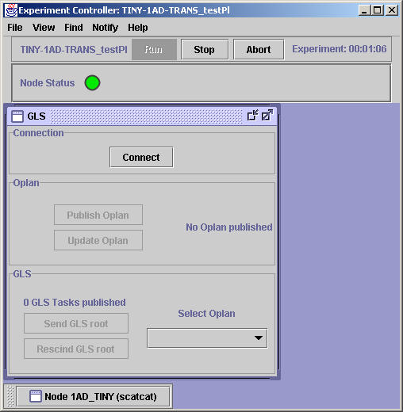

The following sequence of steps must be observed when running the society: (Patience is required)
- Wait until a steady state has been achieved in each of the node windows. A steady state is indicated by the presence of dots as they appear in the below window. If a steady state has not been achieved before pressing the ‘Connect’ button, an error message will appear indicating a connection could not be established.
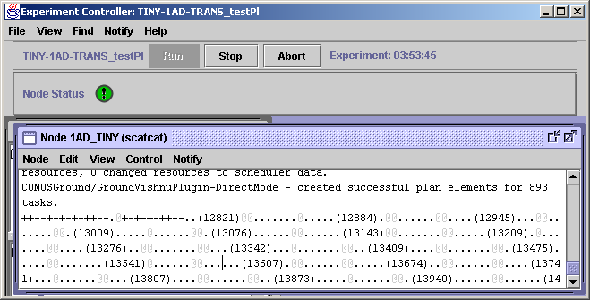
- Press the ‘Connect’ button in the GLS user interface. The ‘Publish Oplan’ button will become enabled in the GLS user interface.
- Press the ‘Publish Oplan’ button. The ‘Send GLS Root’ button will become enabled in the GLS user interface.
- Wait until a steady state has been achieved in each of the node windows.
- Press the ‘Send GLS Root’ button.
- Wait for the society to reach a steady state once again. (May take a ½ hour or more with a FULL_1AD society)

Evaluation

Overview
In release testing, there are two main types of evaluation to be performed, checking for errors during the execution of the running society and checking the results of computation after the society has finished running. If time allows, new features added during the release cycle should be tested as well.

Evaluating the Running Society
Errors may occur during computation. These will generally make themselves visible as thrown Java exceptions in the CSMART node windows. Look for exclamation points in the circles that represent the nodes in the CMSART console as illustrated above. Exceptions are almost always bad news, and uncaught exceptions will more often than not nullify the results of the current run. Capture the full text of the exception (either by cut and paste from the node window or by hunting down the error in the log file) and file a bug report on the Alpine website at https://www.alpine.bbn.com (assuming there is not already a bug on file for this exception).
A special case of Java exception is the “Out Of Memory” exception. You are most likely to see this in the GLMTrans nodes. If you see this error there, you may continue to run the society and validate the inventory results, but you will not get a valid TPFDD (see next section). On the next run, consider modifying your configuration on more machines, or adjusting the maximum memory parameter (-Xmx) in the CSMART.bat or CSMART.sh file.

Evaluating End Results
The job of the FULL-1AD-TRANS society is to plan logistics support for various supply threads including ammunition, fuel, spare parts, and food. One way that we evaluate how well it has done its job is by analyzing inventory charts that show demand and supply events for reasonableness and comparing these charts to previously obtained results. Furthermore, we launch a TPFDD Viewer that displays Time-Phased Force Deployment Data. The viewer shows what cargo is being transported, when it departs and arrives, how it gets to its destination and who owns the cargo.

Inventory Charts
To view the Inventory Charts run the CUI-Inventory script (‘./CUI-Inventory.sh’ or ’./CUI-Inventory,bat’) in $COUGAAR_INSTALL_PATH/bin directory. This launches a user interface from which the supply, demand and inventory levels of various supply items can be viewed. To obtain charts, first select Connections > Connect from the menu. Ensure that the cluster location and port is valid for a machine that is running the society (default localhost:8800 is fine as long as the localhost machine is running a node in the society).
For each of the supply threads, compare the charts obtained on your run to the control versions shown in the $COUGAAR_INSTALL_PATH/doc/testing/screenshots/full-1AD.html file.

Datagrabber and TPFDD
$COUGAAR_INSTALL_PATH/datagrabber/doc/Datagrabber-UserGuide.html contains instructions for running the Datagrabber, which is a prerequisite to running the TPFDD Viewer. This document as well as $COUGAAR_INSTALL_PATH \datagrabber\doc\TPFDDViewer-Introduction.html contain instructions on running the TPFDD Viewer. [N.B.] Make sure you are using the correct grabber xml file when configuring the Datagrabber. (ServletStrategicGrabberConfig.xml for the V9.0 release) Also note that if you split up your transportation agents across one or more nodes for efficiency purposes, it does not matter which you specify in the <HOST> field in your xml file.
Follow the steps indicated in the Datagrabber-UserGuide.html, being observant of the completion of the experiment, the response from your Datagrabber’s run, and if there were any errors which occurred. The Datagrabber’s web controller is http://{datagrabberHost}:7000, which looks like:
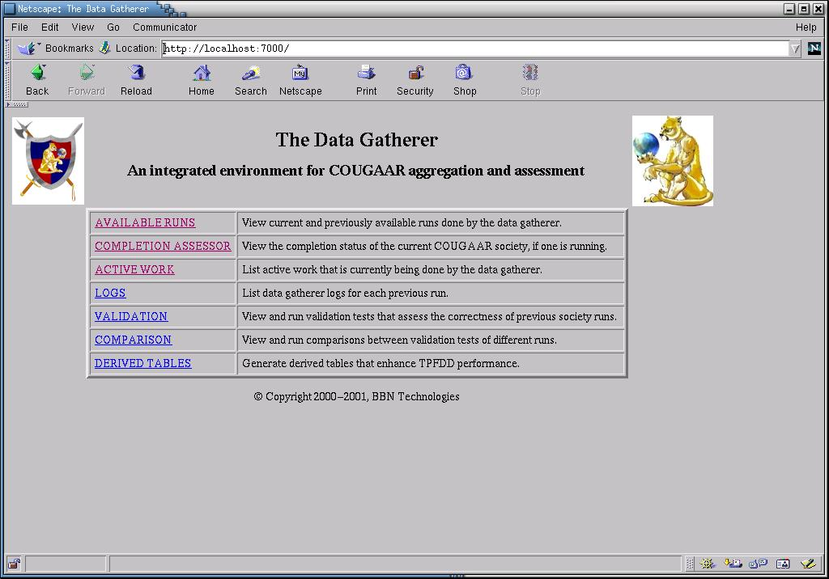

Run the TPFDD script and compare the charts obtained from your run to the control versions shown in the $COUGAAR_INSTALL_PATH/doc/testing/screenshots/xxxxx.html file. Provided below is a few sample supply-chain TPFDD results gathered from a FULL_1AD society, of which there are none in doc/.
Sample Expected TPFDD Results - FULL_1AD_TRANS (8 host) society
If the Datagrabber was successful and complete to a degree (97% reflects the results below), running the TPFDD will produce something similar, reflecting log plan and asset usage views. It is important to note that a gray ‘Not yet queried’ bar does not imply error; the TPFDD is only meant to supply visibility to the supply chain.
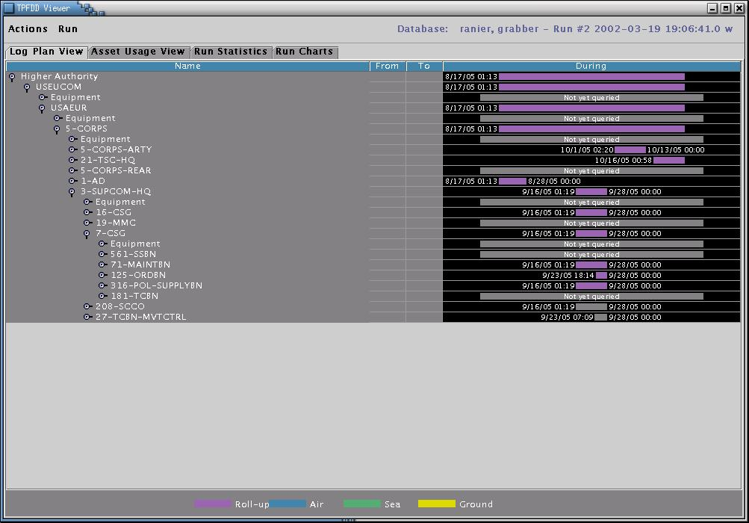

Other Tools
In addition to the above tools, there are several servlet-based tools that can be used to view various aspects of the society. A listing of available servlets can be found by launching a web browser and opening the following URL: http://localhost:8800/$/list Among the most useful is the /tasks servlet which can be used to view blackboard objects at agents. The ‘/completion’ servlet is useful for determining when a steady state has been achieved in the society.
The CSMART Society Monitor creates graphical views of a running society. Instructions on running the monitor are included at $COUGAAR_INSTALL_PATH/csmart/doc/InstallandTest.html.

New Functionality
New functionality for each release should be tested. This new functionality is described in the release notes which can be found at $COUGAAR_INSTALL_PATH\doc\ReleaseNotes\9.X. It may be necessary to talk to the developer to determine how to test and evaluate a new feature. For release specific functionality see $COUGAAR_INSTALL_PATH\doc\testing\Release_Tests\ for a brief description of each release’s enhancements, testing procedures, and notable observations in the testing proces
This page is blank intentionally.

