Cisco ACI

Integrating Openstack and Cisco ACI

Instruction Guide.

TABLE OF CONTENT
TABLE OF CONTENT 1
INTENTED AUDIENCE 1
REFERENCES 1
INTRODUCTION 1
ARCHITECTURE 1
SYSTEM SUPPORT 2
AUTHOR (S) 2

INTENTED AUDIENCE
This document is intended for the development and Support Team within the cloud division.

REFERENCES
A. http://www.cisco.com/c/en/us/products/collateral/switches/nexus-9000-series-switches/white-paper-c11-729383.html;
- http://blogs.cisco.com/datacenter/cisco-aci-with-openstack-at-redhat-summit-a-perfect-pairing;
- http://searchnetworking.techtarget.com/answer/How-does-IPv6-subnetting-work-in-LAN-and-VLAN-network-design

Note: The spreadsheet contains its own set of directives to fill the information.

INTRODUCTION
This directive describes the procedure to be followed by all to ensure an accurate picture of s availability is available to upper management.

THE TOOL

Figure 1 – Example events to be tracked

Bla bla bla

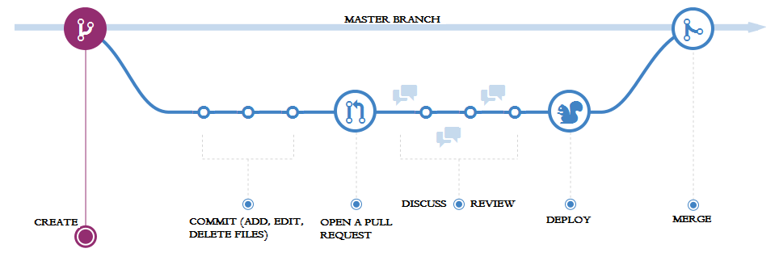

…or create a new repository on the command line
echo "# mb2016" >> README.md
git init
git add README.md
git commit -m "first commit"
git remote add origin https://github.com/codebeaver/mb2016.git
git push -u origin master

…or import code from another repository
You can initialize this repository with code from a Subversion, Mercurial, or TFS project.

…

…or push an

…or push

…or

…
/mb2016.git
git push -u origin master

…or create a new repository on the command line
echo "# mb2016" >> README.md
git init
git add README.md
git commit -m "first commit"
git remote add origin https://github.com/codebeaver/mb2016.git
git push -u origin master

TTN CUSTODIAN

System support via HELPDESK help desk support at
Voice: (613)

AUTHOR (S)
Mario Boisvert
CSD Engineering
Tel: (613)

