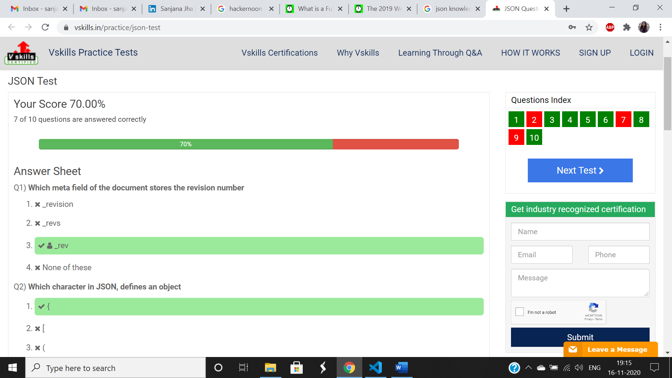

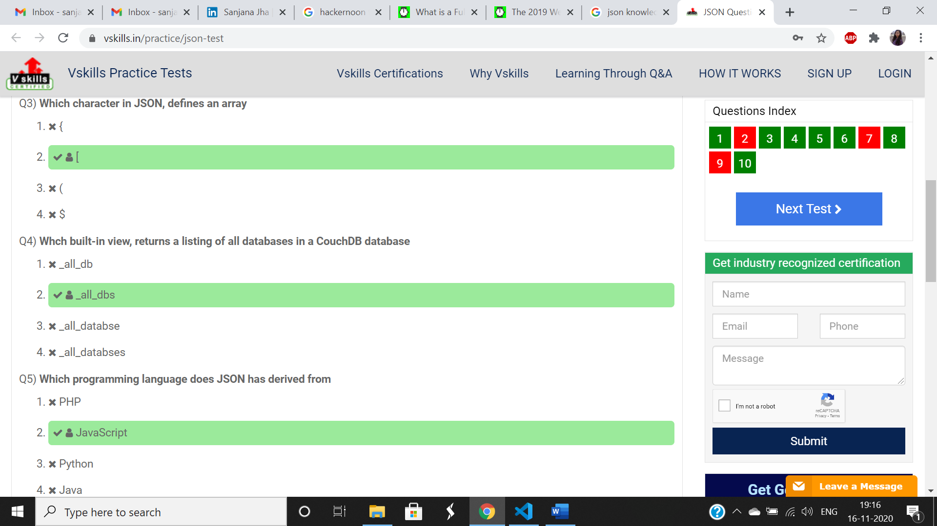

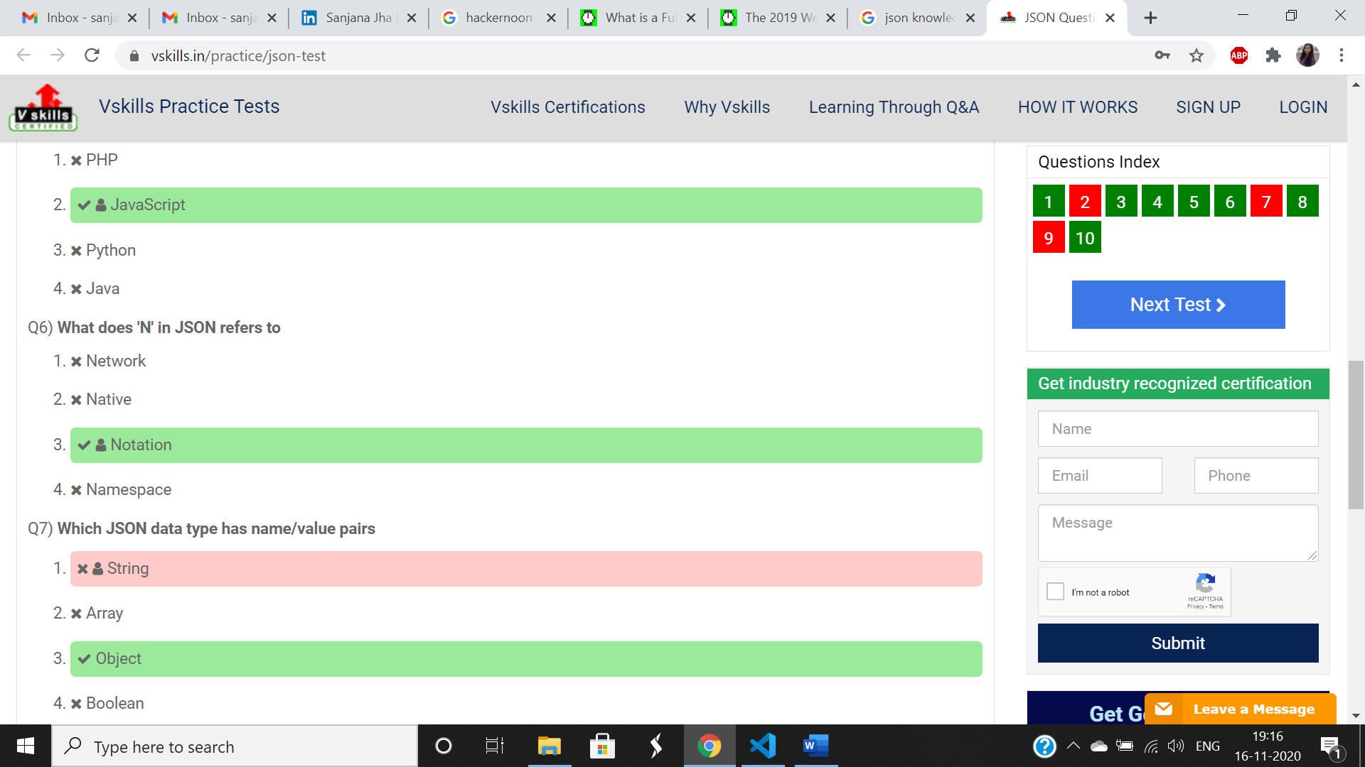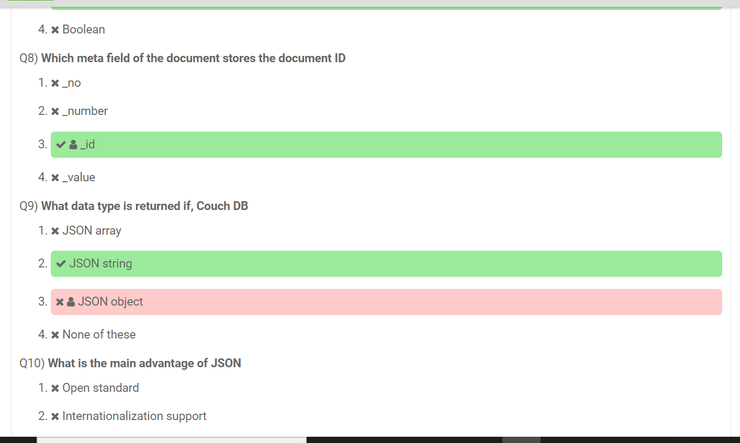

**JSON is built on two structures:**

* A collection of name/value pairs. In various languages, this is realized as an **object**, record, struct, dictionary, hash table, keyed list, or associative array.
* An ordered list of values. In most languages, this is realized as an array, vector, list, or sequence.

Ref: <https://www.onlineinterviewquestions.com/json-mcq/>

Tip <https://stackoverflow.com/questions/1843343/json-parse-vs-eval>