Name: Sahil Zinjal | Branch: AIML | Division: A2
Roll No: A089 | SAP ID: 6007250098 | SUBJECT: Python

1.Implement a lightweight background automation utility to promote ergonomic work habits:

Theory:
Python can automate healthy work habits by sending periodic desktop notifications. The plyer library is used to display operating system notifications, while the schedule library manages recurring reminders. The time module maintains a continuous background loop. This program sends hydration alerts and posture reminders at scheduled intervals and uses exception handling to terminate safely when the user presses Ctrl+C.

OUTPUT:
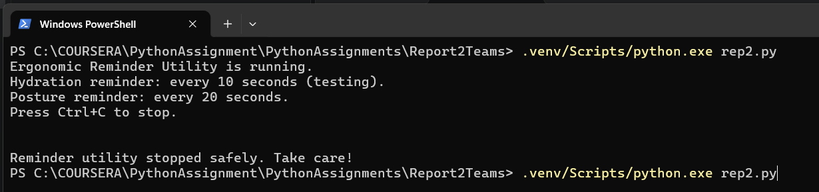
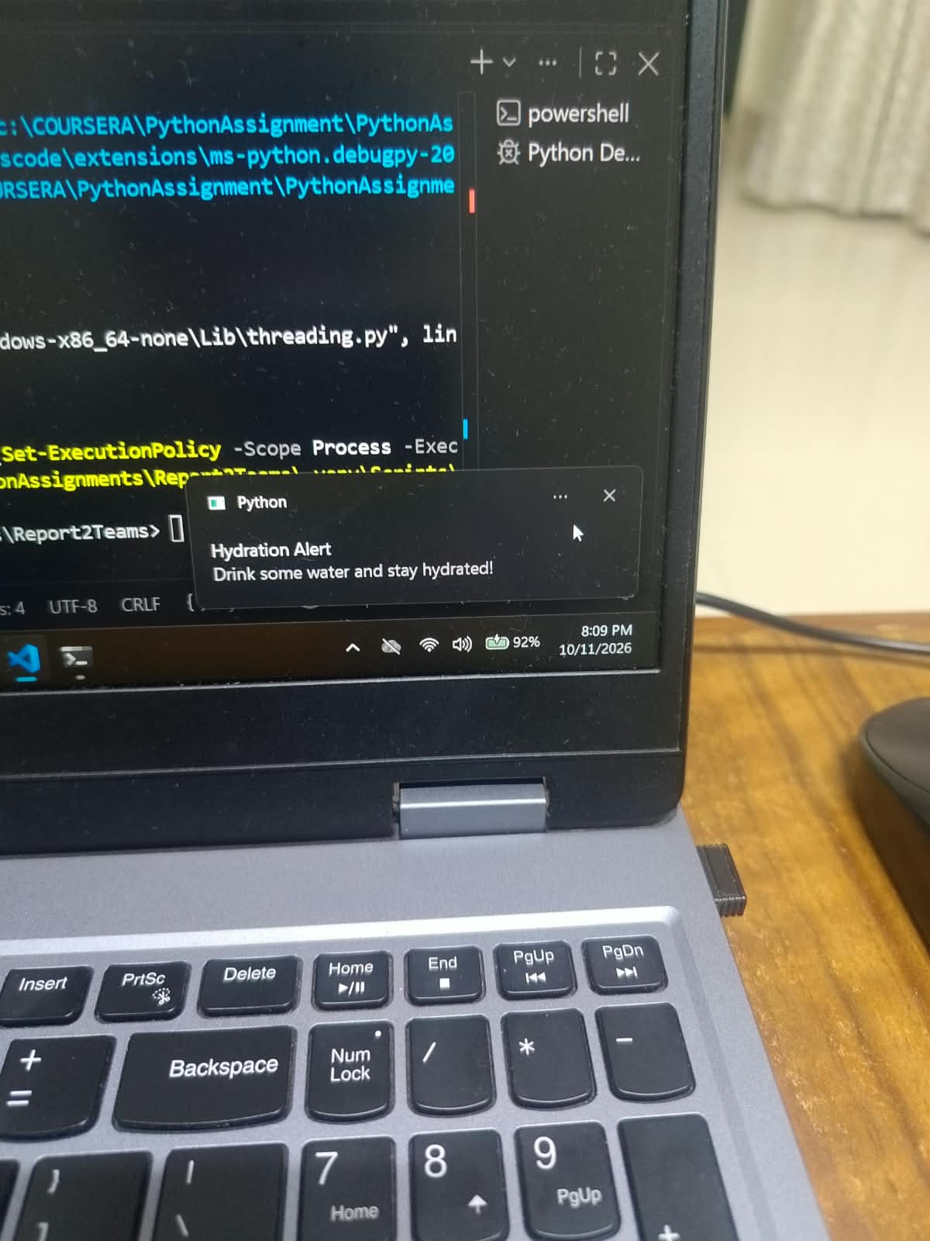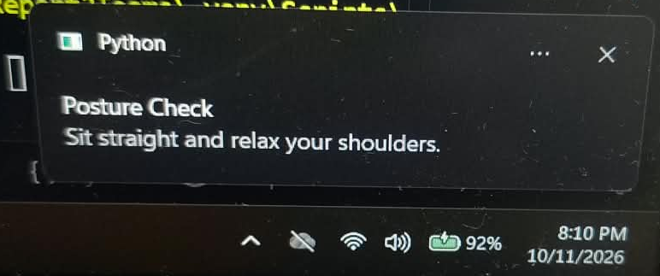

2.Write an automation script using openpyxl to process tabular academic records without requiring Excel software to be installed:

Theory
Python's openpyxl library allows users to create, modify, and format Excel workbooks without requiring Microsoft Excel to be installed. It can automate the processing of student records by calculating total marks, assigning pass or fail results, and computing class averages. It also supports cell styling, making academic data easier to organise and analyse.

OUTPUT:
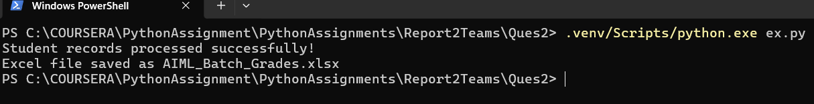
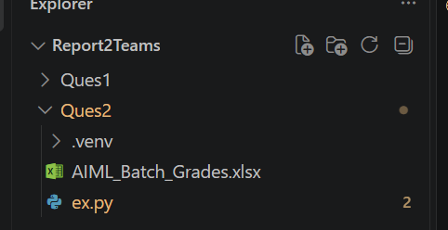
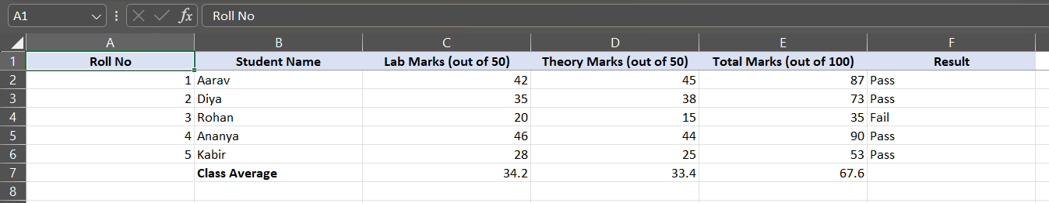

Repository link: https://github.com/codebharata/PythonAssignments/tree/main/Report2Teams

