Name: Sahil Zinjal Roll No: A089 Division: A2 SAP ID: 60017250098
Branch: AIML

1. Introduction
Web APIs help different applications communicate with each other and exchange information over the internet. Python makes working with APIs relatively simple with the help of the requests library, which allows us to send requests to servers and retrieve data. This report explores how to use Web APIs in Python, covering HTTP GET and POST requests, JSON parsing, and error handling, along with useful resources for further learning.

2. Objectives
The main objectives of this activity are:
- To understand how Web APIs work and how applications communicate with servers.
- To learn how to send GET and POST requests using Python.
- To understand how to extract and work with data received in JSON format.
- To identify and handle common errors that occur during API requests.
- To explore online documentation and tutorials for practical learning.

3. Introduction to HTTP Requests
HTTP (Hypertext Transfer Protocol) is the standard protocol used by clients and servers to exchange information. In Python, the requests library makes it easier to interact with APIs without having to handle the entire communication process manually.
Two commonly used HTTP methods are:
- GET Request: Used to retrieve information from a server. For example, an application might use a GET request to fetch weather updates or user details.
- POST Request: Used to send information to a server. For instance, submitting a form or creating a new record may involve a POST request.
Before using the library, it can be installed with the following command:
pip install requests

4. Working with GET and POST Requests

A. GET Request
A GET request allows us to retrieve data from an API. For practice, we can use JSONPlaceholder, a free testing API that provides sample data.
OUTPUT:
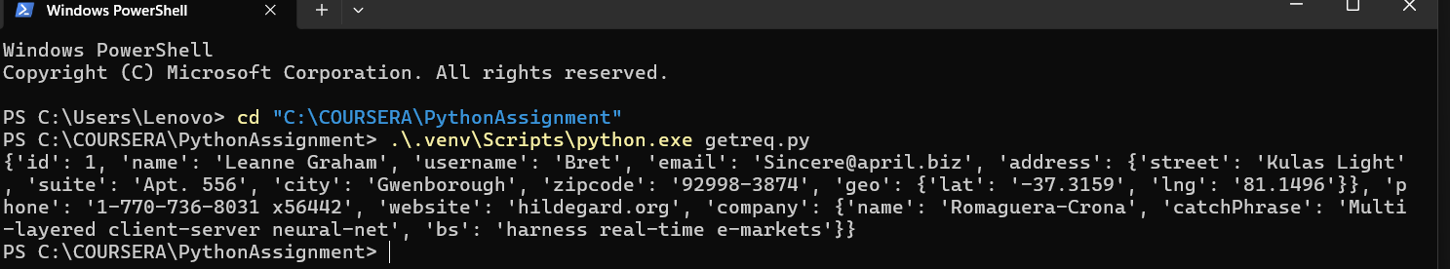
In this example, Python sends a request to retrieve information about a user. The status code helps us check whether the request was successful, while response.json() converts the returned JSON data into a Python dictionary or other suitable data structure.

B. POST Request
Unlike GET requests, POST requests are generally used to send data to a server. The following example demonstrates how to submit information to a testing API.
OUTPUT:
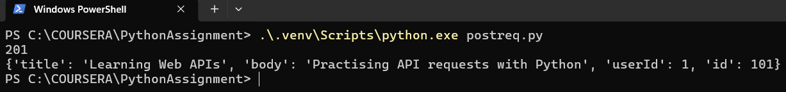
Here, the data is stored in a Python dictionary and sent to the API using the json parameter. The server returns a response that can be inspected to understand how the submitted information was processed. Since JSONPlaceholder is a testing service, the example does not permanently save a new post.

5. Working with JSON Data
JSON (JavaScript Object Notation) is a widely used format for transferring data between applications. Most APIs return information in JSON format because it is easy to read and process.
Python allows us to convert this information into dictionaries and lists, making it convenient to access individual values.
OUTPUT:
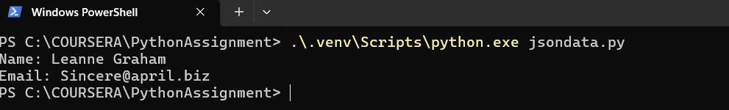
The program retrieves user information and extracts the name and email address from the . This approach is useful when an application needs only specific details from a larger set of data.

6. Handling Errors in API Requests
API requests do not always work as expected. A server might return an error, the internet connection may be interrupted, or a request may take too long to complete. Sometimes, the returned data may also be in an unexpected format.
Python's exception-handling features allow us to manage these situations more effectively.
OUTPUT:
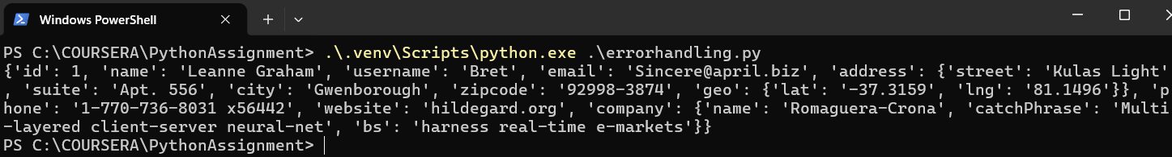
This example uses try and except blocks to handle common problems. Instead of allowing the program to stop unexpectedly, it displays an appropriate message depending on the type of error encountered.

7. Learning Resources
The following resources were useful for understanding and practising API integration in Python:
- Requests Documentation: Explains how to send HTTP requests, process responses, and handle exceptions.
https://requests.readthedocs.io/en/latest/
- Real Python – Python Requests Tutorial: Provides practical explanations and examples for working with HTTP requests.
https://realpython.com/python-requests/
- JSONPlaceholder: Offers sample API endpoints that can be used to practise retrieving and submitting data.
https://jsonplaceholder.typicode.com/
- Python JSON Documentation: Explains how Python handles JSON data and converts it into usable data structures.
https://docs.python.org/3/library/json.html
Repository link: PythonAssignments/Assignment1 at maincodebharata/PythonAssignments
8. Real-World Applications
Understanding Web APIs is useful in many areas of software development. Some common applications include:
- Fetching live information such as weather updates, news, and geographical data.
- Connecting websites and mobile applications to backend servers.
- Integrating online payment services and third-party platforms.
- Collecting information automatically from external services.
- Transferring data between applications and processing it for further use.
These examples show how APIs help developers connect different services and build applications that offer more functionality.

9. Conclusion
Working with Web APIs using Python provides a practical way to understand how applications exchange information over the internet. Through this activity, the use of GET and POST requests, JSON parsing, and error handling becomes easier to understand. The requests library simplifies communication with external services, while testing APIs provide a safe environment for experimentation. These concepts form a useful foundation for developing web applications, automating tasks, and integrating external services into Python projects.

