Name: Sahil Zinjal | Branch: AIML | Division: A2
Roll No: A089 | SAP ID: 6007250098 | SUBJECT: Python

1.Write a modular Python application that allows beginners to draw dynamic geometric art without terminal input:
Theory:
Python provides libraries like EasyGUI and Turtle to create interactive graphical applications. EasyGUI allows users to select shapes, enter dimensions, and choose colors through dialog boxes. The Turtle module draws geometric patterns such as squares, triangles, circles, and stars. Input validation ensures dimensions remain within the specified range.

OUTPUT:

1.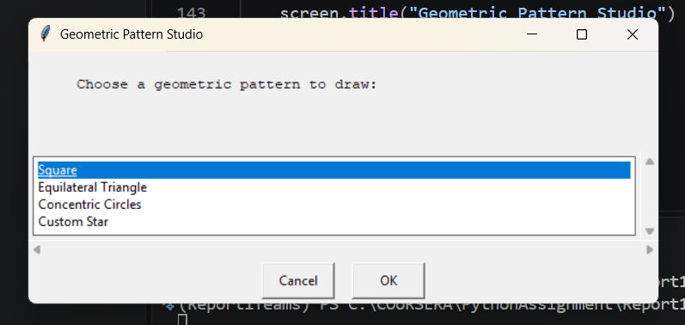 | 2.  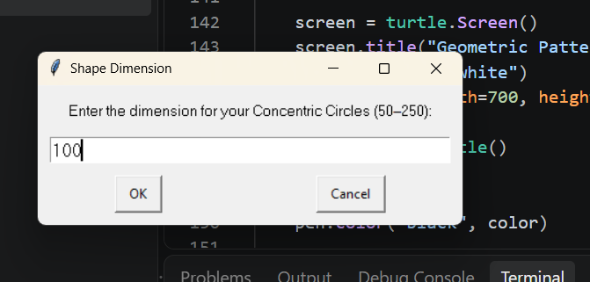
3.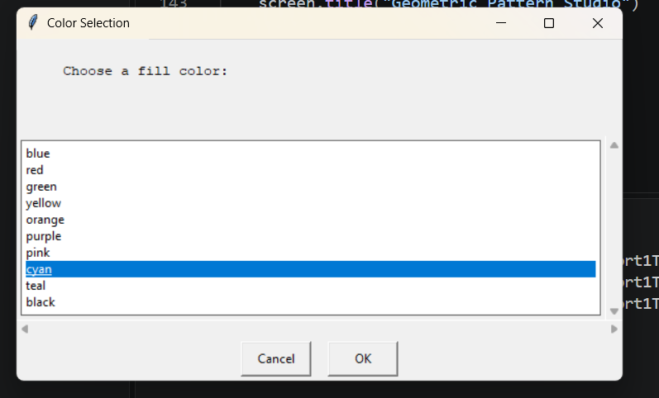 | 4.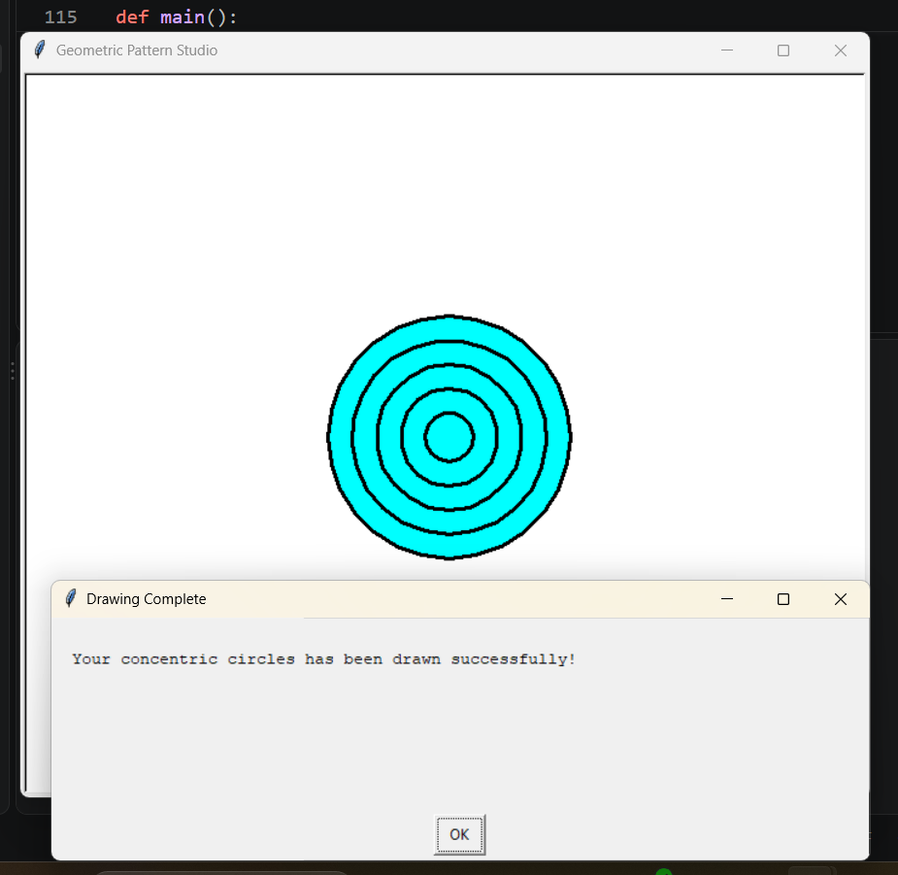

2.Develop a Python script to retrieve and extract real-time environmental data from a public, keyless REST API (e.g., Open-Meteo or wttr.in):
Theory:
Python's requests library allows users to retrieve real-time weather data from public REST APIs using HTTP GET requests. The JSON response is parsed to extract temperature, wind speed, weather conditions, and timezone information. Exception handling manages network errors, while the extracted data is formatted into a readable summary and saved in a local text file.
OUTPUT:

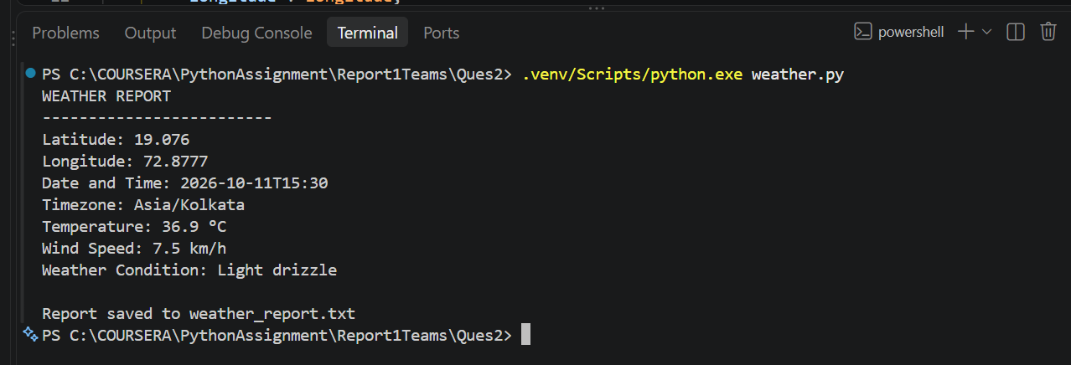

Repository link:

