IPv6

https://www.youtube.com/watch?v=_BcmKwktTZ4

Subnetting was necessary for efficient use of IP addresses.
Dedicated 16 bits for subnetting – subnet masks are not required

16 16 16 16 16 16 16 16 128
16 32 48 64 80 96 112 128 128, 2^128=3.4*10^28

16 15 14 13 12 11 10 9 8 7 6 5 4 3 2 1 0

65536 32768 16384 8192 4096 2048 1024 512 256 128 64 32 16 8 4 2 1 dec
10000 8000 4000 2000 1000 800 400 200 100 80 40 20 10 8 4 2 1 hex

/113 /114 /115 /116 /117 /118 /119 /120 /121 /122 /123 /124 /125 /126 /127 /128
/97 /98 /99 /100 /101 /102 /103 /104 /105 /106 /107 /108 /109 /110 /111 /112
/81 /82 /83 /84 /85 /86 /87 /88 /89 /90 /91 /92 /93 /94 /95 /96
/65 /66 /67 /68 /69 /70 /71 /72 /73 /74 /75 /76 /77 /78 /79 /80
/49 /50 /51 /52 /53 /54 /55 /56 /57 /58 /59 /60 /61 /62 /63 /64
/33 /34 /35 /36 /37 /38 /39 /40 /41 /42 /43 /44 /45 /46 /47 /48
/17 /18 /19 /20 /21 /22 /23 /24 /25 /26 /27 /28 /29 /30 /31 /32
/1 /2 /3 /4 /5 /6 /7 /8 /9 /10 /11 /12 /13 /14 /15 /16
/0

65536 subnets, holding
2001:3200:1000::/48
_____________=Net prefix
__=Internet IDs or hosts
/48 = Prefix length

2001: IANA, ICAVN, public 2000-2003

3200: ARIN given by ISP

1000: company addresses

:: is for subnetting
0000 = 4 bytes = 2^16=64 = 65536 subnets
each digit = 4 bits, group = 16 bits

2001:3200:1000:1000::/64
2000
3000
4000
….
9000
A000
B, C, D, E...
F000

How to get a network with 8 subnets
8 4 2 1
0 0 0 0 0000 0000 0000
2 4 8 16
3 bits /49 /50 /51 not CIDR but Prefix length
2001:3200:1000:1000:2000:/51
2001:3200:1000:1000:4000:/51
2001:3200:1000:1000:6000:/51
2001:3200:1000:1000:8000:/51
2001:3200:1000:1000:A000:/51
2001:3200:1000:1000:C000:/51
2001:3200:1000:1000:E000:/51

DAD duplicate address detection
EUI-64 automates Interface IDs issue

C = 12
8 4 2 1
1 1 0 0 binary form
3 2 1 0 2^3,2,1,0

A9 = 12
A 9
8 4 2 1 8 4 2 1
1 0 1 0 1 0 0 1 binary form

IPv6 from scratch - the very basics of IPv6 explained
https://www.youtube.com/watch?v=oItwDXraK1M&t=12s

8 4 2 1
0 0 0 0 binary form

0 0000
1 0001
2 0010
3 0011
4 0100
5 0101
6 0110
7 0111
8 1000
9 1001
A1010
B 1011
C 1100
D 1101
E 1110
F 1111

F00D : CAFE : FADE
1111 0000 0000 1101 : 1100 1010 11111 1110 : 1111 1010 1101 1110

F00D:CAFE:0000:0000:0000:0000:0000:0001 = long way
F00D:CAFE:0:0:0:0:0:1 = shorter way
F00D:CAFE::1 = shortest way

FF:0:0:0:1:0:0:1
FF::1:0:0:1 or FF:0:0:0:1::1 abbreviation with :: is allowed only once
FF::1::1 is illegal

IPv6 address is 128 bits, 8 groups of 16 bits forming 2 bytes equal to 16 bytes in hexadecimal numbers separated by colons.
Leading zeros can be omitted
Abbreviation with :: is possible only once

1
Fast communication: for voice or video streams, use User Datagram Protocol (UDPv6)
Stateless streaming applications
This protocol transmits packages without checking their arrival

2
Reliable communication: for ensured packet deliveries, use Transmission Control Protocol TCPv6)
Stateful control if package has arrived
This protocol transmits packages with checking their arrival

6
Special usage case for IPv6 routers with controlled transmission
Information, error reporting, diagnostics
Internet Control Message Protocol (ICMPv6)

Assigning of addresses
Static – fixed addresses

Hosts can create their IP addresses automatically to start communication.
SLAAC - Stateless Address Auto Configuration
Stateless – means comes from nowhere

DHCPv6 – Dynamic host configuration protocol (assigned by central server)

Scope
Global: Internet: Scope of the Internet is Global.
Unique Local: everything within LAN: Scope of subnets between the main router and other subrouters called Unique Local
Link Local: subnet, never routed: Scope of the subnet of hosts connected to a router called Link Local.
Locahost: machine: Scope of the host is Localhost

Ranges Predefined
Scope is written in the IP address and machines immediately know the scope.

Global Unicast Addresses: start with 2xxx:
Unique Local LANs: ranges from FC00 to FDFF… or CIDR: FC00::/7
Link Local scope: FE80::/10

Range | Purpose
::1/128 | Loopback address (localhost)
::/128 | Unspecified address
2000::/3 | GLOBAL unicast (Internet)
FC00::/7 | Unique-local (LAN)
FE80::/10 | Link-local Unicast (same switch)

Always use the smallest possible scope for communication, so that routers route locally local scope communication without having to even consider to go out of scope.
A host can have multiple addresses in different scopes.

c1r7s5% ip addr
1: lo: <LOOPBACK,UP,LOWER_UP> mtu 65536 qdisc noqueue state UNKNOWN group default qlen 1000
link/loopback 00:00:00:00:00:00 brd 00:00:00:00:00:00
inet 127.0.0.1/8 scope host lo
valid_lft forever preferred_lft forever
inet6 ::1/128 scope host
valid_lft forever preferred_lft forever
2: enp0s31f6: <BROADCAST,MULTICAST,UP,LOWER_UP> mtu 1500 qdisc fq_codel state UP group default qlen 1000
link/ether 00:be:43:94:c8:2b brd ff:ff:ff:ff:ff:ff
inet 10.11.7.5/16 metric 100 brd 10.11.255.255 scope global enp0s31f6
valid_lft forever preferred_lft forever
inet6 fe80::2be:43ff:fe94:c82b/64 scope link
valid_lft forever preferred_lft forever
3: wlp0s20f3: <BROADCAST,MULTICAST> mtu 1500 qdisc noop state DOWN group default qlen 1000
link/ether 7c:b5:66:06:da:56 brd ff:ff:ff:ff:ff:ff
4: virbr0: <NO-CARRIER,BROADCAST,MULTICAST,UP> mtu 1500 qdisc noqueue state DOWN group default qlen 1000
link/ether 52:54:00:89:cf:0c brd ff:ff:ff:ff:ff:ff
inet 192.168.122.1/24 brd 192.168.122.255 scope global virbr0
valid_lft forever preferred_lft forever
5: docker0: <NO-CARRIER,BROADCAST,MULTICAST,UP> mtu 1500 qdisc noqueue state DOWN group default
link/ether a6:4f:e1:d8:d1:84 brd ff:ff:ff:ff:ff:ff
inet 172.17.0.1/16 brd 172.17.255.255 scope global docker0
valid_lft forever preferred_lft forever
c1r7s5% ip addr |grep inet6
inet6 ::1/128 scope host
inet6 fe80::2be:43ff:fe94:c82b/64 scope link

Subnetting

2003:DE:F74B:CC90: 7C6D:890C:C203:5152
---network prefix---- ------host prefix---------
4 blocks 4 blocks

3 blocks is always assigned for networks, rest hosts.
Prefixes can be delegated.

First 48 bits – network addresses, next 16 (64 bits) subnet addresses, last bits for hosts
Network + Subnet = Prefix

ping -6 www.ibm.com

http://[fdfd:f00d:cafe:90::1]:8000

https://www.youtube.com/watch?v=jlG_nrCOmJc

IPv6 explained - SLAAC and DHCPv6 (IPv6 from scratch part 2)

Unicast: 1 node to 1 node
Multicast: check all subnet for Internet access

Designated subnet: ff02::1

https://www.youtube.com/watch?v=iIAL1NzNpbg

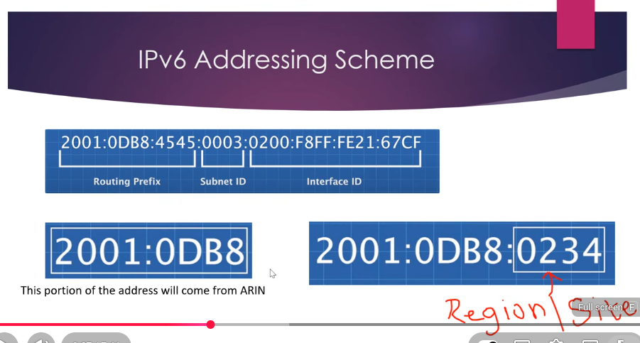

ARIN assigns the first 32 bits. There are 5 ARIN registers in the world.
3rd 16 bit block is assigned to the region.
4th 16 bit block is for subnetting

IPv6 Address Scopes:

https://www.crucial.com.au/blog/2011/04/15/ipv6-subnet-cheat-sheet-and-ipv6-cheat-sheet-reference/

::/128 unspecified address
::1/128 localhost
fe80::/10 link local
fc00::/7 unique local unicast (RFC 4193)
fc00::/8 centrally assigned by unkown, routed within a site (RFC 4193)
fd00::/8 free for all, global ID must be generated randomly with pseudo-random algorithm, routed within a site (RFC 4193)
ff00::/8 multicast, following after the prefix ff there are 4 bits for flags and 4 bits for the scope
::ffff:0:0/96 IPv4 to IPv6 Address, eg: ::ffff:10.10.10.10 (RFC 4038)
2000::/3 global unicast
2001::/16 /32 subnets assigned to providers, they assign /48, /56 or /64 to the customer
2001:db8::/32 reserved for use in documentation
2001:678::/29 Provider Independent (PI) adresses and anycasting TLD nameservers
2002::/16 6to4 scope, 2002:c058:6301:: is the 6to4 public router anycast (RFC 3068)

https://www.site24x7.com/tools/ipv6-subnetcalculator.html

https://www.youtube.com/watch?v=UIGVPvxnCtk

Subnetting IPv6 Addresses

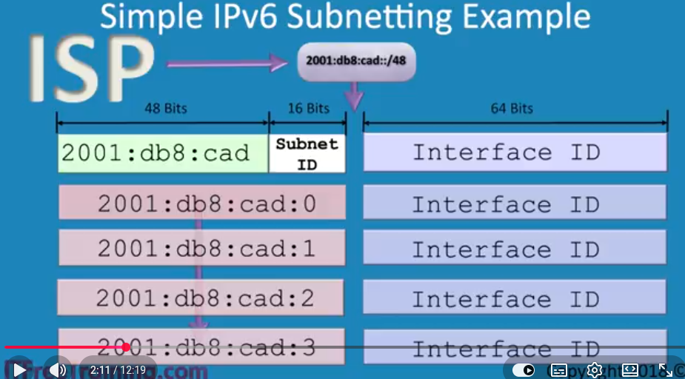
Subnetting is not required as in IPv4
ISP specified the first 48 bits and provided following 16 bits for subnetting. Thus, each number in this full range of 16 bits is a subnet, no hosts, just subnets. Therefore, you can count from 0 to f through all 16 bits.

The provided 16 bits for subnetting allows splitting it into logical units:

4 4 4 4
4 bits each = 16 addresses
3 2 1 0
8 4 2 1= 0 – 15 or 2^4 = 16 combinations

Network of 16 countries, 16 states, 16 offices and 16 departments:
Country 4 bits State 4bits Office 4 bits Department 4 bits
0??? ?0?? ??0? ???0
f??? ?f?? ??f? ???f

8 8
2<8 = 256
Network of 256 countries and 256 offices:
Country 4 bits State 4bits Office 4 bits Department 4 bits
0??? ?0?? ??0? ???0
f??? ?f?? ??f? ???f

Country 5 bits (32 IPs) State 6 bits (64 IPs) Office 3 bits (8 IPs) Networks 2 bit (4 Ips)
Use online calc
32 networks /53
64 networks /59
8 networks /62
4 networks /64

online calculator: http://gestioip.net

Demonstration IPv6 Subnetting • http://gestioip.net • http://subnetonline.com

04:44 Demonstration of IPv6 Subnetting 1. Open Internet Explorer and go to: http://gestioip.net 2. Scroll down the page and select the link “subnet calculator online”. 3. Select the option “IPv6” at the top of the page. By default IPv4 will be selected. 4. Enter in the IP Address that you wish to subnet. In this example, the address 2001:db8:cad:: will be used. 5. Select the prefix length as 48 from the pulldown box. 6. Press the ‘calculate’ button. In this case, the original address allocated by the ISP will be the only address shown. This is because none of the bits of the subnet ID have been allocated. 7. At the bottom of the screen will be the option to create additional networks using the subnet ID. In this example 32 subnets are required which would require 5 bits. 5 bits is not shown so press the ‘more’ button to show additional options. Once the additional options have been shown, select “32 networks /53” 8. Subnet-level I will be shown with a network prefix of 53, since 5 bits have been allocated for level I subnets. 9. Below subnet-level I is subnet-level II. To divide the subnet ID up further, select an option. In this case, 6 bits are required for the states, so the option “64 networks /59” will be chosen. This will allocate the bits that are required. 10. The option subnet-level III will appear. In this example, 3 bits are required for offices,so I will select the option “8 networks /62”. 11. The last network is for networks which requires 2 bits. Under subnet-level IV

select the option “4 networks /64”. 12. All the 16 bits of the subnet ID have been allocated. To see the network, select the option “CREATE PLAN”. 13. The IPv6 calculator will then allow you to enter in a name for each network. For the first network, enter in “Country” and press the send option. 14. For the next level enter in “State” and press the send option. 15. For the next level enter in “Office” and press the send option. 16. The last option will ask the number of networks that you want to create for the last network. In this example, this will be 4 networks. Once 4 has been entered, press the send option. 17. The final screen will show the first network for each level of subnet except for the last network which will be broken down into individual subnets. 08:20 Demonstration of Subnetonline 1. Open the website http://subnetonline.com 2. Select the option “IPv6 Subnet Calculator” from under the “SUBNET CALCULATORS” menu. 3. In the address textbox, enter in “2001:db8:cad::” and from the pulldown select a prefix length of “/48”. 4. In the Subnets textbox, enter in 17 and press the button “Add Level”. This will add 17 subnets to the first level of subnets. In this example there are 5 bits allocated to the first level of subnets, and this would make a maximum number of 32 subnets or networks. This calculator will show all possible networks with the values given. If there are too many networks the process will fail. To ensure that this does not happen, the first level subnet value is kept as low as possible. 5. To add a second level of subnets, I will enter in the value of 33. Since 6 bits have been allocated to states the highest number of networks would be 64. To keep the number of networks expanded low to ensure it does not fail, the value 33 was chosen. This is the smallest value that will require 6 bits. 6. For the next level enter in 5. The office networks require 3 bits. The lowest value that will use 3 bits is 5. 7. For the last level enter in 4. The lowest number that could have been entered in here would have been 3 to require 2 bits, however, in this example 4 networks will not be enough to cause the subnet calculator to fail. 8. To view the network, press the button “Calculate Subnets”. If the process fails, you may need to reduce the number of subnets or networks that you entered in. Remember that, the process is exponential, so higher number of networks a level 1 which greatly increase the number of networks generated at level 1 but reduce the number of networks that can be created at lower levels. High numbers at low levels have less of an effect. 9. Once the networks have been generated, the original network will be shown with the prefix of 48. To expand the network, press the ‘plus’ value on the left of it.

This will show the next level of subnets. Pressing the ‘plus’ value on the left of this will show the next level of subnets and so forth. Looking closely at the different networks, you should notice that there is a certain value that is added to the last network to get the next network. The subnet calculator does the hard work of working out what this value will be. In a later video, I look at the maths involved in working out this subnet value. See http://YouTube.com/ITFreeTraining or http://itfreetraining.com for our always free training videos. This is only one video from the many free courses available on YouTube. References “Installing and Configuring Windows Server 2012 R2 Exam Ref 70-410” pages 210-211 "IPv6 Subnet Calculator" http://www.subnetonline.com/pages/subnetcalculators/ipv6-subnet-calculator.php "IPv4/IPv6 subnet calculator" http://www.gestioip.net/cgi-bin/subnet_calculator.cgi

Manual IPV6 Subnetting

https://www.youtube.com/watch?v=KSiZ751-Zs8

ISP allocates 48 bits, next 16 bits for subnets, rest 64 bits are for Interface IDs or hosts
Some of the 16 bits for the subnets could have been taken by ISP.

f = fixed -taken bits
s = subnets bits
r = remaining / unallocated bits
f+s+r = 16 all bits

required bits determine the size of the sunet. e.g. 2 bits = 2^2 = 4 subnets

Given by ISP: 2001:db8:cad::/48

Hierarchy of subnets
1st level of subnets
We need subnets for 3 countries.
US Canada England
We need 4 subnets, or 2 bits (2^2 = 4), s=2, r=14
2001:db8:cad:0000::/50

Incremental value for next subnet ID: I = 2^(16-f-s), i=2^14=16384 decimal = 4000 hexadecimal
Therefore 4000 is the incremental value:
2001:db8:cad:0000::/50 USA
2001:db8:cad:4000::/50 Canada
2001:db8:cad:8000::/50 England
2001:db8:cad:c000::/50

4 subnets with 16384 addresses in each range.

Second level is allocated to states
We assume we need only 60 subnets per each state, which make it additional 6 bits
fixed = 2 bits from the previous step
s = 6 bits, wanted bits for 60 provinces
r = 8 bits of remaining unallocated bits

i=2^16-f-s = 2^8 = 256, which is 100 in hexadecimal, it is our range:

2001:db8:cad:0000::/50 USA
2001:db8:cad:0100::/56 USA State 1 decimal
2001:db8:cad:0110::/60 USA State 1 Office1
2001:db8:cad:0120::/60 USA State 1 Office2
2001:db8:cad:0130::/60 USA State 1 Office3
2001:db8:cad:01f0::/60 USA State 1 Office
2001:db8:cad:0200::/56 USA State 2 dec
2001:db8:cad:0300::/56 USA State 3 dec
2001:db8:cad:1a00::/56 USA State 26 dec
….
2001:db8:cad:3f00::/56 USA State 40 hex or 64 dec
2001:db8:cad:4000::/50 Canada
2001:db8:cad:4100::/56 Canada State 1
2001:db8:cad:4110::/60 Canada State 1 Office1
2001:db8:cad:4120::/60 Canada State 1 Office2
2001:db8:cad:4130::/60 Canada State 1 Office3
2001:db8:cad:41f0::/60 Canada State 1 Office
2001:db8:cad:4200::/56 Canada state 2
2001:db8:cad:4300::/56 Canada State 3
2001:db8:cad:4a00::/56 Canada State 4
….
2001:db8:cad:7f00::/56 Canada
2001:db8:cad:8000::/50 England
2001:db8:cad:8100::/56 England
2001:db8:cad:8110::/60 England State 1 Office1
2001:db8:cad:8120::/60 England State 1 Office2
2001:db8:cad:8130::/60 England State 1 Office3
2001:db8:cad:81f0::/60 England State 1 Office
2001:db8:cad:8200::/56 England
2001:db8:cad:8300::/56 England
2001:db8:cad:8a00::/56 England
….
2001:db8:cad:bf00::/56 England
2001:db8:cad:c000::/50

To allocate next level of hierarchy for 10 offices, we need other 4 bits (2^4 = 16).
f=2+6=8
s=4
r=4
i=2^16-8-4 = 2^4= 16 dec or 10 hex

