All connections are public.
Levels:
Level 1: ensure connection between two public hosts on /24 and /16 subnets.
Level 2: ensure connection between two private hosts on /27 and /30 subnets.
Level 3: ensure connection between three public hosts on /25 subnet connected via a switch.
Level 4: ensure connection between three public hosts on a subnet connected via a router with three separate interfaces.
Level 5: ensure connection between two public hosts on different subnets connected via a router with two separate interfaces.
Level 6: ensure Internet connection of a public host connected to the Internet via switch and a router.
Level 7: ensure connection between two public hosts connected via two separate routers each with two separate interfaces.
Level 8: ensure Internet connection for two public hosts connected to the Internet via consecutively connected routers.
Level 9: ensure Internet connection for three public subnets connected via two routers.
Level 10: ensure Internet connection for four public hosts connected to the Internet via two routers with a switch.

https://www.youtube.com/watch?v=s_Ntt6eTn94

IP address – an identifier for a computer or device on a network for communication purpose.

192 , 168 . 1 . 0

IPv4 address – 32-bit numeric address, in 4 grouped numbers, separated by periods.
Each number group is called Octet.
Number range in each Octet is from 0 to 255.

IP address consists of two parts: network address and host address.
Network address or network id is the unique number assigned to that network.
Host address or host id is the unique number assigned to each device within than network.

Network which consists of 3 PC, 1 router, 1 bridge

Network address: 192.168.1.0

Host addresses for each device:
PC 1 192.168.1.1
PC 2 192.168.1.2
PC 3 192.168.1.3
Bridge 192.168.1.4

255.255.255.0
Subnet mask is a number that resembles an IP address and reveals how many bits in the IP address are used for the network by masking the network portion of the IP address.

Computers translate everything into bits.
IP address: 192.168.1.0: becomes 11000000. 10101000. 00000001. 0000000
Subnet mask: 255.255.255.0: becomes 11111111. 11111111. 11111111. 0000000

Question is how to convert addresses into the binary form

8 Bit Octet Chart

128 64 32 16 8 4 2 1

if the number is a 1, the number it represents counts. If it is 0, that number does not count.

For example,
IP address 192 . 168 . 1 . 0 is in binary form: 11000000 . 10101000. 00000001. 00000000

192 = 128 + 64 =>
128 64 32 16 8 4 2 1
1 1 0 0 0 0 0 0

168 = 128 + 32 + 8
128 64 32 16 8 4 2 1
1 0 1 0 1 0 0 0

1 = 1
128 64 32 16 8 4 2 1
0 0 0 0 0 0 0 1

0 = 0
128 64 32 16 8 4 2 1
0 0 0 0 0 0 0 0

Subnet mask of 255 . 255 . 255 . 0 is in binary form: 11111111 . 11111111. 11111111. 00000000

255 = all =>
128 64 32 16 8 4 2 1
1 1 1 1 1 1 1 1

255 = all =>
128 64 32 16 8 4 2 1
1 1 1 1 1 1 1 1

255 = all =>
128 64 32 16 8 4 2 1
1 1 1 1 1 1 1 1

0 = 0
128 64 32 16 8 4 2 1
0 0 0 0 0 0 0 0

Line up IP address and Subnet mask. Ones in subnet masks represent portion of the IP address.
11000000 . 10101000. 00000001. 00000000
11111111 . 11111111 . 11111111 . 00000000
network . network . network . host
192 . 168 . 1 . 0
_____________________________ _____
network portion host portion

IP address: 172 . 16. 1 . 0
Subnet: 255. 255. 0 . 0

10101100 . 00010000. 00000001. 00000000
11111111 . 11111111 . 00000000 . 00000000
network . network . host . host
172 . 16 . 0 . 0
____________________ _________________
network portion host portion

IP address: 10 . 0. 1 . 0
Subnet: 255. 0. 0 . 0

00001010 . 00000000. 00000001. 00000000
11111111 . 00000000 . 00000000 . 00000000
network . host . host . host
255 . 0 . 1 . 0
__________ _________________________
network portion host portion

What if the subnet mask is not 255?

255. 255. 224. 0

224 = 128 + 64 + 32
128 64 32 16 8 4 2 1
1 1 1 0 0 0 0 0

11111111. 11111111. 1110000. 00000000

Therefore:
IP address: 172 . 16. 1 . 0
Subnet: 255. 255. 224 . 0

000101100 . 00010000. 00000001. 00000000
11111111 . 11111111 . 11100000 . 00000000
network . network . network host . host
255 . 255 . 1 . 0
________________________ __________________
network portion host portion

IP address has a network and host parts for manageability, so that large networks can be broken down into smaller networks, which are known as subnets = subnettings

In a huge network, a PC wants to talk to a PC. PC must know where and how to reach that other PC. It does it by using a broadcast.

Broadcast is when a PC sends out data to all computers on a network, so it can locate and talk to a certain PC.
If each computer on a network broadcasts simultaneously, the network will come to a halt.
To prevent this, the large network is broken down to smaller parts called subnets by using routers.
Broadcast from a PC does not pass beyond the router. It stays within its subnet. The router intelegently routes the signal to the designated PC in a different subnet.

This is the reason why IP address have a network and a host portions, so networks can be split up into subnets – subnetting.

Example:

IP address: 192.168.1.0
Subnet mask: 255.255.255.0

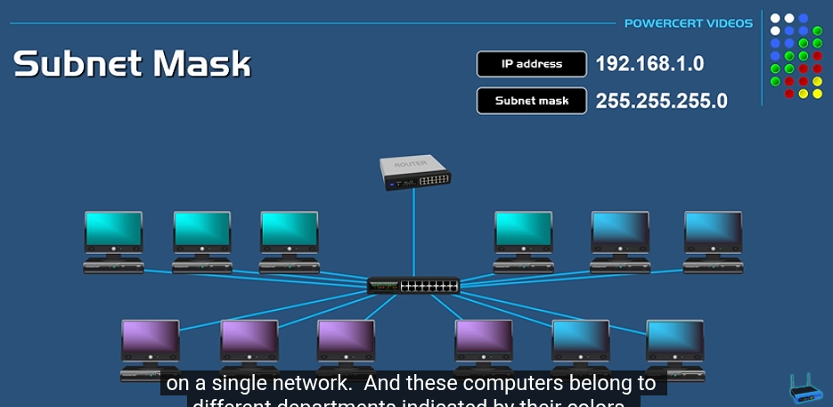

We need to break the network into 3 distinct subnets.

Subnetting is done by changing the default subnet mask by borrowing some of the bits from the host portion.

1s and 0s are reserved for broadcasting
Therefore, in 255.255.255.0, there is 1 network with 256 hosts, minus 2 due to broadcast bits, makes it 1 network with 254 possible hosts.

128 64 32 16 8 4 2 1

Subnet mask | Binary | Networks | Hosts
255.255.255.0 | 11111111. 11111111. 11111111. 00000000 | 1 | 254
255.255.255.128 | 11111111. 11111111. 11111111. 10000000 | 2 | 126
255.255.255.192 | 11111111. 11111111. 11111111. 11000000 | 4 | 62
255.255.255.224 | 11111111. 11111111. 11111111. 11100000 | 8 | 30
255.255.255.240 | 11111111. 11111111. 11111111. 11110000 | 16 | 14
255.255.255.248 | 11111111. 11111111. 11111111. 11111000 | 32 | 6
255.255.255.252 | 11111111. 11111111. 11111111. 11111100 | 64 | 2
255.255.255.254 | 11111111. 11111111. 11111111. 11111110 | 128 | 0

Therefore, to create 3 subnets, we need to use 3 option:

255.255.255.192 | 11111111. 11111111. 11111111. 11000000 | 4 | 62

IP address: 192.168.1.0
Subnet mask: 255. 255. 255. 192.168.1

Outcome:
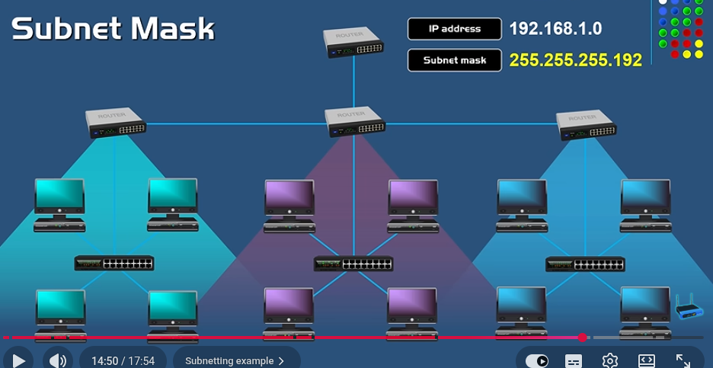

Class | Qty of hosts | First Octet Address | Default Subnet Mask
A | 16 777 216 (2^24) | 1-126 | 255.0.0.0
B | 65 536 (2^16) | 128-191 | 255.255.0.0
C | 256 (2^8) | 192-223 | 255.255.255.0
D | Industrial use
E | Industrial use

Different method for creating subnet masks called CIDR.

CIDR – Classless Inter-Domain Routing (slash notation)

For example:
IP address: 192.168.1.0 /24

Subnet mask: 255.255.255.0
Binary: 11111111. 11111111. 11111111. 00000000
24 means 8 + 8 + 8 = 24 ones

For example:
IP address: 192.168.1.0 /25

Subnet mask: 255.255.255.128
Binary: 11111111. 11111111. 11111111. 10000000
25 means 8 + 8 + 8 + 1= 25 ones

For example:
IP address: 192.168.1.0 /26

Subnet mask: 255.255.255.192
Binary: 11111111. 11111111. 11111111. 11000000

For example:
IP address: 192.168.1.0 /8

Subnet mask: 255.0.0.0
Binary: 11111111. 0000000. 0000000. 00000000

https://www.youtube.com/watch?v=BWZ-MHIhqjM

Subnetting

Subnetting is dividing a network into sub-networks.

256
-
128 64 32 16 8 4 2 1 24 16 8 0

128 24+1 = /25 16+1 = /17 /9 /1
192 24+2 = /26 16+2 = /18 /10 /2
224 24+3 = /27 16+3 = /19 /11 /3
240 24+4 = /28 16+4 = /20 /12 /4
248 24+5 = /29 16+5 = /21 /13 /5
252 24+6 = /30 16+6 = /22 /14 /6
254 24+7 = /31 16+7 = /23 /15 /7
255 24+8 = /32 16+8 = /24 /16 /8
/25 /26 /27 /28 /29 /30 /31 /32
/17 /18/ /19 /20 /21 /22 /23 /24
/9 /10 /11 /12 /13 /14 /15 /16
/1 /2 /3 /4 /5 /6 /7 /8

Network ID:
Broadcast IP:
First Host IP:
Last Host IP:
Next network:
# IP Addresses:
CIDR/Subnet:

Problem 1: 10.1.1.55 /28

We are in column: 16/240/28

Range groups in 16s: 0 16 32 48 64 80 96 112 128
Our range is .55 which is between 48 and 64.

Network ID: 10.1.1.48
Broadcast IP: 10.1.1.63
First Host IP: 10.1.1.49
Last Host IP: 10.1.1.62
Next network: 10.1.1.64
# IP Addresses: 16 , usable 14
CIDR/Subnet: /28 255.255.255.240

Problem 2: 10.1.1.37 /29

We are in column: 8/248/29

Range groups in 8s: 0 8 16 24 32 40 48 56 64 72 80 88 96 104 112 120 128
Our range is in .37 which is between 32 and 40.

Network ID: 10.1.1.32
Broadcast IP: 10.1.1.39
First Host IP: 10.1.1.33
Last Host IP: 10.1.1.38
Next network: 10.1.1.40
# IP Addresses: 8 , usable 6
CIDR/Subnet: /29 255.255.255.248

Problem 3: 10.2.2.88 /27

We are in column: 32/224/27

Group size: 32 0, 32, 64, 96, 128, 160, 192, 224, 256
Our range is in .88 which is between 64 and 96.

Network ID: 10.2.2.64
Broadcast IP: 10.2.2.95
First Host IP: 10.2.2.65
Last Host IP: 10.2.2.94
Next network: 10.2.2.96
# IP Addresses: 32/30
CIDR/Subnet: /27 255.255.255.224

Problem 4: 10.2.2.111 /25

We are in column: 128/128/25

Range groups in 128s: 0 128
Our range is in .111 which is between 0 and 128.

Network ID: 10.2.2.0
Broadcast IP: 10.2.2.127
First Host IP: 10.2.2.1
Last Host IP: 10.2.2.126
Next network: 10.2.2.128
# IP Addresses: 128 , usable 126
CIDR/Subnet: /25 255.255.255.128

Problem 5: 10.2.2.20 /30

We are in column: 4/252/30

Groups in 4s: 0 4 8 12 16 20 24
Our target is in .20 which is between 20 and 24.
Increase by group size until you PASS the target IP.

Network ID: 10.2.2.20, it is in fact the network id
Broadcast IP: 10.2.2.23
First Host IP: 10.2.2.21
Last Host IP: 10.2.2.22
Next network: 10.2.2.24
# IP Addresses: 4 , usable 2
CIDR/Subnet: /30 255.255.255.252

Problem 6: 10.2.2.199 /26

We are in column: 64/192/26

Range groups in 64s: 0 64 128 192 256
Our target is in .199 which is between 192 and 256.

Network ID: 10.2.2.192
Broadcast IP: 10.2.2.255
First Host IP: 10. 2.2.193
Last Host IP: 10.2.2.254
Next network: 10.2.3.0
# IP Addresses: 64/62
CIDR/Subnet: /26 255.255.255.192

pracnet.net/subnet 1 min per 7 steps

1
158.214.65.115 /17

128/128/17
group size: 128
target 115: 0 128

network: 158.214.0.0
broadcast: 158.214.127.255
first:158.214.0.1
last: 158.214.127.254
next network: 158.214.128.0
usable: 128/126
CIDR/Subnet: /17 255.255.128.0

2
145.191.169.51 /26

column: 64/192/26
group size: 64 0 64
target : 0

network: 145.191.169.0
first:145.191.169.0
last: 145.191.169.62
broadcast: 145.191.169.63
next network: 145.191.169.64
usable: 64/62
CIDR/Subnet: /26 255.255.192

3
63.101.206.38 /24

column:
group size:
target : 0

network: 63.101.206.0
first: 63.101.206.1
last: 63.101.206.254
broadcast: 63.101.206.255
next network: 63.101.207.0
usable:
CIDR/Subnet: 24 255.255.255.0

4
93.113.1.195 /27

column: 32/224/27
group size: 32 0 32 64 96 128 160 192 224 256
target :

network: 93.113.1.192
first: 93.113.1.193
last: 93.113.1.222
broadcast: 93.113.1.223
next network: 93.113.1.224
usable: 32/30
CIDR/Subnet: 255.255.255.224

5
196.238.120.144 /29

column: 8/248/29
group size: 8
target : 144 0 8 16 24 32 40 48 56 64 72 80 88 96 104 112 120 128 136 144 152

network: 196.238.120.144
first: 196.238.120.145
last: 196.238.120.150
broadcast: 196.238.120.151
next network: 196.238.120.152
usable:
CIDR/Subnet: 29/255.255.255.248

6
218.86.165.87 /29

column: 8/248/29
group size: 8
target : 144 0 8 16 24 32 40 48 56 64 72 80 88 96 104 112 120 128 136 144 152

network: 218.86.165.80
first:218.86.165.81
last: 218.86.165.86
broadcast: 218.86.165.87
next network: 218.86.165.88
usable: 8/6
CIDR/Subnet:

7
205.57.72.152 /24

column:
group size:
target :

network: 205.57.72.0
first: 205.57.72.1
last: 205.57.72.254
broadcast: 205.57.72.255
next network: 205.57.73.0
usable:
CIDR/Subnet: 255.255.255.0

8
28.59.250.174 /9

column:
group size:
target :

network: 28.0.0.0
first: 28.0.0.1
last: 28.127.255.254
broadcast: 28.127.255.255
next network: 28.128.0.0
usable: 128/126
CIDR/Subnet: 9/255.128.0.0

9
198.72.155.208 /24

column:
group size:
target :

network: 198.72.155.0
first:198.72.155.1
last: 198.72.155.254
broadcast: 198.72.155.255
next network: 198.72.156.0
usable:
CIDR/Subnet: 24/ 255.255.255.0

10
198.104.152.71 /27

column:
group size: 0 32 64 96
target :

network: 198.104.152.64
first: 198.104.152.65
last: 198.104.152.94
broadcast: 198.104.152.95
next network: 198.104.152.96
usable: 32/30
CIDR/Subnet: 27/255.255.255.224

11
39.143.141.166 /14

column:
group size: 0 14 28 42 56 70 84 98 112 126 140 144 148
target :

network: 39.140.0.0
first: 39.140.0.1
last: 39.153.255.254
broadcast: 39.143.255.255
next network: 39.144.0.0
usable: 4/2
CIDR/Subnet: 14/255.252.0.0

12
213.34.12.246/29

column: 8/248/29
group size: 8:
target : 246 240 248 256

network: 213.34.12.240
first: 213.34.12.241
last: 213.34.12.246
broadcast: 213.34.12.247
next network: 213.34.12.248
usable: 8/6
CIDR/Subnet: 255.255.255.248
Classless Inter-Domain Routing
how much of the address represents the network

13
201.237.104.156/26

column: 26/64/192
group size: 64
target : 156 0 64 128 192

network: 201.237.104.128
first: 201.237.104.129
last: 201.237.104.190
broadcast: 201.237.104.191
next network: 201.237.104.192
usable:
CIDR/Subnet: 26/255.255.255.192
Classless Interdomain Routing

14
60.78.241.234/25

column: 128/128
group size: 128
target : 234 128 256

network: 60.78.241.128
first: 60.78.241.129
last: 60.78.241.254
broadcast: 60.78.241.255
next network: 60.78.242.0
usable: 128/126
CIDR/Subnet: 255.255.255.128
Classless interdomain routing

15
136.198.135.214/23

column: 2/254
group size: 2
target : 135 134 136 138 140 ... 252 254 256

network: 136.198.134.0
first: 136.198.134.1
last: 136.198.135.254
broadcast: 136.198.135.255
next network: 136.198.136.0
usable:
CIDR/Subnet: 255.255.254.0

16
53.246.94.239/13

column: 8/248
group size: 8
target: 246 240 248 256

network: 53.240.0.0
first: 53.240.0.1
last: 53.247.255.254
broadcast: 53.247.255.255
next network: 53.248.0.0
usable:
CIDR/Subnet: 255.248.0.0.

17
206.34.8.38/26

column: 64/192
group size: 64
target : 38 0 64

network: 206.34.8.0
first: 206.34.8.1
last: 206.34.8.62
broadcast: 206.34.8.63
next network: 206.34.8.64
usable: 62
CIDR/Subnet: 255.255.255.192

18
141.223.202.46/22

column: 4/252
group size: 4
target : 202 200 204 240 244 248 252 256

network: 141.223.200.0
first: 141.223.200.1
last: 141.223.203.254
broadcast: 141.223.203.255
next network: 141.223.204.0
usable:
CIDR/Subnet:

19
192.194.221.201/28

column: 16/240
group size: 16
target : 201 192 208 224 240 256

network: 192.194.221.192
first: 192.194.221.193
last: 192.194.221.206
broadcast: 192.194.221.207
next network: 192.194.221.208
usable: 14
CIDR/Subnet: 255.255.255.240

20
213.70.236.155/25

column: 128/128
group size: 128
target: 155 0 128 256

network: 213.70.236.128
first: 213.70.236.129
last: 213.70.236.254
broadcast: 213.70.236.255
next network: 213.70.237.0
usable: 126
CIDR/Subnet: 255.255.255.128

CIDR stands for Classless Inter-Domain Routing. It is a way of writing an IP address together with information about how much of the address represents the network.
You will often see it written like:
192.168.1.0/24
The /24 is the important part.

What does /24 mean?
An IPv4 address has 32 bits:
192.168.1.0
CIDR /24 means:
- 24 bits → network portion
- 8 bits → host portion
So:
192.168.1.0/24
represents the range:
192.168.1.0 → 192.168.1.255
There are 256 total addresses in that range.

Some common examples
CIDR | Subnet mask | Total addresses
/8 | 255.0.0.0 | 16,777,216
/16 | 255.255.0.0 | 65,536
/24 | 255.255.255.0 | 256
/25 | 255.255.255.128 | 128
/26 | 255.255.255.192 | 64
/27 | 255.255.255.224 | 32
/28 | 255.255.255.240 | 16
/30 | 255.255.255.252 | 4
For example:
192.168.1.0/24
means essentially:
Network: 192.168.1.0
Usable hosts: 192.168.1.1 - 192.168.1.254
Broadcast: 192.168.1.255
So if you're learning networking, CIDR is basically a compact way of saying "this IP address belongs to this particular network size."
If you're working through 42's NetPractice, CIDR is especially important because you'll constantly need to determine the network address, broadcast address, usable IP range, and number of hosts from things like /24, /26, /30, etc.
Time-saving tricks

10.3.3.85 / 29
Group: 80 88

Network ID: 10.3.3.80
1st Host IP: 10.3.3.81
2nd Host IP: 10.3.3.86
Broadcast IP: 10.3.3.87
Next network: 10.3.3.88
# Addresses: 8
Subnet: 255.255.255.248

Tip 1: The group size can be multiplied by 10.

10.3.3.170 / 29
Group: 80 160 168 176

Network ID: 10.3.3.168
1st Host IP: 10.3.3.169
2nd Host IP: 10.3.3.174
Broadcast IP: 10.3.3.175
Next network: 10.3.3.176
# Addresses: 8
Subnet: 255.255.255.248

Tip 2: The group size can be multiplied by 10. Then, it can be doubled or tripled by the multiplied amount as necessary and then continued as necessary.

10.3.3.147 / 28
Column: 16/240
Group: 128 144 160

Network ID: 10.3.3.144
1st Host IP: 10.3.3.145
2nd Host IP: 10.3.3.158
Broadcast IP: 10.3.3.159
Next network: 10.3.3.160
# Addresses: 16
Subnet: 255.255.255.240

Tip 3: Every group has to pass 128. If the target amount is larger than 128, you can start from 128 and continue adding the group size as necessary. Or you can multiply by group size and go in reverse order by group size.

10.3.3.197 / 30
Column: 4/252
Group: 4 40 80 160 196 200 240 244 248 252 256

Network ID: 10.3.3.196
1st Host IP: 10.3.3.197
2nd Host IP: 10.3.3.198
Broadcast IP: 10.3.3.199
Next network: 10.3.3.200
# Addresses: 4
Subnet: 255.255.255.254

Tip 4: Any group size amount in counting will end on subnet amounts:
128, 192, 224, 240, 248, 252, 254, 256

10.3.3.117 / 29
Column: 8/248
Group: 8 112 120 128

Network ID: 10.3.3.196
1st Host IP: 10.3.3.197
2nd Host IP: 10.3.3.198
Broadcast IP: 10.3.3.199
Next network: 10.3.3.200
# Addresses: 4
Subnet: 255.255.255.254

Tip 5: Decrement from any known higher number by group size.

10.4.77.188 / 19
Column: 32/224
Group: 32 64 96

Network ID: 10.4.64.0
1st Host IP: 10.4.64.1
2nd Host IP: 10.4.95.254
Broadcast IP: 10.4.95.255
Next network: 10.4.96.0
# Addresses: 4
Subnet: 255.255.255.254

Tip 6: When working in 3rd octet, everything works as usual. Only in calculating the number of available addresses subtract from 32 the bit value (19), which is equal to 13, and use it as a power for 2^13 = 8192

10.4.211.66 / 18
Column: 64/192
Group: 192 256

Network ID: 10.4.192.0
1st Host IP: 10.4.192.1
2nd Host IP: 10.4.255.254
Broadcast IP: 10.4.255.255
Next network: 10.5.0.0
# Addresses: 4
Subnet: 255.255.255.254

213.50.111.222 / 2
Column: 64/192
Group: 192 256

Network ID: 192.0.0.0
1st Host IP: 192.0.0.1
2nd Host IP: 255.255.255.254
Broadcast IP: 255.255.255.255
Next network: n/a
# Addresses: 2^30 = 1.07 bil
Subnet: 255.255.255.254

To crush the NetPractice project at 42, you have to master how machines figure out who they are, how they find each other, and how they guarantee the data actually arrives.
Here is the breakdown of the three core concepts you need to configure those network topologies.

1. IP Addressing (The "Where")
An IP address (like 192.168.1.10) is a unique numerical identifier for a device on a network, functioning exactly like a street address for a house.
However, an IP address never works alone; it is always paired with a Subnet Mask (often written in CIDR notation like /24 or /26 in your exercises). The mask's job is to split the IP address into two distinct parts:
- The Network ID: Think of this as the "Street Name." Any devices that share the exact same Network ID are on the same local network and can talk directly to each other through a simple switch.
- The Host ID: Think of this as the "House Number." It identifies the specific computer on that specific street.
NetPractice Rule: If two PCs are plugged into the same switch but have different Network IDs (because their IP/Subnet combos don't match up), they are mathematically invisible to each other.

2. Default Gateway (The "Way Out")
What happens when a computer wants to talk to an IP address that is not on its local subnet? It cannot send the message directly. Instead, it forwards the traffic to its Default Gateway.
- The default gateway is simply the IP address of the router interface connected to your local network.
NetPractice Rule: When configuring routing tables in the project, a computer needs a route (usually written as 0.0.0.0/0) pointing to the router's IP so it knows where to dump "unknown" outside traffic.

3. TCP (Transmission Control Protocol) (The "How")
While IP handles where the data goes, TCP handles how it gets there securely and accurately. It is a transport protocol designed for reliability.
- Connection-Oriented: Before sending any actual data, TCP establishes a connection using a "Three-Way Handshake" (SYN, SYN-ACK, ACK). It is the digital equivalent of calling someone, saying "Can you hear me?", and waiting for them to say "Yes, I hear you," before you start talking.
- Guaranteed Delivery: TCP breaks your data down into small, numbered packets. The receiving device must send an acknowledgment (ACK) for every packet it gets. If the sender doesn't receive that ACK, it assumes the packet was dropped and automatically resends it.
- Ordered: Because packets can take different physical routes and arrive out of order, TCP uses those sequence numbers to reassemble the file perfectly on the other side.

CP operates one level up at the Transport Layer (Layer 4). If IP is the postal service delivering the envelope, TCP is the system verifying the contents arrived intact, in the correct order, and that the recipient is actually ready to read it.
Here is what you need to know about TCP and how it fits into your project.

How TCP Operates: The Core Mechanics
TCP provides connection-oriented, reliable data delivery. It achieves this through three main mechanisms:
- The Three-Way Handshake (Connection Setup): Before any actual data is sent, the two machines establish a stateful connection. It looks like this:
  - SYN (Synchronize): Machine A sends a packet with the SYN flag set, saying, "I want to talk, and my starting sequence number is X."
  - SYN-ACK (Synchronize-Acknowledge): Machine B receives it, opens a port, and replies with SYN-ACK: "I acknowledge your X, and my starting sequence number is Y."
  - ACK (Acknowledge): Machine A replies with an ACK: "I acknowledge your Y. Let's send data."
(Given your background in state machines from other projects, you can think of this as a strict finite state machine where both nodes must transition to an ESTABLISHED state before data flows).
- Sequence Numbers & Reassembly: Data is chopped into segments. Each segment gets a sequence number. Because IP routing can send packets along completely different physical paths, they might arrive out of order. TCP uses these sequence numbers to reassemble the data perfectly on the receiving end.
- Acknowledgments & Retransmissions: Every time Machine B receives a segment, it sends an ACK back to Machine A. If Machine A sends a segment but doesn't receive an ACK within a specific timeout window, it assumes the packet was lost in transit and automatically re-transmits it.

What You Actually Need for NetPractice
Here is the most important takeaway for your evaluation: NetPractice is almost entirely a Layer 3 (IP/Routing) puzzle.
While the subject mentions TCP/IP, the configuration exercises you solve in the project demand deep knowledge of IP, but require virtually zero configuration or deep knowledge of TCP internals.
You do not need to calculate TCP window sizes, worry about congestion control algorithms, or analyze sequence numbers for this project.

What you should know for the defense:
If an evaluator asks you about TCP during your NetPractice defense, they are usually checking if you understand the difference between layers. Be prepared to explain:
- TCP vs. IP: IP routes the packet to the right machine. TCP ensures the data is complete and ordered once it gets there.
- TCP vs. UDP: You should know that TCP is reliable (uses handshakes and acknowledgments) but slower. UDP (User Datagram Protocol) is "fire and forget"—it sends data without checking if it arrived (used for video streaming, gaming).
- Ports: While IP addresses target a specific machine, TCP uses ports (e.g., Port 80 for HTTP, Port 443 for HTTPS) to target a specific application running on that machine.
Focus your technical energy on mastering routing tables (0.0.0.0/0 defaults, specific network routes) and subnet boundaries. That is where the project will actually try to trip you up

The 3 Rules of Routing
Every time a PC or Router wants to send a packet, it looks at its routing table from top to bottom, applying these three rules in order of specificity.

1. The Local Network (Directly Connected)
If a PC has an IP address of 192.168.1.10/24, it implicitly knows how to reach the entire 192.168.1.0/24 network.
- The Logic: "I don't need a router for this. We are on the same switch. I will just shout their name (ARP request) and send it directly."
- In NetPractice: You don't usually have to manually configure these; the system knows them based on the interface IP and subnet mask.

2. Specific Network Routes
If the destination IP is not on the local subnet, the device looks for a specific rule.
- The Logic: "To reach network 10.0.0.0/24, send the packet to the router at 192.168.1.1."
- In NetPractice: You will write rules like: Destination: 10.0.0.0/24 -> Next Hop: 192.168.1.1. The "Next Hop" must always be an IP address on a subnet the device is already directly connected to. You cannot route to a router you can't reach!

3. The Default Route (The Catch-All)
If the destination IP doesn't match the local network, and there are no specific rules for it, the device uses the default route.
- The Logic: "I have no idea where this is. I'm dumping it on my default gateway and letting them figure it out."
- In NetPractice: This is written as 0.0.0.0/0. Almost every PC in your topologies will just have a default route pointing to the router interface it is plugged into.

The NetPractice Trap: The Return Path
This is where 90% of NetPractice configurations fail.
You set up a route on Router A so it knows how to send a packet to Router B. You run the checker, and the ping fails. Why? Because Router B doesn't know how to send the ACK packet back.
Routing is a one-way street. If PC-1 pings PC-2:
- PC-1 needs a route to PC-2.
- AND PC-2 needs a route back to PC-1.
How to solve it: Always trace the packet forward and backward. If you configure a specific route on a left-side router to reach a right-side subnet, make sure the right-side router has a specific route (or a default gateway) pointing back to the left-side subnet.
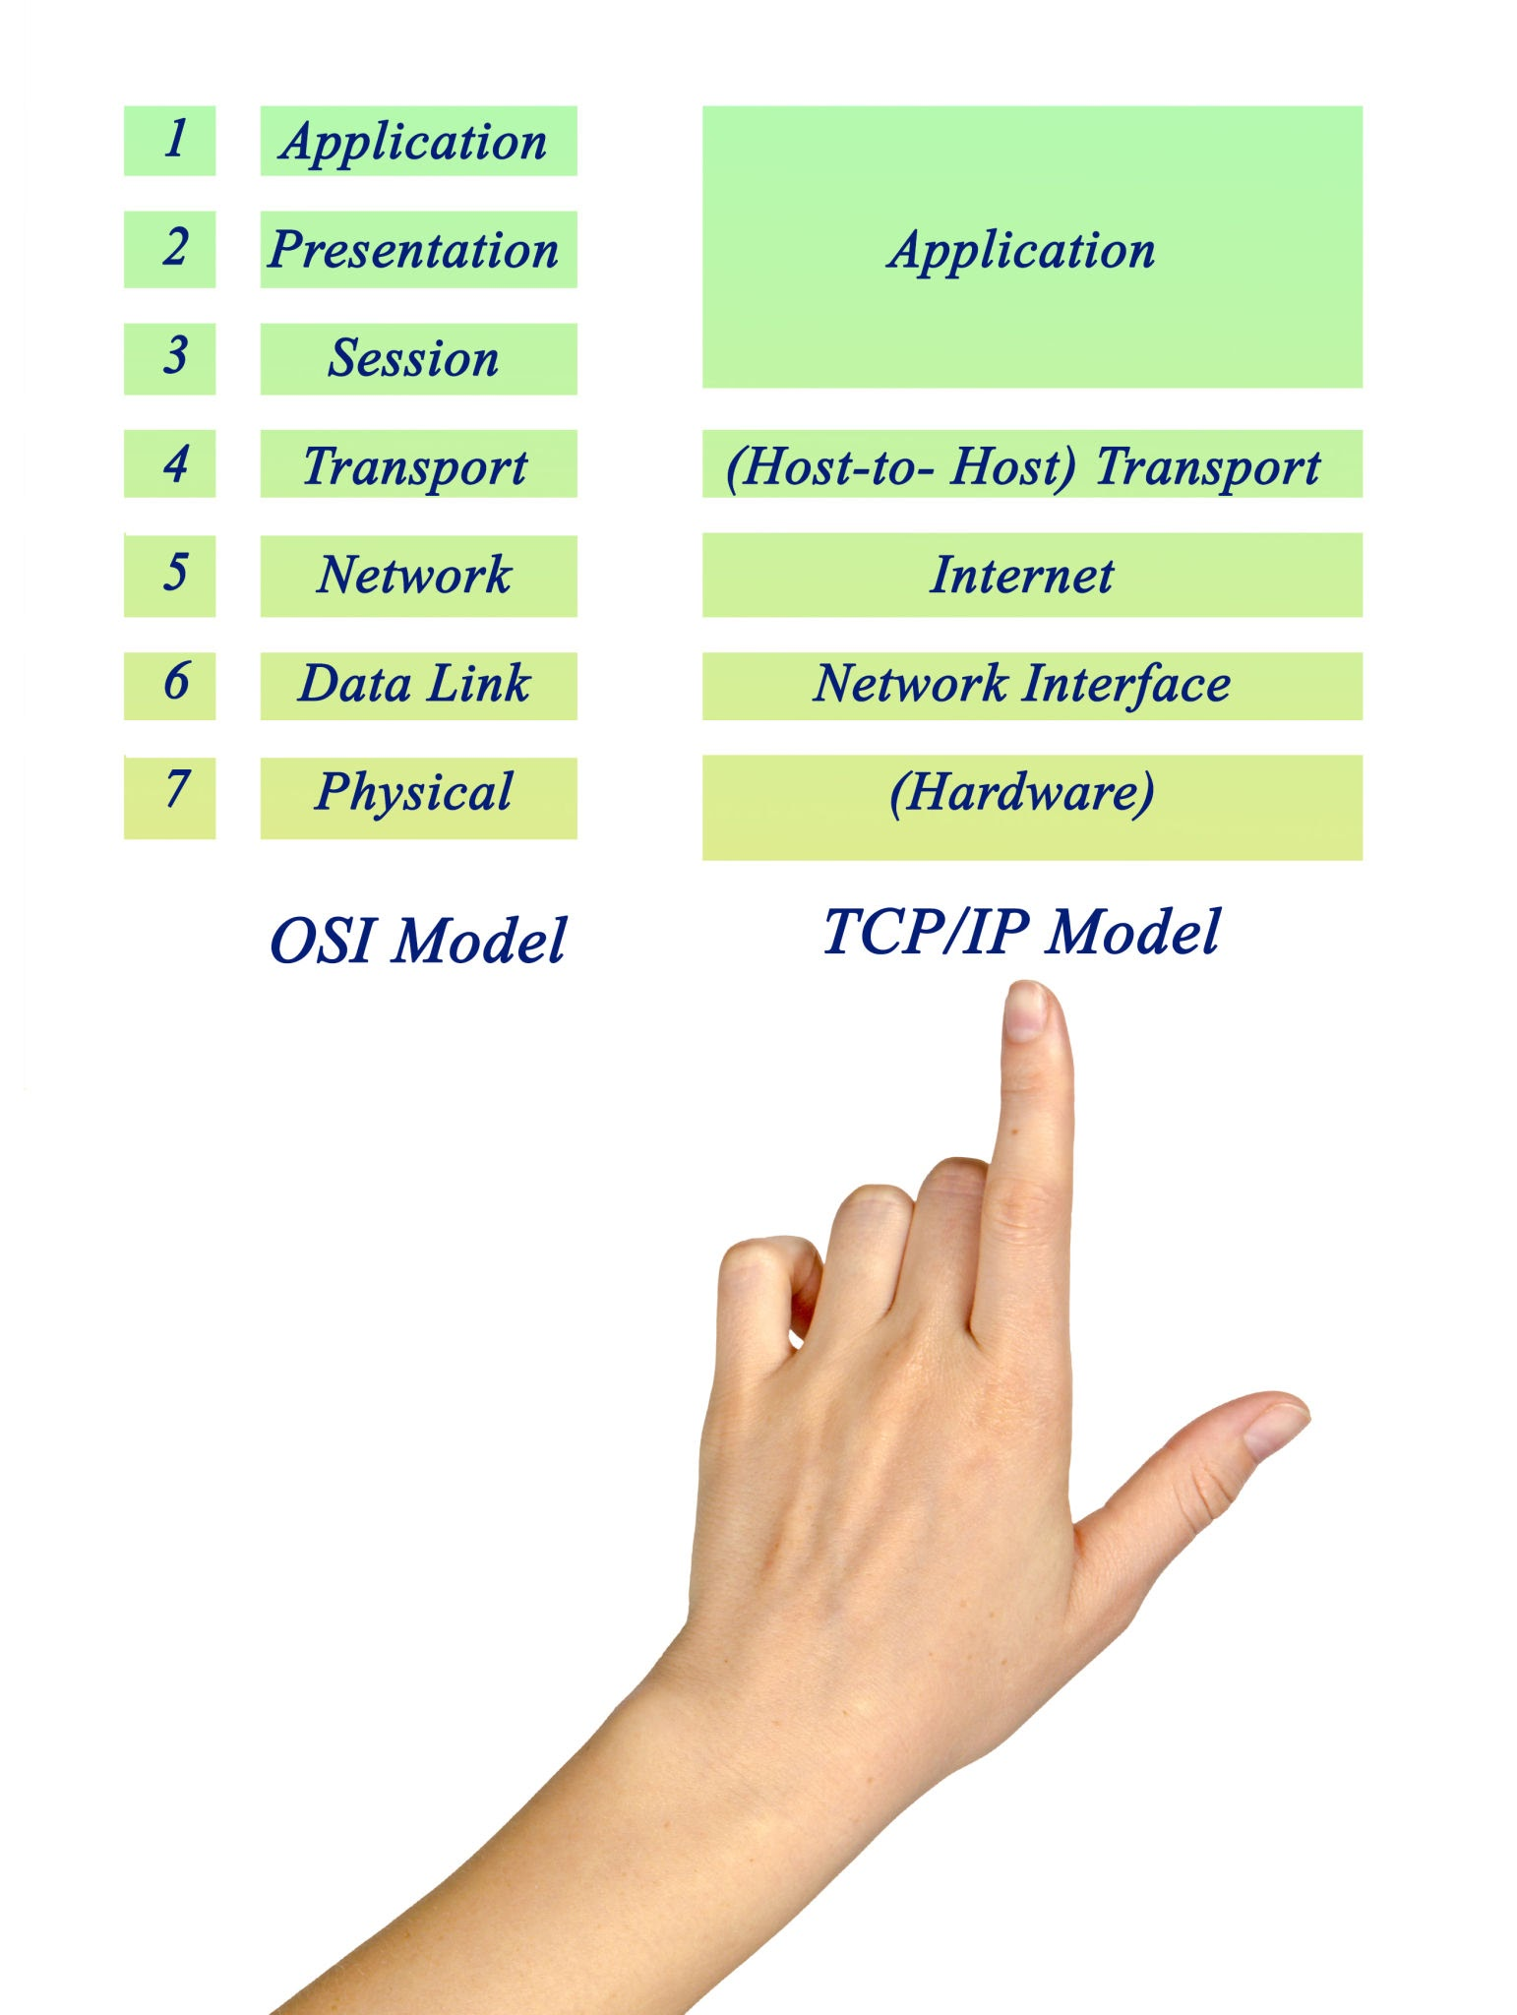

what is APR request, how a router chooses a directly connected network using "Longest Prefix Match" logic,

1. What is an ARP Request?
ARP (Address Resolution Protocol) bridges the gap between the Network Layer (Layer 3 - IP addresses) and the Data Link Layer (Layer 2 - MAC addresses).
Your computer knows the IP address of the destination (e.g., 192.168.1.5), but network hardware (switches and Ethernet cables) doesn’t care about IPs—they only understand physical MAC addresses burned into network cards.

How ARP Works:
- The Broadcast: When your PC wants to talk to an IP on its local network, it checks its local ARP cache. If it doesn't know the MAC address for that IP, it yells out a broadcast message to everyone on the local network:
"Who has IP address 192.168.1.5? Tell 192.168.1.10."
- The Reply: Every machine on the local network hears this, but only the machine with 192.168.1.5 responds. It sends a unicast reply back:
"That's me! My MAC address is AA:BB:CC:DD:EE:FF."
- The Cache: Your PC saves this pair in its ARP cache for a short time so it doesn't have to keep asking.
Note for NetPractice: If a packet is heading outside the local network, your PC doesn't do an ARP request for the final destination IP; it does an ARP request for the Default Gateway's IP to get the router's MAC address instead.

2. Longest Prefix Match (LPM) Logic
When a router receives a packet, it looks at its routing table to find out where to send it next. Often, multiple rules in the table might match the destination IP. How does the router pick the winner? It uses Longest Prefix Match.
The router chooses the route with the most specific subnet mask (the longest prefix, or the highest CIDR number like /28 over /24).

How It Works With an Example:
Imagine a router has these two entries in its routing table:
- Route A: 10.0.0.0 /8 (A huge network covering millions of IPs)
- Route B: 10.1.2.0 /24 (A much smaller, specific subnet covering 256 IPs)
If a packet arrives destined for 10.1.2.55:
- It matches Route A because 10.1.2.55 starts with 10.
- It also matches Route B because 10.1.2.55 falls within the 10.1.2.0 subnet.
The Decision: The router picks Route B because a /24 prefix matches 24 bits of the address, whereas a /8 only matches 8 bits. Longer prefix = higher specificity = winner.
If an IP comes in that matches neither of those (e.g., 8.8.8.8), the router falls back to the default route (0.0.0.0/0, which has a prefix of 0 bits).

To understand network communication, networking is broken down into abstract "layers." There are two main models used to describe this structure: the OSI Model (which has 7 layers) and the TCP/IP Model (which has 4 layers).
The 7-layer OSI (Open Systems Interconnection) model is the standard framework used for teaching and troubleshooting because it breaks things down into the most granular steps.

The 7 Layers of the OSI Model (Bottom to Top)
Data flows from the software down to the physical wire, and back up on the receiving end. Here is how they are structured:

1. The Physical Layer (Layer 1)
- What it is: The actual hardware, raw bits, and physical medium.
- Examples: Ethernet cables, fiber optics, radio waves (Wi-Fi), network interface cards (NICs), hubs.
- Job: Converts digital data into electrical or light signals and pushes them across a wire.

2. The Data Link Layer (Layer 2)
- What it is: Node-to-node data transfer on the same local network.
- Examples: Ethernet switches, MAC addresses.
- Job: Packages raw bits into frames, handles error checking, and uses MAC addresses to deliver data from one device to another on the exact same local segment. (This is where ARP operates).

3. The Network Layer (Layer 3)
- What it is: Route determination and global addressing across different networks.
- Examples: Routers, IP addresses (IPv4/IPv6), ICMP (ping).
- Job: Takes packets, figures out the best path through multiple routers across the internet using IP addresses, and delivers them to the destination network. (This is the core of your NetPractice project).

4. The Transport Layer (Layer 4)
- What it is: Reliable or unreliable end-to-end data delivery between applications.
- Examples: TCP, UDP, port numbers.
- Job: Ensures data arrives intact, in order, and without errors (via TCP), or streams it fast without guarantees (via UDP). It uses ports to hand data off to the right software application.

5. The Session Layer (Layer 5)
- What it is: Session management.
- Job: Establishes, maintains, and terminates connections between applications (managing dialogs and checkpoints).

6. The Presentation Layer (Layer 6)
- What it is: Data translation and formatting.
- Job: Ensures data from the application layer is readable by the receiving system. Handles encryption, decryption, compression, and character encoding (like SSL/TLS or JPEG).

7. The Application Layer (Layer 7)
- What it is: The software interface closest to the user.
- Examples: HTTP/HTTPS (Web browsers), DNS, SSH, FTP, SMTP (Email).
- Job: Provides network services directly to user applications.

The Practical Equivalent: The TCP/IP Model (4 Layers)
While the OSI model has 7 layers, the modern internet actually runs on the TCP/IP Model, which condenses those 7 layers into 4 broader layers:
- Network Access / Link Layer (Combines OSI Layers 1 & 2: Physical & Data Link)
- Internet Layer (Corresponds to OSI Layer 3: Network / IP)
- Transport Layer (Corresponds to OSI Layer 4: TCP/UDP)
- Application Layer (Combines OSI Layers 5, 6, & 7)

How They Work Together: Encapsulation
When you send a message, data goes down the stack. Each layer adds its own "wrapper" (header) containing routing or protocol info—a process called encapsulation:
- Application creates data (Layer 7).
- Transport adds TCP/UDP header with port numbers (Layer 4).
- Network adds IP header with source/destination IPs (Layer 3).
- Data Link adds Ethernet header with MAC addresses (Layer 2).
- Physical turns it into bits on a wire (Layer 1).
On the receiving end, the computer strips those wrappers off one by one going up the stack until the application can read the raw data.

Examples:
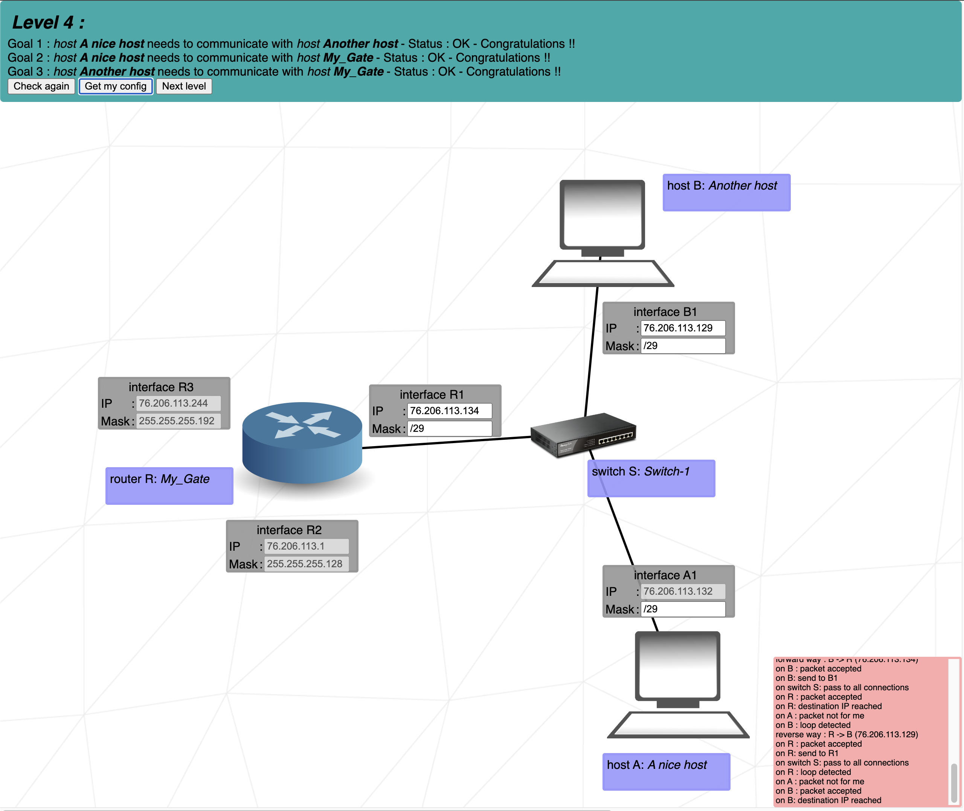
This image shows a network with the following given configuration. Host A with interface A1 and IP 76.206.113.132 and Host B are connected to switch S, which is connected to a router My_Gate with interface R1, with interface R2 with IP 76.206.113.1, Mask: 255.255.255.128, and interface R3 with IP 76.206.113.224, Mask 255.255.255.192. I need to determine Router S’s interface R1, its IP and Mask, Host B’s IP and Mask, and Host A1’s Mask.
From previous knowledge about subnetting, I understand the following: The subnet of Router S’s Interface R2 shows 128, which is /25 in CIDR. The Router S’s Interface 3 subnet mask is in /26 CIDER.
I start solving this as follows:

R2:
IP: 76.206.113.1
Mask: 255.255.255.128
/25
Network ID: 76.206.113.0
First: 76.206.113.1
Last: 76.206.113.126
Broadcast: 76.206.113.127
Netx ID: 76.206.113.128

R3:
IP: 76.206.113.244
Mask: 255.255.255.192
/26 192 256
Network ID: 76.206.113.192
First: 76.206.113.193
Last: 76.206.113.254
Broadcast: 76.206.113.155
Netx ID: 76.206.114.0

R1:
IP: 76.206.113.128
Mask: 255.255.255.248
/29
Network ID: 76.206.113.128
First: 76.206.113.129, .130, .131, .132, .133
Last: 76.206.113.134
Broadcast: 76.206.113.135
Netx ID: 76.206.113.136

However, another student specified that the correct configuration for interface R1 is IP 76.206.113.134 and Mask /29 CIDR. I don’t understand this. Can you explain?

Your calculations for R2 (.0 to .127) and R3 (.192 to .254) are completely spot-on!
The reason you were confused about interface R1 and the /29 mask comes down to looking at the missing gap between your other two subnets, and understanding how switches group devices into a single local network.

1. Find the Missing Gap
Look at the IP ranges you already figured out:
- R2's Subnet (/25): Ends at broadcast .127
- R3's Subnet (/26): Starts at network ID .192
Look closely at the numbers between .127 and .192. That entire block (.128 to .191) is left over! That middle block is precisely where the subnet for Switch S, Host A, Host B, and Router interface R1 lives.

2. Breaking Down the /29 Subnet
All devices plugged into the same switch (Switch S) must be on the exact same local network. That means Host A, Host B, and Router interface R1 all share the same network ID, the same subnet mask, and the same broadcast address.
A /29 CIDR mask (255.255.255.248) means:
- Block size: 32 - 29 = 3 bits for hosts, which gives blocks of 8 IP addresses ($2^3 = 8$).
Starting right where R2 left off at .128, let's map out that 8-address block:
- Network ID: 76.206.113.128 (The address of the network itself)
- First Usable IP: 76.206.113.129 (Assigned to Host B / B1)
- Usable IP: 76.206.113.130
- Usable IP: 76.206.113.131
- Usable IP: 76.206.113.132 (Assigned to Host A / A1)
- Usable IP: 76.206.113.133
- Usable IP / Router: 76.206.113.134 (Assigned to Router Interface R1)
- Broadcast IP: 76.206.113.135 (The final address in the block)

3. Putting It Together
This explains why your fellow student gave you those numbers:
- The Mask: Because they share Switch S, Host A, Host B, and Router R1 all use the /29 mask.
- The IPs: They can take any unique usable IP address from within that .128 to .135 block.
  - Host B took .129
  - Host A took .132
  - Router R1 took .134
As long as an IP falls between .129 and .134 and uses the /29 mask, the switch considers them neighbors on the exact same local network segment!

1. Is .134 the Broadcast ID? (Clarifying the Math)
No! .134 is not the broadcast ID.
For the /29 subnet starting at 76.206.113.128, the math works out like this:
- Network ID: 76.206.113.128 (Reserved for the network name)
- Usable IPs: 76.206.113.129 through 76.206.113.134 (Reserved for devices like Host A, Host B, and Router R1)
- Broadcast ID: 76.206.113.135 (Reserved for blasting data to everyone)
Router interface R1 is assigned 76.206.113.134, which is simply the highest usable host IP in that block, not the broadcast address.

2. Where Does a Router Sit in a Subnet?
You mentioned you thought a router should be positioned at the Network ID or as a default gateway.
- It can never take the Network ID (because that belongs to the network itself).
- It can never take the Broadcast ID (because that belongs to everyone).
- It must take a regular, usable host IP address from that subnet.
Once the router is assigned a usable IP address (like .134), that IP address becomes the Default Gateway for all the other computers on that switch. When Host A wants to talk to the outside world, it sends the packet directly to the router's IP (.134).

3. What is an Interface?
An interface is essentially a physical or logical network port on a device.
- Your laptop has a Wi-Fi interface or an Ethernet interface.
- A router is a heavy-duty box that has multiple ports. Each of those ports is an interface (labeled R1, R2, and R3 in your diagram).
- Every interface has its own physical hardware address (MAC address) and must be configured with its own IP address and subnet mask. It acts as the "doorway" connecting that router to a specific physical switch or network cable.

4. How Can a Single Router Have Different Masks (e.g., /25, /26, /29) on Different Interfaces?
This is actually a router's core superpower!
A router's entire job is to connect completely separate, independent networks together.
- Interface R2 is plugged into a physical switch handling a massive /25 network.
- Interface R3 is plugged into a different physical switch handling a /26 network.
- Interface R1 is plugged into yet another switch handling a small /29 network.
Because these three interfaces are plugged into completely different physical segments (switches), they live in entirely different broadcast domains. They do not care what mask the other interfaces are using.
Think of a router like a translator living in a house with three doors:
- Door 1 (R2) opens into a giant auditorium full of 126 people (/25).
- Door 2 (R3) opens into a medium-sized room with 62 people (/26).
- Door 3 (R1) opens into a small office with 6 people (/29).
The router speaks the local rules of whichever room it is looking into through that specific interface. That is why each interface needs its own unique IP and mask tailored specifically to the local devices sharing that exact switch!

1. Does the Switch Determine the Subnet Size?
Not quite. The switch is essentially a "dumb" multi-way traffic splitter operating at Layer 2 (Data Link layer). It doesn't know what an IP address, a subnet mask, or a CIDR block is; it only looks at MAC addresses to forward frames between devices.
The subnet size is entirely defined by the IP configuration (specifically the subnet mask) chosen by the network administrator (or in this case, the NetPractice project generator). However, you are right about the physical limitation: all devices plugged into the same switch must belong to the exact same subnet. If they don't share the same network ID and mask, they won't be able to communicate through that switch.

2. The Router's IP Range (.0 to .254)
You mentioned that the router splits a single range from .0 to .254 as needed. That is a great way to look at how a parent block (like a /24 network spanning 76.206.113.0 to 76.206.113.255) is subnetted (divided into smaller chunks).
The router doesn't sit at .0 or .254 globally. Instead:
- The router takes one usable IP from each carved-up subnet to act as that subnet's gateway.
- For example, in R2's subnet (.0 to .127), the router takes .1. In R1's subnet (.128 to .135), the router takes .134. In R3's subnet (.192 to .254), the router takes .244.

3. Your Final Summary is Spot-On
Your last sentence hits the nail completely on the head:
"The router creates a separate interface for each subnetwork and associates it with a specific port which is connected to a specific switch, which provides specific physical ports for connecting hosts."
Precisely! The router acts as the boundary keeper. Each interface belongs physically and logically to a different local network (switch), holding a unique IP address on that network to herd traffic back and forth.

https://en.wikipedia.org/wiki/IP_address
Internet Assigned Numbers Authority (IANA) manages IP address space.
Regional Internet Registries (RIRs). There are 5. IANA assigns blocks of IP addresses to the RIRs, which are responsible for distributing them to local Internet registries in their region, such as internet service providers (ISPs) and large institutions.
TCP/IP and UDP Transmission Control Protocol /
IP Address - 2 parts: network prefix and host identifier
CIDR notation - routing prefix
The first three bits of the most significant octet of an IP address were defined as the class of the address. Three classes (A, B, and C) were defined for universal unicast addressing.
NAT network address translation enables private networks to connect to the Internet.
Three non-overlapping ranges of IPv4 addresses for private networks are reserved.[16] These addresses are not routed on the Internet, and thus their use need not be coordinated with an IP address registry. Any user may use any of the reserved blocks. Typically, a network administrator will divide a block into subnets; for example, many home routers automatically use a default address range of 192.168.0.0 through 192.168.0.255 (192.168.0.0/24).
Reserved private IPv4 network ranges
Class A: 10.0.0.0./8 10.0.0.0 - 11.0.0.0.
Class B: 172.16.0./12 172.16.0.0. - 172.32.0.0.
Class C: 192.168.0.0/16 192.168.0.0. - 192.169.0.0.
In IPv6 local networks are called unique local addresses (ULAs)
Dynamic Host Configuration Protocol (DHCP) is the most frequently used technology for assigning dynamic addresses, which are reassigned each time a host gets restarted.

Yes. In the old classful IPv4 system, there are five classes:
Class | First octet | Range | Purpose
A | 1–126 | 1.0.0.0 – 126.255.255.255 | Large networks
B | 128–191 | 128.0.0.0 – 191.255.255.255 | Medium networks
C | 192–223 | 192.0.0.0 – 223.255.255.255 | Small networks
D | 224–239 | 224.0.0.0 – 239.255.255.255 | Multicast
E | 240–255 | 240.0.0.0 – 255.255.255.255 | Experimental / reserved

Class D — Multicast
Class D is:
224.0.0.0 – 239.255.255.255
It's not used for normal host/network addressing.
Instead, it's used for multicast: sending one packet to multiple interested receivers.
For example:
224.0.0.1
is the multicast address for all hosts on the local subnet.
You can remember:
D = multicast

Class E — Experimental
Class E is:
240.0.0.0 – 255.255.255.255
Historically, this range was reserved for experimental/future use.
You can remember:
E = Experimental
There's an important exception at the end:
255.255.255.255
is the limited broadcast address, not a normal Class E host address.

One important thing for NetPractice
If you're studying IPv4 for 42 NetPractice, you'll mostly work with A, B and C-like ranges, but you'll also encounter CIDR, which has largely replaced the old class system.
For example:
192.168.1.0/24
is traditionally a Class C address range, but /24 is the CIDR information that actually tells you the network size.
So think of it as:
A: 1–126
B: 128–191
C: 192–223
D: 224–239 → multicast
E: 240–255 → experimental/reserved
And 127.x.x.x is special: it's reserved for loopback (127.0.0.1, etc.).

Practice

1. The Default Gateway (0.0.0.0/0)
When a host or router receives a packet destined for an IP it does not explicitly know how to reach, it needs an escape hatch. This is the Default Route, written in CIDR as 0.0.0.0/0.
- For Hosts (PCs): Every single host in NetPractice needs a default route pointing to the IP address of the router interface on its local switch. Rule: "If the destination isn't on my switch, hand it to the router."
- For the Internet: In the project, the "Internet" node represents the rest of the world. If a router is connected to the Internet cloud, it needs a route of 0.0.0.0/0 pointing to the Internet's IP address.

2. Specific Routing Tables (The "Next Hop")
Routers automatically know how to talk to the subnets they are physically plugged into. You only need to write routing rules for subnets they cannot see.
A routing table entry looks like this: Destination Network (CIDR) -> Next Hop IP
- Destination Network: This is the Network ID of the target subnet (e.g., 10.1.2.0/24).
- Next Hop IP: This is the absolute most critical rule in the project: The Next Hop IP must be an address on a subnet the router is ALREADY connected to. You cannot tell a router to forward a packet to a router it cannot physically reach. You are simply handing the packet to the nearest door of the next router in the chain.

3. The Return Path Trap
This is the number one reason levels fail in NetPractice. Routing is not a homing pigeon; it is a one-way street.
If Host A pings Host B:
- Forward Path: Host A's router needs a specific route directing traffic toward Host B's subnet.
- Return Path: Host B receives the ping and tries to reply. Host B's router must have a specific route directing traffic back toward Host A's subnet.
Always trace the packet's journey all the way to the destination, and then trace the ACK (acknowledgment) packet all the way back.

The NetPractice Execution Strategy
When you open a new level, follow this exact sequence:
- Calculate the Subnets: Fill in all the missing IPs and masks first, ensuring no overlapping subnets exist on different interfaces.
- Lock in the Hosts: Give every Host a default route (0.0.0.0/0) pointing to its local router interface.
- Trace the Internet: If there is an Internet cloud, give the connecting router a 0.0.0.0/0 route pointing to the Internet IP.
- Connect the Islands: Look at each router. Ask, "Which subnets are missing from this router's physical connections?" Write a specific route for each missing subnet, pointing to the next adjacent router.

Yes — normally, if three hosts are connected to the same switch and are supposed to communicate directly with each other, they should be in the same subnet, which means they should use the same subnet mask.
For example:
PC1 ──┐
PC2 ──┼── Switch
PC3 ──┘
You could have:
PC1: 192.168.1.10/24
PC2: 192.168.1.20/24
PC3: 192.168.1.30/24
All three have:
Subnet mask: 255.255.255.0
Network: 192.168.1.0
Therefore, they can communicate directly through the switch.

But there's an important NetPractice detail
It's not the switch that determines the subnet.
The important thing is that the hosts' IP addresses and masks place them in the same network.
For example, this works:
PC1: 192.168.1.10/24
PC2: 192.168.1.20/24
PC3: 192.168.1.30/24
But this doesn't:
PC1: 192.168.1.10/24
PC2: 192.168.2.20/24
PC3: 192.168.3.30/24
They're connected to the same switch, but they're in different IP networks. A switch by itself doesn't route between those networks.

Can they have different masks?
Technically, yes, but that's an advanced situation and generally not what you want in a basic NetPractice exercise.
For example:
PC1: 192.168.1.10/24
PC2: 192.168.1.20/25
These can still belong to compatible portions of the same address space, but using different masks makes the network behavior more complicated.
For NetPractice, a very useful rule is:
Hosts connected to the same switch and communicating directly should normally have IP addresses in the same subnet and therefore the same subnet mask.
For example:
Switch
/ | \
PC1 PC2 PC3
| | |
10.0.0.1 .2 .3
\____ / \___/
/24
All three:
10.0.0.x/24
are in:
10.0.0.0/24
and can communicate without a router.

Private IPs – watch out. These can’t be routed via public routers
10.x.x.x, 172.16-31.x.x, or 192.168.x.x.

1. Clarifying the "Blocked" Concept
You mentioned that if a host is in 137.20.35.1/25, any other subnet is "blocked."
It is better to think of it not as blocked, but as foreign. A subnet mask is simply a computer's way of asking: "Is the destination IP in my house, or do I need to send it to the post office (the router)?"
- If Host 1 (.2) wants to talk to Host 2 (.3), the /25 mask tells Host 1, "We are in the same house." It sends the packet directly through the switch.
- If Host 1 (.2) wants to talk to Host 4 (.131), the /25 mask tells Host 1, "That IP is outside my house." It immediately hands the packet to the router (137.20.35.1).

2. The Internet's Perspective: Route Summarization
Why does the Internet node's route of 137.20.35.0/24 => 163.172.250.12 work no matter how you chop up the internal network?
Because the Internet node does not care about your internal subnets. Think of a /24 as a giant shipping container. The Internet node is a cargo ship. Its routing table rule basically says: "If I see a packet destined for ANY address inside this /24 container (anything from .0 to .255), I will just drop it off at Router 1's doorstep (163.172.250.12) and let Router 1 sort it out."
Once the packet arrives at Router 1, it is Router 1's job to open the container and look at its specific internal routing table to figure out which smaller box (the /25, /26, or /28) the packet actually belongs in.

3. VLSM: Why the exercise was messy
If using four clean /26 subnets is so much easier, why did the exercise force you to use a /25, a /26, a /28, and a /30?
Because of Variable Length Subnet Masking (VLSM). In the real world, network administrators rarely split a /24 into four equal parts, because networks are rarely equal sizes.
- Maybe Switch S1 (the /25) is a massive open-plan office that needs 100 IPs.
- Maybe Host 3's network (the /28) is a tiny secure server room that only needs 10 IPs.
- The transit link between R1 and R2 (.253/30 and .254/30) only ever needs exactly 2 IPs, so using a full /26 (which provides 62 IPs) would waste 60 valuable IP addresses.
The exercise intentionally forced you to use VLSM to teach you that as long as the smaller subnets do not overlap, and as long as they all mathematically fit inside the parent /24, the outside world (the Internet) will still see them as one single, continuous block.
You have fully grasped the core mechanics. Your hypothetical design is exactly how an engineer would design it from scratch if all four networks needed the exact same number of hosts!

