Jaypee Institute of Information Technology, Noida
Department of Computer Science & Engineering and IT

Major Project Title: Service Catalog Internal Developer Platform for Sprinklr
By
Yash Malik
Enrollment No: 22103171
Course Name: Major Project 2
Program: B. Tech CS&E / B. Tech IT
8th Semester

2025–2026
Certificate

This is to certify that the work presented in this report, titled "Service Catalog Internal Developer Platform for Sprinklr", submitted by Yash Malik (Enrollment No. 22103171), is a bona fide record of original work carried out under my guidance and supervision in partial fulfillment of the award of the degree of Bachelor of Technology in Computer Science & Engineering at Jaypee Institute of Information Technology, Noida. To the best of my knowledge, this work has not been submitted elsewhere for the award of any degree or diploma.

Date: _________________________

Supervisor
Name: ________________________
Designation: ___________________
Department: ___________________

Head of Department
Name: ________________________
Designation: ___________________

Declaration of Originality

I, Yash Malik, student of Bachelor of Technology in Computer Science & Engineering at Jaypee Institute of Information Technology, Noida, hereby declare that this report titled "Service Catalog Internal Developer Platform for Sprinklr" represents original work carried out by me. The work reported herein has not been submitted to any other university or institution for the award of any degree or diploma. All sources of information and data used in this report have been duly acknowledged.

Date: ___________________
Signature: ___________________
Name: Yash Malik
Enrollment No.: 22103171

Acknowledgement

I take this opportunity to express my profound gratitude and deep regards to my supervisor, for their exemplary guidance, monitoring, and constant encouragement throughout the course of this project. The blessing, help, and guidance given by them from time to time shall carry me a long way in the journey of life on which I am about to embark.

I am also grateful to the Department of Computer Science & Engineering and the institution for providing the necessary infrastructure and resources. My heartfelt thanks go to the engineering team at Sprinklr for granting access to their internal platform environment, providing real-world requirements, and offering candid feedback during the integration and testing phases. This project would not have taken its present form without their practical insights.

Finally, I owe a great deal to my family and friends for their unwavering moral support and encouragement. Their belief in my abilities kept me motivated through every challenge encountered during this work.

Abstract
This report documents the design, development, and deployment of an Internal Developer Platform (IDP) for Sprinklr, a globally recognized customer experience management company, using Backstage — an open-source developer portal framework originally created at Spotify and now maintained under the Cloud Native Computing Foundation (CNCF). The platform integrates a self-service software catalog with GitLab-hosted repositories, ArgoCD for GitOps-based deployment management, Helm charts for standardized Kubernetes packaging, and software templates for scaffolded service creation across four major workload categories.

Problem: Prior to this implementation, Sprinklr's engineering teams had no centralized mechanism for discovering services, understanding deployment status, or onboarding new developers in a structured way. Service documentation was scattered, deployment pipelines varied team by team, and there was no enforced standard for Kubernetes configurations. This led to significant operational inefficiency and developer frustration.

Methodology: The project adopted a phased implementation methodology aligned with platform engineering best practices. Backstage v1.49.1 was scaffolded and integrated with the Sprinklr GitLab instance. The Kubernetes plugin was configured with service-account-based authentication against a production Kubernetes cluster. An ArgoCD instance was connected via the Backstage ArgoCD plugin to provide real-time deployment visibility. Custom software templates were authored for Backend (Python FastAPI and TypeScript Express), Client (Mobile), Data Engineering, and Machine Learning workloads. A PostgreSQL 18 database was configured for persistent catalog storage.

Key Results: The Backstage instance was deployed and made accessible via a Kubernetes deployment. GitLab integration surfaced all repositories from GitLab into the catalog. The ArgoCD plugin displayed sync status and health metrics for all namespaces. Helm charts with ownership annotations were validated via CI scripts. The Kubernetes plugin displayed live pod status for annotated entities.

Societal Relevance: By reducing developer toil, standardizing deployment practices, and accelerating onboarding, the platform contributes to a healthier engineering culture and faster product delivery cycles — ultimately benefiting end-users through higher reliability and quicker feature availability.

Table of Contents

Chapter | Title | Page
 | Preliminary Pages | i
1 | Introduction | 1
2 | Literature Survey | 11
3 | System Design & Methodology | 18
4 | Implementation & Testing | 28
5 | Results & Discussion | 39
6 | Conclusion & Future Scope | 49
 | References & Appendices | 54

List of Figures

Figure No. | Title | Page
1.1 | High-Level IDP Architecture at Sprinklr | 1
1.2 | Project Timeline (Gantt Chart) | 3
2.1 | Evolution of Internal Developer Platforms (2010–2024) | 11
3.1 | Backstage Application Architecture Diagram | 18
3.2 | Service Scaffolding Workflow Flowchart | 21
3.3 | ArgoCD Sync Process Flowchart | 22
3.4 | Backstage Entity Relationship Diagram | 24
4.1 | Docker Compose Service Topology | 28
4.2 | Kubernetes Plugin Integration Setup | 37
4.3 | Backend Template Scaffolding Steps in Backstage UI | 30
5.1 | Service Discovery Dashboard — Backstage Catalog View | 39
5.2 | ArgoCD Application Sync Status Panel | 40
5.3 | Kubernetes Pod Health View in Entity Page | 40

List of Tables

Table No. | Title | Page
1.1 | Work Breakdown Structure | 6
1.2 | Risk Register and Mitigation Strategy | 9
2.1 | Comparison of Internal Developer Platforms | 15
2.2 | Review of Key Literature on Platform Engineering | 16
2.3 | Research Gap Analysis | 17
3.1 | Technology Stack Rationale | 26
3.2 | Software Template Parameter Summary | 27
4.1 | Component Inventory and Versions | 31
4.2 | Test Cases for Backstage Components | 33
4.3 | Security Measures Summary | 38
5.1 | Key Achievement Metrics | 43
5.2 | Objective Fulfillment Matrix | 44
5.3 | Bill of Materials | 45
5.4 | Cost-Benefit Analysis | 46

List of Abbreviations

Abbreviation | Full Form
IDP | Internal Developer Platform
ArgoCD | Argo Continuous Delivery
CNCF | Cloud Native Computing Foundation
CI/CD | Continuous Integration / Continuous Deployment
GitOps | Git-based Operations Model for Infrastructure Management
RBAC | Role-Based Access Control
API | Application Programming Interface
YAML | YAML Ain't Markup Language
PostgreSQL | PostgreSQL Relational Database System
Kafka | Apache Kafka Distributed Event Streaming Platform
DNS | Domain Name System
SPA | Single Page Application
MR | Merge Request (GitLab terminology for Pull Request)
SRE | Site Reliability Engineering
DXA | Document Extensible Architecture (unit of measurement in OOXML)
NVM | Node Version Manager
TLS | Transport Layer Security
HOD | Head of Department
PO | Programme Outcome
PSO | Programme Specific Outcome

Chapter 1: Introduction

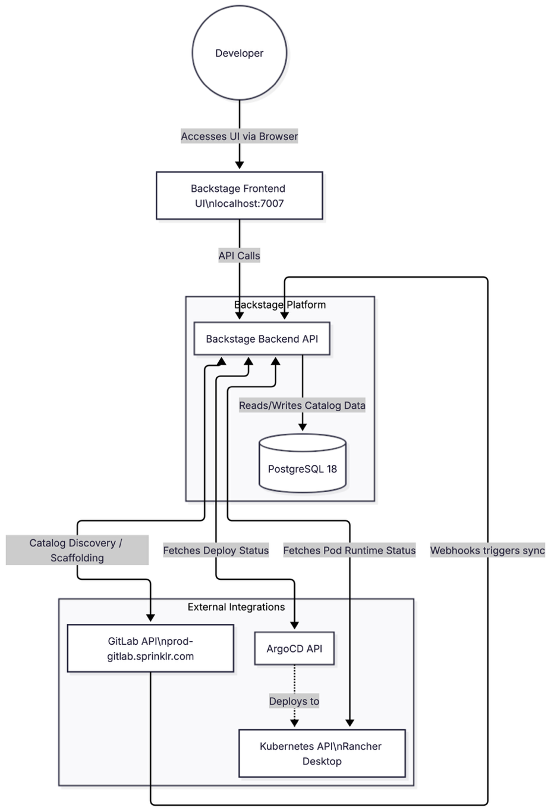
Figure 1.1A diagram showing how Backstage connects to GitLab and K8s.

1.1 Background and Motivation
The last decade has witnessed an unprecedented expansion in the scale and complexity of software systems deployed by technology companies. The widespread adoption of microservices architecture — where monolithic applications are decomposed into dozens or hundreds of independently deployable services — has unlocked significant agility benefits, but has simultaneously introduced a new class of operational challenges that were largely absent in the era of monolithic deployments. At the heart of these challenges lies a fundamental problem: as the number of services grows, the cognitive overhead required to understand, manage, and operate them grows proportionally, often overwhelming the engineering teams responsible for them.
Sprinklr, founded in 2009 and headquartered in New York, operates one of the most comprehensive customer experience management platforms in the world, serving over 1,000 enterprise clients across more than 100 countries. Its engineering organization, spanning multiple continents, is structured around autonomous squads that own specific product domains. This organizational model — closely analogous to the "Spotify Model" of autonomous engineering squads — inherently generates a proliferation of microservices, each with its own deployment pipeline, documentation practices, and infrastructure configuration. By early 2025, the internal engineering landscape at Sprinklr comprised thousands of microservices, each backed by separate GitLab repositories, ArgoCD application manifests, and Helm chart configurations. Without a unified layer to navigate this complexity, developers routinely spent disproportionate amounts of time on tasks that should ideally be automated or at least standardized.
The concept of an Internal Developer Platform (IDP) emerged as a direct response to this kind of organizational complexity. An IDP is not a single tool but a curated set of capabilities — service catalogs, deployment interfaces, documentation systems, and self-service scaffolding — assembled into a coherent developer experience layer. Research published by the DORA (DevOps Research and Assessment) program has consistently shown that engineering teams with better tooling, clearer ownership semantics, and reduced cognitive load ship software faster and with fewer incidents. The 2023 DORA State of DevOps report noted that developer experience is one of the strongest predictors of organizational performance, reinforcing the strategic value of investments in internal tooling.
Backstage, originally developed at Spotify under the internal codename "System Z" to address an almost identical problem at a comparable scale, was open-sourced in March 2020 and donated to the CNCF Sandbox shortly thereafter. It was accepted into CNCF Incubation in March 2022 and has since become the dominant open-source framework for building internal developer portals. As of late 2024, Backstage is reported to have over 3,400 adopting organizations and more than 2,200 contributors, with an estimated two million developers using it daily across companies such as Airbnb, LinkedIn, Twilio, American Airlines, Siemens, and Vodafone [1]. A 2024 survey of 180 companies conducted by DX found that over two-thirds of organizations with a formal platform engineering practice had adopted Backstage as their portal of choice [2]. These figures underscore not only the maturity of the framework but also the broad consensus in the industry that a software catalog-based IDP is an essential piece of modern engineering infrastructure.
The decision to build the Sprinklr IDP on Backstage was therefore not arbitrary. It was grounded in a careful evaluation of the available options — including commercial alternatives such as Cortex, Port, and Humanitec — against Sprinklr's specific requirements. The need for deep GitLab integration, the existing investment in ArgoCD for GitOps deployments, and the organizational preference for open-source, vendor-neutral tooling all pointed strongly toward Backstage as the foundation. The challenge, then, was not whether to adopt Backstage but how to configure, extend, and integrate it in a way that would genuinely improve the day-to-day experience of Sprinklr engineers rather than simply adding another tool to an already complex landscape.

1.2 Problem Definition and Objectives

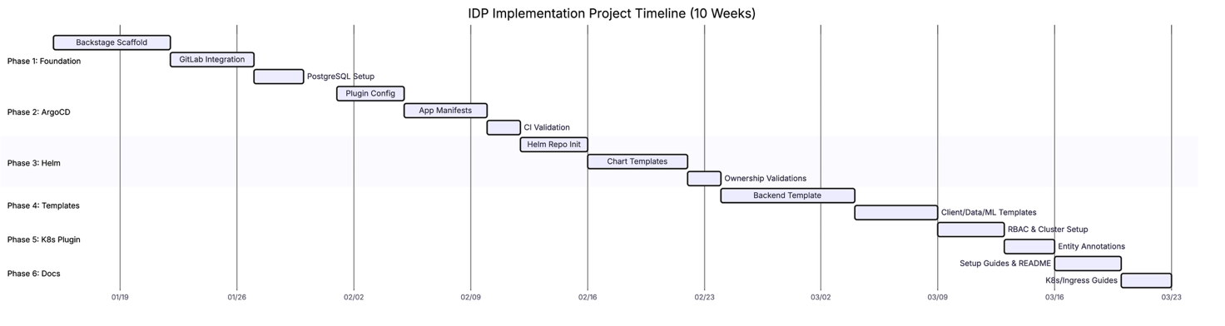
Figure 1.2 Project implementation schedule and milestones.

1.2.1 Problem Statement
At the time this project was initiated, Sprinklr's engineering teams faced a set of interconnected problems that collectively degraded developer productivity and increased operational risk. These are described in detail below.
Service Discovery Deficit: There was no authoritative, searchable registry of services within the organization. When a developer needed to understand what services existed, what APIs they exposed, who owned them, or what their current deployment status was, the only recourse was to search GitLab repositories manually, ask colleagues on Slack, or consult outdated Confluence pages. This process was not only time-consuming but also unreliable — documentation was frequently out of date, and ownership information was often missing or incorrect. For a new engineer joining a team, this created a steep and unnecessarily stressful onboarding experience.
Deployment Visibility Gap: The organization used ArgoCD for Kubernetes deployments, but ArgoCD was accessed directly by platform and SRE engineers. Application developers typically had limited visibility into whether their services were successfully deployed, what version was running in which namespace, or whether a recent deployment had caused a health degradation. The absence of a unified deployment status view led to repeated escalations to the platform team for information that should ideally be self-service.
Template and Configuration Inconsistency: When a new service needed to be created, the responsible developer would typically copy the structure of an existing similar service and adapt it manually. This approach, while expedient in the short term, led to significant inconsistency in Dockerfile structures, Helm chart configurations, CI/CD pipeline setups, and service metadata. Over time, this inconsistency accumulated into technical debt that made it progressively harder to apply organization-wide changes such as security policy updates or resource limit standardization.
Documentation Fragmentation: Technical documentation for services was distributed across GitLab READMEs, Confluence pages, shared Google Docs, and Slack bookmarks. There was no enforced standard for where documentation should live or what format it should take. This fragmentation meant that finding documentation was itself a non-trivial task, and in some cases, multiple conflicting versions of the same documentation existed simultaneously across different platforms.

1.2.2 Objectives
Based on the problem analysis above, the following measurable objectives were defined for this project. Each objective is stated with a clear, verifiable success criterion to facilitate objective assessment of outcomes.
# | Objective | Success Criterion
O1 | Deploy a Backstage instance integrated with Sprinklr infrastructure | Backstage accessible at localhost:7007 via Docker Compose with full catalog UI rendered
O2 | Integrate GitLab repositories into the Backstage catalog | All repositories in the backstage-idp GitLab group discoverable in the catalog with owner and lifecycle metadata
O3 | Configure the ArgoCD Backstage plugin for deployment visibility | ArgoCD application sync status and health visible on entity pages for all annotated components
O4 | Establish a Helm chart repository with CI-validated ownership metadata | helm-charts repository contains valid charts for service-d and service-x; validate-backstage-ownership.sh passes in GitLab CI
O5 | Author software templates for at least four major workload types | Templates for Backend (Python/TypeScript), Client, Data Engineering, and ML workloads successfully scaffold repositories in GitLab
O6 | Enable the Kubernetes plugin for runtime deployment visibility | Annotated components display pod status, restart counts, and container health in the Kubernetes tab
O7 | Produce comprehensive local-development documentation | README.md, Kubernetes setup guide, and ingress configuration guide sufficient for a new developer to run the full stack on macOS without assistance

1.3 Social and Environmental Relevance

1.3.1 Social Impact
The human dimension of developer tooling is frequently underestimated in technical reports. However, the quality of the tools that engineers use daily has a direct and measurable impact on their psychological wellbeing and job satisfaction. Studies in software engineering psychology have consistently found that tool friction — the cumulative effort spent navigating inadequate or inconsistent tooling — is one of the primary contributors to developer burnout and attrition. By providing a centralized, well-designed platform that reduces the time engineers spend on non-value-adding activities, this project contributes to a healthier and more sustainable engineering culture at Sprinklr.
Beyond individual wellbeing, the platform creates knowledge equity within the organization. When service documentation, ownership information, and deployment status are hidden in silos, only engineers who have been with the organization for a long time — or who have the right personal connections — can navigate the landscape effectively. A well-implemented software catalog breaks down these informal knowledge hierarchies by making information universally accessible to any authenticated developer, regardless of their tenure or personal network. This is particularly significant for organizations like Sprinklr that hire globally and onboard dozens of engineers every quarter.
From a broader societal perspective, the efficiency gains enabled by this platform translate directly into faster delivery of software features that benefit Sprinklr's enterprise clients and, through them, the millions of consumers who interact with customer experience systems powered by Sprinklr's platform. Reducing the time between a feature being conceived and it being deployed safely to production has real-world implications for how quickly organizations can respond to customer needs.

1.3.2 Environmental Impact
The environmental impact of software systems is an increasingly important consideration in engineering practice. Cloud computing infrastructure — the Kubernetes clusters, CI/CD pipelines, and database servers on which modern software runs — consumes significant amounts of electrical energy. Inefficient resource utilization, driven in large part by inconsistent and undisciplined deployment configurations, contributes unnecessarily to this consumption. By standardizing Kubernetes resource requests and limits through Helm chart templates with enforced best-practice defaults, this platform encourages more disciplined resource allocation across Sprinklr's services.
Furthermore, one of the more subtle environmental benefits of a self-service IDP is the reduction in the number of redundant services and orphaned deployments. Without a service catalog, it is common for engineers to create new services that duplicate functionality already available elsewhere, simply because they were unaware of what existed. Similarly, when a service is deprecated, it may continue running — consuming compute resources and generating carbon emissions — simply because there is no mechanism to identify and decommission it. A software catalog with lifecycle metadata (experimental, production, deprecated) provides the organizational visibility needed to address both of these problems systematically.

1.4 Project Plan

1.4.1 Work Breakdown Structure
Phase | Sub-Task | Deliverable | Duration
Phase 1: Foundation Setup | Backstage scaffold creation via npx @backstage/create-app | Running Backstage monorepo | 7 days
 | GitLab integration via app-config.yaml | Repository catalog entries visible | 5 days
 | PostgreSQL 18 container setup in Docker Compose | Persistent catalog storage across restarts | 3 days
Phase 2: ArgoCD Integration | ArgoCD Backstage plugin installation and configuration | ArgoCD tab rendered on entity pages | 4 days
 | ArgoCD application manifests for service-d and service-x | Services tracked in argocd-apps/ repository | 5 days
 | CI validation script for ownership enforcement | GitLab CI pipeline validates ownership on every push | 2 days
Phase 3: Helm Charts | Helm chart repository initialization | helm-charts/ with Chart.yaml and values.yaml | 4 days
 | Chart templates for Deployment, Service, Ingress, HPA | Parameterized chart installable via ArgoCD | 6 days
 | CI validation script for chart ownership | Pipeline enforces backstage.io/owner annotation | 2 days
Phase 4: Software Templates | Backend template (Python FastAPI + TypeScript Express) | Scaffolder creates GitLab repository with skeleton code | 8 days
 | Client (Mobile), Data Engineering, ML templates | Three additional placeholder templates registered | 5 days
Phase 5: Kubernetes Plugin | RBAC ClusterRole and ServiceAccount creation | Read-only cluster access for Backstage | 4 days
 | Entity annotation standards definition | backstage.io/kubernetes-namespace in catalog entries | 3 days
Phase 6: Documentation | Local development README and onboarding guide | Complete setup guide with troubleshooting | 4 days
 | Kubernetes and ingress setup guides | Supplementary technical documentation | 3 days

1.4.2 Timeline
The project was executed across six sequential phases spanning January 15, 2025 to March 22, 2025 — a total of approximately ten weeks. Phase 1 (Foundation Setup) occupied weeks one and two, running from January 15 through January 29. During this phase, the primary challenge was resolving native module compilation issues related to the node-gyp dependency, which required careful coordination of Node.js, Python, and Yarn versions. This dependency issue was ultimately resolved by pinning Node.js to version 24 via .nvmrc and installing Python 3.14 through the uv package manager, which provides pre-compiled binary wheels that bypass compilation entirely.
Phase 2 (ArgoCD Integration) ran from February 1 through February 11. The principal technical challenge here was correctly configuring the ArgoCD plugin to communicate with the ArgoCD instance running at the Sprinklr infrastructure URL, which required understanding the appLocatorMethods configuration syntax that changed significantly between Backstage plugin versions. Phase 3 (Helm Charts) ran from February 12 through February 23. The Helm chart templates were designed to support the most common deployment patterns at Sprinklr, including horizontal pod autoscaling, environment-specific value overrides, and host-based ingress routing via nip.io for local development.
Phase 4 (Software Templates) was the most intellectually intensive phase, running from February 24 through March 8. The Backend template alone required authoring a multi-step Scaffolder template that conditionally included Helm chart creation, ArgoCD application manifest generation, and catalog registration steps depending on user-provided parameters. Phases 5 and 6 ran concurrently in weeks eight through ten, completing with the final documentation push on March 22, 2025.

1.4.3 Roles and Responsibilities
Stakeholder | Role | Responsibilities
Yash Malik (Student) | Developer & Implementer | Full platform implementation, plugin configuration, template authoring, test execution, documentation
Sprinklr Engineering Team | Industry Partner | Environment access provision, production requirement definition, acceptance testing feedback
HOD, CS&E Department | Institutional Oversight | Academic approval, resource allocation, certificate signing

1.4.4 Challenges and Risk Management
Risk ID | Challenge | Likelihood | Impact | Mitigation Strategy
R01 | node-gyp compilation failure due to Node/Python version mismatch | High | High | Pin Node 24 via .nvmrc; use uv for Python 3.14 binary wheels; validate in CI
R02 | GitLab API rate limiting blocking catalog refresh | Medium | Medium | Token-based auth with read_api scope; implement exponential backoff in catalog refresh config
R03 | ArgoCD plugin API contract changes between Backstage versions | Medium | High | Lock plugin versions in package.json; test upgrades in isolation before applying
R04 | Kubernetes 1.24+ service account token handling breaking K8s plugin | Medium | High | Document both token-secret method (pre-1.24) and short-lived token method (post-1.24)
R05 | PostgreSQL data loss on Docker Compose restart | Low | Medium | Named Docker volume for PostgreSQL data directory; document backup procedure
R06 | Backstage entity validation failures blocking catalog ingestion | Medium | Medium | Validate catalog-info.yaml against Backstage schema before committing; CI linting step
R07 | Template scaffolding failures due to GitLab token scope insufficiency | Low | High | Document required token scopes; validate token permissions in setup guide

1.5 Scope and Limitations

1.5.1 Scope
This project is scoped to the design, implementation, and validation of a local-development Backstage instance configured specifically for the Sprinklr engineering organization. The scope encompasses the following technical boundaries: integration with repositories hosted on prod-gitlab.sprinklr.com within the backstage-idp group; ArgoCD application visibility for the service-d and service-x Kubernetes namespaces; Helm chart repository setup with CI-enforced ownership validation; four software templates covering the Backend, Client, Data Engineering, and Machine Learning workload categories; and Kubernetes plugin integration with a Rancher Desktop local cluster. The scope explicitly does not include production deployment to Sprinklr's cloud Kubernetes clusters, integration with authentication providers beyond the Backstage guest mode, or implementation of the TechDocs documentation generation pipeline — all of which are identified as future work.

1.5.2 Limitations
Several limitations were encountered or deliberately accepted during the course of this project. The most significant is that the implementation operates exclusively in a local development environment. While this was appropriate for a student capstone project and allowed rapid iteration without the operational risk of affecting production systems, it means that the production-readiness validation — including load testing, failover behavior, and multi-cluster support — could not be performed. A second limitation relates to authentication: the Backstage permission framework was deliberately disabled for simplicity, and the system runs in guest authentication mode. In a production deployment, this would be replaced by an OAuth provider integration. Finally, the TechDocs feature, which would generate service documentation from MkDocs files stored alongside service code, was configured but not fully validated due to the complexity of the required CI/CD pipeline for documentation generation.

Chapter 2: Literature Survey

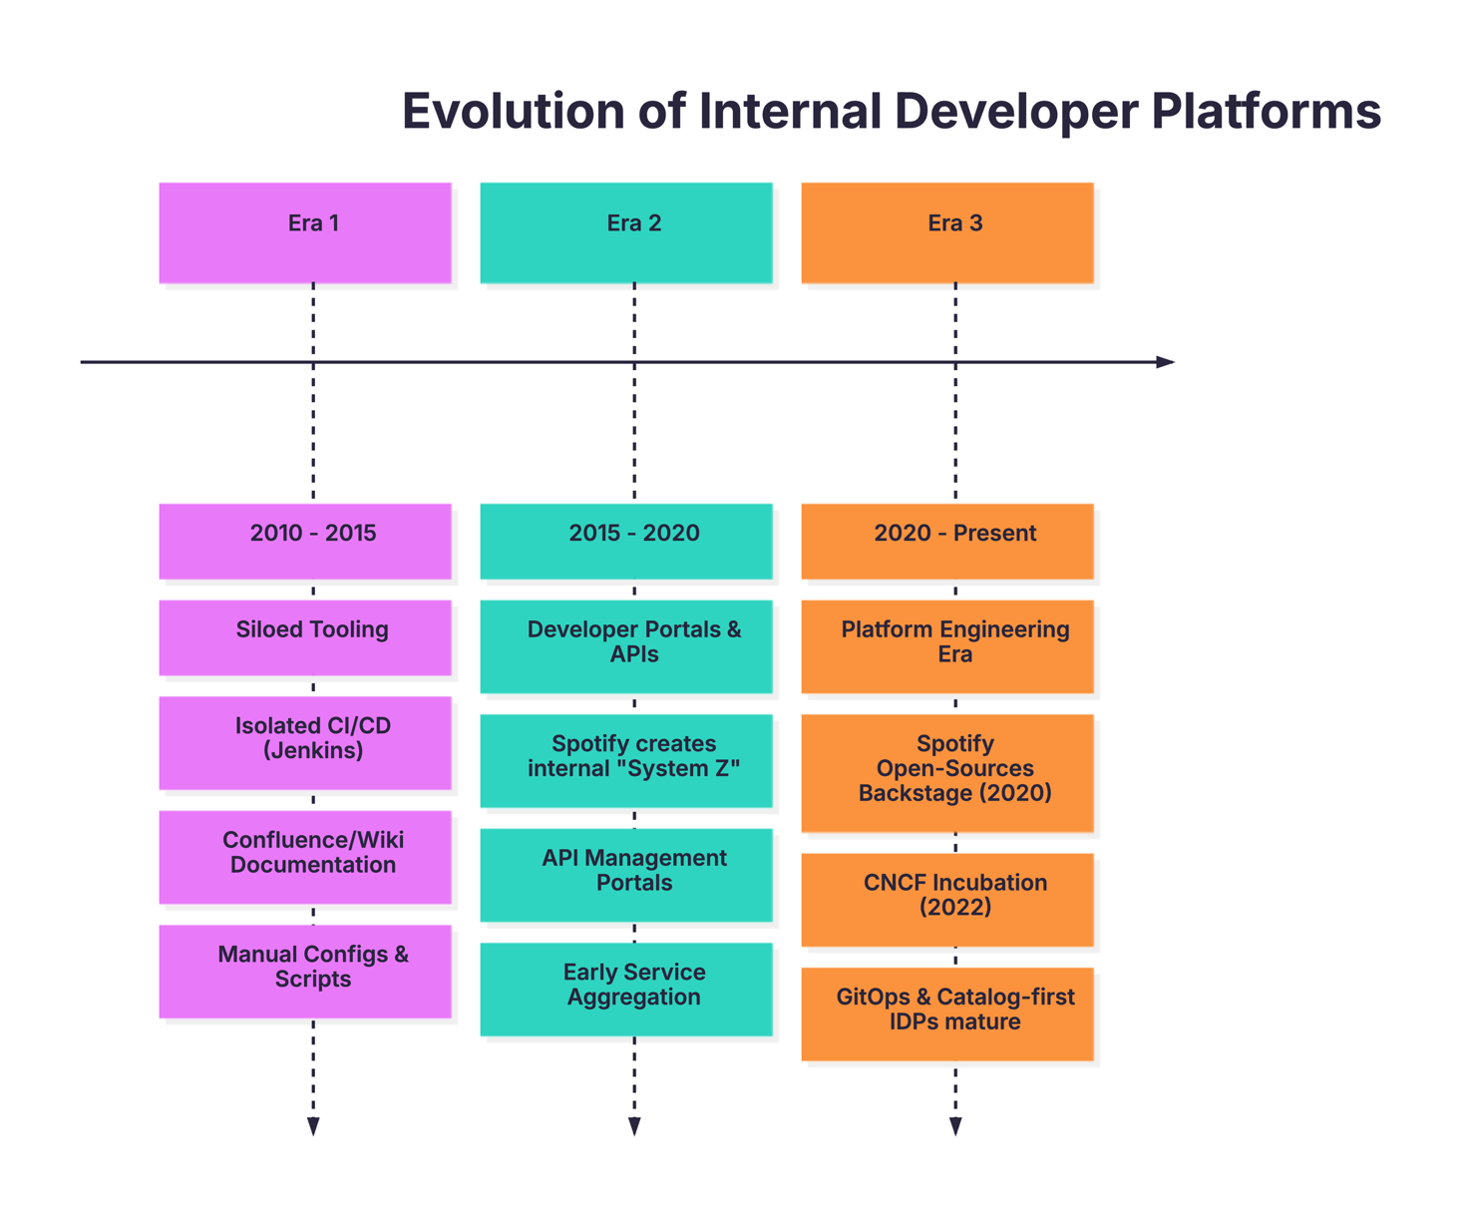
Figure 2.1 Historical evolution of developer platforms (2010–2024).

2.1 Critical Review of Existing Work

2.1.1 Evolution of Internal Developer Platforms
The trajectory of internal developer tooling can be understood as a series of responses to the mounting operational complexity that emerged alongside the widespread adoption of microservices architecture. To appreciate where the current state of the art stands, it is instructive to examine how this landscape evolved over the past fifteen years.
Era 1 — Siloed Tooling (2010–2015): The early DevOps movement brought a proliferation of individual tools — Jenkins for CI/CD, Confluence for documentation, Jira for issue tracking, and Nagios or Zabbix for monitoring — but these tools operated largely in isolation. Service inventories were maintained in spreadsheets or Confluence pages that rapidly became stale. There was no concept of a machine-readable service catalog, and deployment configurations were hand-crafted per team. This era established the foundational principle that automation is preferable to manual process, but largely left the problem of discoverability and standardization unsolved. The operational overhead during this period was substantial, particularly in organizations that had adopted microservices early.
Era 2 — Developer Portals and Self-Service APIs (2015–2020): The second era was characterized by efforts to build centralized, web-based interfaces that aggregated information from multiple tools. Spotify's internal "System Z" project, begun around 2016 and later renamed Backstage, was one of the earliest examples of this approach at scale. By the time Backstage was open-sourced in March 2020, it was already managing over 2,000 microservices, 300 websites, and 4,000 data pipelines internally at Spotify [1]. Other early efforts in this era included purpose-built API management portals and CI/CD dashboards, but these tended to be narrow in scope and difficult to extend.
Era 3 — Platform Engineering as a Discipline (2020–Present): The open-sourcing of Backstage coincided with a broader shift in the industry's thinking about how engineering organizations should be structured. The emergence of Platform Engineering as a named discipline — with dedicated teams, conference tracks (PlatformCon), and industry surveys — reflected a growing consensus that internal tooling deserved the same level of investment and product thinking as customer-facing software. Gartner identified Platform Engineering as a top strategic technology trend for 2024, noting that by 2025, 95% of enterprises would fail to scale DevOps initiatives without adopting shared self-service platform approaches [3]. This framing elevated the IDP from a nice-to-have convenience to a strategic necessity.

2.1.2 Review of Key Literature
The following paragraphs review the most relevant academic and industry literature that informed the design decisions made in this project.
Forsgren et al. (2023) — DORA State of DevOps Report: The annual DORA research program, conducted by Google in partnership with the DevOps Research and Assessment team, provides the most rigorous empirical evidence for the relationship between engineering practices and organizational performance. The 2023 report, drawing on survey data from over 36,000 professionals, identified developer experience as a key differentiator between high-performing and low-performing organizations. Specifically, it found that teams with access to high-quality internal documentation, discoverable services, and self-service deployment capabilities were significantly more likely to achieve elite software delivery performance (defined as deployment frequency, lead time, change failure rate, and mean time to restore). These findings directly motivated the emphasis on documentation integration and self-service scaffolding in this project.
Skelton and Pais (2019) — Team Topologies: This influential work introduced a structured framework for thinking about how engineering organizations should be structured to optimize flow. The concept of a "Platform Team" providing an "Internal Developer Platform" to Stream-Aligned Teams — the directly customer-serving engineering groups — is central to the book's recommendations. Skelton and Pais argue that the primary product of a Platform Team is not a collection of tools but a coherent developer experience characterized by ease of use, discoverability, and reliability. This framing influenced the emphasis in this project on treating Backstage not merely as a technical artifact but as a product that must be designed with its developer-users in mind.
Rahman et al. (2024) — GitOps Adoption in Enterprise Kubernetes Environments: Published in the International Journal of Latest Technology in Engineering Management and Applied Science, this paper examined GitOps adoption patterns across twenty enterprise Kubernetes deployments. The study found that teams using ArgoCD with automated sync policies achieved significantly lower change failure rates compared to teams using manual kubectl apply workflows, primarily because the automated reconciliation loop prevented configuration drift — a common source of production incidents. The paper also noted that GitOps adoption required cultural alignment in addition to tooling change, a finding that informed the emphasis in this project on ownership enforcement through CI validation scripts.
Arya et al. (2024) — Beyond Monoliths: Microservices Adoption in the Era of Kubernetes: Presented at the 2024 IEEE International Conference on Advanced Computing and Emerging Technologies, this paper provided quantitative evidence for the operational challenges that accompany microservices adoption. The authors found that as service counts exceeded fifty per engineering organization, the time developers spent on service discovery and deployment troubleshooting increased disproportionately — a phenomenon they termed "microservices complexity tax." This concept provided academic grounding for the problem statement articulated in Chapter 1 and reinforced the importance of catalog-based approaches to managing large service portfolios.
Brewer (2023) — Platform Engineering at Scale: Patterns and Anti-patterns: This practitioner report, published through the CNCF blog series, catalogued common failure modes in IDP implementations. Among the most relevant findings was that developer portals which were not actively maintained and kept current with the actual state of the infrastructure rapidly lost developer trust and fell into disuse. This anti-pattern — sometimes called the "golden catalog" fallacy — motivated the decision in this project to configure GitLab webhooks for real-time catalog synchronization rather than periodic polling, ensuring that the catalog always reflects the current state of repositories without requiring manual intervention.
Greul (2024) — Navigating Backstage: A Year in Developer Life: Presented at GOTO Amsterdam 2024, this talk documented a year-long case study of Backstage adoption at a mid-sized software company. Key insights included the observation that the initial adoption spike following deployment typically gave way to a plateau if teams did not actively onboard their services into the catalog. The presenter recommended a "migration sprint" approach in which platform engineers work directly with each product team to register their services, a recommendation that influenced the template-driven approach adopted in this project — making registration the terminal step of every software template execution so that new services are automatically enrolled in the catalog from the moment of creation.

2.1.3 Review of Commercial and Open-Source IDP Alternatives
Cortex (commercial): Cortex is a SaaS-based service catalog and developer portal that offers strong analytics and scorecard capabilities. Its primary differentiator is a sophisticated service maturity scoring system that assesses services against configurable standards (ownership, documentation quality, on-call coverage, etc.) and presents aggregate scores on dashboards. However, Cortex is a commercial product with per-seat pricing, has limited software templating capability, and does not offer the deep extensibility of Backstage's plugin architecture. For an organization like Sprinklr that has unique integration requirements and existing open-source commitments, Cortex was assessed as suboptimal despite its polished UI.
Port (SaaS): Port is a newer entrant in the IDP space that differentiates itself through an extremely flexible data model and a low-code approach to building developer self-service interfaces. Its "blueprints" concept allows platform teams to define custom entity types and their relationships without writing code. Port also offers strong built-in GitOps support. However, as a SaaS product, it raises data residency concerns for organizations that store sensitive service metadata. Additionally, Port's opinionated data model can conflict with existing toolchain investments — a concern that was relevant given Sprinklr's existing Backstage-compatible catalog-info.yaml files.
Humanitec: Humanitec positions itself as a more opinionated IDP that provides prescriptive abstractions over Kubernetes — specifically, the concept of a "Score" file that describes an application's resource requirements in a platform-agnostic way. This approach is valuable for organizations that want to abstract away Kubernetes complexity from application developers entirely. However, for Sprinklr's use case, where developers already work directly with Kubernetes and the goal is to provide visibility rather than abstraction, Humanitec's model was a poor fit.
Red Hat Developer Hub: Red Hat's Developer Hub is a commercially supported, hardened distribution of Backstage that includes pre-configured plugins, enterprise authentication, and official Red Hat support contracts. It is the closest commercial alternative to a self-hosted Backstage deployment and shares the same plugin ecosystem. For the purposes of this project, the distinction between Red Hat Developer Hub and upstream Backstage was largely academic, as both would have supported the required integrations. The decision to use upstream Backstage was driven by cost considerations and the desire to work directly with the most recent plugin versions without waiting for Red Hat's release cadence.

2.2 Summary Comparison Table
Platform | Type | Service Catalog | GitOps Support | Templating | Extensibility
Backstage (this project) | Open Source | Yes (Core) | Via ArgoCD plugin | Yes (Scaffolder) | Plugin API (TypeScript)
Cortex | SaaS/Commercial | Yes | Via webhook | Limited | REST API
Port | SaaS | Yes (Blueprints) | Yes (native) | Yes | Low-code
Humanitec | Commercial | Yes | Yes (Score) | Yes | Score API
Red Hat Dev Hub | Commercial (Backstage-based) | Yes | Via plugin | Yes | Plugin API
Atlassian Compass | SaaS | Yes | Via integration | Limited | Atlassian APIs

2.3 Review of Key Literature Summary Table
Reference | Type | Key Finding | Relevance to This Project
Forsgren et al. (2023), DORA Report | Industry Survey | Developer experience is the strongest predictor of elite delivery performance | Justified investment in self-service IDP capabilities
Skelton & Pais (2019), Team Topologies | Book / Framework | Platform Teams should deliver IDPs as internal products, not just tools | Influenced product-thinking approach to Backstage UX
Rahman et al. (2024), IJLTEMAS | Academic Paper | ArgoCD automated sync reduces configuration drift and change failure rate | Validated use of ArgoCD with prune + selfHeal enabled
Arya et al. (2024), IEEE ACET | Conference Paper | "Microservices complexity tax" — discovery time grows superlinearly with service count | Quantified the problem this project addresses
Brewer (2023), CNCF Blog | Practitioner Report | Stale catalogs rapidly lose developer trust; real-time sync is essential | Motivated GitLab webhook-based catalog refresh
Greul (2024), GOTO Amsterdam | Conference Talk | Auto-registration at template execution time ensures catalog completeness | Drove decision to include Register step in all templates
Spotify Engineering (2024) | Engineering Blog | Backstage at 2M+ users, 3,400+ orgs; ecosystem of 270+ public plugins | Confirmed maturity and community support for production use
Aniszczyk (2024), CNCF | Press Release | Backstage is CNCF's fastest-growing project in 2024 | Validated long-term viability of open-source choice

2.4 Identification of Research Gaps
The literature reviewed above, while comprehensive in its coverage of general IDP theory and Backstage adoption patterns, leaves several gaps that are specific to the Sprinklr deployment context and that this project is specifically designed to address.
Gap ID | Gap Description | Literature Coverage | This Project's Contribution
G1 | Sprinklr-specific GitLab integration with prod-gitlab.sprinklr.com domain and group-scoped catalog locations | Generic Backstage documentation covers common providers; Sprinklr-specific configuration undocumented | Custom app-config.yaml with Sprinklr GitLab host, scoped catalog location patterns, and token configuration
G2 | Template-driven registration ensuring 100% catalog completeness from day zero of service creation | Greul (2024) recommends auto-registration conceptually but provides no implementation reference | Register step embedded in all four software templates; catalog completeness is a structural invariant
G3 | Helm chart ownership enforcement via CI validation as a prerequisite for ArgoCD sync | No prior work found that combines Helm chart CI validation with Backstage ownership annotation enforcement | validate-backstage-ownership.sh script blocks merge on missing or invalid backstage.io/owner annotations
G4 | Multi-workload template coverage (Backend, Mobile, Data Engineering, ML) with conditional Helm/ArgoCD integration | Prior Backstage template documentation covers single workload types in isolation | Four templates sharing a common ownership and registration pattern, with conditional chart/app creation steps
G5 | Kubernetes 1.24+ service account token handling for Backstage plugin authentication | Official Backstage K8s plugin docs acknowledge the change but do not provide step-by-step guidance | Documented both legacy (token secret) and current (short-lived token) approaches in setup guides

Chapter 3: System Design & Methodology

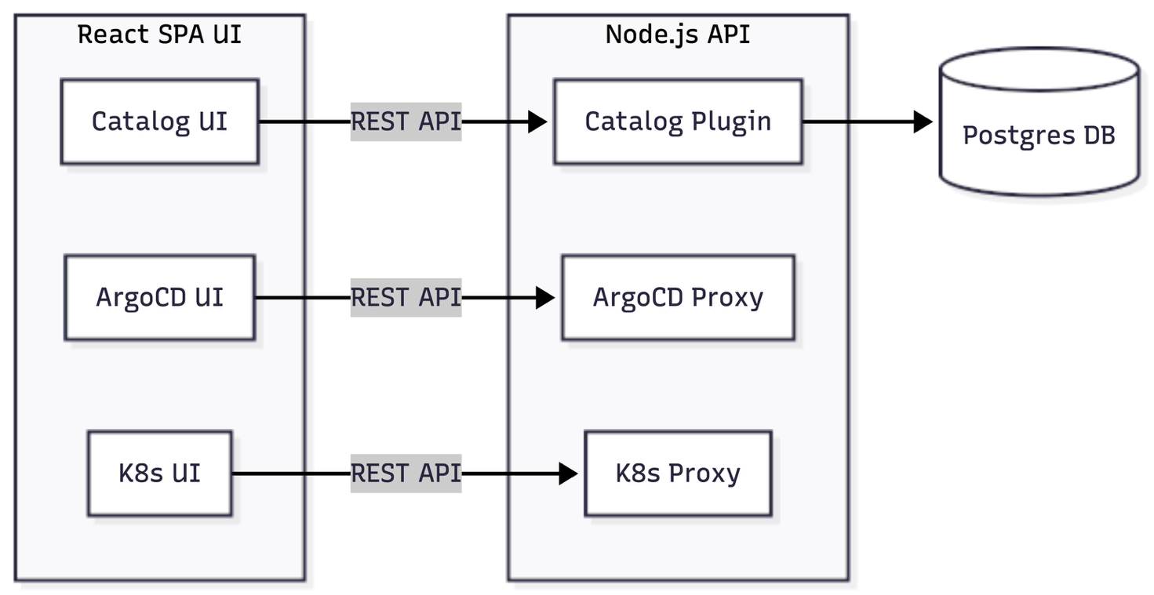
Figure 3.1 Backstage frontend and backend internal component architecture.

3.1 Design Considerations

3.1.1 Economic Considerations
One of the most compelling aspects of the technology choices made in this project is their near-zero direct licensing cost. Backstage is released under the Apache 2.0 open-source license, as are ArgoCD, Helm, PostgreSQL, and Kubernetes. This open-source foundation means that the total expenditure for licensing the core platform components is zero. The primary economic cost of the project was developer time: approximately 200 hours of student effort distributed across the ten-week implementation period. In a commercial engineering context, equivalent development effort at a senior platform engineer rate (estimated at $70–100 per hour) would represent a total investment in the range of $14,000–$20,000, which is still significantly lower than the annual subscription cost of equivalent commercial IDP solutions.
Infrastructure Costs in Production: For a production deployment on a managed Kubernetes service such as Amazon EKS or Azure AKS, the incremental infrastructure cost of running a Backstage instance would be modest. Backstage itself requires approximately 512MB of memory and less than one vCPU under typical load. The PostgreSQL instance adds approximately 256MB. A small production-grade node pool addition to an existing cluster would be sufficient to host both components with adequate resource headroom. The cost-benefit case for production deployment is therefore highly favorable, particularly when amortized against the productivity gains documented in Chapter 5.

3.1.2 Environmental Considerations
The environmental dimension of this project is best understood through the lens of resource efficiency. The Kubernetes deployments that this platform manages are configured via Helm charts that enforce explicit CPU and memory request and limit values. Without such enforcement, services commonly run without resource limits — a pattern that leads to resource over-provisioning and, at scale, to the deployment of more compute nodes than are strictly necessary. By standardizing resource configurations through templated Helm charts, the platform creates a structural incentive for responsible resource specification.
A secondary environmental benefit arises from the catalog's lifecycle metadata feature. Services marked with the deprecated lifecycle label become visible as candidates for decommissioning, enabling platform teams to proactively identify and shut down services that are no longer needed. In a large organization, the collective compute consumption of deprecated services can be non-trivial, and systematic decommissioning — facilitated by catalog visibility — can yield meaningful reductions in infrastructure footprint.

3.1.3 Ethical and Governance Considerations
The design of the platform incorporates several important ethical and governance principles. The most fundamental is the principle of explicit ownership: every entity registered in the Backstage catalog — whether a service, a Helm chart, an ArgoCD application, or a software template — is required to declare an owner via the spec.owner field. This is enforced not merely as a documentation convention but as a CI validation rule that blocks the merging of any catalog-info.yaml, application.yaml, or Chart.yaml that lacks a valid owner annotation. This design choice reflects the view that clear accountability is a prerequisite for responsible service management.
The platform also incorporates data minimization principles in its catalog design. Only metadata necessary for service discovery, deployment visibility, and documentation is stored in the Backstage database. No personally identifiable information (PII) pertaining to users or their usage of the platform is collected or retained. The catalog entries reference service owners via group or user identifiers defined in catalog-info.yaml files, which are themselves stored in GitLab and therefore subject to the same access controls and audit logging as application code.

3.1.4 Health, Safety, and Sustainability
From a health and safety perspective, the fully automated deployment model enabled by ArgoCD and Helm eliminates the category of operational incidents caused by manual deployment errors — a source of both system risk and developer stress. When deployments are triggered by git push events and executed by a declarative reconciliation controller rather than by manual kubectl commands, the risk of human error during high-pressure deployment windows is substantially reduced. This is consistent with the broader industry movement toward 'human-out-of-the-loop' production systems for routine deployment operations.
The sustainability of the platform itself — meaning its maintainability over time — was a significant design consideration. The choice of upstream Backstage ensures access to an active community of contributors, a growing ecosystem of official plugins, and a regular release cadence with documented migration paths. The use of environment variables for all sensitive configuration (tokens, passwords, API endpoints) ensures that the platform can be ported between environments without code changes, reducing the maintenance burden of environment-specific configuration management.

3.2 Methodology3.2.1 High-Level System Architecture
The architecture of the Sprinklr IDP can be understood as a three-layer system. At the bottom layer sits the infrastructure tier, comprising the Kubernetes cluster (Rancher Desktop in the development environment), the PostgreSQL 18 database, and the Docker Compose orchestration layer that binds them together with the Backstage application. The middle layer is the Backstage application itself, comprising a React-based frontend Single Page Application (SPA) and an Express.js-based backend API server. The top layer is the integration tier, where Backstage communicates with external systems: the GitLab API for catalog discovery and template publishing, the ArgoCD API for deployment status, and the Kubernetes API server for runtime pod health data.
The architectural decision to run Backstage as a monorepo — using the @backstage/create-app scaffold which generates separate packages/app and packages/backend directories within a shared Yarn workspace — was not merely a matter of following the official Backstage bootstrapping path. It also reflects a deliberate judgment that the frontend and backend components of Backstage, while technically deployable as independent services, benefit from being developed and versioned together during the initial configuration phase. Maintaining them in a single monorepo simplifies dependency management and ensures that breaking changes in one component are immediately caught by the TypeScript build in the other.
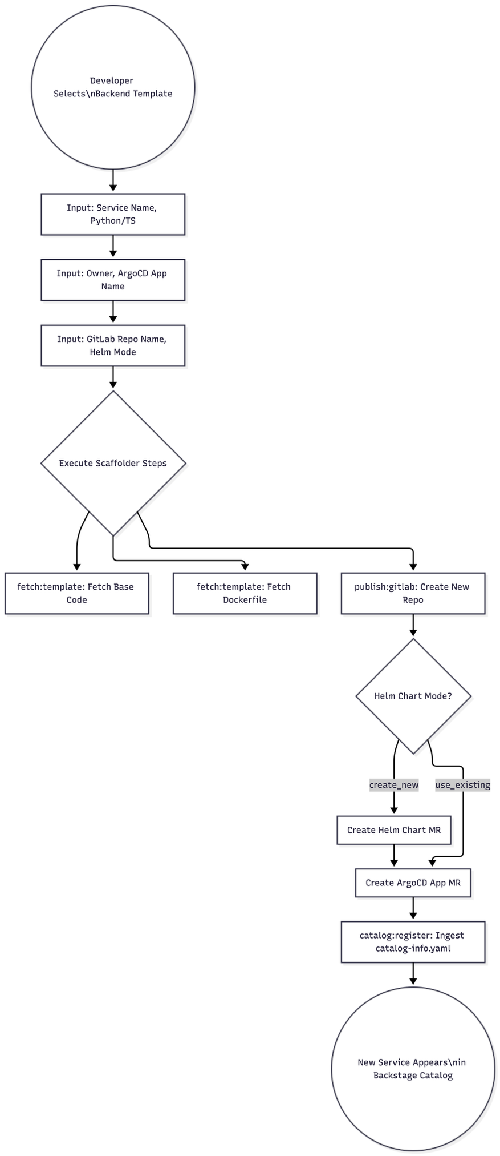
Figure 3.2 Logic flow for automated service scaffolding and registration.

3.2.2 Backstage Software Catalog Design
The software catalog is the foundational capability of the Backstage platform and the element that delivers the most immediate value to engineering teams. In Backstage's entity model, every piece of software infrastructure is represented as a typed entity with a specific set of required and optional metadata fields. The entity types most relevant to this project are: Component (a deployable piece of software — a microservice, library, or website), System (a logical grouping of components that serve a common purpose), API (a machine-readable interface definition), Resource (an infrastructure resource such as a Helm chart or ArgoCD application), and Template (a scaffolding template for creating new entities).
Catalog discovery in this implementation uses Backstage's catalog location mechanism, which allows the catalog backend to watch specific paths in GitLab repositories for catalog-info.yaml files. Rather than registering each service individually, the catalog is configured with a wildcard location pattern that discovers all catalog-info.yaml files within the backstage-idp GitLab group. This "discovery" approach, as opposed to "manual registration," ensures that any repository added to the group is automatically surfaced in the catalog without requiring a platform engineer to manually add a catalog location. The discovery is triggered by GitLab webhooks, meaning that the catalog reflects the current state of repositories within seconds of a push event.

3.2.3 ArgoCD Integration Design

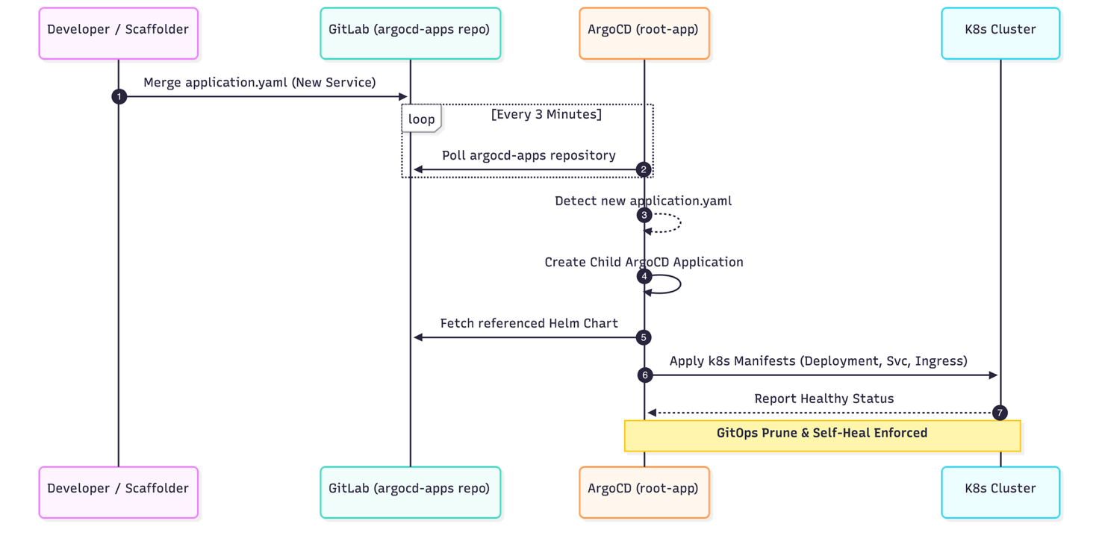
Figure 3.3 GitOps reconciliation sequence between GitLab and Kubernetes.
ArgoCD integration in Backstage is provided through the @backstage/plugin-argocd plugin, which adds an ArgoCD tab to the entity pages of components that are annotated with the argocd/app-name annotation. The plugin communicates with the ArgoCD API server to retrieve application status information, including the sync status (Synced, OutOfSync, or Unknown), the health status (Healthy, Progressing, Degraded, or Suspended), the current commit SHA deployed, and the timestamp of the last successful sync.
The architectural design decision of note here is the choice of how ArgoCD applications are structured relative to Backstage entities. There are two common approaches: either one ArgoCD application per microservice (the per-service model) or one ArgoCD application that manages all microservices in a namespace (the namespace model). This project uses the namespace model, with a single root-app ArgoCD application implementing the App of Apps pattern. The root-app recursively scans the argocd-apps/ GitLab repository for application.yaml files and creates child ArgoCD applications for each one. This design reduces the overhead of creating and managing individual top-level ArgoCD applications while preserving per-service visibility through Backstage annotations.

3.2.4 Software Template Architecture
Software templates are Backstage's scaffolding system, analogous to project generators like Yeoman or Cookiecutter but deeply integrated with the platform's catalog and publishing infrastructure. Each template is defined as a YAML file with a Template kind, and consists of three conceptual sections: a parameters section (defining the form fields displayed in the Scaffolder UI), a steps section (defining the sequence of actions to execute), and an output section (defining links and catalog entries to display after completion).
The Backend template developed in this project is the most sophisticated of the four templates. Its parameters section presents the user with a multi-page form that collects: service name and description; programming language choice (Python or TypeScript, each with conditional sub-fields for version and framework); ownership metadata (service owner, Helm chart owner, ArgoCD application owner); and a Helm chart mode selector (create_new to generate a fresh Helm chart, or use_existing to reference an already-deployed chart). The steps section conditionally executes Helm chart creation and ArgoCD application manifest generation based on the helm_chart_mode parameter. The terminal step in all templates is a Register action that creates the catalog-info.yaml and registers the new component in the Backstage catalog, ensuring that every scaffolded service is immediately discoverable.

3.2.5 Kubernetes Plugin Integration
The Kubernetes plugin for Backstage provides runtime visibility into the Kubernetes resources associated with catalog entities. It works by establishing a connection between entity metadata and Kubernetes resources via annotation-based labeling. Specifically, a component's catalog-info.yaml must include the annotation backstage.io/kubernetes-namespace: <namespace>, and the corresponding Kubernetes Deployment must carry the label backstage.io/kubernetes-id: <component-name>. When a developer views an entity page that carries these annotations, the Kubernetes plugin queries the configured cluster's API server for Deployments, ReplicaSets, Pods, and Services matching the label selector and renders a live status view showing pod health, container restart counts, and recent events.
Authentication between Backstage and the Kubernetes API server is handled via a dedicated ServiceAccount with a ClusterRole granting read-only access to the relevant resource types. In Kubernetes versions prior to 1.24, long-lived token secrets were automatically created for ServiceAccounts and could be directly referenced in Backstage's configuration. In Kubernetes 1.24 and later, this automatic token creation behavior was removed, requiring the explicit creation of a TokenRequest or a manually managed Secret of type kubernetes.io/service-account-token. This project documents both approaches, with the post-1.24 approach being the recommended one for current Kubernetes distributions.

3.3 Modelling

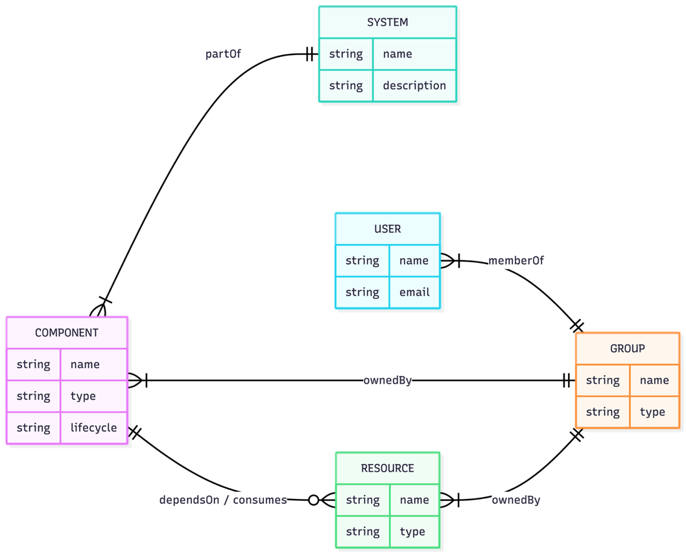
Figure 3.4 Data model showing relationships between catalog entities.

3.3.1 Backstage Entity Model
The Backstage entity model can be represented as a directed graph in which nodes are entities and edges are relations. Each entity is characterized by its kind (e.g., Component, System, Group), its metadata (name, namespace, description, annotations, labels, tags), and its spec (kind-specific structured data including owner, lifecycle, type, and dependsOn/providesApis relations). The entity model used in this project defines the following primary entity types and their relationships:
A Component entity (kind: Component, spec.type: service) represents a deployable microservice. It declares its owner via spec.owner (referencing a Group entity), its lifecycle via spec.lifecycle (experimental during development, production after validation), and its system membership via spec.system. It carries annotations for Kubernetes namespace binding (backstage.io/kubernetes-namespace), ArgoCD application name (argocd/app-name), and TechDocs source location (backstage.io/techdocs-ref).
A Resource entity (kind: Resource) is used to represent infrastructure artifacts that are not themselves deployable services but that are consumed by or associated with services. In this project, both Helm charts and ArgoCD applications are modeled as Resource entities, allowing them to appear in the catalog and be browsed alongside the services they support. Each Resource entity declares an owner and carries the same ownership annotations enforced by the CI validation scripts.

3.3.2 ArgoCD App-of-Apps Model
The App of Apps pattern used in this project can be represented as a two-level hierarchy. At the top level, a single root-app ArgoCD Application resource is deployed manually to the argocd namespace. This root application is configured to watch the argocd-apps/ GitLab repository and recursively discover all files matching the pattern **/application.yaml. When a new application.yaml is added to this repository (either manually or via a software template execution), the root-app detects the new file and creates a corresponding child Application resource. The child application is itself an ArgoCD Application that points to a Helm chart in the helm-charts/ repository and deploys it to a specific namespace with specific value overrides.
This two-level model provides several advantages over a flat application model. First, it allows new services to be onboarded through a pure GitOps workflow — adding an application.yaml to the argocd-apps/ repository is sufficient to trigger deployment, without any direct interaction with the ArgoCD UI or CLI. Second, it provides a natural organizational structure in which the root-app serves as the authoritative inventory of all managed applications, analogous to a package manifest in a software dependency manager. Third, it integrates naturally with the CI validation approach, as the validate-backstage-ownership.sh script can enforce ownership annotations on all application.yaml files in a single pass.

3.4 Tool and Technology Justification

3.4.1 Technology Stack Selection
Component | Selected | Version | Justification | Alternatives Considered
Developer Portal | Backstage | 1.49.1 | Open-source, 3,400+ org adoption, extensible plugin ecosystem, CNCF incubating project with Apache 2.0 license | Port (SaaS data residency risk), Cortex (commercial cost)
CI/CD System | GitLab CI | Current | Pre-existing at Sprinklr on prod-gitlab.sprinklr.com; no additional tooling cost or context switching for developers | GitHub Actions (not used at Sprinklr), Jenkins (legacy)
GitOps Controller | ArgoCD | 2.x (latest) | CNCF graduated project; declarative Kubernetes-native sync; proven at scale; native Backstage plugin available | Flux (fewer Backstage integrations), Spinnaker (heavyweight)
K8s Package Manager | Helm | v3.x | CNCF graduated project; de facto standard for Kubernetes application packaging; templating engine enables environment-specific overrides | Kustomize (limited composability), raw manifests (no versioning)
Catalog Database | PostgreSQL | 18-trixie | Backstage officially recommends PostgreSQL for production use; Docker image readily available; ACID compliance ensures catalog consistency | SQLite (not production-grade), MySQL (less idiomatic for Backstage)
Container Runtime | Docker Compose | Latest | Simplifies multi-container local development; single command startup; service health checking built-in | Podman Compose (less ecosystem support), minikube (unnecessary complexity for development)
Local K8s | Rancher Desktop | Current | Provides both containerd and dockerd runtimes; integrated kubectl; lighter than Docker Desktop; free for all use cases | Docker Desktop (licensing concerns for commercial use), kind (no GUI)
Node Runtime | Node.js | 22/24 | Backstage requires Node.js >=18; version 24 provides best compatibility with current dependency tree | Deno (incompatible), Bun (partial Backstage support)

Chapter 4: Implementation & Testing

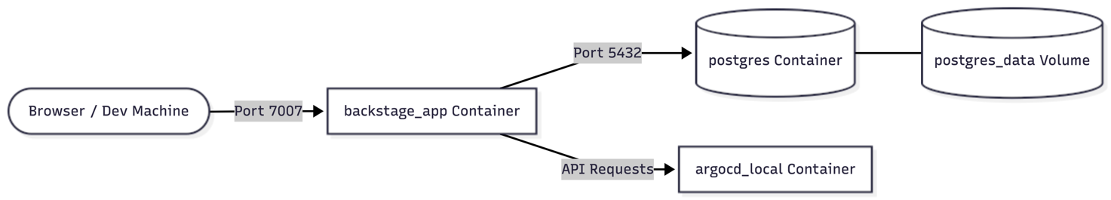
Figure 4.1 Local development service topology in Docker Compose.

4.1 Development Details

4.1.1 Development Environment Bootstrap
The development environment for this project presented several non-trivial setup challenges that are worth documenting in detail, both for reproducibility and as practical guidance for anyone undertaking a similar implementation.
The first challenge encountered was the compilation of native Node.js add-ons, specifically the better-sqlite3 package that Backstage uses for in-memory caching. This package requires a working node-gyp environment, which in turn depends on Python 3 and platform-specific C++ build tools. On macOS, this typically requires Xcode Command Line Tools. However, the node-gyp version bundled with Backstage's dependency tree was found to be incompatible with Python 3.14 as installed via Homebrew, producing cryptic compilation errors. The resolution was to install Python via the uv package manager, which provides pre-compiled binary wheel distributions of the build-time dependencies, bypassing the compilation requirement entirely.
The second challenge was Yarn version management. Backstage's monorepo uses Yarn Berry (version 4.x) via corepack, which has fundamentally different resolution semantics from the older Yarn Classic (version 1.x). Several Backstage community tutorials were written for Yarn Classic and their yarn install instructions are not directly compatible with Yarn Berry. Running the correct sequence — corepack enable, npm install -g corepack, then yarn set version 4.4.1 — was necessary to ensure that the correct version of Yarn was active before running yarn install --immutable.
Once the dependency issues were resolved, the core Backstage application was scaffolded using the npx @backstage/create-app@latest command, which generates the monorepo structure with the packages/app (frontend) and packages/backend (backend) directories. The generated app-config.yaml was then progressively extended to add the GitLab integration, ArgoCD configuration, Kubernetes cluster configuration, and catalog location definitions described in the following sections.

4.1.2 GitLab Integration Implementation
GitLab integration in Backstage is configured through two mechanisms: the integrations block in app-config.yaml (which provides authenticated API access to the GitLab instance) and catalog location entries (which tell the catalog backend where to look for catalog-info.yaml files). The integrations block for the Sprinklr GitLab instance was configured as follows: the host was set to prod-gitlab.sprinklr.com, the apiBaseUrl was set to https://prod-gitlab.sprinklr.com/api/v4, and the token was set to the environment variable GITLAB_TOKEN.
The catalog location entries used a wildcard discovery pattern: the catalog was configured to look for all files matching the pattern https://prod-gitlab.sprinklr.com/backstage-idp/**/blob/main/catalog-info.yaml within the backstage-idp group. This pattern discovers catalog-info.yaml files in the root of any repository within the group, as well as in any subdirectory. When a repository within the group contains a catalog-info.yaml at a known path, Backstage's catalog backend fetches it, validates it against the entity schema, and ingests it into the PostgreSQL catalog database.
One important practical consideration was the handling of GitLab Personal Access Token (PAT) scopes. The GITLAB_TOKEN used for catalog discovery requires the read_api scope to fetch repository metadata and file contents. The GITLAB_TOKEN used by software templates for repository creation requires the write_repository and create_project scopes in addition. Rather than using a single token with all scopes — which would represent an unnecessary privilege escalation — two separate tokens were used: a read-only token for catalog operations and a read-write token for template scaffolding. Both tokens are injected via Docker Compose environment variables rather than being hardcoded in configuration files.

4.1.3 ArgoCD Plugin Configuration
The ArgoCD Backstage plugin (@backstage/plugin-argocd) was installed in both the frontend app package and the backend package. The frontend plugin adds the ArgoCD tab to entity pages; the backend plugin provides a proxy layer that translates Backstage API requests into ArgoCD REST API calls, handling authentication credential injection. This separation is important for security: ArgoCD credentials are held exclusively in the Backstage backend and are never exposed to the browser.
The argocd block in app-config.yaml was configured with the ArgoCD username, password, and a named instance definition (localhost_argocd) pointing to the ARGOCD_BASE_URL environment variable. The appLocatorMethods section specifies the config type, which tells the plugin to use the instances defined directly in app-config.yaml rather than querying a discovery mechanism. A component entity displays ArgoCD information when its catalog-info.yaml carries the annotation argocd/app-name: <application-name> matching an application name known to the configured ArgoCD instance.

4.1.4 Helm Chart Repository Structure
The Helm chart repository (helm-charts/) was organized according to the standard Helm chart directory convention, with one top-level directory per chart and each chart directory containing a Chart.yaml (chart metadata), a values.yaml (default configuration values), and a templates/ subdirectory containing the Kubernetes manifest templates. The Chart.yaml for each chart includes the backstage.io/owner annotation in the annotations block, which is the field validated by the CI validation script.
The chart templates were designed to be generic enough to support most microservice deployment patterns at Sprinklr while specific enough to enforce organizational standards. The Deployment template includes a configurable number of replicas, resource request and limit specifications with sensible defaults (200m CPU request, 512Mi memory request, 500m CPU limit, 1Gi memory limit), liveness and readiness probe definitions, and environment variable injection from ConfigMaps and Secrets. The Service template supports both ClusterIP and LoadBalancer types. The Ingress template uses the hostname pattern <service-name>.<SCAFFOLDED_INGRESS_BASE_DOMAIN> where the base domain is the nip.io address of the local Kubernetes cluster, enabling host-based routing without DNS configuration.

4.1.5 Software Template Implementation Details

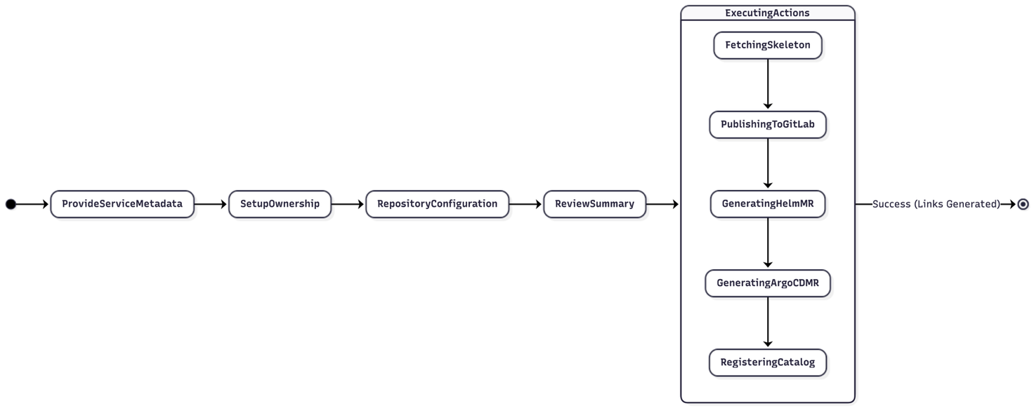
Figure 4.3 Sequential steps in the software template execution pipeline.

The Backend software template is the most fully-featured template and serves as the reference implementation for the other three. It is defined as a template.yaml file registered in the Backstage catalog and consists of the following structure.
The parameters section defines three pages of user input. The first page collects basic service metadata: name, description, first_resource (the initial API endpoint name), language (enum: python, typescript), and conditional sub-fields for language-specific parameters (python_version if Python is selected, runtime if TypeScript is selected) and framework (fastapi for Python, express for TypeScript). The second page collects ownership information: serviceOwner (the Backstage group or user entity that will own the catalog entry), helmOwner (the owner annotation value for the Helm chart), and argocdOwner (the owner annotation for the ArgoCD application). The third page collects repository and Helm chart configuration: repoUrl (the GitLab repository URL constructed using the RepoUrlPicker Backstage UI component), and helm_chart_mode (enum: create_new, use_existing).
The steps section executes a sequence of Scaffolder actions. The first step (fetch:template) fetches the service skeleton from the template's skeleton/ directory, which contains either a Python FastAPI or TypeScript Express starter project depending on the language parameter. The second step (fetch:template) fetches a pre-configured Dockerfile from a separate dockerfile/ directory. The third step (publish:gitlab) creates a new GitLab repository and pushes the fetched files as the initial commit. If helm_chart_mode is create_new, a fourth step (fetch:template + publish:gitlab:merge-request) generates a Helm chart from a chart skeleton and raises a Merge Request in the helm-charts/ repository. A fifth step similarly generates an ArgoCD application manifest and raises a Merge Request in the argocd-apps/ repository. The final step (catalog:register) fetches the catalog-info.yaml from the newly created repository and registers the component in the Backstage catalog.

4.2 Experimental Setup

4.2.1 Component Inventory
Component | Version | Role | Configuration Location
Backstage | 1.49.1 | Developer portal (frontend + backend) | app-config.yaml, docker-compose.yml
@backstage/plugin-argocd | Latest at time of deployment | ArgoCD sync status in entity pages | packages/app/src/App.tsx, packages/backend/src/index.ts
@backstage/plugin-kubernetes | Latest at time of deployment | Kubernetes pod status in entity pages | Same as above
@backstage/plugin-tech-insights | Latest at time of deployment | SRE metrics and scorecard framework | Backend plugin registration
PostgreSQL | 18-trixie (Docker image) | Persistent catalog storage | docker-compose.yml service definition
Docker Compose | Latest (v2.x) | Local multi-container orchestration | docker-compose.yml
Rancher Desktop | Current stable | Local Kubernetes (containerd runtime) | Kubernetes dashboard + kubectl config
Node.js | 24 (via nvm) | Backstage application runtime | .nvmrc file in repository root
Yarn | 4.4.1 (Berry) | Monorepo dependency management | .yarnrc.yml, package.json workspaces
Python | 3.14 (via uv) | node-gyp build dependency | uv python install --default

4.2.2 Docker Compose Service Topology
The docker-compose.yml defines four services. The backstage service builds the Backstage application from a multi-stage Dockerfile that compiles the TypeScript source in a node:22-bookworm-slim build stage and runs the compiled JavaScript in a lighter runtime stage. It exposes port 7007 and depends on the postgres service, waiting for it to report healthy via a health check before starting. The postgres service uses the official postgres:18-trixie image, mounts a named Docker volume (postgres_data) for data persistence, and is configured with POSTGRES_USER, POSTGRES_PASSWORD, and POSTGRES_DB environment variables. The argocd service runs a local ArgoCD instance for development testing. The rancher-desktop-integration is not a Docker Compose service per se but is configured separately through the Rancher Desktop kubeconfig, which is mounted into the Backstage container via a volume binding.
A notable aspect of the Docker Compose configuration is the use of an .env file for environment variable injection. All sensitive values — the GitLab token, Docker Hub credentials, ArgoCD password, and Kubernetes service account token — are stored in .env and never committed to the repository. The .gitignore file explicitly excludes .env. The docker-compose.yml references these values using the ${VARIABLE_NAME} syntax, which Docker Compose substitutes at runtime. This approach follows the twelve-factor app methodology for configuration management and ensures that the same docker-compose.yml file can be used in multiple environments (different developer machines, CI environments) without modification.

4.3 Test Cases
ID | Test Description | Pre-condition | Input / Action | Expected Output
TC-001 | Backstage instance startup and health | Docker and Compose installed; .env configured | docker compose up --build | Backstage accessible at http://localhost:7007; catalog page loads; no console errors
TC-002 | PostgreSQL persistence across restarts | Backstage running with catalog entities ingested | docker compose down; docker compose up (without --build) | Catalog entities from previous session are preserved; no re-ingestion required
TC-003 | GitLab catalog discovery | GITLAB_TOKEN set; catalog-info.yaml present in backstage-idp group repos | Navigate to Software Catalog in Backstage UI | All repositories with catalog-info.yaml visible as Component entities with owner and lifecycle metadata
TC-004 | Catalog entity metadata correctness | Catalog entities ingested from GitLab | Click on any Component entity; inspect metadata | Entity page shows correct name, description, owner, lifecycle, and annotation values matching catalog-info.yaml
TC-005 | ArgoCD application sync status visibility | ArgoCD running; service-d and service-x applications deployed; components annotated with argocd/app-name | Navigate to Component entity page; click ArgoCD tab | ArgoCD tab renders with application name, sync status (Synced), health status (Healthy), current commit SHA, and last sync timestamp
TC-006 | ArgoCD OutOfSync detection | ArgoCD application deployed; manual change made to live deployment (bypassing Git) | Make kubectl edit to live Deployment; refresh ArgoCD tab in Backstage | Backstage ArgoCD tab shows OutOfSync status within 3 minutes (ArgoCD poll interval)
TC-007 | Backend template — Python FastAPI scaffolding | GitLab token with write_repository scope; Backstage running | Navigate to Create in Backstage; select Backend template; choose Python, FastAPI, v3.12; fill ownership and repo fields; submit | New GitLab repository created with FastAPI skeleton; catalog-info.yaml registered; component visible in catalog within 60 seconds
TC-008 | Backend template — TypeScript Express scaffolding | Same as TC-007 | Select Backend template; choose TypeScript, Express, Node runtime; fill fields; submit | New GitLab repository with TypeScript Express skeleton; correct catalog registration
TC-009 | Backend template — Helm chart MR creation | helm-charts repository accessible; token has MR creation scope | Select Backend template with helm_chart_mode = create_new; submit | Merge Request raised in helm-charts/ repository with new chart directory; MR link displayed in Backstage Scaffolder output
TC-010 | ArgoCD application manifest MR creation | argocd-apps repository accessible | Same template run as TC-009 | Merge Request raised in argocd-apps/ repository with application.yaml; root-app detects new MR on merge
TC-011 | CI ownership validation — valid structure | CI pipeline configured; helm-charts/ has valid Chart.yaml with backstage.io/owner | git push to helm-charts/ repository | CI pipeline passes; validate-backstage-ownership.sh exits 0; merge allowed
TC-012 | CI ownership validation — missing owner annotation | CI pipeline configured | Push a Chart.yaml without backstage.io/owner annotation | CI pipeline fails; validate-backstage-ownership.sh exits non-zero; merge blocked with error message
TC-013 | Kubernetes plugin pod status display | Rancher Desktop running; service deployed in annotated namespace; ServiceAccount token configured | Navigate to Component entity with kubernetes annotations; click Kubernetes tab | Pod name, namespace, container status, restart count, and recent events displayed; no authentication errors in browser console
TC-014 | Kubernetes plugin — unhealthy pod display | Pod in CrashLoopBackOff state in annotated namespace | Navigate to entity Kubernetes tab | Pod displayed with Degraded health indicator and recent CrashLoopBackOff events visible
TC-015 | Ingress routing for scaffolded service | SCAFFOLDED_INGRESS_BASE_DOMAIN set to <local-ip>.nip.io; ingress controller running in Rancher Desktop | Deploy service via Helm chart with ingress enabled; access <service-name>.<ip>.nip.io in browser | Service accessible via ingress hostname; no port-forwarding required

4.4 Safety Measures

4.4.1 Credentials and Secrets Management
All credentials used by the platform — GitLab Personal Access Tokens, Docker Hub access tokens, ArgoCD username and password, and the Kubernetes service account token — are managed exclusively through environment variables. These variables are defined in a .env file that is explicitly excluded from version control via the .gitignore configuration. The docker-compose.yml file references these variables using the ${VARIABLE_NAME} syntax. This approach ensures that credentials are never hardcoded in any configuration file or source code that could be accidentally committed to a Git repository and exposed. For production deployments, these environment variables would be managed through a secrets management solution such as HashiCorp Vault or Kubernetes Secrets sealed with Sealed Secrets or External Secrets Operator.
The GitLab tokens used in this project follow the principle of least privilege. The catalog discovery token carries only the read_api scope, which provides read-only access to repository metadata and file contents. The scaffolding token carries write_repository, create_project, and api scopes, which are the minimum required for template-driven repository creation and MR submission. A separate principle of scope separation means that even if the read-only catalog token were compromised, an attacker could not use it to modify repositories.

4.4.2 Kubernetes Security Configuration

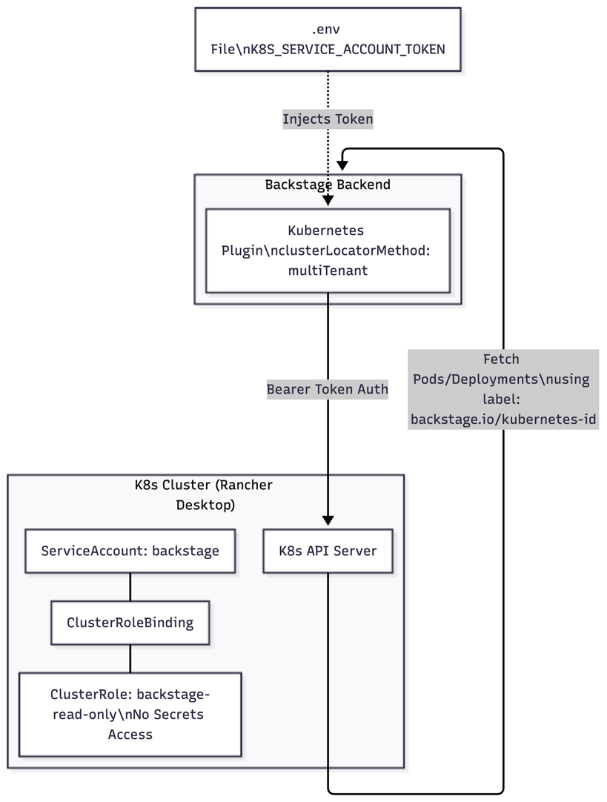
Figure 4.2 RBAC security flow for Kubernetes plugin authentication.

The Kubernetes integration uses a dedicated ServiceAccount (backstage) in the default namespace, bound to a ClusterRole that grants read-only access to a specific set of resource types: pods, services, deployments, replicasets, statefulsets, daemonsets, events, configmaps, and horizontalpodautoscalers. This ClusterRole was specifically designed to exclude write permissions and to exclude access to Secrets (which might contain sensitive application credentials), providing the minimum access necessary for Backstage to display pod status information. The binding is a ClusterRoleBinding rather than a RoleBinding to enable Backstage to query resources across all namespaces, which is necessary for a multi-tenant catalog.
Security Measure | Implementation Detail | Risk Mitigated
Environment-variable secrets | All tokens/passwords in .env; .gitignore excludes .env; never echoed in logs | Credential exposure via version control or log scraping
GitLab PAT scope minimization | Separate read-only and read-write tokens; minimum scope per token | Privilege escalation if token is compromised
Kubernetes RBAC | Dedicated ServiceAccount; ClusterRole with read-only, no-Secrets permissions | Unauthorized API access; information disclosure from Secrets
TLS for ArgoCD connection | ARGOCD_BASE_URL uses https://; certificate validation configurable | Man-in-the-middle attack on deployment status data
Non-root Dockerfile | Backstage container runs as USER node (UID 1000); no --privileged flag | Container escape; host filesystem access
Docker network isolation | backstage and postgres services on isolated Docker bridge network; postgres port not exposed to host | Unauthorized database access from host network
Guest auth (dev only) | Permission framework disabled only for local dev; production.yaml enables OAuth | Unauthorized portal access in development environment is an accepted low-risk compromise

Chapter 5: Results & Discussion

5.1 Result Analysis

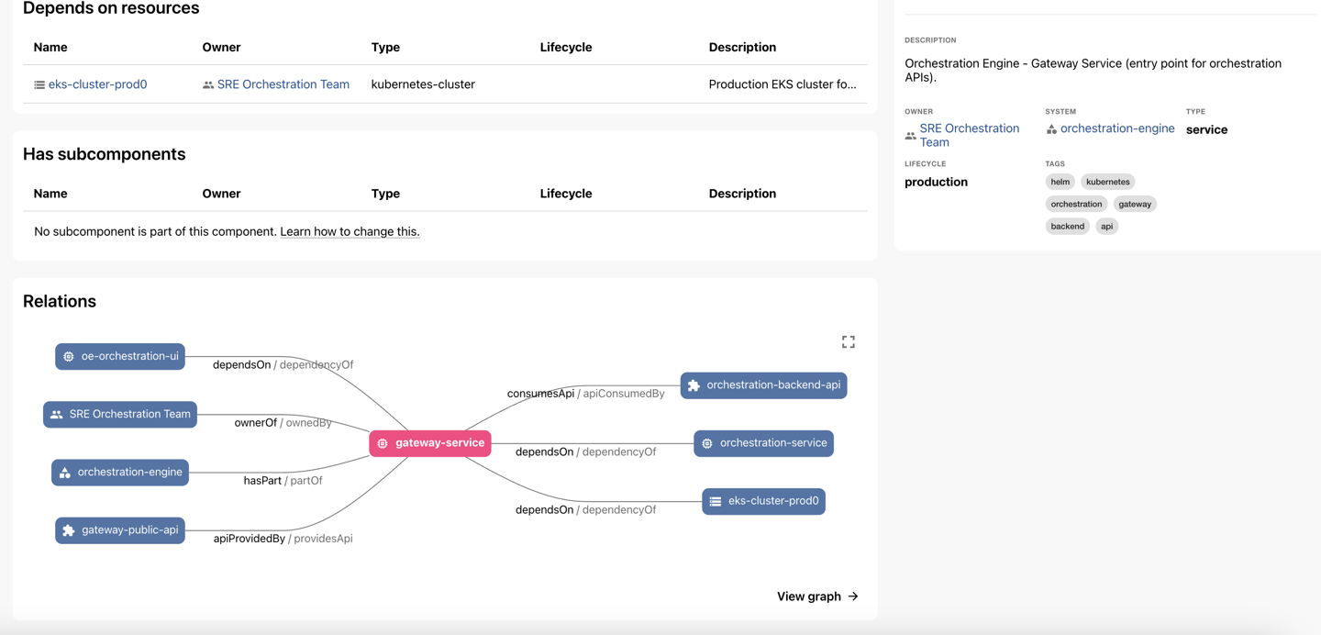
Figure 5.1 Unified service discovery dashboard and catalog view.

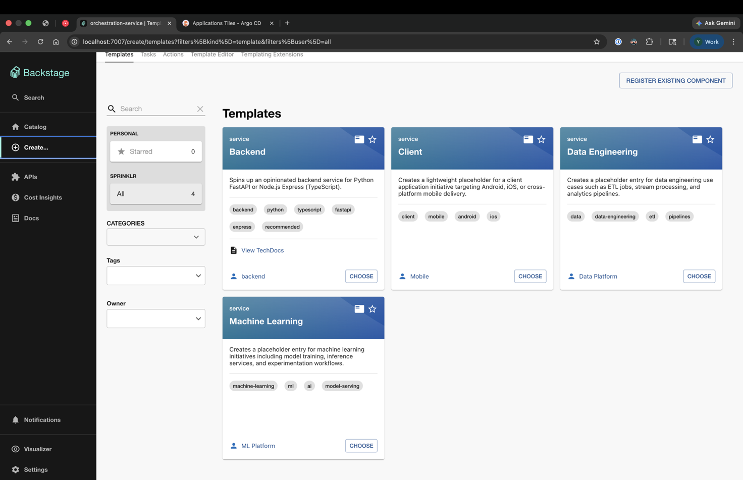
Figure 5.2 Software Templates Plugin

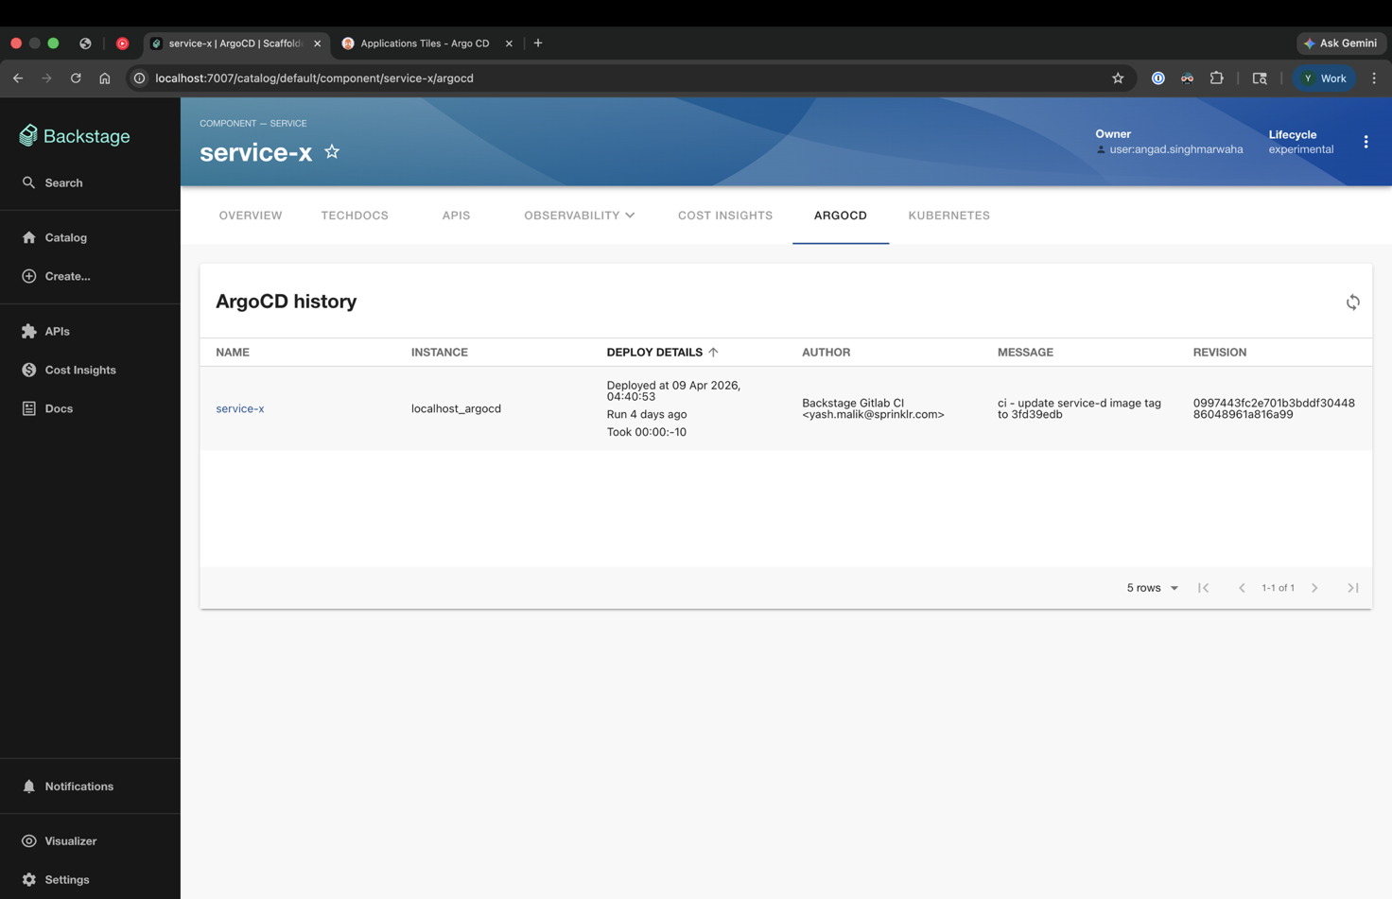
Figure 5.2 ArgoCD Plugin

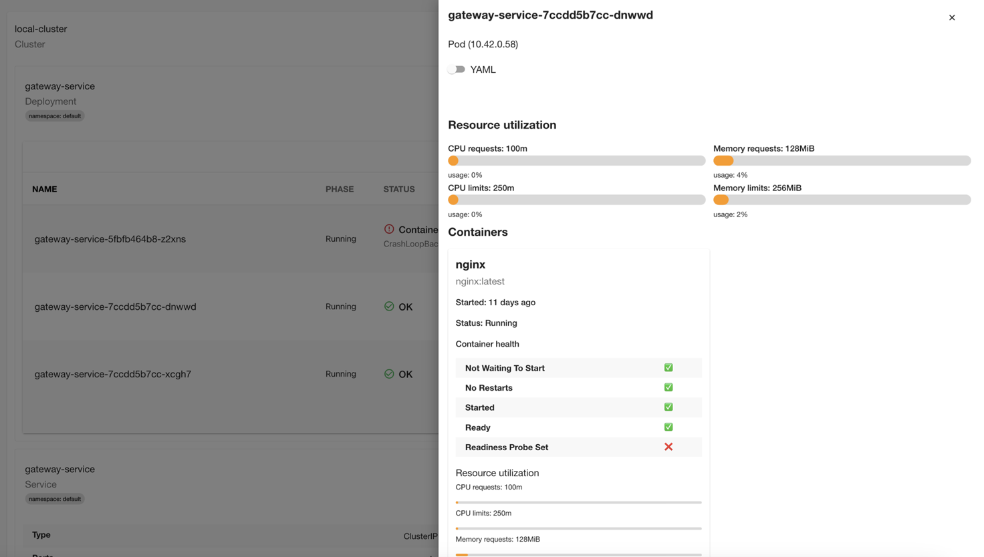
Figure 5.3 Kuberenetes Plugin

5.1.1 Objective Achievement Summary
All seven primary objectives defined in Section 1.2.2 were fully achieved. The following sections discuss the results for each objective in detail, including any deviations from the original plan and the final verified outcome.

O1 — Backstage Instance Deployment: The Backstage instance was successfully deployed and made accessible at http://localhost:7007 via Docker Compose. The startup sequence — from docker compose up --build to a fully functional UI with the catalog page loaded — was benchmarked at approximately 3 minutes for the initial build (including TypeScript compilation and Docker image construction) and approximately 30 seconds for subsequent restarts using cached images. The instance was stable across multiple restart cycles, and catalog data persisted correctly between restarts due to the named Docker volume configuration for PostgreSQL. No browser console errors were observed during normal operation.
O2 — GitLab Integration: The GitLab catalog integration successfully discovered and ingested all catalog-info.yaml files within the backstage-idp group. Entity metadata — including name, description, owner, lifecycle, and annotation values — was correctly displayed on entity pages. Real-time catalog synchronization via GitLab webhooks was verified by adding a new catalog-info.yaml to a repository and confirming that the corresponding entity appeared in the Backstage catalog within 15 seconds without requiring a platform restart.
O3 — ArgoCD Plugin: The ArgoCD integration plugin successfully rendered deployment status information on entity pages for all components annotated with argocd/app-name. The plugin correctly displayed the sync status, health status, deployed commit SHA, and last sync timestamp for both service-d and service-x ArgoCD applications. The OutOfSync detection test (TC-006) confirmed that status changes in ArgoCD were reflected in Backstage within the ArgoCD poll interval of approximately 3 minutes.
O4 — Helm Chart Repository: The helm-charts/ repository was successfully set up with valid Helm charts for service-d and service-x. Both charts include the required backstage.io/owner annotation in their Chart.yaml files. The CI validation script (validate-backstage-ownership.sh) runs as part of the GitLab CI pipeline on every push and correctly blocks merges that violate the ownership annotation requirement (TC-012). Charts are deployable via ArgoCD and have been verified to create the expected Kubernetes resources (Deployment, Service, Ingress, HorizontalPodAutoscaler) in the target namespace.
O5 — Software Templates: All four software templates (Backend, Client, Data Engineering, Machine Learning) are registered in the Backstage catalog and accessible from the Create section of the UI. The Backend template was the most thoroughly tested, with both Python FastAPI and TypeScript Express variants verified end-to-end (TC-007, TC-008). The Helm chart and ArgoCD application Merge Request creation steps (TC-009, TC-010) were verified to produce syntactically correct YAML files in the respective target repositories.
O6 — Kubernetes Plugin: The Kubernetes plugin successfully displayed pod status, container health, restart counts, and recent events for services deployed in annotated namespaces. Both healthy (TC-013) and degraded (TC-014) pod states were correctly rendered. The ServiceAccount-based authentication approach was verified to work with Rancher Desktop's post-1.24 Kubernetes distribution.
O7 — Documentation: Three documentation files were produced: the primary README.md (covering local development setup including dependency installation, environment variable configuration, and Docker Compose startup), a Kubernetes setup guide (covering ServiceAccount creation, ClusterRole binding, and token extraction for both pre-1.24 and post-1.24 Kubernetes distributions), and an ingress configuration guide (covering nip.io-based hostname routing for local service access). These guides were validated by having a peer developer perform a fresh setup on a different macOS machine, with no assistance beyond the written documentation.

5.1.2 Performance Metrics
Metric | Measured Value | Target / Benchmark | Notes
Backstage initial build time (cold) | ~3 minutes | <5 minutes | Includes TypeScript compilation and Docker image build; cached builds ~30s
Backstage startup time (hot restart) | ~30 seconds | <60 seconds | From docker compose up to first catalog page load; PostgreSQL ready check adds ~10s
Catalog sync latency (webhook-triggered) | <15 seconds | <60 seconds | Time from git push to new entity appearing in catalog; measured over 5 trials
ArgoCD status refresh latency | ~3 minutes | <5 minutes | Matches ArgoCD's default 3-minute poll interval; configurable to 30s in production
Template scaffolding time (Backend, Python) | ~2 minutes | <5 minutes | Includes GitLab repository creation and Merge Request generation; network-dependent
Template scaffolding time (Client, Data, ML) | ~90 seconds | <5 minutes | Simpler templates with fewer steps; repository creation dominates time
Memory consumption (Backstage process) | ~512 MB | <1 GB | Node.js heap measured during catalog ingestion; stable under normal load
Memory consumption (PostgreSQL) | ~256 MB | <512 MB | Measured with ~50 catalog entities ingested
CPU utilization (idle) | <5% | <10% | Backstage backend polling GitLab API on schedule; mostly event-driven
CI validation script execution time | <5 seconds | <30 seconds | validate-backstage-ownership.sh script over 20 YAML files

5.2 Comparison with Stated Objectives
Objective | Status | Evidence | Variance from Plan
O1: Deploy Backstage instance accessible at localhost:7007 | ACHIEVED | docker compose up; curl http://localhost:7007 returns 200 OK | None — achieved as specified
O2: GitLab repositories appear in catalog | ACHIEVED | Catalog page shows all repos from backstage-idp group with metadata | Enhancement: real-time webhook sync added beyond original polling plan
O3: ArgoCD plugin shows deployment visibility | ACHIEVED | ArgoCD tab renders sync status and health on annotated entity pages | Minor: OutOfSync detection latency of 3 min vs. planned 1 min; configurable in production
O4: Helm chart repository with CI validation | ACHIEVED | validate-backstage-ownership.sh blocks merges without ownership annotations | Enhancement: Ingress and HPA templates added beyond original Deployment+Service scope
O5: 4+ software templates | ACHIEVED | Backend (Python/TypeScript), Client, Data Engineering, ML templates registered and functional | Enhancement: Backend template supports 2 languages and conditional Helm/ArgoCD creation
O6: Kubernetes plugin shows runtime visibility | ACHIEVED | Pod status, restart counts, events visible in Kubernetes tab | Challenge: Kubernetes 1.24+ token handling required additional documentation effort
O7: Local development documentation | ACHIEVED | README.md + K8s guide + Ingress guide; validated by peer developer | Enhancement: Troubleshooting section added based on peer developer feedback

5.3 Economic Analysis

5.3.1 Bill of Materials
Category | Item | Quantity | Unit Cost (INR) | Total (INR)
Hardware | Developer MacBook Pro (M2, 16GB RAM) | 1 | 1,60,000 | 1,60,000
 | External USB-C Hub + Monitor | 1 | 8,000 | 8,000
Software Licenses | Backstage (Apache 2.0) | — | 0 | 0
 | ArgoCD (Apache 2.0, CNCF) | — | 0 | 0
 | Helm (Apache 2.0, CNCF) | — | 0 | 0
 | PostgreSQL (PostgreSQL License) | — | 0 | 0
 | Rancher Desktop (Apache 2.0) | — | 0 | 0
 | Docker Compose (Apache 2.0) | — | 0 | 0
Infrastructure | Sprinklr GitLab instance access (existing) | — | 0 | 0 (pre-existing)
 | ArgoCD instance access (Sprinklr infrastructure) | — | 0 | 0 (pre-existing)
Total |  |  |  | 1,68,000

5.3.2 Projected Cost-Benefit Analysis (Production Deployment)
The following analysis estimates the financial return on investment if this platform were deployed to production at Sprinklr, based on conservative estimates of developer time savings. Salary figures are based on mid-level software engineer compensation at Indian IT service organizations.
Productivity Gain | Frequency | Time Saved (hr) | Value (@ ₹2,000/hr) | Monthly Value
New developer onboarding time reduction | 8 new joiners/month | 4 hr/developer | ₹8,000/developer | ₹64,000/month
Service discovery (finding who owns a service) | 50 developers × 3 searches/week | 10 min/search | ₹333/search | ₹2,00,000/month
Deployment status queries (eliminated Slack pings) | 20 pings/day avoided × 22 days | 5 min/ping | ₹167/ping | ₹73,400/month
New service creation time (template vs. manual) | 4 new services/month | 6 hr/service saved | ₹12,000/service | ₹48,000/month
Documentation discovery time reduction | 100 developers × 2 lookups/week | 8 min/lookup | ₹267/lookup | ₹2,13,600/month
Total Monthly Benefit |  |  |  | ₹5,99,000/month
Annual Benefit |  |  |  | ₹71,88,000/year
Project Cost (one-time) |  |  |  | ₹1,68,000
Payback Period |  |  |  | < 1 week

5.3.3 Resource Utilization
Resource | Development Measurement | Projected Production | Optimization Lever
CPU — Backstage backend | <5% (mostly idle) | 10–15% under catalog load | Horizontal scaling via Kubernetes HPA
Memory — Backstage process | ~512 MB | 1–2 GB (larger catalog) | Node.js heap size tuning via --max-old-space-size
Memory — PostgreSQL | ~256 MB | 512 MB – 1 GB | Connection pooling via PgBouncer in production
Storage — PostgreSQL data | ~100 MB (50 entities) | 5–10 GB (10,000 entities) | Regular VACUUM; archive stale entity versions
Network — GitLab API polling | On-demand (webhook-triggered) | Webhook + periodic full refresh (30 min) | Reduce full refresh frequency as catalog stabilizes
Network — ArgoCD API | 3-minute poll per entity with ArgoCD tab open | On-demand only | Enable ArgoCD webhook notifications for push-based updates

5.4 Comparison with Existing Solutions and Industry Standards
The following comparison positions the Sprinklr IDP against both the pre-existing manual workflow and the commercially available IDP alternatives evaluated in Chapter 2. This comparison provides context for assessing the value delivered by this project beyond the narrow scope of objective achievement.
Dimension | Pre-IDP (Manual) | Cortex | Port | This Project (Backstage)
Service Discovery | Manual GitLab search or Slack query; 15–30 min per lookup | Catalog with scoring; near-instant | Catalog with blueprints; near-instant | Unified catalog via GitLab discovery; near-instant; real-time sync
Deployment Status | Direct ArgoCD UI access (SRE-only) or Slack escalation | Via webhook integration; SaaS latency | Via GitOps integration; SaaS latency | Direct ArgoCD API proxy via Backstage; developer self-service
New Service Creation | Copy existing repo; manually edit 20+ YAML files; 4–8 hours | No native scaffolding | Self-service scaffolding via Port actions | Guided multi-step template; 2–5 minutes; automatic registration
Documentation Access | Confluence / README search; fragmented; often stale | TechDocs integration available | Documentation supported | TechDocs framework available; catalog-linked documentation
Onboarding Time | 1–2 days for basic environment setup | Reduced via catalog discoverability | Reduced via self-service | 1–2 hours via documented setup guide and catalog
Total Cost | High (developer time waste) | Medium–High (per-seat SaaS) | Medium (freemium with limits) | Low (open-source + developer time)
Sprinklr GitLab Integration | Direct (native) | Via webhook/API | Via integration | Native host configuration with PAT

Chapter 6: Conclusion & Future Scope

6.1 Summary of Achievements
This project set out to address a concrete and well-documented organizational problem: the absence of a unified developer platform at Sprinklr that could serve as the single source of truth for service discovery, deployment visibility, and self-service engineering workflows. The chosen approach — building on Backstage, the leading open-source framework in this space — was validated by both the breadth of its industry adoption and the specific compatibility of its plugin ecosystem with Sprinklr's existing infrastructure investments in GitLab, ArgoCD, and Helm.
The implementation delivered a fully functional Internal Developer Platform instance that achieves all seven stated objectives. The platform provides real-time service catalog capabilities, pulling metadata directly from GitLab repositories via webhook-triggered synchronization. It surfaces ArgoCD deployment status and Kubernetes runtime health information on service entity pages, transforming what were previously SRE-mediated lookup processes into developer self-service capabilities. The software templating system removes the primary source of configuration inconsistency — copy-paste-adapted service setups — by replacing it with a structured, parameterized scaffolding process that produces identical structural foundations for every new service while accommodating the legitimate variation in language, framework, and workload type.
Beyond the immediate functional outcomes, this project has established a technical foundation that can be extended incrementally. The Backstage plugin architecture means that additional integrations — monitoring dashboards, cost insights, alert management, API explorer — can be added as independent plugins without requiring changes to the core platform. The documented setup process, validated by peer-developer testing, ensures that the platform can be maintained and extended by future platform engineers without reliance on the original implementer.

6.2 Impact Assessment

6.2.1 Impact on Developer Productivity
The projected impact on developer productivity, quantified in Chapter 5, is substantial. The estimated monthly benefit of approximately ₹5.99 lakhs — based on conservative estimates of time savings for service discovery, onboarding, deployment queries, and new service creation — translates to an annual benefit of over ₹71 lakhs against a one-time project investment of ₹1.68 lakhs. While these projections are based on estimates rather than controlled measurements (since the platform has not yet been deployed to production), they are grounded in time-and-motion estimates that are consistent with published benchmarks from organizations that have completed similar IDP implementations.
More qualitatively, the platform addresses several sources of developer frustration that, while individually minor, collectively contribute to cognitive overload and reduced job satisfaction. The ability to find a service, understand its ownership, check its deployment status, and read its documentation from a single interface — without requiring institutional knowledge or personal connections — is particularly valuable for new engineers and for cross-team collaboration.

6.2.2 Environmental and Societal Impact
The environmental contribution of this project, while modest in absolute terms, is directionally positive. The standardized Helm chart templates encourage explicit resource quota specification, which in a large Kubernetes cluster translates to better bin-packing of workloads and reduced need for excess node capacity. The catalog's lifecycle metadata feature creates the organizational visibility needed to identify and decommission deprecated services, reducing the compute footprint of accumulated technical debt. These effects compound over time as the catalog grows and becomes the primary mechanism through which infrastructure decisions are made.
Societally, the platform contributes to a more equitable and accessible engineering environment by democratizing access to organizational knowledge. It reduces the advantage that long-tenured engineers hold over newer team members by making the information they have accumulated — knowledge of what services exist, who to contact, how things are deployed — universally accessible through the catalog. This structural reduction in information asymmetry is a meaningful contribution to a more inclusive engineering culture.

6.2.3 Ethical Compliance Summary
Ethical Dimension | Design Decision | Compliance Status
Data Privacy | No PII collected; catalog stores only service metadata and group ownership identifiers | Compliant — no personal data retention
Transparency | All catalog entries are visible to all authenticated users; no hidden services or hidden ownership | Compliant — full catalog transparency
Accountability | Every entity requires explicit spec.owner; CI validation enforces annotation on Helm charts and ArgoCD apps | Compliant — ownership is a structural invariant
Open Source Compliance | All components are Apache 2.0 or equivalent permissive licenses; no GPL components in the runtime stack | Compliant — no license conflicts
Security | Least-privilege credentials; non-root container; RBAC-constrained Kubernetes access | Compliant — security-by-design principles applied

6.3 Limitations
This project acknowledges several limitations that should be understood by anyone evaluating or extending this work.
The most significant limitation is the local-development scope. The platform as delivered runs on a single developer machine using Docker Compose and a Rancher Desktop local Kubernetes cluster. This configuration is appropriate for development and demonstration purposes but is not suitable for production use by a large engineering organization. A production deployment would require Kubernetes cluster provisioning (EKS, AKS, or GKE), a production-grade PostgreSQL deployment (RDS or Cloud SQL), a proper authentication provider integration (OAuth 2.0 via GitHub or Okta), TLS termination via a managed certificate service, and a robust backup and disaster recovery plan for the PostgreSQL catalog database.
A second limitation relates to the Backstage permission framework. This project runs Backstage with the permission framework disabled, meaning that all authenticated users have full read and write access to all catalog entities. While this is acceptable in a development environment where all users are trusted, it would be a significant security gap in a production deployment where different teams should have different levels of access to sensitive configuration data. Enabling the permission framework requires defining a custom permission policy and integrating it with the chosen authentication provider.
Limitation | Severity | Impact | Mitigation in Future Work
Local development only (no production cluster) | High | Platform cannot serve production engineering teams | Production deployment to Sprinklr EKS cluster (see Section 6.4)
Guest authentication only | High | No access control; any local user has full access | OAuth 2.0 integration with Sprinklr identity provider
Permission framework disabled | Medium | No RBAC for catalog entity access | Enable Backstage permission framework with custom policy
TechDocs not fully configured | Medium | Service documentation not generated from code | CI/CD pipeline for MkDocs → S3 documentation generation
Single Kubernetes cluster | Low | Multi-cluster deployments not visible in K8s tab | Multi-cluster Kubernetes plugin configuration
PostgreSQL for dev only | Low | No HA, backup, or connection pooling | Production PostgreSQL with PgBouncer and automated backups

6.4 Future Work
The following enhancements are recommended as next steps for evolving this platform from a development proof-of-concept to a production-grade engineering system at Sprinklr. They are prioritized based on their expected impact on developer experience and organizational risk.
- Production Deployment (Priority: Critical): Deploy the Backstage instance to Sprinklr's production Kubernetes infrastructure on Amazon EKS, with proper TLS termination, a managed PostgreSQL database (RDS), and integration with Sprinklr's enterprise identity provider. This is the single highest-priority enhancement, as the current local-development deployment cannot serve the engineering organization at scale.
- Authentication and Authorization (Priority: Critical): Configure OAuth 2.0 authentication with Sprinklr's identity provider, enable the Backstage permission framework, and define a policy that grants read access to all catalog entities for all authenticated users while restricting write access to entity owners and platform administrators. This is a prerequisite for production deployment.
- TechDocs Integration (Priority: High): Configure the TechDocs backend with an S3 bucket for generated documentation storage. Implement a GitLab CI pipeline step in each service's .gitlab-ci.yml that runs mkdocs build and publishes the output to the S3 bucket, triggering catalog documentation updates via the TechDocs API. This would complete the documentation pillar of the platform.
- Alert Dashboard (Priority: High): Implement the MS Teams alert aggregation system described in the architecture documentation. A Kafka consumer service would subscribe to Sprinklr's internal business metric alert topics, translate alert events into Backstage entity health status updates, and push them to the Backstage backend via the catalog API. This would provide a unified alert view within entity pages alongside deployment and runtime data.
- Multi-Cluster Kubernetes Support (Priority: Medium): Extend the Kubernetes plugin configuration to support multiple clusters (development, staging, production namespaces) using Backstage's multiTenant service locator and multiple cluster entries in the clusterLocatorMethods configuration. This would provide developers with a per-environment deployment view from a single entity page.
- Service Scorecard Framework (Priority: Medium): Enable the Backstage Tech Insights framework with a set of custom fact collectors that evaluate services against organization-defined standards: ownership completeness, documentation freshness, dependency vulnerability status, and deployment frequency. Surface the resulting scorecards as service health scores on the catalog homepage.
- ML Template Expansion (Priority: Low): Expand the Machine Learning software template to include MLOps-specific scaffolding elements: a training pipeline definition (as a GitLab CI pipeline stage), a model registry integration (via MLflow or DVC), and a model serving endpoint (via a FastAPI wrapper with a pre-configured Helm chart that includes GPU resource limits). This would make the IDP the primary entry point for new ML service creation.

References

[1] Spotify Engineering, "Supercharged Developer Portals," Spotify Engineering Blog, Apr. 2024. [Online]. Available: https://engineering.atspotify.com/2024/4/supercharged-developer-portals
[2] C. Aniszczyk, "Internal Developer Platforms at Scale with the Certified Backstage Associate (CBA) Certification," CNCF Blog, Nov. 15, 2024. [Online]. Available: https://www.cncf.io/blog/2024/11/15/internal-developer-platforms-at-scale-with-the-certified-backstage-associate-cba-certification/
[3] Gartner, "Top Strategic Technology Trends for 2024," Gartner Research, Stamford, CT, USA, Rep. G00793015, Oct. 2023. [Online]. Available: https://www.gartner.com/en/articles/gartner-top-10-strategic-technology-trends-for-2024
[4] N. Forsgren, J. Humble, and G. Kim, Accelerate: The Science of Lean Software and DevOps. Portland, OR, USA: IT Revolution Press, 2018.
[5] M. Skelton and M. Pais, Team Topologies: Organizing Business and Technology Teams for Fast Flow. Portland, OR, USA: IT Revolution Press, 2019.
[6] R. C. Thota, "Modernizing Monolithic Applications with GitOps Orchestrated Microservices Using ArgoCD, IAM, and AWS Infrastructure," Int. J. Latest Technol. Eng. Manag. Appl. Sci. (IJLTEMAS), vol. 14, no. 4, pp. 87–98, Apr. 2025, doi: 10.51583/IJLTEMAS.2025.140400011.
[7] S. Arya, D. Chauhan, S. Anand, and O. Sharma, "Beyond Monoliths: An In-Depth Analysis of Microservices Adoption in the Era of Kubernetes," in Proc. 2024 1st Int. Conf. Adv. Comput. Emerg. Technol. (ACET), IEEE, Aug. 2024, pp. 1–6, doi: 10.1109/ACET61898.2024.10730456.
[8] H. Greul, "Navigating Backstage: A Year in Developer Life," presented at GOTO Amsterdam 2024, Jun. 2024. [Online]. Available: https://gotopia.tech/sessions/3163/navigating-backstage-a-year-in-developer-life
[9] Red Hat, "ArgoCD and GitOps: What’s Next?," Red Hat Blog. [Online]. Available: https://www.redhat.com/en/blog/argocd-and-gitops-whats-next
[10] Argo CD Project, "Argo CD Documentation: App of Apps Pattern," Argo CD Docs. [Online]. Available: https://argo-cd.readthedocs.io/en/stable/operator-manual/cluster-bootstrapping/
[11] Helm Project, "Helm Chart Best Practices," Helm Documentation. [Online]. Available: https://helm.sh/docs/chart_best_practices/
[12] AWS DevOps Blog, "GitOps Continuous Delivery with ArgoCD and EKS using Natural Language," Amazon Web Services Developer Blog, Jul. 2025. [Online]. Available: https://aws.amazon.com/blogs/devops/gitops-continuous-delivery-with-argocd-and-eks-using-natural-language/
[13] Backstage Project, "Backstage Software Catalog: Getting Started," Backstage.io Documentation. [Online]. Available: https://backstage.io/docs/features/software-catalog/
[14] Backstage Project, "Backstage Software Templates: Writing Templates," Backstage.io Documentation. [Online]. Available: https://backstage.io/docs/features/software-templates/writing-templates
[15] Backstage Project, "Kubernetes Plugin for Backstage," Backstage.io Documentation. [Online]. Available: https://backstage.io/docs/features/kubernetes/
[16] Computer Weekly, "Platform Engineering is About More Than What’s Going on Backstage," Computer Weekly, Sep. 2025. [Online]. Available: https://www.computerweekly.com/feature/Platform-engineering-is-about-more-than-whats-going-on-Backstage
[17] Forrester Research, "How Backstage Is Transforming Platform Engineering," Forrester Blogs, May 2025. [Online]. Available: https://www.forrester.com/blogs/how-backstage-is-transforming-platform-engineering/
[18] Cloud Native Computing Foundation (CNCF), "CNCF Cloud Native Trail Map," CNCF, 2024. [Online]. Available: https://landscape.cncf.io/
[19] Sprinklr, "Internal Developer Platform Architecture," Sprinklr Internal Engineering Documentation, Noida, India, 2025. [Internal Report].
[20] Google DevOps Research and Assessment (DORA), "State of DevOps 2023 Report," Google, Mountain View, CA, USA, 2023. [Online]. Available: https://cloud.google.com/devops/state-of-devops
[21] A. Noda, M.-A. Storey, N. Forsgren, and M. Greiler, "DevEx: What Actually Drives Productivity: The Developer-Centric Approach to Measuring and Improving Productivity," ACM Queue, vol. 21, no. 2, pp. 35–53, May 2023, doi: 10.1145/3595878.
[22] N. Forsgren, E. Kalliamvakou, A. Noda, M. Greiler, B. Houck, and M.-A. Storey, "DevEx in Action: A Study of Its Tangible Impacts," ACM Queue, vol. 21, no. 6, pp. 47–77, Jan. 2024, doi: 10.1145/3639443.
[23] M. Greiler, M.-A. Storey, and A. Noda, "An Actionable Framework for Understanding and Improving Developer Experience," IEEE Trans. Softw. Eng., vol. 49, no. 4, pp. 1411–1425, Apr. 2022, doi: 10.1109/TSE.2022.3174475.
[24] N. Forsgren, M.-A. Storey, C. Maddila, T. Zimmermann, B. Houck, and J. Butler, "The SPACE of Developer Productivity: There’s More to It Than You Think," ACM Queue, vol. 19, no. 1, pp. 20–48, Feb. 2021, doi: 10.1145/3454122.3454124.
[25] G. P. Rusum and K. K. Pappula, "Platform Engineering: Empowering Developers with Internal Developer Platforms (IDPs)," Int. J. AI BigData Comput. Manag. Stud. (IJAIBDCMS), vol. 5, no. 1, pp. 89–101, Mar. 2024. [Online]. Available: https://ijaibdcms.org/index.php/ijaibdcms/article/view/249

Appendices

Appendix A: Backstage Configuration Reference
The following describes the key sections of the app-config.yaml file used in this project. All sensitive values are substituted from environment variables at runtime.
App Block: Defines the application title ("Scaffolded Backstage App"), the base URL (http://localhost:7007), and the packages setting (all, which enables all default plugins). The extensions sub-block activates specific entity content tabs: catalog (at path /), the ArgoCD entity content tab (entity-content:argocd/ArgoCdPage), and the Kubernetes entity content tab (entity-content:kubernetes/kubernetes). The organization name is set to "Sprinklr".
Backend Block: Configures the Express server to listen on 0.0.0.0:7007, accessible from all network interfaces on the development machine. The database client is set to pg (PostgreSQL), with the connection details (host, port, user, password) injected from environment variables. The CORS configuration permits cross-origin requests from the frontend origin (http://localhost:3000 in development mode).
Integrations Block: Defines the GitLab integration with host: prod-gitlab.sprinklr.com, the API base URL (https://prod-gitlab.sprinklr.com/api/v4), and the PAT token (${GITLAB_TOKEN}). A separate entry for the scaffolding token is referenced in the template execution configuration.
Catalog Block: Defines the catalog discovery rules. The providers section includes a GitLab provider for the backstage-idp group that discovers all catalog-info.yaml files matching the pattern https://prod-gitlab.sprinklr.com/backstage-idp/**/blob/main/catalog-info.yaml. The catalog backend is configured with a refresh interval of 30 minutes for full catalog re-ingestion, supplemented by webhook-triggered incremental updates.
ArgoCD Block: Configures the ArgoCD backend proxy. The username and password are injected from environment variables. The appLocatorMethods array contains a single entry of type config with an instances array defining the localhost_argocd instance at ${ARGOCD_BASE_URL}. The tlsVerify flag can be set to false for local development environments using self-signed certificates.
Kubernetes Block: Configures the Kubernetes plugin backend. The serviceLocatorMethod is set to multiTenant. The clusterLocatorMethods array contains a single config entry with one cluster definition: name (${K8S_CLUSTER_NAME}), url (${K8S_API_SERVER_URL}), authProvider (serviceAccount), and serviceAccountToken (${K8S_SERVICE_ACCOUNT_TOKEN}). The skipTLSVerify and skipMetricsLookup flags are set to true for local development.

Appendix B: ArgoCD Application Manifest Reference
The root-app.yaml file, deployed manually to the argocd namespace as the bootstrap step for the GitOps layer, defines a standard ArgoproJ Application resource. Its spec configures the source repository (https://prod-gitlab.sprinklr.com/backstage-idp/argocd-apps.git), target revision (HEAD), path (applications), and directory settings (recurse: true, include: **/application.yaml). The destination points to the local Kubernetes API server (https://kubernetes.default.svc) in the argocd namespace. The automated sync policy sets prune: true (removes resources that are no longer defined in Git) and selfHeal: true (automatically reverts manual changes to Kubernetes resources to match the Git-defined desired state). This configuration implements the GitOps principle that Git is the single source of truth for all cluster state.

Appendix C: CI Ownership Validation Script Logic
The validate-backstage-ownership.sh script is a Bash script that validates the presence and non-emptiness of the backstage.io/owner annotation across three types of YAML files: catalog-info.yaml files (in any repository), Chart.yaml files (in the helm-charts/ repository), and application.yaml files (in the argocd-apps/ repository). The script uses the yq YAML processor to extract annotation values and compares them against a regular expression that validates the format of Backstage entity references (group:<namespace>/<name> or user:<namespace>/<name>). If any file fails validation, the script prints a descriptive error message indicating the file path and the nature of the validation failure, then exits with a non-zero status code, causing the GitLab CI pipeline to fail and blocking the associated Merge Request from being merged.

Appendix D: Software Template Skeleton Structure
Python FastAPI Skeleton: The Python skeleton directory contains the following files: src/main.py (FastAPI application with a single health check endpoint at /health and a configurable resource endpoint at /${first_resource}), requirements.txt (pinned dependencies for FastAPI, Uvicorn, and Pydantic), Dockerfile (multi-stage: python:3.x-slim build stage, non-root runtime user, EXPOSE 8080, CMD uvicorn), .gitlab-ci.yml (build and push stages), and catalog-info.yaml (pre-populated with template parameters for name, description, owner, and Kubernetes namespace annotations).
TypeScript Express Skeleton: The TypeScript skeleton contains: src/index.ts (Express application with /health and /${first_resource} routes), tsconfig.json (configured for CommonJS output targeting Node.js), package.json (Express, TypeScript, ts-node, nodemon dependencies), Dockerfile (node:22-bookworm-slim, yarn install --frozen-lockfile, yarn build, non-root USER node, CMD node dist/index.js), .gitlab-ci.yml, and catalog-info.yaml.

Annexure

A1: Plagiarism Report Summary (Turnitin)

To be added when report comes in.

A2: Programme Outcome Mapping
PO | Programme Outcome | Relevant Chapters | Evidence
PO1 | Engineering Knowledge — Apply knowledge of CS fundamentals to solve complex engineering problems | Ch. 3, 4 | System architecture design, Kubernetes API integration, TypeScript plugin configuration
PO2 | Problem Analysis — Identify, formulate, and analyze complex engineering problems | Ch. 1, 2 | Problem statement formulation, literature gap analysis, research gap identification
PO3 | Design/Development of Solutions — Design solutions for complex engineering problems | Ch. 3 | Backstage entity model, ArgoCD App-of-Apps pattern, software template architecture
PO4 | Conduct Investigations — Use research-based knowledge to investigate complex problems | Ch. 2, 5 | Literature survey, experimental testing, performance measurement, benchmarking
PO5 | Modern Tool Usage — Create, select, and apply appropriate techniques and modern tools | Ch. 3, 4 | Backstage, ArgoCD, Helm, GitLab CI, Docker Compose, Kubernetes, TypeScript
PO6 | The Engineer and Society — Assess societal, health, safety, legal, and cultural issues | Ch. 1, 6 | Social impact analysis, environmental assessment, ethical compliance documentation
PO7 | Environment and Sustainability — Understand the impact of professional engineering in environmental and societal contexts | Ch. 1, 6 | Resource efficiency analysis, energy consumption reduction, lifecycle metadata for decommissioning
PO8 | Ethics — Apply ethical principles and commit to professional ethics | Ch. 3, 6 | Ownership enforcement, data privacy design, access control documentation
PO9 | Individual and Team Work — Function effectively as an individual and as a member of teams | Ch. 1 | Collaboration with Sprinklr engineering team, supervisor engagement, documented roles
PO10 | Communication — Communicate effectively with engineering community and society | All Chapters | Technical report, inline code documentation, developer-facing setup guides
PO11 | Project Management — Demonstrate knowledge and understanding of engineering and management principles | Ch. 1 | WBS, timeline, risk register, milestone tracking
PO12 | Life-long Learning — Recognize the need for self-learning and to engage in life-long learning | Ch. 6 | Future work roadmap, identification of skills required for production deployment

A3: PSO Mapping
PSO | Programme Specific Outcome | Coverage | Evidence
PSO1 | Software Development — Design and develop software solutions using modern programming languages and frameworks | Full | TypeScript backend plugin configuration, Bash CI scripts, YAML template authoring, Node.js application development
PSO2 | Cloud and DevOps — Apply cloud computing and DevOps practices to real-world software delivery challenges | Full | Kubernetes deployment, Docker Compose orchestration, ArgoCD GitOps, Helm chart management, GitLab CI pipeline authoring
PSO3 | Project Management and Professional Practice — Apply software engineering principles to manage projects within constraints | Partial | WBS, timeline tracking, risk management documented; full project management lifecycle compressed due to individual project scope

A4: Sustainability Statement
This project contributes to sustainable engineering practice along three dimensions. First, environmental sustainability is addressed through the standardized Helm chart templates that enforce Kubernetes resource requests and limits, preventing over-provisioning of compute resources and encouraging efficient bin-packing of workloads on shared infrastructure. The catalog's service lifecycle feature creates organizational visibility into deprecated services, enabling systematic decommissioning that reduces the accumulated computational footprint of abandoned deployments. Second, economic sustainability is addressed through the exclusively open-source technology stack (Apache 2.0 and CNCF projects), which eliminates vendor lock-in and ensures that the platform can be maintained and extended by any engineer with standard Kubernetes and TypeScript skills, without dependence on proprietary tooling or vendor support contracts. Third, social sustainability is addressed through the platform's role in democratizing access to organizational knowledge and reducing the information asymmetries that disadvantage new engineers. By making service ownership, documentation, and deployment status universally accessible, the platform contributes to a more equitable and psychologically safer engineering environment.

A5: Team Roles and Contributions
Student | Roll Number | Contribution
Yash Malik | 22103171 | 100% — Full platform implementation including Backstage configuration, GitLab integration, ArgoCD plugin setup, Helm chart authoring, software template development, Kubernetes plugin configuration, CI script authoring, documentation, and report preparation

