# PRACTICAL 1

1. **Design a simple machine learning model to train the training instances and test the same.**

## CODE:

from sklearn.linear_model import LinearRegression from random import randint

TRAIN_limit=1000 train_set_count=100 train_input=list() train_output=list()

for i in range(train_set_count): a=randint(0,TRAIN_limit) b=randint(0,TRAIN_limit) c=randint(0,TRAIN_limit) op=a+(2*b)+(3*c) train_input.append([a,b,c]) train_output.append(op)

predictor=LinearRegression(n_jobs=-1) predictor.fit(X=train_input,y=train_output) X_test=[[3,3,5]] outcome=predictor.predict(X=X_test) coefficients=predictor.coef_

print('Outcome:{}\n coefficients:{}'.format(outcome, coefficients))

## OUTPUT:

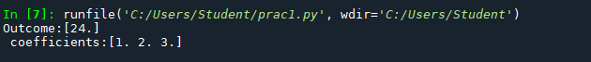

1. **Implement and demonstrate the FIND-S algorithm for finding the most specific hypothesis based on a given set of training data samples. Read the training data from a .CSV file**

## CODE:

import pandas as pd import numpy as np

data=pd.read_csv("D:/Prakash/find-s.csv") print(data,"n")

d=np.array(data)[:,:-1] print("\n The attributes are:",d) target=np.array(data)[:,-1] print("\n The target is:",target)

def train(c,t):

for i, val in enumerate(t): if val=="Yes":

specific_hypothesis=c[i].copy() break

for i,val in enumerate(c): if t[i]=="Yes":

for x in range(len(specific_hypothesis)): if val[x]!=specific_hypothesis[x]:

specific_hypothesis[x]="?" else:

pass

return specific_hypothesis

print("\n The final Hypothesis is :",train(d,target))

**OUTPUT:**

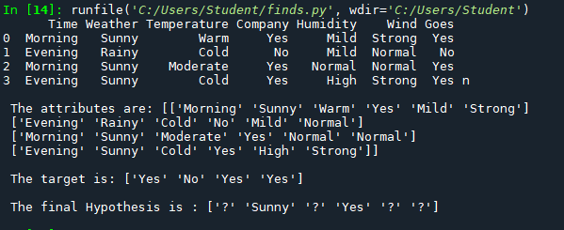

# PRACTICAL 2

## For a given set of training data examples stored in a .CSV file, implement and demonstrate the Candidate-Elimination algorithm to output a description of the set of all hypotheses consistent with the training examples.

**CODE:**

from operator import ge,le import re

import pandas as pd import numpy as np

data=pd.DataFrame(data=pd.read_csv("D:/Prakash/candidate.csv")) print(data)

concepts=np.array(data.iloc[:,0:-1]) target=np.array(data.iloc[:,-1]) print("\n",target) print("\n",concepts)

def learn(concepts,target): specific_h=concepts[0].copy()

print("\n Initialization of Specific_H and general_h") print("\n specific_h:",specific_h)

general_h=[["?"for i in range(len(specific_h))]for i in range(len(specific_h))] print("\ngeneral_h:",general_h)

print("\nconcepts",concepts) for i,h in enumerate(concepts):

if target[i]=="Yes":

for x in range(len(specific_h)): if h[x]!=specific_h[x]:

specific_h[x]=="?" general_h[x][x]=="?"

for x in range(len(specific_h)): if h[x]!=specific_h[x]:

general_h[x][x]==specific_h[x] else:

general_h[x][x]=="?"

print("\n steps of candidate elimination algorithm:",i+1) print("\n Specific_h:",i+1)

print(specific_h,"\n") print("general_h:",i+1) print(general_h)

indices=[i for i, val in enumerate(general_h) if val==["?","?","?","?","?","?"]] print("\n Indices",indices)

for i in indices: general_h.remove(["?","?","?","?","?","?"])

return specific_h,general_h s_final,g_final=learn(concepts, target) print("\n Final specific_h",s_final,sep="\n")

**OUTPUT:**

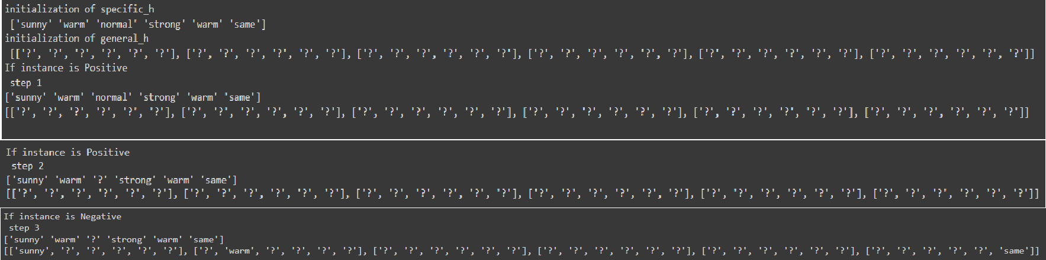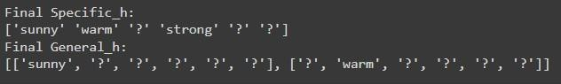

**PRACTICAL 3**

# Write a program to implement the naïve Bayesian classifier for a sample training data set stored as a .CSV file. Compute the accuracy of the classifier, considering few test data sets.

## CODE:

import numpy as nm

import matplotlib.pyplot as mtp import pandas as pd

dataset = pd.read_csv('D:/Prakash/user_data.csv') x = dataset.iloc[:, [1, 2]].values

y = dataset.iloc[:, 3].values

from sklearn.model_selection import train_test_split

x_train, x_test, y_train, y_test = train_test_split(x, y, test_size = 0.25, random_state = 0) from sklearn.preprocessing import StandardScaler

sc = StandardScaler()

x_train = sc.fit_transform(x_train) x_test = sc.transform(x_test)

from sklearn.naive_bayes import GaussianNB classifier = GaussianNB() classifier.fit(x_train, y_train)

y_pred = classifier.predict(x_test)

from sklearn.metrics import confusion_matrix cm = confusion_matrix(y_test, y_pred) print(cm)

from matplotlib.colors import ListedColormap x_set, y_set = x_train, y_train

X1, X2 = nm.meshgrid(nm.arange(start = x_set[:, 0].min() - 1, stop = x_set[:, 0].max() + 1, step = 0.01),nm.arange(start = x_set[:, 1].min() - 1, stop = x_set[:, 1].max() + 1, step = 0.01)) mtp.contourf(X1, X2, classifier.predict(nm.array([X1.ravel(), X2.ravel()]).T).reshape(X1.shape),alpha = 0.75, cmap = ListedColormap(('purple', 'green'))) mtp.xlim(X1.min(), X1.max())

mtp.ylim(X2.min(), X2.max())

for i, j in enumerate(nm.unique(y_set)): mtp.scatter(x_set[y_set == j, 0], x_set[y_set == j, 1],

c = ListedColormap(('purple', 'green'))(i), label = j) mtp.title('Naive Bayes (Training set)')

mtp.xlabel('Age') mtp.ylabel('Estimated Salary') mtp.legend()

mtp.show()

x_set, y_set = x_test, y_test

X1, X2 = nm.meshgrid(nm.arange(start = x_set[:, 0].min() - 1, stop = x_set[:, 0].max() + 1, step = 0.01), nm.arange(start = x_set[:, 1].min() - 1, stop = x_set[:, 1].max() + 1, step = 0.01)) mtp.contourf(X1, X2, classifier.predict(nm.array([X1.ravel(), X2.ravel()]).T).reshape(X1.shape), alpha = 0.75, cmap = ListedColormap(('purple', 'green'))) mtp.xlim(X1.min(), X1.max())

mtp.ylim(X2.min(), X2.max())

for i, j in enumerate(nm.unique(y_set)): mtp.scatter(x_set[y_set == j, 0], x_set[y_set == j, 1],

c = ListedColormap(('purple', 'green'))(i), label = j) mtp.title('Naive Bayes (Test set)')

mtp.xlabel('Age') mtp.ylabel('Estimated Salary') mtp.legend()

mtp.show()

**OUTPUT:**

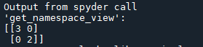

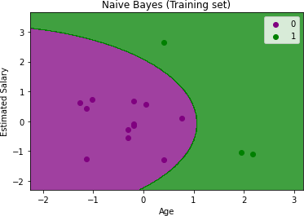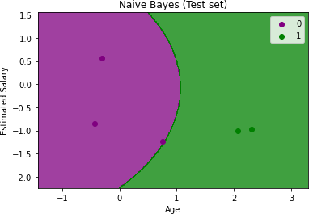

# Write A Program to Implement a Decision Tree with Prediction, Test Score And Confusion Matrix.

## CODE:

import numpy as nm

import matplotlib.pyplot as mtp import pandas as pd

dataset = pd.read_csv('D:/Prakash/user_data.csv') x = dataset.iloc[:, [1, 2]].values

y = dataset.iloc[:, 3].values

from sklearn.model_selection import train_test_split

x_train, x_test, y_train, y_test = train_test_split(x, y, test_size = 0.25, random_state = 0)

from sklearn.preprocessing import StandardScaler sc = StandardScaler()

x_train = sc.fit_transform(x_train) x_test = sc.transform(x_test)

from sklearn.tree import DecisionTreeClassifier classifier =DecisionTreeClassifier(criterion='entropy') classifier.fit(x_train, y_train)

DecisionTreeClassifier(class_weight=None,criterion='entropy',max_depth=None,max_featur es=None,max_leaf_nodes=None,min_impurity_decrease=0.0,min_samples_leaf=1,min_samp les_split=2,min_weight_fraction_leaf=0.0,random_state=0,splitter='best')

y_pred = classifier.predict(x_test)

from sklearn.metrics import confusion_matrix cm = confusion_matrix(y_test, y_pred) print(cm)

from sklearn.metrics import accuracy_score sc1=accuracy_score(y_test, y_pred)*100 print("Accuracy",sc1)

from matplotlib.colors import ListedColormap x_set, y_set = x_train, y_train

X1, X2 = nm.meshgrid(nm.arange(start = x_set[:, 0].min() - 1, stop = x_set[:, 0].max() + 1, step = 0.01),nm.arange(start = x_set[:, 1].min() - 1, stop = x_set[:, 1].max() + 1, step = 0.01)) mtp.contourf(X1, X2, classifier.predict(nm.array([X1.ravel(), X2.ravel()]).T).reshape(X1.shape),alpha = 0.75, cmap = ListedColormap(('purple', 'green'))) mtp.xlim(X1.min(), X1.max())

mtp.ylim(X2.min(), X2.max())

for i, j in enumerate(nm.unique(y_set)): mtp.scatter(x_set[y_set == j, 0], x_set[y_set == j, 1],

c = ListedColormap(('purple', 'green'))(i), label = j) mtp.title('Decision Tree Algorithm (Training set)') mtp.xlabel('Age')

mtp.ylabel('Estimated Salary') mtp.legend()

mtp.show()

x_set, y_set = x_test, y_test

X1, X2 = nm.meshgrid(nm.arange(start = x_set[:, 0].min() - 1, stop = x_set[:, 0].max() + 1, step = 0.01),

nm.arange(start = x_set[:, 1].min() - 1, stop = x_set[:, 1].max() + 1, step = 0.01)) mtp.contourf(X1, X2, classifier.predict(nm.array([X1.ravel(), X2.ravel()]).T).reshape(X1.shape),

alpha = 0.75, cmap = ListedColormap(('purple', 'green'))) mtp.xlim(X1.min(), X1.max())

mtp.ylim(X2.min(), X2.max())

for i, j in enumerate(nm.unique(y_set)): mtp.scatter(x_set[y_set == j, 0], x_set[y_set == j, 1],

c = ListedColormap(('purple', 'green'))(i), label = j) mtp.title('Decision Tree Algorithm (Test set)') mtp.xlabel('Age')

mtp.ylabel('Estimated Salary') mtp.legend()

mtp.show()

## OUTPUT:



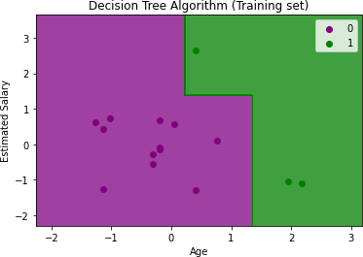 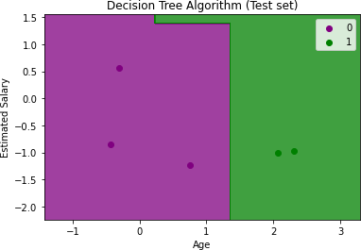

# Write a Program to Implement Random Forest with Prediction, Test Score and Confusion Matrix.

## CODE:

import numpy as nm import pandas as pd

import matplotlib.pyplot as mtp data_set=pd.read_csv('D:/Prakash/Social_Network_Ads.csv') x=data_set.iloc[:,[2,3]].values

y = data_set.iloc[:, 4].values

from sklearn.model_selection import train_test_split

x_train, x_test, y_train, y_test = train_test_split(x, y, test_size = 0.25, random_state = 0)

from sklearn.preprocessing import StandardScaler st_x = StandardScaler()

x_train = st_x.fit_transform(x_train) x_test = st_x.transform(x_test)

from sklearn.ensemble import RandomForestClassifier

classifier =RandomForestClassifier(n_estimators=10,criterion='entropy') classifier.fit(x_train, y_train)

y_pred=classifier.predict(x_test) print(y_pred)

from sklearn.metrics import confusion_matrix cm = confusion_matrix(y_test, y_pred) print(cm)

from sklearn.metrics import accuracy_score sc1=accuracy_score(y_test, y_pred)*100 print("Accuracy",sc1)

from matplotlib.colors import ListedColormap x_set, y_set = x_train, y_train

X1, X2 = nm.meshgrid(nm.arange(start = x_set[:, 0].min() - 1, stop = x_set[:, 0].max() + 1, step = 0.01),nm.arange(start = x_set[:, 1].min() - 1, stop = x_set[:, 1].max() + 1, step = 0.01)) mtp.contourf(X1, X2, classifier.predict(nm.array([X1.ravel(), X2.ravel()]).T).reshape(X1.shape),alpha = 0.75, cmap = ListedColormap(('purple', 'green'))) mtp.xlim(X1.min(), X1.max())

mtp.ylim(X2.min(), X2.max())

for i, j in enumerate(nm.unique(y_set)): mtp.scatter(x_set[y_set == j, 0], x_set[y_set == j, 1],

c = ListedColormap(('purple', 'green'))(i), label = j) mtp.title('RandomForest Algorithm (Training set)') mtp.xlabel('Age')

mtp.ylabel('Estimated Salary') mtp.legend()

mtp.show()

x_set, y_set = x_test, y_test

X1, X2 = nm.meshgrid(nm.arange(start = x_set[:, 0].min() - 1, stop = x_set[:, 0].max() + 1, step = 0.01),

nm.arange(start = x_set[:, 1].min() - 1, stop = x_set[:, 1].max() + 1, step = 0.01)) mtp.contourf(X1, X2, classifier.predict(nm.array([X1.ravel(), X2.ravel()]).T).reshape(X1.shape),

alpha = 0.75, cmap = ListedColormap(('purple', 'green'))) mtp.xlim(X1.min(), X1.max())

mtp.ylim(X2.min(), X2.max())

for i, j in enumerate(nm.unique(y_set)): mtp.scatter(x_set[y_set == j, 0], x_set[y_set == j, 1],

c = ListedColormap(('purple', 'green'))(i), label = j) mtp.title('Random Forest Algorithm (Test set)') mtp.xlabel('Age')

mtp.ylabel('Estimated Salary') mtp.legend()

mtp.show()

## OUTPUT:

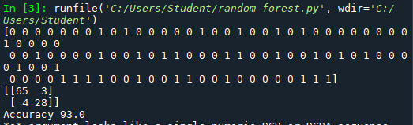

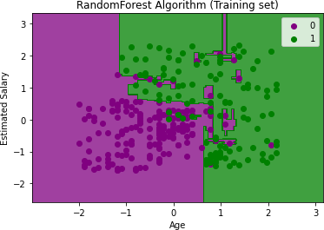 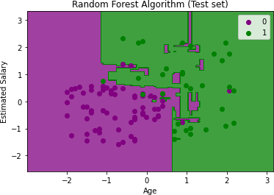

# PRACTICAL 4

1. **For a given set of training data examples stored in a .CSV file implement Least Square Regression algorithm.**

## CODE:

import numpy as np import pandas as pd

import matplotlib.pyplot as plt data=pd.read_csv('D:/Prakash/sale.csv') print(data.shape)

(6,2)

print(data.head())

X=data['Price of T-shirts in dollars(x)'].values Y=data['# of T - Shirts Sold(y)'].values mean_x=np.mean(X)

mean_y=np.mean(Y) n=len(X)

numer=0 denom=0

for i in range(n):

numer+=(X[i]-mean_x)*(Y[i]-mean_y) denom+=(X[i]-mean_x)**2 m=numer/denom

c=mean_y-(m*mean_x) print('Coefficients') print(m,c) max_x=np.max(X)+100 min_x=np.min(X)-100

x=np.linspace(min_x,max_x,1000) y=m*x+c

plt.plot(x,y,color='#58b970',label="Regression Line") plt.scatter(X, Y, c='#ef5423',label='Scatter Plot') plt.xlabel('Price of T-shirts in Dollars(x)') plt.ylabel("# of T-shirts Sold(y)")

plt.legend() plt.show() rmse=0

for i in range(n): y_pred=c+m*X[i] print(y_pred) rmse+=(Y[i]-y_pred)**2

rmse=np.sqrt(rmse/n) print(rmse)

ss_tot=0 ss_res=0

for i in range(n): y_pred=c+m*X[i] ss_tot+=(Y[i]-mean_y)**2 ss_res+=(Y[i]-y_pred)**2

r2=1-(ss_res/ss_tot) print("R2 SCORE :",r2)

**OUTPUT:**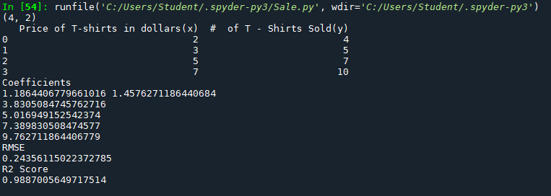

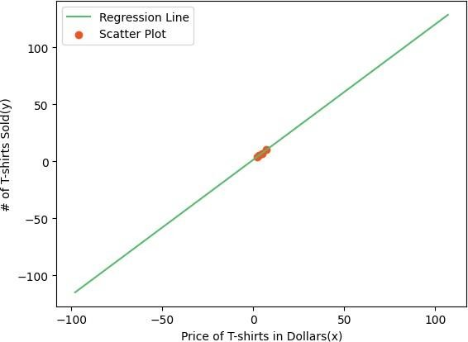

# For a given set of training data examples stored in a .CSV file implement Logistic Regression algorithm.

## CODE:

import numpy as nm

import matplotlib.pyplot as mtp import pandas as pd

data_set=pd.read_csv("D:/Vinish/Social_Network_Ads.csv") x=data_set.iloc[:,[2,3]].values

y=data_set.iloc[:,4].values

from sklearn.model_selection import train_test_split x_train,x_test,y_train,y_test=train_test_split(x,y,test_size=0.20,random_state=0) from sklearn.preprocessing import StandardScaler

sc=StandardScaler() x_train=sc.fit_transform(x_train) x_test=sc.transform(x_test)

from sklearn.linear_model import LogisticRegression classifier=LogisticRegression(random_state=0) classifier.fit(x_train,y_train) y_pred=classifier.predict(x_test)

from sklearn.metrics import confusion_matrix cm=confusion_matrix(y_test, y_pred) print(cm)

from sklearn.metrics import accuracy_score sc1=accuracy_score(y_test,y_pred)*100 print("Accuracy",sc1)

from sklearn.metrics import classification_report creport=classification_report(y_test,y_pred) print(creport)

from matplotlib.colors import ListedColormap x_set, y_set = x_train, y_train

X1, X2 = nm.meshgrid(nm.arange(start = x_set[:, 0].min() - 1, stop = x_set[:, 0].max() + 1, step = 0.01),nm.arange(start = x_set[:, 1].min() - 1, stop = x_set[:, 1].max() + 1, step = 0.01)) mtp.contourf(X1, X2, classifier.predict(nm.array([X1.ravel(), X2.ravel()]).T).reshape(X1.shape),alpha = 0.75, cmap = ListedColormap(('red', 'green'))) mtp.xlim(X1.min(), X1.max())

mtp.ylim(X2.min(), X2.max())

for i, j in enumerate(nm.unique(y_set)): mtp.scatter(x_set[y_set == j, 0], x_set[y_set == j, 1],

c = ListedColormap(('red', 'green'))(i), label = j) mtp.title('logistic Regression (Training set)')

mtp.xlabel('Age') mtp.ylabel('Estimated Salary') mtp.legend()

mtp.show()

x_set, y_set = x_test, y_test

X1, X2 = nm.meshgrid(nm.arange(start = x_set[:, 0].min() - 1, stop = x_set[:, 0].max() + 1, step = 0.01),

nm.arange(start = x_set[:, 1].min() - 1, stop = x_set[:, 1].max() + 1, step = 0.01)) mtp.contourf(X1, X2, classifier.predict(nm.array([X1.ravel(), X2.ravel()]).T).reshape(X1.shape),

alpha = 0.75, cmap = ListedColormap(('red', 'green'))) mtp.xlim(X1.min(), X1.max())

mtp.ylim(X2.min(), X2.max())

for i, j in enumerate(nm.unique(y_set)): mtp.scatter(x_set[y_set == j, 0], x_set[y_set == j, 1],

c = ListedColormap(('red', 'green'))(i), label = j) mtp.title('Logistic regression (Test set)') mtp.xlabel('Age')

mtp.ylabel('Estimated Salary') mtp.legend()

mtp.show()

**OUTPUT:**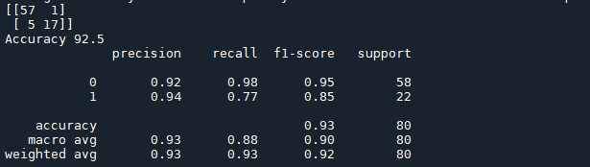

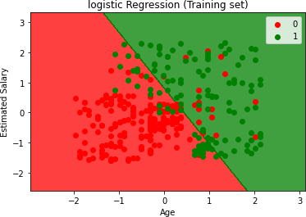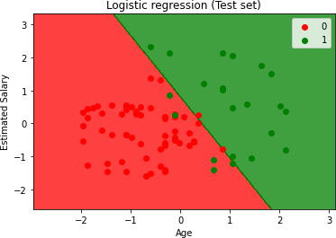

# PRACTICAL 5

## Write a program to demonstrate the working of the decision tree based ID3 algorithm. Use an appropriate data set for building the decision tree and apply this knowledge to classify a new sample.

**CODE:**

import numpy as nm

import matplotlib.pyplot as mtp import pandas as pd

dataset = pd.read_csv('D:/Prakash/user_data.csv') x = dataset.iloc[:, [1, 2]].values

y = dataset.iloc[:, 3].values

from sklearn.model_selection import train_test_split

x_train, x_test, y_train, y_test = train_test_split(x, y, test_size = 0.25, random_state = 0)

from sklearn.preprocessing import StandardScaler st_x = StandardScaler()

x_train = st_x.fit_transform(x_train) x_test = st_x.transform(x_test)

from sklearn.tree import DecisionTreeClassifier classifier=DecisionTreeClassifier(criterion='entropy',random_state=0) classifier.fit(x_train,y_train) DecisionTreeClassifier(class_weight=None,criterion='entropy',max_depth=None,max_featur es=None,max_leaf_nodes=None,min_impurity_decrease=0.0,min_samples_leaf=1,min_samp les_split=2,min_weight_fraction_leaf=0.0,random_state=0,splitter='best') y_pred=classifier.predict(x_test)

from sklearn.metrics import confusion_matrix cm=confusion_matrix(y_test,y_pred) print(cm)

from sklearn.metrics import accuracy_score sc1=accuracy_score(y_test,y_pred)*100 print("Acuracy Score: ",sc1)

from matplotlib.colors import ListedColormap x_set, y_set = x_train, y_train

X1, X2 = nm.meshgrid(nm.arange(start = x_set[:, 0].min() - 1, stop = x_set[:, 0].max() + 1, step = 0.01),nm.arange(start = x_set[:, 1].min() - 1, stop = x_set[:, 1].max() + 1, step = 0.01)) mtp.contourf(X1, X2, classifier.predict(nm.array([X1.ravel(), X2.ravel()]).T).reshape(X1.shape),alpha = 0.75, cmap = ListedColormap(('red', 'green'))) mtp.xlim(X1.min(), X1.max())

mtp.ylim(X2.min(), X2.max())

for i, j in enumerate(nm.unique(y_set)): mtp.scatter(x_set[y_set == j, 0], x_set[y_set == j, 1],

c = ListedColormap(('red', 'green'))(i), label = j) mtp.title('Decision Tree Algorithm (Training set)') mtp.xlabel('Age')

mtp.ylabel('Estimated Salary') mtp.legend()

mtp.show()

x_set, y_set = x_test, y_test

X1, X2 = nm.meshgrid(nm.arange(start = x_set[:, 0].min() - 1, stop = x_set[:, 0].max() + 1, step = 0.01),

nm.arange(start = x_set[:, 1].min() - 1, stop = x_set[:, 1].max() + 1, step = 0.01)) mtp.contourf(X1, X2, classifier.predict(nm.array([X1.ravel(), X2.ravel()]).T).reshape(X1.shape),

alpha = 0.75, cmap = ListedColormap(('red', 'green'))) mtp.xlim(X1.min(), X1.max())

mtp.ylim(X2.min(), X2.max())

for i, j in enumerate(nm.unique(y_set)): mtp.scatter(x_set[y_set == j, 0], x_set[y_set == j, 1],

c = ListedColormap(('red', 'green'))(i), label = j) mtp.title('Decision Tree Algorithm (Test set)') mtp.xlabel('Age')

mtp.ylabel('Estimated Salary') mtp.legend()

mtp.show()

## OUTPUT:

1. **Write a program to implement k-Nearest Neighbour algorithm to classify the iris data set.**

## CODE:

import numpy as np import pandas as pd

import matplotlib.pyplot as mtp

import re as T data_set=pd.read_csv('D:/Vinish/Social_Network_Ads.csv') x=data_set.iloc[:,[2,3]].values

y = data_set.iloc[:, 4].values

from sklearn.model_selection import train_test_split

x_train, x_test, y_train, y_test = train_test_split(x, y, test_size = 0.25, random_state = 0) from sklearn.model_selection import train_test_split x_train,x_test,y_train,y_test=train_test_split(x,y,test_size=0.20,random_state=0) print("len",len(y_test))

from sklearn.preprocessing import StandardScaler st_x = StandardScaler()

x_train = st_x.fit_transform(x_train) x_test = st_x.transform(x_test) print(x_train)

print(x_test)

from sklearn.neighbors import KNeighborsClassifier classifier=KNeighborsClassifier(n_neighbors=5,metric="minkowski",p=2) classifier.fit(x_train,y_train)

y_pred=classifier.predict(x_test) print(y_pred)

from sklearn.metrics import confusion_matrix cm = confusion_matrix(y_test, y_pred) print(cm)

from sklearn.metrics import accuracy_score sc1=accuracy_score(y_test, y_pred)*100 print("Accuracy",sc1)

**OUTPUT:**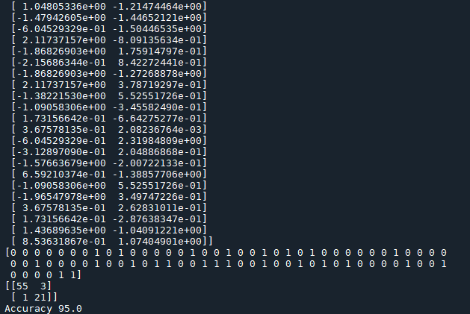

**PRACTICAL 6**

# Implement the different Distance methods (Euclidean) with Prediction, Test Score and Confusion Matrix.

## CODE:

import numpy as np

from sklearn import datasets

from sklearn.model_selection import train_test_split from sklearn.neighbors import KNeighborsClassifier

from sklearn.metrics import confusion_matrix, accuracy_score

wine = datasets.load_wine()

X = wine.data y = wine.target

X_train, X_test, y_train, y_test = train_test_split(X, y, test_size=0.3, random_state=42) knn = KNeighborsClassifier(n_neighbors=5, metric='euclidean')

knn.fit(X_train, y_train) y_pred = knn.predict(X_test)

accuracy = accuracy_score(y_test, y_pred) print(f"Accuracy: {accuracy:.2f}")

conf_matrix = confusion_matrix(y_test, y_pred) print("Confusion Matrix:")

print(conf_matrix)

distances, indices = knn.kneighbors(X_test)

print("\nEuclidean Distances for the test set (showing first 5 samples):") for i in range(5):

print(f"Sample {i}: Distances - {distances[i]}, Neighbors - {indices[i]}")

**OUTPUT:**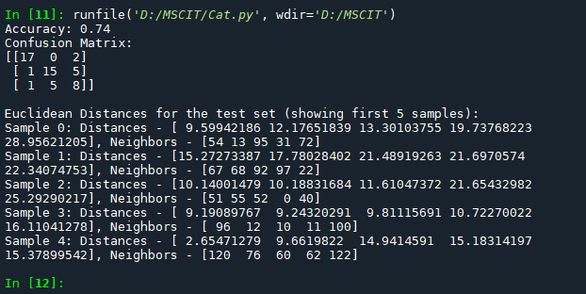

# Implement the classification model using clustering for the following techniques with K means clustering with Prediction, Test Score and Confusion Matrix.

## CODE:

from sklearn.cluster import KMeans import matplotlib.pyplot as mtp

import pandas as pd

data_set = pd.read_csv('D:/Prakash/Mall_Customers.csv') x = data_set.iloc[:, [3, 4]].values

wcss_list = []

for i in range(1, 11):

kmeans = KMeans(n_clusters=i, init='k-means++', random_state=42) kmeans.fit(x)

wcss_list.append(kmeans.inertia_) mtp.plot(range(1, 11), wcss_list) mtp.title("The Elbow Method Graph") mtp.xlabel("Number of Clusters(k)") mtp.ylabel('wcss_list')

mtp.show()

kmeans = KMeans(n_clusters=5, init='k-means++', random_state=42) y_predict = kmeans.fit_predict(x)

print(y_predict)

mtp.scatter(x[y_predict == 0, 0], x[y_predict == 0, 1],s=100, c='blue', label='Cluster 1')

mtp.scatter(x[y_predict == 1, 0], x[y_predict == 1, 1],s=100, c='green', label='Cluster 2')

mtp.scatter(x[y_predict == 2, 0], x[y_predict == 2, 1],s=100, c='red', label='Cluster 3') mtp.scatter(kmeans.cluster_centers_[:,0],kmeans.cluster_centers_[:,1],s=300,c='yellow',label

="Centroid")

mtp.title('Clusters of Customers') mtp.xlabel('Annual Income(k$)') mtp.ylabel('Spending Score(1-100)') mtp.legend()

mtp.show()

**OUTPUT:**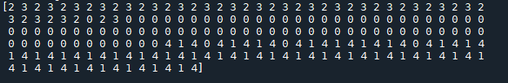

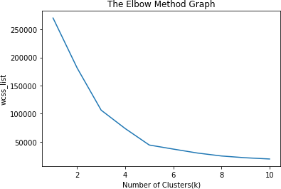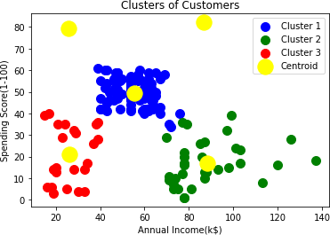

# PRACTICAL 7

1. **Implement the classification model using clustering for the following techniques with hierarchical clustering with Prediction, Test Score and Confusion Matrix.**

## CODE:

import numpy as np

import matplotlib.pyplot as mtp import pandas as pd

dataset=pd.read_csv('D:/Prakash/Mall_Customers.csv') x = dataset.iloc[:, [3, 4]].values

import scipy.cluster.hierarchy as she dendro=she.dendrogram(she.linkage(x,method="ward")) mtp.title('Dendogram Plot')

mtp.ylabel('Euclidean Distances') mtp.xlabel('Customers') mtp.show()

from sklearn.cluster import AgglomerativeClustering hc=AgglomerativeClustering(n_clusters=5,affinity='euclidean',linkage='ward') y_pred=hc.fit_predict(x)

print(y_pred)

mtp.scatter(x[y_pred == 0, 0], x[y_pred == 0, 1],s=100, c='blue', label='Cluster 1')

mtp.scatter(x[y_pred == 1, 0], x[y_pred == 1, 1],s=100, c='green', label='Cluster 2')

mtp.scatter(x[y_pred == 2, 0], x[y_pred == 2, 1],s=100, c='red', label='Cluster 3')

mtp.scatter(x[y_pred == 3, 0], x[y_pred == 3, 1],s=100, c='cyan', label='Cluster 4')

mtp.scatter(x[y_pred == 4, 0], x[y_pred == 4, 1],s=100, c='magenta', label='Cluster 5') mtp.title('Clusters of Customers')

mtp.xlabel('Annual Income(k$)') mtp.ylabel('Spending Score(1-100)') mtp.legend()

mtp.show()

**OUTPUT:**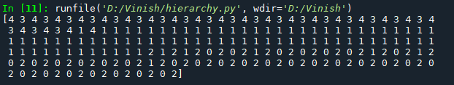

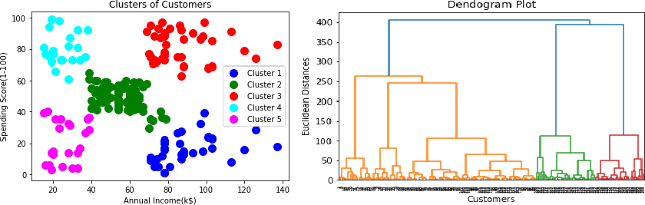

# Implement the Rule based method and test the same.

## CODE:

import numpy as np import pandas as pd

from sklearn.model_selection import train_test_split

from sklearn.feature_extraction.text import TfidfVectorizer from sklearn.linear_model import LogisticRegression

from sklearn.metrics import accuracy_score from sklearn.metrics import confusion_matrix

mail_data = pd.read_csv(r"/content/mail_data.csv") print(mail_data)

data = mail_data.where((pd.notnull(mail_data)), '')

data.loc[data['Category'] == 'spam', 'Category',] = 0 data.loc[data['Category'] == 'ham', 'Category',] = 1 data.head()

X = data['Message'] y = data['Category'] print(X)

print(y)

X_train, X_test, y_train, y_test = train_test_split(X, y, test_size = 0.2, random_state = 3) print(X.shape)

print(X_train.shape) print(X_test.shape) print(y.shape) print(y_train.shape) print(y_test.shape)

feature_extraction = TfidfVectorizer(min_df = 1, stop_words = 'english', lowercase = True)

X_train_features = feature_extraction.fit_transform(X_train) X_test_features = feature_extraction.transform(X_test)

# convert the targets into integers y_train = y_train.astype('int') y_test = y_test.astype('int') print(X_train_features)

model = LogisticRegression() model.fit(X_train_features, y_train)

prediction_on_training_data = model.predict(X_train_features) accuracy_on_training_data = accuracy_score(y_train, prediction_on_training_data) print('Accuracy on training data :', accuracy_on_training_data)

prediction_on_test_data = model.predict(X_test_features) accuracy_on_test_data = accuracy_score(y_test, prediction_on_test_data) print('Accuracy on test data :', accuracy_on_test_data)

print('Confusion Matrix \n',confusion_matrix(y_test,prediction_on_test_data ))

# building a predective system

input_mail = ["XXXMobileMovieClub: To use your credit, click the WAP link in the next txt message or click here>> [http://wap](http://wap/). [xxxmobilemovieclub.com?n=QJKGIGHJJGCBL](http://xxxmobilemovieclub.com/?n=QJKGIGHJJGCBL)"]

# convert text into feature vectors

input_data_features = feature_extraction.transform(input_mail) # make predictions

prediction = model.predict(input_data_features) print(prediction)

if prediction[0] == 1 : print('Ham')

else :

print('Spam')

**OUTPUT:**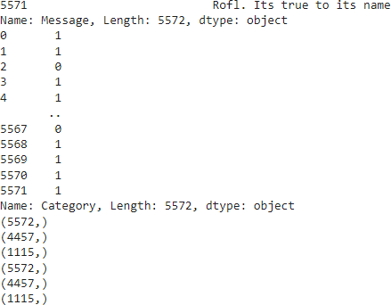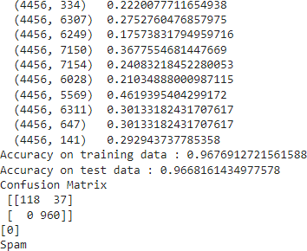

# PRACTICAL 8

1. **Build an Artificial Neural Network by implementing the Backpropagation algorithm and test the same using appropriate data sets.**

## Code:

import numpy as np

x=np.array(([2,9],[1,5],[3,6]),dtype=float)

y=np.array(([92],[86],[89]),dtype=float) x=x/np.amax(x,axis=0)

y=y/100

def sigmoid(x):

return 1/(1+np.exp(-x)) def der_sigmoid(x):

return x*(1-x) epoch=5

lr=0.1 inputlayer_neurons=2 hiddenlayer_neurons=3 output_neurons=1

wh=np.random.uniform(size=(inputlayer_neurons,hiddenlayer_neurons)) bh=np.random.uniform(size=(hiddenlayer_neurons,output_neurons)) wout=np.random.uniform(size=(hiddenlayer_neurons,output_neurons)) bout=np.random.uniform(size=(output_neurons))

for i in range(epoch): hinp1=np.dot(x,wh) hinp=hinp1+bh hlayer_act=sigmoid(hinp) outinp1=np.dot(hlayer_act,wout) outinp=outinp1+bout output=sigmoid(outinp)

EO=y-output outgrad=der_sigmoid(output) d_output=EO*outgrad EH=d_output.dot(wout.T) hiddengrad=der_sigmoid(hlayer_act) d_hiddenlayer=EH*hiddengrad wout+=hlayer_act.T.dot(d_output)*lr wh+=x.T.dot(d_hiddenlayer)*lr

print(" Epoch",i+1,"Starts ") print("input:\n"+str(x))

print("Actual Output:\n"+str(y)) print("Predicted Output:\n",output)

**OUTPUT:**

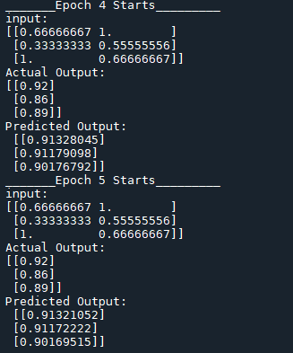

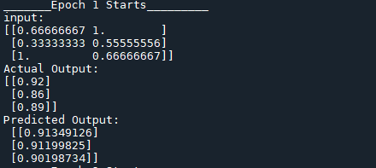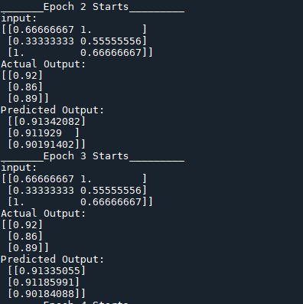

# Assuming a set of documents that need to be classified, use the naive Bayesian Classifier model to perform this task.

## CODE:

import pandas as pd

from sklearn.feature_extraction.text import TfidfVectorizer from sklearn.model_selection import train_test_split

from sklearn.naive_bayes import MultinomialNB from sklearn import metrics

data=pd.read_csv('D:/Prakash/naivebayes.csv',names=['text','label']) print("\n Dataset is :\n",data)

print("Dimension of the dataset",data.shape) data['labelnum']=data.label.map({'Positive':1,'Negative':0}) x=data.text

y=data.labelnum print(x)

print(y)

vectorizer=TfidfVectorizer() data=vectorizer.fit_transform(x)

print('\n The tf-idf features of Dataset:\n') df=pd.DataFrame(data.toarray(),columns=vectorizer.get_feature_names()) df.head() x_train,x_test,y_train,y_test=train_test_split(data,y,test_size=0.3,random_state=2)

print("\n the total number of training Data:",y_train.shape)

print("\n the total number of test Data:",y_test.shape)

clf=MultinomialNB().fit(x_train,y_train) predicted=clf.predict(x_test)

print("\n Accuracy of Classifier:",metrics.accuracy_score(y_test, predicted)) print("Confusion matrix:",metrics.confusion_matrix(y_test, predicted)) print("Classification report",metrics.classification_report(y_test,predicted)) print("\n the value of precision",metrics.precision_score(y_test,predicted)) print("\n The value of recall:",metrics.recall_score(y_test,predicted))

**OUTPUT:**

