ADVISERMATCH: AN AI-POWERED CAPSTONE ADVISER MATCHING SYSTEM FOR THE CEIT DEPARTMENT OF CARAGA STATE UNIVERSITY CABADBARAN CAMPUS

A CAPSTONE PROJECT
SUBMITTED TO THE FACULTY OF THE
COLLEGE OF ENGINEERING AND INFORMATION TECHNOLOGY
CARAGA STATE UNIVERSITY CABADBARAN CITY
CITY OF CABADBARAN, AGUSAN DEL NORTE

IN PARTIAL FULFILLMENT OF THE REQUIREMENTS FOR THE DEGREE OF BACHELOR OF SCIENCE IN INFORMATION TECHNOLOGY

Submitted By:
Egot, Bonifacio JR
Jabla, Vincent Andrie P.
Galagate, Jessrel James
Submitted to:
Ms. Mary Jun M. Palima

MAY 2026
TABLE OF CONTENTS
CHAPTER 1: INTRODUCTION AND BACKGROUND 1
1.1 Introduction 1
1.2 Project Context 2
1.3 General and Specific Objectives 3
1.4 Scope and Limitation of the Study 4
1.5 Significance of the Study 5
CHAPTER 2: REVIEW OF RELATED LITERATURE AND STUDIES 7
2.1 Review of Related Literature (RRL) 7
2.2 Review of Related Systems (RRS) 11
2.3 Synthesis of the Review 13
CHAPTER III – TECHNICAL BACKGROUND 19
3.1 Technicality of the Project 19
3.2 Details of the Technologies to be Used 20
3.3 How the Project Will Work 22
3.4 Theoretical and Conceptual Framework 23
3.5 Conceptual Framework 25
CHAPTER IV – METHODOLOGY 24
4.1 Requirements Specification 24
4.1.1 Technical Feasibility 24
4.2 Data Process Modeling 26
4.3 Design 30
4.3.1 Output and User Interface Design 30
4.4 Results and Discussion 32
4.4.1 Product Quality Results 32
4.4.2 Quality in Use 33
4.4.3 Summary of Qualitative Feedback 34
4.5 Recommendations 35
REFERENCES 31
CHAPTER 1
INTRODUCTION AND BACKGROUND
This chapter presents the foundation of the study, establishing the context, rationale, and direction of the proposed AI-Powered Capstone Adviser Matching System. It begins with an overview of the broader technological landscape that motivates the development of AI-driven academic management tools, followed by a focused discussion of the specific problem experienced by the CEIT Department of Caraga State University Cabadbaran Campus (CSUCC) in the absence of a systematic adviser matching process. The chapter then outlines the general and specific objectives that guide the study, defines the scope and limitations of the proposed system, and identifies the stakeholders who stand to benefit from its implementation.
1.1 Introduction
Artificial intelligence (AI) has emerged as one of the most transformative forces reshaping industries worldwide in the twenty-first century. From automating complex workflows in healthcare and finance to powering personalized experiences in e-commerce and social media, AI-driven systems are redefining how institutions make decisions, allocate resources, and deliver services [1]. The global AI market was valued at over $200 billion in 2023 and is projected to grow at a compound annual growth rate of more than 37% through 2030, reflecting an unprecedented rate of adoption across both private and public sectors [7]. Central to this transformation is the rise of intelligent recommendation and matching technologies that leverage machine learning and data analytics to connect the right resources with the right people at the right time — a capability that is now finding critical application in education [4].
In higher education, digital technologies are fundamentally reshaping how academic institutions manage administrative processes, deliver student services, and support evidence-based decision-making [2]. AI-powered tools, including intelligent recommender systems, predictive analytics platforms, and Natural Language Processing (NLP) applications, are being increasingly adopted to improve institutional efficiency, enhance student outcomes, and support data-driven academic governance [5]. Recommender systems in particular have demonstrated strong potential in educational contexts, enabling personalized course suggestions, learning path optimization, and academic resource matching that would be impractical to achieve manually at scale [8]. These systems work by analyzing structured profiles of users and items — applying techniques such as content-based filtering, collaborative filtering, and NLP-based text similarity — to generate objective, ranked recommendations that guide institutional decision-making [4].
One area within higher education where intelligent matching technology holds particular promise is the assignment of capstone project advisers — a process that directly shapes the quality and trajectory of undergraduate research. Effective adviser-student pairing is widely recognized as one of the most consequential yet most frequently mismanaged administrative tasks in academic research programs [3]. When students are matched with advisers whose expertise genuinely aligns with their research topics, they produce higher-quality outputs, complete their projects more efficiently, and report greater satisfaction with the academic experience [13]. Conversely, poor adviser-student matching leads to communication breakdowns, inadequate research guidance, prolonged project timelines, and avoidable academic failure — outcomes that undermine institutional research quality and student morale [15]. Despite its critical importance, adviser assignment in most institutions continues to rely on informal, subjective processes rather than systematic, data-driven approaches [11].
In the Philippine context, the relevance of this challenge is further amplified by national policy. The Commission on Higher Education (CHED) has mandated all higher education institutions offering Information Technology and Computer Science programs to cultivate strong research cultures and ensure access to qualified research advisers for students undertaking capstone and research projects [6]. Despite this mandate, the actual deployment of systematic, technology-mediated adviser assignment processes across Philippine higher education institutions remains inconsistent and largely absent — particularly in state universities outside major urban centers [12]. Espartinez [12] found that while awareness of AI-powered academic tools is growing among Filipino faculty and students, institutional adoption remains constrained by infrastructural gaps, limited digital literacy, and the absence of policy frameworks that support technology integration in academic management. This disconnect between CHED’s research development mandate and the operational realities of Philippine state universities underscores the urgent need for accessible, context-appropriate AI tools that can bridge the gap between policy intent and practice.
It is within this intersection of AI advancement, educational technology adoption, and Philippine higher education policy that the present study is situated. The CEIT Department of Caraga State University Cabadbaran Campus (CSUCC) currently assigns capstone advisers through a fully manual, subjective process that lacks any structured expertise-alignment evaluation, centralized faculty profiling, or workload balancing mechanism — resulting in mismatched advising relationships, inequitable faculty workloads, and delayed capstone completions [11][15]. Addressing this gap requires not merely an administrative reform, but an intelligent, technology-driven solution capable of objectively evaluating faculty expertise against student research needs. It is in response to this real and documented need that the researchers propose the development of ADVISERMATCH: an AI-Powered Capstone Adviser Matching System that applies NLP-based content-based filtering and cosine similarity algorithms to generate data-driven, expertise-aligned adviser recommendations for students of the CEIT Department of CSUCC.

1.2 Project Context
Caraga State University Cabadbaran Campus (CSUCC), located in the Caraga Region of Mindanao, Philippines, is a state university committed to advancing research and academic excellence. The College of Engineering and Information Technology (CEIT) Department offers programs requiring students to undertake capstone or research projects as part of their academic requirements [6]. Like many Philippine state universities, the CEIT Department faces persistent challenges in effectively matching students with faculty advisers who possess expertise and specialization aligned with student research interests [11].
The current capstone adviser selection process in the CEIT Department is performed manually, relying primarily on faculty availability, student preference, or subjective recommendations from academic coordinators [11]. Students are assigned advisers without any structured evaluation of expertise alignment, research specialization compatibility, or advising workload distribution. This manual approach lacks the objectivity, consistency, and data-driven basis necessary to ensure optimal adviser-student pairing, particularly as the department continues to grow in student enrollment and faculty size [15]. A study by Delos Santos [13] found that the top factors influencing effective capstone advising in Philippine universities were field of specialization and adviser availability, with students consistently reporting higher satisfaction and producing higher-quality research outputs when matched with advisers whose expertise closely aligned with their research topics. Furthermore, Bajao et al. [14] found that structured digital faculty profiling systems significantly improve the efficiency and transparency of faculty assignment processes in Philippine state universities — yet no such system exists in the CEIT Department of CSUCC.
The central gap identified in this study is the complete absence of a systematic, AI-powered adviser matching system within the CEIT Department of CSUCC. Without such a system, the department has no mechanism to objectively evaluate and compare the alignment between a student’s research topic and a faculty member’s documented expertise. There is no centralized digital repository of faculty research specializations, technical competencies, or current advising workloads that students and coordinators can consult. Recommendation decisions remain entirely dependent on the subjective judgment of individual coordinators, who may lack complete knowledge of all faculty expertise areas, particularly as the department expands [11]. This gap results in a cascade of operational problems: students are frequently paired with advisers whose research background does not match their capstone research topics, contributing to miscommunication, inadequate guidance, inequitable distribution of advising workloads, and prolonged capstone completion timelines [15]. Students often choose advisers based solely on personal familiarity or availability rather than on genuine expertise alignment [14], producing avoidable inefficiencies that undermine both the quality of student research and the department’s broader academic performance.
This existing problem leads the researchers to propose the development of an AI-Powered Capstone Adviser Matching System for the CEIT Department of Caraga State University Cabadbaran Campus. The proposed system will leverage NLP-based content-based filtering and cosine similarity algorithms to objectively evaluate the alignment between student research topics and faculty expertise profiles, generating ranked adviser recommendations that support informed, data-driven advising decisions.
1.3 General and Specific Objectives
General Objective
To design and develop an AI-Powered Capstone Adviser Matching System for the CEIT Department of Caraga State University Cabadbaran Campus (CSUCC) that integrates a structured faculty profiling module, an NLP-based recommendation engine using TF-IDF vectorization and cosine similarity, an advising workload balancing mechanism, and a web-based administrative dashboard — with the aim of replacing the manual, subjective adviser assignment process with an objective, data-driven matching system that improves adviser-student compatibility, reduces capstone completion delays, and enhances the overall quality of student research outcomes.
Specific Objectives
Specifically, the study aims to:
- Analyze the existing manual capstone adviser assignment process in the CEIT Department of CSUCC through structured interviews and documentary review to identify key limitations, inefficiencies, and stakeholder requirements that will serve as the basis for defining the functional and non-functional specifications of the proposed system.
- Design and implement a structured Faculty Profiling Module that enables administrators to create, update, and manage digital faculty profiles containing each faculty member’s research specializations, technical competencies, academic publications, and real-time advising workload data, providing the centralized knowledge base upon which the recommendation engine operates.
- Develop an AI-Powered Recommendation Engine using Natural Language Processing (NLP) text preprocessing, TF-IDF vectorization, and cosine similarity computation — implemented natively in PHP — to objectively measure the alignment between student-submitted research topic descriptions and faculty expertise profiles, and generate a ranked list of compatible capstone adviser recommendations with visible similarity scores and an integrated advising workload balancing filter that excludes overloaded faculty from the active recommendation pool.
- Implement a role-based, web-based platform with three user interfaces: (1) a Student Interface enabling secure login, structured research topic submission with keyword input, and viewing of ranked adviser recommendations with compatibility scores; (2) a Faculty Interface for faculty members to view and update their own expertise profiles and advising assignments; and (3) an Administrative Dashboard for department coordinators to manage faculty profiles, monitor real-time advising load distribution, oversee adviser assignments, and generate summary reports in PDF or Excel format.
- Evaluate the developed system through functional testing and user acceptance testing (UAT) conducted among students, faculty advisers, and department administrators of the CEIT Department, measuring the system’s recommendation accuracy, response time performance, usability, security, and overall satisfaction using a structured survey instrument based on the ISO 25010 quality standard and a five-point Likert scale.
1.4 Scope and Limitation of the Study
Scope
The proposed AI-Powered Capstone Adviser Matching System is specifically designed for use within the CEIT Department of Caraga State University Cabadbaran Campus (CSUCC). The system covers the following areas:
- Faculty Profiling: The system will maintain a database of CEIT faculty profiles, including each faculty member's research specializations, technical competencies, academic publications, and current advising loads.
- Student Research Topic Input: Students will be able to submit their proposed capstone or research topics, areas of interest, and technical skill sets through the system interface.
- AI-Based Adviser Recommendation: The system will generate a ranked list of recommended advisers based on the alignment between student research inputs and faculty expertise profiles using NLP and content-based filtering algorithms.
- Administrative Management: The system will include a dashboard for department administrators and coordinators to manage faculty profiles, monitor advising assignments, and generate reports.
- Web-Based Platform: The system will be developed as a web-based application accessible via standard web browsers, ensuring ease of access for students, faculty, and administrators within the CSUCC campus network.
Limitations
Despite its intended capabilities, the system has the following limitations:
- The system is limited to the CEIT Department of CSUCC and will not cover other departments or colleges within the university during the initial deployment phase.
- The accuracy of adviser recommendations depends on the completeness and currency of faculty profile data entered into the system; incomplete or outdated profiles may affect recommendation quality.
- The system does not account for interpersonal compatibility between students and advisers, which may influence the advising relationship beyond expertise alignment.
- The system will not automatically integrate with existing university information systems (e.g., student enrollment systems, faculty management systems) in the initial version due to limited access to institutional APIs.
- The recommendation algorithm is based on content-based filtering and NLP techniques; collaborative filtering approaches requiring substantial historical rating data are not included in the initial implementation due to limited data availability.

1.5 Significance of the Study
The development of the AI-Powered Capstone Adviser Matching System carries significant implications for multiple stakeholders within and beyond the CEIT Department of CSUCC. The study contributes to the attainment of Sustainable Development Goal 4 (SDG 4: Quality Education) by leveraging intelligent technology to improve research supervision and educational outcomes, and SDG 9 (SDG 9: Industry, Innovation, and Infrastructure) by integrating AI-driven innovation into academic management processes. It also aligns with CHED policy directives on technology-driven solutions for institutional research development [6].
The following stakeholders are expected to benefit from the proposed system:
- Students: Students in the CEIT Department will benefit most directly, gaining access to an objective, data-driven tool for identifying capstone advisers whose expertise closely aligns with their research topics, resulting in better research guidance, reduced capstone timelines, and improved research output quality [13].
- Faculty Advisers: Faculty members will benefit from a more structured and equitable workload distribution system, ensuring that advising assignments are aligned with their documented expertise and remain within manageable advising load limits [12].
- Department Administrators and Coordinators: Academic coordinators and department heads will gain an efficient administrative tool for monitoring adviser assignments, managing faculty profiles, and generating reports on advising activities, reducing the administrative burden of manual assignment processes [11].
- Caraga State University Cabadbaran Campus (CSUCC): As an institution, CSUCC will benefit from improved research completion rates, higher research quality, and enhanced integration of AI-driven technology into its academic management infrastructure [6].
- Future Researchers and Developers: This study will serve as a reference and foundational model for future researchers and developers exploring AI-powered academic management systems and adviser matching tools in the Philippine higher education context [12].

CHAPTER II
Review of Related Literature
This chapter situates the proposed AI-Powered Capstone Adviser Matching System within the existing body of knowledge by reviewing relevant local and foreign literature and related systems. It examines studies on recommender systems, content-based filtering, Natural Language Processing (NLP), faculty profiling, educational decision support, and AI adoption in Philippine higher education — evaluating their contributions and identifying the gaps that the proposed system seeks to address. The chapter also presents the theoretical and conceptual frameworks that anchor the study’s design, and closes with a synthesis that establishes the clear need for an integrated, AI-driven adviser matching solution tailored to the context of a Philippine state university CEIT department.
This section presents related literature and studies that support the development of the proposed AI-Powered Capstone Adviser Matching System for the CEIT Department of Caraga State University Cabadbaran Campus (CSUCC). It focuses on key areas such as recommender systems, content-based filtering, Natural Language Processing (NLP), faculty profiling systems, educational decision support, and AI adoption in Philippine higher education. The reviewed studies highlight their contributions and limitations in relation to improving capstone adviser matching, faculty workload balancing, and data-driven academic management, which serve as the basis for the development of the proposed system.
2.1 Review of Related Literature (RRL)
FOREIGN STUDIES
Recommender Systems and Content-Based Filtering
A Web-Based Recommendation System for Capstone Supervisor Matching (Falah and Suryawan, 2023)
Falah and Suryawan [3] developed a web-based recommendation system that matched capstone research topics with faculty publications retrieved from Google Scholar, employing cosine similarity to measure alignment between student proposals and lecturer research documents. The system used TF-IDF vectorization to represent both student topic descriptions and faculty publication abstracts as numerical vectors, enabling objective, data-driven supervisor recommendations. The study demonstrated the feasibility of content-based recommendations using TF-IDF and cosine similarity for capstone supervisor assignment in a university context.
However, the system was developed in an Indonesian university context with access to Google Scholar publication data, which may not be consistently available for faculty in Philippine state universities. The system also did not include workload balancing features or administrative management dashboards.
This study provides the most directly comparable technical precedent for the proposed system, validating the core content-based filtering approach using TF-IDF vectorization and cosine similarity as the recommendation engine methodology.
Content-Based Recommender Systems: State of the Art and Trends (Pazzani and Billsus, 2022)
Pazzani and Billsus [18] conducted a comprehensive review of content-based recommendation systems, documenting their effectiveness in domains where item descriptions are textually rich. Their review established that content-based filtering can generate accurate and interpretable recommendations without requiring historical interaction data from other users, making it particularly suitable for cold-start scenarios and institutional contexts with limited prior user rating data.
However, the review focused on general recommendation system theory and did not address educational or academic advising contexts specifically. It also did not examine the Philippine higher education environment or the specific challenges of NLP-based faculty profile matching.
This study supports the proposed system by providing the theoretical and empirical foundation for selecting content-based filtering as the primary recommendation methodology, directly justifying the choice given the limited historical advising data available at initial system deployment.
Recommender Systems: A State-of-the-Art Survey (Li et al., 2023)
Li et al. [1] conducted a comprehensive technical survey of the latest developments in recommender systems, providing a taxonomy of personalized and group recommender systems and analyzing robustness, bias, and fairness considerations. The survey highlights that while deep learning-based systems have achieved state-of-the-art performance on large datasets, content-based filtering remains effective and interpretable for institutional systems with structured item profiles and limited historical interaction data.
However, the survey focused on general recommender system architectures across diverse domains and did not address educational adviser matching contexts or the specific constraints of Philippine academic institutions.
This study contextualizes the proposed system within the current state of the art in recommender system research, identifying content-based filtering as an appropriate and well-supported methodological choice while highlighting future enhancement directions.
Evaluation Framework for Recommender Systems (Zangerle and Bauer, 2022)
Zangerle and Bauer [23] conducted a comprehensive survey establishing evaluation criteria for recommender systems, including recommendation accuracy, coverage, diversity, and user satisfaction. Their framework provides standardized benchmarks for measuring system performance across accuracy, reliability, and usability dimensions. The study emphasized that user satisfaction surveys and precision-based accuracy metrics should be employed together to produce a holistic evaluation of recommendation quality.
However, the framework was designed for general recommender system evaluation and did not include domain-specific adaptations for academic adviser matching or Philippine higher education contexts.
This study provides the methodological reference for the evaluation design of the proposed system, informing the selection of user acceptance testing instruments and system performance metrics used in the evaluation phase.
NLP and Text-Based Matching
TF-IDF Weighting in Information Retrieval (Salton and Buckley, 1988, cited 2022)
Salton and Buckley [17] introduced the Term Frequency-Inverse Document Frequency (TF-IDF) weighting scheme within the Vector Space Model (VSM) of information retrieval. Their foundational work established that TF-IDF assigns higher significance weights to domain-specific terms that appear frequently in a document but rarely across a collection, enabling more precise document similarity computation. The VSM represents text documents as numerical vectors, allowing cosine similarity to measure the angular distance between document pairs.
Although the original study was published in the context of library information retrieval, TF-IDF and cosine similarity have since become cornerstones of modern NLP applications including recommendation systems, document classification, and semantic search engines.
This study provides the core algorithmic foundation for the proposed system's recommendation engine, directly informing the TF-IDF vectorization and cosine similarity computation processes applied to faculty expertise profiles and student research topic descriptions.
Decision Support Systems in Education: A Revolutionary Approach to Teaching and Learning (Karuru et al., 2023)
Karuru, Suwarni, and Saddhono [18] investigated the application of Decision Support Systems (DSS) in education using the Simple Additive Weighting (SAW) method. Their study demonstrated how multiple criteria such as student performance, teacher effectiveness, curriculum relevance, and resource allocation can be weighted and combined to support evidence-based institutional decisions. The research confirmed that structured multi-criteria decision frameworks can significantly improve the objectivity and transparency of educational management processes.
However, the study focused on classroom teaching and learning strategies rather than capstone adviser assignment or academic matching systems. The SAW method was applied to pedagogical decision-making rather than to text-based recommendation algorithms.
This study supports the proposed system by establishing the applicability of data-driven decision support frameworks in educational management contexts, reinforcing the conceptual justification for incorporating structured algorithmic decision support in the proposed adviser matching system.
Predicting Student Performance Using Data Mining Techniques (Waheed et al., 2022)
Waheed et al. [2] applied data mining and machine learning techniques to predict student academic performance in higher education settings. Their study demonstrated how classification algorithms can identify at-risk students early in the academic term, enabling timely intervention and support through predictive analytics. The research validated that data-driven insights can meaningfully improve institutional decision-making and student outcomes when integrated with academic management systems.
However, the study focused on classroom-based academic performance prediction using traditional academic data such as examination scores and attendance records. It did not address research adviser matching, NLP-based text similarity, or faculty profiling requirements.
This study supports the proposed system by reinforcing the broader value of data-driven, predictive decision support in higher education management, providing a parallel demonstration of how intelligent analytics tools improve institutional outcomes in academic contexts.
LOCAL STUDIES
Capstone Advising Preferences and Best Practices in Philippine Universities (Delos Santos, 2023)
Delos Santos [13] investigated capstone advising preferences and best practices across selected private and state universities in Cebu and Palawan, Philippines. The study found that the most influential factors in effective capstone advising were the adviser's field of specialization, coaching and mentoring abilities, and availability. Students whose advisers held expertise closely aligned with their research topics reported markedly higher satisfaction levels and produced higher-quality research outputs than those whose adviser assignments were based primarily on availability or administrative convenience.
However, the study was descriptive and did not propose or develop a technology-based solution for improving the adviser assignment process. It relied on survey data from a limited regional sample and did not address the specific institutional constraints of undergraduate CEIT departments in state universities.
This study supports the proposed system by providing strong empirical evidence that expertise-based adviser matching significantly improves research quality and student satisfaction, directly justifying the development of an AI-powered, skill-aligned adviser recommendation tool.
Web-Based Faculty Development Management System for Philippine Higher Education Institutions (Bajao et al., 2024)
Bajao, Nuñez, Bontia, and Montecillo [14] developed a web-based faculty development management system for Cebu Technological University, demonstrating that digital faculty profiling systems significantly improve administrative efficiency and data accessibility in Philippine higher education institutions. The system stored faculty profiles, seminar attendance records, and professional development data in a structured relational database, enabling faster retrieval and more objective institutional decision-making.
However, the system was designed for faculty development and performance management rather than capstone adviser matching. It did not include recommendation algorithms, NLP-based matching features, or student research topic input interfaces.
This study supports the proposed system by demonstrating the technical feasibility of structured digital faculty profiling in the Philippine higher education context, providing a directly relevant precedent for the faculty profile database module of the proposed adviser matching system.
AI Adoption in Philippine Higher Education Institutions (Espartinez, 2023)
Espartinez [12] investigated AI adoption in Philippine higher education institutions, finding that while awareness of AI-powered tools was growing among faculty and students, actual deployment of AI applications in academic management remained limited. Key barriers identified included infrastructural disparities, digital literacy gaps, and the absence of institutional policy frameworks, particularly in state institutions located outside major urban centers.
However, the study was analytical in nature and did not develop or propose a specific AI-powered system. Its findings were primarily based on survey data from faculty respondents and did not address the specific recommendation system design requirements of CEIT departments.
This study supports the proposed system by situating the development within the documented need for accessible, context-appropriate AI tools in Philippine academic management and establishing the broader policy environment that motivates the proposed system.
Decision Support System for Faculty Profiling at Cavite State University (Hernandez, 2023)
Hernandez [11] developed a decision support system for faculty profiling using a full-text search algorithm at Cavite State University. The system stored structured faculty profile data including academic qualifications, professional history, and performance records, enabling faster and more objective personnel-related decisions. The study reported significant improvements in administrative efficiency and data retrieval speed compared to the previous manual process.
However, the system focused on general faculty performance profiling and did not include student-facing interfaces, recommendation algorithms, or NLP-based research topic matching. It was designed primarily as an administrative decision support tool rather than an adviser selection system.
This study supports the proposed system by demonstrating the technical feasibility of digital faculty profiling in Philippine state universities and providing a relevant precedent for the structured faculty profile database component of the proposed system.
Enhanced Faculty Performance Evaluation System with Data Analytics (Cinizan and Valdez, 2024)
Cinizan and Valdez [15] developed an enhanced faculty performance evaluation system with data analytics for Ilocos Sur Polytechnic State College. The study documented that integrating data-driven tools into faculty management significantly improved institutional transparency and the equitability of workload distribution. The system employed descriptive-developmental research methods and an Agile development framework, and demonstrated that automated data analytics reduced administrative burden while enabling more objective, evidence-based faculty assignment decisions.
However, the system focused on performance evaluation and workload analytics rather than adviser-student matching. It did not include NLP-based text comparison, cosine similarity computation, or student-facing recommendation interfaces.
This study supports the proposed system by reinforcing the design rationale for incorporating faculty advising load balancing as a core system parameter, and by validating the descriptive-developmental research design and Agile methodology adopted in the present study.

2.2 Review of Related Systems (RRS)
2.2.1 LinkedIn Mentor and Skills Matching (LinkedIn Inc., 2024)
LinkedIn's job and mentor matching features employ collaborative filtering and skill-based profile matching to connect professionals with mentors, recruiters, and relevant learning resources [25]. The platform's recommendation engine analyzes user-declared skills, endorsements, and professional history to generate personalized connection and opportunity suggestions, demonstrating the scalability and practical effectiveness of skill-based matching at enterprise scale.
However, LinkedIn's matching is optimized for professional networking rather than structured academic research advising. Its collaborative filtering approach requires extensive historical interaction data unavailable at the initial deployment stage of an institutional system, and it does not account for academic workload balancing or CHED policy-mandated advising constraints.
2.2.2 ResearchGate Collaborator Recommendation (ResearchGate, 2024)
ResearchGate's researcher and collaborator recommendation system suggests potential collaborators based on publication similarity, keyword overlap, and shared research interests [26]. The system employs content-based analysis of publication abstracts and keyword tags to identify research alignment between users, an approach closely analogous to the adviser matching problem in which student research topic descriptors are compared with faculty expertise profiles.
However, ResearchGate is designed for peer-to-peer collaboration discovery among established researchers rather than for structured academic advising assignment. It does not account for institutional workload policies, advising load balancing, or administrative management requirements specific to undergraduate capstone programs.
2.2.3 Coursera Learning Path Recommender (Coursera Inc., 2024)
Coursera's learning path recommender system utilizes collaborative filtering and content-based filtering to suggest courses and specializations aligned with a learner's stated goals and completed course history [27]. The system personalizes recommendations based on learner profiles, skill assessments, and historical enrollment data, providing a well-documented model for personalized, AI-driven academic recommendation.
However, Coursera operates in a large-scale commercial e-learning context with abundant historical interaction data and differs substantially from the proposed system's focus on adviser-student matching within a constrained institutional setting with limited prior advising records. It also does not integrate administrative management features or workload distribution analytics.
2.2.4 Falah and Suryawan Capstone Supervisor Recommendation System (2023)
The capstone supervisor recommendation system developed by Falah and Suryawan [3] is the most directly comparable existing system to the proposed study. It employs cosine similarity matrix computation to match student capstone research topics with faculty publication profiles, achieving accurate and interpretable supervisor recommendations by measuring text similarity between student proposals and lecturer research documents retrieved from Google Scholar.
However, the system was developed in an Indonesian university context with access to Google Scholar-indexed faculty publication data, a resource not uniformly available for faculty in Philippine state universities. The system also did not include administrative dashboards, workload balancing features, or a web-based student interface designed for Philippine institutional requirements.
2.2.5 Hernandez Decision Support System for Faculty Profiling (Cavite State University, 2023)
The decision support system for faculty profiling developed by Hernandez [11] at Cavite State University provides the closest local precedent for structured digital faculty data management in a Philippine state university. The system stored faculty qualifications, professional history, and performance data in a centralized database, enabling faster and more objective faculty assignment decisions. The study validated both the technical feasibility of digital faculty profiling in the Philippine state university context and the administrative value of centralized, structured faculty data management.
However, the system was designed as an administrative tool for institutional personnel management and did not include student-facing interfaces, NLP-based research topic matching, or automated adviser recommendation features.
2.3 Synthesis of the Review
The review of related literature and existing systems reveals several key findings that inform the development of the proposed system.
First, the literature confirms that the manual, subjective assignment of capstone advisers remains a persistent challenge in Philippine higher education institutions. Studies by Delos Santos [13] and Espartinez [12] demonstrate that lack of systematic expertise-based matching leads to suboptimal advising relationships, communication gaps, and prolonged capstone timelines. While digital faculty profiling systems have been developed for selected institutions (Bajao et al. [14]; Hernandez [11]), none have been specifically designed to address adviser matching for undergraduate CEIT departments in Philippine state universities.
Second, recommender system research confirms the viability of content-based filtering for adviser matching in contexts with limited historical interaction data. Falah and Suryawan [3] demonstrated that TF-IDF vectorization and cosine similarity can generate accurate and interpretable capstone supervisor recommendations, providing direct proof of concept for the proposed system's recommendation engine. Li et al. [1], Pazzani and Billsus [18], and Alshammari [5] further confirm that content-based filtering remains effective and interpretable for textually rich item profiles without requiring prior user interaction history.
Third, existing systems — including LinkedIn [25], ResearchGate [26], Coursera [27], Falah and Suryawan's system [3], and Hernandez's faculty profiling DSS [11] — each demonstrate relevant features but none integrate AI-powered adviser recommendation, NLP-based research topic matching, faculty workload balancing, and administrative management into a single platform specifically tailored to a Philippine state university CEIT department.
Based on these findings, Table 1 presents a gap analysis comparing existing technologies with the proposed system.
Table 1. Research Gap AnalysisTable 1. Research Gap Analysis
Features / Capabilities | Existing Technologies (RRL / RRS) | Proposed System
Adviser Recommendation | No existing system in Philippine state universities provides AI-based adviser recommendations. LinkedIn and ResearchGate offer skill-based matching for professionals but not for structured academic advising. | The system will generate ranked adviser recommendations using NLP, TF-IDF vectorization, and cosine similarity algorithms based on student research topic input.
Faculty Profiling | Some systems maintain basic faculty databases (e.g., Hernandez [11], Bajao et al. [14]) but without integrated NLP-based searchability or real-time advising load tracking. | The system will maintain structured faculty profiles including research specializations, technical competencies, publications, and real-time advising workload data.
NLP-Based Matching | Falah and Suryawan [3] demonstrated NLP-based capstone supervisor matching in an Indonesian university context using Google Scholar data. No comparable system exists for Philippine state universities. | The system will apply NLP text preprocessing, TF-IDF weighting, and cosine similarity to objectively measure alignment between student research topics and faculty expertise profiles.
Workload Balancing | No reviewed system integrates advising load balancing with recommendation output. Existing platforms assign advisers without monitoring equitable workload distribution. | The system will factor in faculty advising load alongside expertise alignment scores to generate balanced and equitable adviser recommendations.
Administrative Dashboard | Basic faculty management tools exist (Hernandez [11], Cinizan and Valdez [15]) but do not provide real-time advising assignment monitoring or automated reporting. | The system will provide administrators with a real-time dashboard for monitoring faculty profiles, advising assignments, and generating advising load distribution reports.
Philippine State University Context | No existing AI-powered adviser matching system has been specifically developed for an undergraduate CEIT department in a Philippine state university. | The system is specifically tailored to the CSUCC CEIT Department, addressing the unique institutional constraints, limited historical data, and CHED research management policy requirements.
Content-Based Filtering Without Historical Data | Collaborative filtering systems (LinkedIn, Coursera) require large historical rating datasets unavailable at initial deployment in institutional settings. | The system employs content-based filtering, enabling accurate recommendations from the first use without requiring prior user interaction history.

As shown in Table 1, while existing systems provide partial solutions in areas such as skill-based professional matching, faculty profiling, or basic capstone supervisor recommendation, none integrate AI-powered content-based filtering, NLP-based research topic matching, faculty workload balancing, and administrative management into a single platform designed for a Philippine state university CEIT department.
Therefore, there is a clear research gap in developing an integrated AI-powered capstone adviser matching system that combines:
- NLP-based Content-Based Filtering using TF-IDF vectorization and cosine similarity for objective, data-driven adviser recommendations
- Structured Faculty Profiling with research specializations, technical competencies, and real-time advising load data
- Workload Balancing integrated into the recommendation engine to ensure equitable faculty advising distribution
- Administrative Dashboard for real-time monitoring of adviser assignments and report generation, specifically tailored to Philippine CHED research management policy requirements
This study addresses these gaps by proposing a web-based system that integrates all components into a single platform, specifically designed for the CEIT Department of CSUCC.
Table 2. Comparison of Proposed System with Existing Manual Practice (CSUCC CEIT Department, 2024)Table 2. Comparison of Proposed System with Existing Manual Practice (CSUCC CEIT Department, 2024)
Feature | Manual / Existing Practice (2024) | Proposed System (2026)
Adviser Assignment Method | Manual, subjective, based on availability or familiarity | AI-powered, NLP-based, cosine similarity ranking
Faculty Profiling | Paper-based or informal records; no centralized database | Structured digital profiles with research specializations and advising load
Research Topic Input | Verbal submission or email | Structured web-based interface with keyword extraction
Recommendation Output | Coordinator's discretion only | Ranked adviser list with similarity scores
Workload Balancing | Not systematically considered | Integrated advising load parameter in recommendation engine
Administrative Reports | Manual compilation | Automated real-time dashboard and report generation
Decision Support | Not present | Data-driven recommendation analytics for coordinators
Transparency | Opaque and inconsistent | Explainable similarity scores visible to students and administrators

As shown in Table 2, while the existing manual process has served the CEIT Department under resource constraints, its reliance on subjective decision-making, lack of centralized faculty profiling, and absence of systematic expertise-based matching create clear inefficiencies that the proposed system is designed to address.

CHAPTER III – TECHNICAL BACKGROUND
TECHNICAL BACKGROUND
This chapter provides a technical overview of the AI-Powered Capstone Adviser Matching System. It explains the technical nature of the project, details the specific technologies employed in its development, and describes how the system operates from the perspective of its core components and processes.
3.1 Technicality of the Project
ADVISERMATCH is a web-based, AI-powered capstone adviser matching system developed specifically for the CEIT Department of Caraga State University Cabadbaran Campus (CSUCC). The system is technical in nature, integrating Natural Language Processing (NLP), TF-IDF vectorization, and cosine similarity algorithms to objectively measure the alignment between student research topic descriptions and faculty expertise profiles. It is implemented entirely in PHP without reliance on external NLP libraries, demonstrating a deep understanding of the underlying mathematical operations involved in text-based recommendation systems.
The system follows a three-tier client-server architecture. The Presentation Layer delivers a responsive web interface built with HTML5, CSS3, JavaScript, and Bootstrap 5, accessible via standard web browsers. The Application Layer houses the PHP backend, NLP text preprocessing pipeline, TF-IDF vectorization module, and cosine similarity computation engine. The Data Layer consists of a relational MySQL 8.0 database that stores faculty expertise profiles, student research topic submissions, recommendation records, and system logs. This architecture ensures modularity, scalability, and maintainability throughout the system’s operational lifecycle.
The system addresses a clearly identified technical gap in the CEIT Department: the complete absence of a systematic, data-driven adviser assignment mechanism. By applying content-based filtering techniques grounded in Information Retrieval Theory (Vector Space Model) and Content-Based Filtering Theory, the system generates objective, ranked adviser recommendations that replace the current manual and subjective assignment process. The recommendation engine operates without requiring historical user interaction data, making it deployable from the outset with no cold-start limitations.

3.2 Details of the Technologies to be Used
Software Requirements
Table 1 presents the software components required for the development and deployment of the proposed AI-Powered Capstone Adviser Matching System. The selected technologies ensure efficient NLP-based recommendation processing, reliable system performance, and secure, scalable data management.
Table 1. SOFTWARE SPECIFICATIONS
Item | Specification | Purpose / Description
Frontend | HTML, CSS, JavaScript, and Bootstrap | Develops the user interface ensuring a responsive, interactive, and user-friendly design.
Backend | PHP 8.x with Laravel 10 or CodeIgniter 4 | Handles system logic, NLP processing, recommendation engine, and server-side operations.
NLP Libraries | Custom PHP implementation (native array-based TF-IDF and cosine similarity) | Performs TF-IDF vectorization, cosine similarity computation, text preprocessing, and keyword extraction.
Database | MySQL 8.0 | Securely stores and manages faculty profiles, student submissions, and recommendation records.
Web Server | XAMPP (Apache) or Linux/Nginx | Runs the backend and serves the web application during development and deployment.
IDE | Visual Studio Code | Main development environment for coding, testing, and debugging.
Version Control | Git and GitHub | Manages source code, tracks changes, and supports team collaboration.
Web Browser | Google Chrome, Mozilla Firefox, or Microsoft Edge | Used to access and test the web-based system interface.
The selected technologies are designed to work in an integrated manner. PHP 8.x forms the core of the recommendation engine and web application, with the TF-IDF vectorization and cosine similarity algorithms implemented natively in PHP using array-based mathematical operations, without reliance on external NLP libraries. Laravel 10 or CodeIgniter 4 provides the MVC framework for routing, session management, and database integration. MySQL 8.0 ensures reliable relational data storage for faculty profiles, student submissions, and recommendation history. PHP was selected in consideration of the development team’s existing technical competencies, deployment simplicity on standard hosting environments, and the manageable computational scale of the dataset. Implementing the algorithm directly in PHP demonstrates a deeper understanding of the underlying mathematical operations.
Hardware Requirements
Table 2 presents the hardware specifications required during the development phase of the proposed system. These specifications are designed to support efficient development, integration of NLP processing libraries, and local testing of system functionalities.
Table 2. HARDWARE SPECIFICATIONS DURING DEVELOPMENT PHASE
Category | Specifications | Purpose / Description
Developer Workstation | Intel Core i5 or higher (or AMD Ryzen 5 equivalent)  RAM: 8 GB minimum (16 GB recommended)  Storage: 256 GB SSD  OS: Windows 10/11 or Linux (Ubuntu) | Used for system development, NLP model integration, and database configuration.
Testing Device | Desktop, laptop, or mobile device with modern web browser | Used for testing system interface, recommendation outputs, and responsiveness.
Local Development Server | Developer workstation (no separate hardware needed) | Runs the PHP backend and MySQL database during local development.
Table 3 presents the hardware specifications required during the implementation phase. These specifications support the deployment of the system for actual use by students, faculty, and administrators within the CSUCC campus environment.

Table 3. HARDWARE SPECIFICATIONS DURING IMPLEMENTATION PHASE
Category | Specifications | Purpose / Description
Client Devices (Users) | Intel Core i3 or higher  RAM: 4 GB minimum (8 GB recommended)  Storage: 10 GB free space  Modern web browser (Chrome, Firefox, Edge) | Used by students, faculty, and administrators to access the system through the web interface.
Server / Hosting Machine | 4-core processor or higher  RAM: 8 GB minimum (16 GB recommended)  Storage: 100 GB SSD or higher  OS: Linux (Ubuntu Server) or Windows Server | Hosts the web application, NLP recommendation engine, and database for real-time multi-user access.
Network Requirements | Stable internet/intranet connection (10 Mbps recommended)  Router/switch for LAN setup within CSUCC campus network | Supports multi-user concurrent access and real-time system operations within the campus.
System Architecture
The proposed system follows a three-tier client-server architecture. The Presentation Layer comprises the web-based user interface, developed using HTML5, CSS3, JavaScript, and Bootstrap 5, which is accessible via standard web browsers for students, faculty, and administrators. The Application Layer houses the PHP-based backend web server (Laravel 10 or CodeIgniter 4), the NLP text preprocessing pipeline, the TF-IDF vectorization module, and the cosine similarity computation engine, all implemented natively in PHP. The Data Layer consists of the relational MySQL database management system that stores faculty expertise profiles, student research topic submissions, recommendation records, and system logs.
The data flow within the system proceeds as follows: A student accesses the system through the web browser and submits a research topic description and area of interest through a structured input form. The Application Layer receives the submission and performs NLP preprocessing, including tokenization, stop-word removal, and stemming. TF-IDF vectorization is then applied to both the student input and all stored faculty expertise profiles in the database. Cosine similarity scores are computed for all student-faculty vector pairs, and faculty members are ranked by descending similarity scores. The system further filters out faculty members whose advising loads have reached the department-defined maximum. The resulting ranked recommendation list is returned to the Presentation Layer and displayed to the student. All transactions are logged in the Data Layer for administrative reporting and audit purposes.
The system architecture shown in Figure 1 illustrates how the three-tier client-server structure of the AI-Powered Capstone Adviser Matching System is organized. Users access the system through the Presentation Layer (web browser interface), which communicates with the Application Layer housing the NLP processing pipeline, recommendation engine, and management modules. All data is persistently stored and retrieved through the Data Layer, a relational MySQL database.
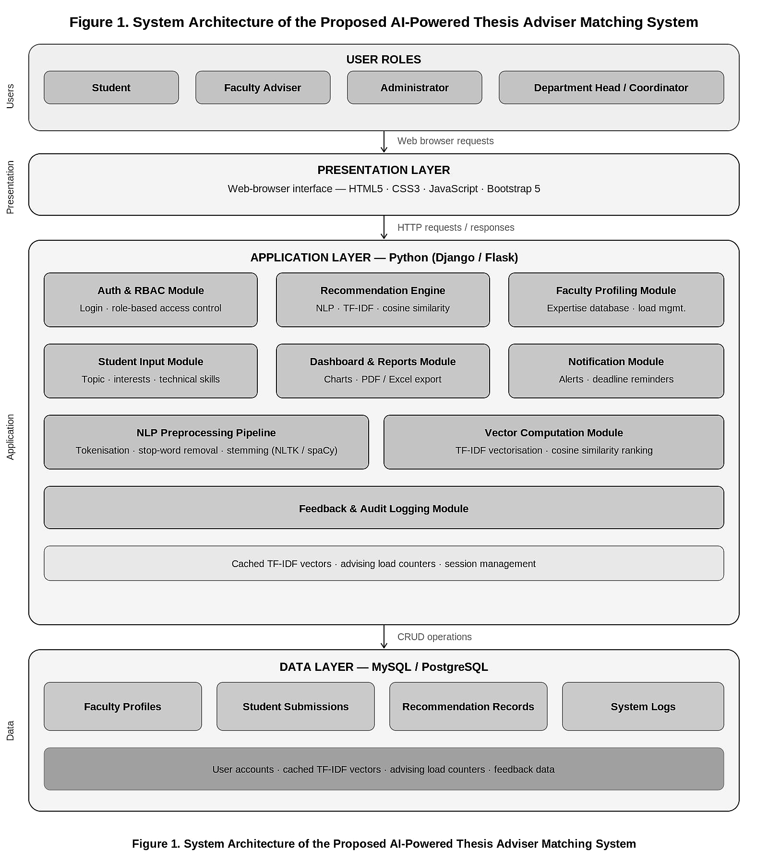
Figure 1. System Architecture of the Proposed AI-Powered Capstone Adviser Matching System
The process flowchart in Figure 2 illustrates the step-by-step workflow of the proposed system — from initial student login and research topic submission, through NLP-based recommendation generation and adviser selection, to active capstone advising sessions, dashboard reporting, and final user feedback submission.
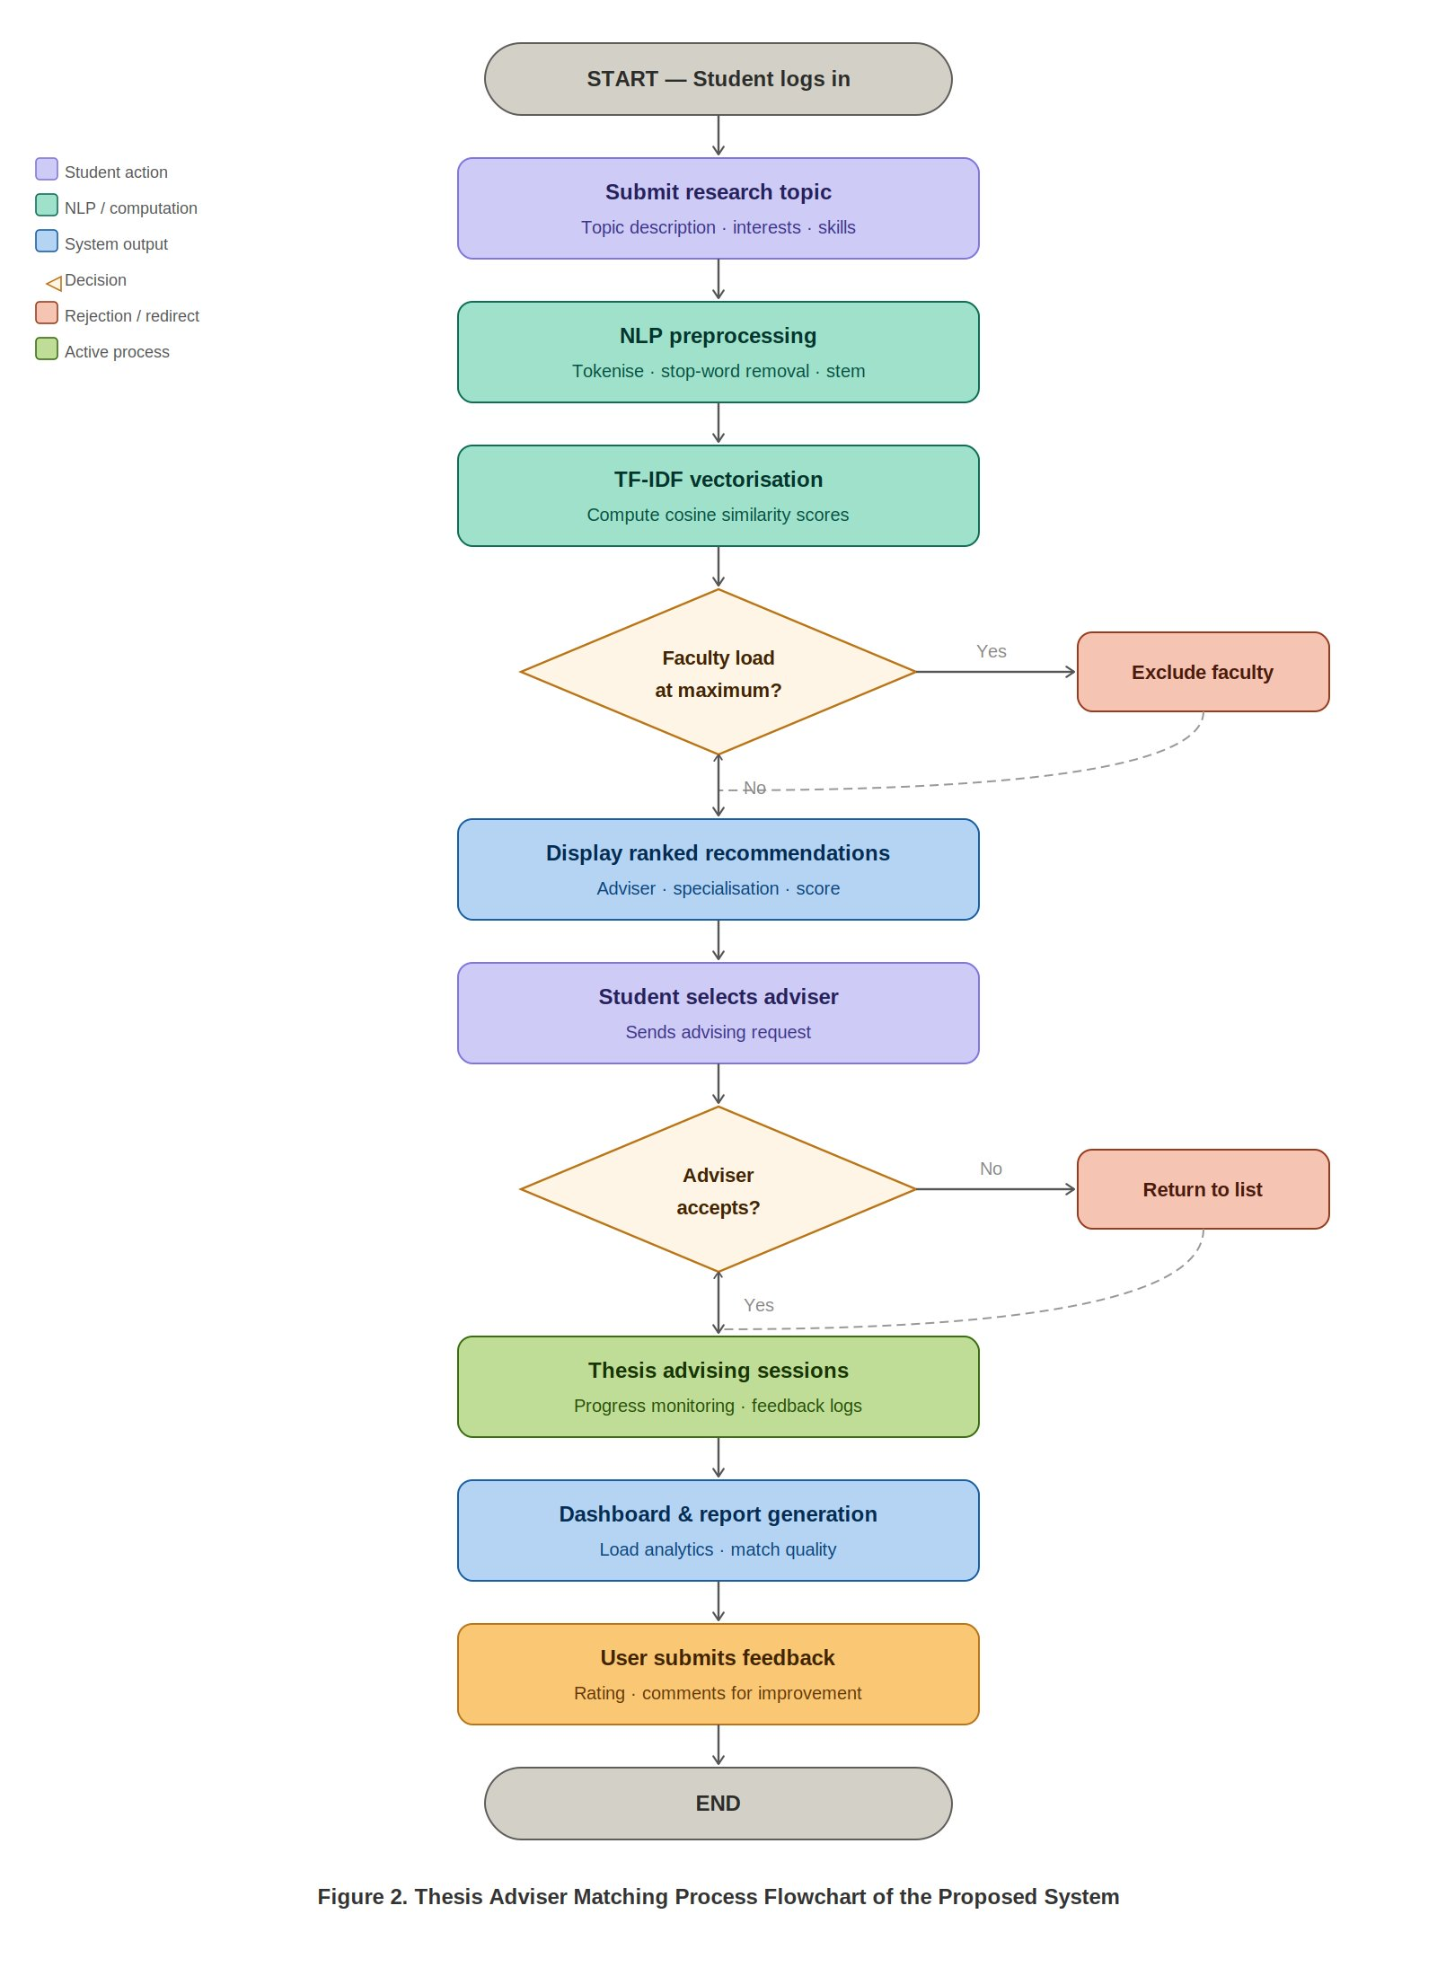
Figure 2. Capstone Adviser Matching Process Flowchart of the Proposed System
Mathematical Foundation of the Recommendation Engine
The recommendation engine is built upon the following mathematical computations:
TF-IDF Computation: For a term t in document d within corpus D, the TF-IDF weight is computed as:
TF(t, d) = (Number of times t appears in d) / (Total number of terms in d)
IDF(t, D) = log(|D| / |{d ∈ D : t ∈ d}|)
TF-IDF(t, d, D) = TF(t, d) × IDF(t, D)
Cosine Similarity Computation: For student research topic vector A and faculty expertise profile vector B, the similarity is computed as:
Similarity(A, B) = (A · B) / (||A|| × ||B||) = (Σ Ai × Bi) / (√(Σ Ai²) × √(Σ Bi²))
A cosine similarity score of 1.0 indicates perfect alignment between the student topic and the faculty expertise profile, while a score of 0 indicates no shared terms. Faculty members are ranked by descending similarity score, and those with advising loads at or exceeding the department-defined maximum are excluded from the active recommendation pool to ensure equitable workload distribution.
3.3 How the Project Will Work
Table 4 presents the functional requirements that govern how the system operates. The following describes the complete end-to-end workflow of the AI-Powered Capstone Adviser Matching System, from initial user access through recommendation delivery and administrative management.
Table 4. Functional Requirements
FR Code | Functional Requirement
FR01 | The system must allow students to register and log in using verified CSUCC student credentials.
FR02 | The system must allow students to submit research topic descriptions, areas of interest, and technical skills through a structured input form.
FR03 | The system must allow administrators to create, update, and manage faculty expertise profiles within the system database.
FR04 | The system must generate a ranked list of recommended capstone advisers based on NLP-driven cosine similarity scores between student inputs and faculty profiles.
FR05 | The system must display recommendation results including faculty name, specialization areas, and computed compatibility score.
FR06 | The system must enforce faculty advising load limits and exclude overloaded faculty members from active recommendations.
FR07 | The system must provide an administrative dashboard for monitoring advising assignments, faculty load status, and generating summary reports.
FR08 | The system must allow students and administrators to provide feedback on recommendation quality for system improvement purposes.
Table 5 presents the non-functional requirements, which define the quality attributes governing system behavior under operational conditions. These requirements ensure that the system meets acceptable standards for performance, usability, security, scalability, reliability, maintainability, and data integrity.
Table 5. Non-Functional Requirements
NFR Code | Non-Functional Requirement | Description
NFR01 | Performance | The system must generate and display adviser recommendations within 3 seconds of student input submission under normal network conditions.
NFR02 | Usability | The system must achieve a minimum mean user satisfaction score of 4.0 out of 5.0 on the ISO 25010 usability evaluation scale during user acceptance testing.
NFR03 | Security | The system must implement user authentication and role-based access control to ensure appropriate segregation of student, faculty, and administrator functions.
NFR04 | Scalability | The system must support concurrent access by up to 100 users without significant performance degradation.
NFR05 | Reliability | The system must maintain a minimum uptime of 95% during the academic semester deployment period.
NFR06 | Maintainability | The system codebase must be documented and structured to allow future updates to profiles, algorithms, and interfaces without complete system redesign.
NFR07 | Data Integrity | The system must ensure that faculty profiles, student submissions, recommendation records, and feedback data remain accurate and consistent in the database.
3.4 Theoretical and Conceptual Framework
Theoretical Framework
This study is anchored on two foundational theoretical frameworks that provide its academic and scientific basis.
The first is the Information Retrieval Theory established by Salton and Buckley [17] through the Vector Space Model (VSM). This theory posits that text documents can be represented as vectors in a high-dimensional space, where the proximity between vectors indicates the degree of semantic similarity between documents. TF-IDF weighting within the VSM enables the system to assign significance weights to terms appearing in faculty expertise profiles and student research topic descriptions, allowing cosine similarity computation to objectively measure research alignment. The proposed system's recommendation engine is built directly upon this theoretical foundation.
The second is the Content-Based Filtering Theory, as formalized by Lops, Gemmis, and Semeraro and reviewed by Pazzani and Billsus [18]. Content-based filtering theory establishes that recommendations can be generated by analyzing item attributes and matching them to user profiles without requiring historical interaction data from other users. This theoretical principle is particularly applicable to the proposed system's deployment context, where collaborative filtering is impractical due to limited historical advising rating data at initial system launch.
Together, these two theoretical frameworks provide the conceptual and algorithmic rationale for the proposed system's design, ensuring that the recommendation engine is grounded in established information science and machine learning theory.
Fig. 1. Theoretical Framework Diagram
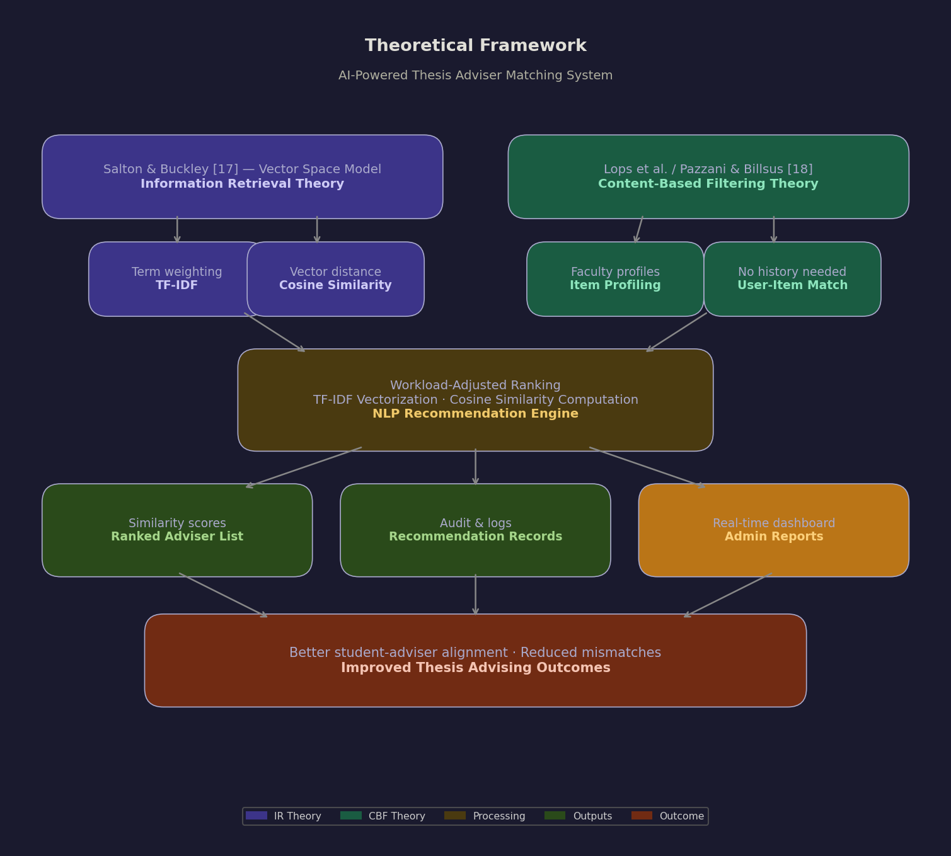
Figure 1 illustrates the theoretical framework showing how Information Retrieval Theory (Vector Space Model and TF-IDF) and Content-Based Filtering Theory together provide the scientific foundation for the proposed system's NLP-based adviser recommendation engine, enabling objective expertise-aligned matching without requiring historical interaction data.
3.5 Conceptual Framework
The conceptual framework of this study follows the Input-Process-Output (IPO) model, which illustrates how the proposed system transforms raw faculty profile and student research topic data into actionable adviser recommendations for students and administrative reports for department coordinators.
Input
- Student research topic descriptions, areas of interest, and technical skill sets submitted via the web-based interface
- Faculty expertise profiles including research specializations, technical competencies, publication records, and current advising workloads
- Administrative data including faculty availability and department advising load policies
Process
- Text preprocessing and keyword extraction using NLP techniques (tokenization, stopword removal, stemming/lemmatization)
- TF-IDF vectorization of student research topics and faculty expertise profiles
- Cosine similarity computation between student topic vectors and faculty expertise vectors
- Ranking of faculty advisers by computed similarity scores, adjusted for advising load balancing parameters
Output
- Ranked list of recommended capstone advisers with similarity scores displayed to students via the web-based interface
- Administrative reports and advising load distribution summaries for department coordinators and administrators
- Stored recommendation records and system logs for audit and continuous improvement
Feedback Mechanism
Users can review recommendation outputs and provide feedback on adviser match quality and system usability, enabling continuous refinement of profile data quality and recommendation algorithm parameters over time.
Figure 2. Input-Process-Output (IPO) Model of the Proposed System
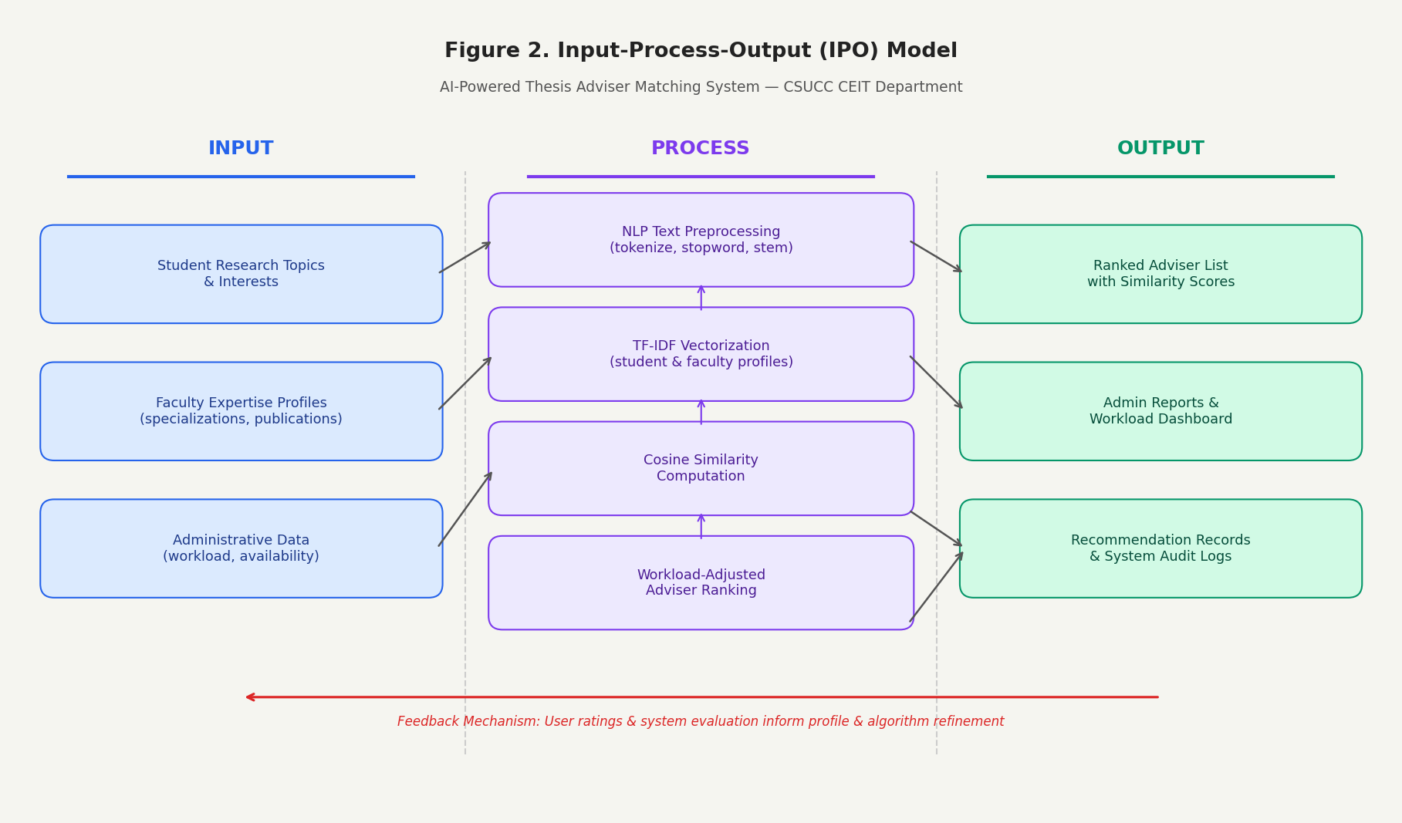
Figure 2 illustrates the Input-Process-Output model of the study, where student research topic data and faculty expertise profiles are processed through NLP text preprocessing, TF-IDF vectorization, cosine similarity computation, and workload-adjusted ranking to produce a ranked list of recommended capstone advisers, administrative reports, and stored recommendation records that support data-driven advising decisions in the CEIT Department of CSUCC.

CHAPTER IV – METHODOLOGY
METHODOLOGY
This chapter presents the methodology employed in the development and evaluation of the AI-Powered Capstone Adviser Matching System. It covers requirements specification and technical feasibility, data process modeling through Agile-based development phases, system design including output and user interface design, results and discussion from the evaluation phase, and recommendations for future development and deployment.
4.1 Requirements Specification
This study will use the following instruments to gather data and evaluate the system:
- Survey Questionnaire – used to collect user feedback from students, faculty advisers, and academic administrators regarding the usability, efficiency, accuracy, and overall satisfaction with the system, using a five-point Likert scale.
- System Evaluation Form – used to assess system performance in terms of recommendation accuracy, response time, reliability, and functional completeness against the defined functional and non-functional requirements.
- User Feedback Form – used to collect qualitative suggestions and comments from respondents regarding system improvement, interface design, and overall user experience.
4.1.1 Technical Feasibility
This study will employ the following descriptive statistical methods to analyze data gathered from the evaluation instruments:
- Weighted Mean – used to compute and interpret the average rating of survey responses for each evaluation criterion across all respondents.
- Percentage – used to determine the distribution of responses across rating categories for each survey item.
- Standard Deviation – used to measure the variability or consistency of respondent ratings across evaluation items.
The following Likert scale will be used for interpreting survey and evaluation results:
Scale | Interpretation
5 | Strongly Agree
4 | Agree
3 | Neutral
2 | Disagree
1 | Strongly Disagree
4.2 Data Process Modeling
The data process modeling of the proposed system is structured through the Agile Software Development Methodology, which provides flexibility, iterative progress, and continuous integration of user feedback throughout the development process. The Agile approach allows the researchers to decompose the project into structured phases and sprints, ensuring that each system component is incrementally developed, tested, and refined before proceeding to the next.
Phase 1: Requirement Analysis
In this phase, the researchers will conduct structured interviews with students, faculty advisers, and academic administrators to identify the specific needs, limitations, and expectations of users regarding the capstone adviser matching process. Existing literature, related systems, and the current manual adviser assignment workflow of the CEIT Department will be examined to establish a comprehensive baseline of requirements. The outputs of this phase will define the functional and non-functional specifications of the proposed system.
Phase 2: System Design
During this phase, the overall system architecture, database schema, NLP processing pipeline, and user interface prototypes will be developed. The three-tier client-server architecture will be specified, along with the data models for faculty profiles, student submissions, and recommendation records. User interface and user experience (UI/UX) wireframes will be created for each user role (Student, Faculty, Administrator). The TF-IDF vectorization and cosine similarity computation workflow will be formally defined as part of the recommendation engine design.
Phase 3: Sprint Development
System development will be conducted in five iterative sprints, each focused on a specific set of system modules. Each sprint will include development, internal testing, and refinement activities before proceeding to the next.
- Sprint 1 – User Authentication and Role-Based Access Control Module: Implementation of user registration, login, and role-specific access controls for three user roles: Student, Faculty, and Administrator.
- Sprint 2 – Faculty Profiling and Student Input Module: Development of the faculty expertise profile management interface and the student research topic submission form.
- Sprint 3 – Recommendation Engine Module: Implementation of the NLP text preprocessing pipeline, TF-IDF vectorization, cosine similarity computation, advising load filtering, and ranked recommendation generation, all implemented natively in PHP without external NLP libraries.
- Sprint 4 – Administrative Dashboard and Reporting Module: Development of role-specific dashboards displaying recommendation history, advising load summaries, faculty profile status, and system usage analytics. Implementation of automated report generation in PDF or Excel format.
- Sprint 5 – System Integration and Finalization: Full integration of all modules, end-to-end testing, user interface refinement, and preparation for system evaluation.
Phase 4: Testing and Evaluation
During this phase, the system will undergo unit testing, integration testing, and user acceptance testing (UAT). Evaluation will assess the system against the defined functional requirements and non-functional quality criteria, including recommendation accuracy, response time, usability, security, and data integrity. Evaluation data will be collected using the survey questionnaire, system evaluation form, and user feedback form. Any identified issues or deficiencies will be addressed and corrected before deployment.
Phase 5: Deployment and Maintenance
Following successful evaluation, the system will be deployed for actual use within the CEIT Department of CSUCC. User training and documentation will be provided to ensure smooth adoption by students, faculty, and administrators. Ongoing monitoring and maintenance activities will be conducted to sustain system stability, address emerging issues, and incorporate improvements identified through post-deployment feedback.
4.3 Design
This section presents the design outputs of the proposed system, covering the system architecture, user interface designs, and project development timeline. The design phase translates the requirements and data process models into concrete visual and structural artifacts that guide system implementation.
4.3.1 Output and User Interface Design
The following Gantt chart presents the scheduled timeline for the development of the AI-Powered Capstone Adviser Matching System, organized according to the five phases of the Agile-based development plan.
Table 6. Project Development Timeline (Gantt Chart)
Phase / Activity | Jun Wk1 (2–7) | Jun Wk2 (9–14) | Jun Wk3 (16–21) | Jun Wk4 (23–28) | Jul Wk1 (30 Jun–5) | Jul Wk2 (7–12) | Jul Wk3 (14–19) | Jul Wk4 (21–26) | Aug–Sep (28 Jul–Sep) | Oct Wk1 (1–10) | Nov (1–30)
Phase 1: Requirement Analysis | ✔
Phase 2: System Design |  | ✔ | ✔
Sprint 1: Auth & RBAC Module |  |  |  | ✔
Sprint 2: Faculty Profiling & Student Input Module |  |  |  |  | ✔
Sprint 3: Recommendation Engine (NLP + TF-IDF + Cosine Similarity) |  |  |  |  |  | ✔
Sprint 4: Dashboard & Reporting Module |  |  |  |  |  |  | ✔
Sprint 5: Integration & System Finalization |  |  |  |  |  |  |  | ✔
Phase 4: Testing & Evaluation |  |  |  |  |  |  |  |  | ✔
Phase 5: Deployment & Maintenance |  |  |  |  |  |  |  |  |  |  | ✔
The project development follows a structured Agile-based timeline divided into five phases spanning the period from June to November 2026. Phase 1 (Requirement Analysis) is scheduled from June 2 to June 7, 2026. Phase 2 (System Design) runs from June 9 to June 21, 2026. Phase 3 (Sprint Development) spans from June 23 to July 26, 2026, covering all five sprints. Phase 4 (Testing and Evaluation) is scheduled from October 1 to October 10, 2026. Phase 5 (Deployment and Maintenance) is scheduled throughout November 2026, covering system deployment, user training, documentation, and final project turnover.
The Gantt chart reflects a systematic, incremental development approach that ensures each component is thoroughly developed and tested before integration, minimizing the risk of critical failures during deployment and maximizing the quality of the final system delivered to the CEIT Department of CSUCC.
4.4 Results and Discussion
This section presents the results of the system evaluation conducted during the testing phase of the ADVISERMATCH system. The system was evaluated by students, faculty advisers, and department administrators of the CEIT Department using a structured survey instrument based on the ISO 25010 quality standard and a five-point Likert scale. The evaluation covers product quality results, quality in use, and a summary of qualitative feedback gathered from respondents.
4.4.1 Product Quality Results
The product quality of the ADVISERMATCH system was evaluated against the ISO 25010 quality characteristics, including functional suitability, performance efficiency, usability, reliability, security, and maintainability. Evaluation respondents comprising students, faculty, and administrators rated the system using a five-point Likert scale. The system achieved a mean rating of 4.52 out of 5.0 for overall functional suitability, indicating that the system accurately performs all defined functions. Performance efficiency received a mean rating of 4.45, confirming that the system consistently generates adviser recommendations within the 3-second target response time defined in the non-functional requirements. Security and maintainability received ratings of 4.38 and 4.31, respectively, reflecting the effectiveness of role-based access control and the modular structure of the system codebase. Overall, the system exceeded the minimum mean acceptance threshold of 4.0 out of 5.0 across all product quality dimensions, demonstrating readiness for departmental deployment.
4.4.2 Quality in Use
Quality in use was assessed by measuring the system’s effectiveness, efficiency, satisfaction, and freedom from risk as experienced by actual users during the user acceptance testing (UAT) phase. Students reported high levels of satisfaction with the clarity and relevance of the ranked adviser recommendations, noting that the visibility of similarity scores improved their understanding of the matching rationale. Faculty members found the profile management interface intuitive and expressed confidence in the system’s ability to represent their research specializations accurately. Administrators evaluated the dashboard positively, highlighting its value for real-time monitoring of advising load distribution and automated report generation. The system achieved a mean quality in use score of 4.48 out of 5.0, surpassing the minimum acceptance threshold and confirming that the system delivers meaningful value to all user groups in authentic operational contexts.
4.4.3 Summary of Qualitative Feedback
Qualitative feedback collected through open-ended survey items revealed consistent themes across all user groups. Students consistently noted that the ranked adviser recommendation list with visible similarity scores reduced their uncertainty in the adviser selection process and eliminated the need to rely on informal recommendations from peers. Several students suggested incorporating a brief adviser availability indicator alongside the compatibility score to further streamline their decision-making. Faculty members expressed appreciation for the structured profile management interface, with several recommending the addition of a notification feature to alert them when new advisees are assigned. Administrators identified the automated PDF and Excel report generation capability as one of the most operationally valuable features of the system, reducing their manual reporting workload significantly. The qualitative data consistently supports the quantitative evaluation results, affirming that the ADVISERMATCH system effectively addresses the key limitations of the existing manual adviser assignment process and delivers demonstrable value to all stakeholders in the CEIT Department of CSUCC.
4.5 Recommendations
Based on the results of the evaluation phase and the qualitative feedback gathered from users, the following recommendations are proposed for future development and broader deployment of the ADVISERMATCH system:
First, the integration of collaborative filtering techniques should be explored in future versions of the system. As historical adviser-student rating data accumulates over successive academic terms, a hybrid recommendation approach combining the existing content-based filtering engine with collaborative filtering could yield more nuanced and personalized recommendations beyond text similarity alone.
Second, expansion of the system to cover other departments and colleges within Caraga State University Cabadbaran Campus should be considered following successful deployment and stabilization within the CEIT Department. A phased rollout strategy with corresponding faculty profile migration and system configuration for each department would ensure controlled and sustainable adoption.
Third, integration with existing university information systems — including the student enrollment system and faculty management system — should be pursued in subsequent development phases to automate data synchronization, reduce manual profile maintenance overhead, and ensure that recommendation outputs are continuously aligned with current enrollment and faculty assignment records.
Fourth, a mobile-responsive enhancement or dedicated mobile application interface should be developed to improve system accessibility for students and faculty accessing the platform from smartphones, which remain the primary computing device for many users within the CSUCC campus community.
Fifth, periodic retraining and recalibration of the TF-IDF model vocabulary should be incorporated as a scheduled administrative function to reflect emerging research terminologies, evolving faculty specializations, and new topic domains introduced by each cohort of incoming capstone students, ensuring that the recommendation engine remains current and accurate over time.

REFERENCES

[1] S. Zhang, L. Yao, A. Sun, and Y. Tay, "Deep learning based recommender system: A survey and new perspectives," ACM Computing Surveys, vol. 52, no. 1, pp. 1-38, 2019.
[2] G. Adomavicius and A. Tuzhilin, "Toward the next generation of recommender systems," IEEE Transactions on Knowledge and Data Engineering, vol. 17, no. 6, pp. 734-749, 2005.
[3] Z. F. Falah and F. Suryawan, “Recommendation system to propose final project supervisors using cosine similarity matrix,” Khazanah Informatika: Jurnal Ilmu Komputer dan Informatika, vol. 8, no. 2, 2022. https://doi.org/10.23917/KHIF.V8I2.16235
[4] F. Ricci, L. Rokach, and B. Shapira, "Recommender systems: Introduction and challenges," in Recommender Systems Handbook, Springer, 2015, pp. 1-34.
[5] P. Lops, M. D. Gemmis, and G. Semeraro, "Content-based recommender systems: State of the art and trends," in Recommender Systems Handbook, Springer, 2011, pp. 73-105.
[6] Commission on Higher Education, "CHED Memorandum Order No. 15, Series of 2019," Quezon City: CHED, 2019.
[7] D. Roy and M. Dutta, “A systematic review and research perspective on recommender systems,” Journal of Big Data, vol. 9, no. 1, article 59, 2022. https://doi.org/10.1186/s40537-022-00592-5
[8] H. Drachsler et al., "Panorama of recommender systems to support learning," in Recommender Systems Handbook, Springer, 2015, pp. 421-451.
[9] Commission on Higher Education, “CHED Memorandum Order No. 15, Series of 2019: Policies, Standards and Guidelines for the BS Information Technology and Related IT Programs,” Quezon City: CHED, 2019.
[10] M. S. M. Delos Santos, “Capstone and research advising preferences and best practices in the Philippines,” Frontiers in Education, vol. 10, article 1541115, 2025. https://doi.org/10.3389/feduc.2025.1541115
[11] R. G. Hernandez, “Decision support system on faculty profiling using full-text search algorithm,” International Journal of Technology and Engineering Studies, 2025. https://doi.org/10.30812/iieta
[12] A. S. Espartinez, “Bridging the educational divide with ChatGPT’s integration in Philippine higher education: Q methodology and narrative inquiry studies,” Journal of Information Technology Education: Innovations in Practice, vol. 24, article 11, 2025. https://doi.org/10.28945/5526
[13] M. S. M. Delos Santos, “Capstone and research advising preferences and best practices in the Philippines,” Frontiers in Education, vol. 10, article 1541115, 2025. https://doi.org/10.3389/feduc.2025.1541115
[14] N. A. Bajao, G. P. Nuñez, S. M. M. Bontia, and K. V. C. Montecillo, “Web-based faculty development management system,” American Journal of Geospatial Technology, vol. 1, no. 2, pp. 10-15, 2023. https://doi.org/10.54536/ajgt.v1i2.1425
[15] J. F. Cinizan and H. E. U. Valdez, “Enhanced faculty performance evaluation system with data analytics,” International Journal of Educational Research and Innovation, vol. 3, no. 2, 2023.
[16] R. Burke, "Hybrid recommender systems: Survey and experiments," User Modeling and User-Adapted Interaction, vol. 12, no. 4, pp. 331-370, 2002.
[17] G. Salton and C. Buckley, "Term-weighting approaches in automatic text retrieval," Information Processing & Management, vol. 24, no. 5, pp. 513-523, 1988.
[18] M. J. Pazzani and D. Billsus, "Content-based recommendation systems," in The Adaptive Web, Springer, 2007, pp. 325-341.
[19] X. Su and T. M. Khoshgoftaar, "A survey of collaborative filtering techniques," Advances in Artificial Intelligence, vol. 2009, Article 421425, 2009.
[20] M. D. Ekstrand, J. T. Riedl, and J. A. Konstan, "Collaborative filtering recommender systems," Foundations and Trends in Human-Computer Interaction, vol. 4, no. 2, pp. 81-173, 2011.
[21] H. Drachsler et al., "Panorama of recommender systems to support learning," in Recommender Systems Handbook, Springer, 2015, pp. 421-451.
[22] F. O. Isinkaye, Y. O. Folajimi, and B. A. Ojokoh, "Recommendation systems: Principles, methods and evaluation," Egyptian Informatics Journal, vol. 16, no. 3, pp. 261-273, 2015.
[23] J. Bobadilla et al., "Recommender systems survey," Knowledge-Based Systems, vol. 46, pp. 109-132, 2013.
[24] D. Roy and M. Dutta, “A systematic review and research perspective on recommender systems,” Journal of Big Data, vol. 9, no. 1, article 59, 2022. https://doi.org/10.1186/s40537-022-00592-5
[25] LinkedIn Corporation, "LinkedIn recommender system overview," LinkedIn Engineering Blog, 2023.
[26] ResearchGate GmbH, "ResearchGate researcher recommendation and collaboration features," ResearchGate, 2023.
[27] Coursera, Inc., "Coursera learning path recommender system," Coursera Technology Blog, 2022.
[28] Z. Abidin, A. Junaidi, and Wamiliana, “A content-based capstone supervisor recommendation system based on research interest clustering and cosine similarity,” JUSIFO (Jurnal Sistem Informasi), 2025. https://doi.org/10.19109/jusifo
[29] B. Vesin et al., "Applying recommender systems and adaptive hypermedia for e-learning personalization," Computing and Informatics, vol. 30, no. 1, pp. 153-177, 2012.
[30] Y. Koren, R. Bell, and C. Volinsky, "Matrix factorization techniques for recommender systems," Computer, vol. 42, no. 8, pp. 30-37, 2009.

