Yash Soni

2/7/2019

Comp Org   
Programming Report – Project 1

Code for “first” program:

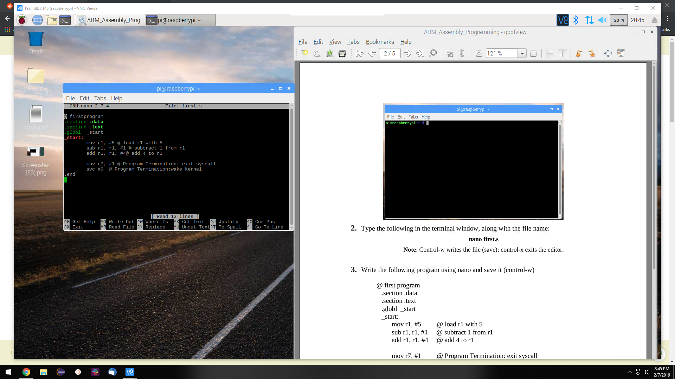

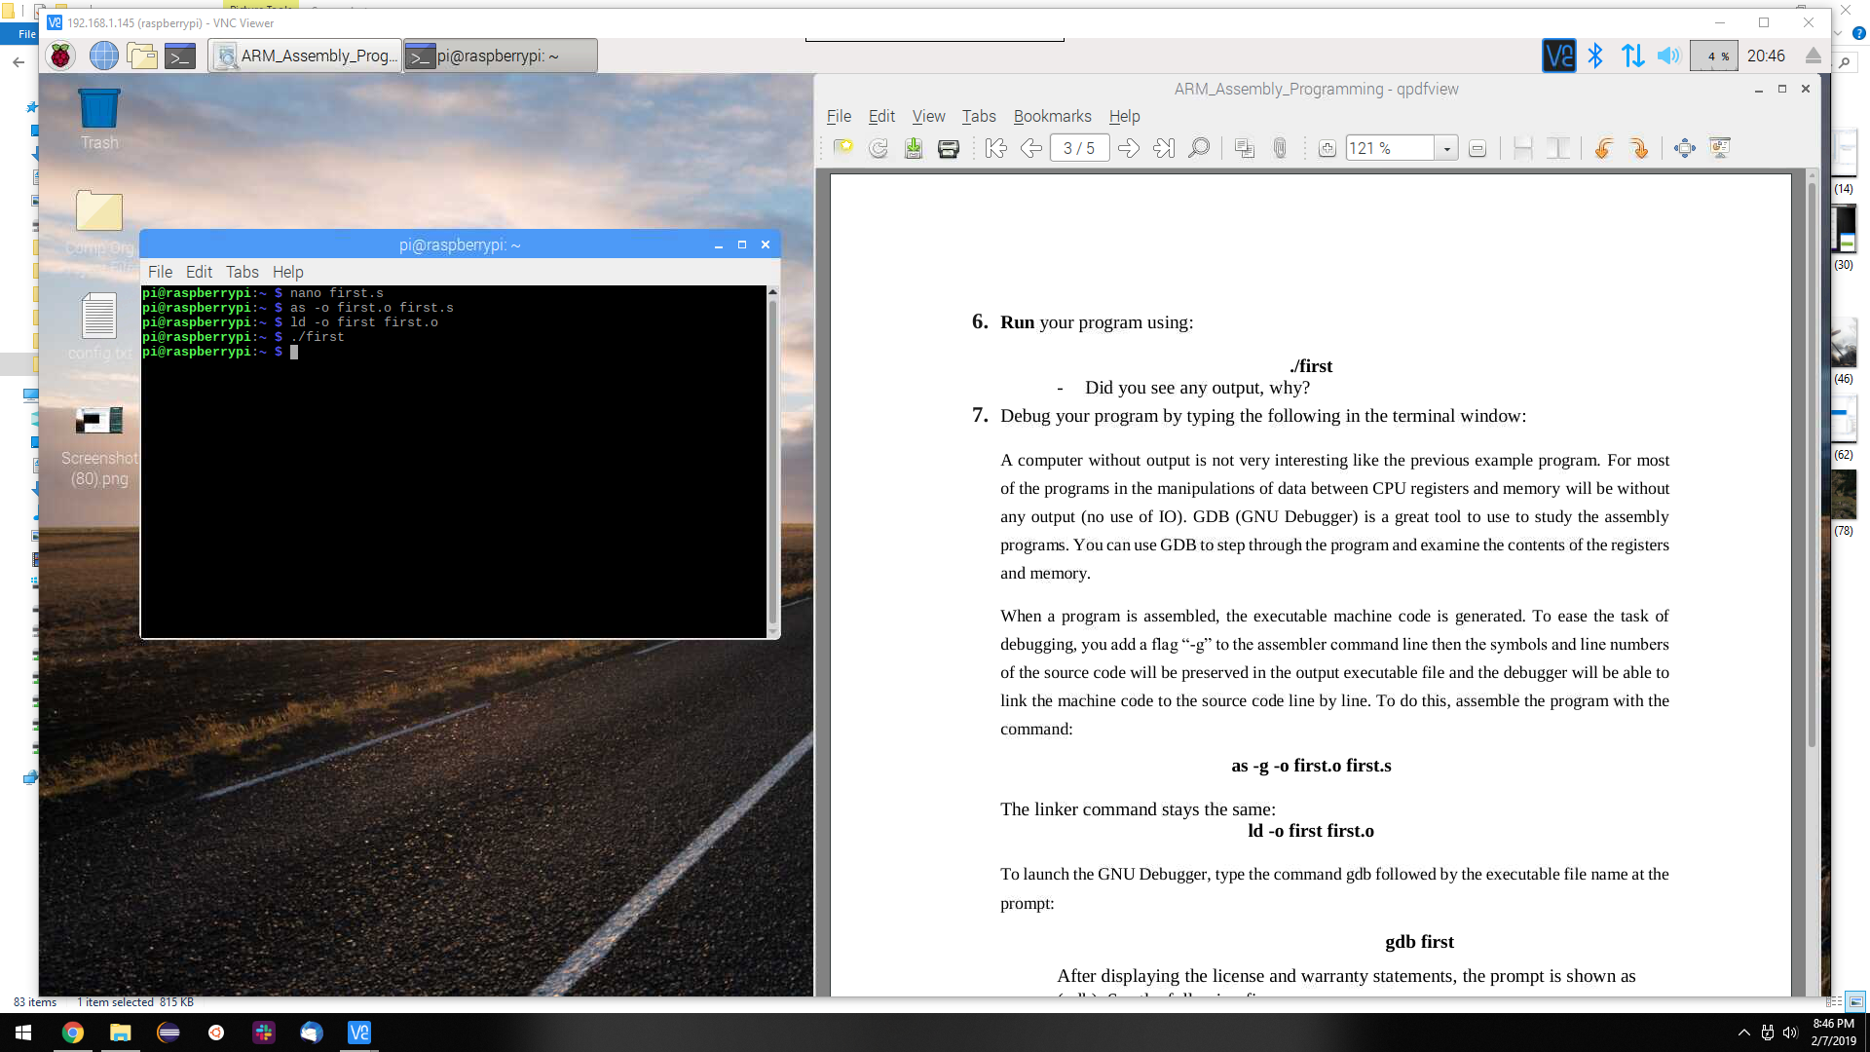

After, executing the program there was no result that was outputted by the terminal. This is not strange behavior, it is totally normal for Assembly Language to not output any result when executing.

Only way to get access to the output Assembly Language is through the respective Debugger.

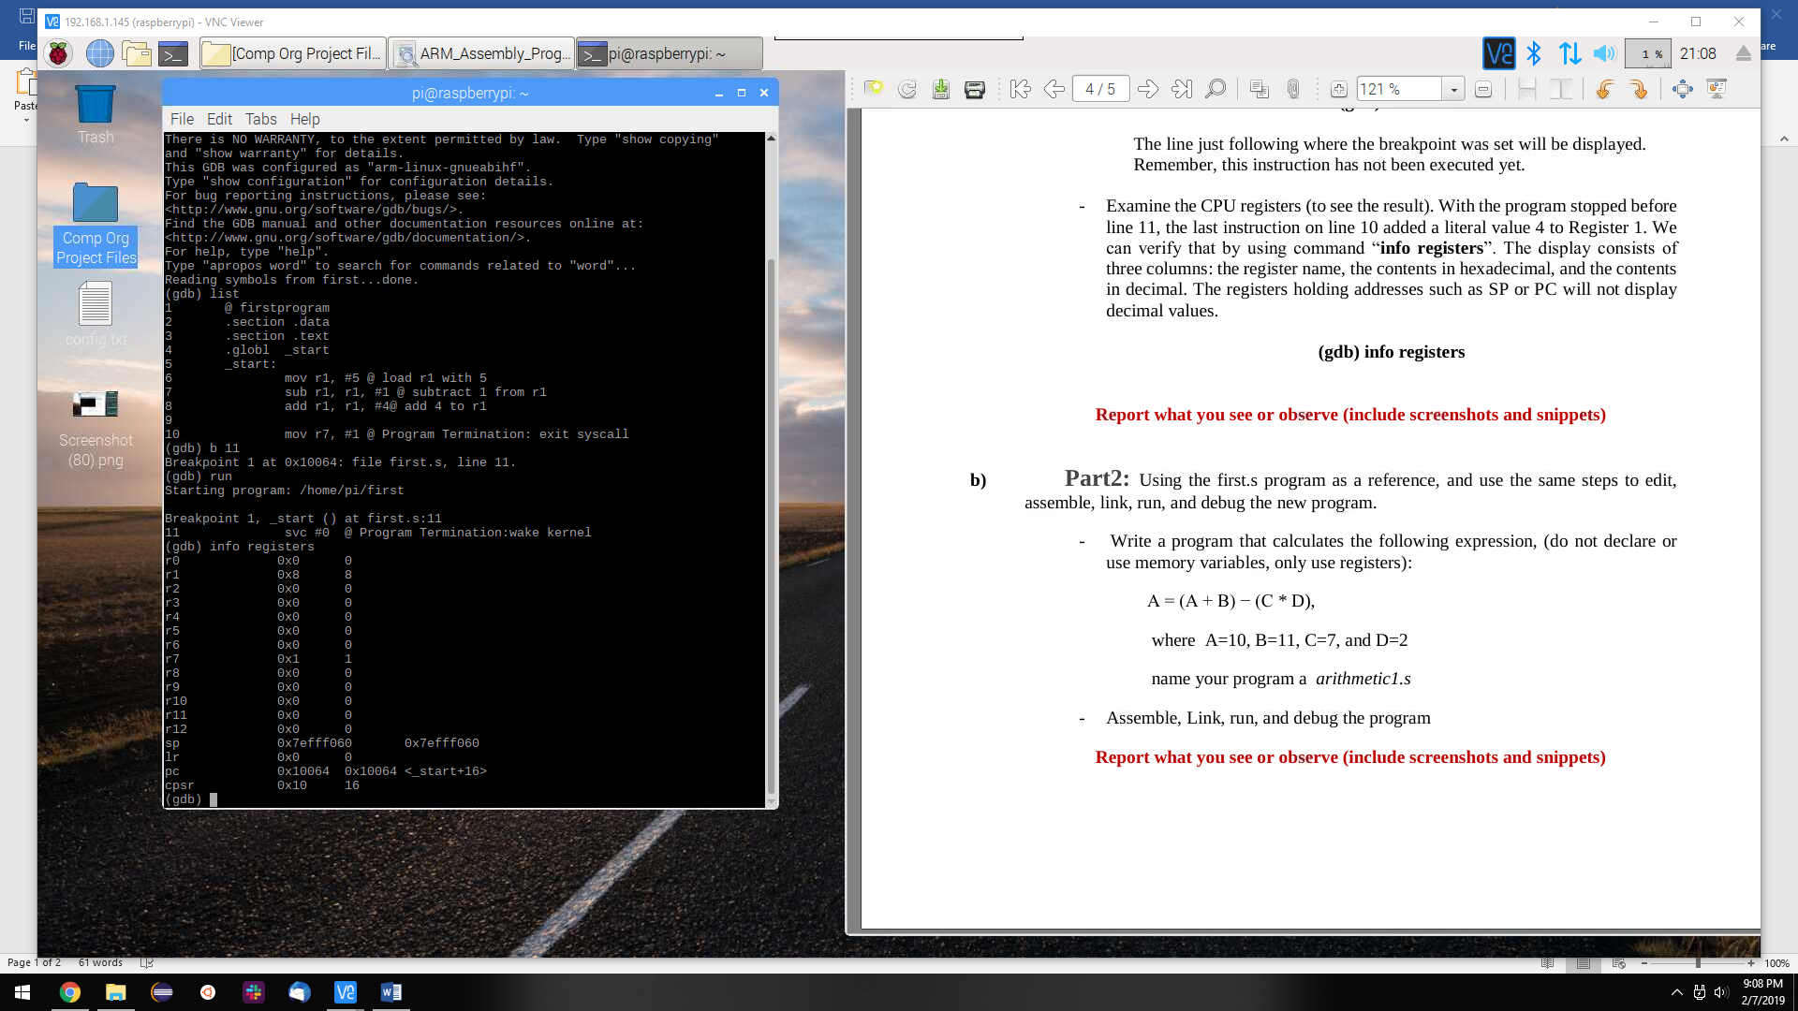

In the screenshot above, each of the CPU registers hold a value, which may be assigned to them. In the case above, only Register r1 was used. r0-r5, r8-12 are available register that one might use to store their data.   
  
Since, only r1 was used, the final value for r1 that appears in the debugger is the result for the problem.

Arithmetic1 Program:

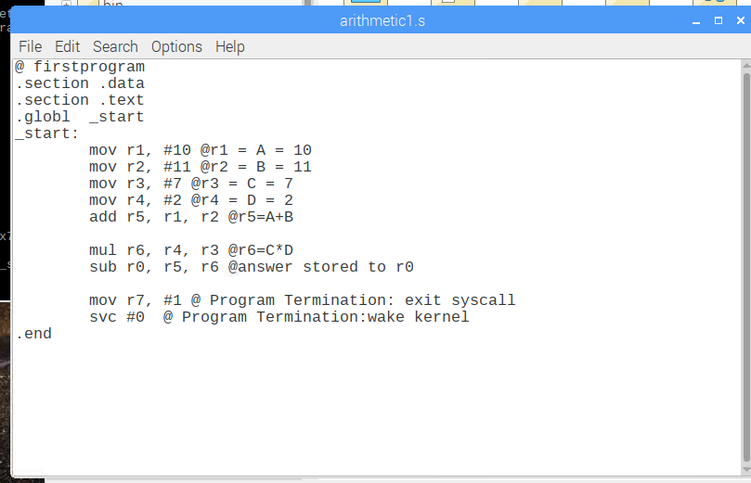

Above was the program used to solve the problem below:

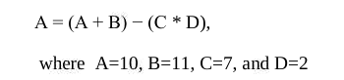

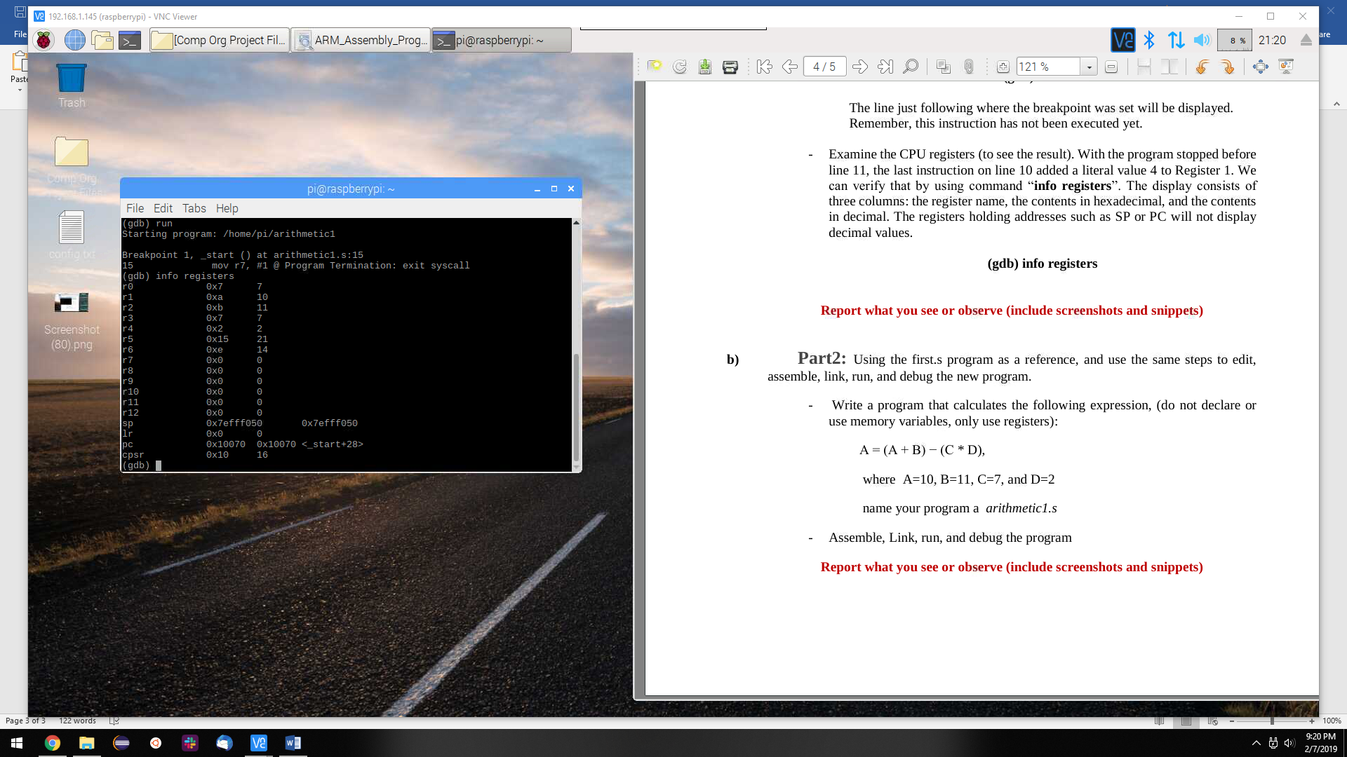

After, debugging the program it was observed that more than one register had to be used in order to solve the problem. The procedure was the same for tackling the program, only the method to solve it was different.