Worksheet 2

Student Name: Aryan UID: 25MCI10082
Branch: MCA (AI&ML) Section/Group: 1/A
Semester: 2nd Date of Performance: 30/03/2026
Subject Name: DBMS LAB Subject Code:

1. Aim of the Session

Implementation of joins in PostgreSQL (inner join ,left join,right join, self join and cross join).

2. Objective of the Session

Apply joins to a real-world database schema (e.g., Students, Courses, Enrollments, Departments)

3. Practical / Experiment Steps

Design the database schema for different tables.

Create table using appropriate constraints.

Insert sample records into tables.

Perform joins.

4. Procedure of the Practical

(i) Start the system and log in to the computer.

(ii) Open PostgreSQL software.

(iii) create database Experiment7;

(iv) Create a tables.

CREATE TABLE departments (

department_id INT PRIMARY KEY,

department_name VARCHAR(50)

);

CREATE TABLE students (

student_id INT PRIMARY KEY,

name VARCHAR(50),

department_id INT,

FOREIGN KEY (department_id) REFERENCES departments(department_id)

);

CREATE TABLE courses (

course_id INT PRIMARY KEY,

course_name VARCHAR(50)

);

CREATE TABLE enrollments (

student_id INT,

course_id INT,

PRIMARY KEY (student_id, course_id),

FOREIGN KEY (student_id) REFERENCES students(student_id),

FOREIGN KEY (course_id) REFERENCES courses(course_id)

);

(v) Insert records using DML commands.

INSERT INTO departments VALUES

(1, 'Computer Science'),

(2, 'Mechanical'),

(3, 'Electrical');

INSERT INTO students VALUES

(1, 'Aryan', 1),

(2, 'Rohit', 2),

(3, 'Priya', 1),

(4, 'Simran', 3),

(5, 'Karan', NULL);

INSERT INTO courses VALUES

(101, 'DBMS'),

(102, 'OS'),

(103, 'Maths'),

(104, 'Physics');

INSERT INTO enrollments VALUES

(1, 101),

(1, 102),

(2, 103),

(3, 101);

(vi) Queries to list students with their enrolled courses (INNER JOIN).

SELECT s.name,c.course_name

FROM students s

INNER JOIN enrollments e ON s.student_id = e.student_id

INNER JOIN courses c ON e.course_id = c.course_id;

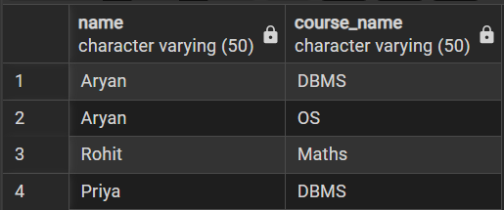

(vii) Students not enrolled in any course (LEFT JOIN).

SELECT s.name

FROM students s

LEFT JOIN enrollments e ON s.student_id = e.student_id

WHERE e.course_id IS NULL;

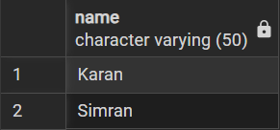

(viii) Courses with or without enrolled students (RIGHT JOIN).

SELECT c.course_name, s.name

FROM students s

RIGHT JOIN enrollments e ON s.student_id = e.student_id

RIGHT JOIN courses c ON e.course_id = c.course_id;

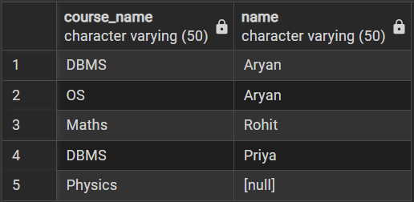

(ix) Students with department info using SELF JOIN or multiple joins.

SELECT s.name, d.department_name

FROM students s

LEFT JOIN departments d ON s.department_id = d.department_id;

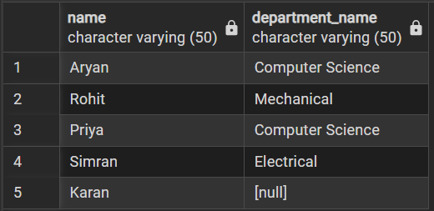

(x) Display all possible student-course combinations (CROSS JOIN).

SELECT s.name, c.course_name

FROM students s

CROSS JOIN courses c;

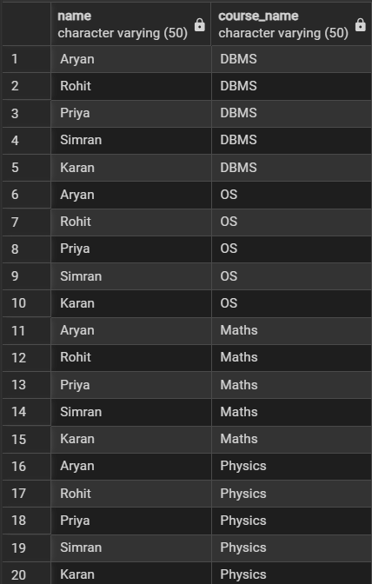

Learning Outcomes
- Understand the concept of relational databases and how data is distributed across multiple tables.
- Apply different types of SQL joins such as INNER JOIN, LEFT JOIN, RIGHT JOIN, SELF JOIN, and CROSS JOIN.
- Retrieve meaningful information by combining data from multiple related tables like Students, Courses, Enrollments, and Departments.
- Identify the appropriate join type based on the problem requirement and data relationship.
- Analyze query results to understand how NULL values and unmatched records are handled in different joins.

