Name – Aryan UID – 25MCI10082
Leetcode Problem – 1587
Code-
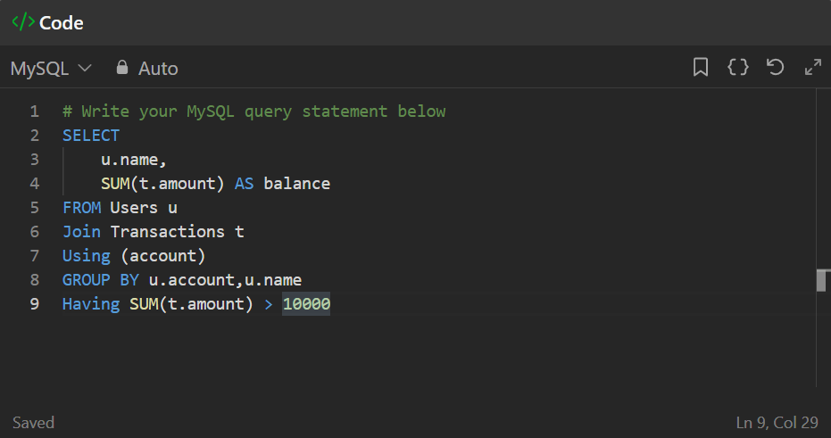

Submission-
