Worksheet 3

Student Name: Aryan UID: 25MCI10082
Branch: MCA (AI&ML) Section/Group: 1/A
Semester: 2nd Date of Performance: 22/01/2026
Subject Name: DBMS LAB Subject Code:

1. Aim of the Session

To implement conditional decision-making logic in PostgreSQL using IF–ELSE constructs and CASE expressions for classification, validation, and rule-based data processing.

2. Tools Used
- PostgreSQL

3. Objective of the Session
- To understand conditional execution in SQL
- To implement decision-making logic using CASE expressions
- To simulate real-world rule validation scenarios
- To classify data based on multiple conditions
- To strengthen SQL logic skills required in interviews and backend systems

4. Practical / Experiment Steps
- Design the database schema for implementing conditional logic.
- Create tables using appropriate constraints.
- Insert sample records into tables.
- Perform data classification using CASE expressions.
- Perform conditional data updates using CASE logic.
- Implement IF–ELSE logic using PL/pgSQL blocks.
- Perform custom sorting using CASE expressions.
- Display and verify results.

5. Procedure of the Practical

(i) Start the system and log in to the computer.

(ii) Open PostgreSQL software.

(iii) create database Experiment3;

(iv) Create a table to store schema-level violations.

CREATE TABLE schema_violations (

schema_id INT PRIMARY KEY,

schema_name VARCHAR(50),

violation_count INT

);

(v) Insert records using DML commands.

INSERT INTO schema_violations VALUES

(1, 'Finance', 0),

(2, 'HR', 2),

(3, 'Sales', 6),

(4, 'Audit', 12);

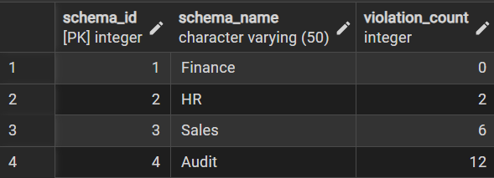

(vi) Classifying Data Using CASE Expression

SELECT

schema_name,

violation_count,

CASE

WHEN violation_count = 0 THEN 'No Violation'

WHEN violation_count BETWEEN 1 AND 3 THEN 'Minor Violation'

WHEN violation_count BETWEEN 4 AND 7 THEN 'Moderate Violation'

ELSE 'Critical Violation'

END AS violation_status

FROM schema_violations;

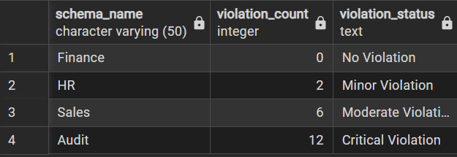

(vii) Applying CASE Logic in Data Updates

ALTER TABLE schema_violations

ADD COLUMN approval_status VARCHAR(20);

UPDATE schema_violations

SET approval_status =

CASE

WHEN violation_count = 0 THEN 'Approved'

WHEN violation_count <= 5 THEN 'Needs Review'

ELSE 'Rejected'

END;

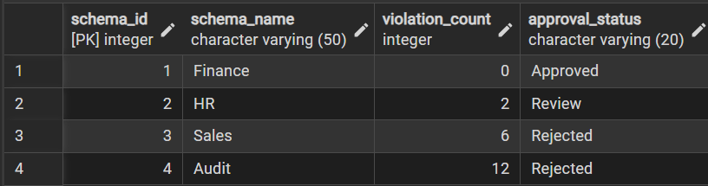

(viii) Implementing IF–ELSE Logic Using PL/pgSQL.

DO $$

DECLARE

v_count INT := 6;

BEGIN

IF v_count = 0 THEN

RAISE NOTICE 'No violations detected.';

ELSIF v_count <= 5 THEN

RAISE NOTICE 'Minor issues found. Review required.';

ELSE

RAISE NOTICE 'Critical violations detected!';

END IF;

END $$;

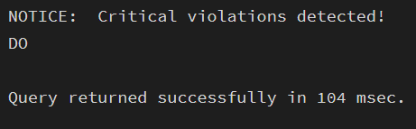

(ix) Real-World Classification Scenario (Grading System).

CREATE TABLE students (

student_id INT PRIMARY KEY,

student_name VARCHAR(50),

marks INT

);

INSERT INTO students VALUES

(1, 'Aman', 85),

(2, 'Riya', 72),

(3, 'Kunal', 58),

(4, 'Neha', 40);

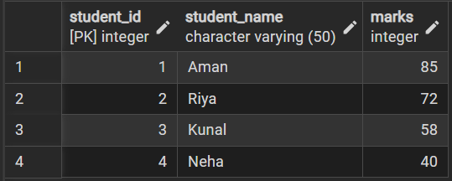

Grade Classification.

SELECT

student_name,

marks,

CASE

WHEN marks >= 80 THEN 'A'

WHEN marks >= 60 THEN 'B'

WHEN marks >= 50 THEN 'C'

ELSE 'Fail'

END AS grade

FROM students;

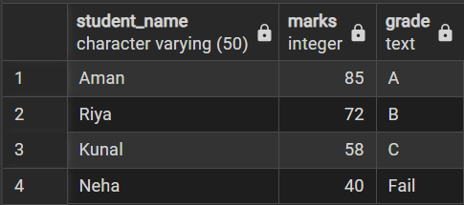

(xi) Using CASE for Custom Sorting

SELECT schema_name, violation_count

FROM schema_violations

ORDER BY

CASE

WHEN violation_count = 0 THEN 1

WHEN violation_count <= 3 THEN 2

WHEN violation_count <= 7 THEN 3

ELSE 4

END;

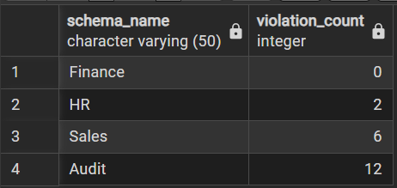

Learning Outcomes
- How data can be filtered to retrieve only relevant records from a database.
- Learn how sorting improves readability and usefulness of query results in reports.
- Gain the ability to group data for analytical purposes.
- Differentiate between row-level conditions and group-level conditions.
- Develop confidence in writing analytical SQL queries used in real-world scenarios.
- Better prepared to answer SQL-based placement and interview questions related to filtering, grouping, and aggregation.

