**MySpace Loader - Quickhelp**

Overview

1. How to download music
2. What can I do if an error happens?

1. How to download music

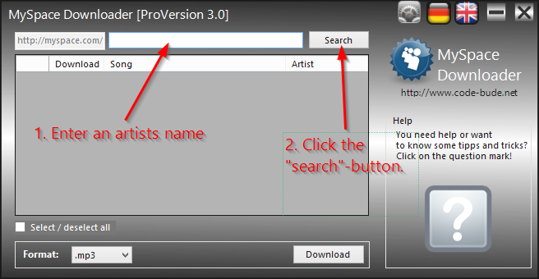Enter an artist’s name (the name of the myspace profile page) and click on the search button.

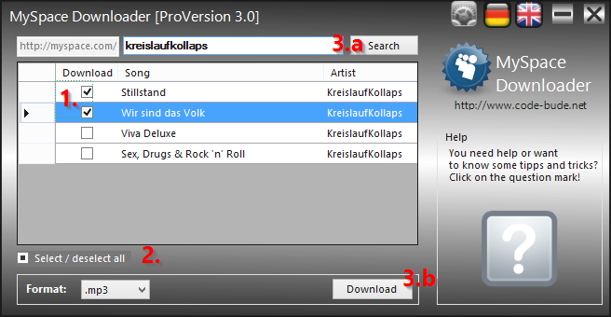

1. Check the boxes left to the song names for each song you want to download
2. Click the checkbox on bottom if you want to select or deselect all songs
3. a) Start another search if you want to download from various artists at the same time. Already checked songs will be kept even for the following searches.  
   b) Click on the download button to start the download.

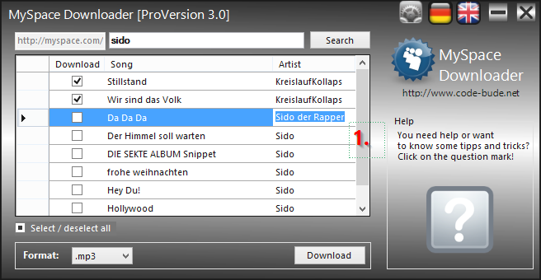

1. If you double click on an artists name before download, you can change it. This also takes effect on the filenames and ID3-tags set by the MySpace Downloader

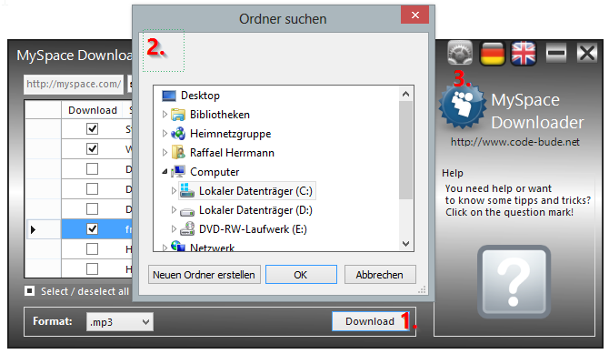

1. After clicking the download button (1.) you have to choose the download folder.
2. You can preset a custom folder in the settings dialog (3.)

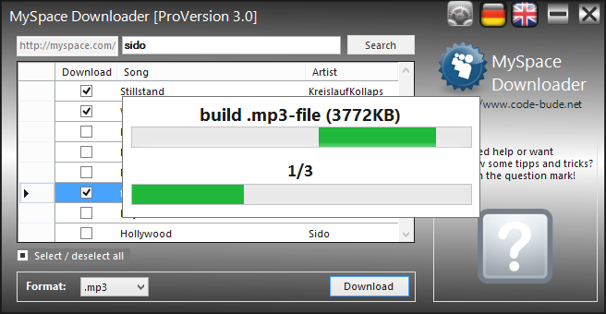

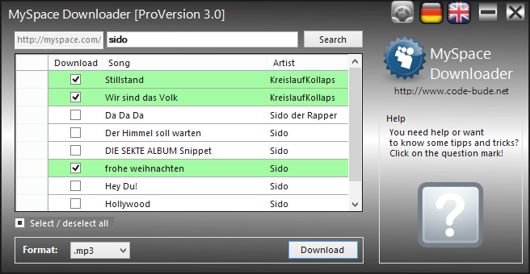

When downloads are finished, the downloader marks all songs. If a song has got a green background the download was finishes without problems.   
If the backcolor is red there was a problem. You should try to download it again. If there’s another time an error, you should read on and learn how to behave if there’s an error.

2. What can I do if an error happens?

From version 3.0 of the MySpace Loader on, there’s a debug & help mode implemented. Write the following phrase in the artist’s field:

/debug=1

You should get some feedback now. After the debug mode is activated. Use the downloader like you used it before. After getting the error, look into the folder where the MySpace Loader.exe is stored. There should be a file called “error_log.txt” send this file or its **exact** contents to me. You could write a comment on the MySpace Loader article at [www.code-bude.net](http://www.code-bude.net) or send a mail to [netblognet@googlemail.com](mailto:netblognet@googlemail.com)