**Tableau**

**\**

1. **Using the superstore dataset identify the product category with highest profit margin ratio? Use calculated field to input the formula (Profit divided by Sales)**

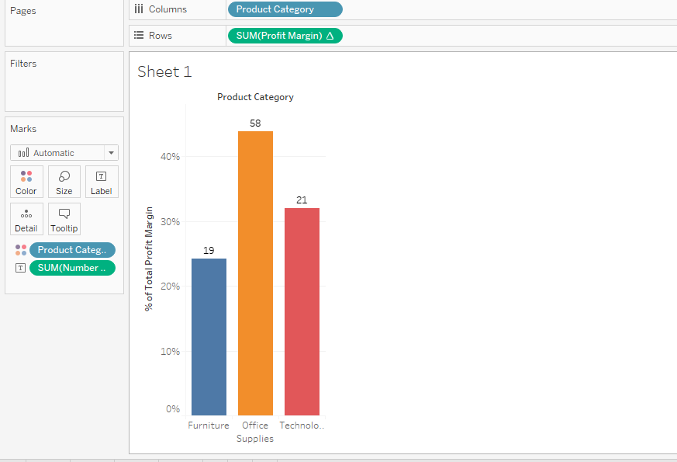

1. **Data Joins and blends Topic: Load the sample superstore dataset and find the total value in sales revenues for the returned goods. Which Product category has the highest returns**

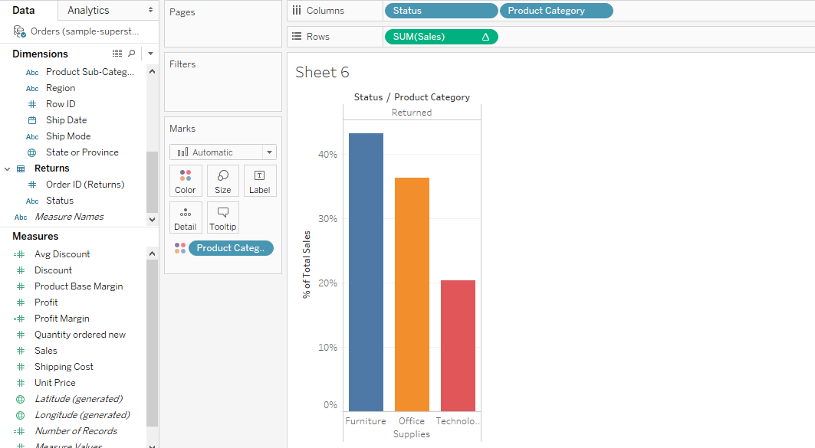

1. **Data filters and instant calculations Topic: Load the sample superstore dataset and calculate the total percentage of sales that were shipped through a SMALL BOX, SMALL PACK & WRAP BAG**

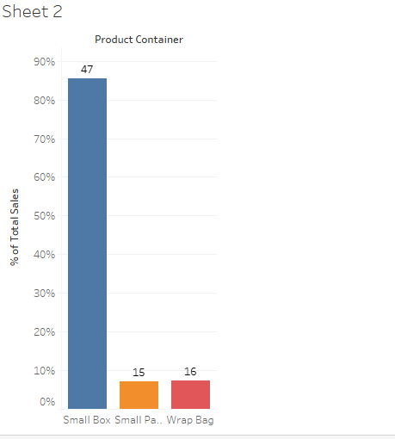

1. **Explain relationship between discount and sales measures**

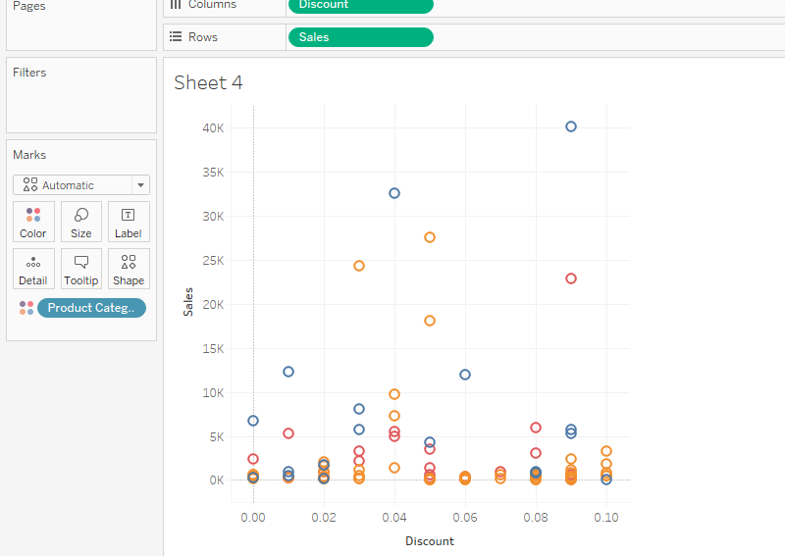

1. **What is the Average discount of individual product subcategories**

