Website Splash Weaver

Wireframe Documentation

Home Page

In the home page we can create new page by specifying the Name of the page.

It lists down all the pages created in the table as shown in below screen.

There are options available for view, edit and delete the pages created.

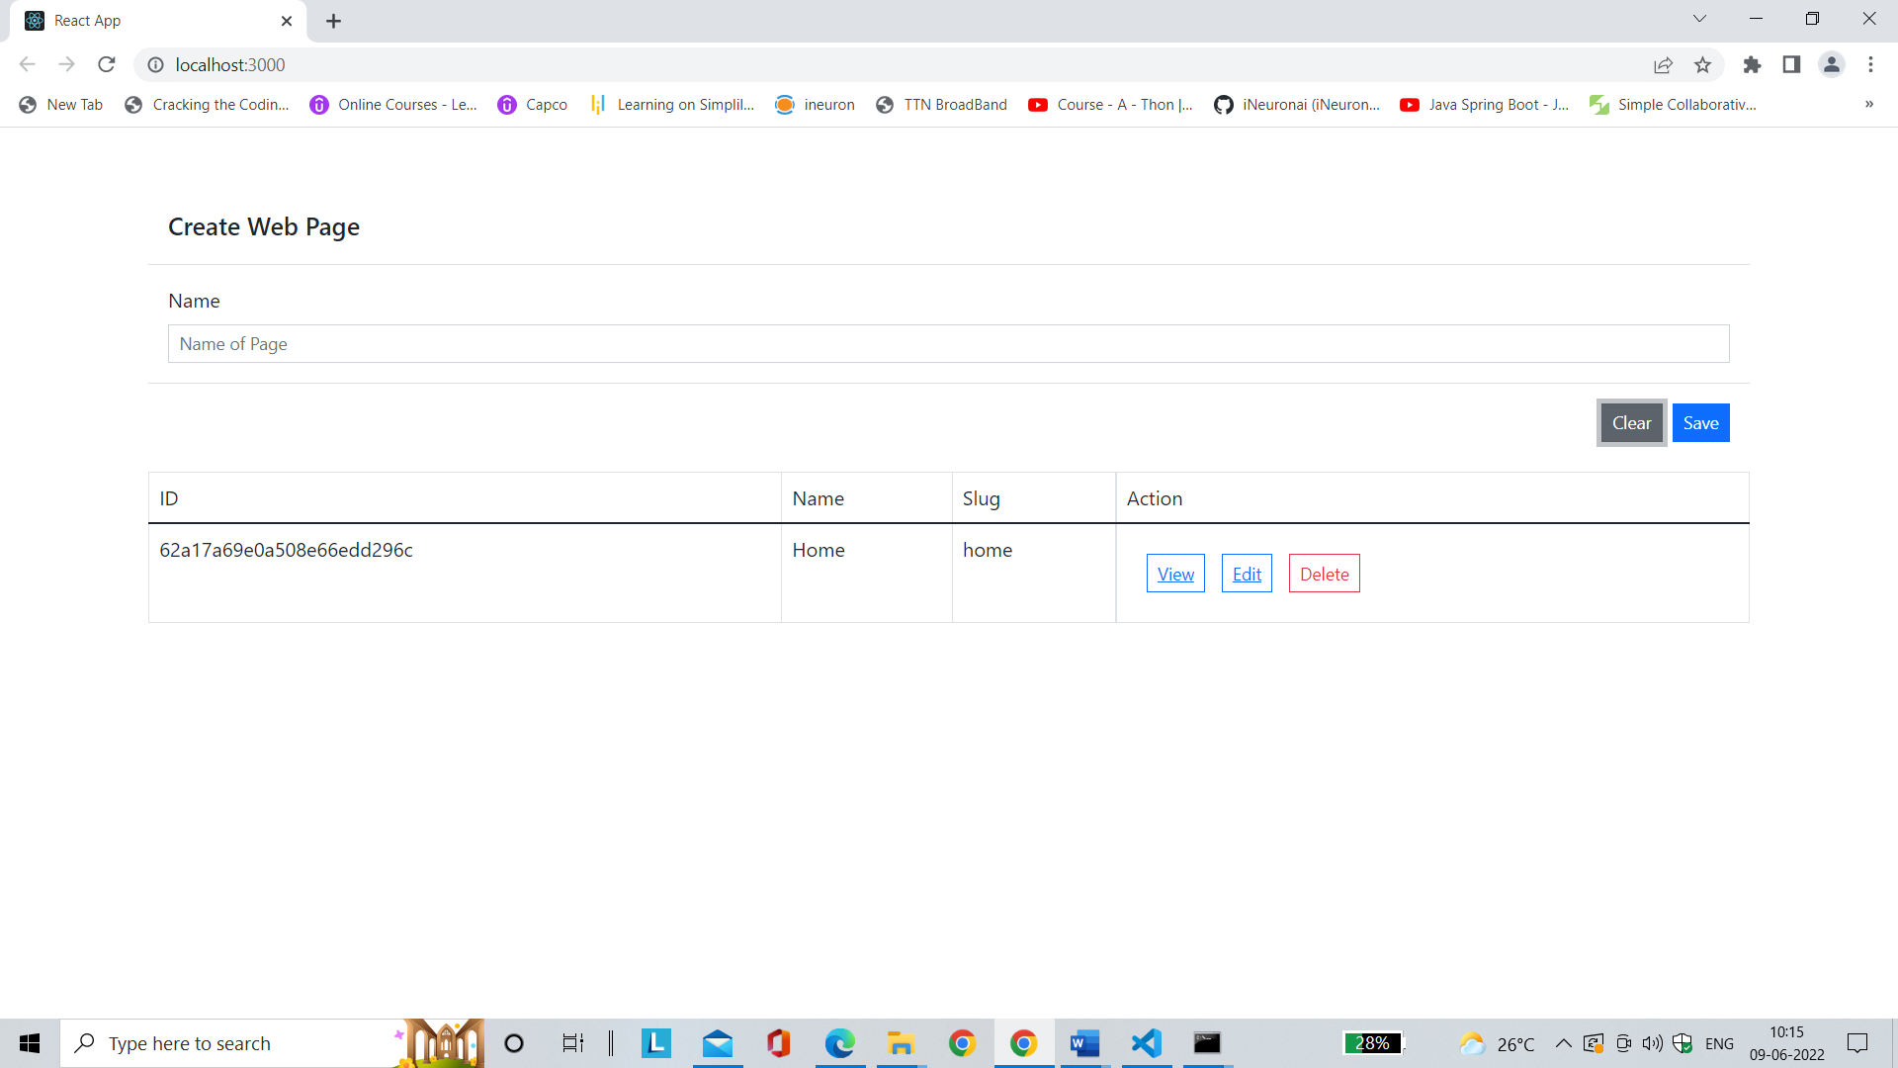

If we click the view button and if there are components added to the created page then it will show the contents of the page as shown below

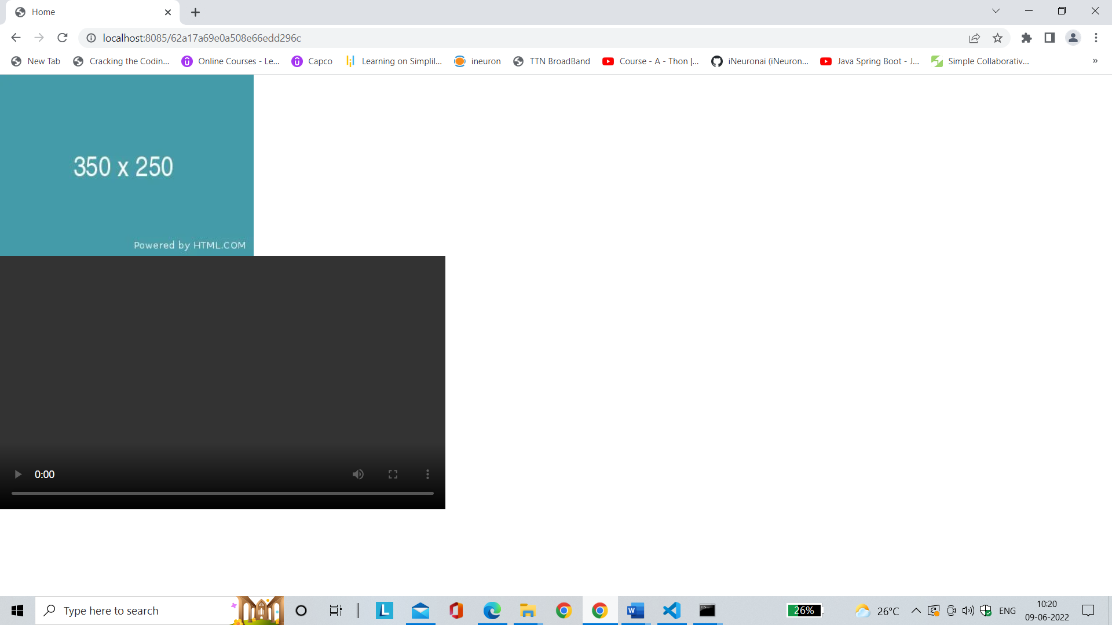

If there is no content added to created page then view page will show as below

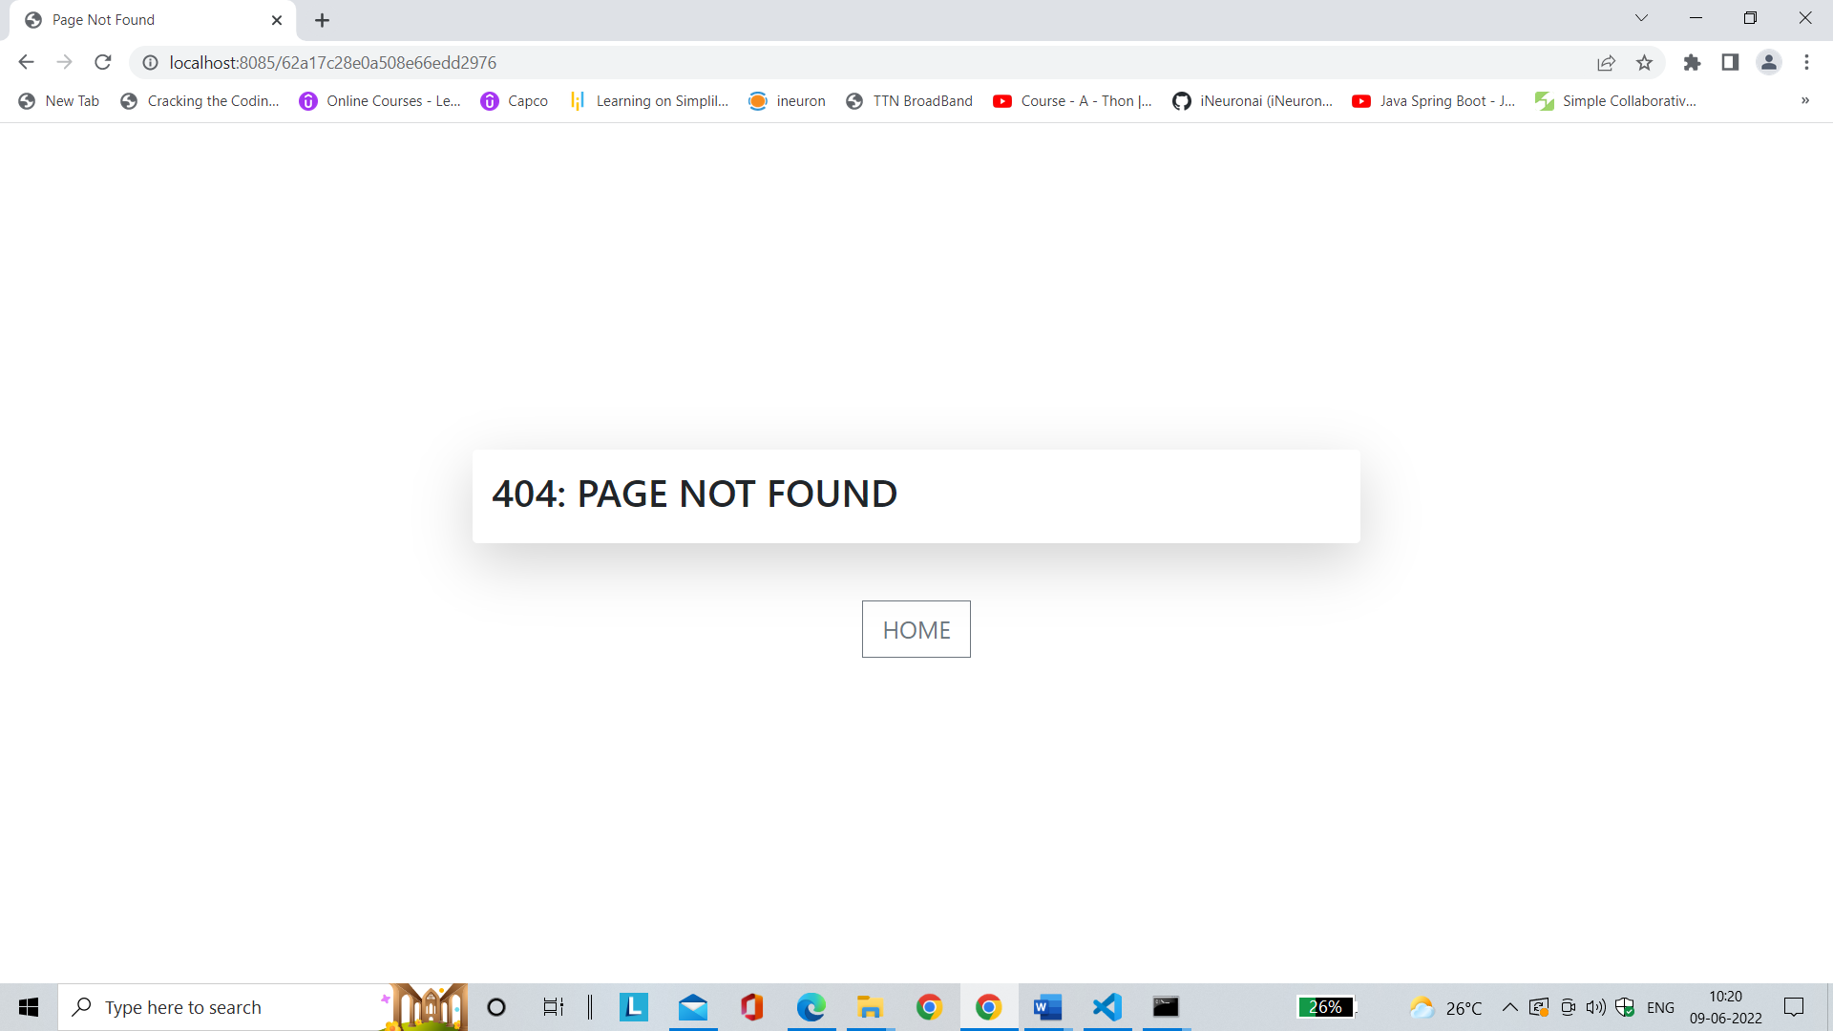

If we click **Home** button the application loads home page.

Editor Page

If we click **Edit** button on the **Home Page** for editing the contents of the page created the Editor page loads the page created as shown below

Here there are options available for drag and drop, save, delete, undo, redo, export, preview etc.

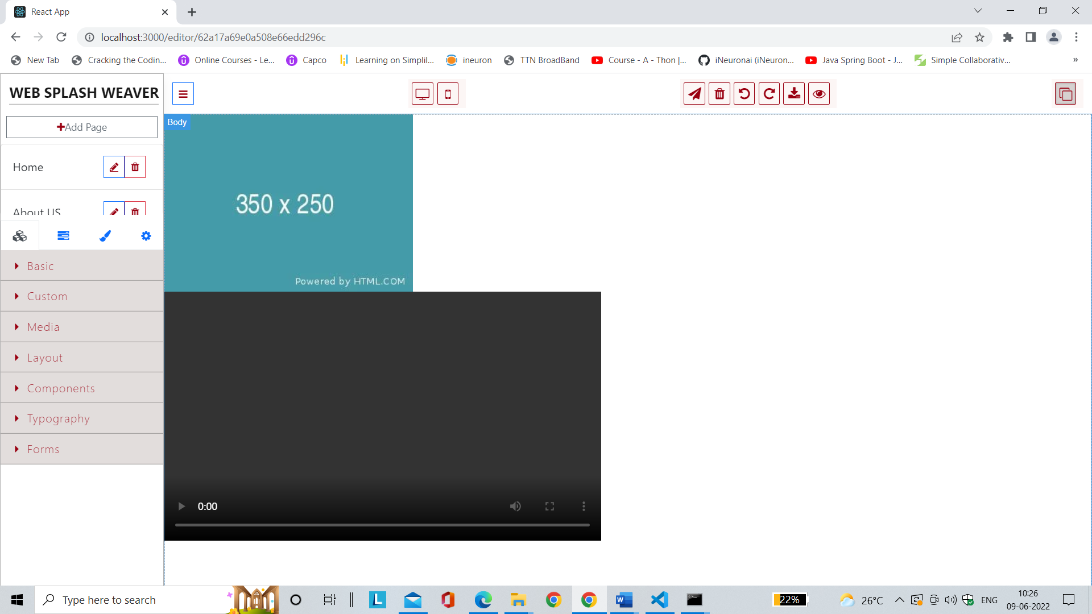

Delete Page

Delete page option is available in both Home page as well as in Editor page. If we click Delete button page gets deleted and control goes to Home page.

