DATABASE DESIGN BRIEF | ERD
Hostel Management API
Revised ERD: unified users, role hierarchy (super admin > city admin > branch admin), soft delete, DRY schema
Purpose
This revision replaces the ERD that was returned by the project manager. It is derived from the supplied API v2 code (schema.sql, auth.py, branches.py, hostel.py) and applies the five requested changes. The diagram is on the next page (landscape). Revision 3.1 adds the city_admin role and explains how the user hierarchy is stored and queried (sections 2 and 8).

Entity Relationship Diagram
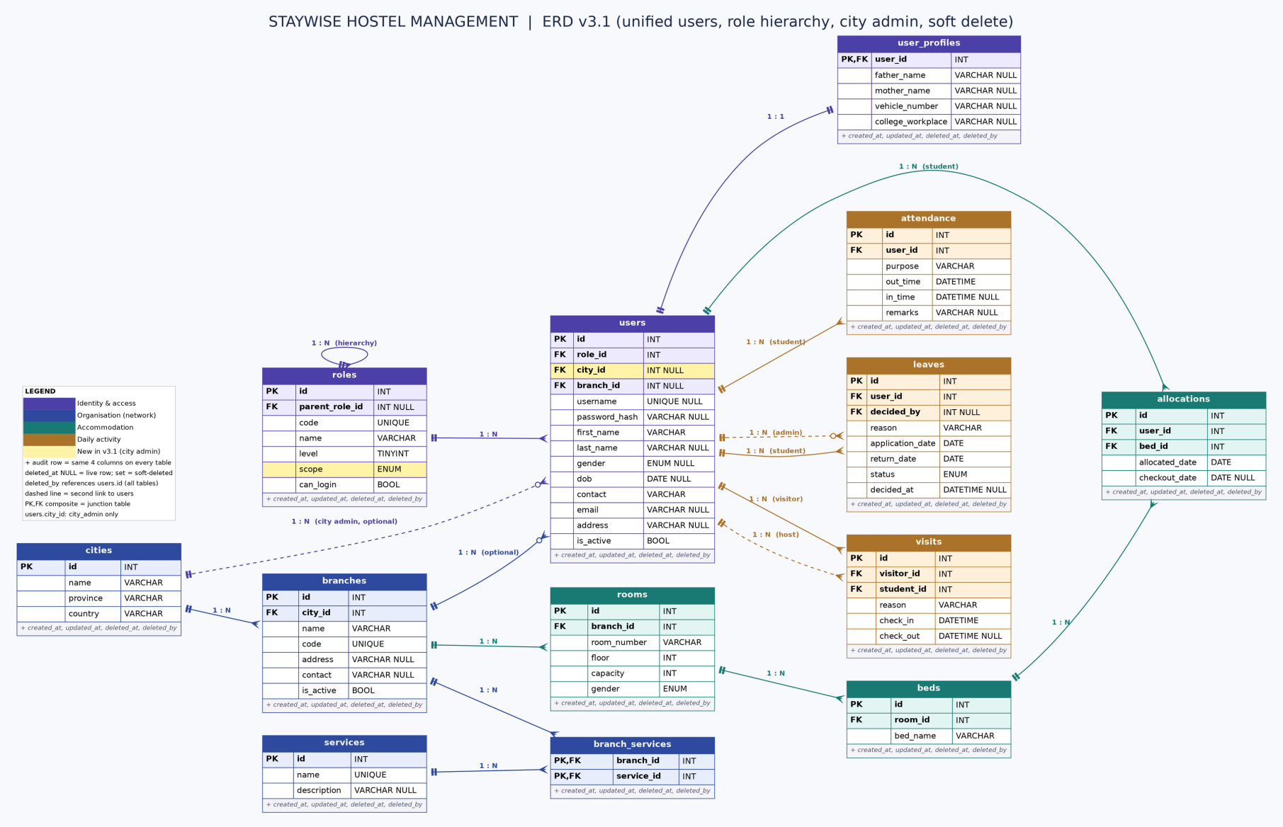

1. How each requested change is met
Requirement | How the ERD satisfies it
1. One users table, separated by role, with a hierarchy | students, visitors and all three admin types (super_admin, city_admin, branch_admin) are rows in users. A roles table (with parent_role_id, level, scope) separates them and forms the hierarchy: super_admin > city_admin > branch_admin > student > visitor. There is no students table.
2. Candidates mapped properly (1:N, N:1, 1:1, M:N) | All relationships are listed in section 3 with cardinality and key. The model contains 1:N / N:1 (most links), one 1:1 (users to user_profiles), one M:N (branches to services via branch_services) and one self-reference (roles hierarchy).
3. Soft delete for cities, branches, etc. | Every table carries deleted_at and deleted_by. A row is live when deleted_at IS NULL. DELETE endpoints become UPDATE ... SET deleted_at = NOW(). Detail in section 4.
4. Visitors are users | A visitor is a users row with role visitor. The visits table links a visitor user to the host student user, and records reason, check_in and check_out.
5. DRY | No repeated entities or columns: one identity table, one audit/soft-delete column set, a shared service catalog, and no stored values that can be derived. Detail in section 5.

2. Role hierarchy (users.role_id → roles)
roles is a small self-referencing table. parent_role_id points to the role directly above, and level gives a number that code can compare (a lower level means more authority). scope says how far a role reaches: global (whole network), city (one city) or branch (one branch).
Role | Level | Parent role | Can log in | scope and users columns
super_admin | 0 | NULL (root) | Yes | global: city_id NULL, branch_id NULL (head office)
city_admin | 1 | super_admin | Yes | city: city_id required, branch_id NULL
branch_admin | 2 | city_admin | Yes | branch: branch_id required, city_id NULL
student | 3 | branch_admin | Optional (future portal) | branch: branch_id required (branch they live in)
visitor | 4 | student | No | branch: branch_id required (branch visited)

Why this is better: a new role (for example warden or accountant) is one new row in roles, not a new table. username and password_hash are nullable because students and visitors do not log in today; the roles.can_login flag says which roles must have them.
City admin is exactly that case: one new row in roles plus one new column users.city_id. No new table.

How the chain of authority is stored (example: F-10 branch)
The user hierarchy is kept in two places. No table stores "this person reports to that person" row by row.
- roles (position level): parent_role_id and level say which role sits above which. This answers "what is above a branch_admin?": city_admin, then super_admin.
- users + branches + cities (people level): the person above a user is found from scope. A branch admin has users.branch_id, which gives branches.city_id, which gives the users row with role city_admin and the same city_id. The super_admin is the single global role.
- Why there is no reports_to_id column: a stored boss id must be edited whenever a branch moves city or a city admin changes, and it can disagree with branches.city_id. Deriving the chain keeps one source of truth (DRY).

Level | Role | How it is found | Example (F-10)
1 | super_admin | roles.code = 'super_admin' (global, no city or branch) | Ali Khan
2 | city_admin | users.city_id = branches.city_id of F-10 (Islamabad) | Sara Malik
3 | branch_admin | users.branch_id = F-10 branch id | Usman Tariq
4 | student | users.branch_id = F-10 branch id | Ahmed Noor

Edge cases: a city may have two city admins (the query returns one row each) or none (LEFT JOIN returns NULL and the API falls back to super_admin). Soft-deleted users are ignored through deleted_at IS NULL.

3. Relation mapping
Parent is the "one" side, child holds the foreign key. "Optional" means the foreign key may be NULL.
Parent | Child | Cardinality | Key mapping / rule
roles | roles | 1 : N (self) | roles.parent_role_id → roles.id. Builds the hierarchy.
roles | users | 1 : N | users.role_id → roles.id. Each user has exactly one role.
cities | branches | 1 : N | branches.city_id → cities.id
branches | users | 1 : N, optional | users.branch_id → branches.id. NULL for super_admin and city_admin.
cities | users | 1 : N, optional | users.city_id → cities.id. Set only for city_admin: the city they manage.
users | user_profiles | 1 : 1 | user_profiles.user_id is both PK and FK → users.id. Optional personal details.
branches | rooms | 1 : N | rooms.branch_id → branches.id. room_number unique within a branch.
rooms | beds | 1 : N | beds.room_id → rooms.id. bed_name unique within a room.
beds | allocations | 1 : N over time | allocations.bed_id → beds.id. One active allocation per bed.
users (student) | allocations | 1 : N over time | allocations.user_id → users.id. One active allocation per student.
branches | branch_services | 1 : N | branch_services.branch_id → branches.id
services | branch_services | 1 : N | branch_services.service_id → services.id. Together with the row above this makes branches ↔ services many-to-many.
users (visitor) | visits | 1 : N | visits.visitor_id → users.id
users (student) | visits | 1 : N | visits.student_id → users.id. The host student being visited.
users (student) | leaves | 1 : N | leaves.user_id → users.id
users (admin) | leaves | 1 : N, optional | leaves.decided_by → users.id. Who approved or rejected. NULL while Pending.
users (student) | attendance | 1 : N | attendance.user_id → users.id. One open OUT record at a time.
users | every table | 1 : N, optional | deleted_by → users.id. Who soft-deleted the row.

Reading the many-to-one direction
Every 1:N above is also N:1 from the child side: many beds belong to one room, many rooms to one branch, many branches to one city, many users to one role. A visit is the link between two users (visitor and host), so users is also related to itself through visits.

4. Soft delete
- Columns (on every table): deleted_at TIMESTAMP NULL and deleted_by INT NULL (FK users.id).
- Queries: every list and lookup adds AND deleted_at IS NULL. A MySQL view or a shared query helper keeps this in one place.
- Delete endpoints: DELETE /students/{id} and similar become UPDATE ... SET deleted_at = NOW(), deleted_by = <caller>. The 409 "cannot delete because records exist" case disappears, because history is kept.
- Closed vs deleted: branches.is_active (temporarily closed) and users.is_active (login suspended) stay as they are. They are reversible states, not removal.
- Unique keys: a plain UNIQUE (branch_id, room_number) would block re-creating a deleted room. Use a unique index that includes deleted_at, or a generated "active key" column that is NULL when the row is deleted. The same applies to branches.code, cities (name, province, country), services.name and users.username.
- Cascade by rule: soft-deleting a branch should be refused while it has live rooms or users, or must soft-delete them in the same transaction. Restoring is deleted_at = NULL.

5. DRY decisions
Repetition removed | Replacement
students, branch admins and visitors as separate shapes with overlapping fields (names, contact, address) | One users table with first_name, last_name, contact, email, address. Role decides meaning.
Optional personal details (father, mother, vehicle, college/workplace) on identity table | user_profiles (1:1). Role-agnostic, so a visitor can also have a vehicle number. users stays narrow.
branch_id copied onto beds, allocations, visitors, leaves, attendance | Kept only where a record is owned by a branch (users, rooms). beds reach the branch through rooms; leaves, visits and attendance through users.
allocations.room_id (always equals the bed's room) | Removed. The room is bed → room.
beds.status, allocations.status, visitors.status (each can be derived) | Removed. Bed occupied = it has an allocation with checkout_date IS NULL. Visit open = check_out IS NULL. Attendance already worked this way (in_time IS NULL).
services typed again for every branch (Wi-Fi, Laundry, ...) | One services catalog plus branch_services junction.
is_active / created_at / delete handling decided table by table | One audit and soft-delete column set applied to every table.
Repeated enum definitions (gender on students and rooms) | Same ENUM (Male, Female, Other) defined once in the schema script and reused.

6. API-to-table mapping
API area | Endpoint(s) | Main table(s)
Authentication | POST /auth/login; GET /auth/me | users, roles, branches
Cities and branches | /cities; /branches; PUT /branches/{id} | cities, branches
Branch admins | /branches/{id}/admins | users (role = branch_admin)
City admins | /cities/{id}/admins (new) | users (role = city_admin)
Network overview | /network/overview; /network/cities | Counts over branches, rooms, beds, allocations, users
Dashboard | /branches/{id}/dashboard | users, rooms, beds, allocations, attendance, leaves, visits
Students | /branches/{id}/students | users (role = student), user_profiles
Rooms and beds | /rooms; /rooms/{id}/beds; /beds/available | rooms, beds, allocations
Allocations | /allocations; /allocations/{id}/checkout | allocations, users, beds
Services | /services | services, branch_services
Visitors | /visitors; /visitors/{id}/checkout | users (role = visitor), visits
Leaves | /leaves; /leaves/{id}/approve|reject | leaves, users
Attendance | /attendance; /attendance/out; /attendance/in | attendance, users

7. Impact on the existing code
This ERD is a redesign, so the API needs matching changes. The endpoint URLs and response bodies can stay the same.
- Branch isolation: schema.sql used composite foreign keys such as (student_id, branch_id) to block cross-branch links. With branch_id kept only on users and rooms, an allocation that joins a student to a bed of another branch is no longer rejected by a foreign key. Keep the existing require_branch_access check and add a BEFORE INSERT trigger on allocations that compares users.branch_id with the bed's room branch.
- Role checks: a foreign key cannot say "this user must be a student". Validate role on allocations, leaves and attendance (student) and on visits (visitor and student), in code or in the same trigger.
- Scope check for city admins: a city_admin must have city_id and no branch_id, a branch_admin must have branch_id and no city_id, and super_admin has neither. Validate this in code or the same trigger, because a CHECK constraint cannot read roles.scope. Every branch-level endpoint for a city admin must test that branches.city_id equals the caller's city_id (query 8.8).
- Visitors: POST /visitors creates or reuses a users row (role visitor), then inserts a visits row. The request body does not change.
- Derived values: queries that read beds.status or allocations.status switch to the checkout_date IS NULL test. A view named active_allocations keeps the SQL short.
- New columns not in the current API: leaves.decided_by and leaves.decided_at (set on approve and reject), the audit columns, the roles table, roles.scope (replaces is_branch_scoped) and users.city_id. Existing data migrates by inserting the five roles and moving students into users.

8. Hierarchy queries (F-10 example)
Sample data used for every query: city Islamabad, branch F-10 (code ISB-F10), branch admin Usman Tariq, city admin Sara Malik, super admin Ali Khan. Queries are MySQL 8 and were run against this sample data. Replace the literals (or the @variables) with real values.

8.1 Schema changes for city admin
ALTER TABLE roles ADD COLUMN scope ENUM('global','city','branch') NOT NULL DEFAULT 'branch';
UPDATE roles SET scope = CASE code WHEN 'super_admin' THEN 'global' ELSE 'branch' END;
ALTER TABLE roles DROP COLUMN is_branch_scoped;

UPDATE roles SET level = level + 1 WHERE level >= 1; -- make room at level 1
INSERT INTO roles (parent_role_id, code, name, level, scope, can_login)
SELECT id, 'city_admin', 'City Admin', 1, 'city', 1 FROM roles WHERE code = 'super_admin';
UPDATE roles b JOIN roles c ON c.code = 'city_admin'
SET b.parent_role_id = c.id WHERE b.code = 'branch_admin';

ALTER TABLE users ADD COLUMN city_id INT NULL AFTER role_id,
ADD CONSTRAINT fk_users_city FOREIGN KEY (city_id) REFERENCES cities(id);
CREATE INDEX ix_users_city ON users (city_id);
CREATE INDEX ix_branches_city ON branches (city_id);

A helper view gives every live user an effective city and branch. Queries 8.7 and 8.8 use it.
CREATE VIEW v_user_scope AS
SELECT u.id AS user_id, u.role_id, r.code AS role_code, r.level, r.scope,
u.branch_id,
COALESCE(b.city_id, u.city_id) AS city_id -- city of the branch, or the admin's own city
FROM users u
JOIN roles r ON r.id = u.role_id
LEFT JOIN branches b ON b.id = u.branch_id
WHERE u.deleted_at IS NULL;

8.2 Who is the admin of F-10?
SELECT u.id, u.first_name, u.last_name
FROM users u
JOIN roles r ON r.id = u.role_id
JOIN branches b ON b.id = u.branch_id
WHERE b.code = 'ISB-F10'
AND r.code = 'branch_admin'
AND u.deleted_at IS NULL AND b.deleted_at IS NULL;
Result: Usman Tariq (id 4).

8.3 Who is the city admin of the F-10 admin?
Path: branch F-10 → branches.city_id → users with role city_admin and that city_id.
SELECT ca.id, ca.first_name, ca.last_name, c.name AS city
FROM branches b
JOIN cities c ON c.id = b.city_id
JOIN users ca ON ca.city_id = c.id AND ca.deleted_at IS NULL
JOIN roles r ON r.id = ca.role_id AND r.code = 'city_admin'
WHERE b.code = 'ISB-F10' AND b.deleted_at IS NULL;
Result: Sara Malik, Islamabad.

8.4 Who is the super admin?
SELECT u.id, u.first_name, u.last_name
FROM users u
JOIN roles r ON r.id = u.role_id
WHERE r.code = 'super_admin' AND u.deleted_at IS NULL;
Result: Ali Khan (id 1).

8.5 Full chain in one row (F-10 admin, city admin, super admin)
SELECT adm.id AS admin_id,
CONCAT(adm.first_name, ' ', adm.last_name) AS branch_admin,
b.name AS branch, c.name AS city,
CONCAT(ca.first_name, ' ', ca.last_name) AS city_admin,
CONCAT(sa.first_name, ' ', sa.last_name) AS super_admin
FROM users adm
JOIN roles ra ON ra.id = adm.role_id AND ra.code = 'branch_admin'
JOIN branches b ON b.id = adm.branch_id
JOIN cities c ON c.id = b.city_id
LEFT JOIN (SELECT u.* FROM users u JOIN roles r ON r.id = u.role_id
WHERE r.code = 'city_admin' AND u.deleted_at IS NULL) ca ON ca.city_id = c.id
LEFT JOIN (SELECT u.* FROM users u JOIN roles r ON r.id = u.role_id
WHERE r.code = 'super_admin' AND u.deleted_at IS NULL) sa ON 1 = 1
WHERE b.code = 'ISB-F10' AND adm.deleted_at IS NULL;
Result: Usman Tariq | F-10 Hostel | Islamabad | Sara Malik | Ali Khan.

8.6 Role chain above a role (uses roles.parent_role_id)
This is the only query that walks parent_role_id. It answers which roles sit above branch_admin.
WITH RECURSIVE chain AS (
SELECT id, code, level, parent_role_id FROM roles WHERE code = 'branch_admin'
UNION ALL
SELECT r.id, r.code, r.level, r.parent_role_id
FROM roles r JOIN chain c ON r.id = c.parent_role_id
)
SELECT code, level FROM chain ORDER BY level;
Result: super_admin (0), city_admin (1), branch_admin (2).

8.7 Everyone under a city admin (downward)
SELECT u.id, u.first_name, r.code AS role, b.code AS branch
FROM v_user_scope ca
JOIN branches b ON b.city_id = ca.city_id AND b.deleted_at IS NULL
JOIN users u ON u.branch_id = b.id AND u.deleted_at IS NULL
JOIN roles r ON r.id = u.role_id
WHERE ca.user_id = @city_admin_id; -- e.g. 2 (Sara Malik)
Result for Sara Malik: Usman Tariq and Hina Shah (branch admins), Ahmed Noor and Kamran Ali (students) of F-10 and G-11. Nobody from Lahore appears.

8.8 Can this user act on that user? (authority check)
A caller may act on a target only if the caller is higher in level and the target falls inside the caller's scope. Use this before approving a leave, editing a student or deleting a branch admin.
SELECT 1 AS allowed
FROM v_user_scope a
JOIN v_user_scope t ON t.user_id = @target_id
WHERE a.user_id = @caller_id
AND a.level < t.level -- caller must be higher in the hierarchy
AND ( a.scope = 'global'
OR (a.scope = 'city' AND a.city_id = t.city_id)
OR (a.scope = 'branch' AND a.branch_id = t.branch_id) );
-- one row = allowed, no row = forbidden (HTTP 403)
Tested: Sara (city admin) on Usman (F-10): allowed. Sara on a Lahore branch admin: denied. Usman on a G-11 student: denied. A student on a branch admin: denied. Ali (super admin): allowed everywhere.

8.9 All branches with branch admin and city admin (super admin screen)
SELECT c.name AS city, b.code AS branch,
adm.first_name AS branch_admin, ca.first_name AS city_admin
FROM branches b
JOIN cities c ON c.id = b.city_id
LEFT JOIN (SELECT u.* FROM users u JOIN roles r ON r.id = u.role_id
WHERE r.code = 'branch_admin' AND u.deleted_at IS NULL) adm ON adm.branch_id = b.id
LEFT JOIN (SELECT u.* FROM users u JOIN roles r ON r.id = u.role_id
WHERE r.code = 'city_admin' AND u.deleted_at IS NULL) ca ON ca.city_id = c.id
WHERE b.deleted_at IS NULL
ORDER BY c.name, b.code;
Result: Islamabad ISB-F10 Usman Sara; Islamabad ISB-G11 Hina Sara; Lahore LHR-GUL Zain Bilal. A branch without an admin still appears, with NULL.
Indexes: users(role_id), users(city_id), users(branch_id), branches(city_id) and branches(code) keep these queries fast.

Scope note
Tables and relationships were derived from the supplied code and SQL. Items marked new in section 7 are design proposals that go beyond what the v2 API stores today.

