Cognifyz Technologies
Data Analysis Internship
Complete Data Analysis Report
Restaurant Dataset
Prepared using Python, Pandas, NumPy and Matplotlib.

1. Executive Summary
The supplied dataset contains 9,551 restaurant records and 21 columns. This report completes the available analysis tasks across Levels 1, 2 and 3 of the Cognifyz Data Analysis internship task list. The analysis covers cuisine popularity, city performance, price ranges, online delivery, ratings, cuisine combinations, geographic distribution, restaurant chains, votes, and service availability.
One Level 3 task, Restaurant Reviews, cannot be fully completed because the supplied dataset has no review-comment text column. It has a 'Rating text' field, but that is a categorical rating label rather than the original written review. Therefore, review keyword frequency, review length, and review-length versus rating analysis are not calculated.

2. Dataset Overview
Rows: 9,551
Columns: 21
Only the Cuisines column contains missing values, with 9 missing records. These were treated as 'Unknown' for analysis.
Column | Data Type
Restaurant ID | int64
Restaurant Name | object
Country Code | int64
City | object
Address | object
Locality | object
Locality Verbose | object
Longitude | float64
Latitude | float64
Cuisines | object
Average Cost for two | int64
Currency | object
Has Table booking | object
Has Online delivery | object
Is delivering now | object
Switch to order menu | object
Price range | int64
Aggregate rating | float64
Rating color | object
Rating text | object
Votes | int64

3. Level 1 Analysis

Task 1: Top Cuisines
The three most common cuisines are North Indian (3,960 restaurants, 41.46%), Chinese (2,735, 28.64%), and Fast Food (1,986, 20.79%). Cuisine strings were split so that restaurants serving multiple cuisines contribute to each individual cuisine count.
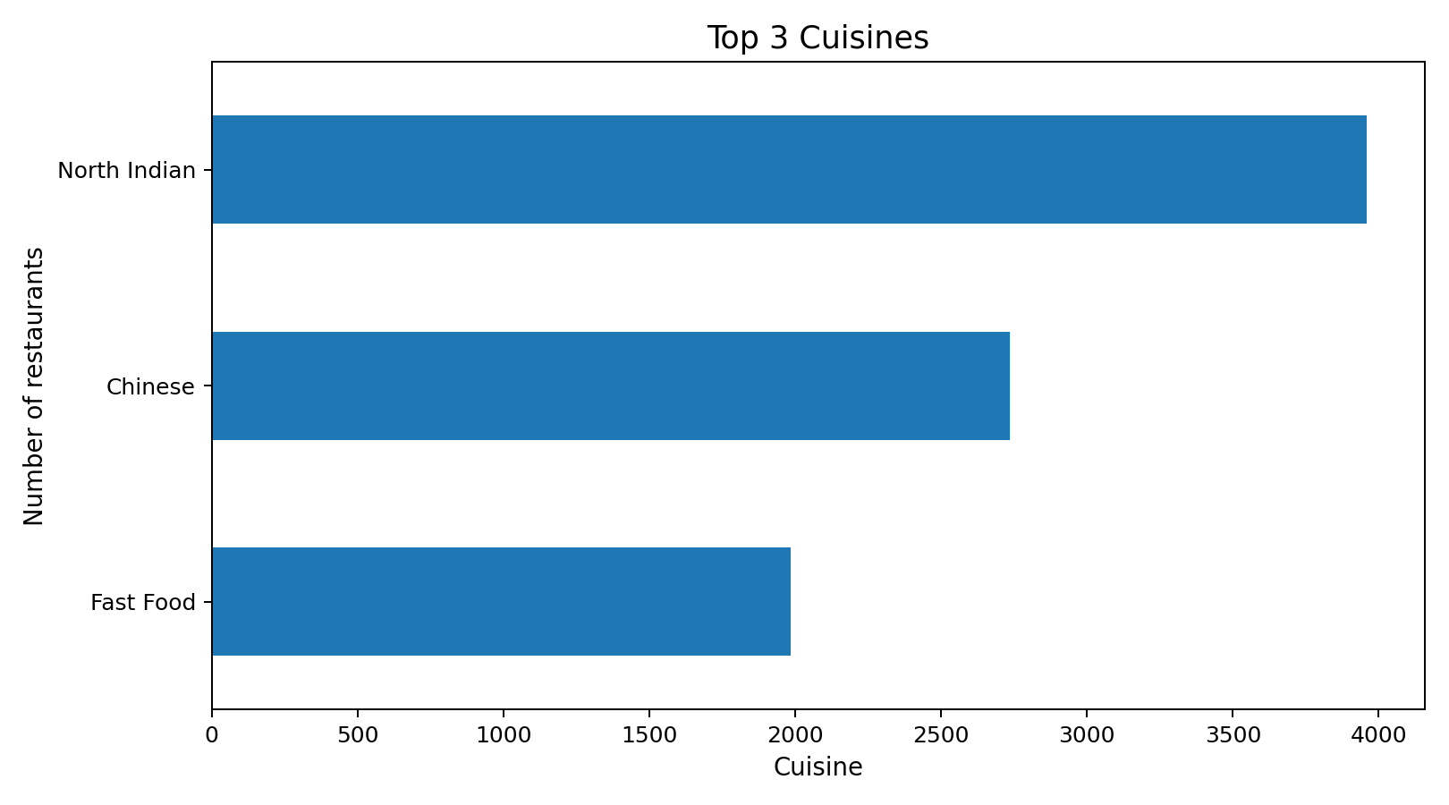

Task 2: City Analysis
New Delhi has the highest number of restaurants, with 5,473. The highest average rating among cities is recorded for Inner City at 4.900. Because city sizes vary substantially, average rating should be interpreted together with restaurant count.
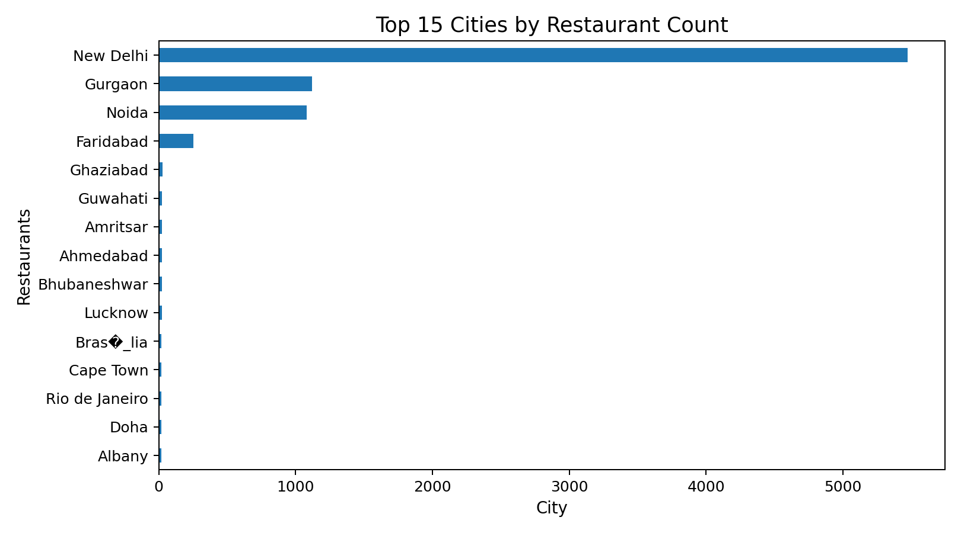
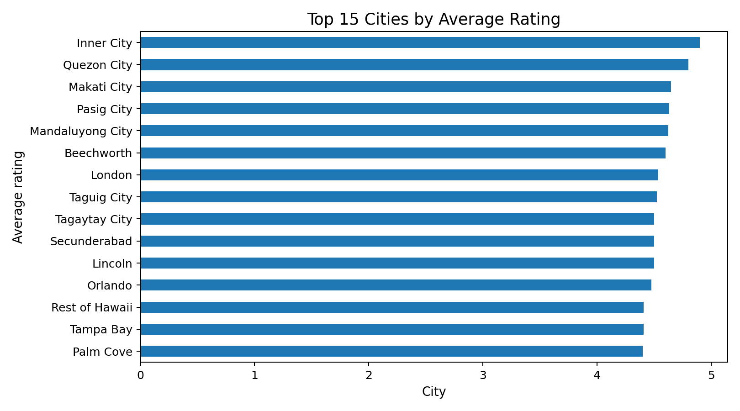
Selected city results:
City | Average Rating
Inner City | 4.9
Quezon City | 4.8
Makati City | 4.65
Pasig City | 4.633
Mandaluyong City | 4.625
Beechworth | 4.6
London | 4.535
Taguig City | 4.525
Secunderabad | 4.5
Lincoln | 4.5
Tagaytay City | 4.5
Orlando | 4.475
Tampa Bay | 4.41
Rest of Hawaii | 4.41
Palm Cove | 4.4

Task 3: Price Range Distribution
Price range 1 is the largest category with 4,444 restaurants (46.53%), followed by range 2 with 3,113 (32.59%).
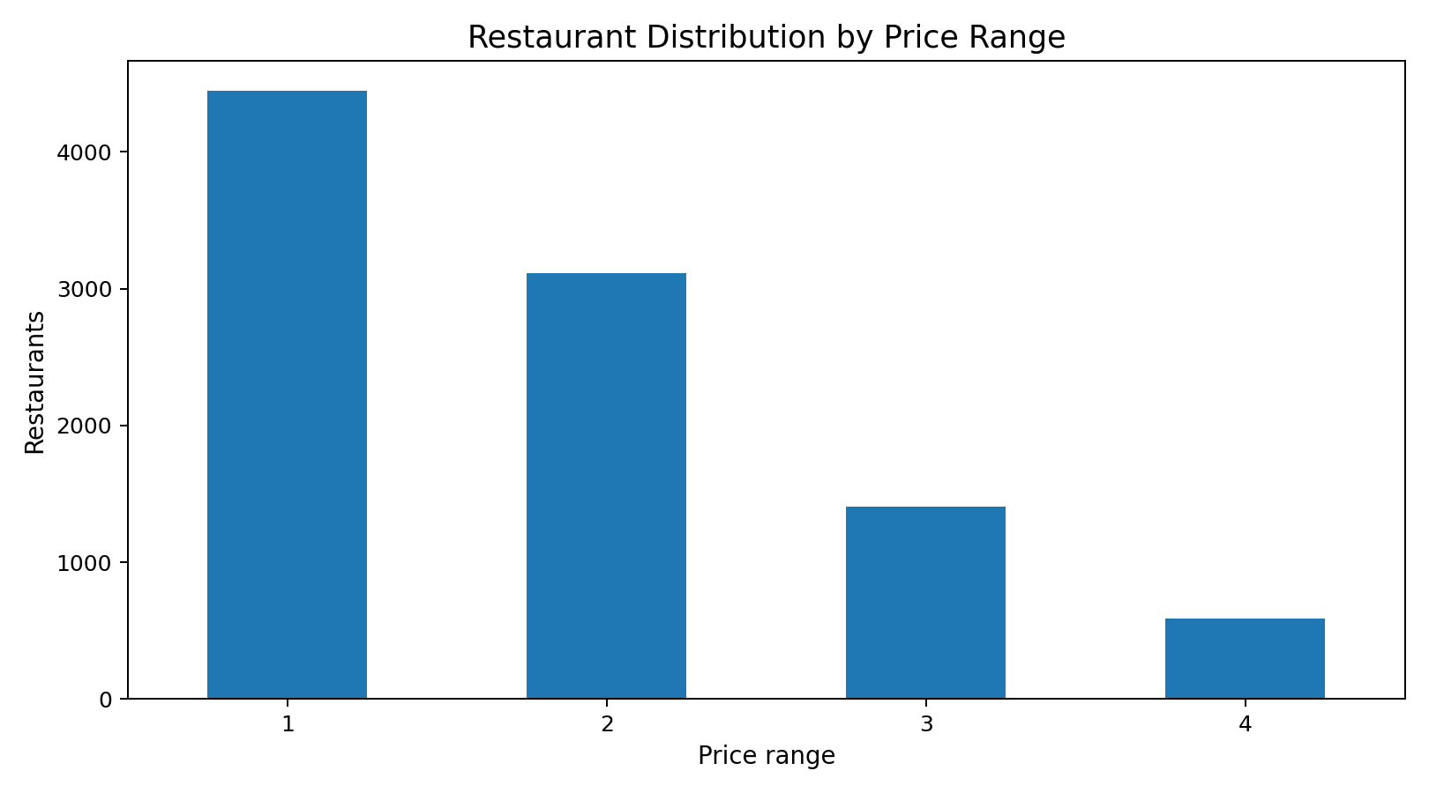
Price Range | Restaurants | Percentage
1.0 | 4444.0 | 46.53
2.0 | 3113.0 | 32.59
3.0 | 1408.0 | 14.74
4.0 | 586.0 | 6.14

Task 4: Online Delivery
25.66% of restaurants offer online delivery, while 74.34% do not. The average rating is 3.249 for restaurants with delivery and 2.465 for restaurants without delivery.
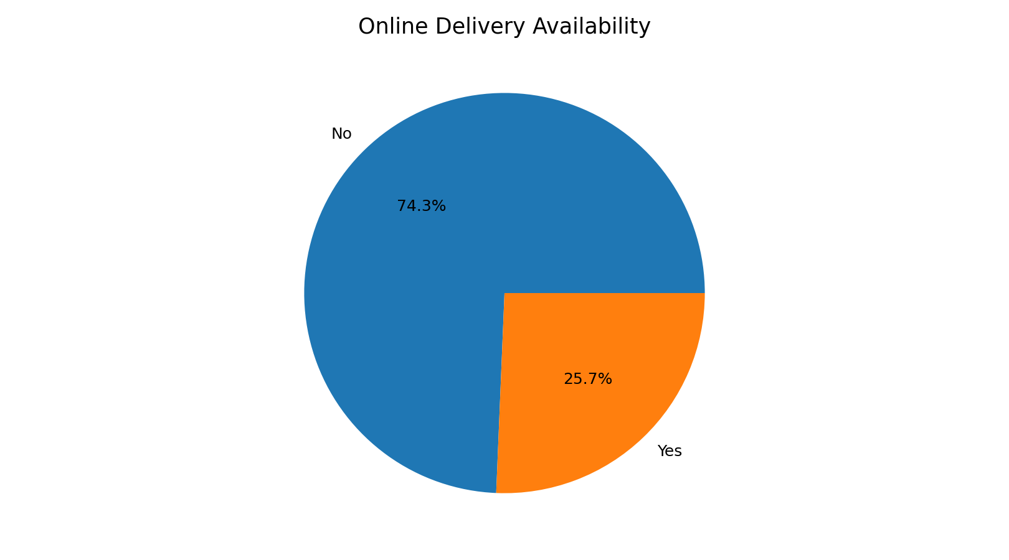

4. Level 2 Analysis

Task 1: Restaurant Ratings
The most common rating range is 3.00-3.99, containing 4,590 restaurants. The average number of votes per restaurant is 156.91.
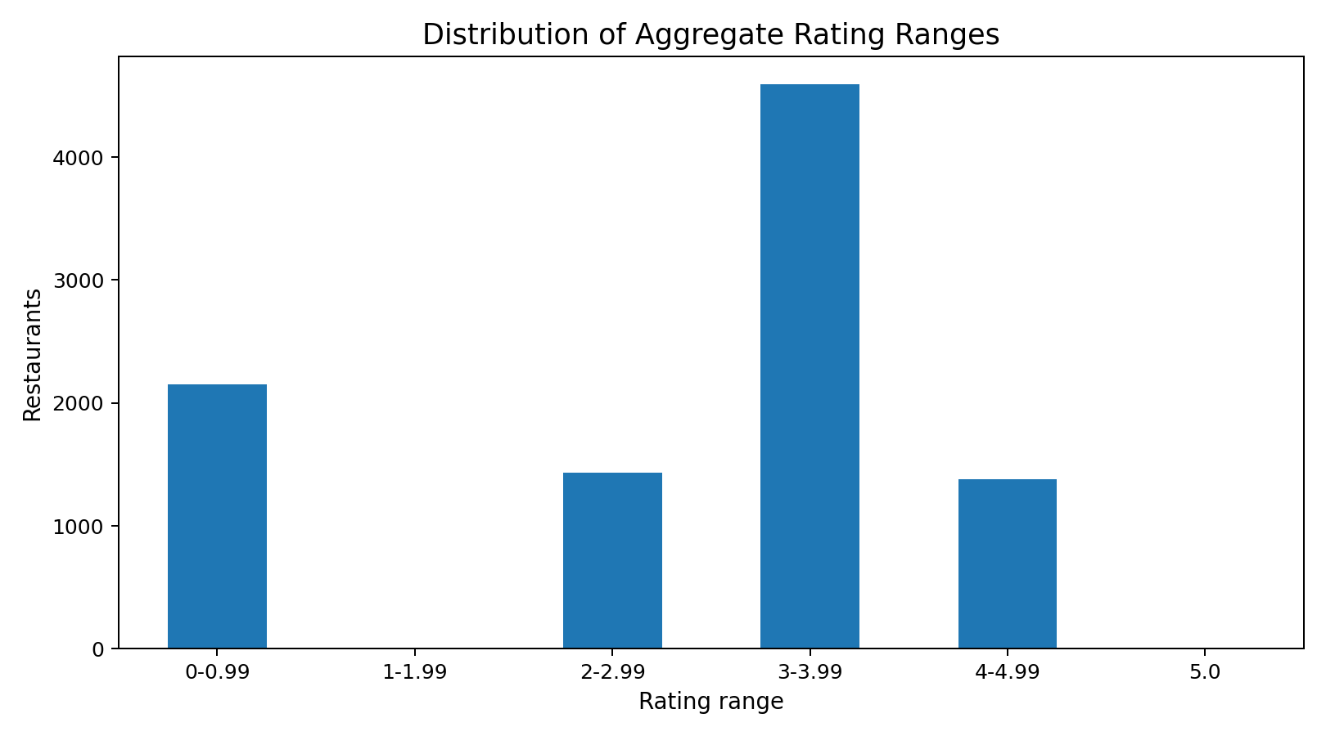
Rating Range | Restaurants
0-0.99 | 2148
1-1.99 | 3
2-2.99 | 1430
3-3.99 | 4590
4-4.99 | 1380
5.0 | 0

Task 2: Cuisine Combination
The most frequent exact cuisine entries include North Indian, North Indian + Chinese, Chinese, Fast Food, and North Indian + Mughlai. For rating comparison, combinations with at least 10 restaurants were used to reduce distortion from very small groups.
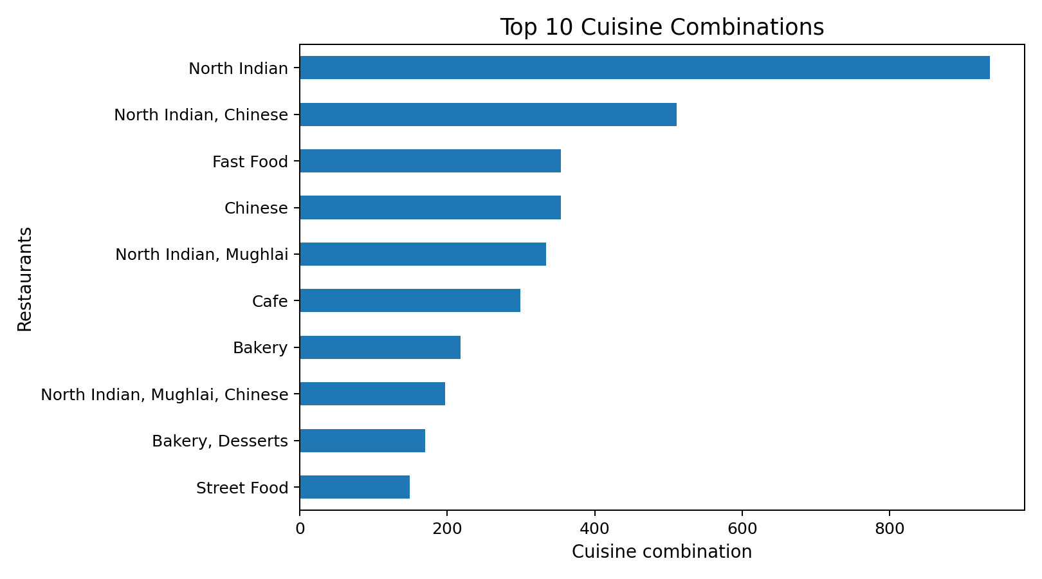
Most common cuisine combinations:
Cuisine Combination | Restaurants
North Indian | 936
North Indian, Chinese | 511
Chinese | 354
Fast Food | 354
North Indian, Mughlai | 334
Cafe | 299
Bakery | 218
North Indian, Mughlai, Chinese | 197
Bakery, Desserts | 170
Street Food | 149
Highest-rated cuisine combinations among combinations with at least 10 restaurants:
Cuisines | Restaurants | Avg_Rating | Avg_Votes
Modern Indian | 11 | 4.345 | 1123.18
Indian | 18 | 4.25 | 337.11
Seafood | 14 | 4.114 | 380.86
Thai | 16 | 4.1 | 206.19
Cafe, Continental, Italian | 10 | 4.08 | 183.0
American, Burger | 13 | 4.077 | 490.08
Japanese, Sushi | 18 | 4.044 | 284.39
Pizza, Italian | 19 | 3.668 | 318.21
American | 31 | 3.668 | 251.68
Italian | 54 | 3.657 | 274.06

Task 3: Geographic Analysis
Longitude and latitude were plotted to identify geographic concentration. The scatter plot shows strong clustering because the dataset covers multiple countries and cities, with large concentrations around major urban areas.
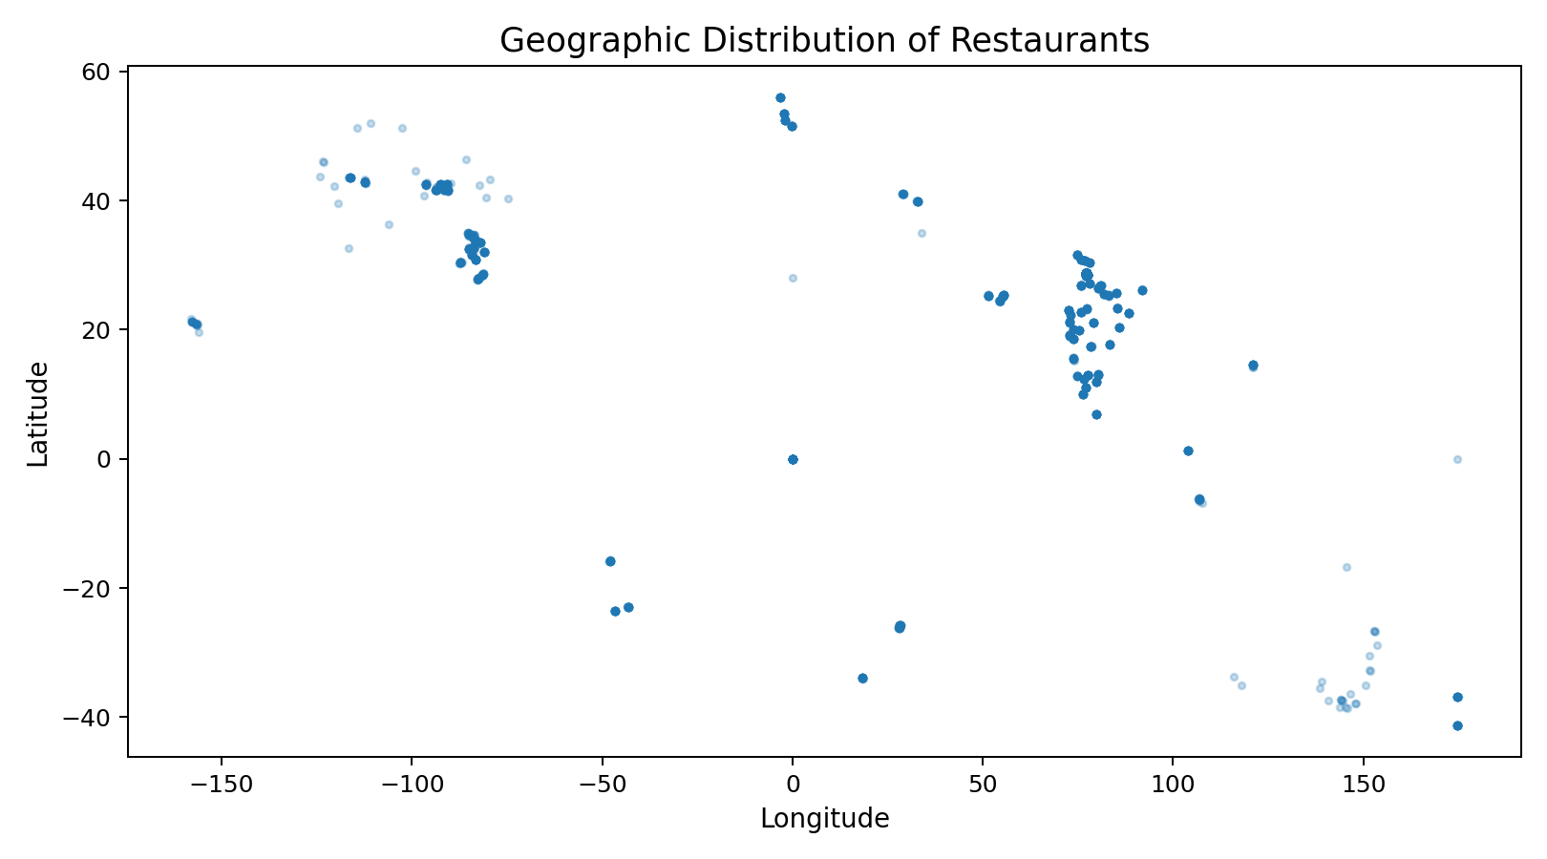

Task 4: Restaurant Chains
The dataset contains 734 restaurant names appearing more than once, which indicates repeated restaurant names/chain locations. The table below shows the ten names with the largest number of locations and their average rating and votes.
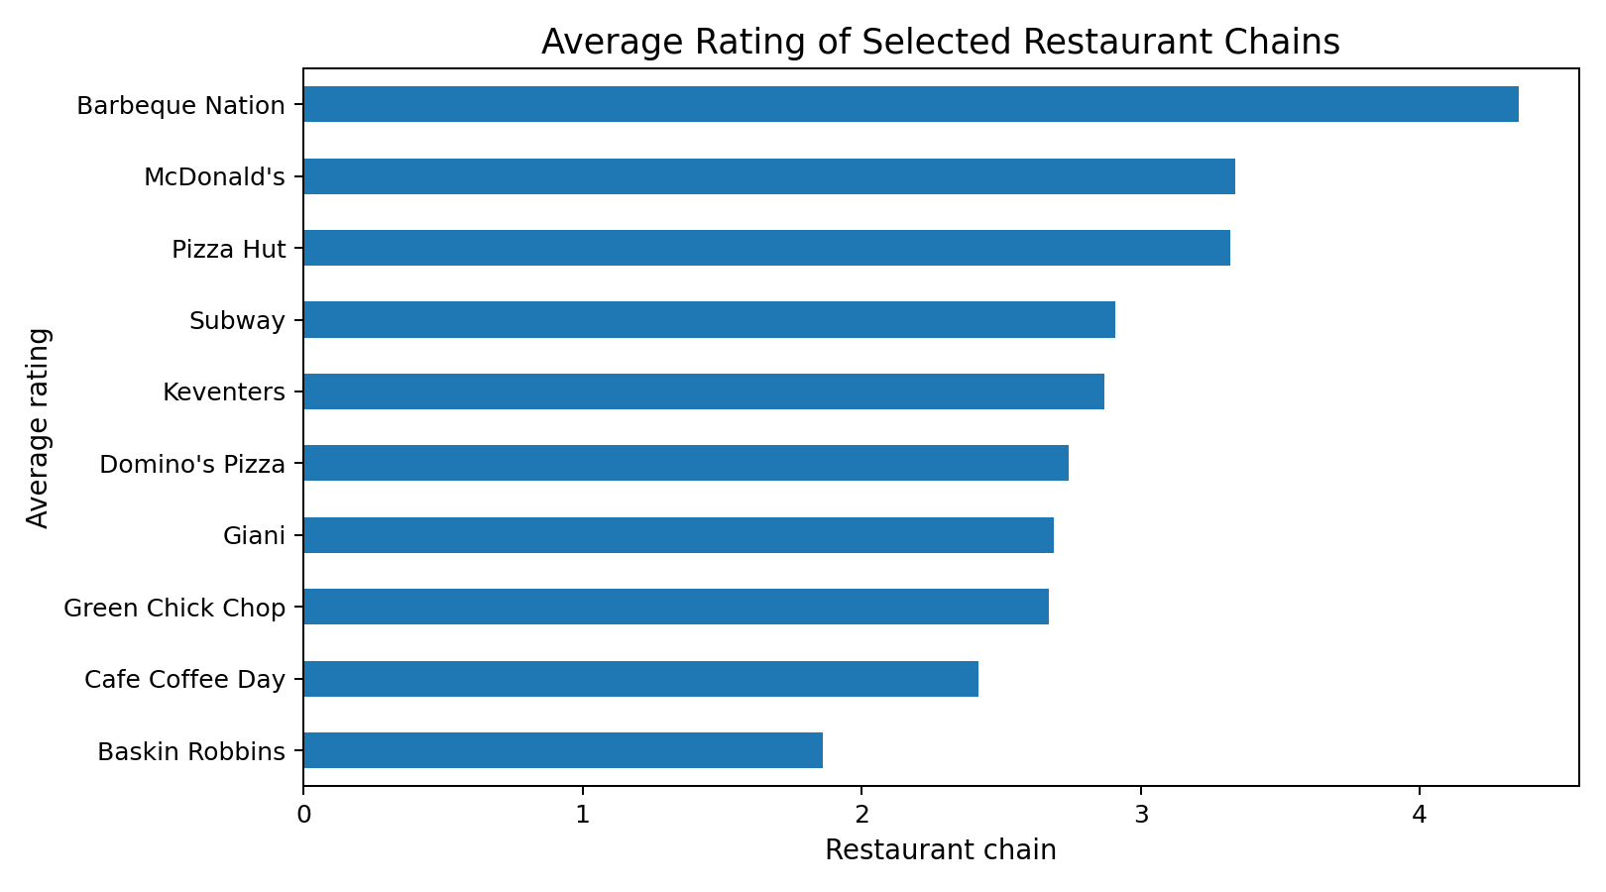
Restaurant Name | Locations | Avg_Rating | Avg_Votes
Cafe Coffee Day | 83 | 2.42 | 29.25
Domino's Pizza | 79 | 2.74 | 84.09
Subway | 63 | 2.91 | 97.21
Green Chick Chop | 51 | 2.67 | 18.9
McDonald's | 48 | 3.34 | 110.23
Keventers | 34 | 2.87 | 37.15
Pizza Hut | 30 | 3.32 | 165.37
Giani | 29 | 2.69 | 29.45
Baskin Robbins | 28 | 1.86 | 15.29
Barbeque Nation | 26 | 4.35 | 1082.38

5. Level 3 Analysis

Task 1: Restaurant Reviews
Limitation: the supplied CSV does not contain written restaurant review comments. The only review-related field is 'Rating text', which stores labels such as Excellent, Very Good, Good, Average and Poor. Consequently, the requested positive/negative keyword extraction, average review length, and review-length versus rating relationship cannot be calculated from this dataset without an additional review-text source.

Task 2: Votes Analysis
The restaurant with the highest number of votes is Toit in Bangalore with 10,934 votes and a rating of 4.8. The lowest vote count is 0, recorded for Cantinho da Gula. The Pearson correlation between votes and aggregate rating is 0.3137, indicating a positive but relatively weak-to-moderate linear association.
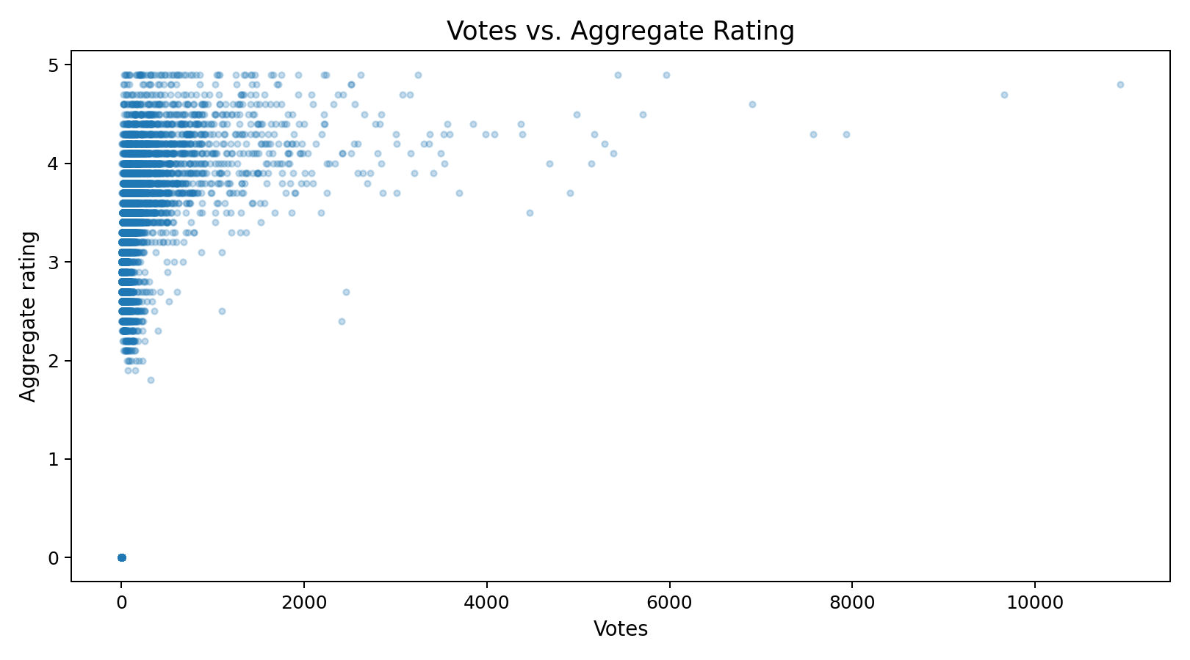

Task 3: Price Range vs Online Delivery and Table Booking
Service availability varies by price range. Online delivery is most common in price range 2, while table booking becomes substantially more common in price ranges 3 and 4. This suggests that price category is associated with service availability, although the relationship is not monotonic for online delivery.
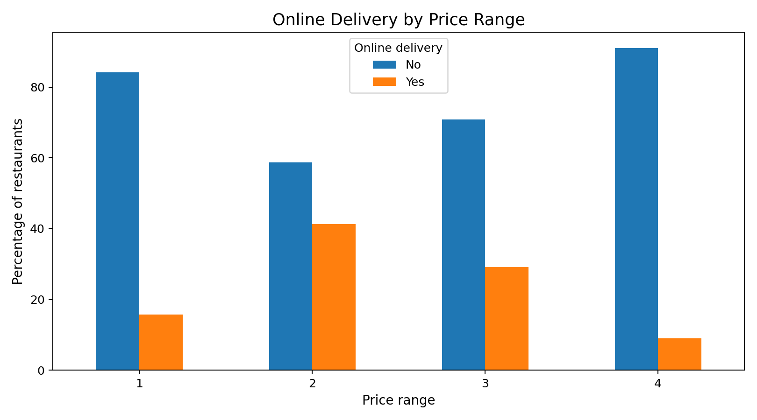
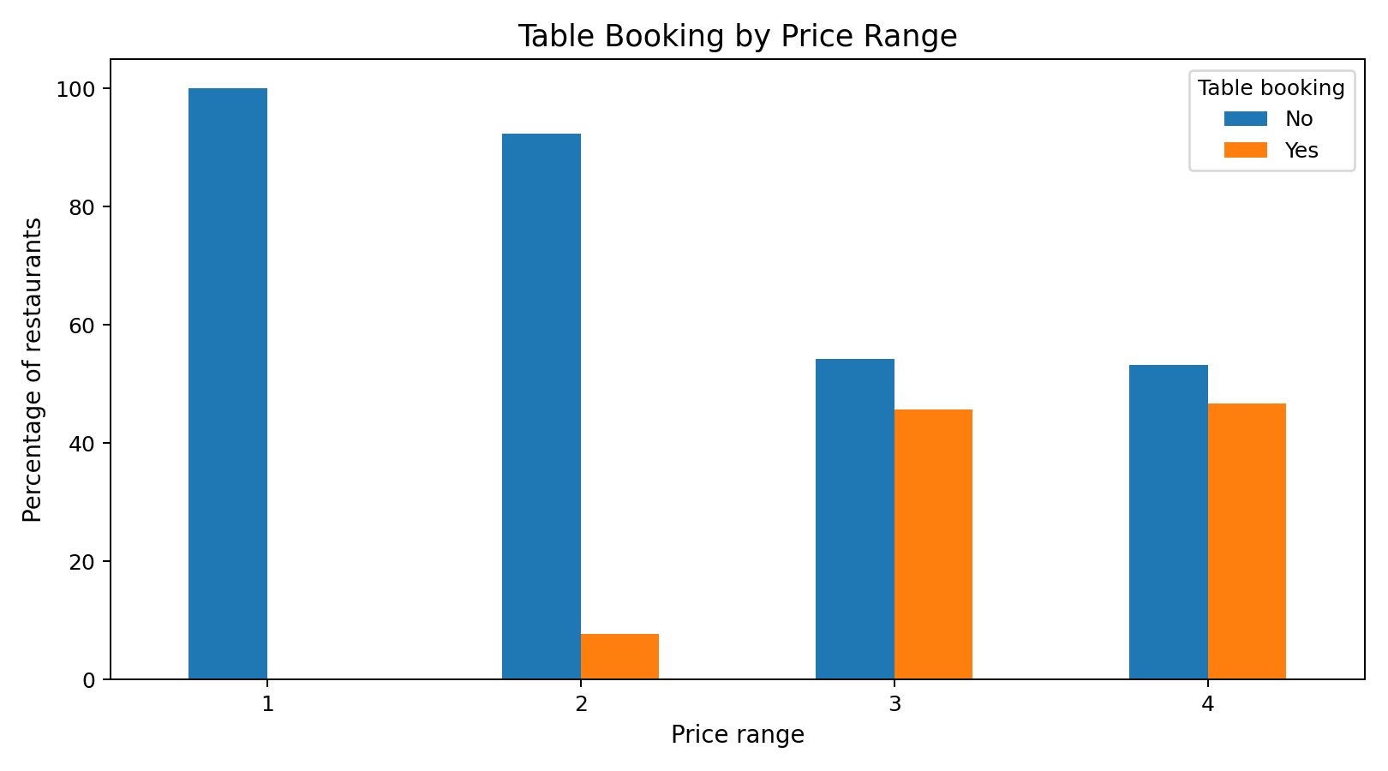
Online delivery percentage by price range:
Price range | No | Yes
1.0 | 84.23 | 15.77
2.0 | 58.69 | 41.31
3.0 | 70.81 | 29.19
4.0 | 90.96 | 9.04
Table booking percentage by price range:
Price range | No | Yes
1.0 | 99.98 | 0.02
2.0 | 92.32 | 7.68
3.0 | 54.26 | 45.74
4.0 | 53.24 | 46.76

6. Key Findings
- North Indian is the most common cuisine, appearing in 3,960 restaurant records.
- New Delhi has the highest number of restaurants in the dataset with 5,473 records.
- Price range 1 represents 46.53% of all restaurants.
- Only 25.66% of restaurants offer online delivery.
- Restaurants offering online delivery have a higher average rating (3.249) than those without it (2.465).
- The most common aggregate rating range is 3.00-3.99.
- The vote-rating correlation is 0.3137, so higher votes are associated with somewhat higher ratings, but votes do not explain ratings strongly on their own.
- Table booking is substantially more common in price ranges 3 and 4 than in price ranges 1 and 2.

7. Methodology
The analysis was performed using Python with Pandas for data manipulation, NumPy for numerical operations, and Matplotlib for visualization. Missing cuisine values were labeled Unknown. Multi-cuisine records were split on commas for cuisine-frequency analysis. Average ratings were calculated using the Aggregate rating field. Percentages use the full dataset of 9,551 restaurant records as the denominator unless otherwise stated.

8. Deliverables
The submission package includes the complete Python script, generated charts, this report, and a PDF copy of the report. The code is organized according to the Cognifyz Level 1, Level 2 and Level 3 task structure.

