Fractal Blasters Audio Suite Commonality Analysis

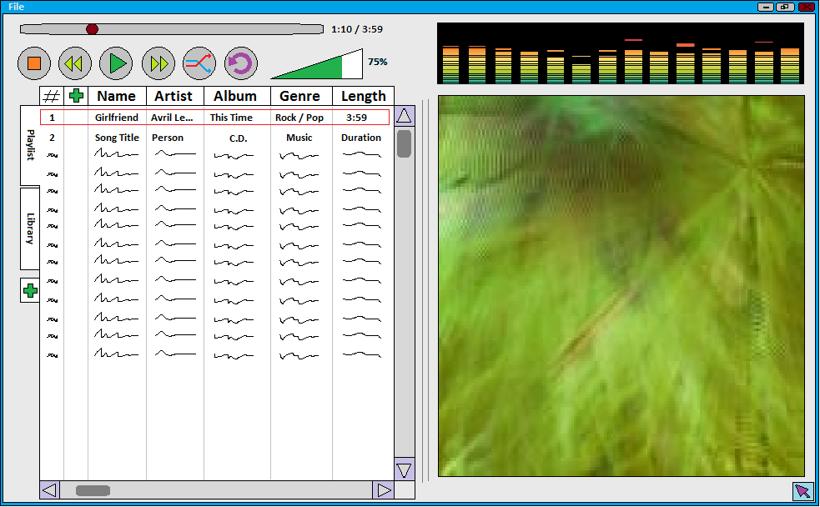
Fractal Blasters Audio Suite Commonality Analysis
- Introduction
The Audio Suite is a media player capable of playing a large range of audio files. It doubles as a library for media that is available. It allows the user to organize the music from the library into playlists that can be saved and loaded. The suite also has a visualizer that responds to the audio being played.
The purpose of this analysis is to provide the following capabilities for the Audio Suit Family:
A way to specify the configuration of a particular media player.
A way to generate, for a specified media player, the software that runs the media player.
- Overview/ Notes
This commonality analysis is concerned with the following issues:
What various features should be available for a build?
What file types should be readable/playable?
What is the base level of functionality for a given suite?

Interfaces To Other Domains

3. Dictionary of Terms
TERM | MEANING
Codec | Device or program capable of encoding and and or decoding a digital data stream or signal
FFmpeg | Command line tool to convert multimedia files between formats
RAW | Computer format for storing uncompressed audio in a raw form. Does not include header information. (*.raw / *.pcm)
Music Visualizer | Generates animated imagery based on a piece of music. Basis often a function of loudness and frequency spectrum.
Audio Library | Effective collection of music. Holds knowledge of all songs available to the audio suite
Playlist | A list of songs assembled by the user. Linearly traversed by the suite on queue. Saveable and Loadable.
File Format | Particular way that information is encoded for storage in a computer file. Ex: wav, ogg, mpc, flac, TTA, aiff, raw, au, gsm, dct, vox, mmf, mp3, aac, mp4, wma, artac, .wav, ra&rm, dss, msv, dvf, m4p, iklax, mxp4, 3gp, amr, and awb.

4. Commonalities
The following statements are basic assumptions about the Audio Suite – things that will be true for every release of the suite.
Behavior
- Will be able to decode and play .wav and .raw file forms
- Will be able to utilize basic media controls (play, pause, stop, back, forward, volume, position)
Devices
- Accept controls from user via mouse
- Output audio through variable devices
- Support progressing playlist
- The suite will support a built-in library feature
5. Variabilities
The following statements describe how an audio suite may vary.
Behavior
- The suite may or may not support various file extensions (including mp3, wma).
- The suite may or may not be capable of sorting music by category
- The suite may or may not support saving and loading playlists.
Devices
- The suite may or may not have a visualizer packaged with it.
- The packaged visualizer may have a large range of available features/styles, or fewer
- The suite may or may not support multiple playlists being open at the same time.

6. Parameters of Variation

Parameter | Meaning | Value Space | Binding Time | Default
Behavior
- : Supported file formats | What kinds of files can be played by the suite | Any combination of: wav, ogg, mpc, flac, TTA, aiff, raw, au, gsm, dct, vox, mmf, mp3, aac, mp4, wma, artac, .wav, ra&rm, dss, msv, dvf, m4p, iklax, mxp4, 3gp, amr, and awb. | Specification | .wav, .raw
- : Sorting music by category | Whether or not a list of songs can be sorted by the categories Title/ Artist/ Album/ Time/ etc. | Boolean: Available/ Unavailable | Specification | Unavailable
- : Saving/ Loading playlists | Whether or not the user is allowed to save and load playlists | Boolean: Available/ Unavailable | Specification | Unavailable
- : Visualizer Included | Whether or not the visualizer is included in the suite | Boolean: Available/ Unavailable | Specification | Unavailable
- : Visualizer Level | Features/ Settings of the visualizer:  Basic – only equalizer  Regular – equalizer and visualizer available  Pro – equalizer and visualizer with customizable settings available | Basic, Regular, Pro  *Only available if the visualizer is included | Specification | Basic
- : Multiple Playlist support | Whether or not the user is allowed to have multiple playlists open at the same time | Boolean: Available/ Unavailable | Specification | Unavailable

7. Issues
- What if a file that the suite is running is suddenly relocated or deleted by outside forces?
The audio suite should safely stop playing, indicate the error, and move onto the next song if available.

- Should we allow for a variety of songs with different file formats to be in the same playlist
- Yes. This should be handled robustly by the engine, and is crucial for many playlists
- No. This will add unnecessary complications to the development of the suite
We will support variable file formats within the same playlist for the user's sake. This will also encourage a more robust program development that will scale more easily.

- Should we add the ability to play various video formats?
- Yes. This would broaden the utility of our tool, and would be super cool
- No. This would hugely complicate the software (as we would need to encode support for each new video type), immensely extend the time and cost of domain engineering, and make it more difficult to achieve our objectives.
Considering something like this would take a much larger team much more time, and might as well me an entirely separate project. That being said, in producing this, we will structure the code in a way that would allow us to more easily integrate video support in the future.

8. Review Questions
- For each commonality, if possible, give an example of a family member where the commonality is violated.
- For each variability, if possible, give a reason why it should be a commonality.
- Are there any commonalities that are missing?
- For each commonality, identify corresponding variabilities.
- For each commonality, can you find a corresponding variability that is omitted?
- Are there any variabilities that are missing?
- Does every variability have at least one parameter of variation?
- Does every parameter of variation (PoV) have an associated variability?
- For each PoV are there values that should be included in the value space but that are not? Are there values that are in the value space but that should not be?
- For each PoV are there values that will make it particularly hard to implement the PoV?
- Is every issue resolved? Convincingly?
- Are there terms that should be defined but are not?
- Are there terms that are incorrectly or vaguely defined?

8.1 Conclusion
No review question indicates a potential issue.

