AI-Based Study Planner Using a Rational Agent
1. Problem Formulation
Students often find it difficult to manage multiple subjects, deadlines and limited study time. This project develops an AI-Based Study Planner that automatically creates a weekly study schedule.
The agent takes the following inputs:
Subject name
Deadline
Difficulty level
Priority or importance
Available daily study hours
The goal is to create a rational study plan by giving higher importance to urgent and high-priority subjects.
2. Approach
The AI Study Planner uses a priority-based approach. Each subject is evaluated using factors such as deadline urgency, difficulty and priority.
A higher utility score is given to subjects that are more urgent and important. The planner then schedules these subjects first based on the available study hours.
3. Rational Agent Approach
This project acts as a Rational Agent.
Perceive: The agent receives subject details and available study hours.
Decide: The agent calculates the priority or utility score for each subject.
Act: The agent generates a weekly study timetable by scheduling high-priority subjects first.
This approach is rational because the agent selects actions that help achieve the objective of completing important subjects before their deadlines.
4. Complexity Analysis
Let n be the number of subjects.
The system calculates the priority for each subject and arranges the subjects based on their priority.
The approximate time complexity is:
O(n log n)
The space complexity is:
O(n)
5. Results
The AI-Based Study Planner successfully accepts subject details and available study hours. It calculates a utility score and generates a readable weekly study schedule.
The program was tested using subjects with different deadlines and difficulty levels. Subjects with higher urgency and priority were scheduled first.

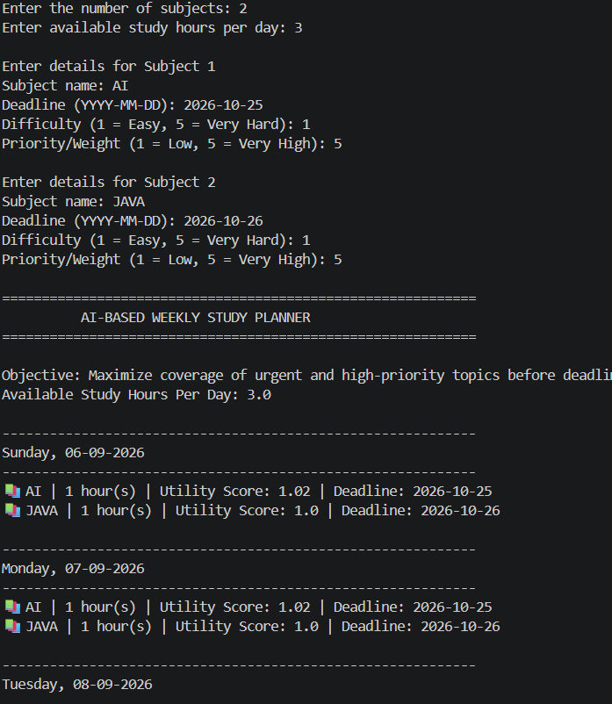

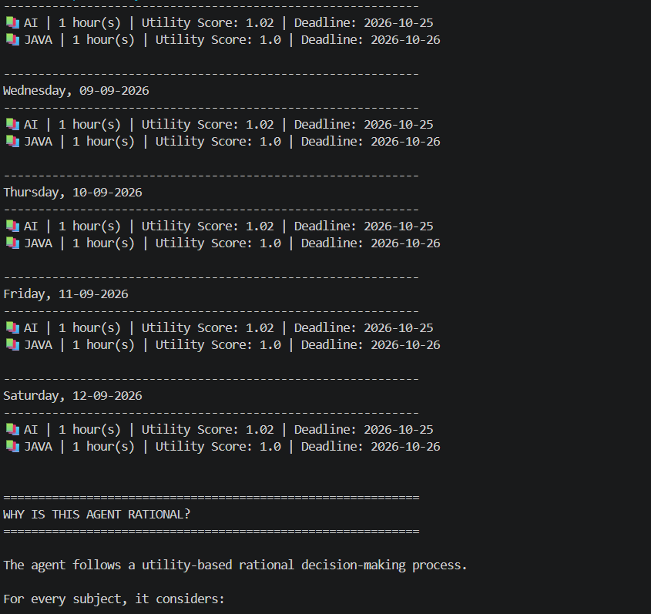

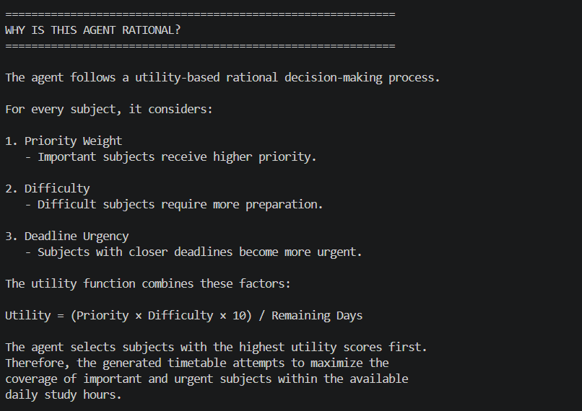

6. Reflection
The main challenge was designing a priority rule that considers different factors such as deadlines and difficulty.
In the future, the project can be improved by adding:
A graphical user interface
Automatic reminders
More detailed subject analysis
Calendar integration
7. Honesty Note
AI assistance was used for guidance and learning during the development of this project. The final project was reviewed and understood before submission.
8. Conclusion
The AI-Based Study Planner demonstrates how a Rational Agent can make intelligent decisions based on available information. The project helps students organise their study time by prioritising urgent and important subjects.

