
MICRO-LEVEL PROJECT REPORT
25ML35T / FOUNDATIONS OF ARTIFICIAL INTELLIGENCE

PROJECT TITLE:
AI-BASED STUDY PLANNER:
A CONSTRAINT-BASED ADAPTIVE TIMETABLER
SUBMITTED BY: ANSLIN JENI J.S
REGISTER NUMBER: 113025148005
YEAR / SECTION: II / A
SUBMITTED TO: DR. MANOJ KUMAR D S
ASSOCIATE PROFESSOR, DEPARTMENT OF CSE (AI&ML)
ACADEMIC YEAR: 2026–2027
SUBMISSION DATE: 13-10-2026

1. ABSTRACT AND PROJECT OBJECTIVES

1.1 Abstract
The AI-Based Study Planner is a rational agent that converts a student’s subjects, deadlines, difficulty ratings, importance weights and required study hours into a weekly timetable. Each subject receives a priority score, (difficulty × weight) ÷ days left, which is used to break ties during search. Every required study hour is modelled as a variable of a Constraint Satisfaction Problem (CSP) whose domain is the set of available (day, session) slots, and the timetable is found using backtracking search improved with Minimum Remaining Values (MRV), Least Constraining Value (LCV), forward checking and AC-3-style arc consistency. A small rule base with forward chaining handles subject prerequisites and produces an auditable inference trace, a heuristic completion-likelihood estimate is reported for each subject, and the plan can be rebuilt after a missed session. The program was run on user-entered data and on a built-in demo, and it produced valid timetables in both cases.

1.2 Keywords
Rational Agent, Constraint Satisfaction Problem (CSP), Backtracking, MRV, LCV, AC-3, Forward Chaining, Adaptive Re-planning.

1.3 Problem Statement
Students have limited time to prepare for several subjects that differ in deadline, difficulty and importance. Manually prepared or equal-split timetables often ignore urgent deadlines, subject prerequisites and the need to spread sessions fairly, and they are not repaired when a session is missed. This project builds an explainable planner that produces a conflict-free timetable respecting slot, deadline, prerequisite and spacing constraints, and that can re-plan automatically.

1.4 Objectives
- Compute a priority score for every subject using difficulty, importance and days remaining.
- Generate a timetable in which no two study hours share a slot and every subject is finished before its deadline.
- Schedule prerequisite subjects before the subjects that depend on them, and reject cyclic or unknown prerequisites.
- Compare plain backtracking with MRV + LCV + forward checking + AC-3 by reporting nodes expanded and backtracks.
- Report a completion-likelihood estimate with an explanation, and re-plan after a missed session.

1.5 Scope
Included: console-based input and validation, a 7-day planning horizon with a configurable number of sessions per day, CSP timetable generation, prerequisite reasoning, completion-likelihood estimates, search comparison and re-planning. Excluded: graphical interface, calendar export, persistent storage of progress, and learning from past performance.

2. INTRODUCTION AND PROPOSED SOLUTION

2.1 Background
Study planning is a decision problem: several subjects compete for a fixed number of study slots before their deadlines. Because the problem has clear variables, finite domains and hard rules, it fits naturally into artificial-intelligence techniques such as intelligent agents, search and constraint satisfaction, and it is relevant to every student preparing for internal assessments and semester examinations.

2.2 Existing System / Current Approach
Students normally prepare a timetable by hand, divide time equally among subjects, or follow a fixed template copied from a friend or a planner app. Prerequisites and deadlines are tracked mentally.

2.3 Limitations of the Existing Approach
- Manual plans can overlook urgent deadlines or difficult subjects, and may double-book a time slot.
- Fixed timetables do not adapt when a session is missed, so pending work silently piles up.
- Prerequisite order (for example Python before AI Basics) is not checked automatically.
- The reasoning behind a timetable is not explained, so the student cannot verify it.

2.4 Proposed AI-Based Solution
The proposed planner accepts subject details, validates them, and treats scheduling as a CSP. A priority score guides the search, constraint propagation removes impossible slots early, and a forward-chaining rule base reasons about prerequisites. The program prints the timetable together with each subject’s priority, an inference trace, a completion-likelihood estimate with its explanation, and a comparison of baseline and improved search. If a session is missed it rebuilds the plan from the remaining hours.

2.5 Expected Benefits / Intended Users
School and college students, and competitive-exam aspirants, benefit from a transparent timetable that respects deadlines and prerequisites, and from quick recovery when plans change. The explanation output also helps a teacher or mentor review the plan.

3. AI CONCEPTS AND PROBLEM FORMULATION

3.1 AI Concept Used
Intelligent (rational) agent, Constraint Satisfaction Problem with backtracking search, heuristic variable and value ordering (MRV, LCV), constraint propagation (forward checking and AC-3), rule-based reasoning with forward chaining, and a simple heuristic treatment of uncertainty.

3.2 Why This AI Concept Is Suitable
A timetable is a set of assignments that must satisfy many simultaneous constraints, which is exactly what a CSP expresses. MRV and LCV reduce the search effort, propagation detects dead ends early, and forward chaining over explicit rules makes prerequisite decisions explainable. The priority score gives the agent a utility-like measure for choosing between competing subjects.

3.3 Problem Formulation
Element | Description
Variables | One variable (subject, hour_k) for every remaining study hour of every subject.
Domains | All (day, session) slots from today up to min(planning horizon, days to the subject’s deadline), with the configured sessions per day.
Initial state | No hour assigned; subjects with deadline, difficulty (1–5), weight (1–5), required and completed hours, and prerequisites.
Actions | Assign a (day, session) slot to one unassigned study hour.
Goal test | Every study hour is assigned and all constraints hold.
Constraints | (1) No two hours share a slot. (2) The same subject is not placed in consecutive sessions of one day. (3) Every hour is placed on or before the subject’s deadline. (4) A prerequisite’s hours are scheduled earlier than the dependent subject’s hours.

3.4 PEAS Description
Component | Project-specific description
Performance measure | All hours scheduled before deadlines with no constraint violated; high-priority subjects placed early; fewer nodes and backtracks; reasonable completion-likelihood values.
Environment | A student’s weekly calendar: subjects, deadlines, difficulty and importance values, prerequisites and a limited number of study sessions per day.
Actuators | Printed weekly timetable, inference trace, likelihood explanations, search statistics and the re-planned timetable.
Sensors / inputs | Subject name, deadline, difficulty, importance, required hours, prerequisites, sessions per day, and a missed-session report.

3.5 Input, Output and Assumptions
Input: number of subjects; for each subject its name, deadline (YYYY-MM-DD), difficulty (1–5), importance (1–5), required study hours and prerequisites; sessions available per day. Output: a 7-day timetable, priority values, forward-chaining trace, completion-likelihood percentages, baseline-versus-improved search statistics, and a revised timetable after a missed session.
Assumptions: one session equals one study hour; the planning horizon is seven days starting today; the entered difficulty, importance and hours are accurate; and no personal identifiers are entered.

4. SYSTEM ARCHITECTURE AND DESIGN

4.1 System Architecture Diagram
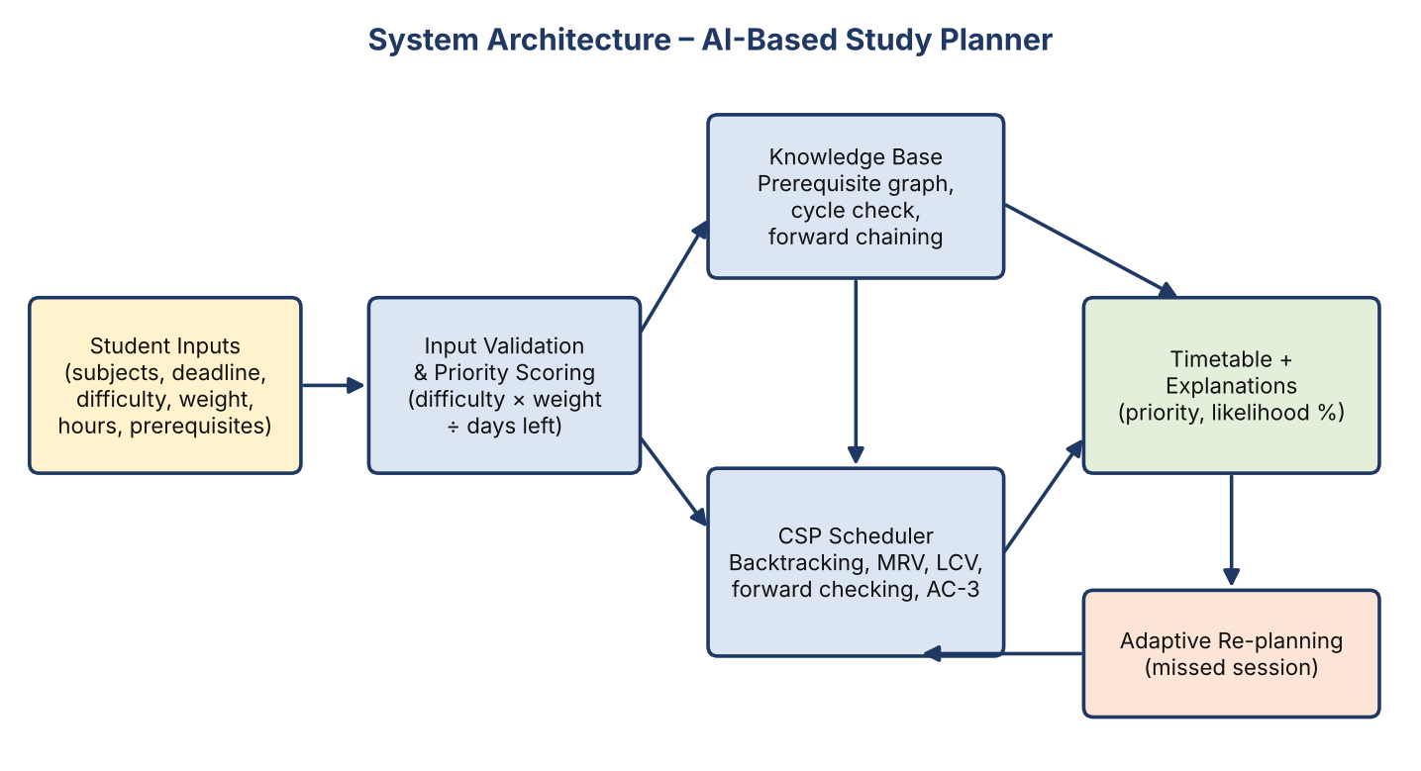
Figure 1: Architecture – inputs are validated and scored, the knowledge base and CSP scheduler produce the timetable, and missed sessions trigger re-planning.

4.2 Workflow / Flowchart
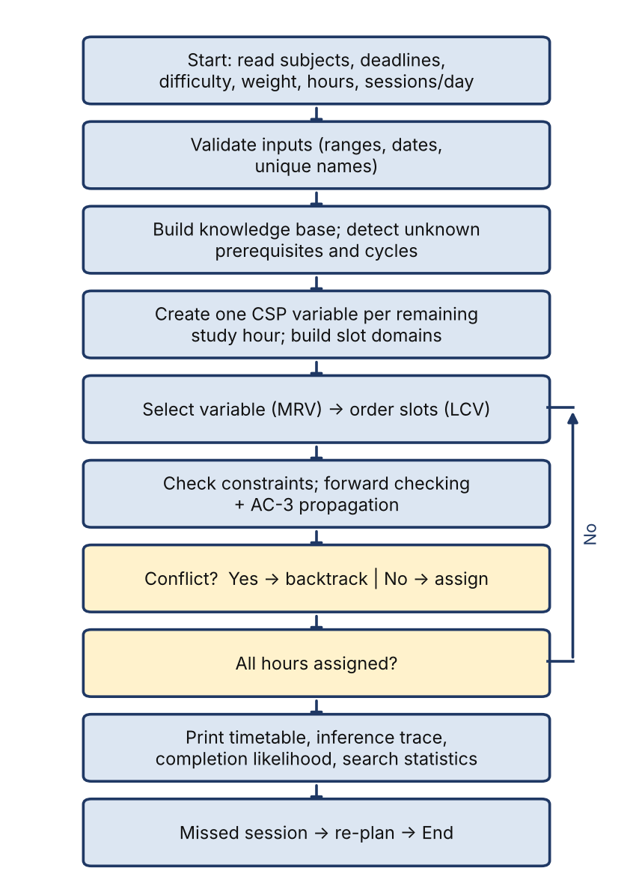
Figure 2: Workflow of the planner from input reading to re-planning.

4.3 Modules and Responsibilities
Module | Responsibility / function
Subject (data class) | Stores and validates subject data; computes days_left, remaining_hours and priority = (difficulty × weight) ÷ days_left.
Knowledge base | Checks unknown/self prerequisites, detects cycles by depth-first topological ordering, and runs forward chaining with an inference trace.
CSP scheduler | Creates variables and domains, selects variables by MRV, orders values by LCV, applies forward checking and AC-3, and backtracks.
Uncertainty estimator | Computes a heuristic completion likelihood from capacity, difficulty and urgency.
Re-planner and reporter | Rebuilds the plan after a missed session; prints timetable, statistics and the responsible-AI note.

4.4 Tools, Language and Libraries Used
Python 3.13 in Visual Studio Code on Windows. Only the standard library is used: argparse, copy, json, dataclasses, datetime and typing.

5. ALGORITHM AND METHODOLOGY

5.1 Methodology
- Read and validate subject details (date format, ranges 1–5, hours ≥ 1, unique names).
- Build the prerequisite knowledge base and reject unknown prerequisites or cycles.
- Create one CSP variable for every remaining study hour and build its slot domain up to the deadline.
- Search with backtracking, using MRV, LCV, forward checking and AC-3.
- Print the timetable, forward-chaining trace and completion-likelihood estimates.
- Run baseline and improved search on the same input and compare the counters; re-plan after a missed session.

5.2 Algorithm / Pseudocode
function SOLVE(domains, assignment):
nodes ← nodes + 1
if all variables assigned: return assignment
v ← MRV(unassigned) # fewest legal slots
for slot in LCV_ORDER(v): # least-constraining first
if not CONSISTENT(v, slot): continue
copy domains; remove slot from every other unassigned domain
if any domain becomes empty: backtracks++ ; continue
if not AC3(remaining domains): backtracks++ ; continue
result ← SOLVE(new domains, assignment + {v: slot})
if result ≠ failure: return result
backtracks++ ; return failure

5.3 Explanation of the AI Technique
MRV selects the hour with the fewest legal slots first (“fail-first”), and ties are broken by the higher subject priority so that urgent subjects are placed early. When a variable has to receive a slot, LCV tries the slot that leaves the most freedom to the other hours. Forward checking removes the chosen slot from all other domains, and AC-3 removes a slot from one domain when another variable is left with only that slot. CONSISTENT also enforces the no-consecutive-session rule and the prerequisite ordering. The knowledge base uses forward chaining: a fact completed(S) is added when all hours of S are done, and the rule prerequisites_satisfied(X) fires when every prerequisite of X is completed or X has none; each firing is logged as a trace line.

5.4 Data Structures / Knowledge Representation
- Subject dataclass with validation; dictionary of subjects keyed by name.
- Slot = (day_index, session_index); variable = (subject, hour_number); domains = dictionary variable → list of slots.
- Facts as strings such as completed(Python) in a set; trace as a list of explanation strings.
- Prerequisites as a directed graph checked by depth-first search.

5.5 Time and Space Complexity
For n study-hour variables and d slots per domain, plain backtracking is O(dⁿ) in the worst case. MRV, LCV, forward checking and AC-3 do not change this worst case but prune the search; each AC-3 pass costs O(n²) pair checks in this implementation. Space is O(n·d) because domains are copied at every search node. In the runs below, 5–7 hours over 21 slots were solved with the minimum possible number of nodes.

6. IMPLEMENTATION AND GITHUB REPOSITORY

6.1 Development Environment
Visual Studio Code, Python 3.13 (Windows, PowerShell terminal), standard library only.

6.2 Implementation Steps
- Defined the Subject class with validation and the priority property.
- Implemented StudyPlanner with prerequisite validation and topological ordering.
- Implemented forward_chain() to derive facts and record a trace.
- Created CSP variables and deadline-limited domains; wrote the _consistent() constraint checks.
- Implemented plain backtracking, then added MRV, LCV, forward checking and AC-3.
- Added completion_likelihood() and replan_after_missed_session().
- Added the command-line interface (interactive and --demo) and the responsible-AI note.

6.3 GitHub Repository URL
https://github.com/codebyjeni/AI-Study-Planner.git

6.4 Repository Name and Access Status
Repository name: AI-Study-Planner and Public

6.5 Repository Structure
File / folder | Purpose | Included?
src/study_planner.py | Main implementation (CSP, rules, CLI) | Yes
README.md | Project overview and execution steps | Yes / No
requirements.txt | Dependencies (none beyond standard library) | Yes / No
tests/ | Test scripts or test cases | Yes / No
screenshots/ | Execution evidence | Yes / No
.gitignore | Excludes local files and secrets | Yes / No

6.6 Setup and Execution Instructions
1. Install Python 3.10 or later.
2. Open the project folder (AI Study Planner for IA) in VS Code.
3. Interactive mode : python src/study_planner.py
4. Demo mode : python src/study_planner.py --demo

6.7 Commit History / Contribution Summary
Individual project. I implemented the data model, CSP search with heuristics, the rule base, the likelihood estimate, re-planning and testing. (Replace with your actual commit messages from GitHub.)

7. RESULTS AND OBSERVATIONS

7.1 Results Summary
The planner accepted the entered data, validated it, and produced a valid timetable in every run: no slot was double-booked, every subject finished before its deadline, and the same subject never occupied consecutive sessions on one day. Run 1 used two subjects (fai: deadline 2026-10-15, difficulty 4, weight 4, 3 h; oops: deadline 2026-10-17, difficulty 3, weight 4, 2 h) with 3 sessions per day.
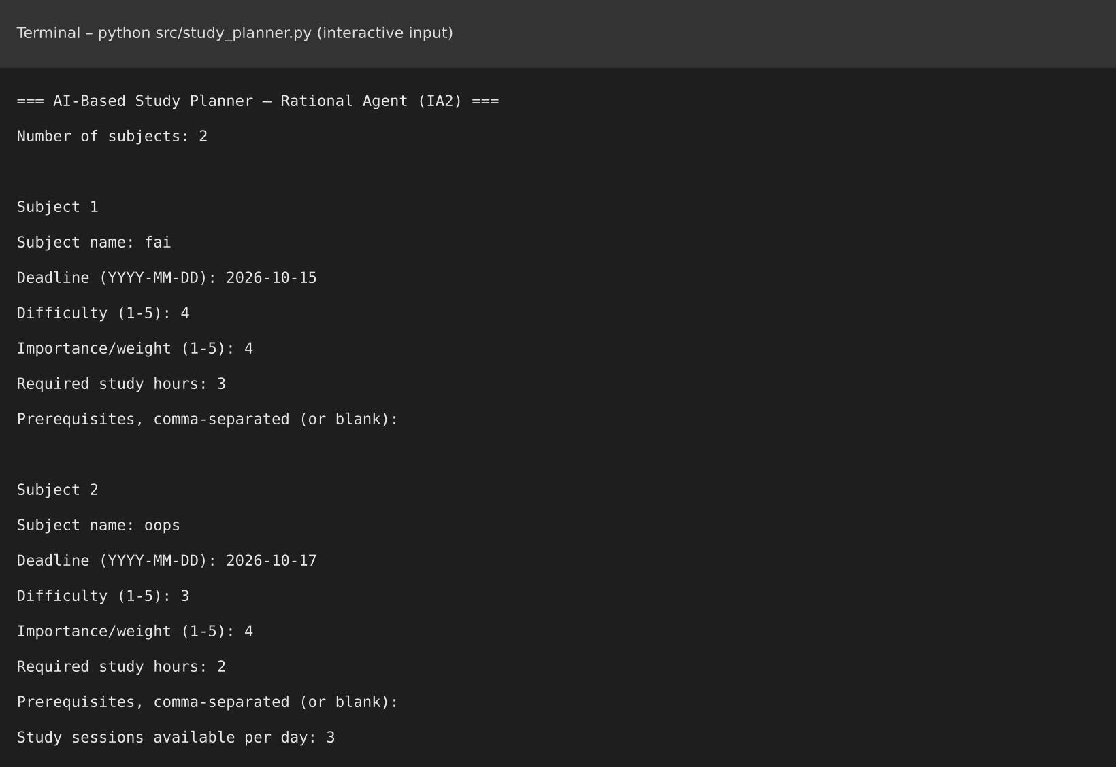
Figure 3: Input entered in Run 1 (two subjects, 3 sessions per day).
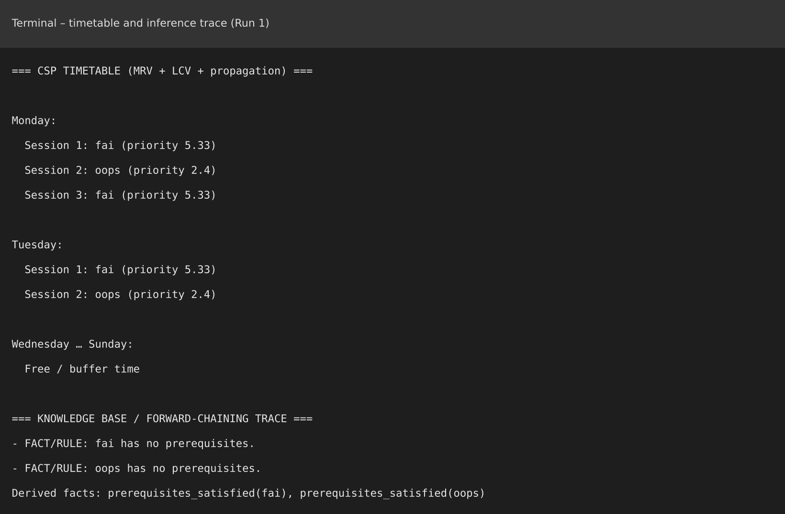
Figure 4: CSP timetable and forward-chaining trace produced in Run 1.
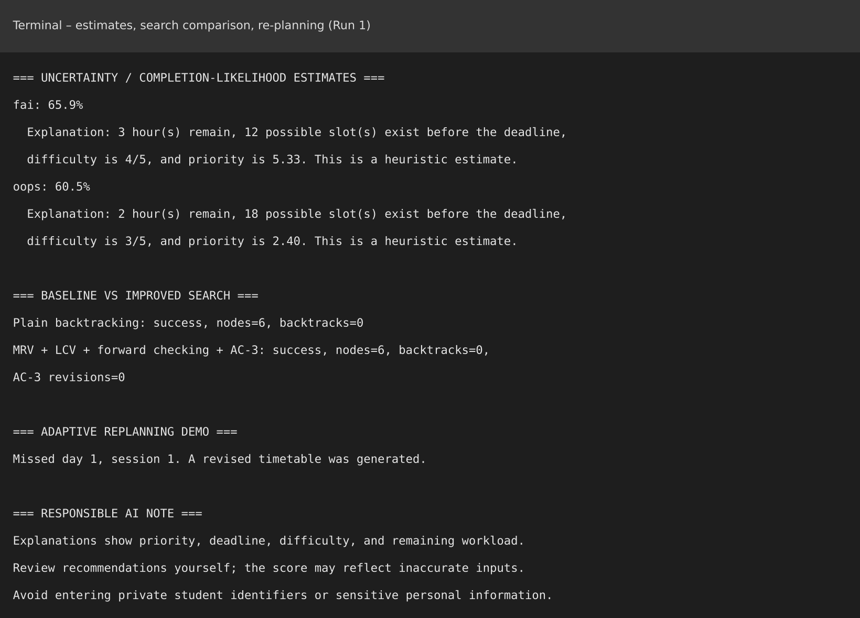
Figure 5: Completion-likelihood estimates, search comparison and re-planning output (Run 1).

7.2 Observations
Run | Subjects | Timetable used | Nodes / backtracks | AC-3 revisions
1: fai, oops (3 h, 2 h) | 2 | Mon S1–S3, Tue S1–S2 | 6 / 0 (both methods) | 0
2: demo (4 subjects) | 4 | Mon–Wed | 8 / 0 (both methods) | 0
3: fai, oops (3 h, 3 h) | 2 | Mon–Wed | 7 / 0 (both methods) | 0

- The higher-priority subject was placed first: in Run 1 fai (priority 5.33) takes Monday sessions 1 and 3 and Tuesday session 1, with oops (2.40) in between.
- In the demo, Mathematics (priority 6.25) and Python were scheduled on Monday, and AI Basics on Tuesday session 2 after both Python hours, satisfying the prerequisite rule.
- Fairness rule: fai never occupies two consecutive sessions on a day (Monday sessions 1 and 3 with oops in session 2).
- Because these inputs are small and loosely constrained, plain backtracking and the improved search both reached a solution with the same nodes (equal to the number of study hours) and no backtracks, and AC-3 made no revisions. The advantage of MRV, LCV and AC-3 would only appear on tighter inputs, and I have not claimed any speed-up.
- Re-planning after a missed day-1 session produced the same timetable, because the planner rebuilds from remaining hours starting today.

7.3 Performance Measure / Completion Likelihood
Subject (run) | Likelihood | Priority | Basis (from program output)
fai (Run 1) | 65.9% | 5.33 | 3 h remain, 12 slots before deadline, difficulty 4/5
oops (Run 1) | 60.5% | 2.40 | 2 h remain, 18 slots, difficulty 3/5
Mathematics (demo) | 62.0% | 6.25 | 2 h remain, 15 slots, difficulty 5/5
AI Basics (demo) | 55.7% | 2.67 | 1 h remains, 21 slots, difficulty 4/5
oops (Run 3) | 57.8% | 5.00 | 3 h remain, 18 slots, difficulty 5/5
These values are heuristic estimates built from capacity, difficulty and urgency factors; they are not calibrated probabilities. Harder subjects receive lower likelihoods even when they have plenty of slots.

7.4 Test Cases
No. | Scenario | Expected result | Observed
1 | Two independent subjects, enough slots | All 5 hours scheduled before deadlines | Pass
2 | Different priorities (5.33 vs 2.40) | Higher-priority subject gets earlier/more sessions | Pass
3 | Same subject twice in one day | Not in consecutive sessions | Pass (Mon S1, S3)
4 | AI Basics requires Python (demo) | Python hours scheduled first | Pass (Tue S2 after Python)
5 | Forward chaining on unfinished prerequisite | No prerequisites_satisfied(AI Basics) fact until Python is complete | Pass (3 facts only)
6 | Session 1 on day 1 missed | Revised timetable generated | Pass (message printed)

8. DISCUSSION, LIMITATIONS AND FUTURE ENHANCEMENTS

8.1 Discussion
Modelling each study hour as a CSP variable made every rule explicit and checkable, so a printed timetable is always consistent with the constraints. The priority score decides which subject is placed first when options tie, the forward-chaining trace explains prerequisite decisions, and the likelihood estimate warns the student about subjects that may be at risk.

8.2 Limitations
- The quality of the plan depends on accurate difficulty, weight and hour estimates entered by the user.
- The completion likelihood is a heuristic and is not learned from real data.
- Re-planning rebuilds from the stored remaining hours and does not yet record which sessions were actually completed, so the revised plan equals the original in the demo.
- On the small sample inputs, MRV/LCV/AC-3 showed no measurable gain over plain backtracking; larger and tighter cases are needed for a fair comparison.
- Console interface only; the horizon is fixed at seven days.

8.3 Future Enhancements
- Track completed hours per session so that re-planning really changes the schedule.
- Add a graphical interface and export to a calendar.
- Test on larger, tighter inputs and report runtimes; add break and revision-spacing constraints.
- Learn the likelihood model from a student’s past progress.

8.4 Practical Applications
Student revision planning, coaching centres preparing exam schedules, and any task-scheduling setting with deadlines, dependencies and limited time slots.

8.5 Learning Outcomes
I learned how to formulate a real problem as a CSP, how MRV, LCV, forward checking and AC-3 work, how forward chaining produces an explainable inference trace, how to treat uncertainty with a simple heuristic, and how to validate inputs and document results honestly in a Python project.

9. CONCLUSION AND REFERENCES

9.1 Conclusion
The AI-Based Study Planner successfully combines a priority score, CSP search with MRV, LCV, forward checking and AC-3, prerequisite reasoning with forward chaining, and adaptive re-planning. In all executed runs it produced conflict-free timetables that finish each subject before its deadline, respect prerequisite order and avoid consecutive sessions of the same subject. The project also reports its limits openly: the likelihood values are heuristic, and the sample inputs were too small to show a difference between plain and improved search. With progress tracking and a larger test set it can become a practical study-planning assistant.

9.2 References
- S. Russell and P. Norvig, Artificial Intelligence: A Modern Approach, 4th ed., Pearson, 2021.
- Python Software Foundation, Python 3 documentation, https://docs.python.org/3/
- A. K. Mackworth, “Consistency in Networks of Relations,” Artificial Intelligence, vol. 8, no. 1, 1977 (AC-3).
- Course material: 25ML35T Foundations of Artificial Intelligence, Vel Tech High Tech Dr. Rangarajan Dr. Sakunthala Engineering College.

