1. INTRODUCTION
The Student Portal Management System is a Java-based web application designed to digitize and simplify the process of managing student academic records within an educational institution. In traditional systems, student data such as names, roll numbers, and marks are maintained manually in registers or basic spreadsheets, which often leads to errors, data loss, and time-consuming evaluations.
This project addresses these issues by providing a lightweight, browser-accessible portal where faculty members can add student information, automatically evaluate their pass/fail status, and view real-time statistics on a clean dashboard. The system is developed entirely in Core Java using the built-in com.sun.net.httpserver package, which eliminates the need for heavy external frameworks like Spring or Tomcat. The user interface is rendered dynamically using HTML and CSS embedded within the Java code, making the application portable and easy to deploy.
The portal demonstrates the practical application of Object-Oriented Programming (OOP) principles such as inheritance, interfaces, method overloading, and static members, while also integrating web technologies to deliver a seamless user experience. It serves as both a functional tool for academic record-keeping and an educational demonstration of how Java can be used to build full-stack applications without third-party dependencies.
2. OBJECTIVES
- To develop a simple and efficient web-based portal that allows users to add, store, and evaluate student academic records in real time.
- To demonstrate the practical implementation of Object-Oriented Programming concepts such as classes, inheritance, interfaces, method overloading, and static variables in a real-world scenario.
- To build a lightweight application that runs independently using only Java's built-in HTTP server, without requiring external servers like Apache Tomcat.
3. TECHNOLOGIES USED
Category | Technology / Tool
Programming Language | Java (JDK 8 or above)
Web Server | com.sun.net.httpserver (Built-in Java HTTP Server)
Frontend | HTML5, CSS3 (rendered via Java StringBuffer)
IDE | Eclipse IDE
Protocol | HTTP (GET & POST methods)
Data Storage | In-memory storage using Java ArrayList
Encoding | UTF-8 / URL Decoding
Table 3.1: Technologies, Tools, and Framework Components Used in the Student Portal Management System
4.HARDWARE/SOFTWARE REQUIRED
Requirement | Specification
Operating System | Windows 7/10/11, Linux, or macOS
RAM | Minimum 2 GB (4 GB recommended)
Java Version | JDK 8 or above
IDE | Eclipse 2020 or later
Browser | Chrome, Firefox, Edge (any modern browser)
Disk Space | 200 MB minimum
Table 4.1: Hardware and Software Requirements for Project Execution
5. SYSTEM DESIGN / ARCHITECTURE
The system follows a simple three-layer architecture that separates the concerns of data handling, business logic, and user interface rendering.
Layer 1 – Presentation Layer (Client Side): The user interacts with the system through a web browser. The browser displays HTML forms styled with CSS for entering student details and viewing the records table.
Layer 2 – Application Layer (Server Side): The Java HTTP Server listens on port 8085. The PortalHandler class processes incoming requests. When a user submits the form (POST request), the data is parsed, validated, and used to create a new Student object. When the page is loaded (GET request), the server dynamically generates the HTML response.
Layer 3 – Data Layer: Student records are stored in a static ArrayList<Student>. Static counters track the total number of students, passed students, and failed students throughout the application's runtime.
Workflow Diagram:
User Browser
(HTTP Request)
Java HTTP Server - Port 8085

PortalHandler Class

Student Class - Object Creation & Validation

ArrayList Storage + Static Counters
(HTTP Response - HTML)
User Browser - Updated Dashboard
Figure 5.1: System Workflow Diagram of the Student Portal Application
6. FEATURES OF THE PROJECT
- Dynamic Student Registration: Users can add new student records through a clean web form with fields for name, roll number, and marks.
- Automatic Pass/Fail Evaluation: The system automatically determines the status of each student based on whether their marks are above or below 50%.
- Live Statistics Dashboard: Real-time counters display the total number of students, passed students, and failed students at the top of the page.
- Input Validation: The system rejects invalid entries, such as names containing numerical digits, and displays clear error messages to the user.
- Optional Marks Field: Faculty can register a student without entering marks (using the overloaded constructor), which defaults the marks to zero.
- Standalone Deployment: Runs on a single Java file without any external server or database setup.

7. OOP CONCEPTS USED
- Class and Object: The Student and Person classes define blueprints for creating student objects. Each student added through the form becomes an object of the Student class.
- Inheritance: The Student class extends the Person class, inheriting the name attribute. This shows the "is-a" relationship — every Student is a Person.
- Interface (Abstraction): The Evaluable interface declares two methods: getStatus() and toHtmlRow(). The Student class implements this interface, ensuring that every evaluable entity follows a consistent contract.
- Encapsulation: Private fields such as rollNo and marks are hidden within the Student class and accessed only through controlled methods, protecting data integrity.
- Method Overloading (Polymorphism): The Student class has two constructors — one accepting name, roll number, and marks, and another accepting only name and roll number. This is a clear example of compile-time polymorphism.
- Method Overriding (Polymorphism): The getStatus() and toHtmlRow() methods declared in the Evaluable interface are overridden in the Student class to provide specific implementations.
- Static Members: Variables like totalStudents, totalPassed, and totalFailed are declared as static, meaning they belong to the class itself rather than any individual object. They keep track of cumulative statistics across all student instances.
- Constructor Chaining: The overloaded constructor calls the main constructor using this(name, rollNo, 0.0), demonstrating constructor chaining.
- Use of super Keyword: The Student constructor uses super(name) to invoke the parent Person class constructor.

8. WORKING OF THE PROJECT
Step 1 – Server Initialization: When the program is executed in Eclipse, the main() method starts an HTTP server on port 8085. Two sample students are pre-loaded into the list as seed data.
Step 2 – Accessing the Portal: The user opens a web browser and navigates to http://localhost:8085. The server receives a GET request and responds by rendering the complete HTML page, including the dashboard, form, and existing student records.
Step 3 – Adding a New Student: The user fills in the form with the student's name, roll number, and (optionally) marks, then clicks the "Add Student Record & Evaluate" button. This triggers a POST request to the server.
Step 4 – Data Parsing and Validation: The server reads the form data, decodes it using UTF-8, and splits it into key-value pairs. It then validates the input — for example, checking that the name does not contain digits. If validation fails, an error message is stored to be displayed on the next page load.
Step 5 – Object Creation and Evaluation: If validation passes, a new Student object is created. The constructor automatically increments the static counters and determines whether the student has passed or failed.
Step 6 – Page Refresh: The server sends a redirect response (HTTP 303) back to the home page. The browser reloads, displaying the updated dashboard, the new student in the table, and any error messages if applicable.
9. CODE EXPLANATION
- The Evaluable Interface: This interface acts as a contract for any class that needs to be evaluated. It defines two abstract methods — getStatus() to return pass/fail status and toHtmlRow() to generate an HTML table row representation.
- The Person Class: This is a simple parent class containing a single protected attribute name. It serves as the base class for inheritance.
- The Student Class: This is the core class of the project. It extends Person and implements Evaluable. It contains private fields (rollNo, marks), static counters, two constructors (demonstrating overloading), and overridden methods for status evaluation and HTML rendering.
- The Student_Portal Main Class: This class contains the main() method that initializes the HTTP server. It maintains a static ArrayList of students and a validationErrorMessage string for displaying errors.
- The PortalHandler Inner Class: This class implements HttpHandler and handles all incoming HTTP requests. It distinguishes between GET requests (rendering the page) and POST requests (processing form submissions). It also dynamically constructs the entire HTML response using StringBuffer, including inline CSS for styling.
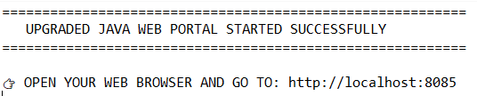
10. OUTPUT
The following screenshots demonstrate the successful execution and functionality of the Student Portal Management System.
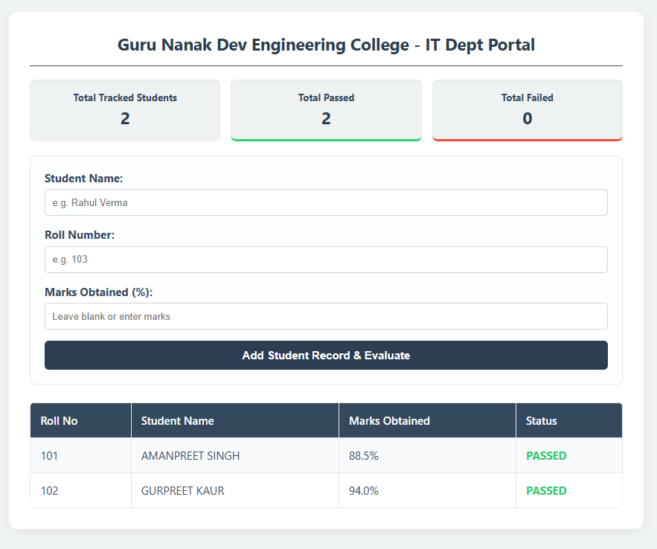
Figure 10.1: Console Output Showing Successful Startup of the Student Portal Server on Port 8085
Figure 10.2: Main Dashboard Interface Displaying Student Records and Evaluation Statistics
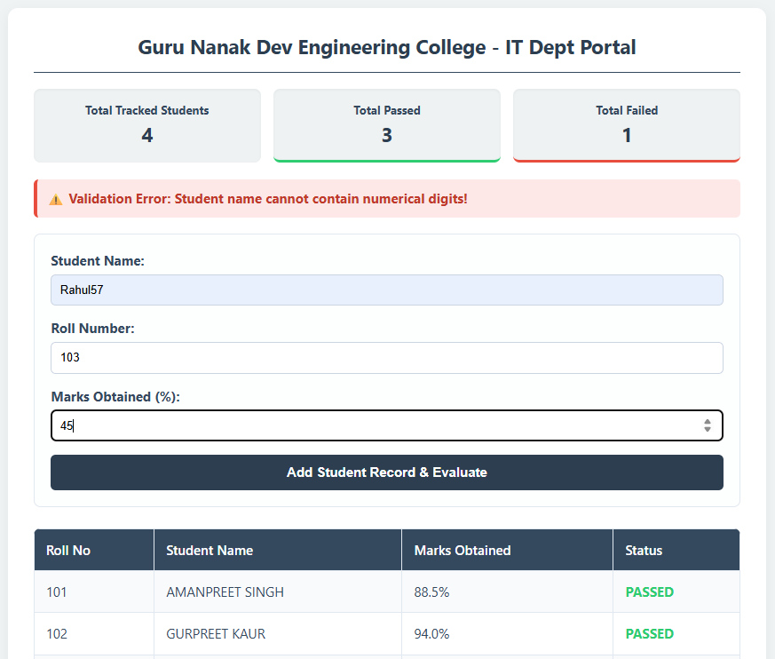
Figure 10.3: Input Validation Mechanism Displaying Error for Invalid Student Name Entry
11. ADVANTAGES
- Lightweight and Portable: Runs on a single Java file without requiring any external server or database installation.
- Fast and Responsive: Since data is stored in memory, retrieval and updates are instantaneous.
- Educational Value: Clearly demonstrates the practical use of OOP concepts in a real application.
- User-Friendly Interface: Clean, color-coded UI that is easy to understand for non-technical users.
- Real-Time Statistics: The dashboard updates instantly whenever a new student is added.
- Cross-Platform: Works on Windows, macOS, and Linux as long as Java is installed.
- No Dependencies: Uses only built-in Java libraries, making it easy to compile and run anywhere.
12. LIMITATIONS
- No Persistent Storage: Data is stored in memory and is lost when the server is stopped or restarted.
- Single-User Access: The application is designed for local use and does not support concurrent multi-user authentication.
- No Database Integration: Lacks integration with databases like MySQL or MongoDB for long-term data storage.
- Limited Security: Does not include features like login authentication, password protection, or encrypted data transmission (HTTPS).
- Basic UI: While clean, the interface lacks advanced features like search, sort, edit, or delete functionalities.
- Scalability Issues: Not suitable for handling thousands of records due to in-memory storage limitations.
13. FUTURE SCOPE
- Database Integration: Connect the application to a relational database such as MySQL or PostgreSQL using JDBC for permanent data storage.
- User Authentication: Add login and registration modules with role-based access for administrators, faculty, and students.
- CRUD Operations: Implement edit, update, and delete functionalities for managing existing records.
- Search and Filter: Add search bars and filters to quickly locate students by name, roll number, or status.
- Report Generation: Enable export of student data into PDF or Excel formats for offline use.
- Email Notifications: Automatically send result notifications to students via email upon evaluation.
- Cloud Deployment: Deploy the application on cloud platforms like AWS, Heroku, or Azure for global accessibility.
14. CONCLUSION
The Student Portal Management System successfully demonstrates how Core Java can be used to build a fully functional web application without relying on heavy external frameworks. The project combines theoretical concepts of Object-Oriented Programming with practical web development, resulting in a system that is both educational and useful.
Through this project, key OOP principles such as inheritance, interfaces, method overloading, static members, and encapsulation have been implemented in a meaningful real-world context. The integration of Java's built-in HTTP server with dynamically generated HTML pages showcases the versatility of the Java platform for full-stack development.
While the current version is limited to in-memory storage and basic functionalities, it lays a strong foundation for future enhancements such as database integration, authentication, and cloud deployment. Overall, the project achieves its goal of providing a lightweight, efficient, and educational tool for managing student records and serves as an excellent demonstration of how programming fundamentals can be transformed into a working application.
15. REFERENCES
- Herbert Schildt, "Java: The Complete Reference", 12th Edition, McGraw-Hill Education.
- Cay S. Horstmann, "Core Java Volume I – Fundamentals", 11th Edition, Pearson.
- Java HTTP Server API – https://docs.oracle.com/javase/8/docs/jre/api/net/httpserver/spec/
- W3Schools HTML & CSS Tutorials – https://www.w3schools.com/
- GeeksforGeeks Java Tutorials – https://www.geeksforgeeks.org/java/
- Eclipse IDE Documentation – https://www.eclipse.org/documentation/

