TASK 1

1. Design and implement the function bstMaximum(), which finds and returns the

maximum key value in a binary search tree.

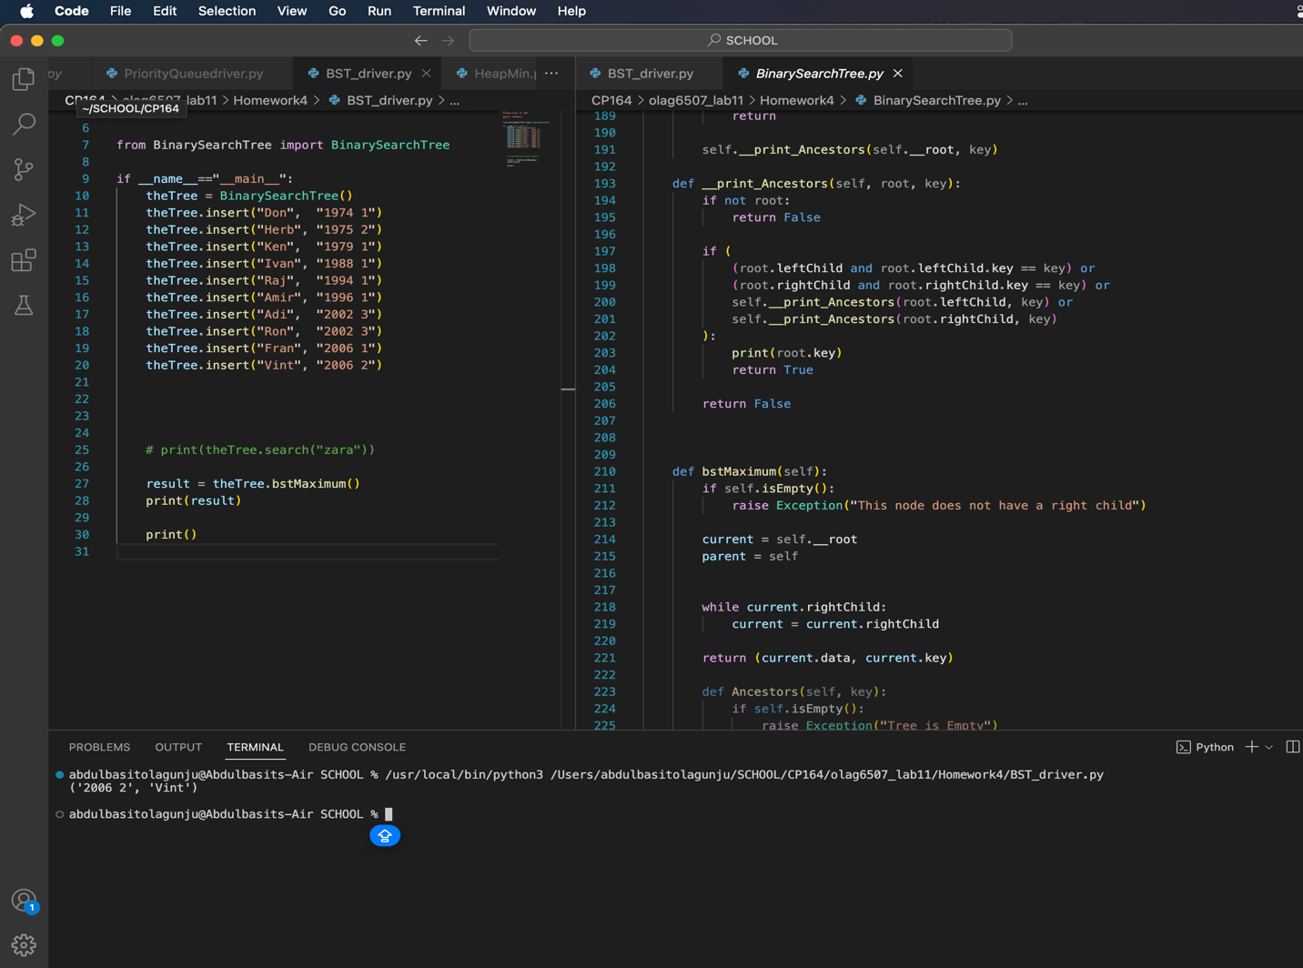

TASK 2

The min-heap has the opposite property of Max-heap

TASK 3

priority Queue using a linked list

