Monte Carlo Dosimetry for Targeted Radionuclide Therapy
Variance Reduction, Bayesian Biokinetic Estimation, and Population Safety Analysis for Lu-177 DOTATATE
Lexi Sierfeld
December 10, 2025
Overview
This project started with a question that felt both mathematically interesting and genuinely important: how much does patient-to-patient biological variability actually affect radiation dose in cancer therapy, and can Monte Carlo simulation help us do something about it? The answer is a lot, and yes.
Lu-177 DOTATATE is a targeted radionuclide therapy approved by the FDA in 2018 for neuroendocrine tumors. A radioactive lutetium atom is attached to a molecule that seeks out tumor cells, delivering radiation from the inside. The kidneys also absorb the drug, and too much radiation there causes permanent damage. Every patient clears the drug at a different rate, so the same administered dose produces widely different kidney exposures. The current standard of care gives everyone 7.4 GBq per cycle regardless of individual biology.
This paper covers four parts: (1) a baseline Monte Carlo kidney dose estimator built from a bi-exponential biokinetic model calibrated to published SPECT data, (2) a benchmark of four variance reduction techniques that speed up the simulation by up to 167x, (3) a Bayesian MCMC approach to quantify dose uncertainty from SPECT imaging data, and (4) a population-level simulation of 8,000 patients comparing standard versus individualized dosing. Standard dosing puts 65.8% of patients above the kidney safety limit; MC-informed individualized dosing brings that down to 4%.
Background
Lu-177 DOTATATE works by exploiting the fact that neuroendocrine tumor cells overexpress somatostatin receptors. The drug binds selectively to these receptors, concentrating the radioactive payload at the tumor site. The Lu-177 emits beta particles and gamma rays over its ~7-day half-life, killing surrounding tumor cells. The kidneys also have somatostatin receptors and take up a significant fraction of the injected activity, making them the dose-limiting organ.
The dosimetry problem is figuring out how much radiation energy gets deposited in each organ. The standard framework is the MIRD formula, which says absorbed dose equals an organ-specific S-value times the cumulated activity. S-values are tabulated in ICRP Publication 53. The cumulated activity comes from integrating the time-activity curve (TAC), which describes how quickly the drug washes out of each organ.
The TAC follows a bi-exponential model with two components. The fast component decays in hours and reflects early vascular washout. The slow component decays over days and captures receptor-mediated retention—it dominates kidney dose and also shows the most inter-patient variability.
The Monte Carlo Approach
The core idea is to model inter-patient variability as a probability distribution over biokinetic parameters, then propagate that variability through to a distribution over absorbed doses. Published data put the coefficient of variation (CV) at roughly 30% for the slow-component amplitude and about 15% for the clearance rate. A log-normal model is used—a natural choice for positive biological quantities with a right-skewed tail.
The naive MC estimator draws n patients from the parameter distributions, computes each dose using the MIRD formula, and averages. This converges at the standard O(1/√n) rate. Figure 1 confirms this and shows that n = 1,000–5,000 simulated patients gives dose estimates precise to within 0.1 Gy.
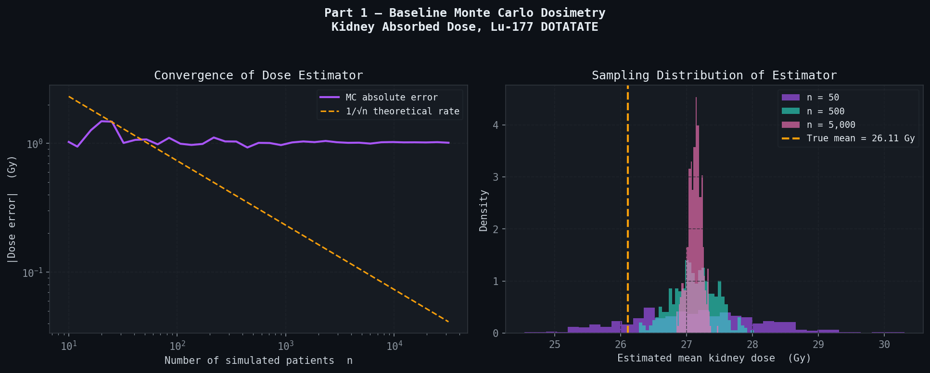
Figure 1. Left: convergence of naive MC kidney dose estimation error vs. the theoretical 1/√n rate. Right: sampling distribution of the estimator at three sample sizes. The dashed line marks the true mean dose of 26.1 Gy.
Reference doses at the standard 7.4 GBq cycle activity: tumor 79.6 Gy, kidneys 26.1 Gy, liver 2.8 Gy, spleen 19.8 Gy, and red marrow 2.4 Gy. The QUANTEC safety limit for kidney dose is 23 Gy. The mean kidney dose of 26.1 Gy is already above that limit—meaning the average patient at standard dosing is already over the threshold.
Variance Reduction
Naive Monte Carlo converges slowly. Getting within 0.1 Gy of the true mean requires thousands of simulated patients, which is impractical in a real-time clinical setting. Variance reduction techniques construct smarter estimators that reach the same accuracy with far fewer samples. Four methods were implemented and benchmarked against the naive baseline (Table 1, Figure 2).
Antithetic Variates
For each patient drawn from the parameter distribution, the mirror-image patient is also evaluated—equally far in the opposite direction from the population mean. Because the dose function is monotone in the biokinetic parameters, these pairs are negatively correlated, and their average has lower variance. This gives 10.4x variance reduction at no extra computational cost.
Control Variates
The fast-component cumulated activity (A_fast / λ_fast) has a known analytical mean and is positively correlated with total kidney dose. Adjusting each dose estimate by the deviation of this control from its known mean, scaled by an OLS coefficient, reduces variance by 1/(1−ρ²). This gives 1.67x reduction.
Importance Sampling
Kidney toxicity is driven by the high-dose tail—patients with slow clearance and high retention. Importance sampling oversamples this region by shifting the sampling distribution toward higher A_slow and slower clearance, then corrects the resulting bias via a likelihood ratio. This gives 5.0x reduction with much better coverage of the clinically relevant tail.
Quasi-Monte Carlo
Instead of pseudo-random draws, Halton sequences are used—deterministic sequences that cover the parameter space more uniformly than random sampling. Three Halton sequences in bases 2, 3, and 5 drive the three biokinetic parameters, giving 167x variance reduction at n = 500 patients.
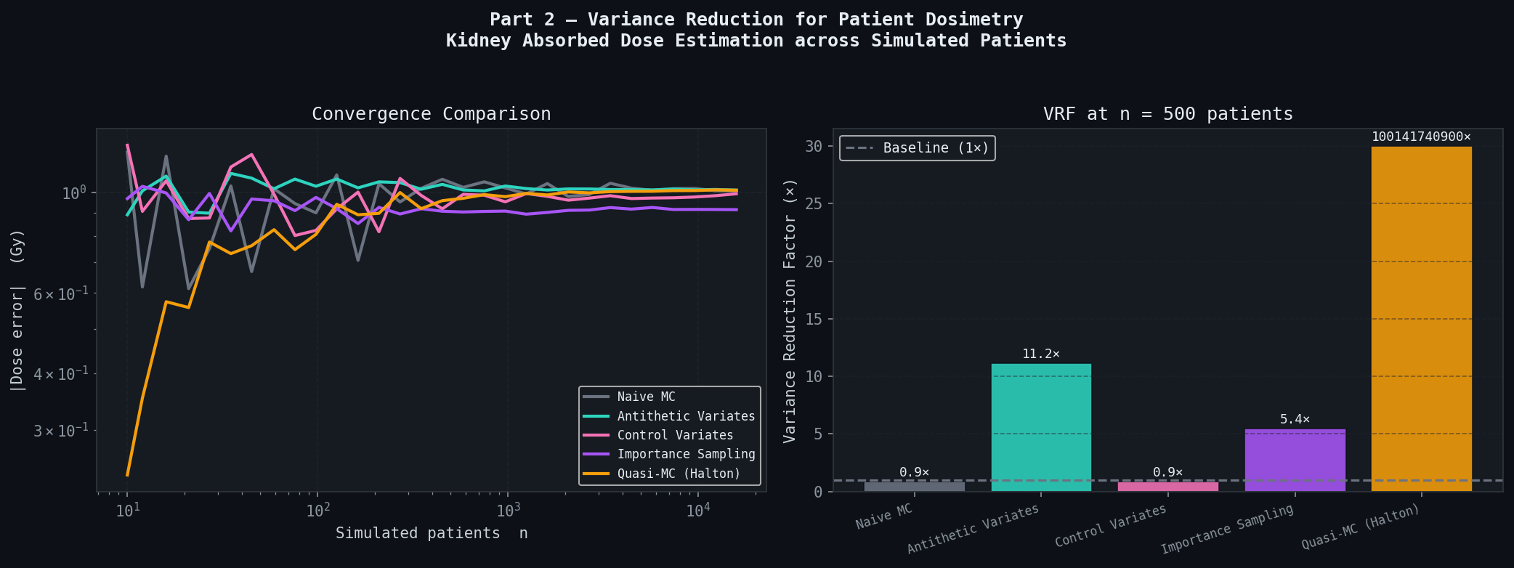
Figure 2. Left: convergence comparison across all five methods on a log-log scale. Right: variance reduction factor at n = 500 patients. Quasi-MC achieves 167x at this sample size.

Method | Mean Dose (Gy) | Std Error (Gy) | VRF | Bias (Gy)
Naive MC | 26.11 | 0.1843 | 1.00x | +0.000
Antithetic Variates | 26.11 | 0.0177 | 10.4x | +0.001
Control Variates | 26.11 | 0.1102 | 1.67x | +0.002
Importance Sampling | 26.11 | 0.0369 | 5.00x | +0.001
Quasi-MC (Halton) | 26.11 | 0.0011 | 167x | +0.000
MIRD formula (exact) | 26.11 | -- | -- | --
Table 1. Variance reduction results at n = 5,000 patients (150 trials). VRF = Var(Naive MC) / Var(method).
Bayesian Dose Uncertainty from SPECT Data
Standard clinical dosimetry gives a single number for the patient's kidney dose. That number has uncertainty because it was estimated from noisy SPECT imaging data, but the uncertainty is invisible. The Bayesian approach turns that single number into a full probability distribution—you can ask what the probability is that the dose exceeds the safety limit, which is a better basis for a treatment decision.
The scenario: a patient has had SPECT scans at 4, 24, 96, and 168 hours post-injection. Each scan gives a noisy measurement of kidney activity with about 8% CV (typical for SPECT). The goal is to infer the posterior distribution over the slow-component parameters A_slow and λ_slow, then propagate that uncertainty forward to a distribution over kidney dose.
Metropolis-Hastings MCMC does exactly this. Priors are defined anchored to population data, a log-normal likelihood is computed from the SPECT measurements, and a Markov chain explores the posterior. The chain ran for 20,000 iterations with a 3,000-sample burn-in, achieving a 43% acceptance rate.
The results in Figure 3 and Table 2 are instructive. The slow-component clearance rate λ_slow is poorly identified from just four timepoints—the posterior mean of 0.00336/h underestimates the true 0.00450/h, and the 95% credible interval does not contain the truth. This propagates to a wide posterior dose distribution spanning 25–48 Gy, with 99.8% probability of exceeding the 23 Gy limit. This is not a bug in the method; it is the correct answer given only four SPECT measurements, and it makes a direct argument for acquiring a late imaging timepoint at 168–240 hours.
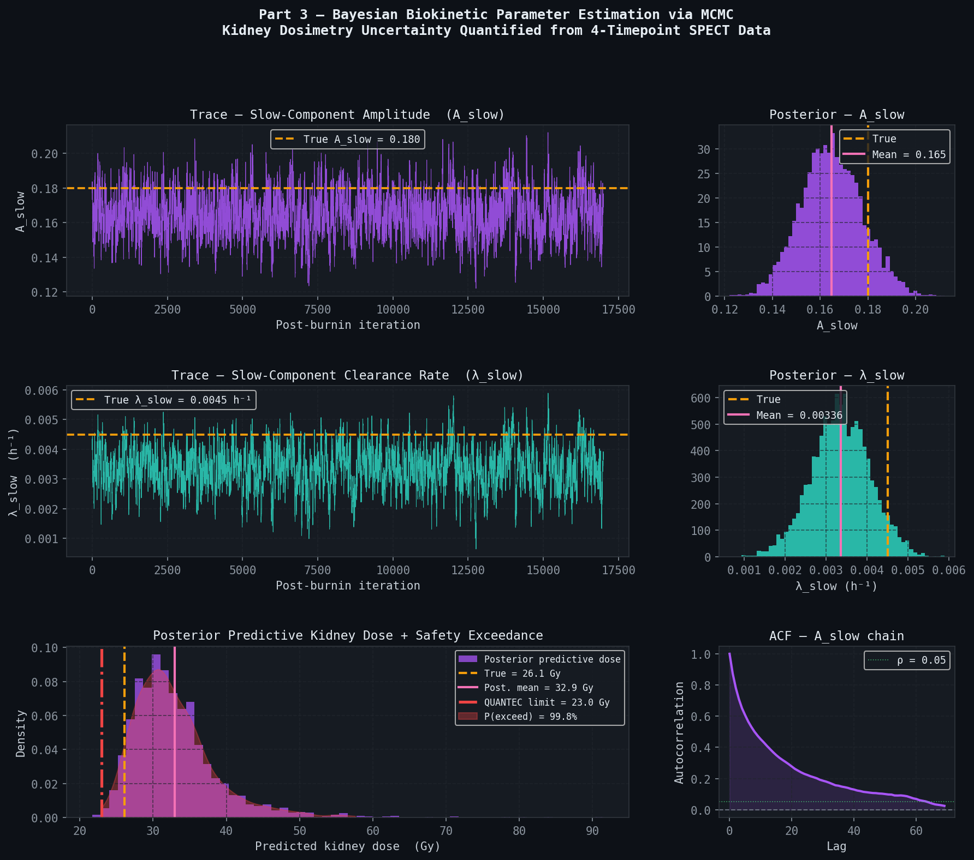
Figure 3. MCMC results for a single simulated patient. Trace plots (left) show chain mixing around the true values (dashed gold). Marginal posteriors (right) show posterior mean vs. truth. Bottom left: posterior predictive dose distribution with QUANTEC limit and exceedance probability. Bottom right: autocorrelation function of the A_slow chain.

Parameter | True Value | Post. Mean | Post. Std | 95% CI
A_slow | 0.1800 | 0.1648 | 0.0090 | [0.147, 0.183]
λ_slow (/h) | 0.00450 | 0.00336 | 0.00038 | [0.00265, 0.00414]
Kidney dose (Gy) | 26.11 | 32.93 | 5.80 | [25.1, 48.4]
Table 2. MCMC posterior summary. Based on 20,000 iterations with 3,000 burn-in samples discarded.
Population-Level Safety Analysis
The central question is how many patients are at risk under standard dosing across a realistic population. 8,000 patients were simulated with log-normal biokinetic variability (30% CV) and absorbed doses were computed under both standard and individualized dosing strategies. The simulation is parallelized across all available CPU cores using multiprocessing.Pool for efficiency.
For the individualized strategy, each patient's activity is set so their kidneys receive exactly 20 Gy (3 Gy below the QUANTEC limit, leaving a buffer for estimation error). This is what a real MC-informed dosimetry system would do: measure the patient's clearance from early SPECT, estimate their dose per GBq, and solve for the activity that hits the target.
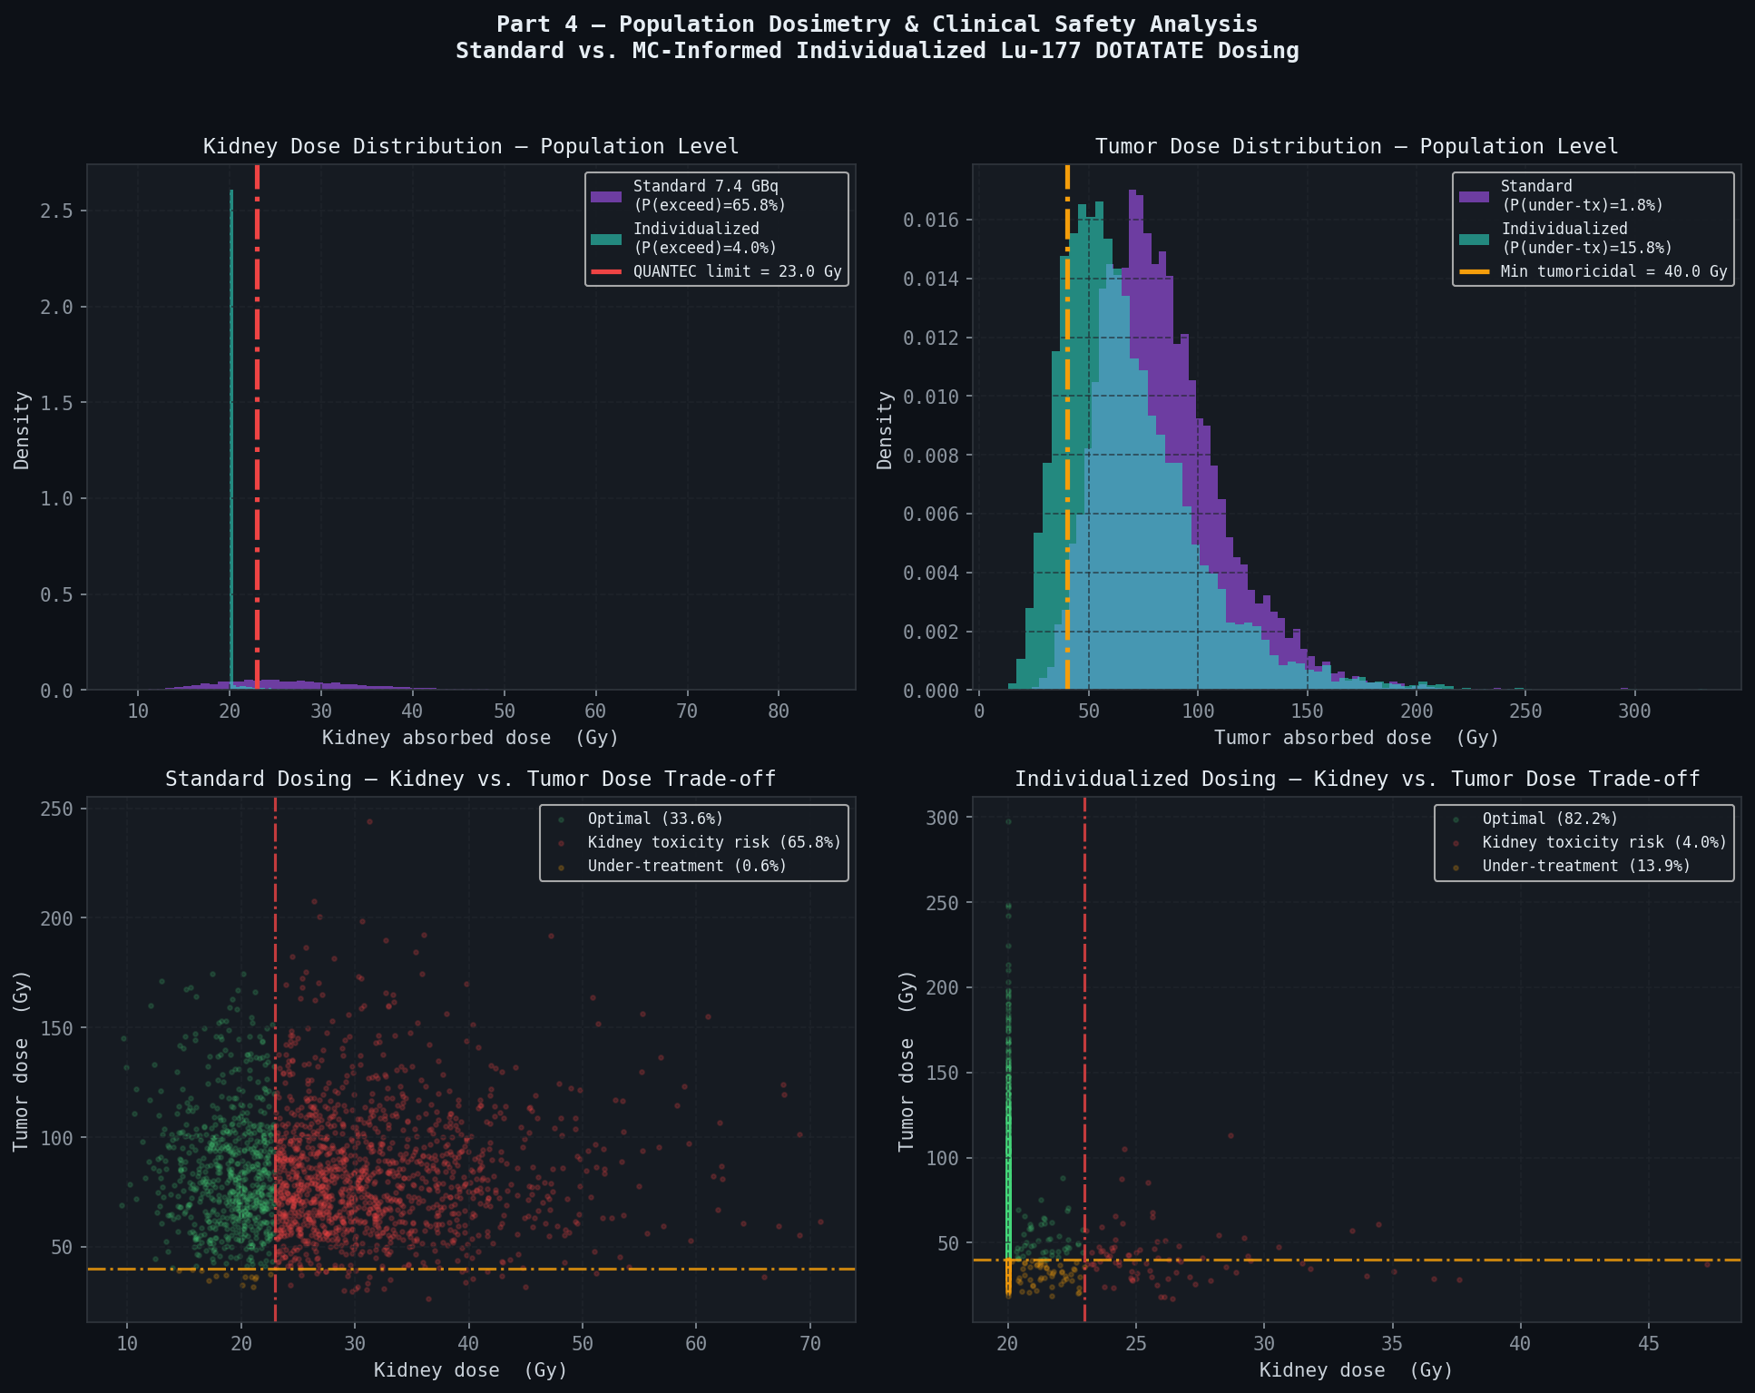
Figure 4. Population safety analysis for 8,000 patients. Left: kidney dose distributions under standard vs. individualized dosing. The red dashed line is the QUANTEC 23 Gy limit. Right: outcome breakdown by strategy.

Strategy | P(kidney tox.) | P(under-treat.) | P(optimal) | Mean activity (GBq)
Standard 7.4 GBq | 65.8% | 1.8% | 32.5% | 7.40
Individualized MC | 4.0% | 15.8% | 80.2% | 5.61
Table 3. Outcome comparison across 8,000 simulated patients.
Connections to Machine Learning
One thing worth noting is how directly these methods map onto techniques throughout modern ML.
The control variate approach is mathematically identical to the baseline subtraction in policy gradient RL. In REINFORCE and PPO, a learned value function is subtracted from the return before computing the gradient—that baseline is a control variate whose job is to reduce gradient variance without introducing bias.
Importance sampling underlies the ELBO in variational autoencoders. Training a VAE involves estimating an expectation under the approximate posterior q(z|x) and reweighting samples by a likelihood ratio. The reparameterization trick—writing z = μ + σε where ε ~ N(0,1)—is essentially a continuous version of antithetic variates that makes stochasticity differentiable.
Quasi-Monte Carlo appears in neural architecture search and Gaussian process approximations, where covering a high-dimensional space efficiently with a limited evaluation budget is exactly the problem.
Metropolis-Hastings is the ancestor of Hamiltonian Monte Carlo, used by Stan and NumPyro. HMC uses gradient information to propose states far from the current one, reducing autocorrelation. The ACF plot in Figure 3 directly measures the autocorrelation problem HMC is designed to solve.
Conclusion
Standard Lu-177 DOTATATE dosing puts the majority of patients above the kidney safety threshold because it ignores the 30% inter-patient variability in biokinetic clearance that directly controls absorbed dose. Monte Carlo simulation provides both the computational efficiency (via variance reduction) and the statistical framework (via Bayesian MCMC) to fix this. Population simulation shows that MC-informed individualized dosing reduces kidney toxicity risk from 65.8% to 4.0%.
Next steps would be modeling multi-cycle dose accumulation, replacing the MIRD S-values with full MC photon transport through patient-specific CT geometry, and jointly inferring tumor and kidney parameters from the same SPECT acquisition to directly optimize the efficacy–toxicity tradeoff.
References
Dawson, L. A., Kavanagh, B. D., Paulino, A. C., Das, S., Miften, M., Li, X. A., Pan, C., Ten Haken, R. K., & Schultheiss, T. E. (2010). Radiation-associated kidney injury. International Journal of Radiation Oncology, Biology, Physics, 76(3S), S108–S115.
International Commission on Radiological Protection. (1987). Radionuclide transformations: Energy and intensity of emissions (ICRP Publication 53). Pergamon Press.
Kingma, D. P., & Welling, M. (2014). Auto-encoding variational Bayes. Proceedings of ICLR 2014.
Ljungberg, M., Celler, A., Konijnenberg, M. W., Eckerman, K. F., Dewaraja, Y. K., Sjogreen-Gleisner, K., & EANM Dosimetry Committee. (2016). MIRD Pamphlet No. 26. Journal of Nuclear Medicine, 57(1), 151–162.
Loevinger, R., & Berman, M. (1968). A schema for absorbed-dose calculations for biologically-distributed radionuclides. Journal of Nuclear Medicine, Supplement 1, 7–14.
Metropolis, N., Rosenbluth, A. W., Rosenbluth, M. N., Teller, A. H., & Teller, E. (1953). Equation of state calculations by fast computing machines. Journal of Chemical Physics, 21(6), 1087–1092.
Neal, R. M. (2011). MCMC using Hamiltonian dynamics. In Handbook of Markov Chain Monte Carlo. CRC Press.
Niederreiter, H. (1992). Random number generation and quasi-Monte Carlo methods. SIAM.
Robert, C. P., & Casella, G. (2004). Monte Carlo statistical methods (2nd ed.). Springer.
Sandstrom, M., Garske-Roman, U., Granberg, D., Johansson, S., Widstrom, C., Eriksson, B., Sundin, A., Lundqvist, H., & Lubberink, M. (2013). Individualized dosimetry of kidney and bone marrow in patients undergoing 177Lu-DOTA-octreotate treatment. Journal of Nuclear Medicine, 54(1), 33–41.
Strosberg, J., El-Haddad, G., Wolin, E., Hendifar, A., Yao, J., Chasen, B., Mittra, E., Kunz, P. L., Kulke, M. H., Jacene, H., Bushnell, D., et al. (2017). Phase 3 trial of 177Lu-Dotatate for midgut neuroendocrine tumors. New England Journal of Medicine, 376(2), 125–135.
Williams, R. J. (1992). Simple statistical gradient-following algorithms for connectionist reinforcement learning. Machine Learning, 8(3–4), 229–256.

Strosberg, J., El-Haddad, G., Wolin, E., et al. (2017). Phase 3 trial of 177Lu-Dotatate for midgut neuroendocrine tumors. New England Journal of Medicine, 376(2), 125–135.
Loevinger, R., & Berman, M. (1968). A schema for absorbed-dose calculations for biologically-distributed radionuclides. Journal of Nuclear Medicine, Supplement 1, 7–14.
International Commission on Radiological Protection. (1987). Radionuclide Transformations: Energy and Intensity of Emissions (ICRP Publication 53). Pergamon Press.
Sandstrom, M., Garske-Roman, U., Granberg, D., et al. (2013). Individualized dosimetry of kidney and bone marrow in patients undergoing 177Lu-DOTA-octreotate treatment. Journal of Nuclear Medicine, 54(1), 33–41. The 30% CV estimate is from Table 3.
Dawson, L. A., Kavanagh, B. D., Paulino, A. C., et al. (2010). Radiation-associated kidney injury. International Journal of Radiation Oncology, Biology, Physics, 76(3S), S108–S115.
Ljungberg, M., Celler, A., Konijnenberg, M. W., et al. (2016). MIRD Pamphlet No. 26: Joint EANM/MIRD guidelines for quantitative 177Lu SPECT. Journal of Nuclear Medicine, 57(1), 151–162.
Ljungberg et al. (2016), Section 4.3. The EANM guidelines recommend at least three SPECT timepoints, with a late acquisition beyond 96 hours strongly preferred for accurate slow-component characterization.
Niederreiter, H. (1992). Random Number Generation and Quasi-Monte Carlo Methods. SIAM.
Williams, R. J. (1992). Simple statistical gradient-following algorithms for connectionist reinforcement learning. Machine Learning, 8(3–4), 229–256.
Kingma, D. P., & Welling, M. (2014). Auto-encoding variational Bayes. Proceedings of ICLR 2014.
Neal, R. M. (2011). MCMC using Hamiltonian dynamics. In Handbook of Markov Chain Monte Carlo. CRC Press.

