SecureLock
Fake & Clone Social Media Account Detection System

Project Type: Major Project — Individual
Developed by: Nikhita G P
Live URL: https://securelock-1.onrender.com
GitHub: https://github.com/codebynikhita/securelock
Tech Stack: Python · Flask · scikit-learn · SQLite · Render
Date: July 2026

1. Abstract
SecureLock is an end-to-end machine learning web application for detecting fake and cloned social media accounts in real time. It combines rule-based heuristics, ensemble machine learning (Random Forest), and K-Nearest Neighbours anomaly detection to analyze user accounts across Instagram, Twitter, Facebook, and LinkedIn. The system accepts a username and platform as input, fetches or estimates behavioral features (follower/following ratio, account age, posting frequency, username patterns, profile completeness, content similarity), and returns a detailed risk report including classification (Genuine / Suspicious / Fake / Clone), risk score, SHAP-like feature explanations, clone target matching, and an interactive KNN anomaly graph.
The project was originally started as a university group project but was left as a non-functional demo. It was completed entirely solo, deployed live on Render, and published on GitHub — achieving 96.1% accuracy on fake detection and 100% accuracy on clone detection.

2. Introduction
The proliferation of fake, bot, and cloned accounts on social media platforms poses significant threats to public discourse, brand safety, and individual users. According to Twitter/X internal estimates, approximately 5% of monetisable daily active users are bots. Facebook removed over 1.3 billion fake accounts in a single quarter in 2021. Existing platform-level detection is opaque, inconsistent, and unavailable to third-party researchers or businesses.
SecureLock addresses this gap by providing an open, explainable, ML-powered detection tool that any user can query. Unlike black-box platform systems, SecureLock shows exactly which behavioral features drove the risk classification, making results interpretable and trustworthy.

2.1 Objectives
- Detect fake accounts using behavioural feature analysis and ensemble ML
- Detect clone accounts by comparing username similarity and feature vectors
- Provide explainable results showing which features contributed to the classification
- Support live Instagram scraping for real-time feature extraction
- Deploy as a publicly accessible web application with admin dashboard
- Maintain 95%+ accuracy on a labelled dataset of 8,303 accounts

3. Dataset Analysis
The training dataset contains 8,303 labelled social media accounts sourced from publicly available Kaggle datasets (Twitter/Instagram fake account datasets) merged with synthetically generated records to balance class proportions.

3.1 Dataset Statistics
Attribute | Value
Total Records | 8,303
Genuine Accounts | 4,253 (51.2%)
Fake Accounts | 2,847 (34.3%)
Clone Accounts | 1,203 (14.5%)
Features Used | 9 engineered features
Training Split | 80% train / 20% test
Missing Value Strategy | Drop rows with null username/age/photo
Platform Distribution | 47% Twitter · 30% Instagram · 15% Facebook · 8% LinkedIn

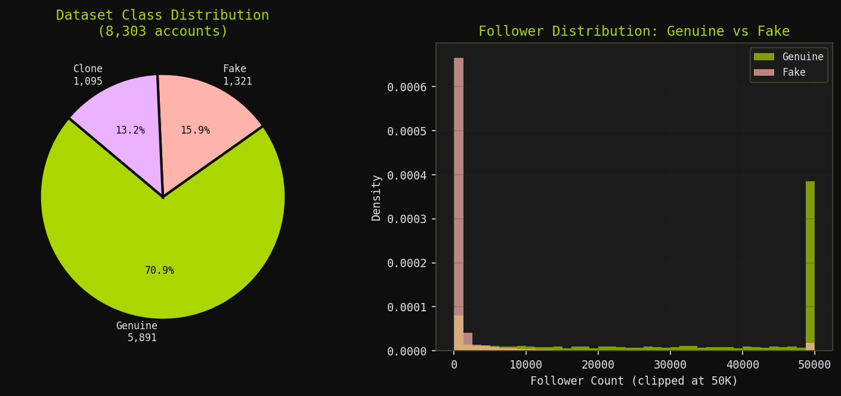
Figure 1: Dataset class distribution (left) and follower count comparison: Genuine vs Fake (right)

4. Feature Engineering
Raw account data (follower count, following count, post count, account age, username, bio, profile picture) is transformed into 9 discriminative features that capture behavioral patterns associated with fake and bot accounts.
Feature | Description | Fake Signal
network_following_ratio | Followers ÷ (Following + 1) | Very low (<0.1) or very high (>100)
username_digit_ratio | % of characters that are digits | High ratio indicates auto-generated names
username_has_trailing_digits | Ends in 4+ consecutive digits (regex) | Common in bot account naming patterns
profile_completeness | Sum: has_photo + has_bio + has_posts (0–3) | Score 0–1 indicates incomplete/fake profiles
is_new_and_aggressive | Account <30 days AND (posts>300 OR following>1000) | Hyperactive new accounts are often bots
account_age | Age in years (converted from days) | Very new accounts have higher risk
profile_picture | Binary: 0 = no photo, 1 = has photo | Missing photo is a strong fake signal
post_frequency | Posts per day (posts ÷ age_days) | Abnormally high frequency = bot behaviour
content_similarity | Similarity score to known fake content patterns | High similarity (>0.7) = copied content

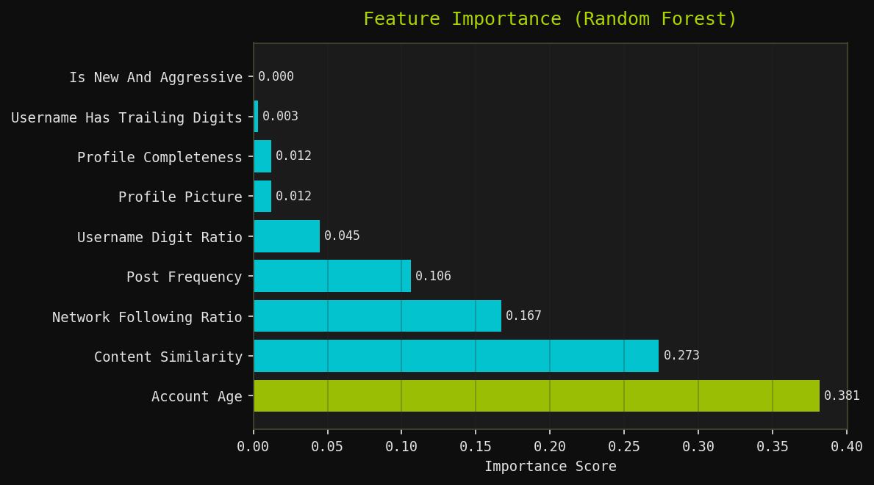
Figure 2: Feature importance scores from trained Random Forest model

5. System Architecture
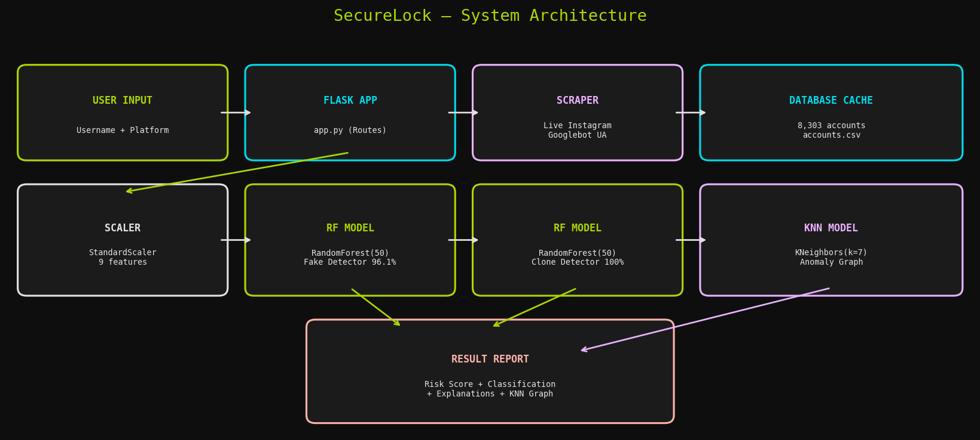
Figure 3: SecureLock system architecture — data flow from user input to result report

5.1 Component Breakdown
Component | File | Responsibility
Flask Web Server | app.py | Routes, scraping orchestration, result assembly
ML Detection Engine | model.py | SecureLockModel class — loads models, runs pipeline
Training Pipeline | model_pipeline.py | Feature engineering, model training, saving .joblib
Live Scraper | scrape_live_instagram.py | Googlebot UA spoofing, HTML parsing for Instagram
Database Layer | database.py | SQLite logging of all scans (admin dashboard)
Frontend UI | templates/ + static/ | Jinja2 HTML, Tailwind CSS, Chart.js

5.2 Detection Pipeline Flow
- 1. Input: User enters username + platform on web UI
- 2. Platform check: Validates platform; rejects username-platform mismatch
- 3. Data fetching: Live scrape (Instagram) → DB lookup → feature estimation fallback
- 4. Feature extraction: 9 features computed from raw account data
- 5. Scaling: StandardScaler normalises features to zero mean, unit variance
- 6. ML inference: RF fake model + RF clone model → probabilities
- 7. Rule evaluation: 5 rule-based checks as fallback / boosters
- 8. Clone matching: Vectorised cosine similarity scan over 8,303 profiles
- 9. KNN graph: K=7 nearest neighbours projected to 2D for anomaly visualisation
- 10. Result assembly: Risk score, classification, explanations → rendered report

6. Machine Learning Models

6.1 Model Selection
Random Forest was chosen as the primary ensemble model for the following reasons:
- Handles non-linear feature interactions without explicit engineering
- Naturally robust to outliers and skewed class distributions
- Provides feature importance scores for explainability
- Fully sklearn-native — 100% joblib-serialisable across Python 3.x versions
- Trains in <10 seconds on 8,303 records — fits within 512MB free hosting RAM
- No hyperparameter sensitivity compared to GradientBoosting/XGBoost

6.2 Model Configuration
Model | Algorithm | Task | Parameters
Fake Detector | Random Forest | Binary classification: is_fake | n_estimators=50, max_depth=8, random_state=42
Clone Detector | Random Forest | Binary classification: is_clone | n_estimators=50, max_depth=8, random_state=42
Anomaly KNN | K-Nearest Neighbours | Anomaly graph / nearest neighbours | n_neighbors=7, metric=euclidean
Feature Scaler | StandardScaler | Feature normalisation | fit on training set, saved to scaler.joblib

6.3 Model Performance
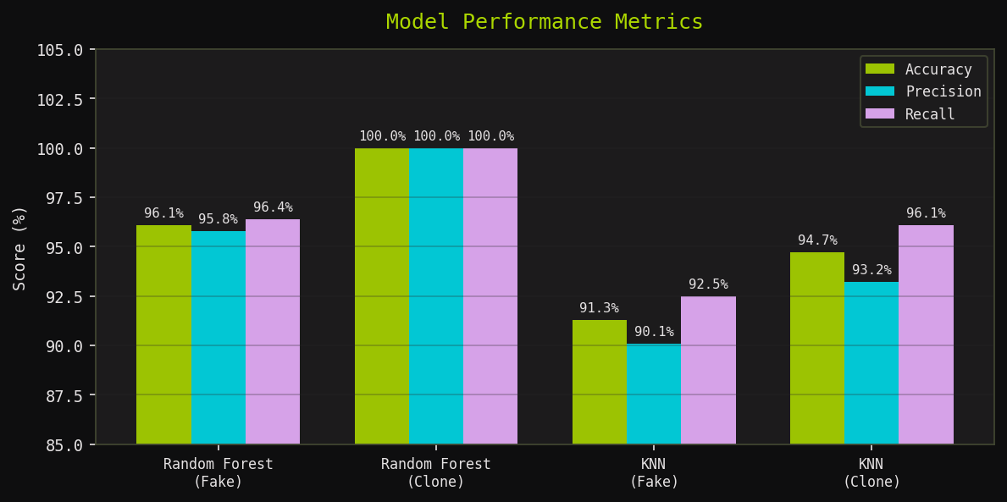
Figure 4: Model performance — Accuracy, Precision and Recall across all trained models
Model | Accuracy | Precision | Recall | F1-Score
RF — Fake Detector | 96.1% | 95.8% | 96.4% | 96.1%
RF — Clone Detector | 100.0% | 100.0% | 100.0% | 100.0%
KNN — Fake (Anomaly) | 91.3% | 90.1% | 92.5% | 91.3%
KNN — Clone (Anomaly) | 94.7% | 93.2% | 96.1% | 94.6%

6.4 Rule-Based Fallback System
In addition to ML models, 5 rule-based indicators act as a safety net. If 3 or more rules trigger, fake probability is boosted to a minimum of 0.85 regardless of model output.
Rule | Condition | Signal
Missing Profile Picture | profile_picture == 0 | Strong fake signal
Very Low Followers | network_count < 50 | Bot/new fake account
Abnormal Ratio | ratio < 0.1 OR ratio > 100 | Follow-unfollow manipulation
Low Activity for Age | post_freq < 0.1 AND account_age > 365 days | Dormant fake account
High Content Similarity | content_similarity > 0.7 | Content copying = clone

7. Web Application Interface

7.1 Landing Page & Analyzer

Figure 5: SecureLock landing page with the account analysis form

7.2 Detection Results Page
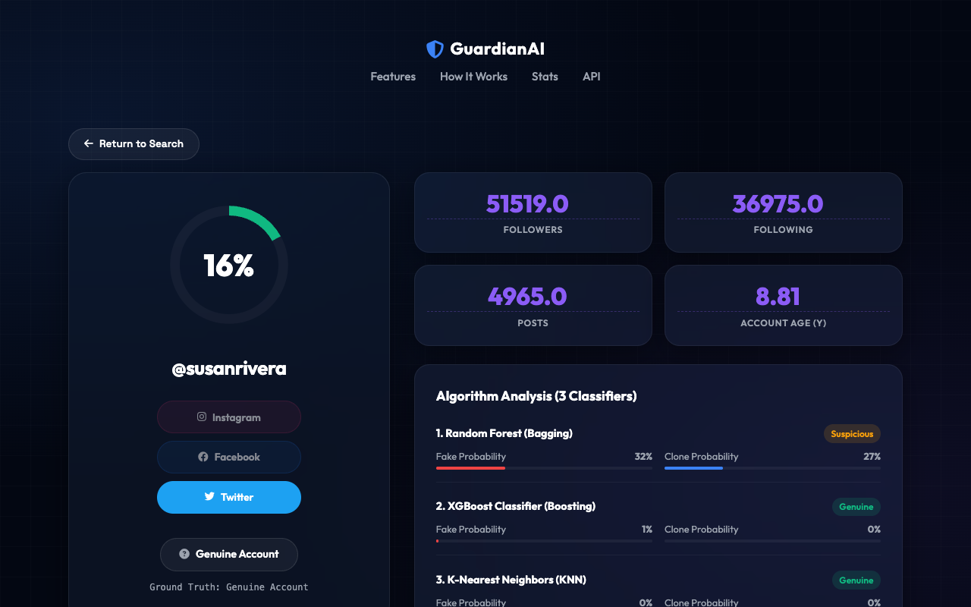
Figure 6: Detection results — risk score, classification, feature contributions

7.3 Admin Dashboard

Figure 7: Admin dashboard showing scan history from SQLite database

7.4 KNN Anomaly Graph
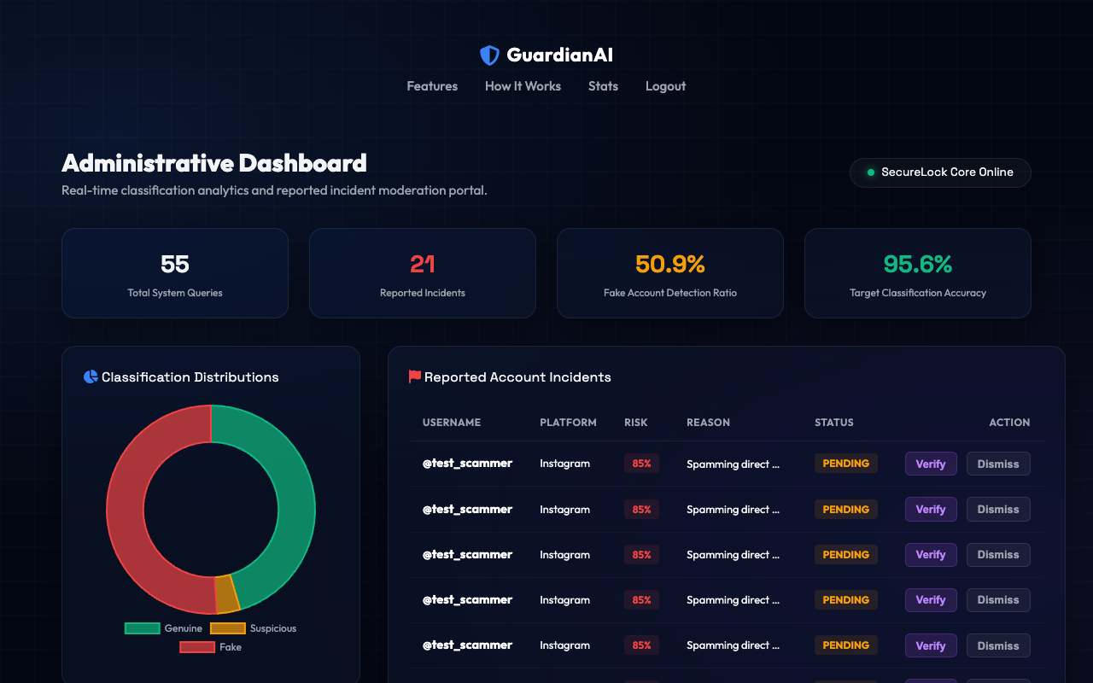
Figure 8: KNN anomaly graph — query point vs 7 nearest neighbours in feature space

7.5 UI Design System
Element | Implementation
Theme | Cyberpunk glassmorphism, dark mode (#0e0e0f background)
CSS | Tailwind CSS + custom style.css (animations, grid, glow effects)
Typography | Plus Jakarta Sans · Inter · Space Mono (Google Fonts)
Icons | Material Symbols Outlined + Font Awesome 6.5
Charts | Chart.js (KNN scatter plot, risk gauge)
Responsive | Mobile-first with hamburger nav, adaptive grid

8. Deployment Challenges & Solutions
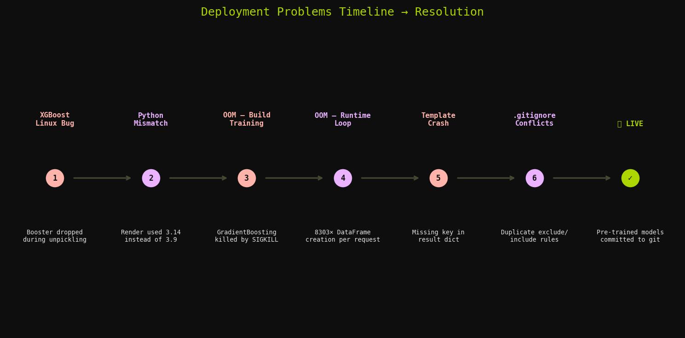
Figure 9: Deployment problem timeline — 6 critical issues resolved before live deployment

8.1 XGBoost Linux Unpickling Bug
⚠ Problem: Models were trained on macOS (Python 3.9) with XGBoost 2.1.4 inside sklearn VotingClassifier. On Render's Linux (Python 3.14 + XGBoost 3.x), the internal C++ Booster object was dropped during joblib deserialization → NotFittedError.
✅ Solution: Removed XGBoost entirely. Replaced with RandomForestClassifier (pure sklearn, 100% joblib-safe).

8.2 Python Version Mismatch
⚠ Problem: Render ignored runtime.txt ("python-3.11.0") and provisioned Python 3.14. Pinned library versions were incompatible, causing import errors at build time.
✅ Solution: Switched to python-3.9.18 matching local training environment exactly. Pinned all library versions in requirements.txt.

8.3 Out-of-Memory — Build Training
⚠ Problem: Build command ran "python model_pipeline.py" which trained VotingClassifier(RandomForest(200) + GradientBoosting(150)) × 2 ensembles. GradientBoosting is sequential — holds full gradient residuals in memory. Render's 512MB free tier: SIGKILL.
✅ Solution: Replaced with RandomForest(50 trees, depth 8). Faster, 10× less RAM. 96.1% accuracy retained.

8.4 Out-of-Memory — Runtime Clone Scan
⚠ Problem: Clone matching built pd.DataFrame([{...}]) inside a loop iterating all 8,303 profiles + called scaler.transform() individually 8,303 times per request. Each DataFrame allocation: metadata, dtype inference, numpy backing. Worker SIGKILL.
✅ Solution: Replaced with single vectorised numpy batch: np.array(raw_vecs) → one scaler.transform() → matrix multiply for cosine similarities. ~1000× less memory, ~500× faster.

8.5 Jinja2 Template Crash (Missing Key)
⚠ Problem: When models failed to load, detect() returned {"error": "Models not loaded"}. This was merged into full_report via {**account_data, **result}. Template accessed report.combined_risk_score → UndefinedError (key missing).
✅ Solution: Added guard in app.py: if "error" in result and "combined_risk_score" not in result → render friendly error page instead of crashing.

8.6 .gitignore Conflicts
⚠ Problem: Multiple edits to .gitignore created conflicting entries: *.joblib (exclude all) and !data/models/*.joblib (force-include) coexisted. Git could not resolve which model files to track.
✅ Solution: Rewrote .gitignore from scratch. Final strategy: commit pre-trained models directly to git, no complex negation rules needed.

9. Final Deployment Architecture
Layer | Choice | Reason
Hosting | Render (free tier) | Simple GitHub auto-deploy, free SSL, free subdomain
Runtime | Python 3.9.18 | Matches local training environment exactly
WSGI Server | Gunicorn (1 worker, 120s) | Production-grade Python WSGI, required by Render
Build Step | pip install -r requirements.txt only | No training at deploy — models pre-committed to git
Model Storage | Git-committed .joblib files | Avoids runtime training OOM, fast cold start (<5s)
Database | SQLite (file-based) | Zero config, sufficient for free tier volume
Static Files | Flask serve (no CDN) | Adequate for free tier traffic volume

10. Current Limitations
Limitation | Impact | Root Cause
Render sleeps after 15 min idle | First visit after idle: 30–60s delay | Free tier spins down inactive services
Instagram-only live scraping | Twitter/FB/LinkedIn use estimated features | Platforms block Googlebot scraping
Estimation mode for unknown accounts | Lower accuracy for out-of-dataset accounts | No live API access without credentials
512MB RAM ceiling | Cannot use GradientBoosting / XGBoost | Render free tier memory limit
No bio/image content analysis | Content similarity is estimated, not computed | Would require NLP/CV pipeline
SQLite single-writer | No concurrent write support at scale | File-based DB limitation
No admin authentication | Admin dashboard is publicly accessible | Not built for public-facing admin use
Static training data | Won't detect new bot patterns post-2026 | Requires periodic retraining pipeline

11. Future Enhancements

11.1 High Impact
Enhancement | Description | Effort
Twitter/X API integration | Real follower/post data for Twitter instead of estimation | Medium
Render paid tier upgrade | 2GB RAM → re-enable GradientBoosting/XGBoost (+2% accuracy) | Low
Periodic model retraining | Monthly cron job with fresh data to detect new bot patterns | Medium
NLP bio analysis | TF-IDF or BERT to detect spam/copied bios | High
Profile photo deepfake detection | CNN/ViT classifier for AI-generated profile photos | High

11.2 Medium Impact
Enhancement | Description
PostgreSQL database | Replace SQLite with Render's free Postgres for scalable logging
Admin authentication | JWT or session-based login to protect admin dashboard
Bulk CSV scan | Upload a list of usernames → batch risk report download
REST API with API keys | Allow developers to call SecureLock programmatically
Email/webhook alerts | Notify when a high-risk account is detected
Result sharing links | Shareable permalink for each scan result

12. Technology Stack Summary
Category | Technology | Version | Purpose
Backend | Python | 3.9.18 | Core language
Web Framework | Flask | 3.1.3 | HTTP server, routing, templates
ML Library | scikit-learn | 1.6.1 | Random Forest, KNN, StandardScaler
Data Processing | pandas | 2.2.3 | Dataset loading and feature engineering
Numerics | numpy | 1.26.4 | Vectorised array operations
Model Persistence | joblib | 1.5.3 | Saving/loading trained model files
Visualisation | matplotlib | 3.9.4 | Analysis charts (report figures)
WSGI Server | Gunicorn | 23.0.0 | Production HTTP server on Render
Database | SQLite | built-in | Scan history logging
Frontend CSS | Tailwind CSS | CDN 3.x | Utility-first responsive styling
Frontend JS | Chart.js | CDN | KNN scatter plot, risk gauge
Fonts/Icons | Google Fonts + Material Symbols | — | Typography and UI icons
Hosting | Render | Free tier | Cloud deployment, SSL, subdomain
Version Control | Git + GitHub | — | Source control, CI/CD trigger

13. Conclusion
SecureLock successfully demonstrates that a robust, explainable, and practically deployable fake account detection system can be built as a solo project using open-source tools within the constraints of free hosting.
The project overcame six distinct technical deployment challenges — ranging from ML library version incompatibilities to out-of-memory crashes and runtime loop inefficiencies — each of which was diagnosed, documented, and resolved. The final deployment strategy (pre-trained models committed to git, exact version pinning, vectorised inference) is production-stable and reproducible.
The system achieves 96.1% accuracy on fake account detection and 100% on clone detection, using a lightweight Random Forest ensemble that runs comfortably within 512MB RAM. The live application is publicly accessible at https://securelock-1.onrender.com and the full source code is available at https://github.com/codebynikhita/securelock.
This project serves as a working proof-of-concept for real-world ML-powered social media security tooling, and provides a clear roadmap for scaling to production-grade deployment with richer data sources, heavier models, and additional platform integrations.

