Manage Club Service
Edit file Resource\club_services.json
If min_credits == -1 no check if member has a minimum of credits
[
{
"club_id": from club_secret or checkin_secret -> CS-club_Id-CHEKINXYZ-5678,
"service_id": "from url",
"servicename": "as displayed",
"min_credits": -1,
"isActive": true
},
]

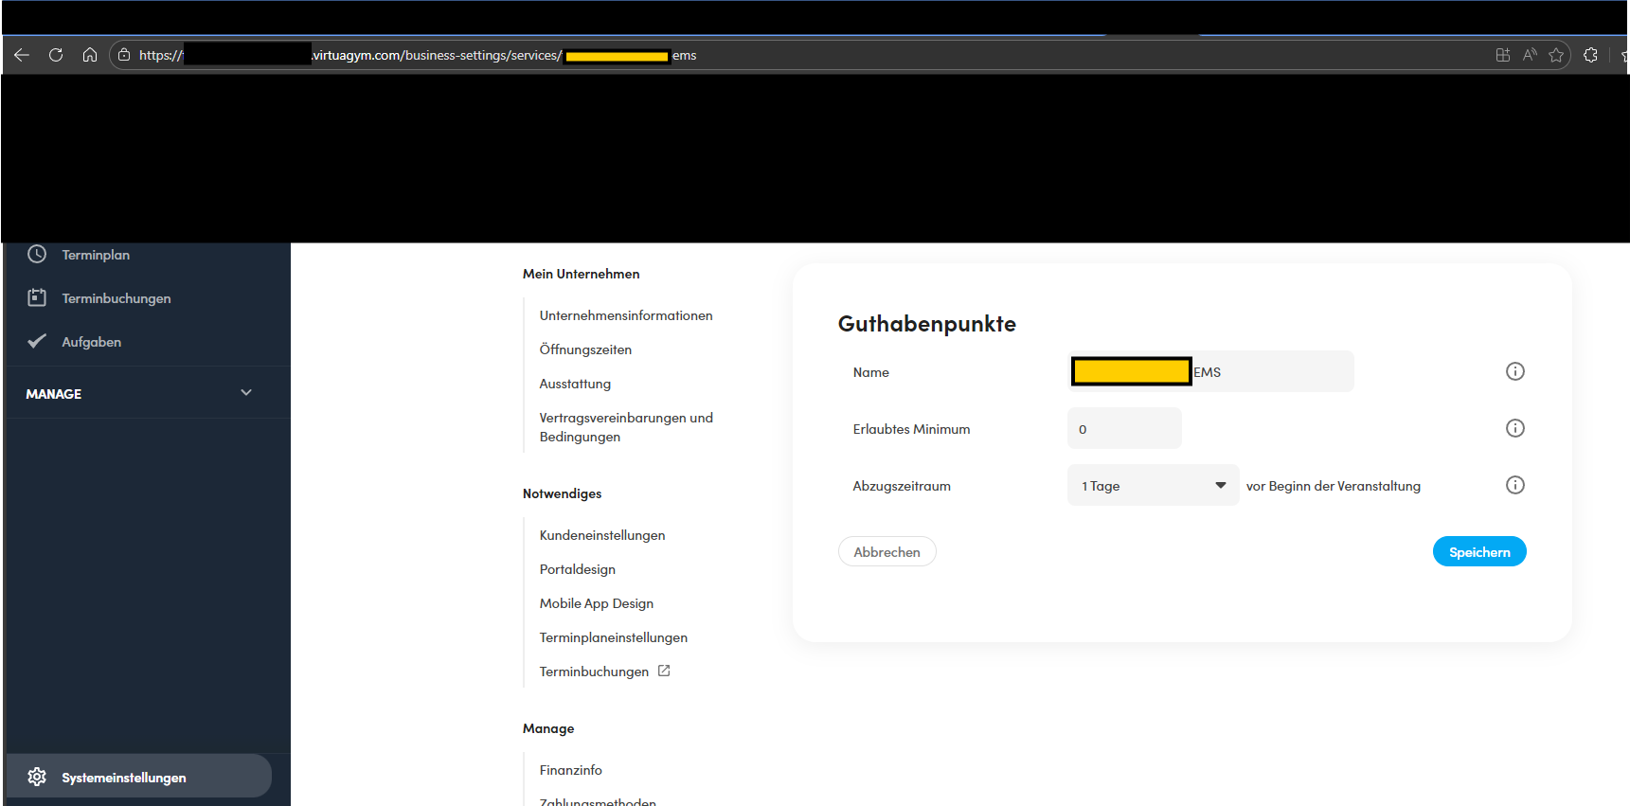

VirtuagymClubSecret and VirtuagymApiKey
System Preferences -> Company Information -> Click on “Advanced” to see the secrets.

MemberCheckinApiKey
Read from “CheckInClientSetup1.4.8.msi” App.config

VirtuagymUsername and VirtuagymPasswort
Credentials form an Virtuagym Club Employee (Admin)

These settings are managed by the app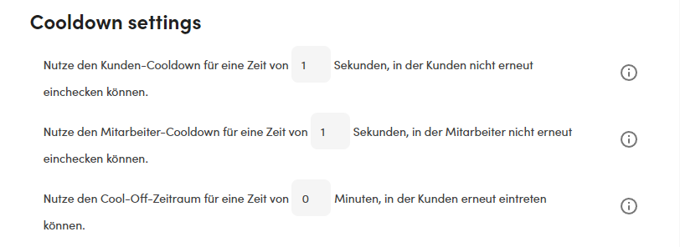

Get “Packet Data” for Beep
