**SANDEEP KR CHAUHAN**

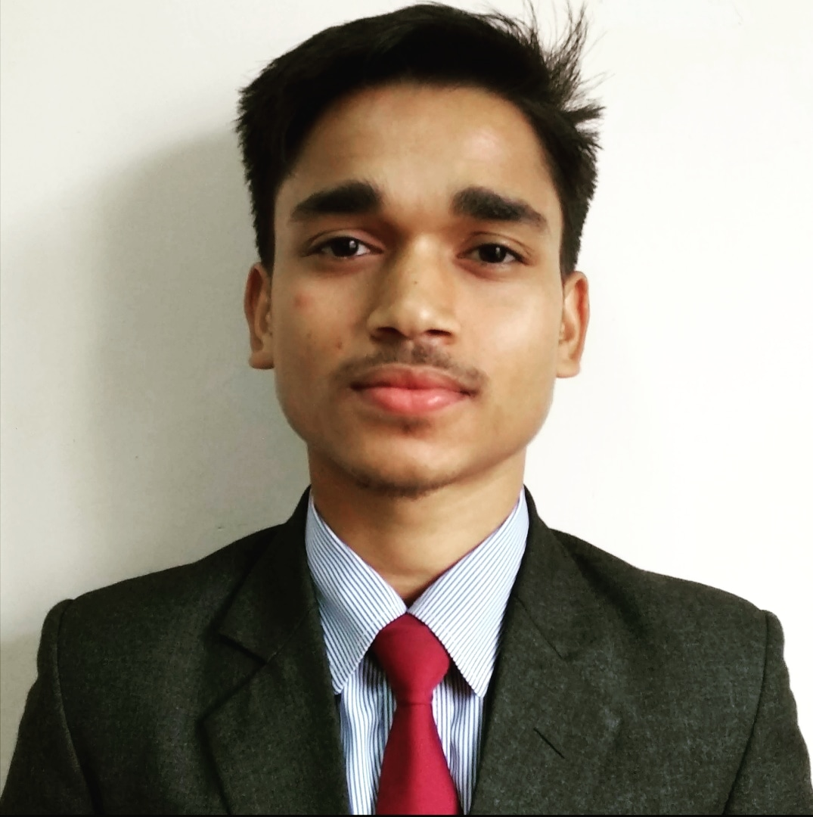

**DC building 1st floor, Near Lal Bazaar**

**Gangtok-737101, East Sikkim**

**Mobile: 9474476085 / 7047123239**

**Email : sandeepkc422@gmail.com**

CAREER OBJECTIVE

**To build career in a growing organization, where I can get the opportunities to prove my abilities by accepting**

**Challenges, fulfilling the organizational goal and climb the career ladder through continuous learning and**

**commitment.**

EXPERIENCE

**I have 9 month experienced to develop an e-commerce website named ”shopinbags” , where customers can purchase groceries, fruits, vegetables, spices, etc. And this website developed by using HTML5, CSS3, JS, Boostrap4 and PHP7.2.3.**

ACADEMICS QUALIFICATION

|  |  |  |  |  |
| --- | --- | --- | --- | --- |
| Degree / Certificate | School / University | Board / University | Year of Passing | Percentage / CGPA |
| BCA | ICFAI University Sikkim | -- | 2021 | -- |
| 12th | West Point Sr Sec School | CBSE | 2018 | 64.4% |
| 10th | West Point Sr Sec School | CBSE | 2016 | 54% |

OTHER QUALIFICATION

|  |  |  |  |
| --- | --- | --- | --- |
| Diploma | Foundation | Year | Grade |
| PGDCA | Vedanta Foundation | 2016-2017 | B+ |

TECHNICAL SKILLS SOFT SKILLS

* **Languages:** HTML5, CSS3, JS, Bootstrap5, PHP7.3, React.js, React-Native, NodeJs

Basics: ASP.Net, Python.

* **Tools:** Adobe Photoshop / Illustrator, Figma.

Basics: Adobe XD, Coral Draw.

* **Database:** MySQL, MariaDB.

|  |  |
| --- | --- |
|  | * Honesty * Team Spirit * Accepting Challenges |

PERSONAL INFORMATION

* **Father’s Name : Shri Paras Nath Chauhan**
* **Date of Birth : 18.07.1999**
* **Sex : Male**
* **Marital Status : Unmarried**
* **Nationality : Indian**
* **Hobbies : Listening Music and Jogging at morning**
* **Language Known : Can Speak, Read, & Write English, Hindi and Nepali**