Sales Performance Dashboard (Power BI)

Overview
This project presents an interactive Sales Performance Dashboard built in Power BI using the Global Superstore dataset.
The dashboard analyzes sales, profit, product performance, and regional trends to identify key business insights.

Business Questions
- How do sales and profit evolve over time?
- Which categories and regions perform best?
- Which products generate the highest profit?
- Are there products with high sales but low profitability?
- Where are the main inefficiencies?

Tools & Technologies
- Power BI
- Power Query (data cleaning)
- DAX (measures & calculations)

Key Metrics
- Total Sales
- Total Profit
- Profit Margin
- Total Orders
- Average Order Value

Dashboard Features
Page 1 — Executive Overview
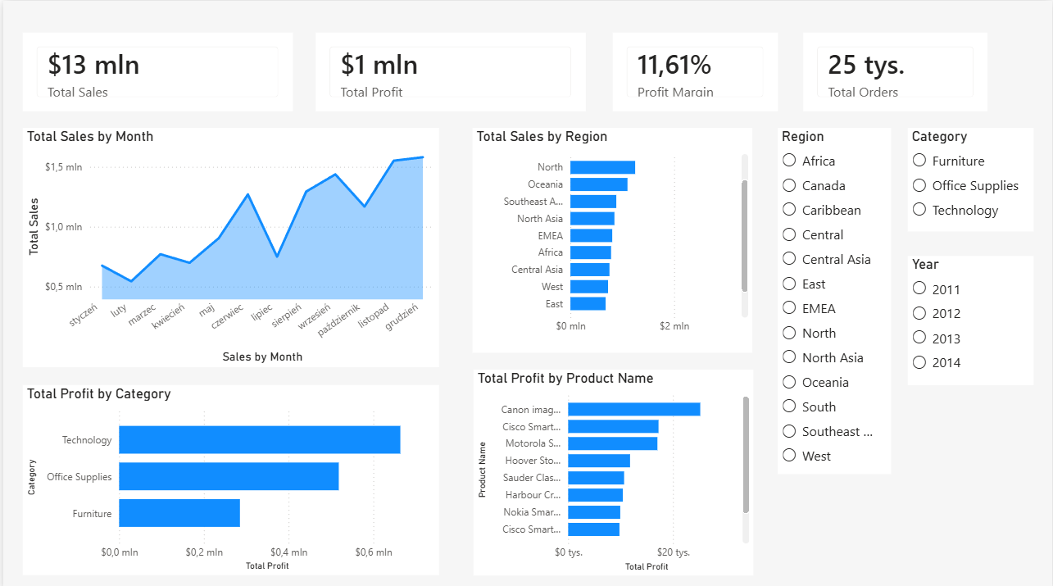
- KPI cards (Sales, Profit, Margin, Orders)
- Sales trend over time
- Profit by Category
- Sales by Region
- Top 10 Products by Profit
- Interactive slicers (Region, Category, Year)

Page 2 — Product Analysis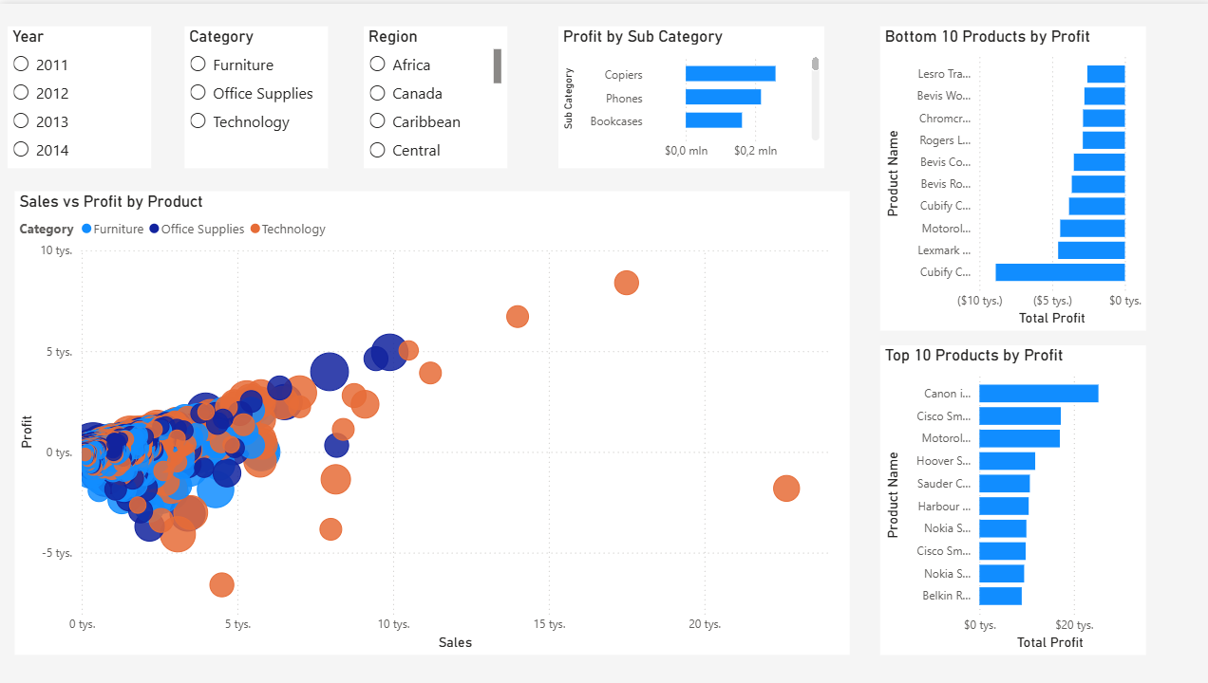
- Sales vs Profit scatter analysis
- Top & Bottom performing products
- Profit by Sub-Category
- Product-level performance insights

Key Insights
- Sales peak in Q4, indicating strong seasonality.
- Technology is the most profitable category.
- Some high-selling products generate low or negative profit.
- Profitability varies across sub-categories.
- A small number of products drive most of the profit.

Project Structure
/dashboard → Power BI file
/screenshots → dashboard images
/data → dataset

Author
Szymon Dębiński

