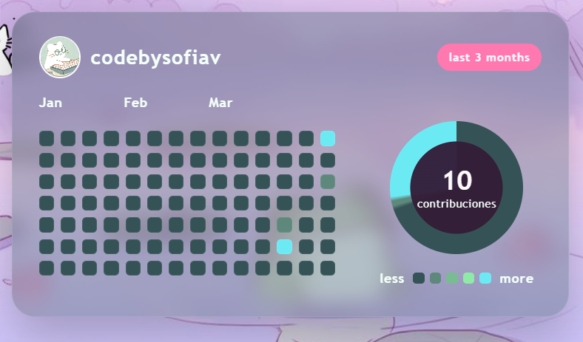
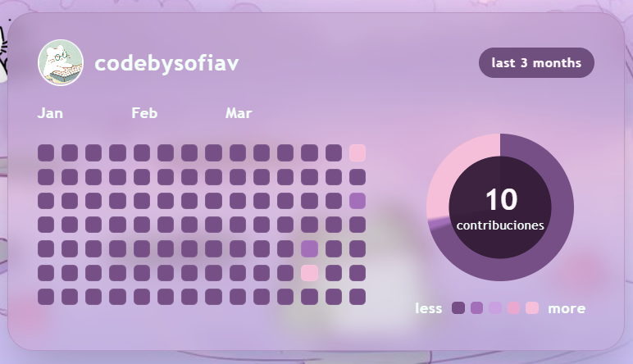
--bg: #8fd8d2;
--widget-bg: rgba(37, 16, 38, 0.50);
--widget-border: rgba(160, 115, 162, 0.4);
--text: #f4fff9;
--muted: #b3d2cb;
--accent: #6f4f7d;
--level-0: #754f86;
--level-1: #a36fb9;
--level-2: #c9a1e0;
--level-3: #e9a8cf;
--level-4: #f5bfd9;
}
